Table of Contents

1 Sensitivity Analysis 2

2 PK parameters 12

2.1 PK Parameters of Raltegravir 12

2.1.1 C_max 12

2.1.2 C_max_norm 39

2.1.3 t_max 66

2.1.4 C_tEnd 93

2.1.5 AUC 120

2.1.6 AUC_norm 147

2.1.7 AUC_inf 174

2.1.8 AUC_inf_norm 201

2.1.9 MRT 228

2.1.10 Thalf 255

2.1.11 CL 282

2.1.12 Vss 309

2.1.13 Vd 336

3 Time profiles and residual plots 364

3.1 Time profiles and residual plots for Filmcoated_tablet_400mg_sd 364

3.2 Time profiles and residual plots for Larson 2013 8y-18y 400mg FCT meal 372

3.3 Residuals across all simulations 380

4 Demography 387

4.1 Age-dependence 387

4.1.1 Dependence of Height 387

4.1.2 Dependence of Weight 393

4.1.3 Dependence of BMI 399

# Sensitivity Analysis

**Figure 1-1: Most sensitive parameters for C_max of Raltegravir for individuals at percentiles 5, 50, 95 for Larson 2013 8y-18y 400mg FCT meal, Filmcoated_tablet_400mg_sd.**

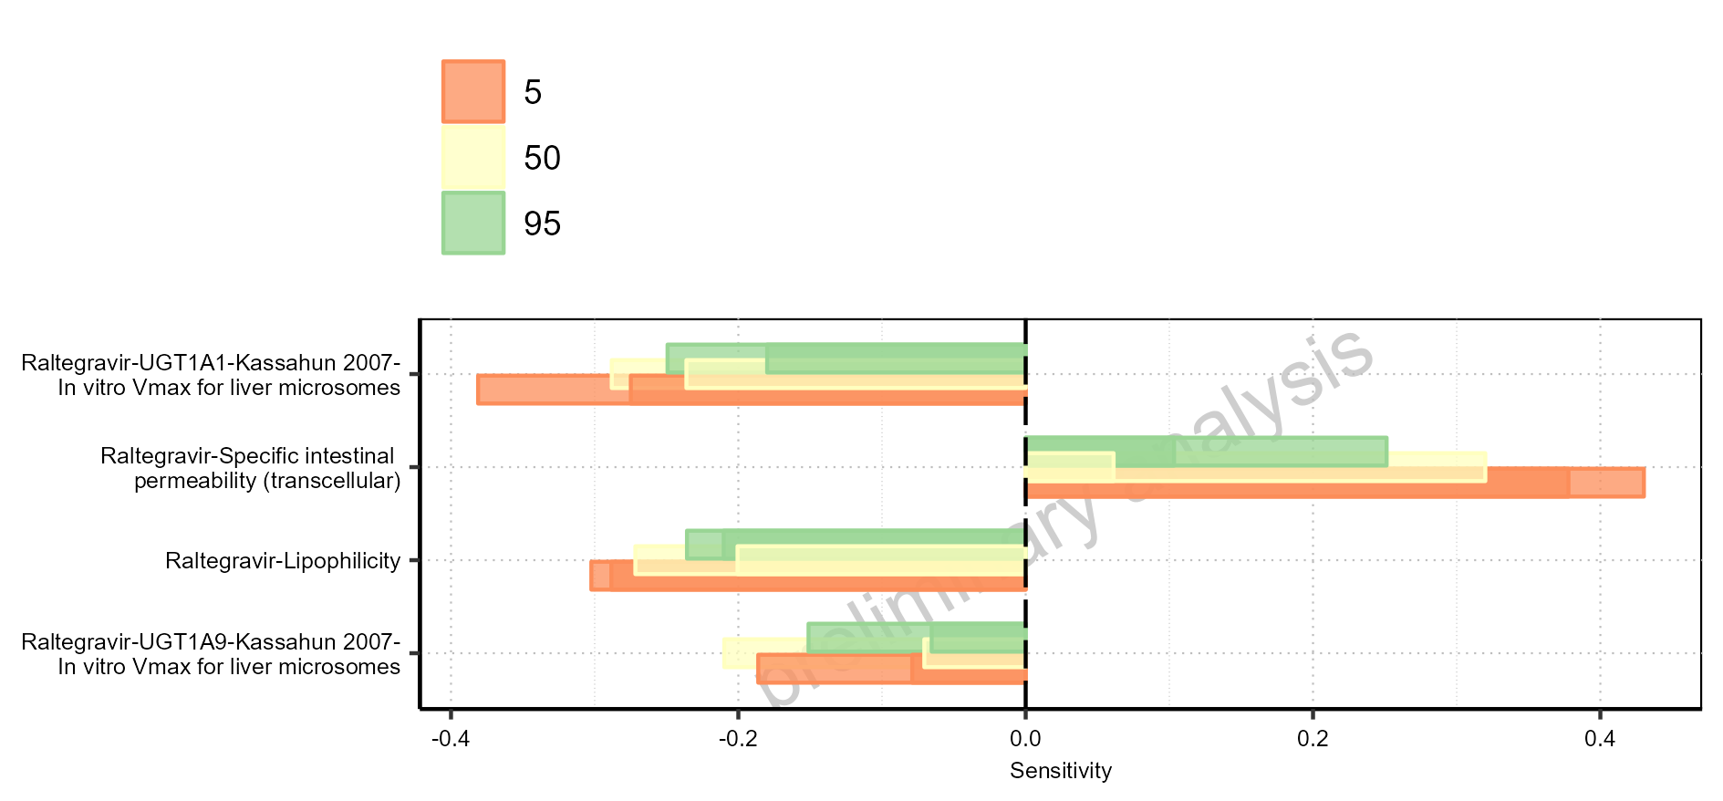

Figure 1-2: Most sensitive parameters for t_max of Raltegravir for individuals at percentiles 5, 50, 95 for Filmcoated_tablet_400mg_sd, Larson 2013 8y-18y 400mg FCT meal.

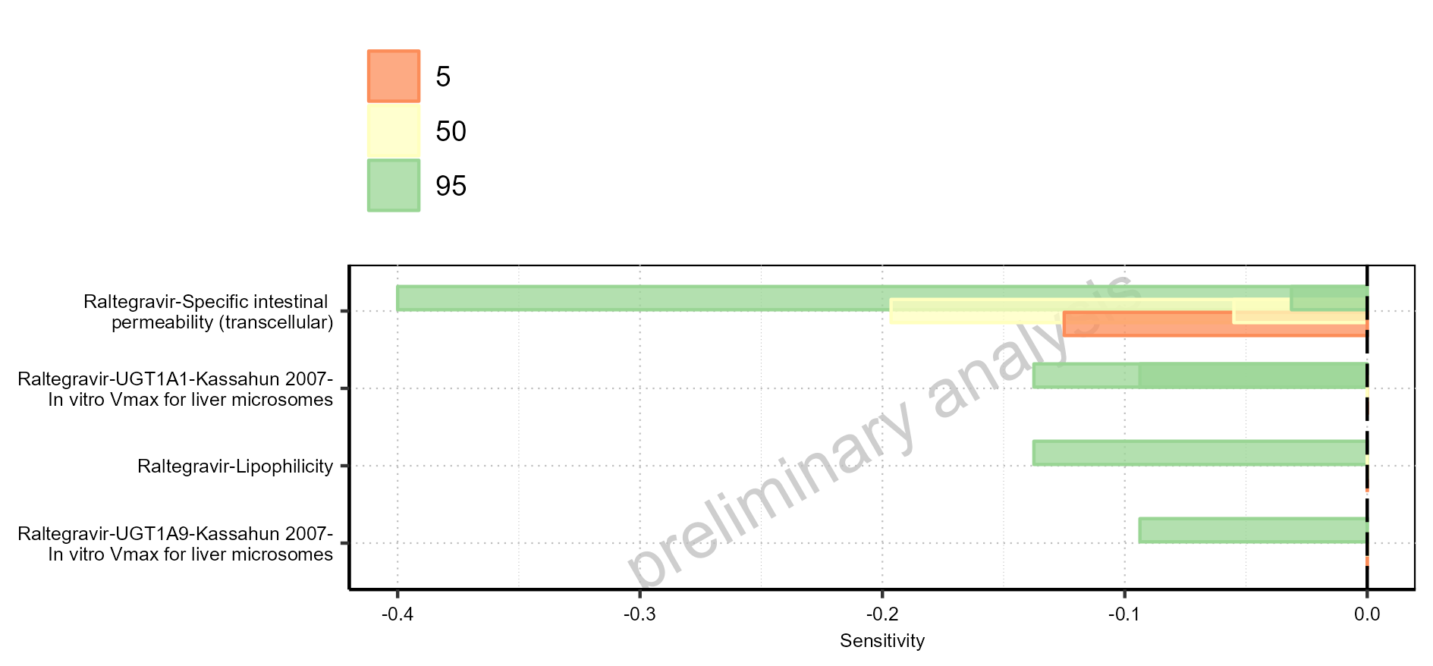

Figure 1-3: Most sensitive parameters for C_tEnd of Raltegravir for individuals at percentiles 5, 50, 95 for Filmcoated_tablet_400mg_sd, Larson 2013 8y-18y 400mg FCT meal.

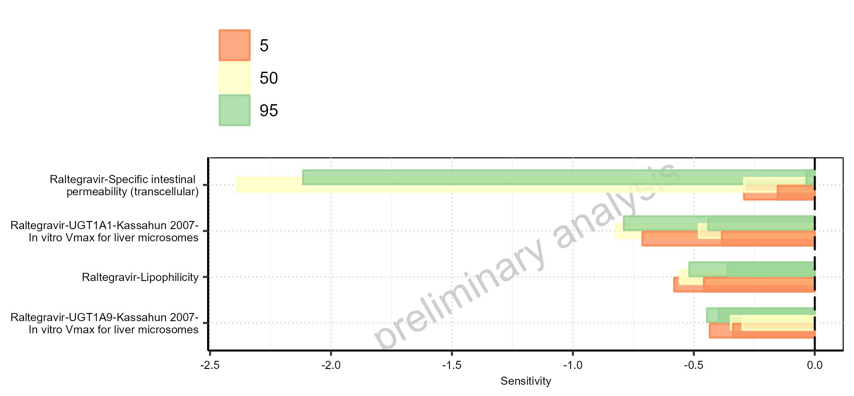

Figure 1-4: Most sensitive parameters for AUC of Raltegravir for individuals at percentiles 5, 50, 95 for Larson 2013 8y-18y 400mg FCT meal, Filmcoated_tablet_400mg_sd.

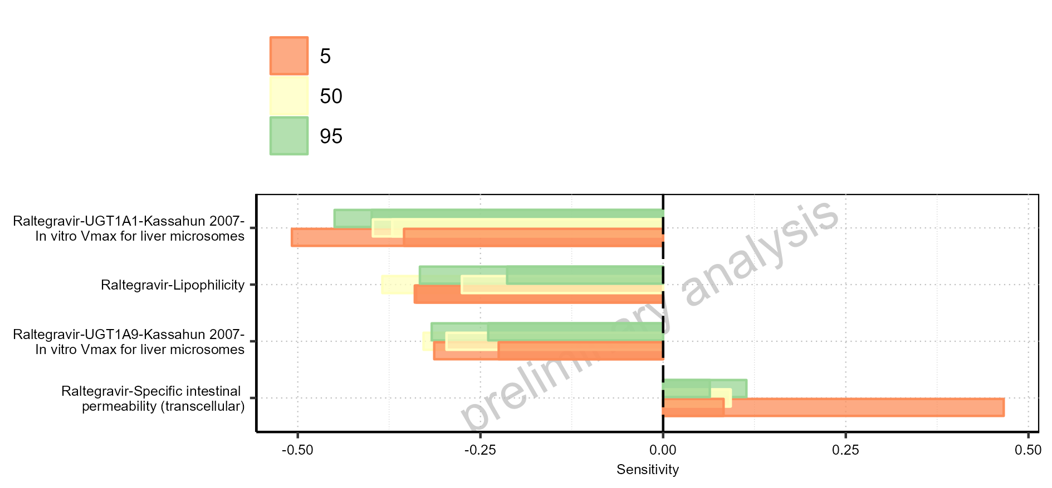

Figure 1-5: Most sensitive parameters for AUC_inf of Raltegravir for individuals at percentiles 5, 50, 95 for Larson 2013 8y-18y 400mg FCT meal, Filmcoated_tablet_400mg_sd.

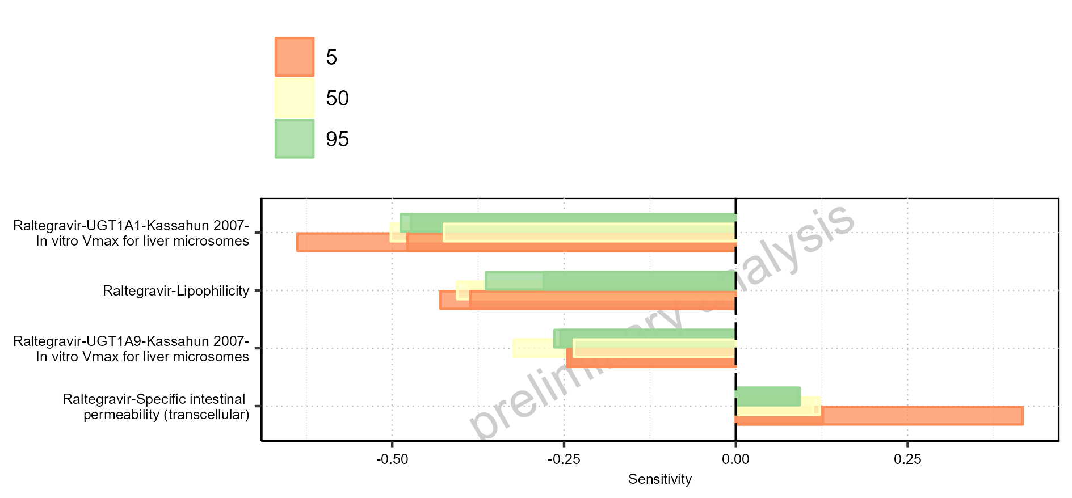

Figure 1-6: Most sensitive parameters for MRT of Raltegravir for individuals at percentiles 5, 50, 95 for Larson 2013 8y-18y 400mg FCT meal, Filmcoated_tablet_400mg_sd.

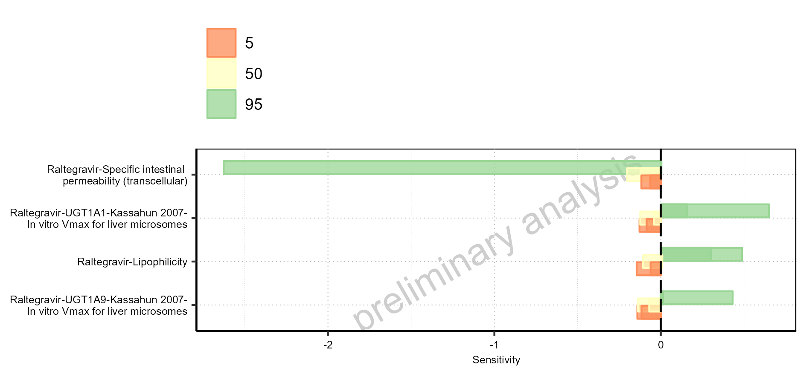

Figure 1-7: Most sensitive parameters for Thalf of Raltegravir for individuals at percentiles 5, 50, 95 for Filmcoated_tablet_400mg_sd, Larson 2013 8y-18y 400mg FCT meal.

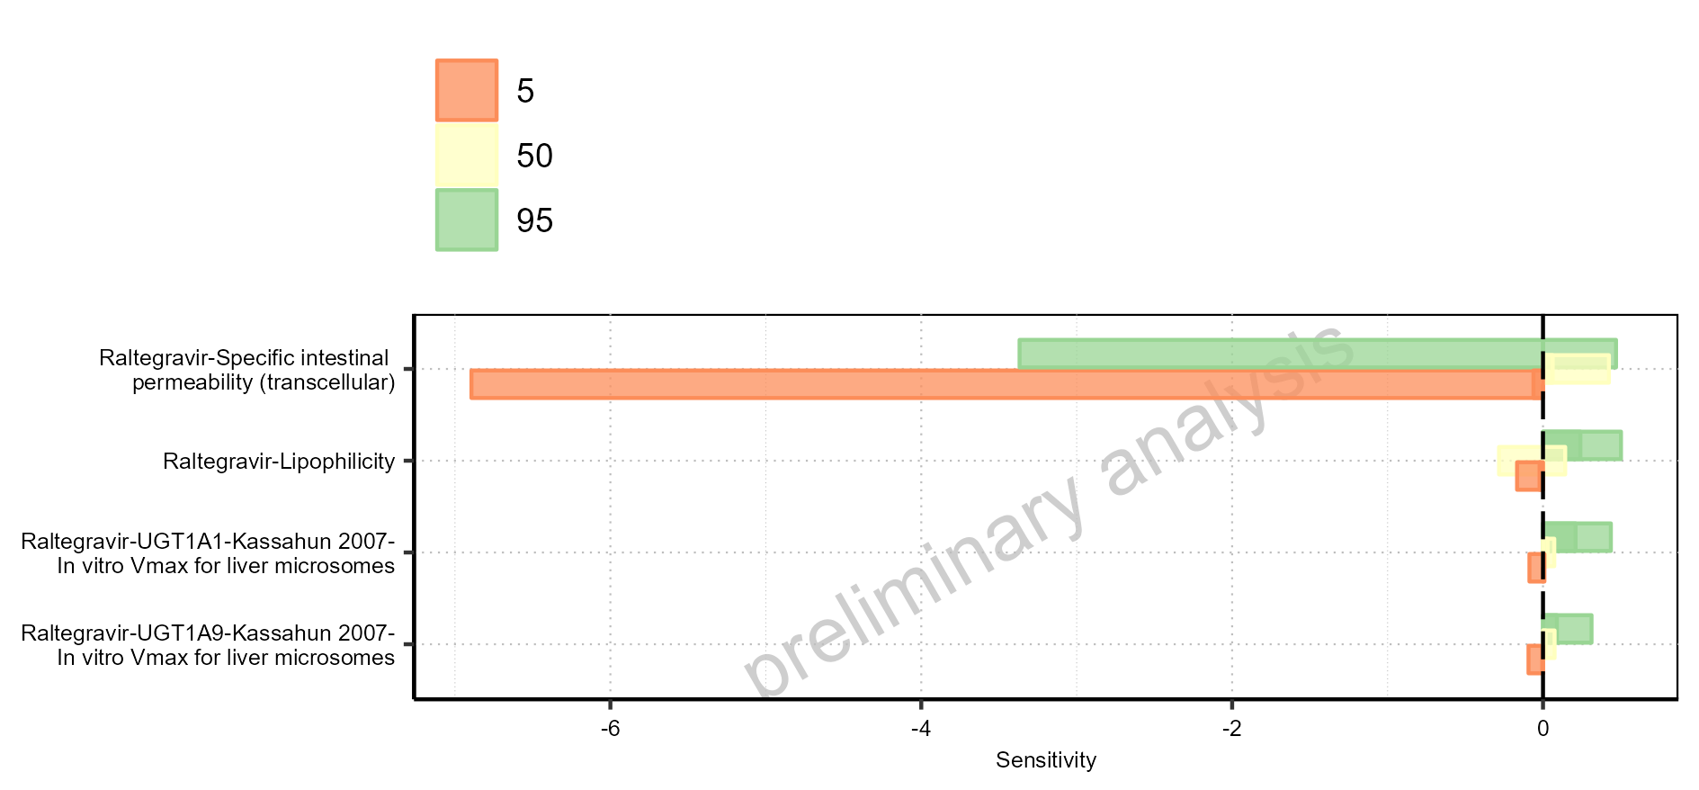

Figure 1-8: Most sensitive parameters for CL of Raltegravir for individuals at percentiles 5, 50, 95 for Larson 2013 8y-18y 400mg FCT meal, Filmcoated_tablet_400mg_sd.

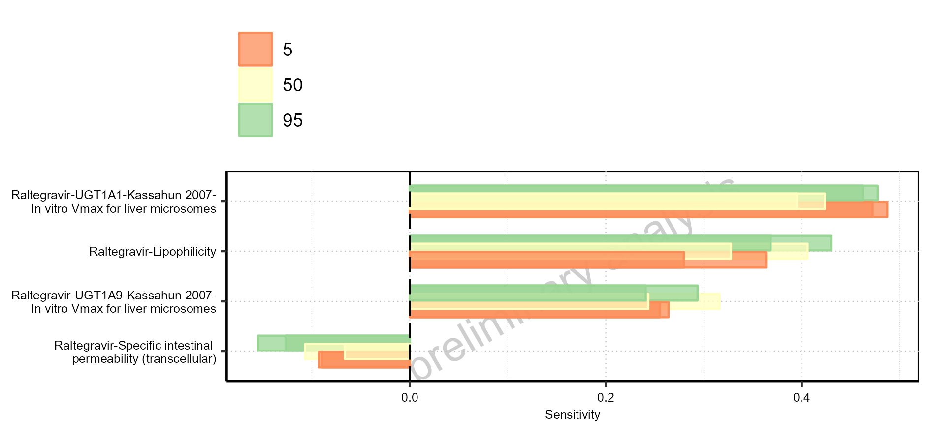

Figure 1-9: Most sensitive parameters for Vss of Raltegravir for individuals at percentiles 5, 50, 95 for Larson 2013 8y-18y 400mg FCT meal, Filmcoated_tablet_400mg_sd.

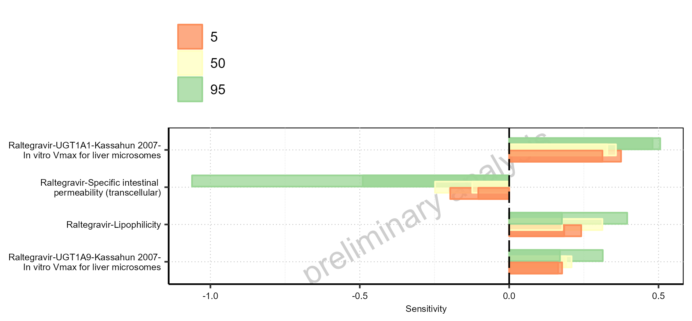

Figure 1-10: Most sensitive parameters for Vd of Raltegravir for individuals at percentiles 5, 50, 95 for Larson 2013 8y-18y 400mg FCT meal, Filmcoated_tablet_400mg_sd.

# PK parameters

## PK Parameters of Raltegravir

### C_max

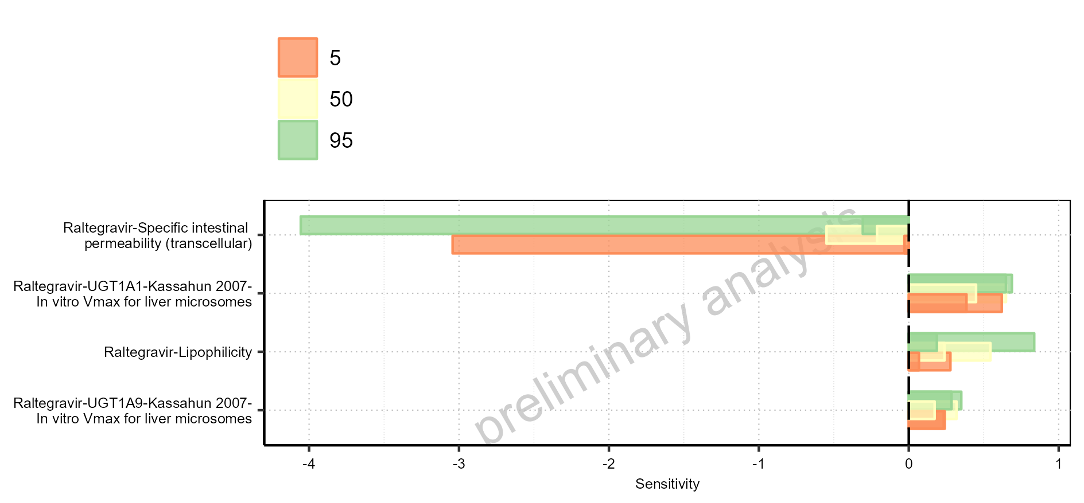

Figure 2-1: C_max of Raltegravir for Larson 2013 8y-18y 400mg FCT meal, Filmcoated_tablet_400mg_sd shown as box-whisker plot, which indicates the 5<U+1D57><U+02B0>, 25<U+1D57><U+02B0>, 50<U+1D57><U+02B0>, 75<U+1D57><U+02B0>, 95<U+1D57><U+02B0> percentiles in logarithmic scale.

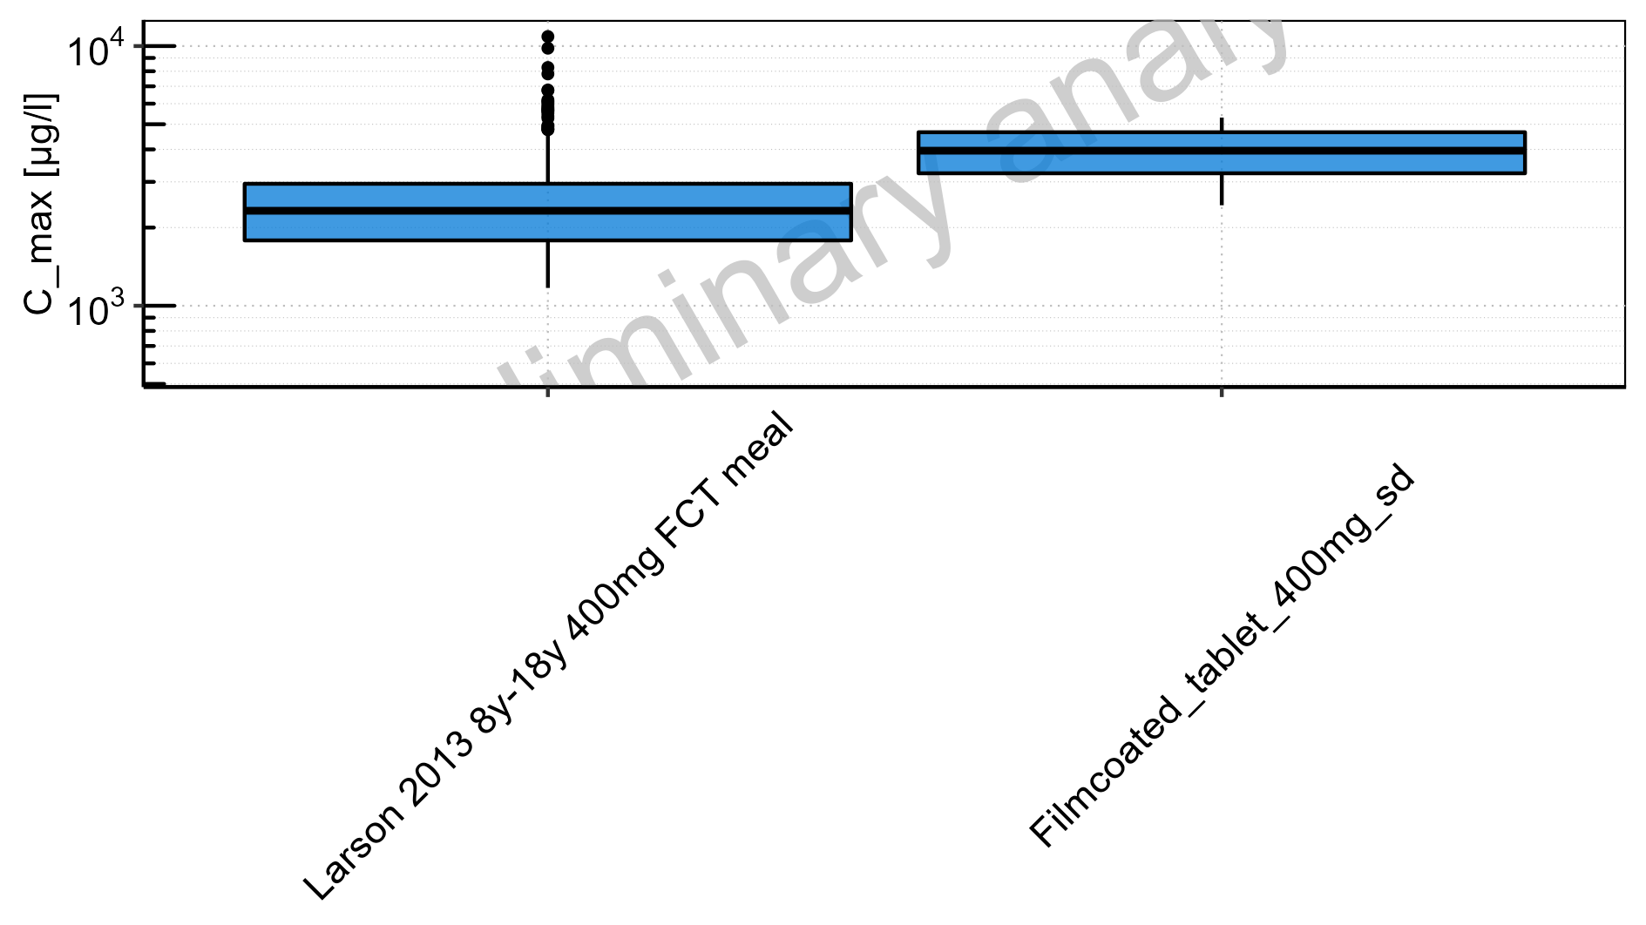

Figure 2-2: C_max of Raltegravir for Larson 2013 8y-18y 400mg FCT meal, Filmcoated_tablet_400mg_sd shown as box-whisker plot, which indicates the 5<U+1D57><U+02B0>, 25<U+1D57><U+02B0>, 50<U+1D57><U+02B0>, 75<U+1D57><U+02B0>, 95<U+1D57><U+02B0> percentiles in linear scale.

**Table 2-1: C_max of Raltegravir for Larson 2013 8y-18y 400mg FCT meal, Filmcoated_tablet_400mg_sd reported in [µg/l]**

|  |  |  |  |  |  |  |  |  |  |  |
| --- | --- | --- | --- | --- | --- | --- | --- | --- | --- | --- |
| Population | N | 5<U+1D57><U+02B0> pctl | 25<U+1D57><U+02B0> pctl | 50<U+1D57><U+02B0> pctl | 75<U+1D57><U+02B0> pctl | 95<U+1D57><U+02B0> pctl | Mean | SD | Geo Mean | Geo SD |
| Larson 2013 8y-18y 400mg FCT meal | 500 | 1171.26 | 1784.94 | 2321.55 | 2949.24 | 4651.40 | 2549.83 | 1206.89 | 2326.87 | 1.52 |
| Filmcoated_tablet_400mg_sd | 100 | 2437.79 | 3236.54 | 3954.54 | 4657.56 | 5304.38 | 3940.92 | 908.89 | 3833.70 | 1.27 |

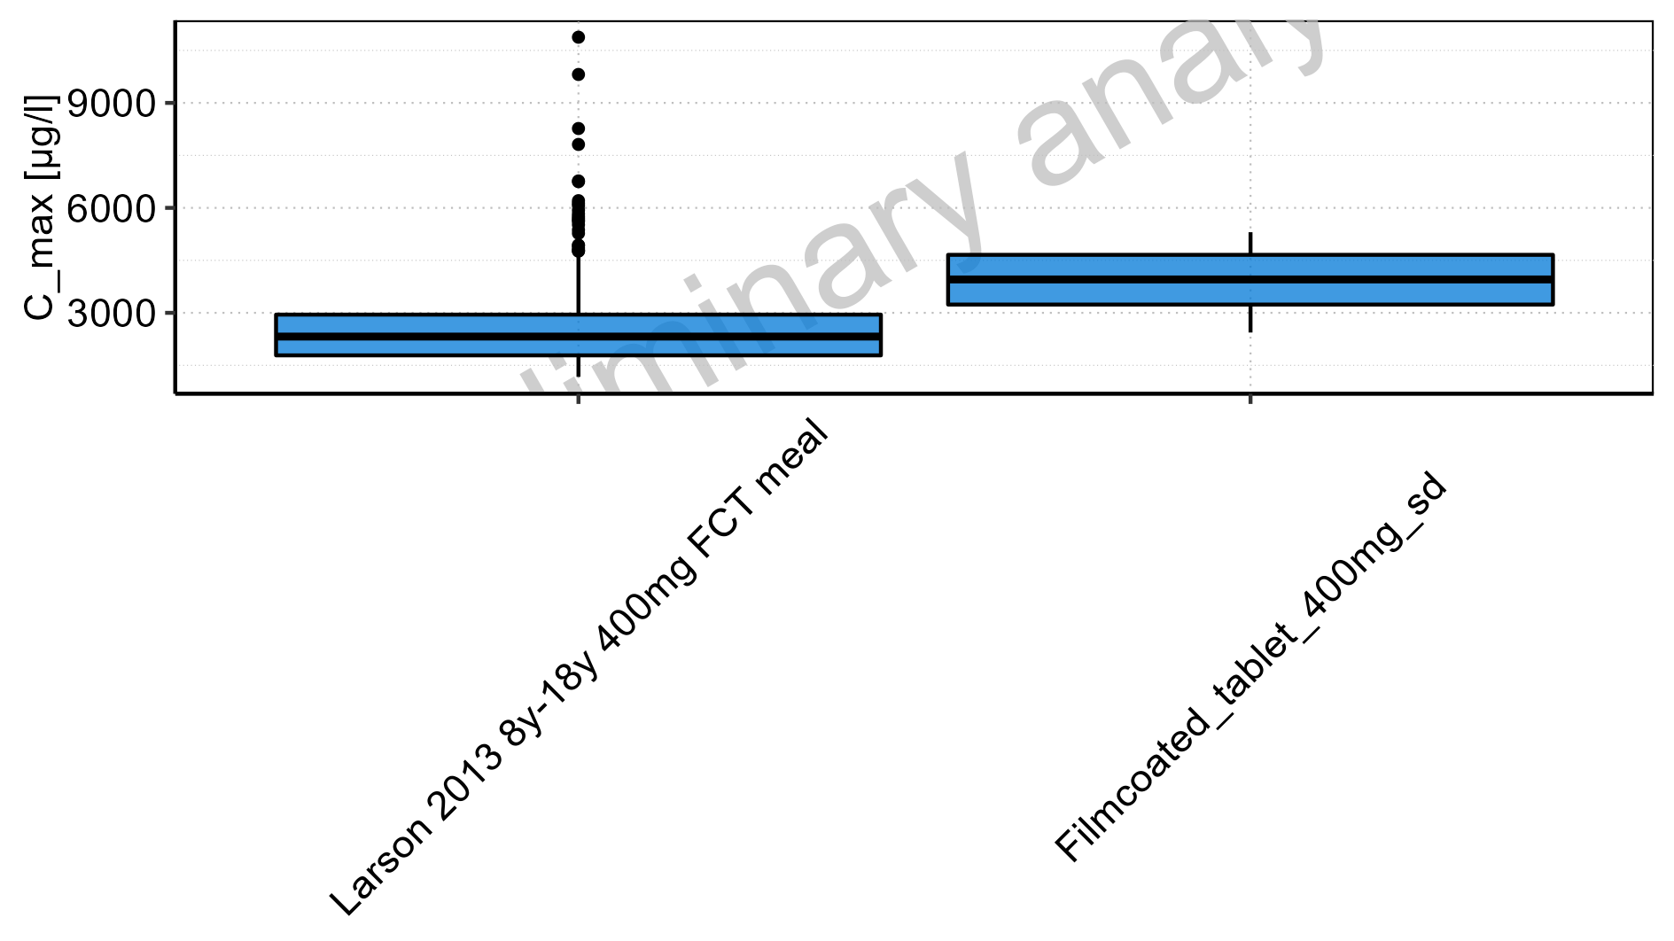

Figure 2-3: Age-dependence of C_max for Larson 2013 8y-18y 400mg FCT meal in comparison to Filmcoated_tablet_400mg_sd. Profiles are plotted in a logarithmic scale.

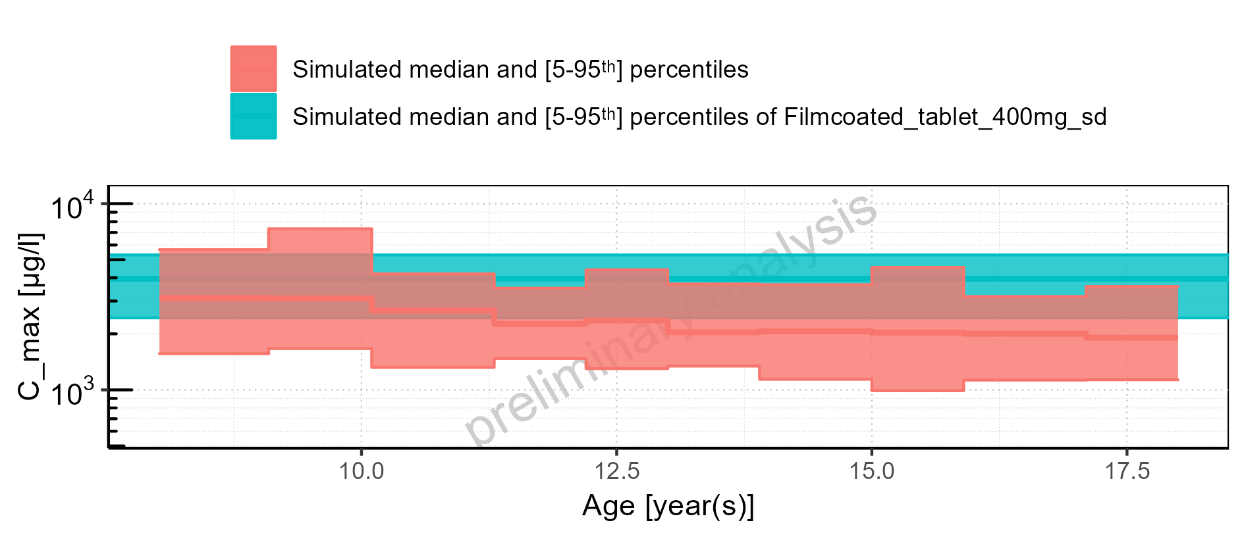

Figure 2-4: Age-dependence of C_max for Larson 2013 8y-18y 400mg FCT meal in comparison to Filmcoated_tablet_400mg_sd. Profiles are plotted in a linear scale.

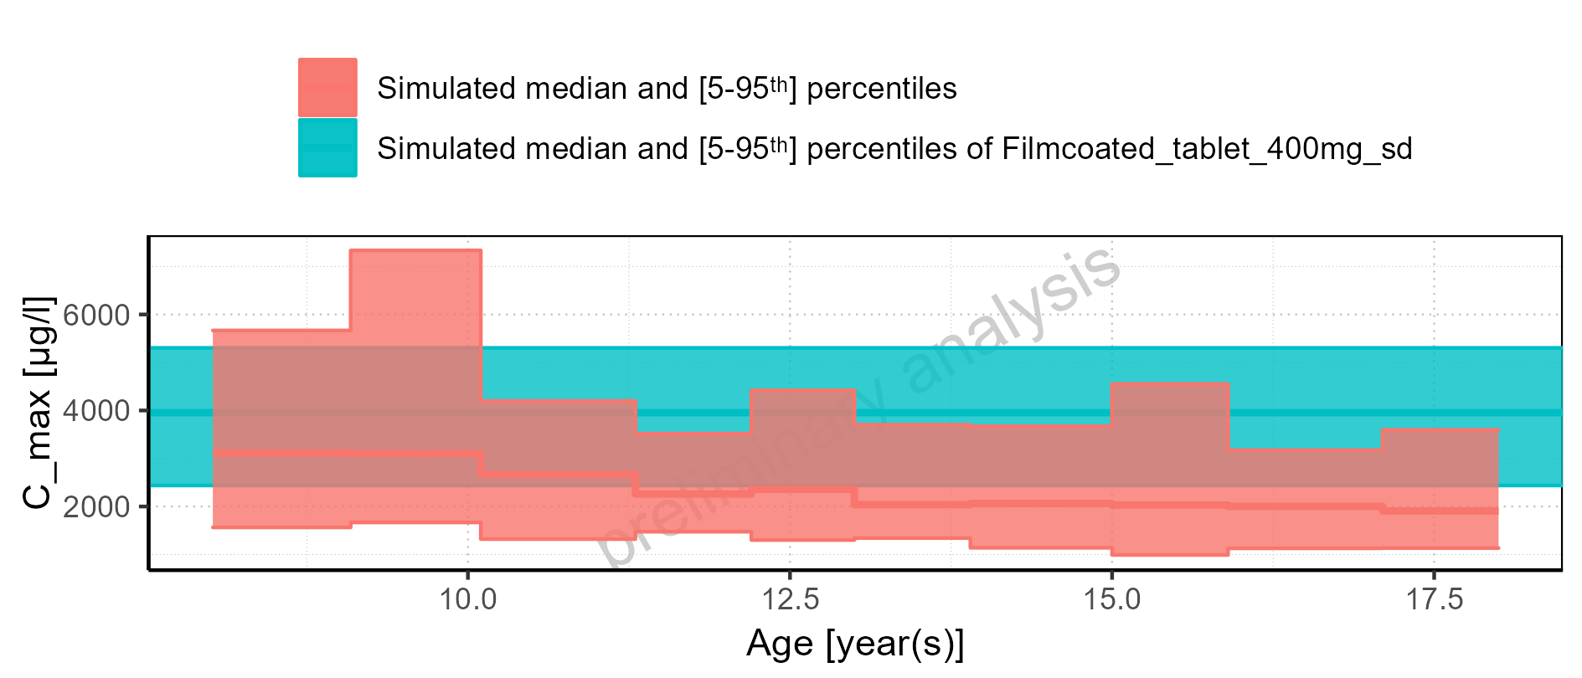

Figure 2-5: Age-dependence of C_max for Larson 2013 8y-18y 400mg FCT meal. Profiles are plotted in a logarithmic scale.

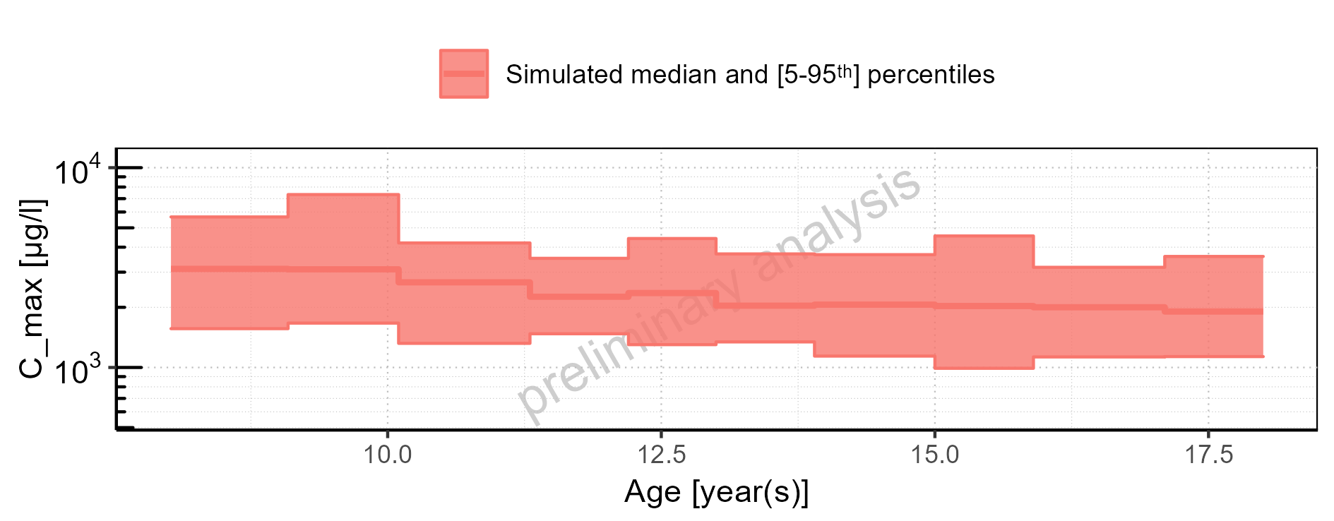

Figure 2-6: Age-dependence of C_max for Larson 2013 8y-18y 400mg FCT meal. Profiles are plotted in a linear scale.

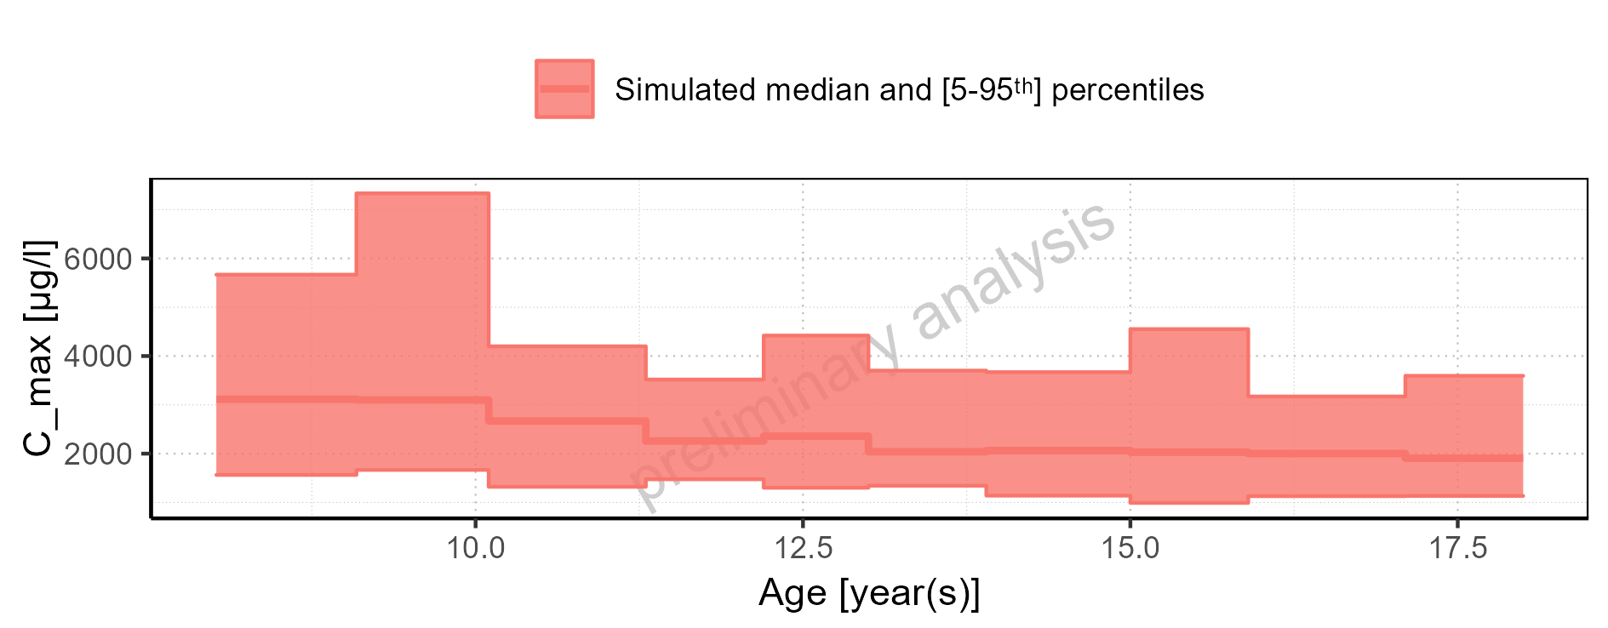

Figure 2-7: Age-dependence of C_max for Filmcoated_tablet_400mg_sd. Profiles are plotted in a logarithmic scale.

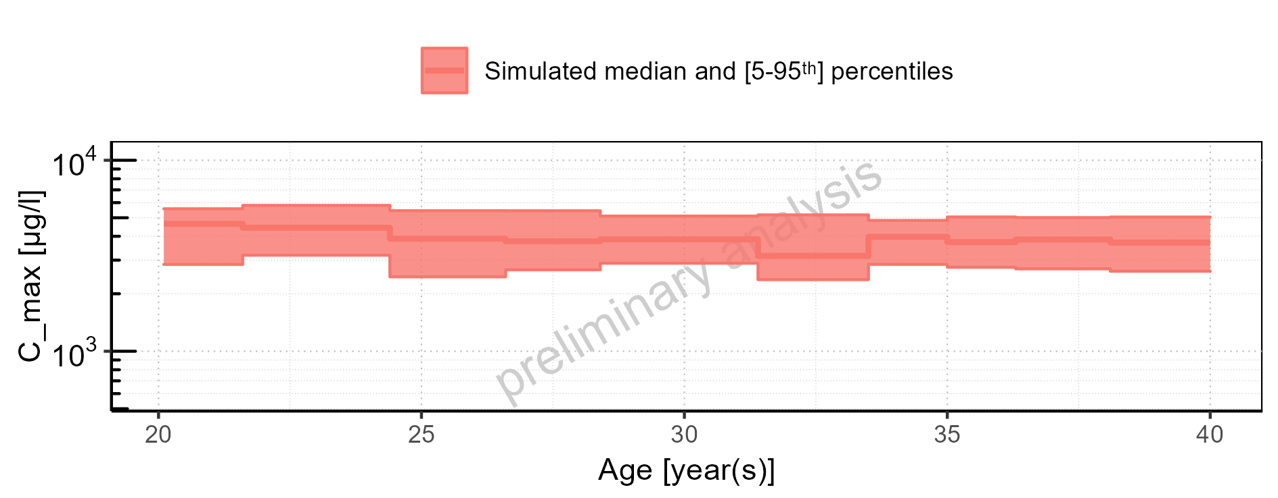

Figure 2-8: Age-dependence of C_max for Filmcoated_tablet_400mg_sd. Profiles are plotted in a linear scale.

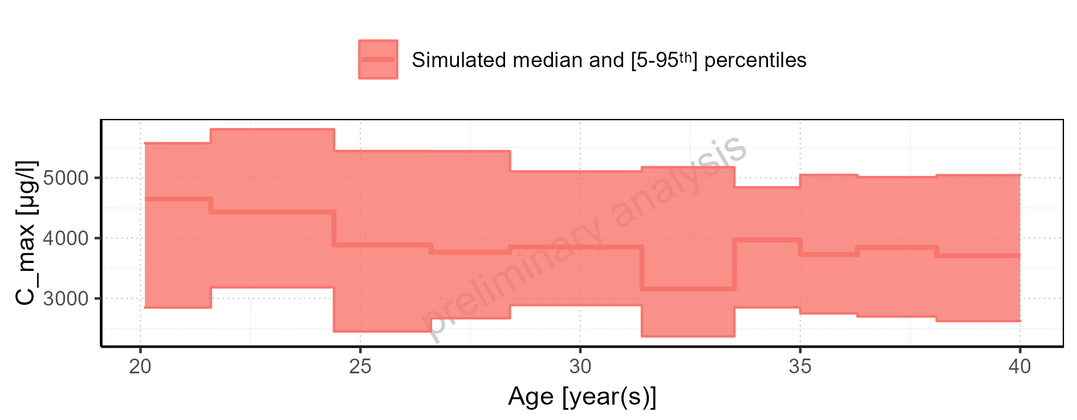

Figure 2-9: Height-dependence of C_max for Larson 2013 8y-18y 400mg FCT meal in comparison to Filmcoated_tablet_400mg_sd. Profiles are plotted in a logarithmic scale.

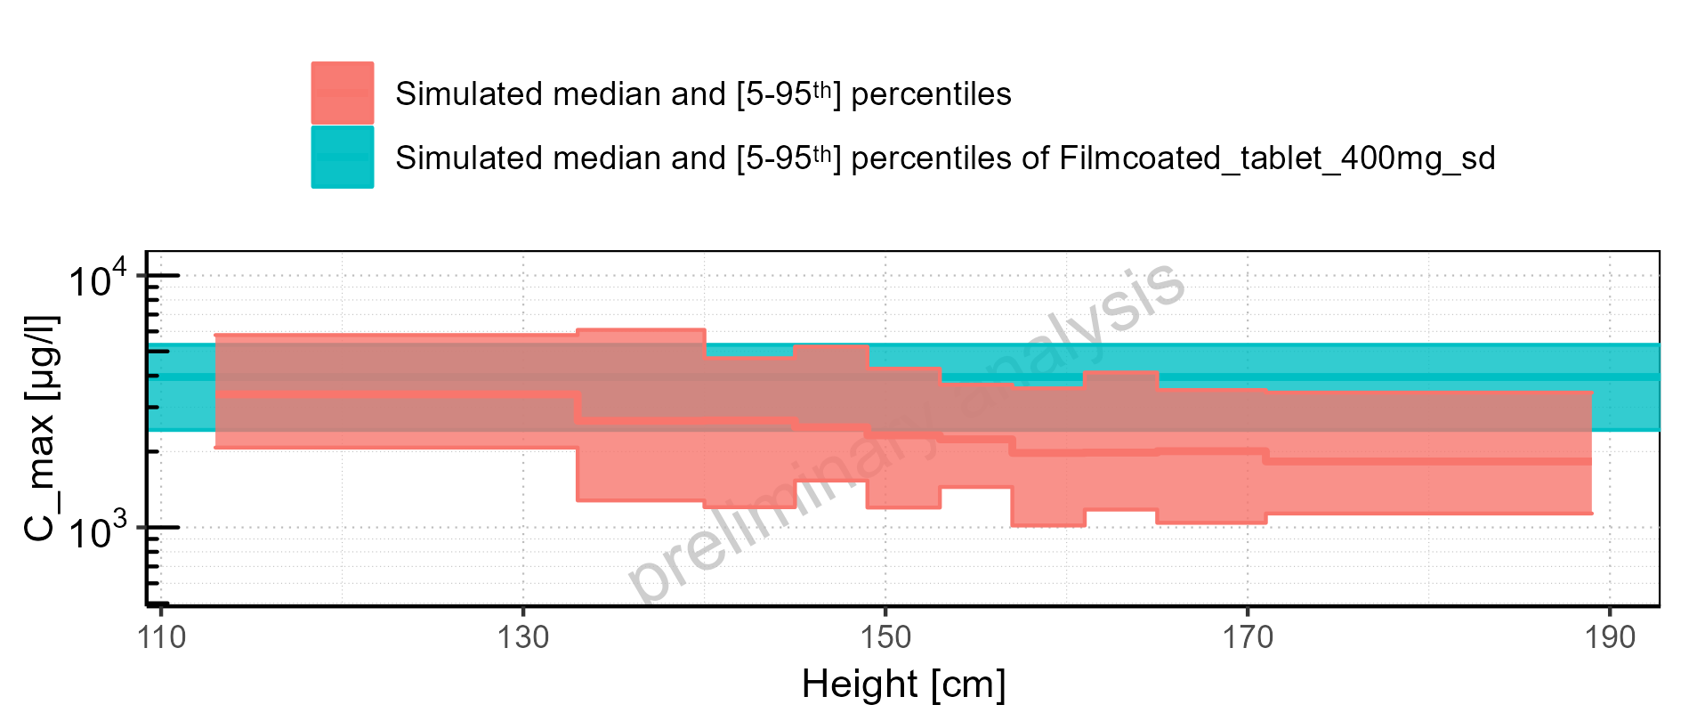

Figure 2-10: Height-dependence of C_max for Larson 2013 8y-18y 400mg FCT meal in comparison to Filmcoated_tablet_400mg_sd. Profiles are plotted in a linear scale.

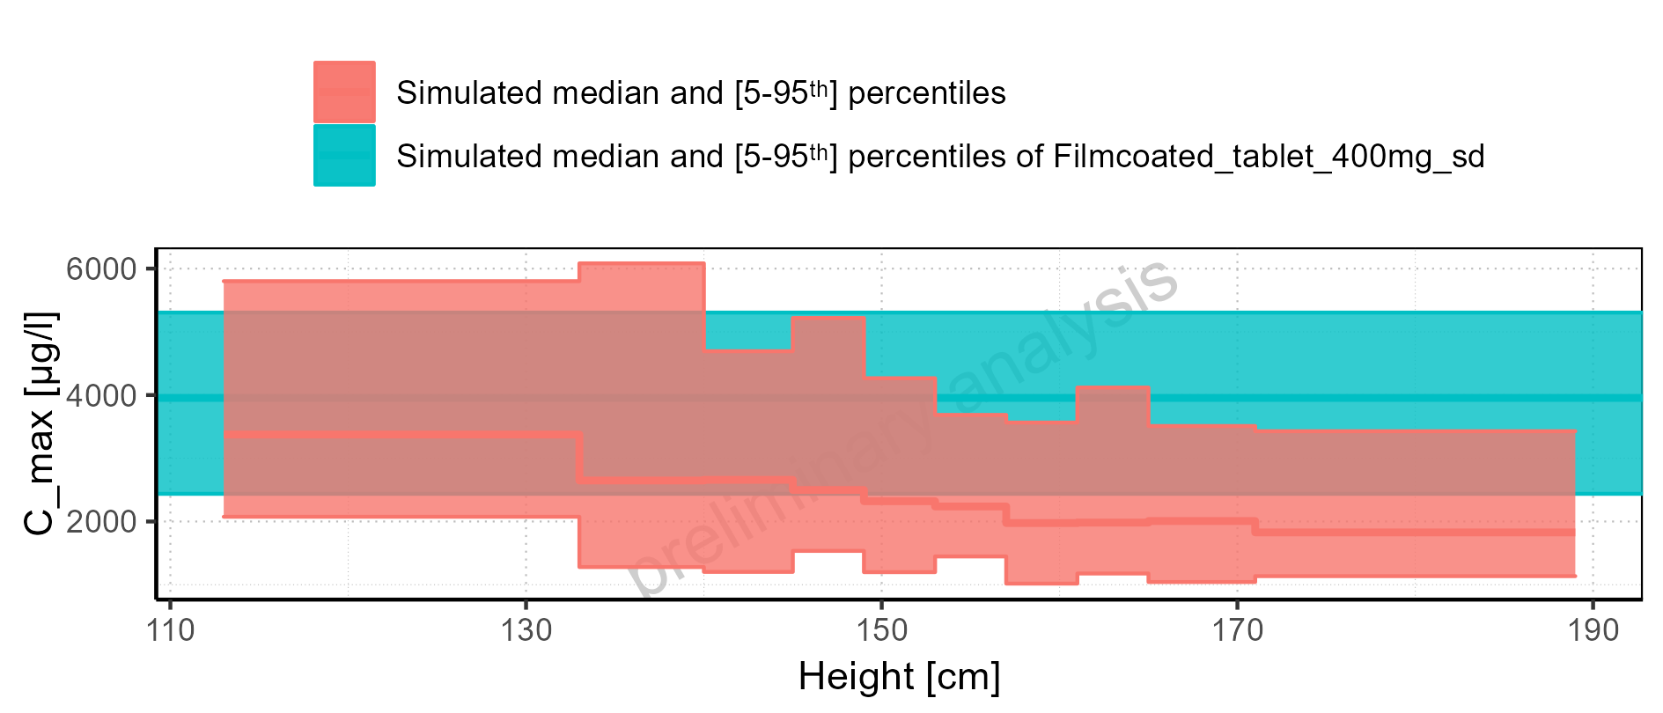

Figure 2-11: Height-dependence of C_max for Larson 2013 8y-18y 400mg FCT meal. Profiles are plotted in a logarithmic scale.

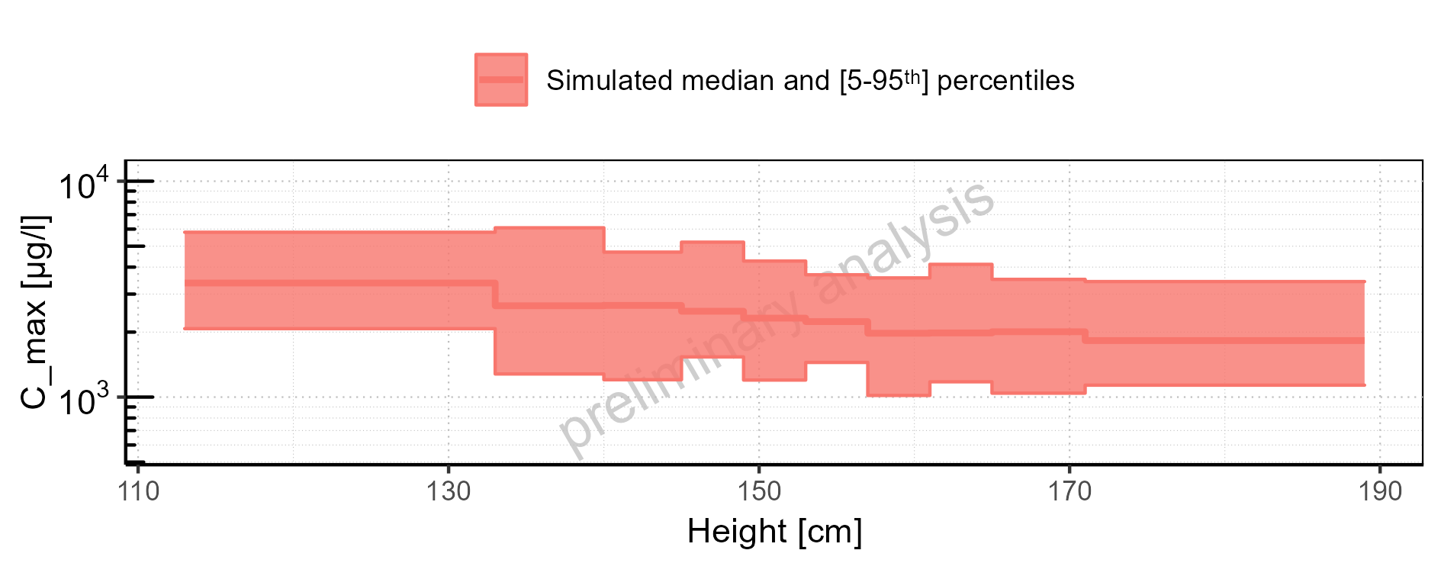

Figure 2-12: Height-dependence of C_max for Larson 2013 8y-18y 400mg FCT meal. Profiles are plotted in a linear scale.

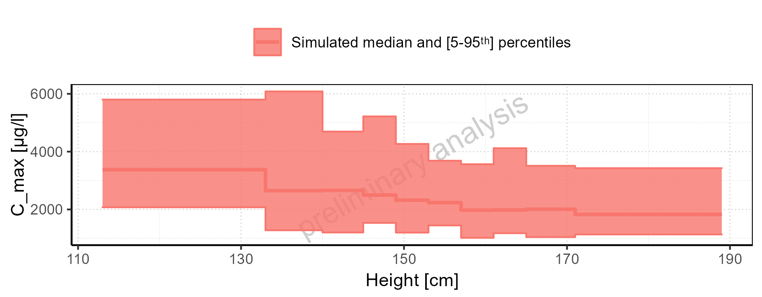

Figure 2-13: Height-dependence of C_max for Filmcoated_tablet_400mg_sd. Profiles are plotted in a logarithmic scale.

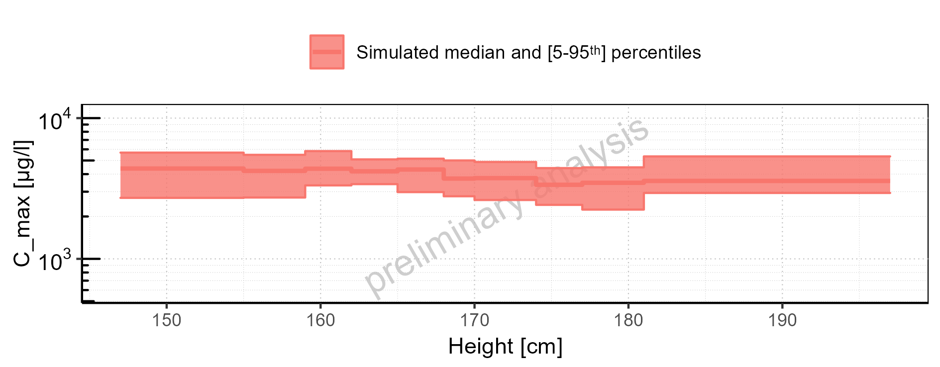

Figure 2-14: Height-dependence of C_max for Filmcoated_tablet_400mg_sd. Profiles are plotted in a linear scale.

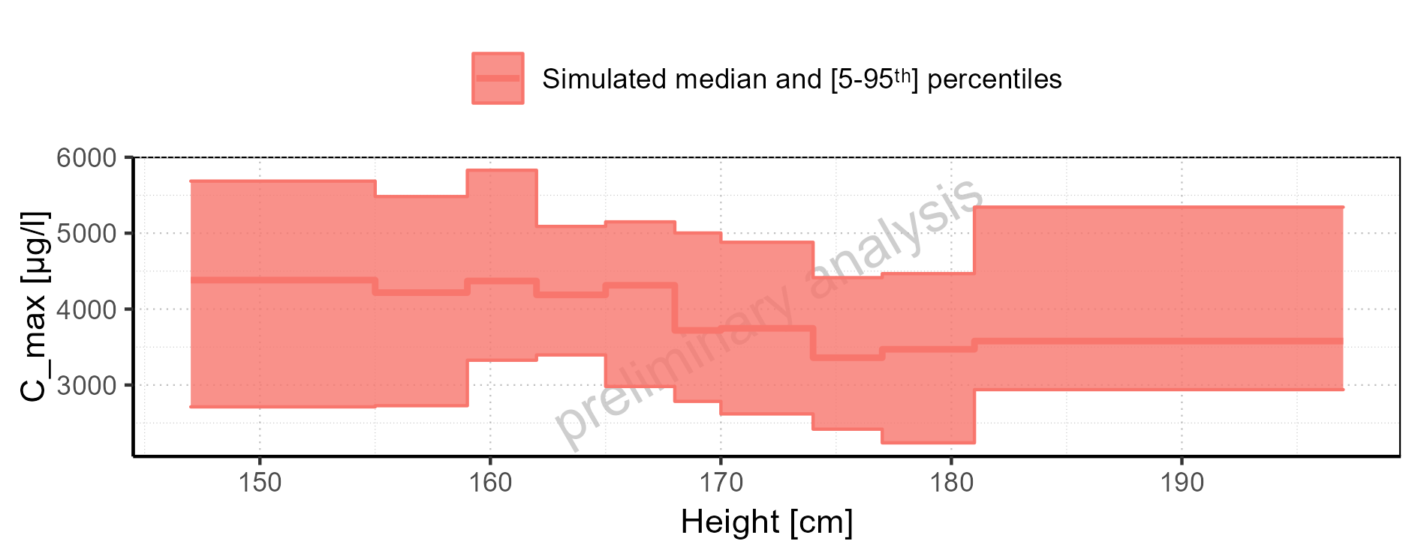

Figure 2-15: Weight-dependence of C_max for Larson 2013 8y-18y 400mg FCT meal in comparison to Filmcoated_tablet_400mg_sd. Profiles are plotted in a logarithmic scale.

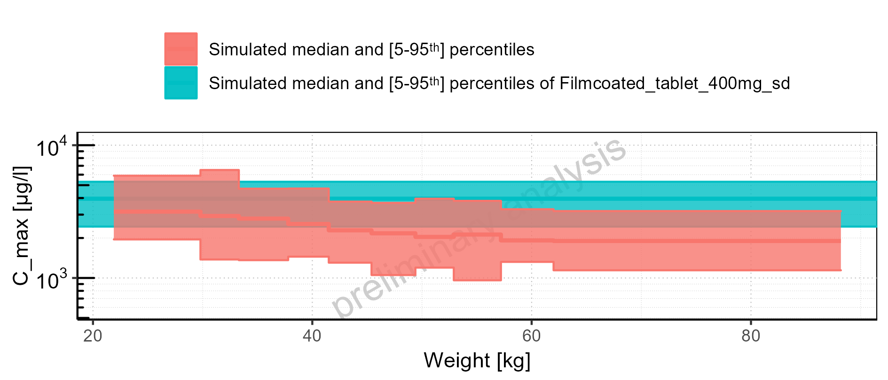

Figure 2-16: Weight-dependence of C_max for Larson 2013 8y-18y 400mg FCT meal in comparison to Filmcoated_tablet_400mg_sd. Profiles are plotted in a linear scale.

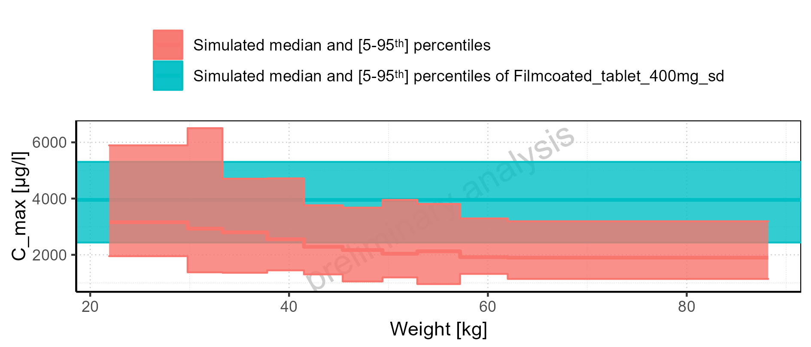

Figure 2-17: Weight-dependence of C_max for Larson 2013 8y-18y 400mg FCT meal. Profiles are plotted in a logarithmic scale.

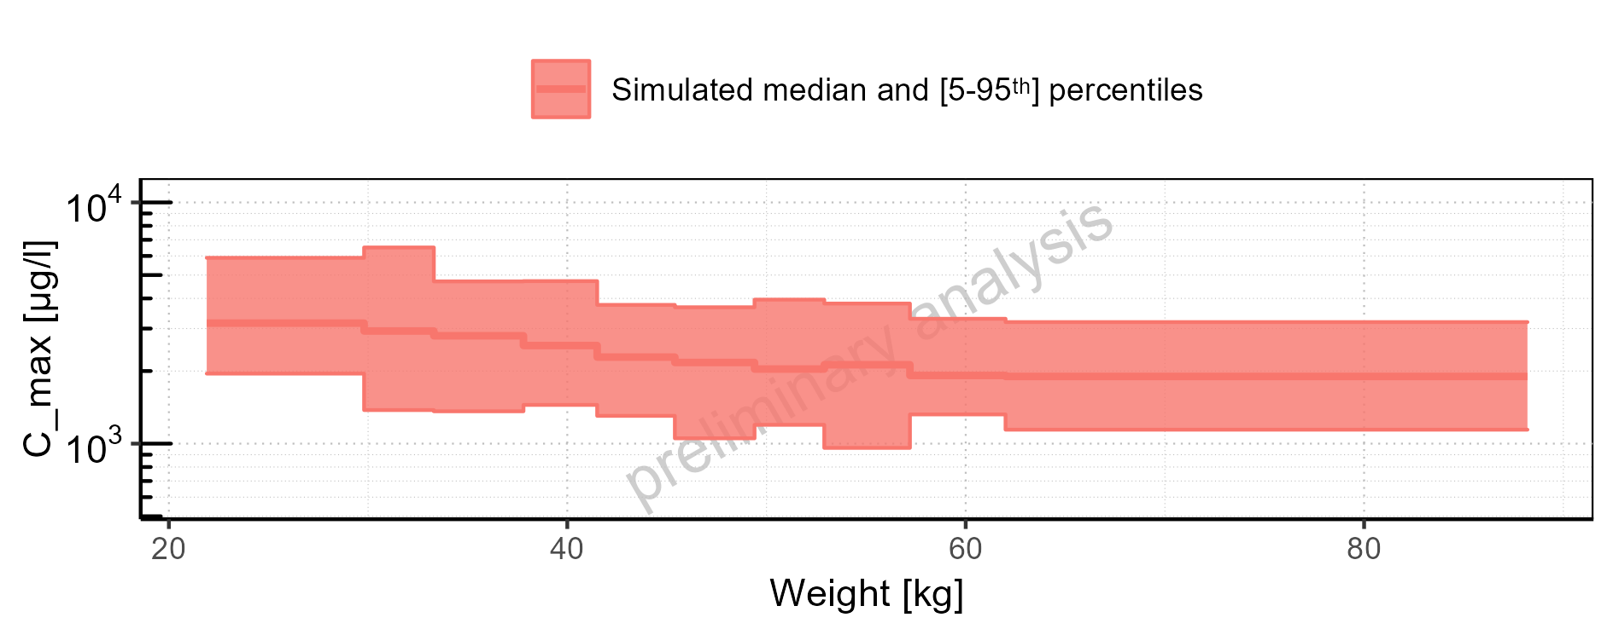

Figure 2-18: Weight-dependence of C_max for Larson 2013 8y-18y 400mg FCT meal. Profiles are plotted in a linear scale.

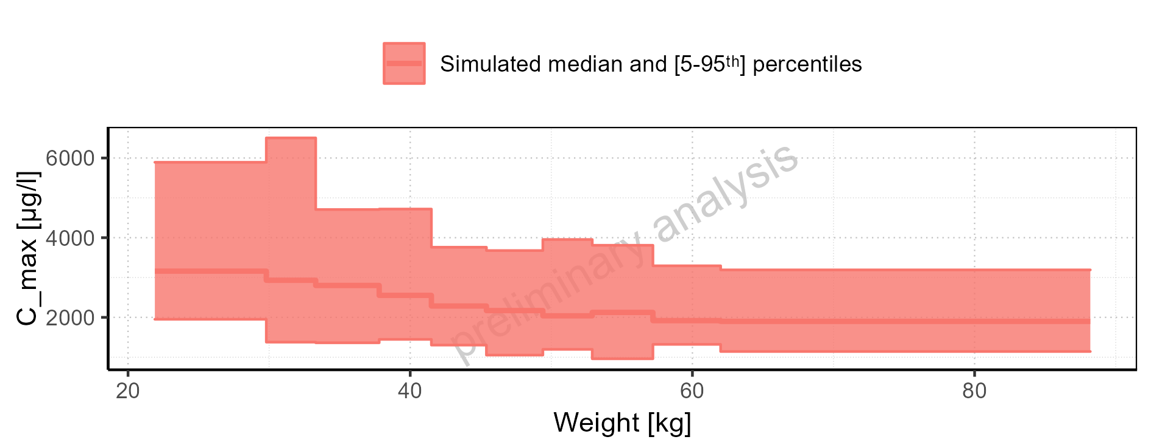

Figure 2-19: Weight-dependence of C_max for Filmcoated_tablet_400mg_sd. Profiles are plotted in a logarithmic scale.

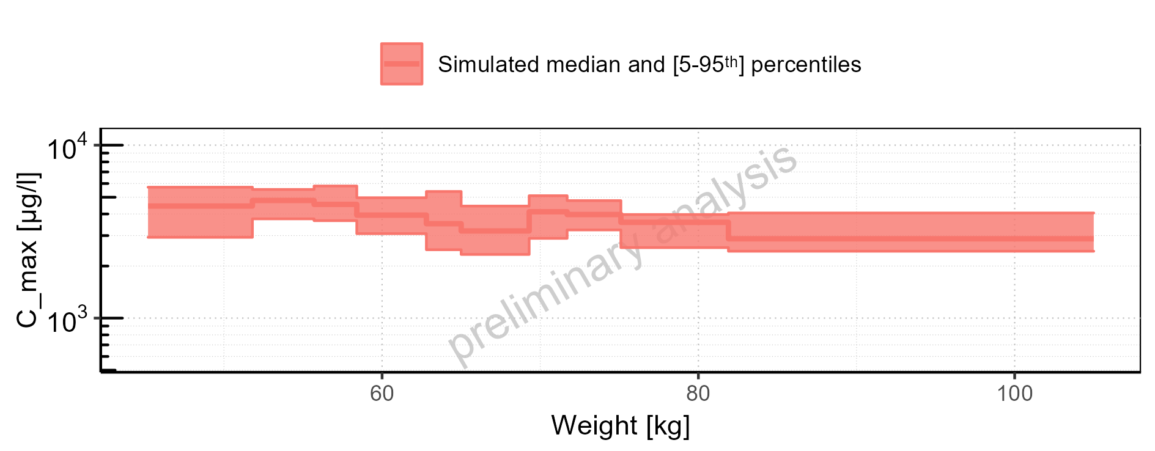

Figure 2-20: Weight-dependence of C_max for Filmcoated_tablet_400mg_sd. Profiles are plotted in a linear scale.

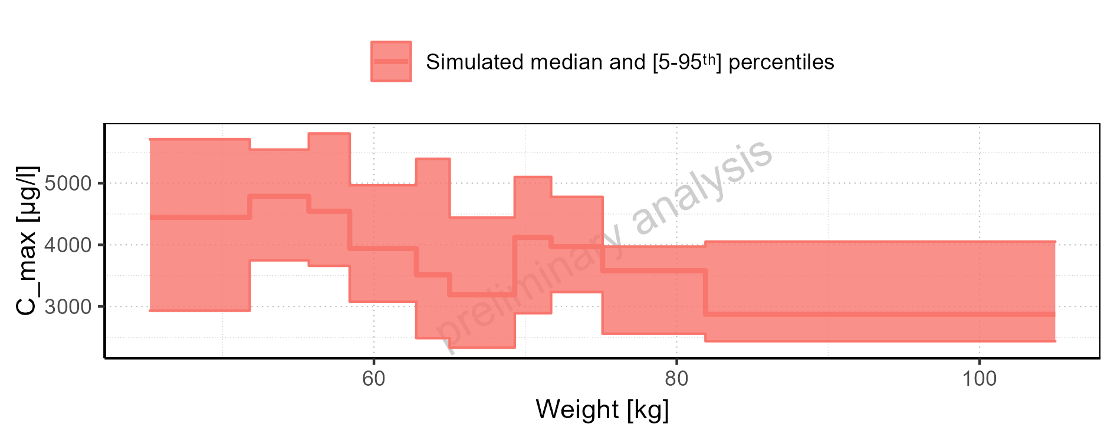

Figure 2-21: BMI-dependence of C_max for Larson 2013 8y-18y 400mg FCT meal in comparison to Filmcoated_tablet_400mg_sd. Profiles are plotted in a logarithmic scale.

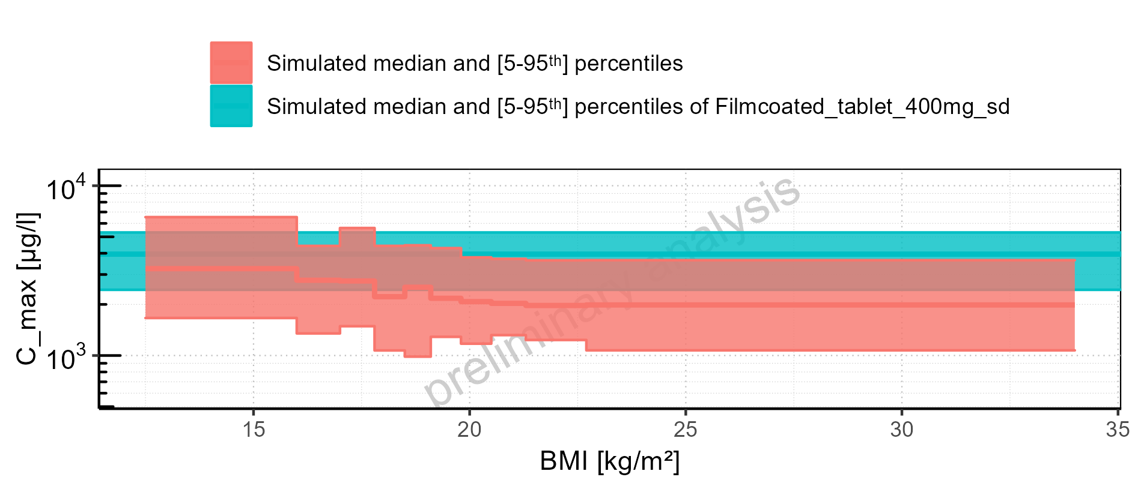

Figure 2-22: BMI-dependence of C_max for Larson 2013 8y-18y 400mg FCT meal in comparison to Filmcoated_tablet_400mg_sd. Profiles are plotted in a linear scale.

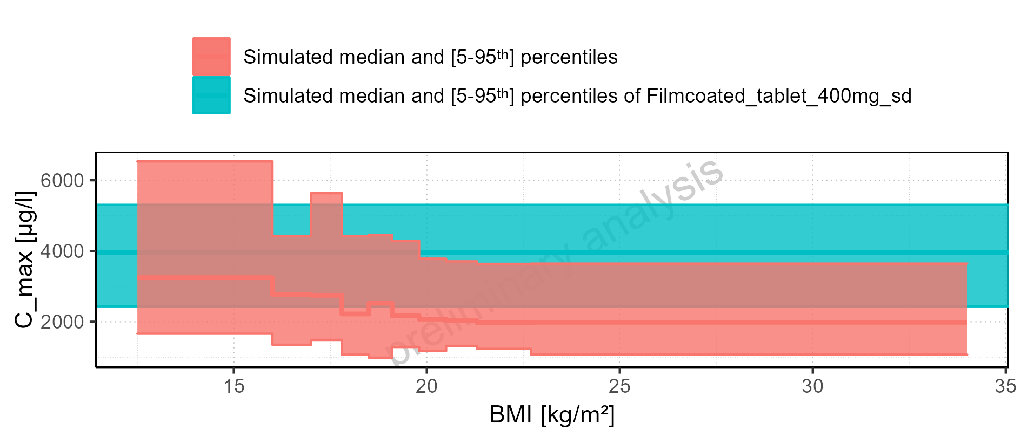

Figure 2-23: BMI-dependence of C_max for Larson 2013 8y-18y 400mg FCT meal. Profiles are plotted in a logarithmic scale.

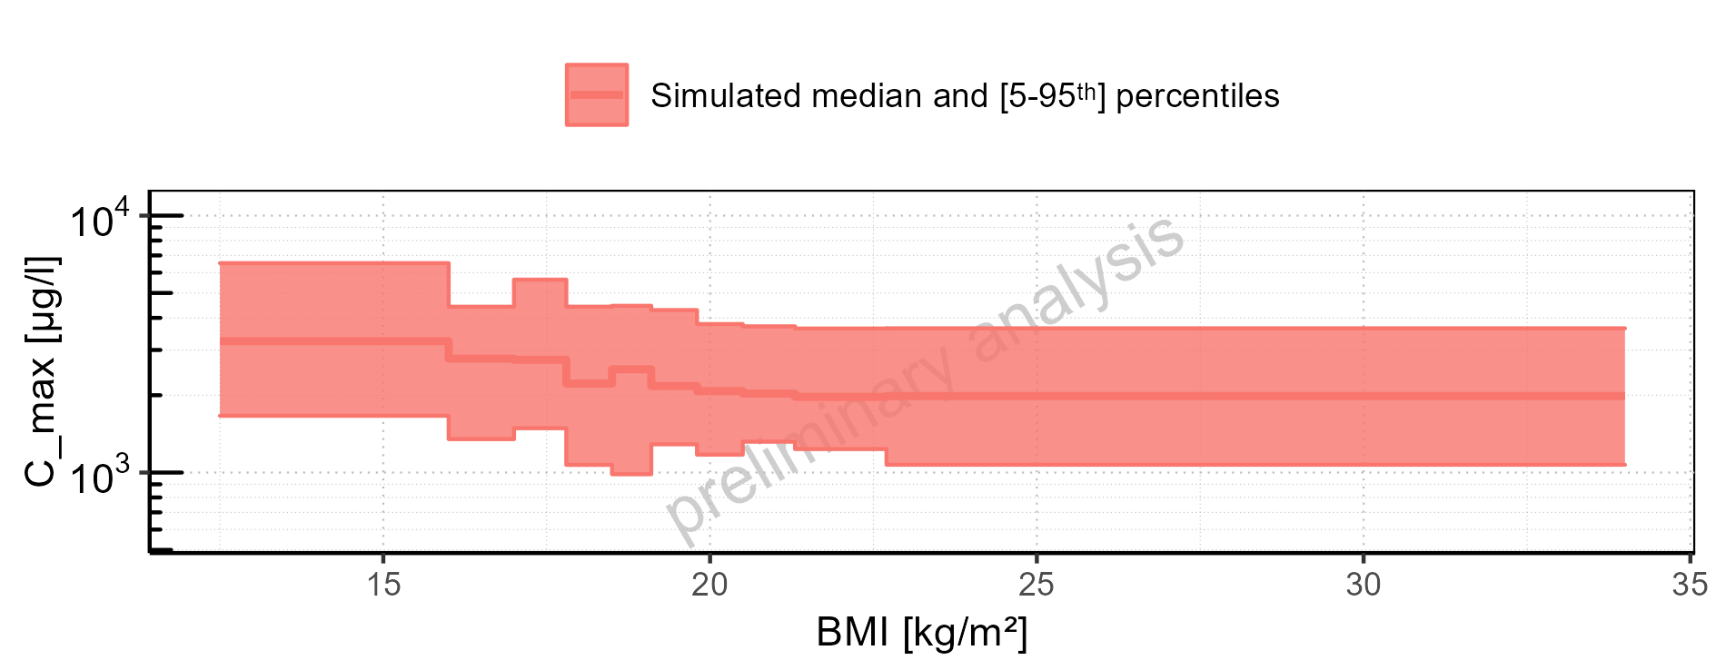

Figure 2-24: BMI-dependence of C_max for Larson 2013 8y-18y 400mg FCT meal. Profiles are plotted in a linear scale.

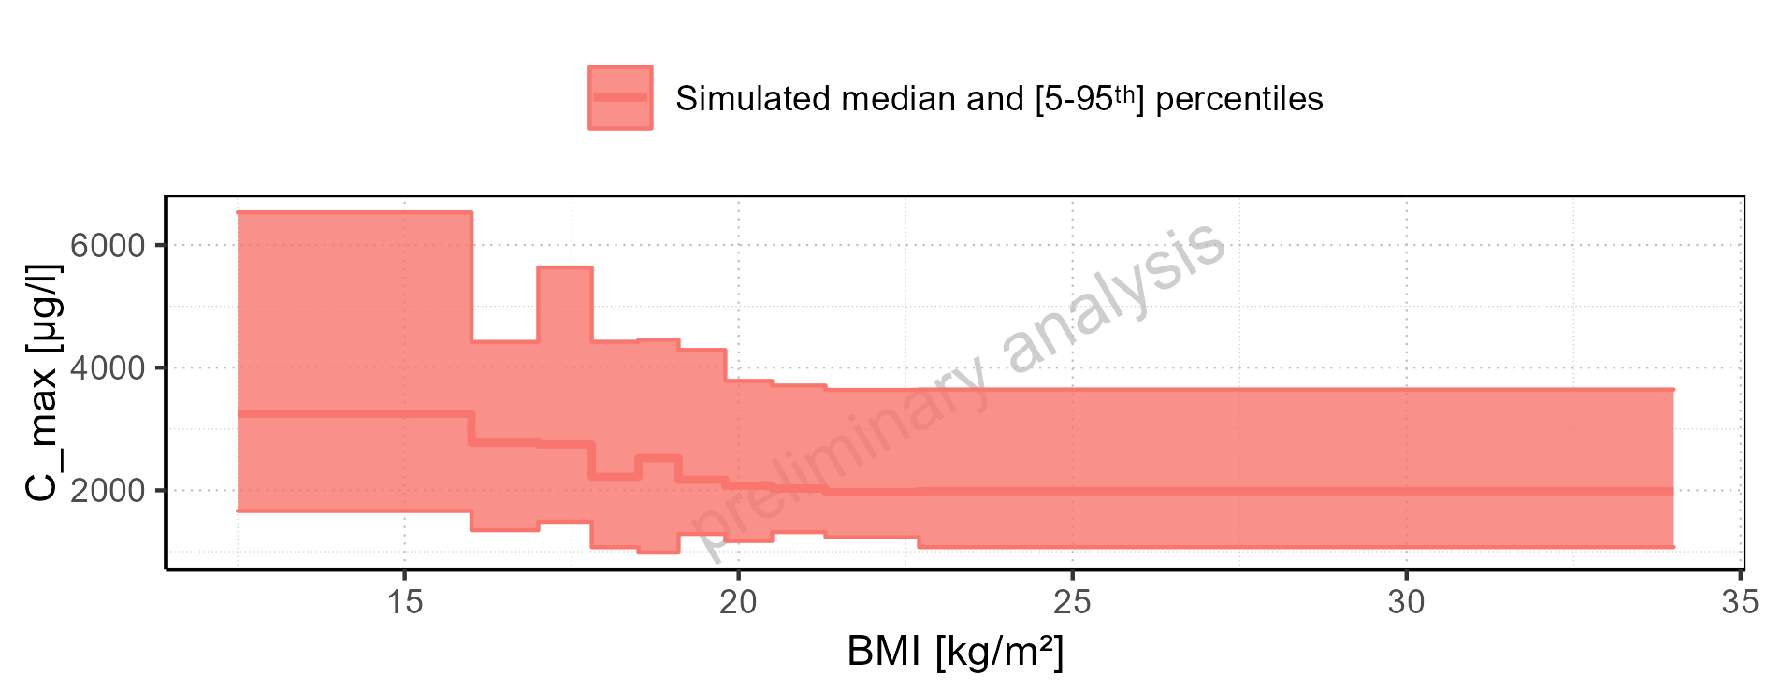

Figure 2-25: BMI-dependence of C_max for Filmcoated_tablet_400mg_sd. Profiles are plotted in a logarithmic scale.

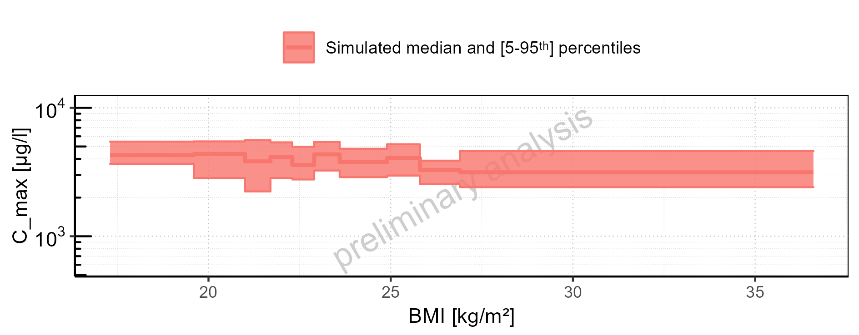

Figure 2-26: BMI-dependence of C_max for Filmcoated_tablet_400mg_sd. Profiles are plotted in a linear scale.

### C_max_norm

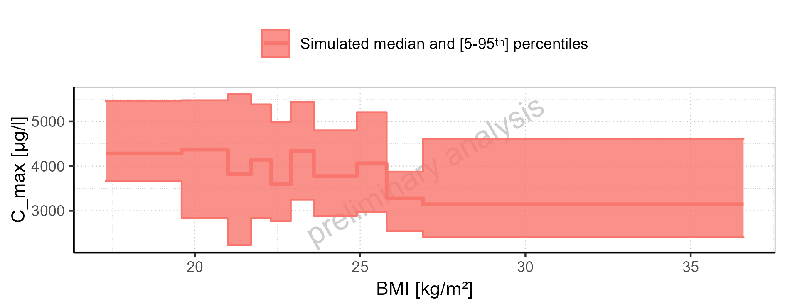

Figure 2-27: C_max_norm of Raltegravir for Larson 2013 8y-18y 400mg FCT meal, Filmcoated_tablet_400mg_sd shown as box-whisker plot, which indicates the 5<U+1D57><U+02B0>, 25<U+1D57><U+02B0>, 50<U+1D57><U+02B0>, 75<U+1D57><U+02B0>, 95<U+1D57><U+02B0> percentiles in logarithmic scale.

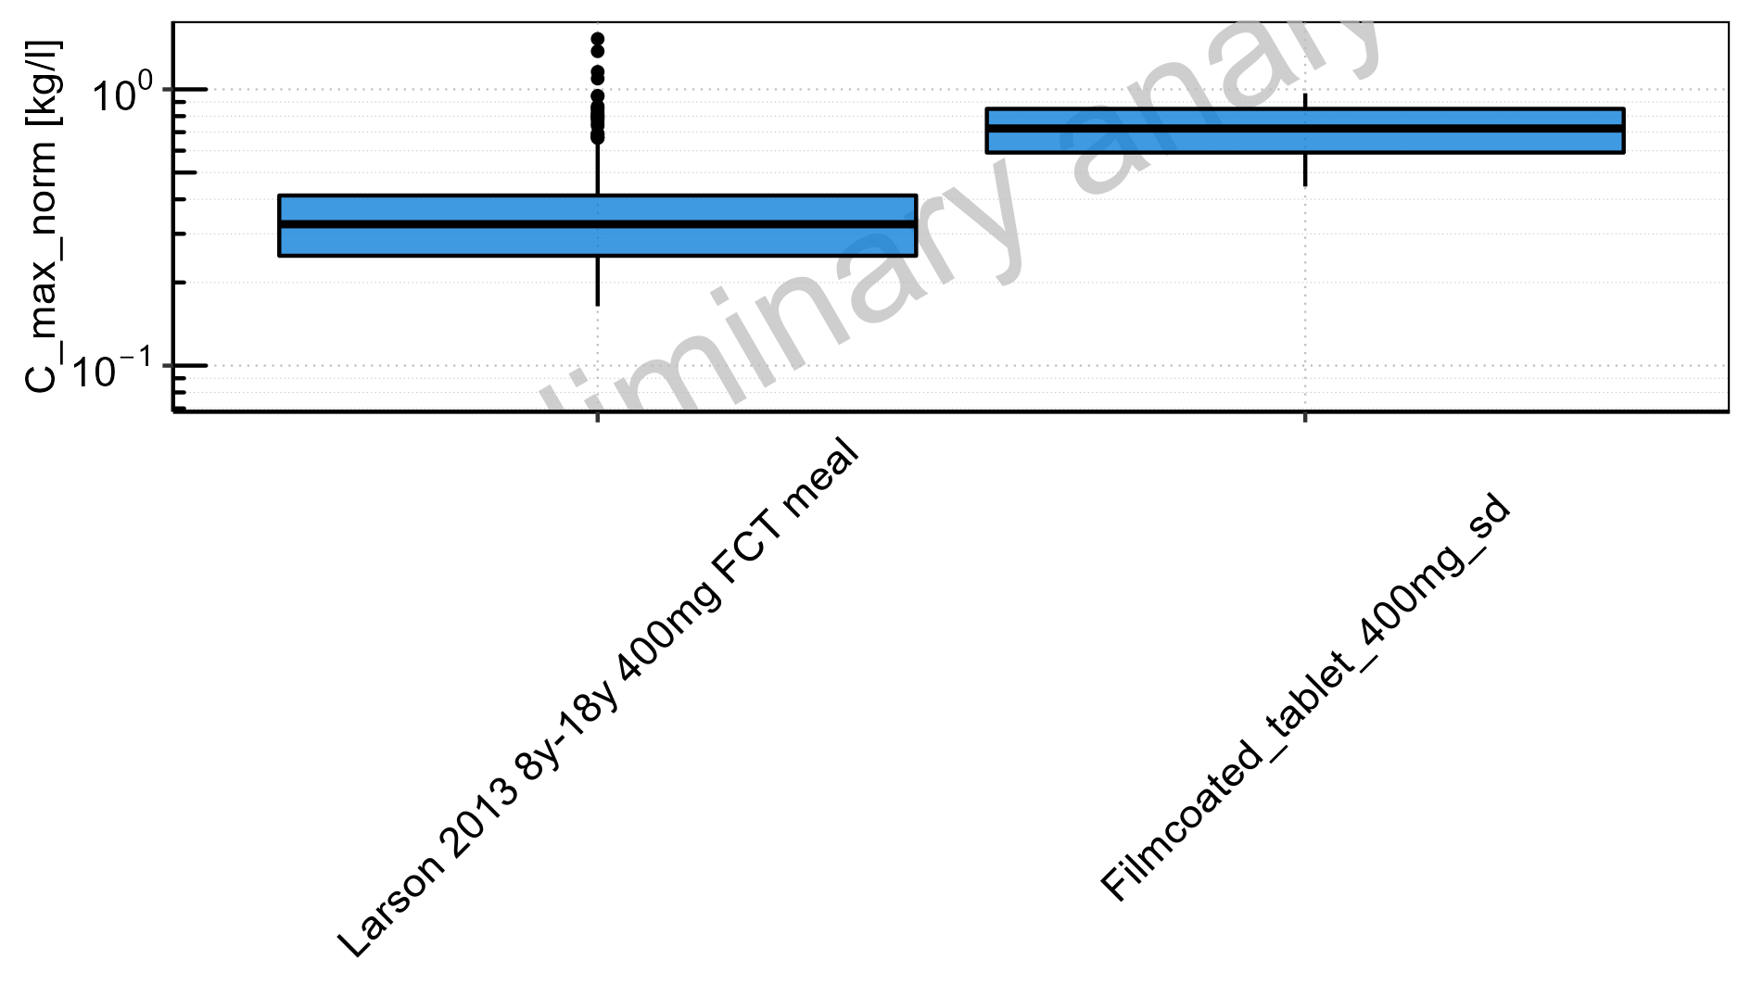

Figure 2-28: C_max_norm of Raltegravir for Larson 2013 8y-18y 400mg FCT meal, Filmcoated_tablet_400mg_sd shown as box-whisker plot, which indicates the 5<U+1D57><U+02B0>, 25<U+1D57><U+02B0>, 50<U+1D57><U+02B0>, 75<U+1D57><U+02B0>, 95<U+1D57><U+02B0> percentiles in linear scale.

**Table 2-2: C_max_norm of Raltegravir for Larson 2013 8y-18y 400mg FCT meal, Filmcoated_tablet_400mg_sd reported in [kg/l]**

|  |  |  |  |  |  |  |  |  |  |  |
| --- | --- | --- | --- | --- | --- | --- | --- | --- | --- | --- |
| Population | N | 5<U+1D57><U+02B0> pctl | 25<U+1D57><U+02B0> pctl | 50<U+1D57><U+02B0> pctl | 75<U+1D57><U+02B0> pctl | 95<U+1D57><U+02B0> pctl | Mean | SD | Geo Mean | Geo SD |
| Larson 2013 8y-18y 400mg FCT meal | 500 | 0.16 | 0.25 | 0.33 | 0.41 | 0.65 | 0.36 | 0.17 | 0.33 | 1.52 |
| Filmcoated_tablet_400mg_sd | 100 | 0.44 | 0.59 | 0.72 | 0.85 | 0.97 | 0.72 | 0.17 | 0.70 | 1.27 |

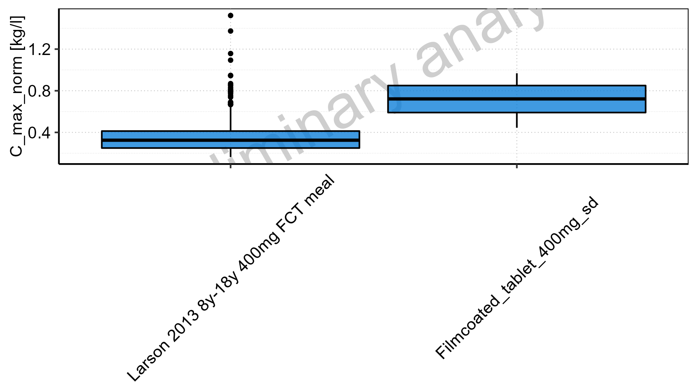

Figure 2-29: Age-dependence of C_max_norm for Larson 2013 8y-18y 400mg FCT meal in comparison to Filmcoated_tablet_400mg_sd. Profiles are plotted in a logarithmic scale.

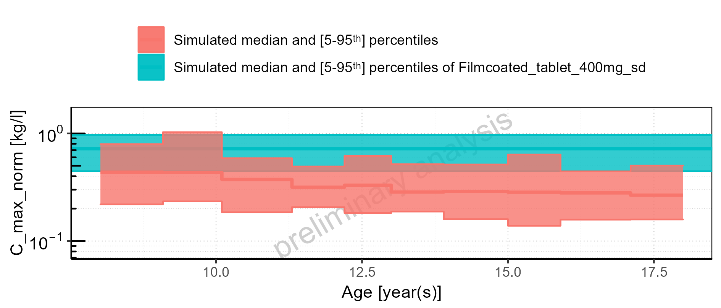

Figure 2-30: Age-dependence of C_max_norm for Larson 2013 8y-18y 400mg FCT meal in comparison to Filmcoated_tablet_400mg_sd. Profiles are plotted in a linear scale.

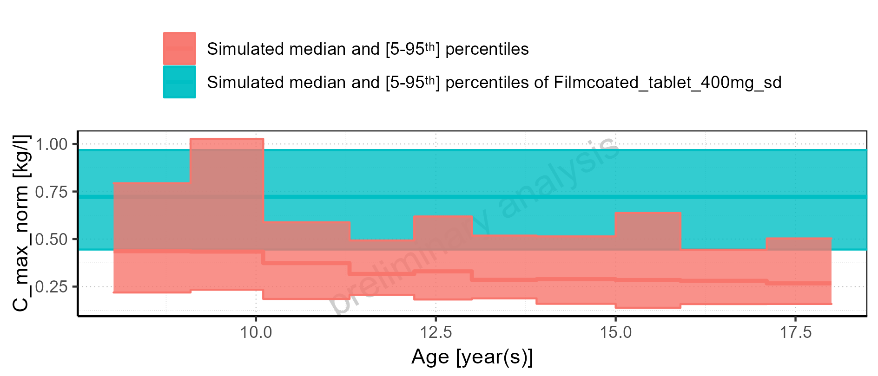

Figure 2-31: Age-dependence of C_max_norm for Larson 2013 8y-18y 400mg FCT meal. Profiles are plotted in a logarithmic scale.

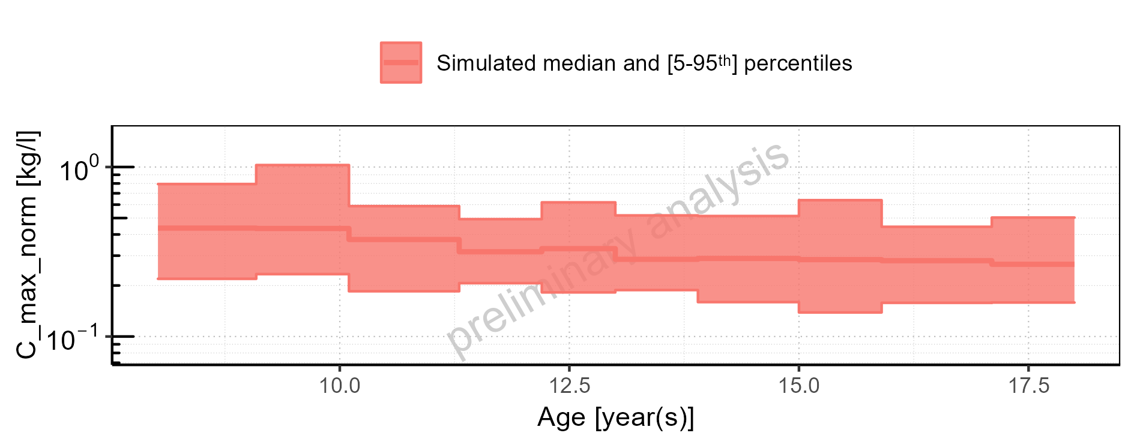

Figure 2-32: Age-dependence of C_max_norm for Larson 2013 8y-18y 400mg FCT meal. Profiles are plotted in a linear scale.

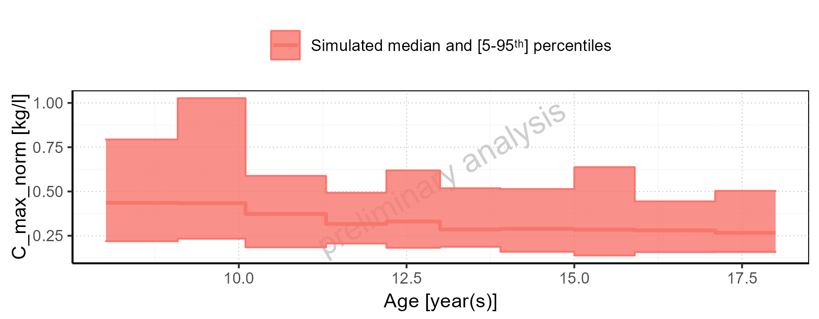

Figure 2-33: Age-dependence of C_max_norm for Filmcoated_tablet_400mg_sd. Profiles are plotted in a logarithmic scale.

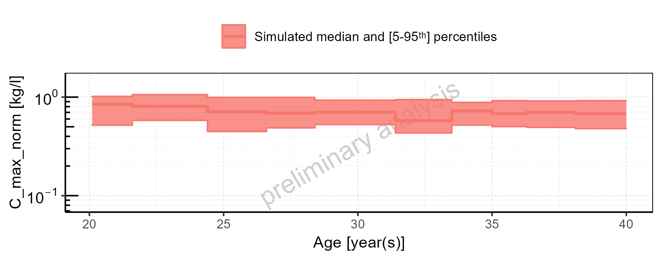

Figure 2-34: Age-dependence of C_max_norm for Filmcoated_tablet_400mg_sd. Profiles are plotted in a linear scale.

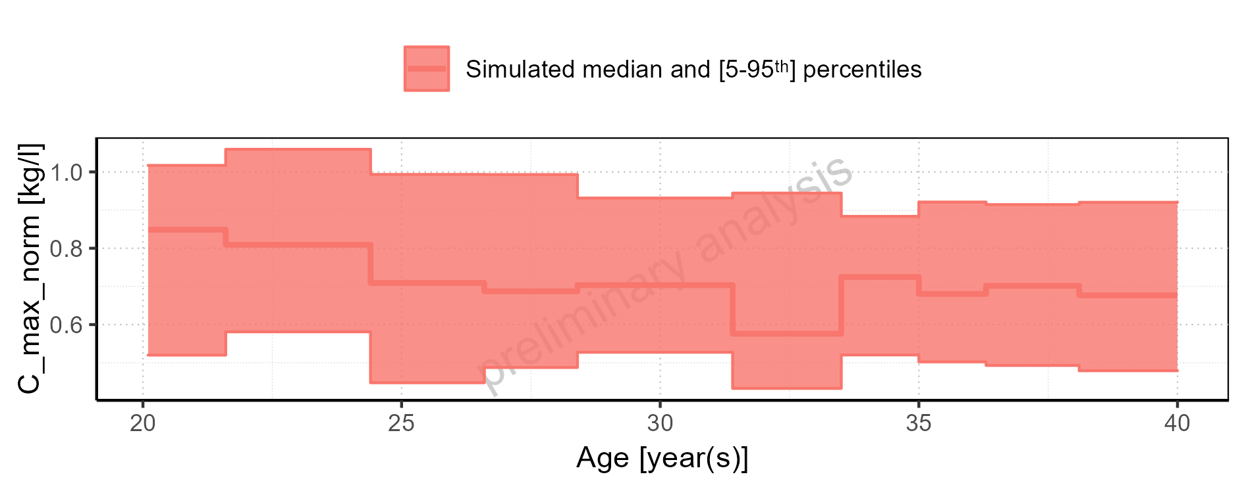

Figure 2-35: Height-dependence of C_max_norm for Larson 2013 8y-18y 400mg FCT meal in comparison to Filmcoated_tablet_400mg_sd. Profiles are plotted in a logarithmic scale.

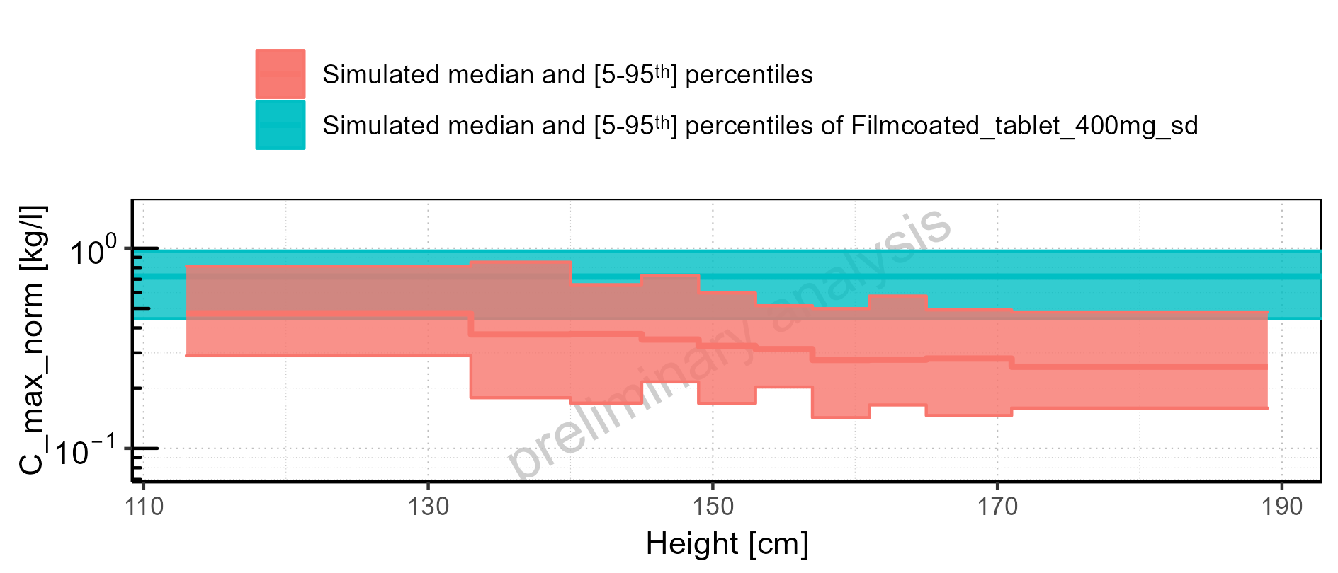

Figure 2-36: Height-dependence of C_max_norm for Larson 2013 8y-18y 400mg FCT meal in comparison to Filmcoated_tablet_400mg_sd. Profiles are plotted in a linear scale.

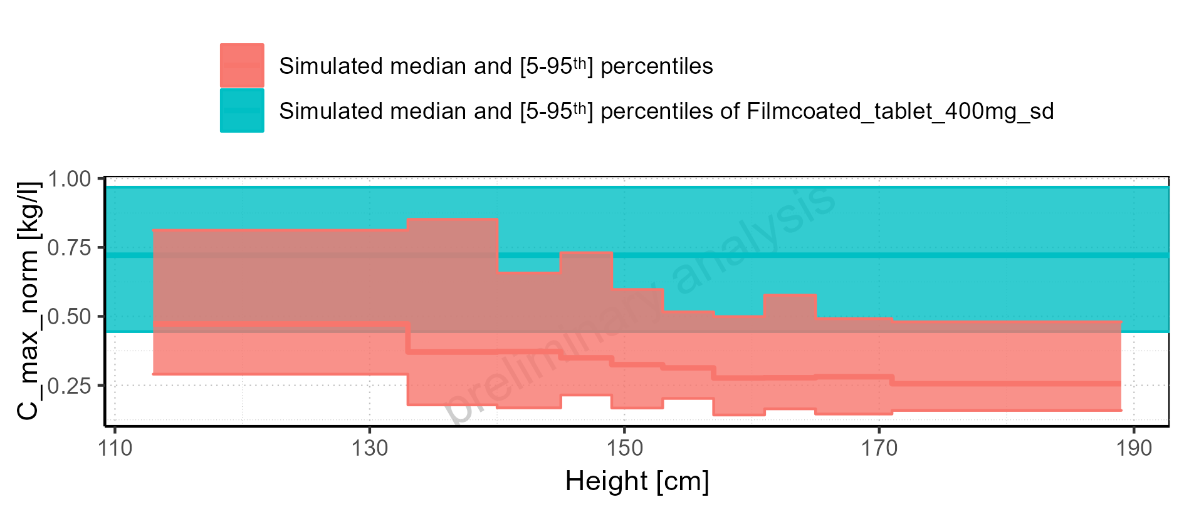

Figure 2-37: Height-dependence of C_max_norm for Larson 2013 8y-18y 400mg FCT meal. Profiles are plotted in a logarithmic scale.

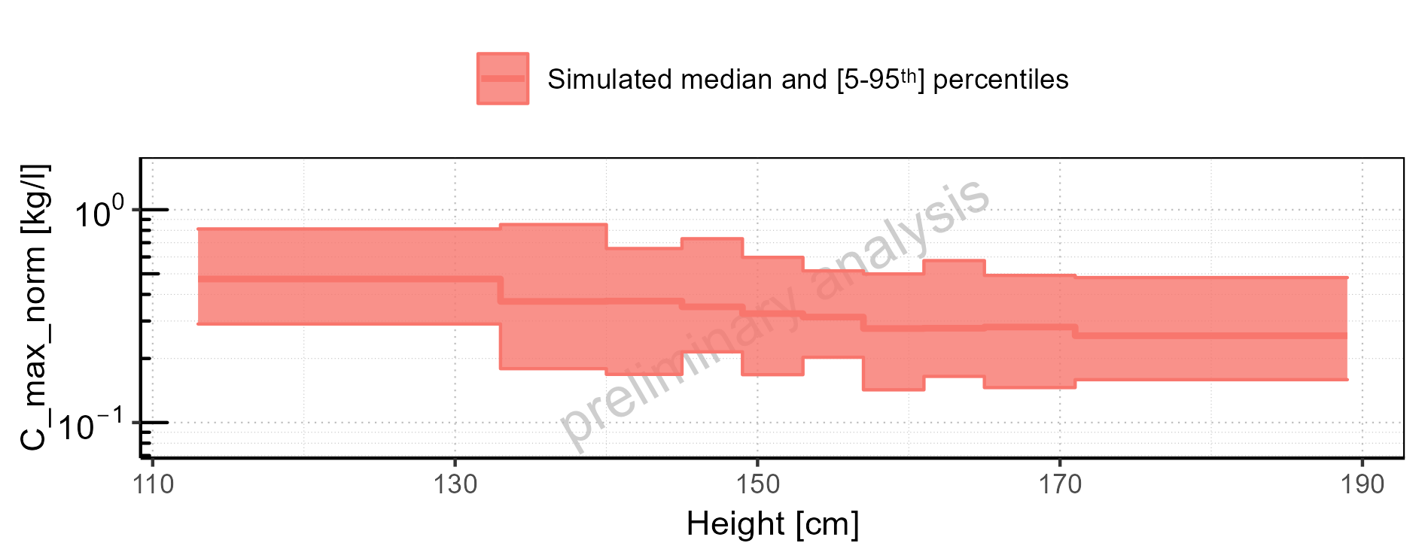

Figure 2-38: Height-dependence of C_max_norm for Larson 2013 8y-18y 400mg FCT meal. Profiles are plotted in a linear scale.

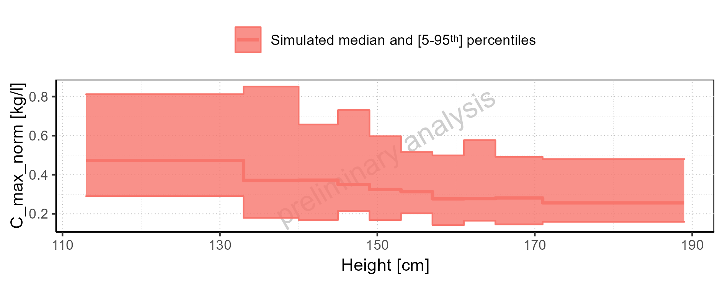

Figure 2-39: Height-dependence of C_max_norm for Filmcoated_tablet_400mg_sd. Profiles are plotted in a logarithmic scale.

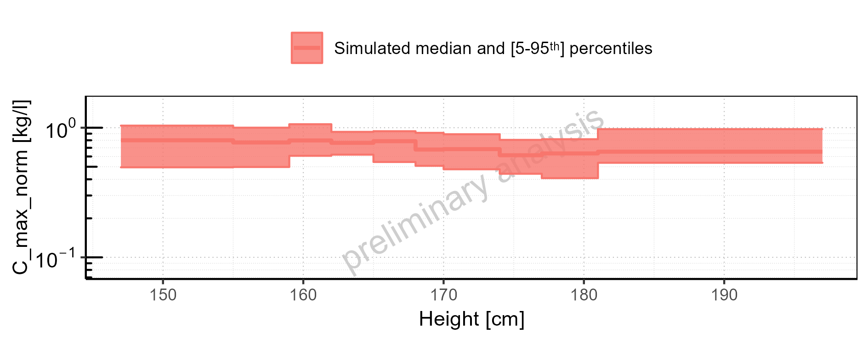

Figure 2-40: Height-dependence of C_max_norm for Filmcoated_tablet_400mg_sd. Profiles are plotted in a linear scale.

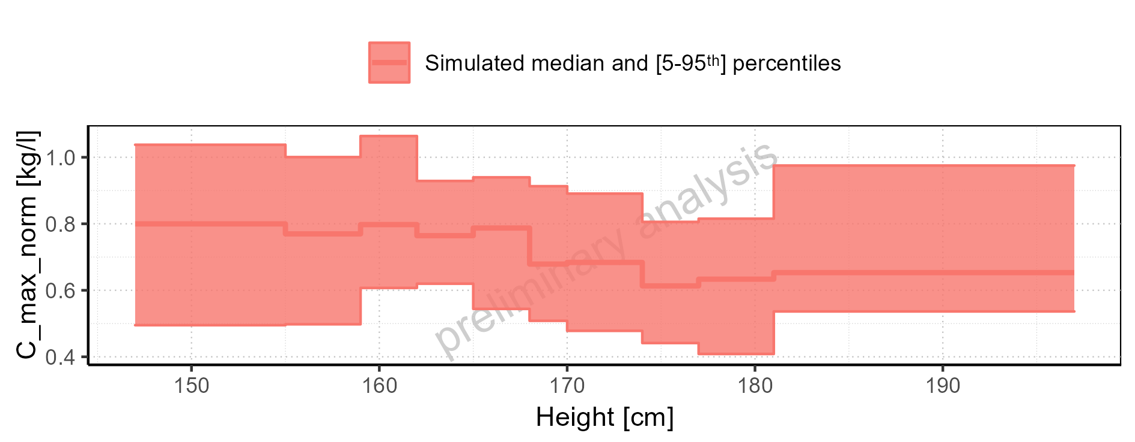

Figure 2-41: Weight-dependence of C_max_norm for Larson 2013 8y-18y 400mg FCT meal in comparison to Filmcoated_tablet_400mg_sd. Profiles are plotted in a logarithmic scale.

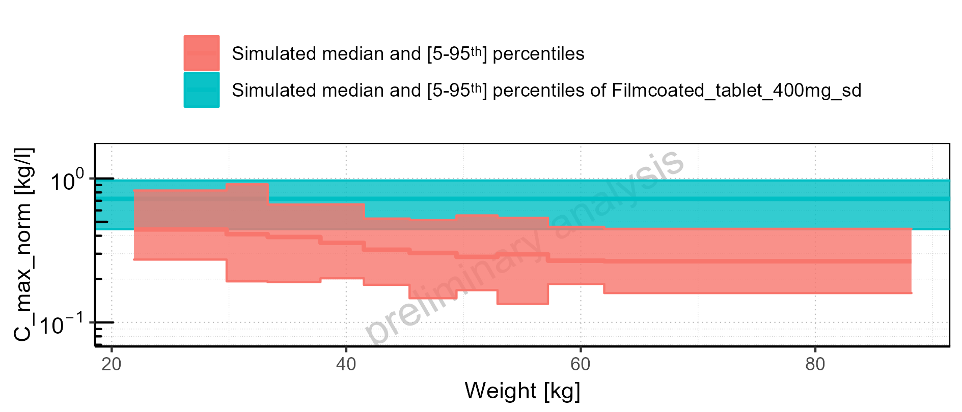

Figure 2-42: Weight-dependence of C_max_norm for Larson 2013 8y-18y 400mg FCT meal in comparison to Filmcoated_tablet_400mg_sd. Profiles are plotted in a linear scale.

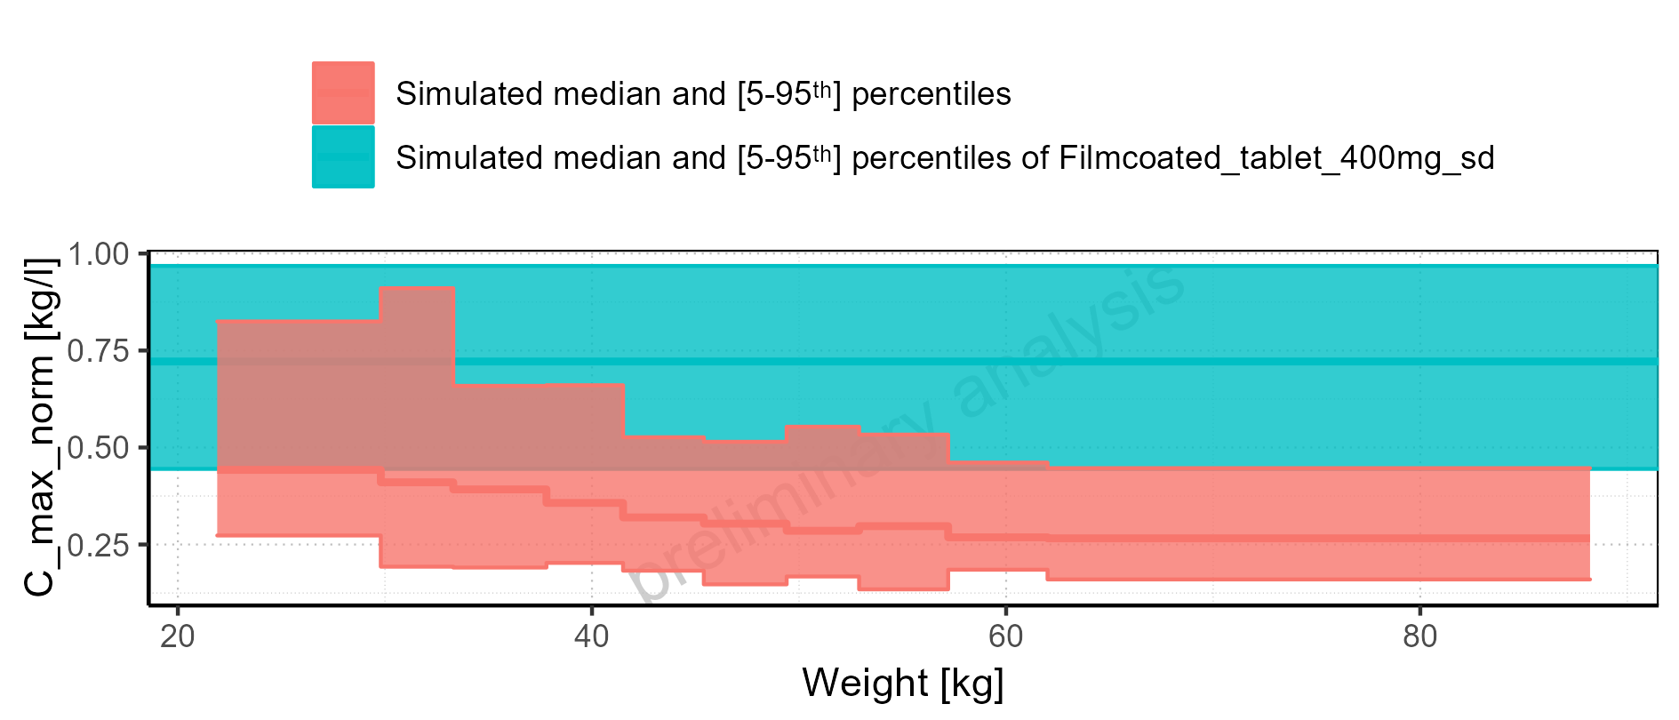

Figure 2-43: Weight-dependence of C_max_norm for Larson 2013 8y-18y 400mg FCT meal. Profiles are plotted in a logarithmic scale.

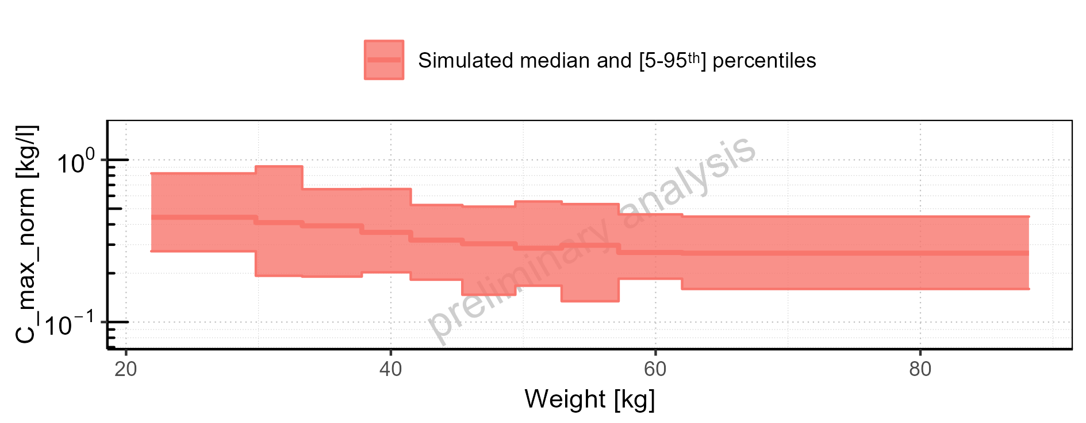

Figure 2-44: Weight-dependence of C_max_norm for Larson 2013 8y-18y 400mg FCT meal. Profiles are plotted in a linear scale.

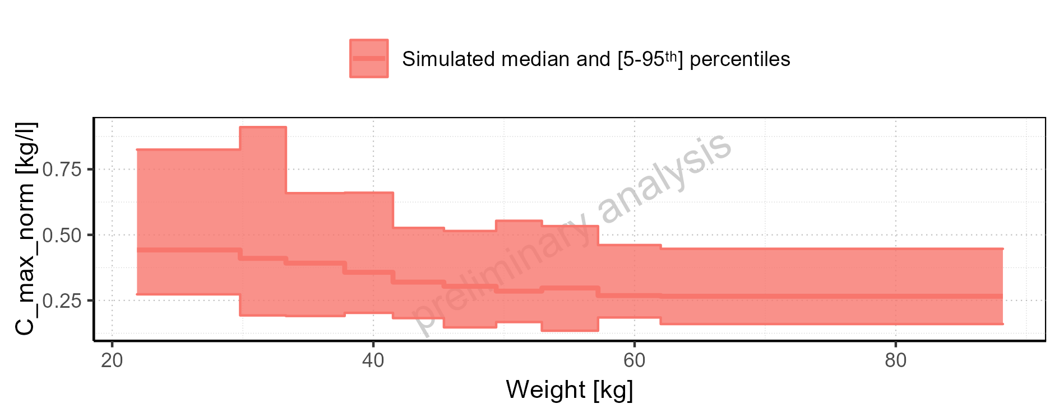

Figure 2-45: Weight-dependence of C_max_norm for Filmcoated_tablet_400mg_sd. Profiles are plotted in a logarithmic scale.

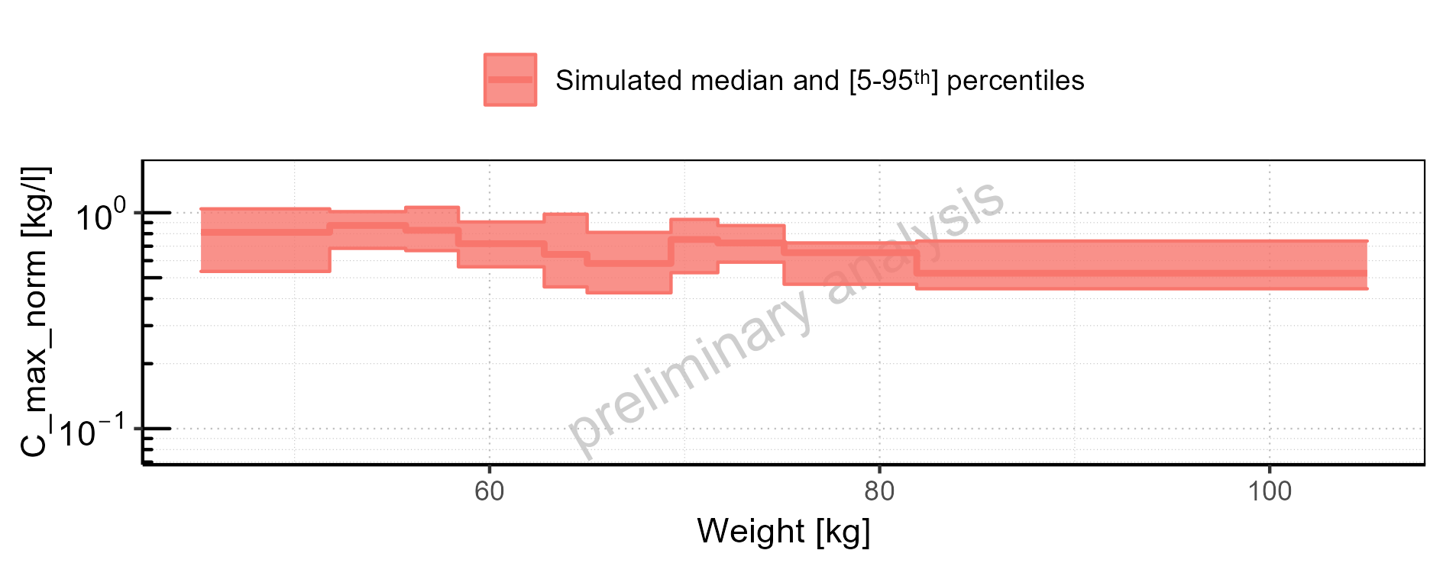

Figure 2-46: Weight-dependence of C_max_norm for Filmcoated_tablet_400mg_sd. Profiles are plotted in a linear scale.

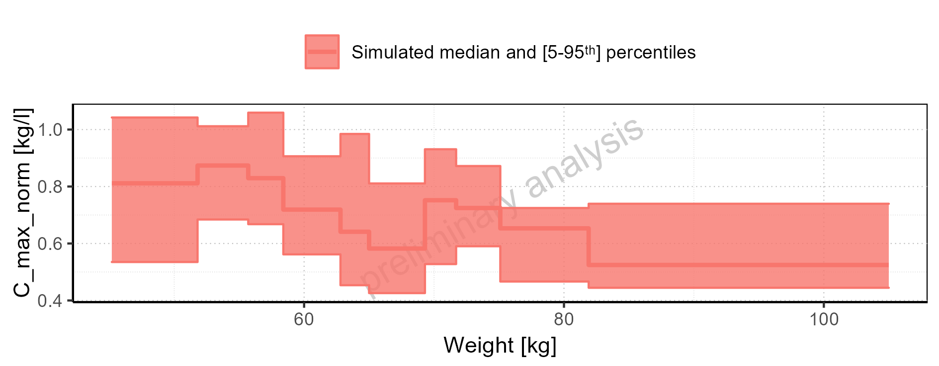

Figure 2-47: BMI-dependence of C_max_norm for Larson 2013 8y-18y 400mg FCT meal in comparison to Filmcoated_tablet_400mg_sd. Profiles are plotted in a logarithmic scale.

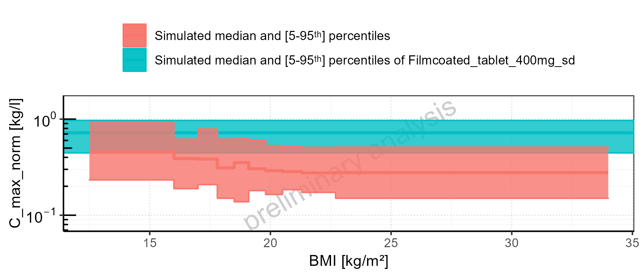

Figure 2-48: BMI-dependence of C_max_norm for Larson 2013 8y-18y 400mg FCT meal in comparison to Filmcoated_tablet_400mg_sd. Profiles are plotted in a linear scale.

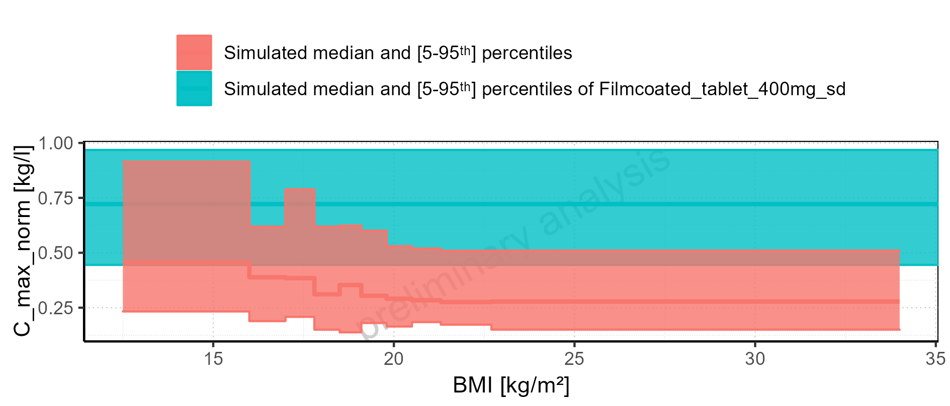

Figure 2-49: BMI-dependence of C_max_norm for Larson 2013 8y-18y 400mg FCT meal. Profiles are plotted in a logarithmic scale.

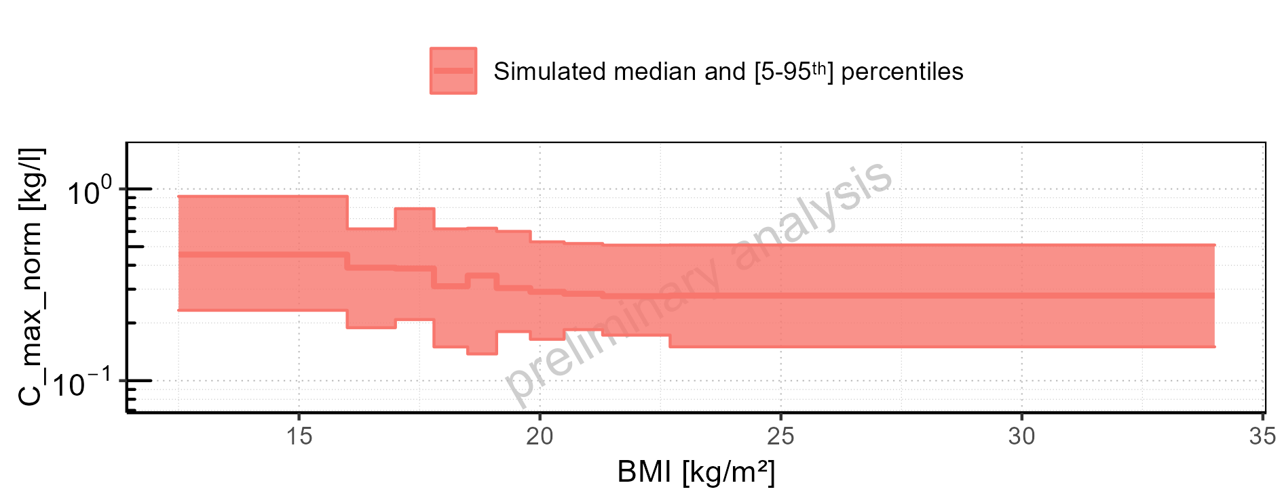

Figure 2-50: BMI-dependence of C_max_norm for Larson 2013 8y-18y 400mg FCT meal. Profiles are plotted in a linear scale.

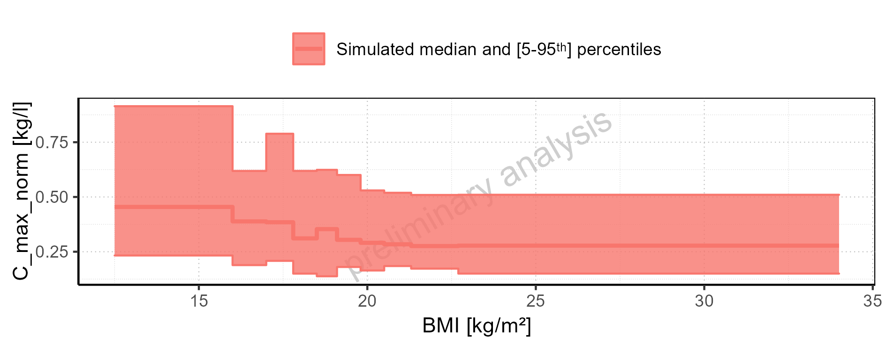

Figure 2-51: BMI-dependence of C_max_norm for Filmcoated_tablet_400mg_sd. Profiles are plotted in a logarithmic scale.

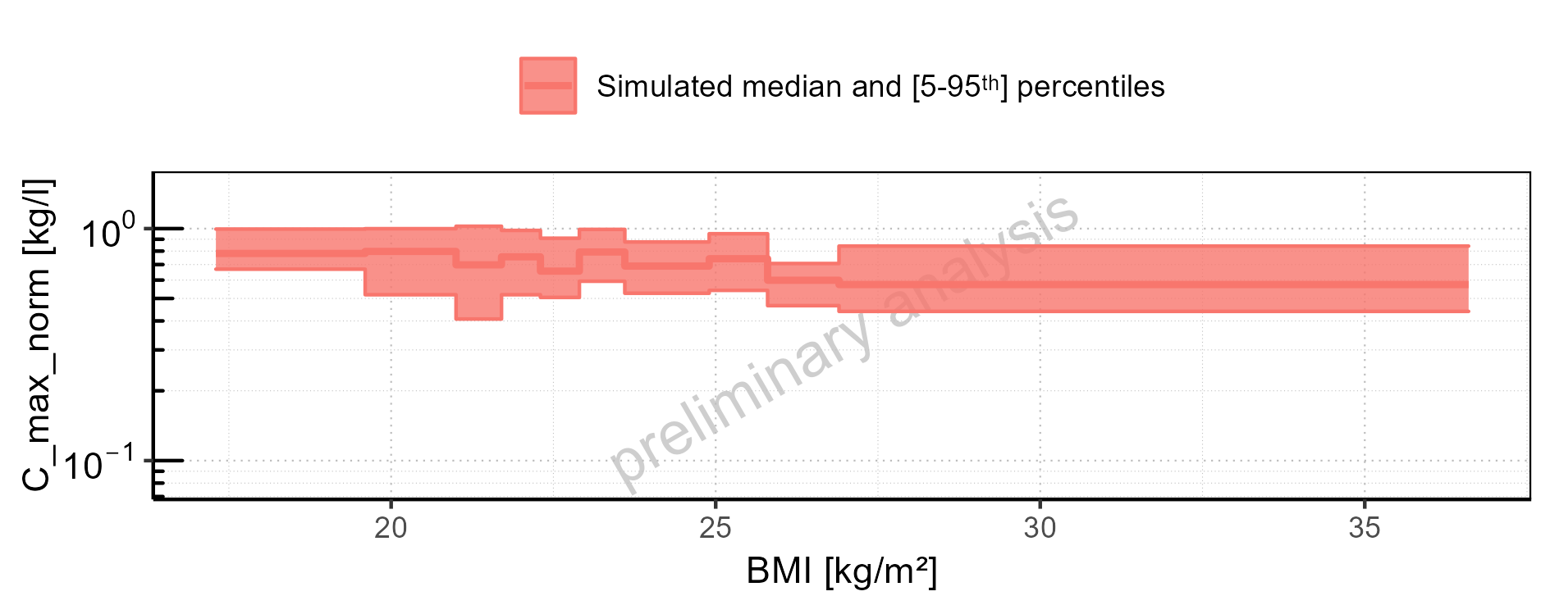

Figure 2-52: BMI-dependence of C_max_norm for Filmcoated_tablet_400mg_sd. Profiles are plotted in a linear scale.

### t_max

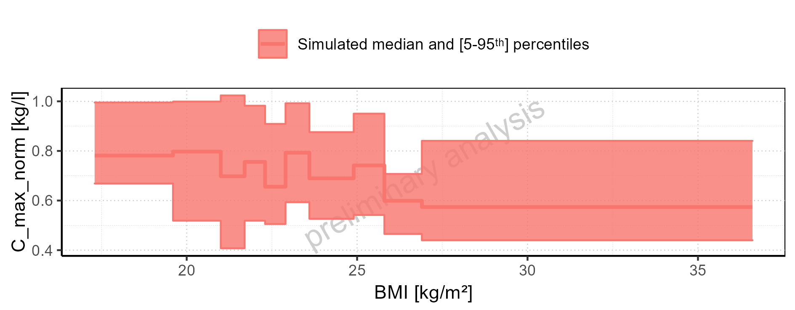

Figure 2-53: t_max of Raltegravir for Larson 2013 8y-18y 400mg FCT meal, Filmcoated_tablet_400mg_sd shown as box-whisker plot, which indicates the 5<U+1D57><U+02B0>, 25<U+1D57><U+02B0>, 50<U+1D57><U+02B0>, 75<U+1D57><U+02B0>, 95<U+1D57><U+02B0> percentiles in logarithmic scale.

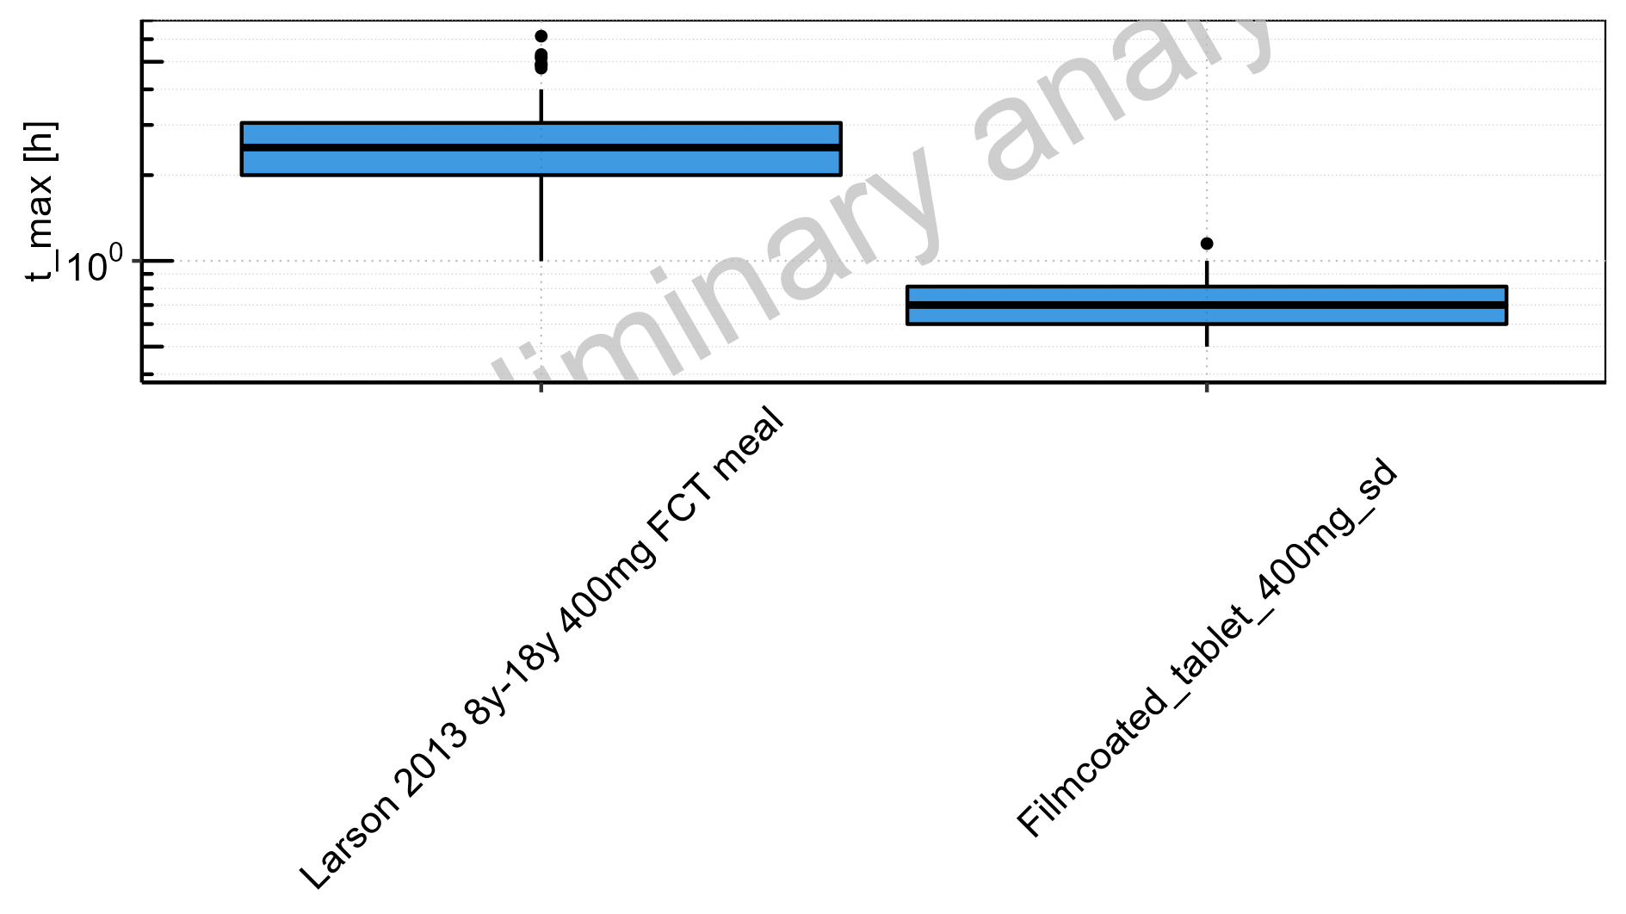

Figure 2-54: t_max of Raltegravir for Larson 2013 8y-18y 400mg FCT meal, Filmcoated_tablet_400mg_sd shown as box-whisker plot, which indicates the 5<U+1D57><U+02B0>, 25<U+1D57><U+02B0>, 50<U+1D57><U+02B0>, 75<U+1D57><U+02B0>, 95<U+1D57><U+02B0> percentiles in linear scale.

**Table 2-3: t_max of Raltegravir for Larson 2013 8y-18y 400mg FCT meal, Filmcoated_tablet_400mg_sd reported in [h]**

|  |  |  |  |  |  |  |  |  |  |  |
| --- | --- | --- | --- | --- | --- | --- | --- | --- | --- | --- |
| Population | N | 5<U+1D57><U+02B0> pctl | 25<U+1D57><U+02B0> pctl | 50<U+1D57><U+02B0> pctl | 75<U+1D57><U+02B0> pctl | 95<U+1D57><U+02B0> pctl | Mean | SD | Geo Mean | Geo SD |
| Larson 2013 8y-18y 400mg FCT meal | 500 | 1.00 | 2.00 | 2.50 | 3.05 | 4 | 2.54 | 0.88 | 2.37 | 1.49 |
| Filmcoated_tablet_400mg_sd | 100 | 0.50 | 0.60 | 0.70 | 0.81 | 1 | 0.73 | 0.15 | 0.71 | 1.23 |

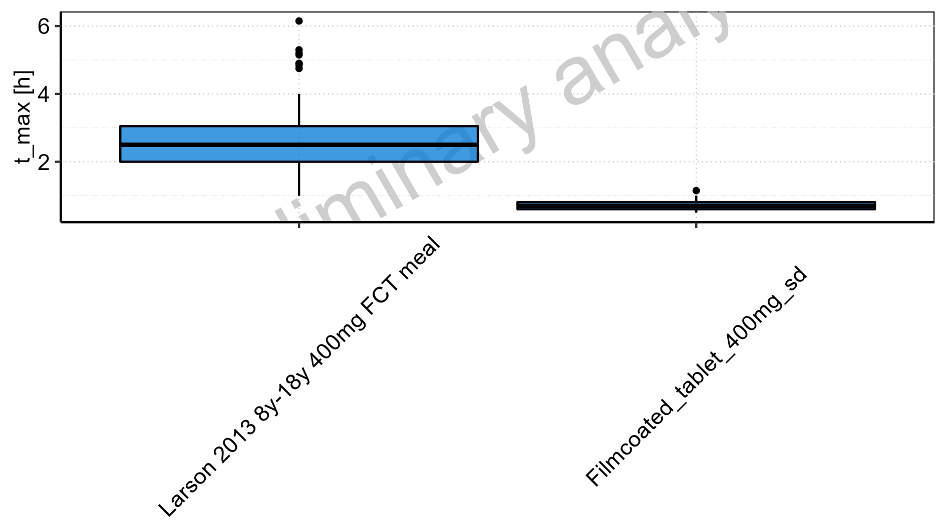

Figure 2-55: Age-dependence of t_max for Larson 2013 8y-18y 400mg FCT meal in comparison to Filmcoated_tablet_400mg_sd. Profiles are plotted in a logarithmic scale.

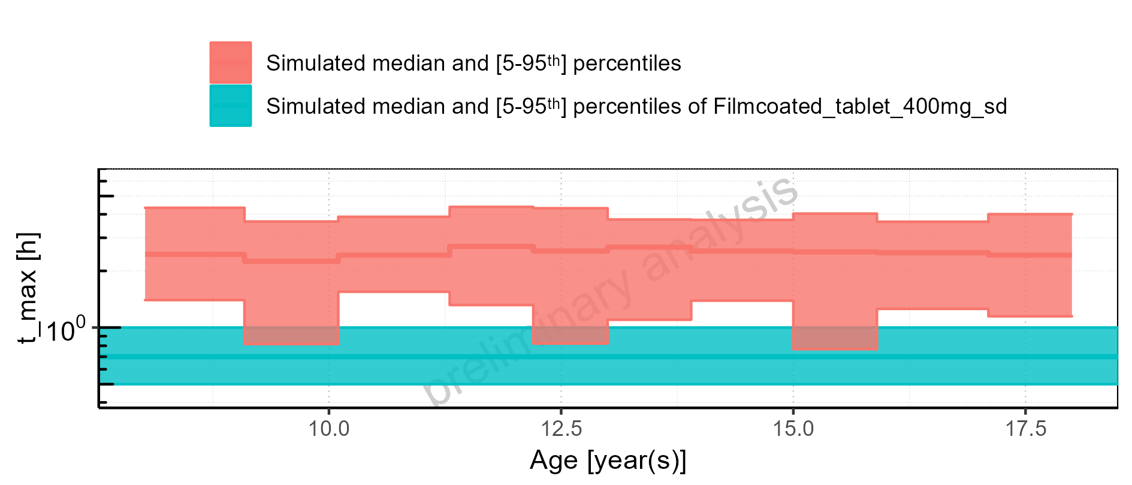

Figure 2-56: Age-dependence of t_max for Larson 2013 8y-18y 400mg FCT meal in comparison to Filmcoated_tablet_400mg_sd. Profiles are plotted in a linear scale.

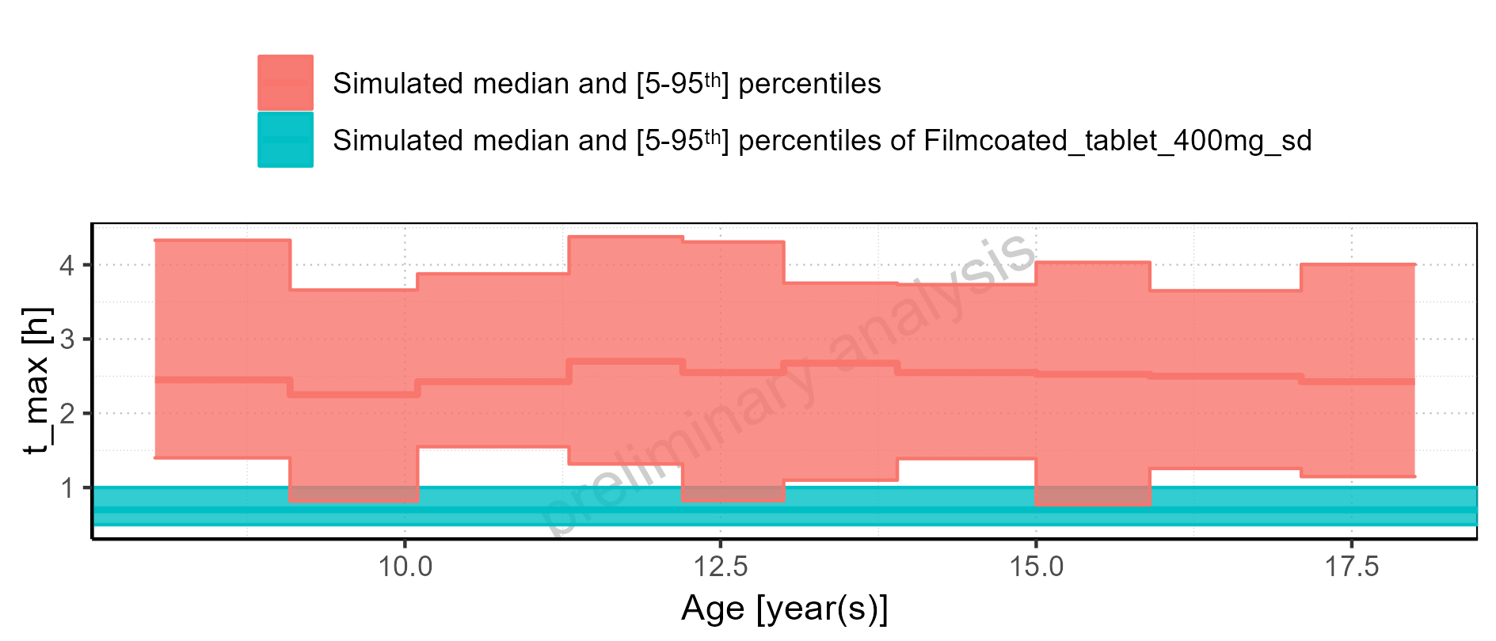

Figure 2-57: Age-dependence of t_max for Larson 2013 8y-18y 400mg FCT meal. Profiles are plotted in a logarithmic scale.

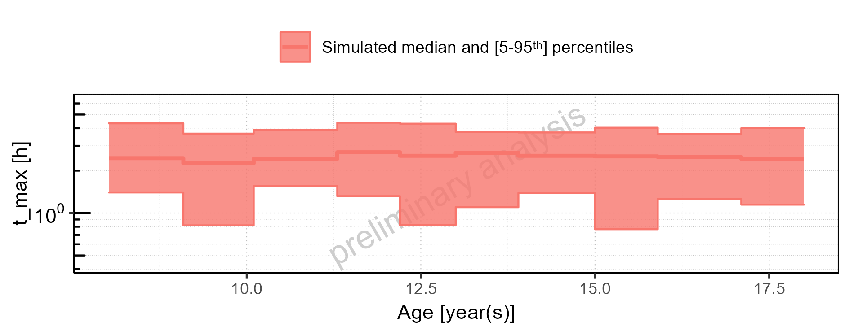

Figure 2-58: Age-dependence of t_max for Larson 2013 8y-18y 400mg FCT meal. Profiles are plotted in a linear scale.

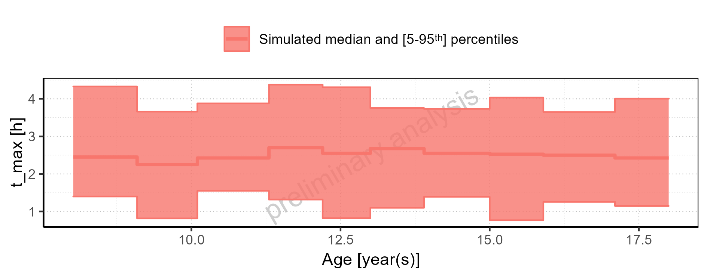

Figure 2-59: Age-dependence of t_max for Filmcoated_tablet_400mg_sd. Profiles are plotted in a logarithmic scale.

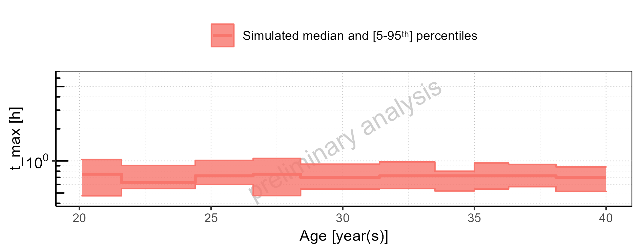

Figure 2-60: Age-dependence of t_max for Filmcoated_tablet_400mg_sd. Profiles are plotted in a linear scale.

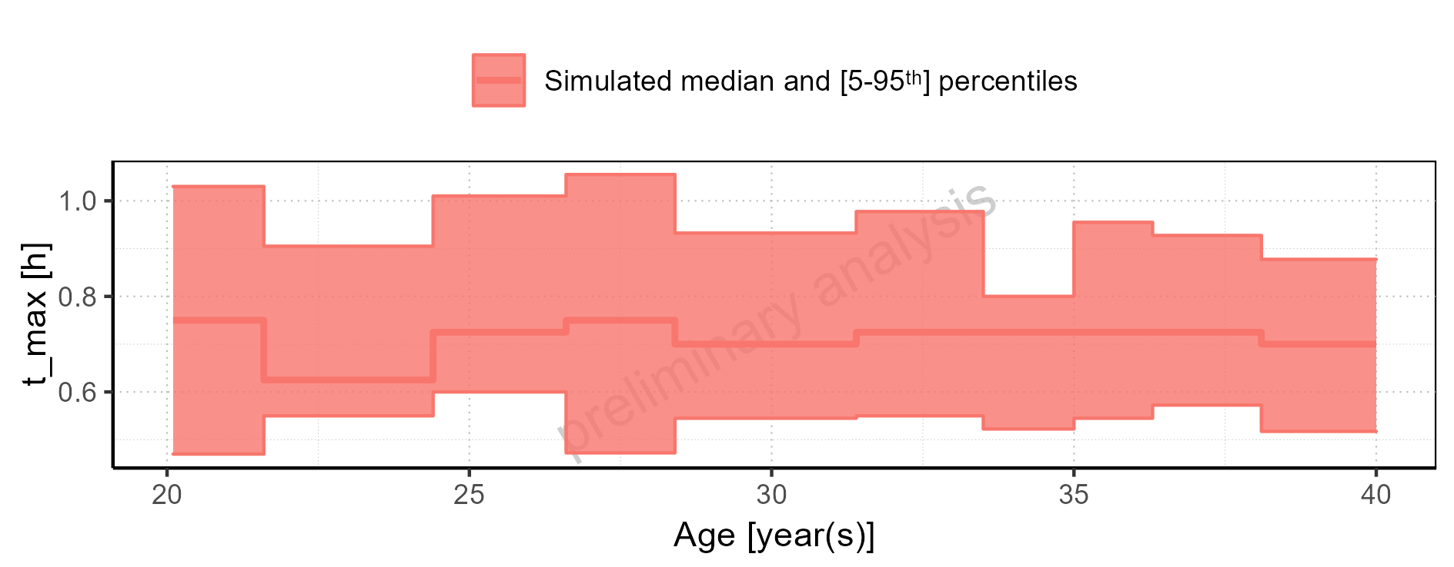

Figure 2-61: Height-dependence of t_max for Larson 2013 8y-18y 400mg FCT meal in comparison to Filmcoated_tablet_400mg_sd. Profiles are plotted in a logarithmic scale.

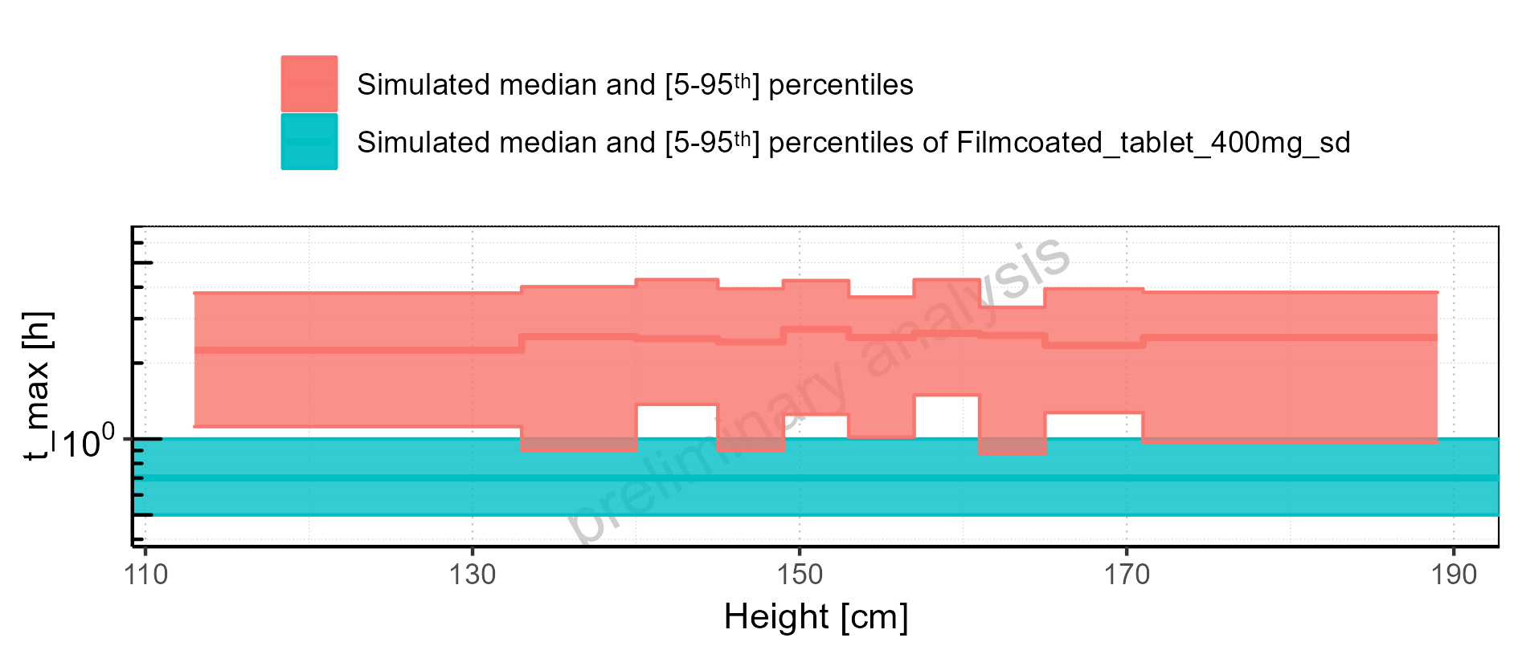

Figure 2-62: Height-dependence of t_max for Larson 2013 8y-18y 400mg FCT meal in comparison to Filmcoated_tablet_400mg_sd. Profiles are plotted in a linear scale.

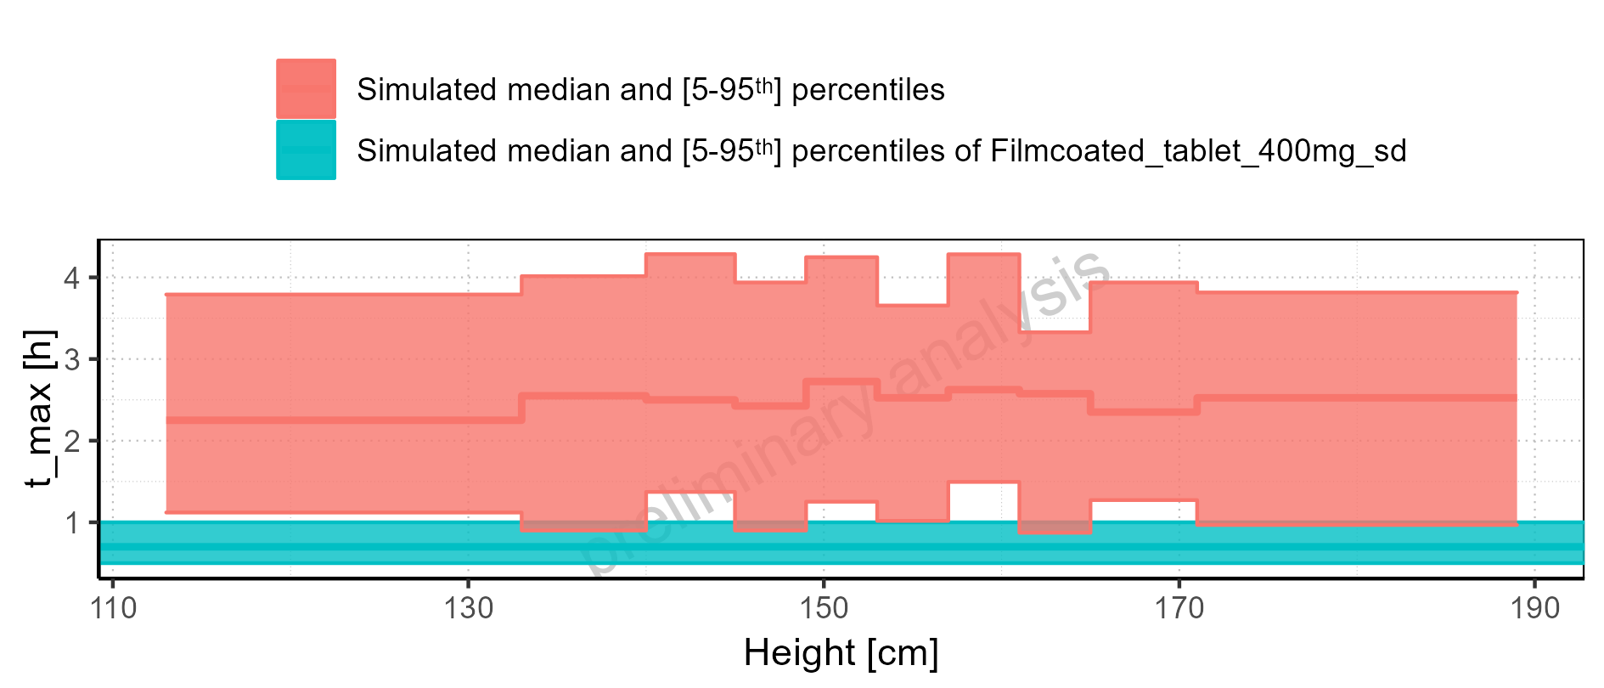

Figure 2-63: Height-dependence of t_max for Larson 2013 8y-18y 400mg FCT meal. Profiles are plotted in a logarithmic scale.

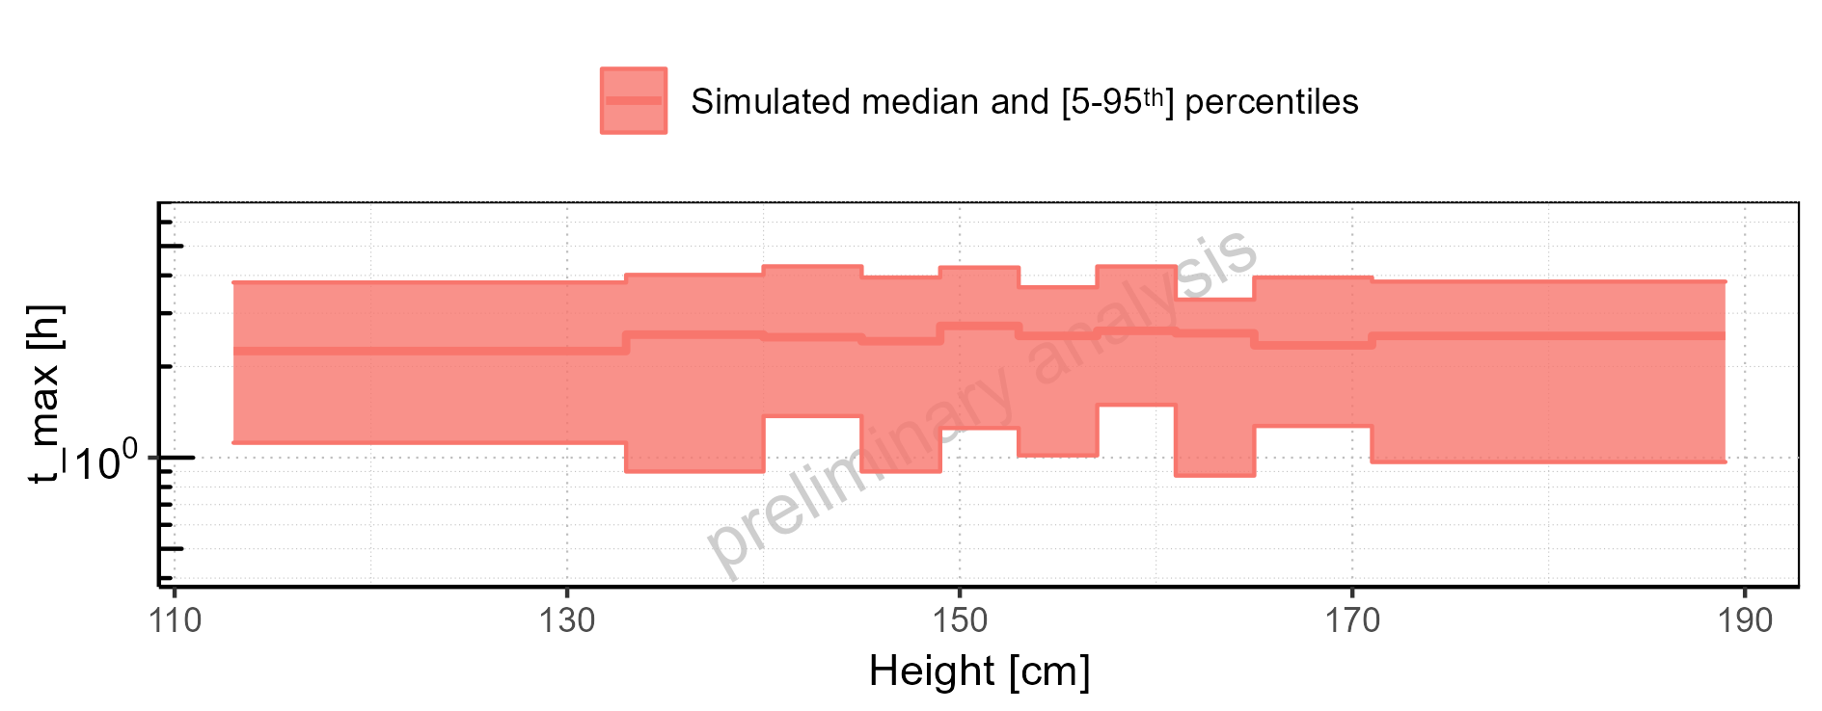

Figure 2-64: Height-dependence of t_max for Larson 2013 8y-18y 400mg FCT meal. Profiles are plotted in a linear scale.

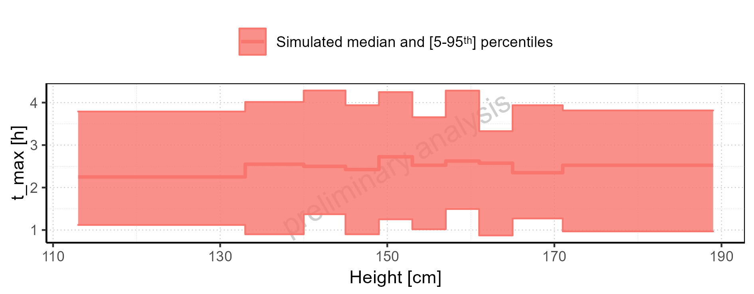

Figure 2-65: Height-dependence of t_max for Filmcoated_tablet_400mg_sd. Profiles are plotted in a logarithmic scale.

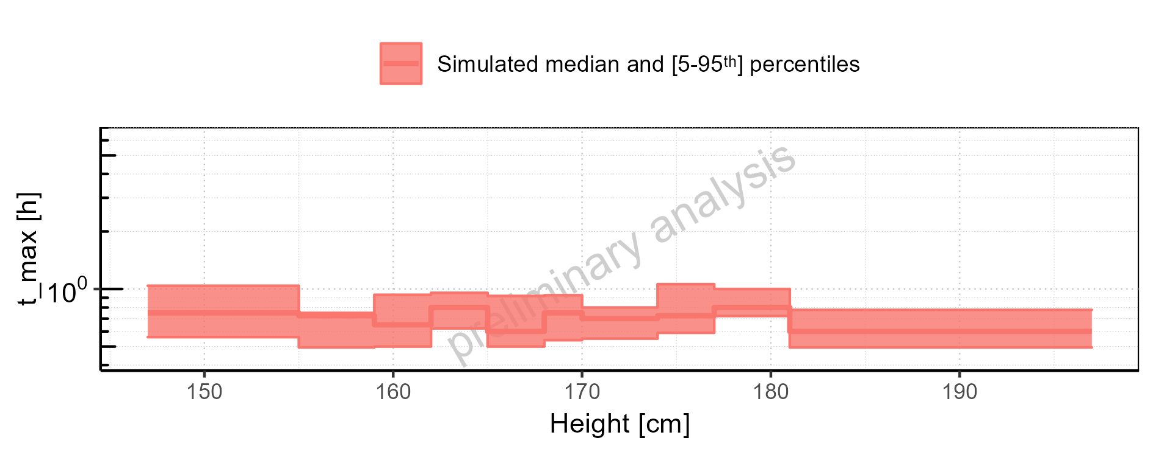

Figure 2-66: Height-dependence of t_max for Filmcoated_tablet_400mg_sd. Profiles are plotted in a linear scale.

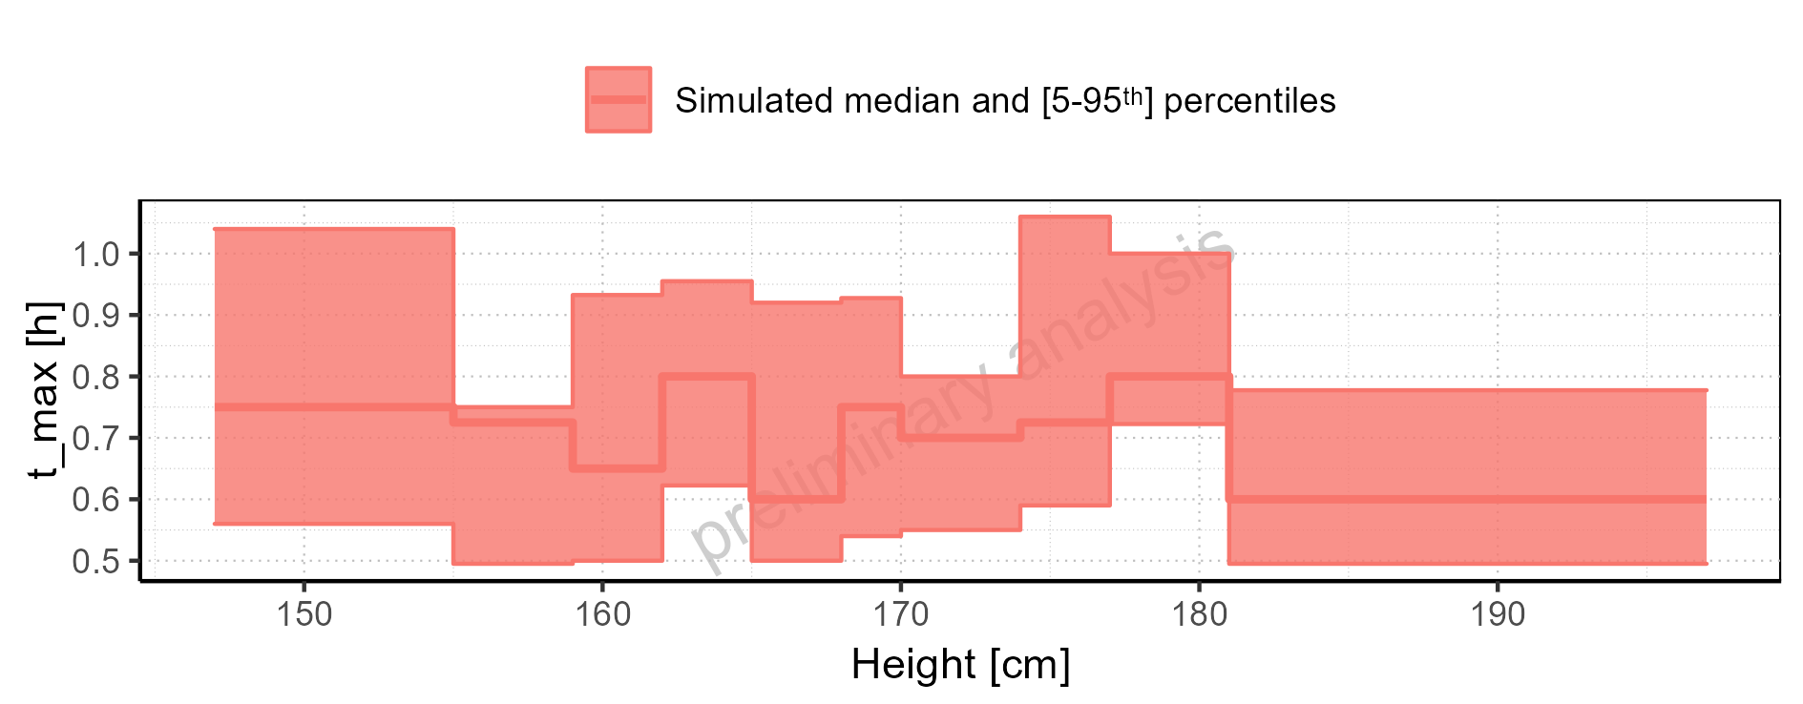

Figure 2-67: Weight-dependence of t_max for Larson 2013 8y-18y 400mg FCT meal in comparison to Filmcoated_tablet_400mg_sd. Profiles are plotted in a logarithmic scale.

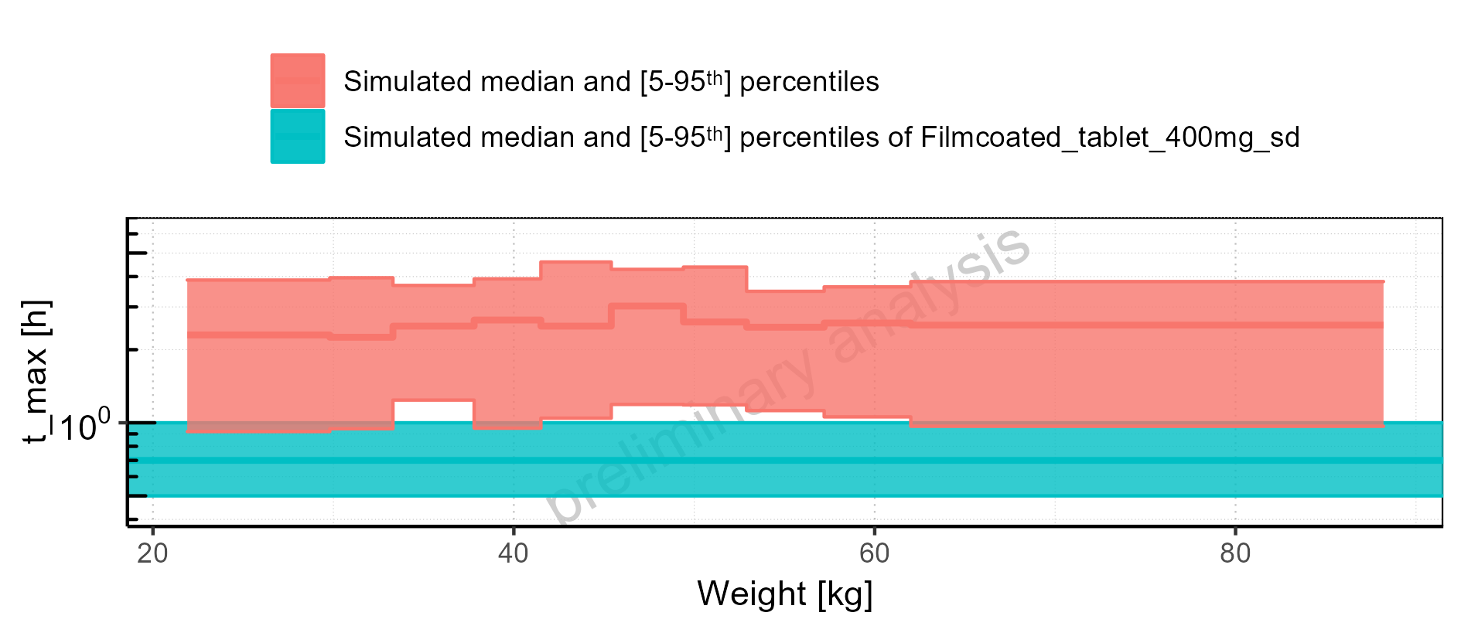

Figure 2-68: Weight-dependence of t_max for Larson 2013 8y-18y 400mg FCT meal in comparison to Filmcoated_tablet_400mg_sd. Profiles are plotted in a linear scale.

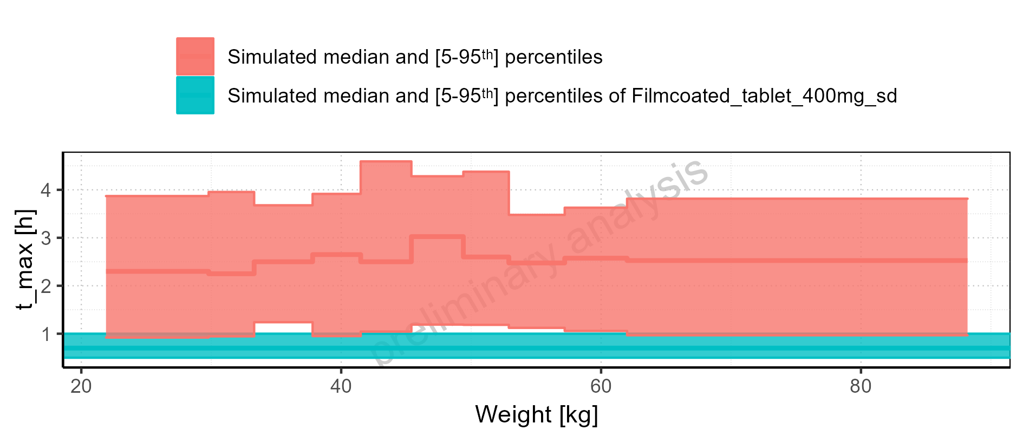

Figure 2-69: Weight-dependence of t_max for Larson 2013 8y-18y 400mg FCT meal. Profiles are plotted in a logarithmic scale.

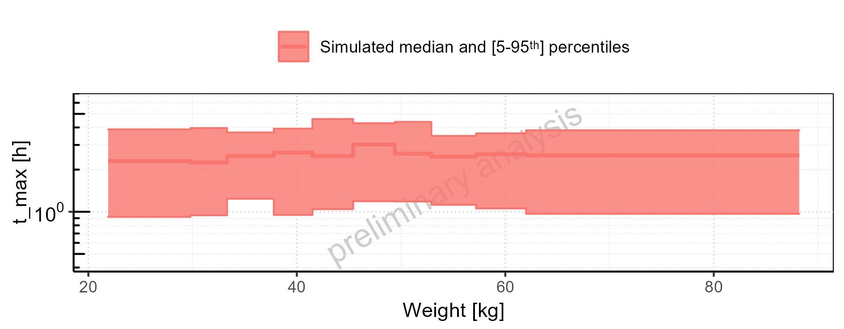

Figure 2-70: Weight-dependence of t_max for Larson 2013 8y-18y 400mg FCT meal. Profiles are plotted in a linear scale.

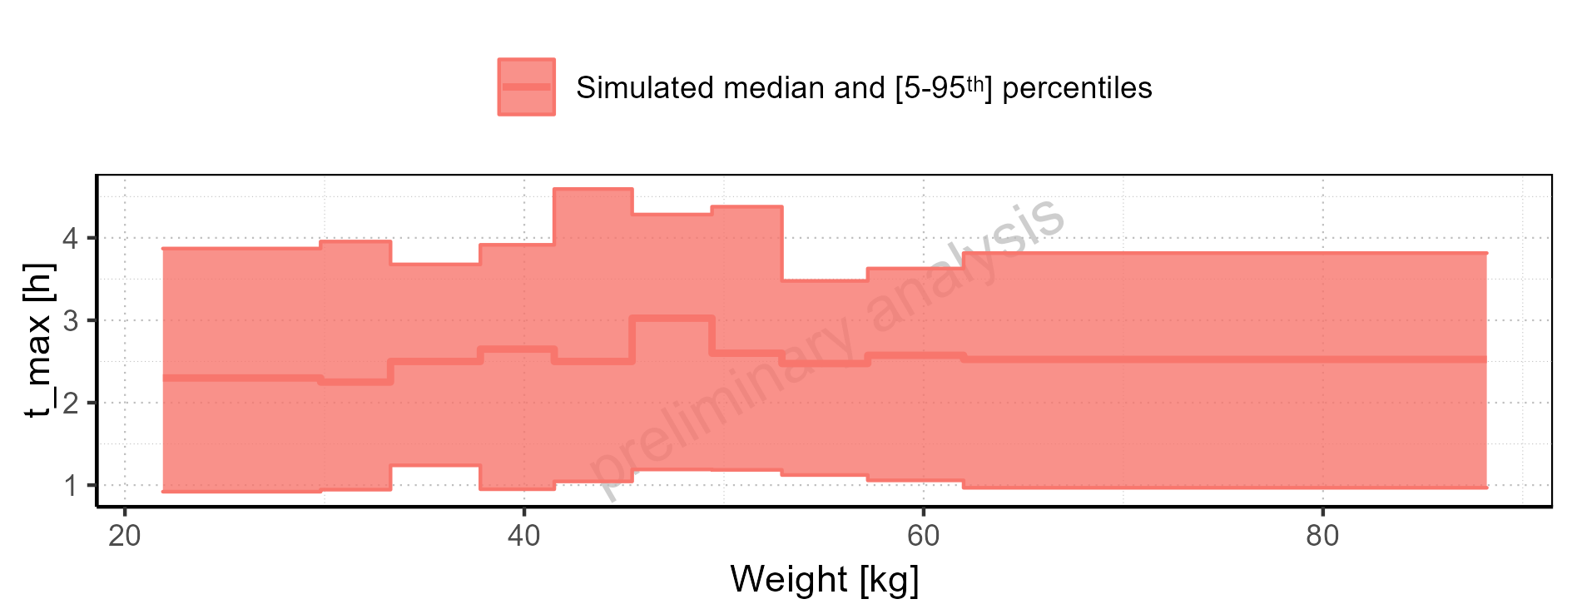

Figure 2-71: Weight-dependence of t_max for Filmcoated_tablet_400mg_sd. Profiles are plotted in a logarithmic scale.

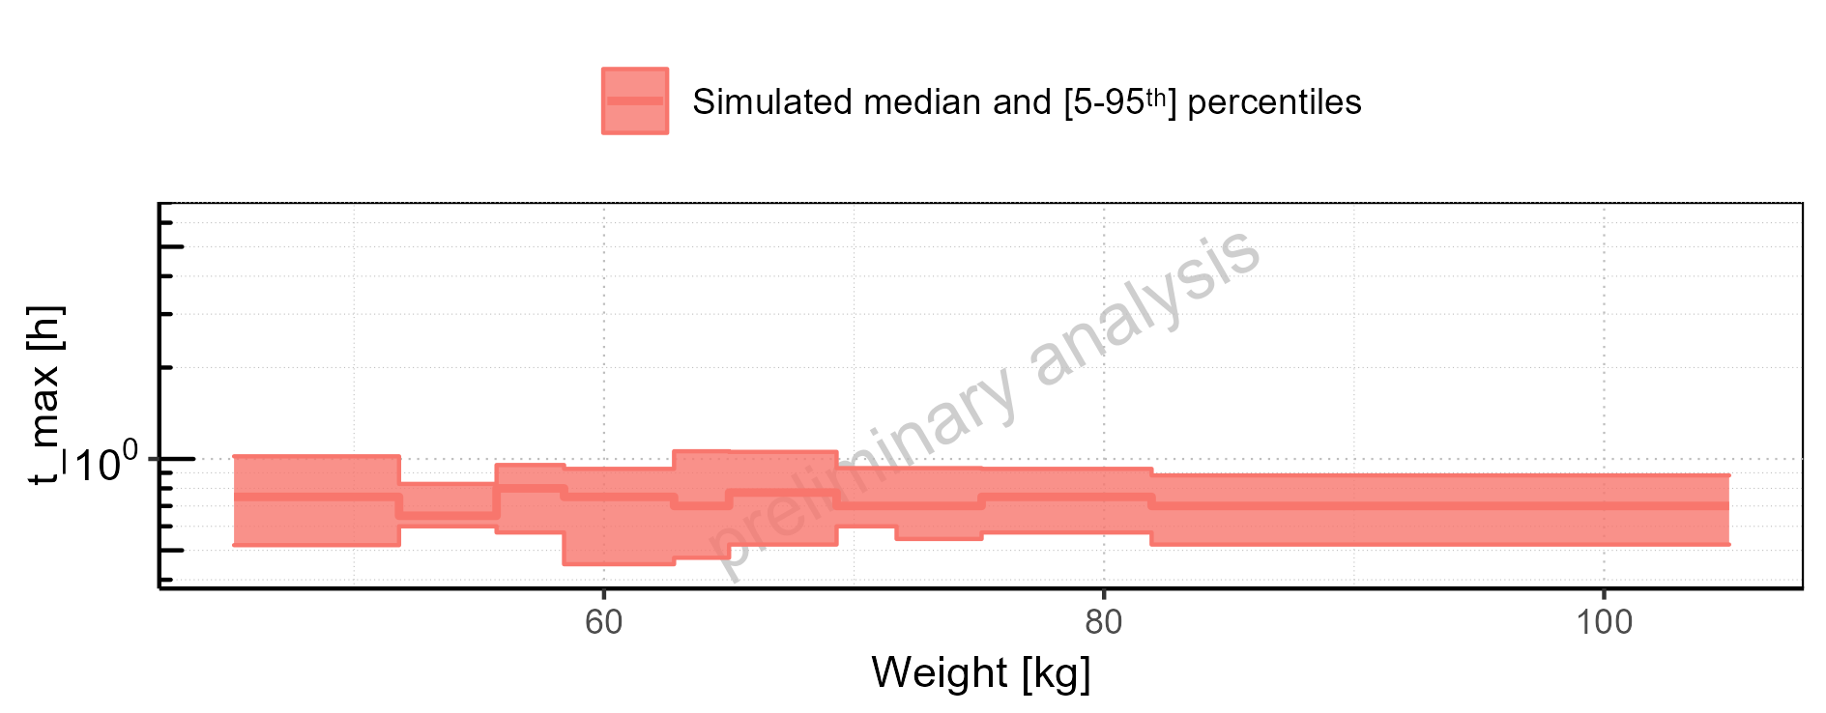

Figure 2-72: Weight-dependence of t_max for Filmcoated_tablet_400mg_sd. Profiles are plotted in a linear scale.

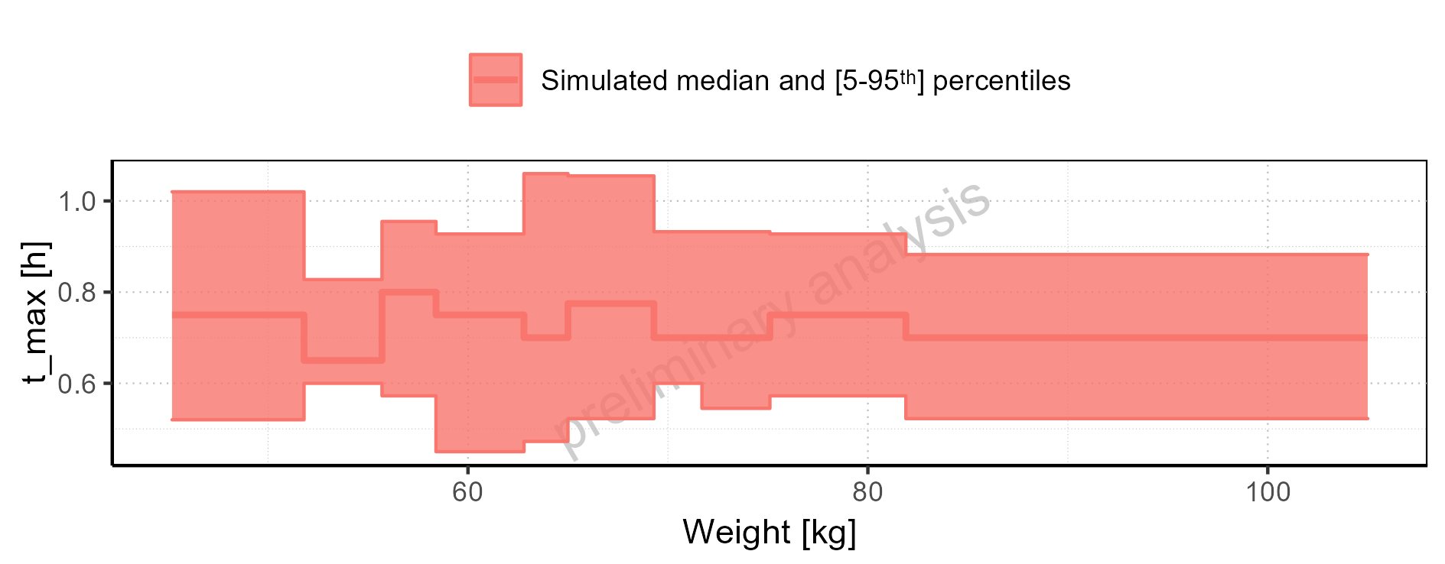

Figure 2-73: BMI-dependence of t_max for Larson 2013 8y-18y 400mg FCT meal in comparison to Filmcoated_tablet_400mg_sd. Profiles are plotted in a logarithmic scale.

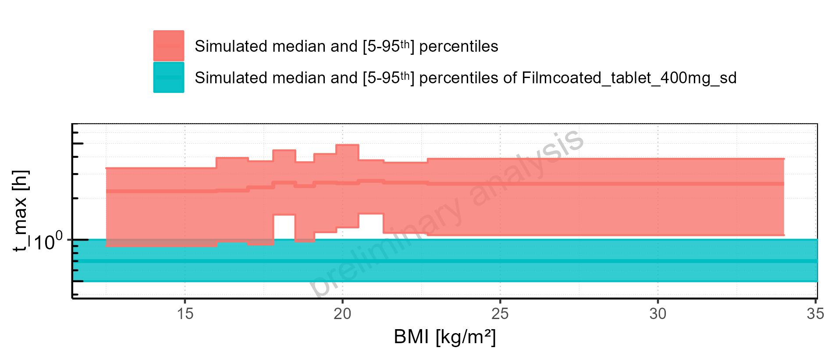

Figure 2-74: BMI-dependence of t_max for Larson 2013 8y-18y 400mg FCT meal in comparison to Filmcoated_tablet_400mg_sd. Profiles are plotted in a linear scale.

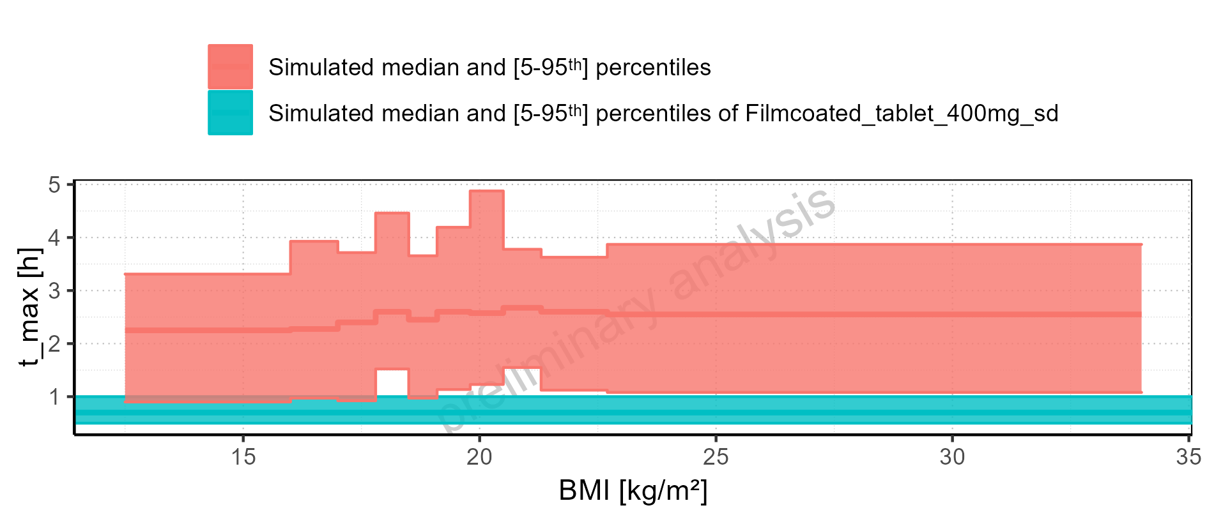

Figure 2-75: BMI-dependence of t_max for Larson 2013 8y-18y 400mg FCT meal. Profiles are plotted in a logarithmic scale.

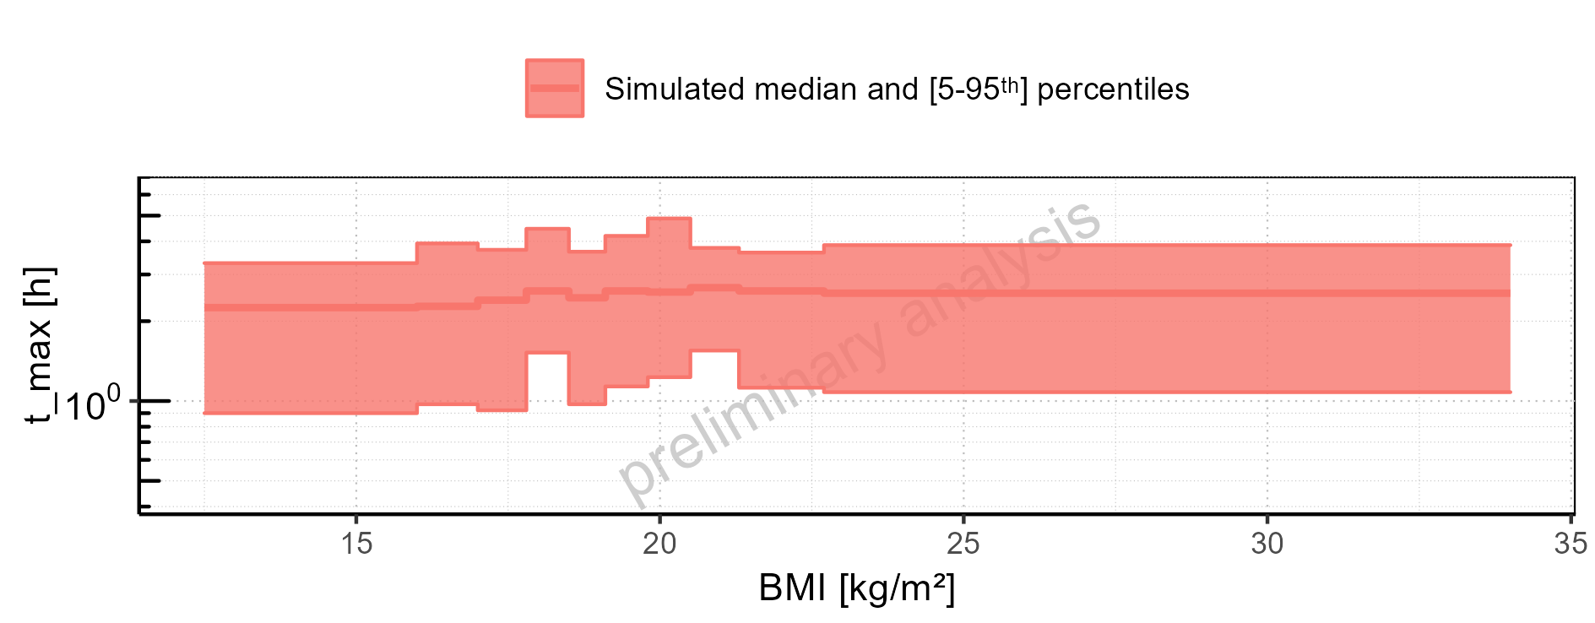

Figure 2-76: BMI-dependence of t_max for Larson 2013 8y-18y 400mg FCT meal. Profiles are plotted in a linear scale.

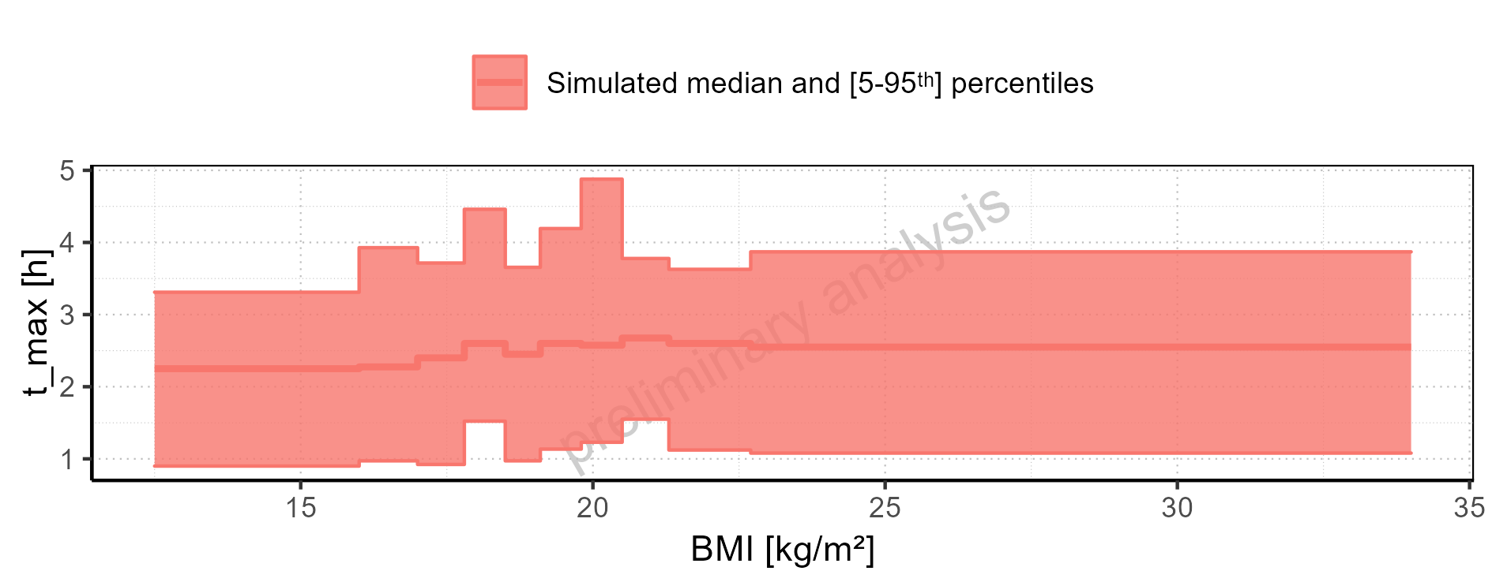

Figure 2-77: BMI-dependence of t_max for Filmcoated_tablet_400mg_sd. Profiles are plotted in a logarithmic scale.

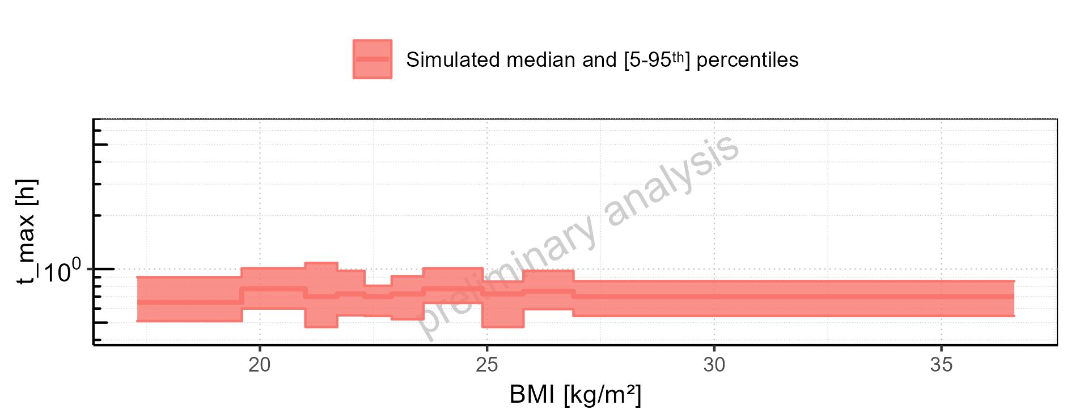

Figure 2-78: BMI-dependence of t_max for Filmcoated_tablet_400mg_sd. Profiles are plotted in a linear scale.

### C_tEnd

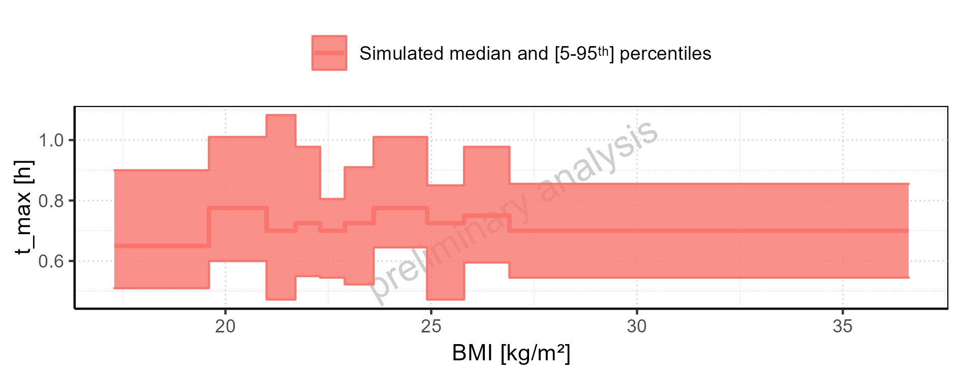

Figure 2-79: C_tEnd of Raltegravir for Larson 2013 8y-18y 400mg FCT meal, Filmcoated_tablet_400mg_sd shown as box-whisker plot, which indicates the 5<U+1D57><U+02B0>, 25<U+1D57><U+02B0>, 50<U+1D57><U+02B0>, 75<U+1D57><U+02B0>, 95<U+1D57><U+02B0> percentiles in logarithmic scale.

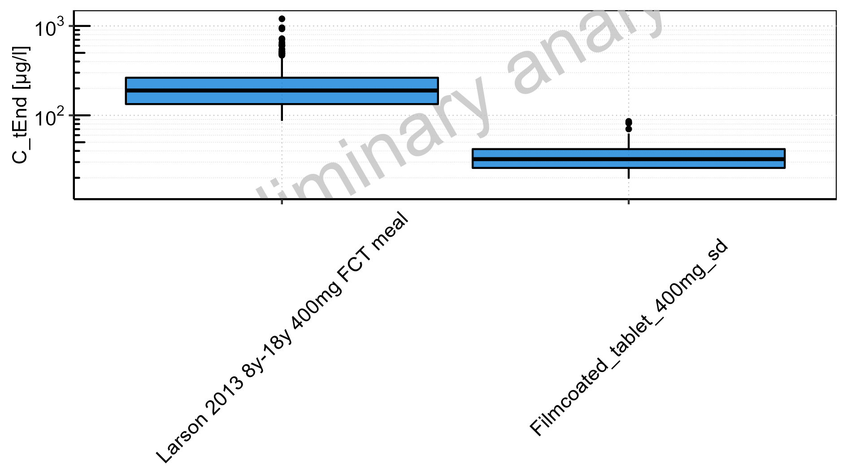

Figure 2-80: C_tEnd of Raltegravir for Larson 2013 8y-18y 400mg FCT meal, Filmcoated_tablet_400mg_sd shown as box-whisker plot, which indicates the 5<U+1D57><U+02B0>, 25<U+1D57><U+02B0>, 50<U+1D57><U+02B0>, 75<U+1D57><U+02B0>, 95<U+1D57><U+02B0> percentiles in linear scale.

**Table 2-4: C_tEnd of Raltegravir for Larson 2013 8y-18y 400mg FCT meal, Filmcoated_tablet_400mg_sd reported in [µg/l]**

|  |  |  |  |  |  |  |  |  |  |  |
| --- | --- | --- | --- | --- | --- | --- | --- | --- | --- | --- |
| Population | N | 5<U+1D57><U+02B0> pctl | 25<U+1D57><U+02B0> pctl | 50<U+1D57><U+02B0> pctl | 75<U+1D57><U+02B0> pctl | 95<U+1D57><U+02B0> pctl | Mean | SD | Geo Mean | Geo SD |
| Larson 2013 8y-18y 400mg FCT meal | 500 | 86.63 | 133.65 | 189.56 | 263.51 | 448.02 | 218.90 | 129.12 | 191.12 | 1.67 |
| Filmcoated_tablet_400mg_sd | 100 | 19.57 | 25.80 | 32.35 | 41.91 | 62.68 | 35.39 | 14.21 | 33.01 | 1.44 |

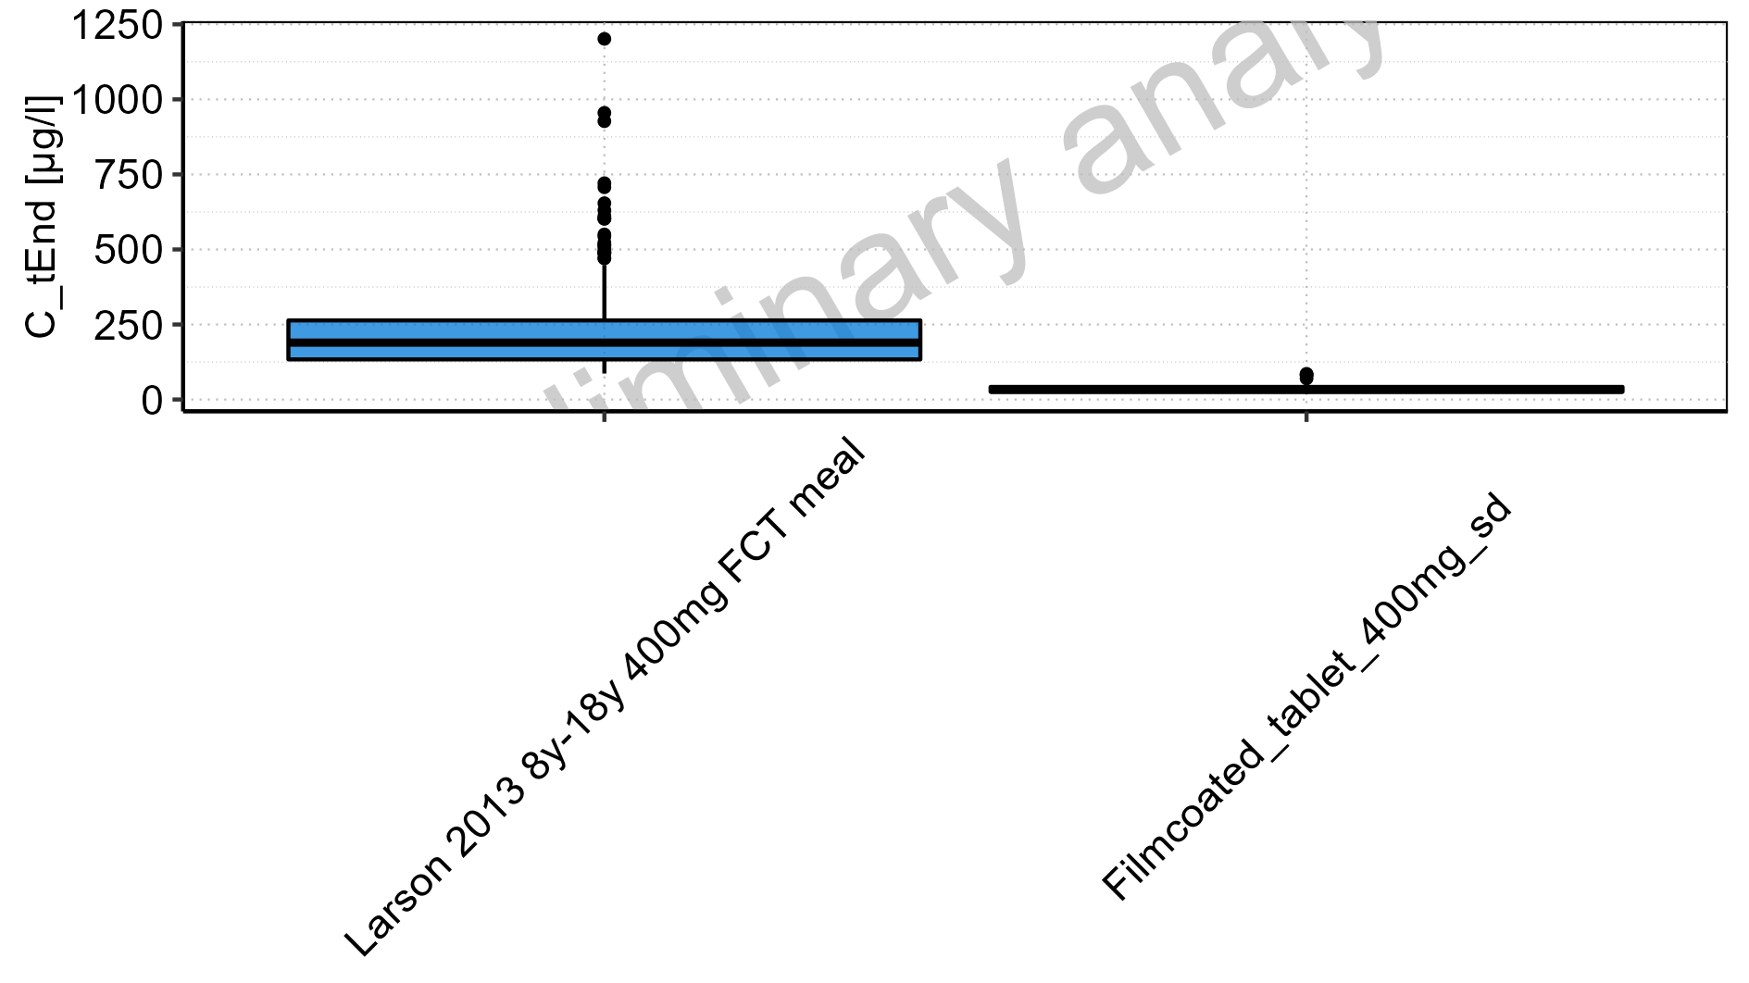

Figure 2-81: Age-dependence of C_tEnd for Larson 2013 8y-18y 400mg FCT meal in comparison to Filmcoated_tablet_400mg_sd. Profiles are plotted in a logarithmic scale.

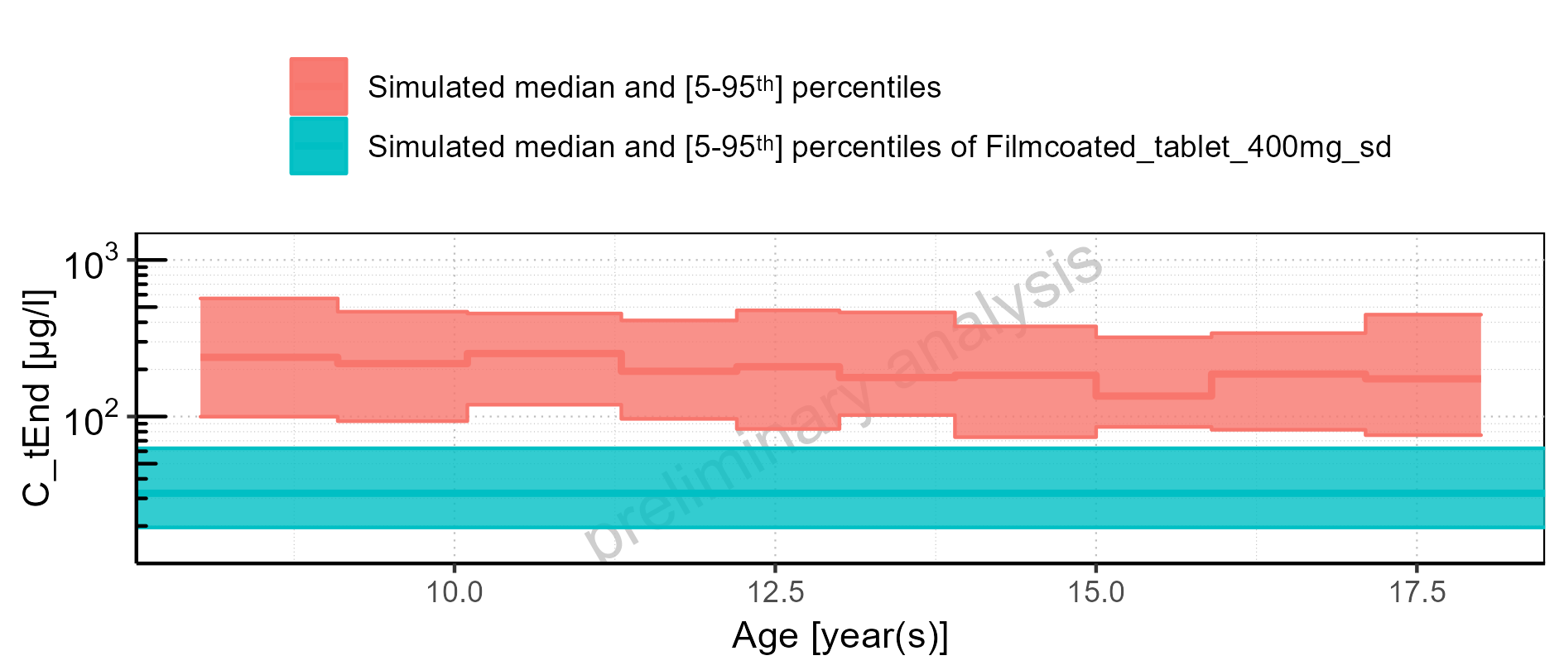

Figure 2-82: Age-dependence of C_tEnd for Larson 2013 8y-18y 400mg FCT meal in comparison to Filmcoated_tablet_400mg_sd. Profiles are plotted in a linear scale.

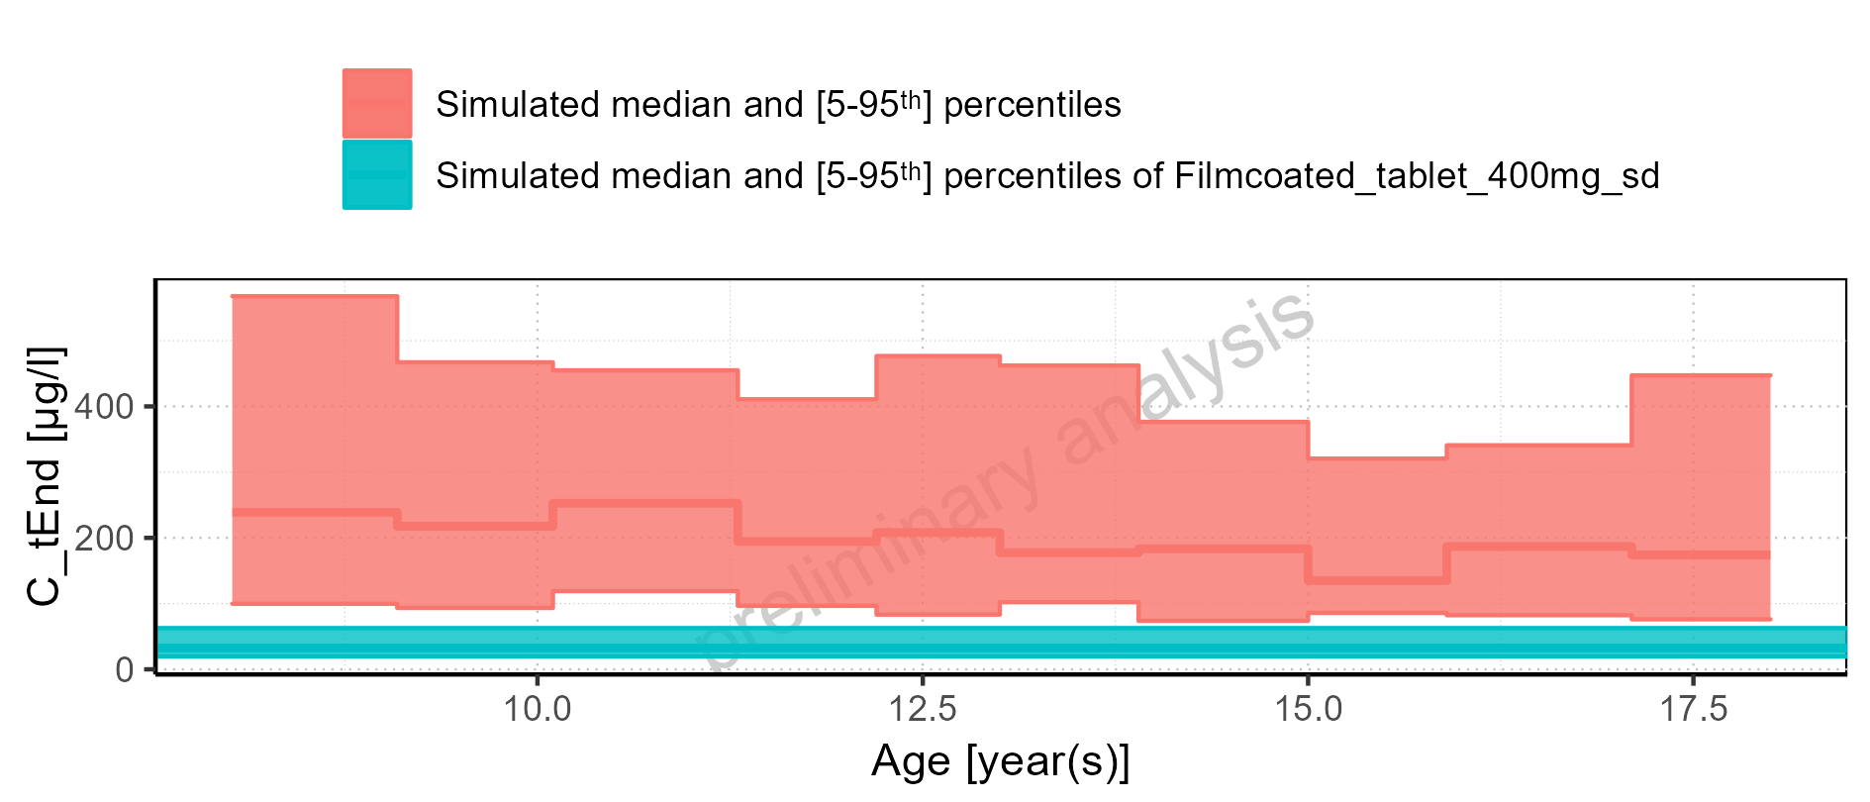

Figure 2-83: Age-dependence of C_tEnd for Larson 2013 8y-18y 400mg FCT meal. Profiles are plotted in a logarithmic scale.

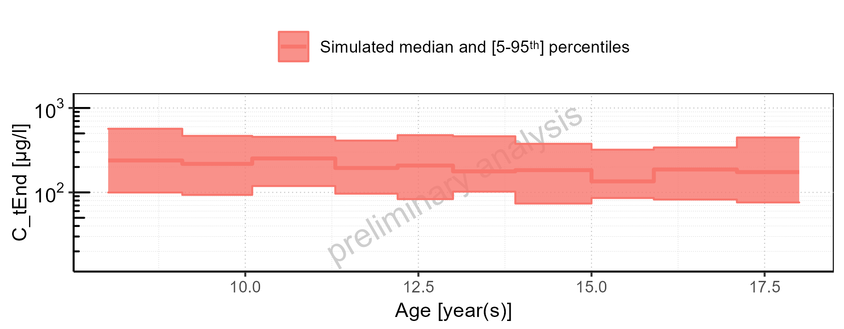

Figure 2-84: Age-dependence of C_tEnd for Larson 2013 8y-18y 400mg FCT meal. Profiles are plotted in a linear scale.

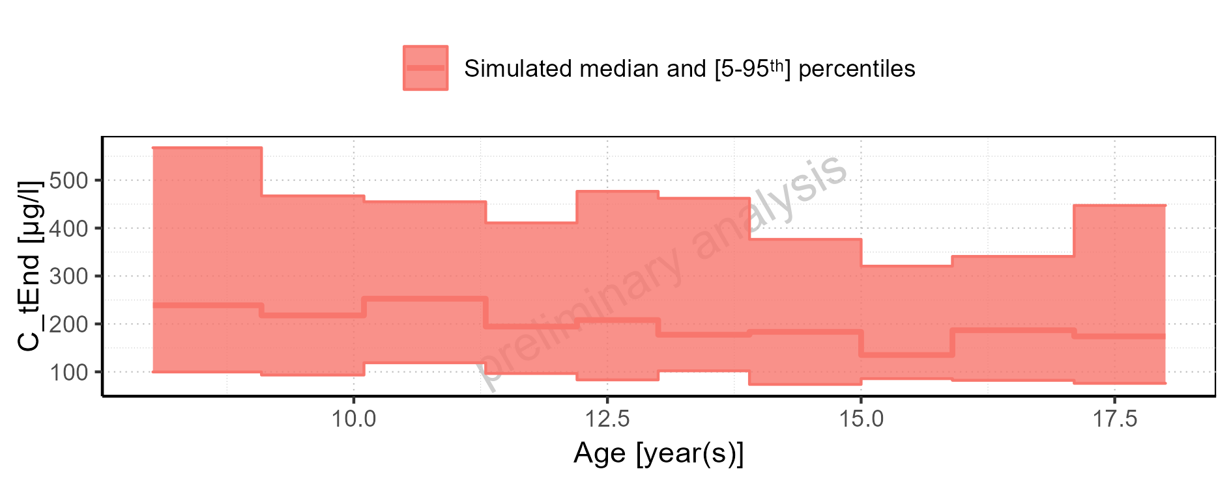

Figure 2-85: Age-dependence of C_tEnd for Filmcoated_tablet_400mg_sd. Profiles are plotted in a logarithmic scale.

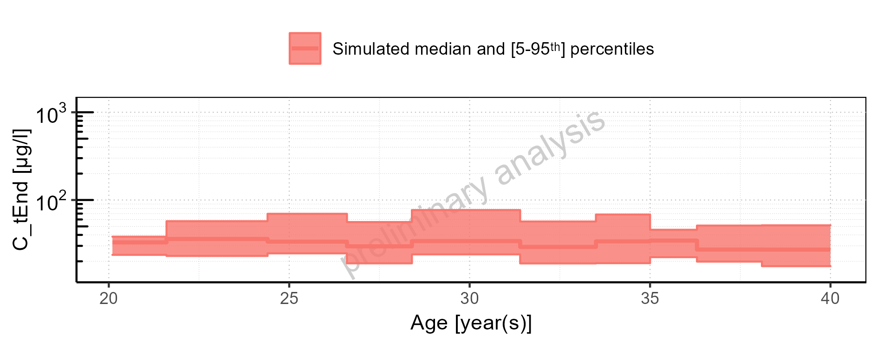

Figure 2-86: Age-dependence of C_tEnd for Filmcoated_tablet_400mg_sd. Profiles are plotted in a linear scale.

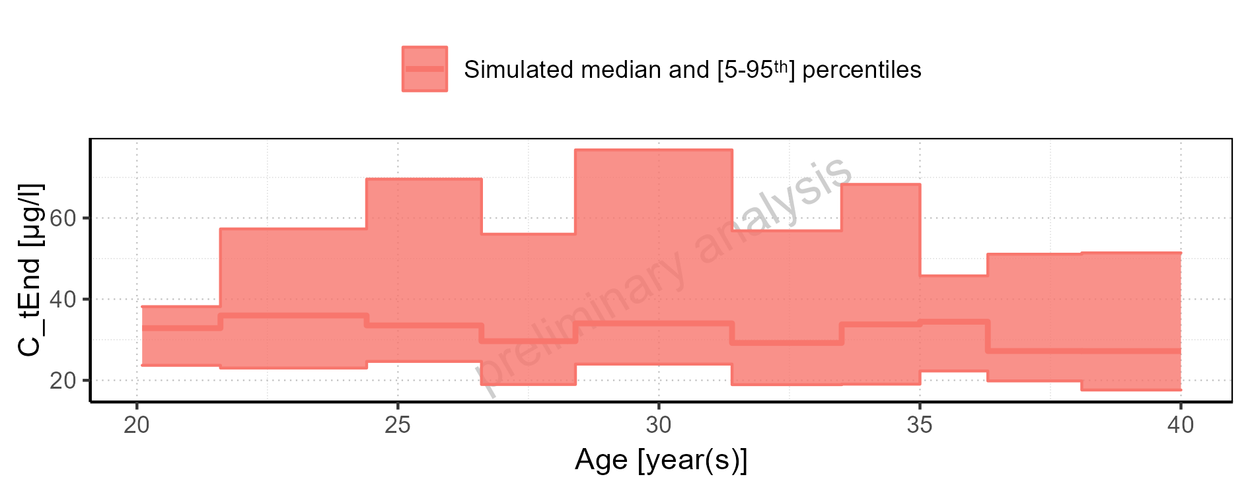

Figure 2-87: Height-dependence of C_tEnd for Larson 2013 8y-18y 400mg FCT meal in comparison to Filmcoated_tablet_400mg_sd. Profiles are plotted in a logarithmic scale.

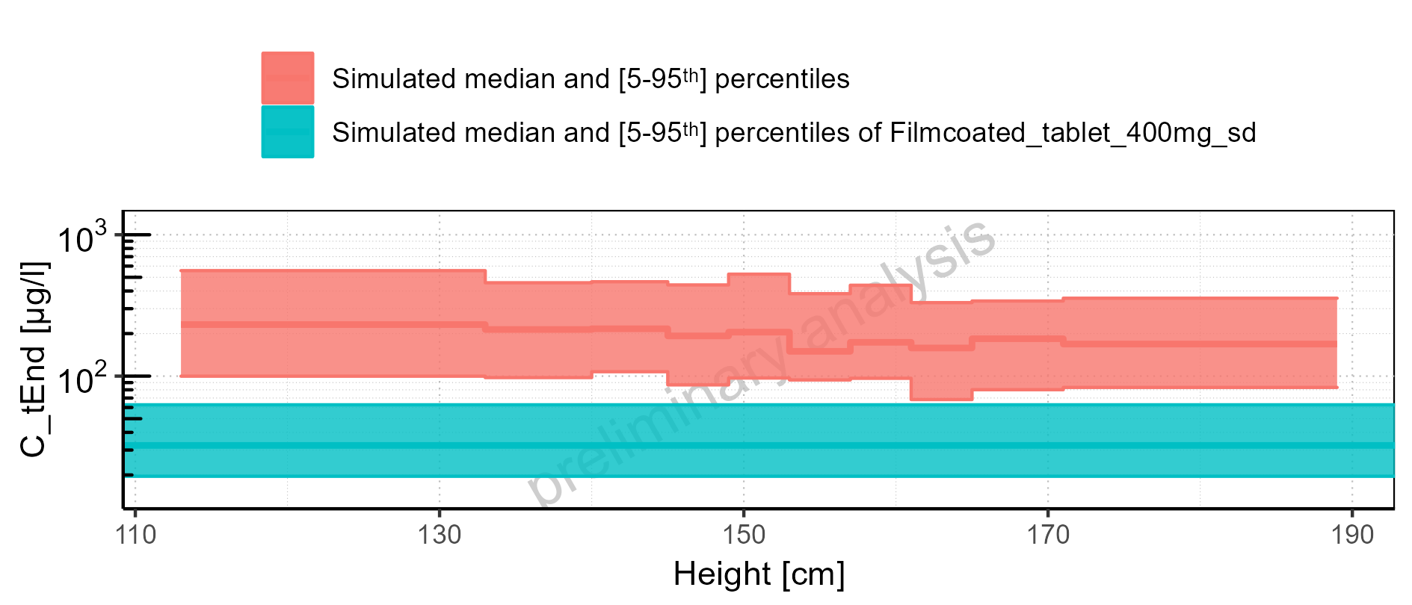

Figure 2-88: Height-dependence of C_tEnd for Larson 2013 8y-18y 400mg FCT meal in comparison to Filmcoated_tablet_400mg_sd. Profiles are plotted in a linear scale.

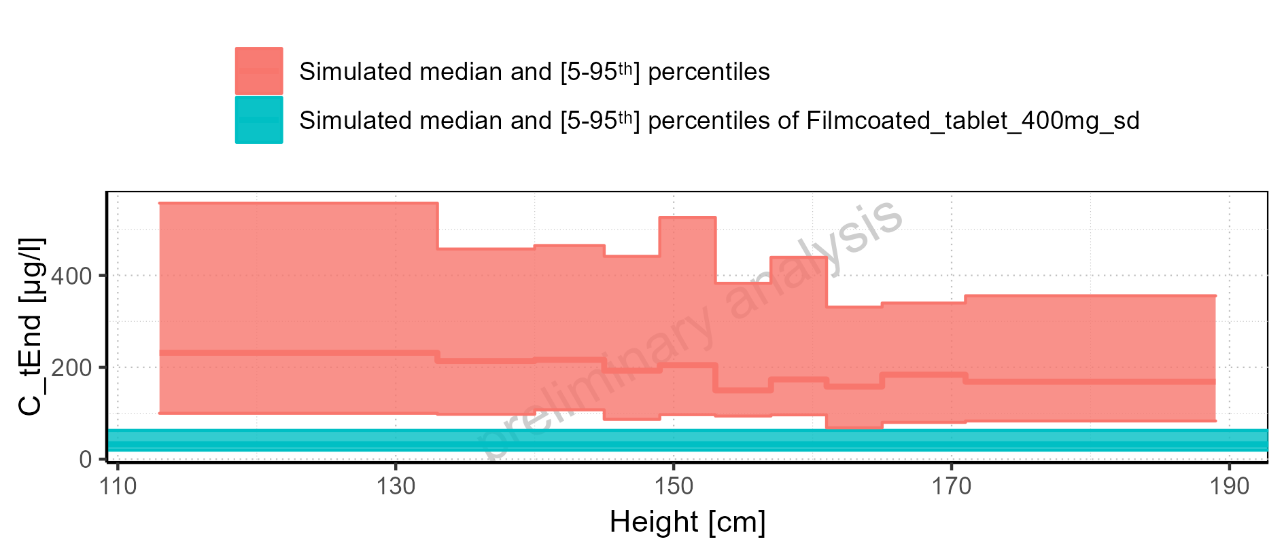

Figure 2-89: Height-dependence of C_tEnd for Larson 2013 8y-18y 400mg FCT meal. Profiles are plotted in a logarithmic scale.

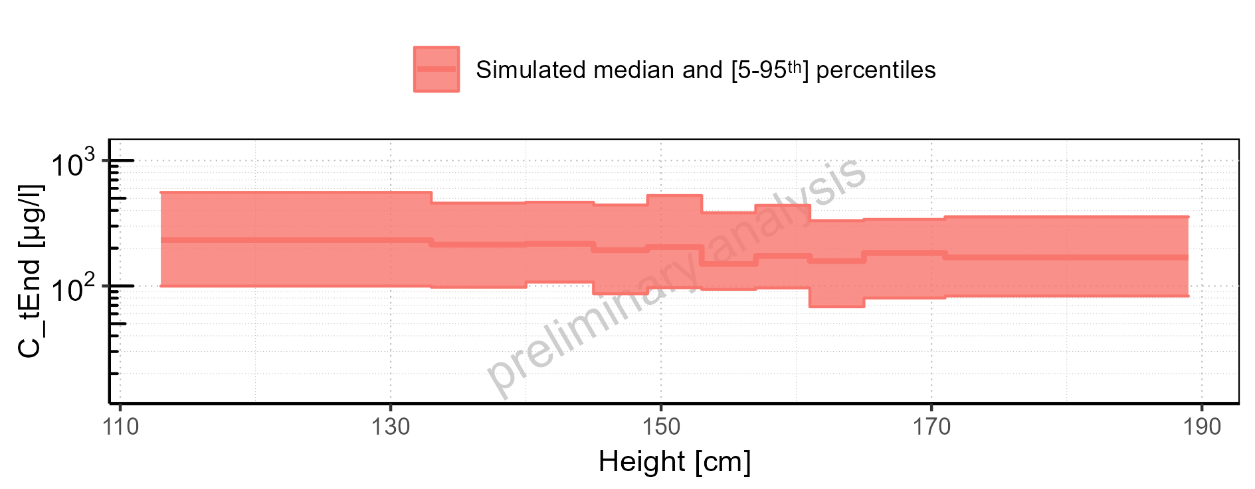

Figure 2-90: Height-dependence of C_tEnd for Larson 2013 8y-18y 400mg FCT meal. Profiles are plotted in a linear scale.

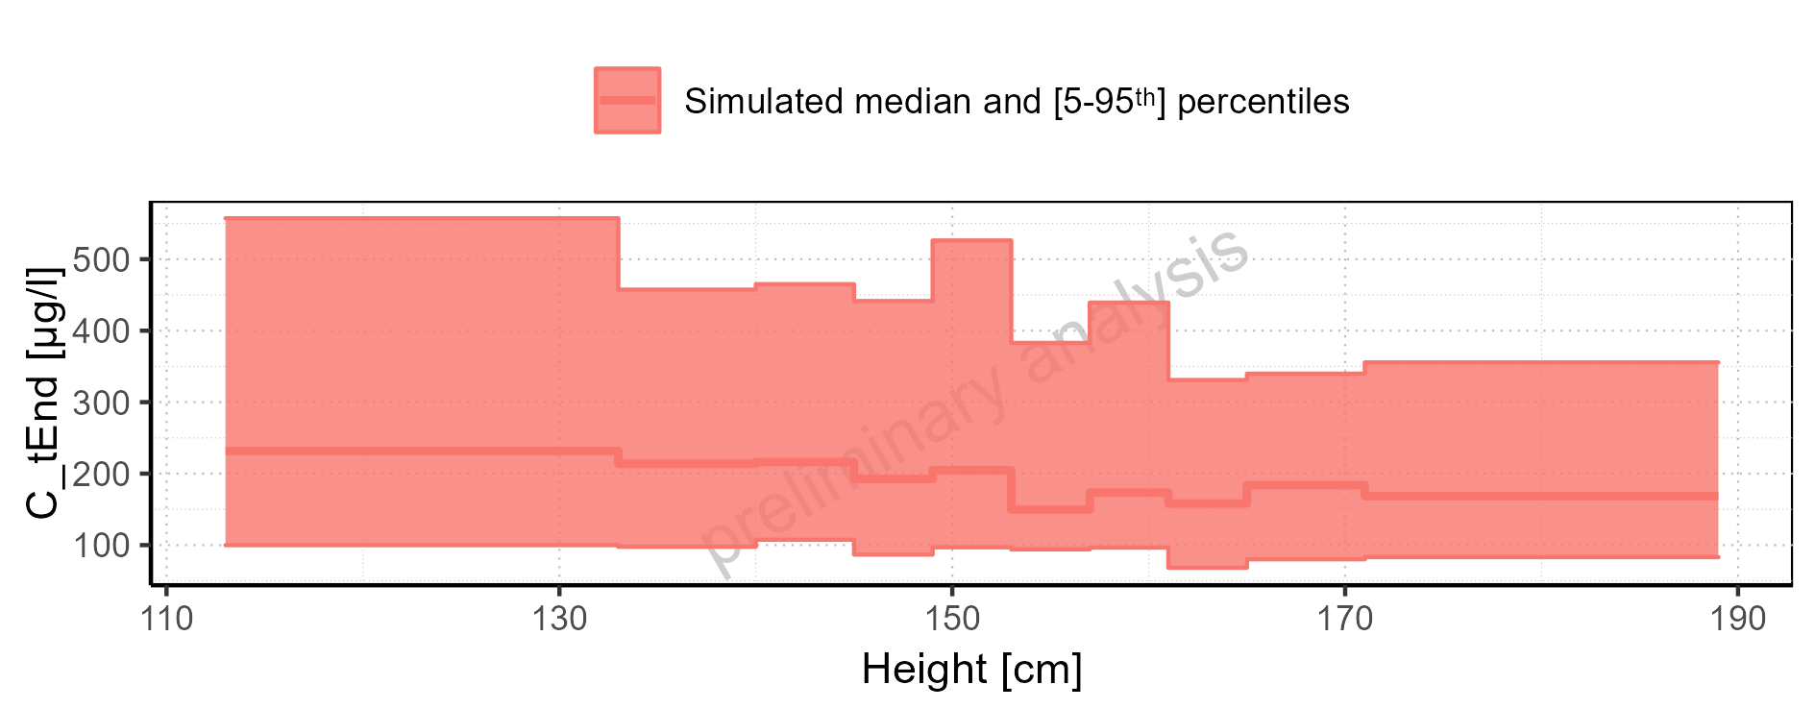

Figure 2-91: Height-dependence of C_tEnd for Filmcoated_tablet_400mg_sd. Profiles are plotted in a logarithmic scale.

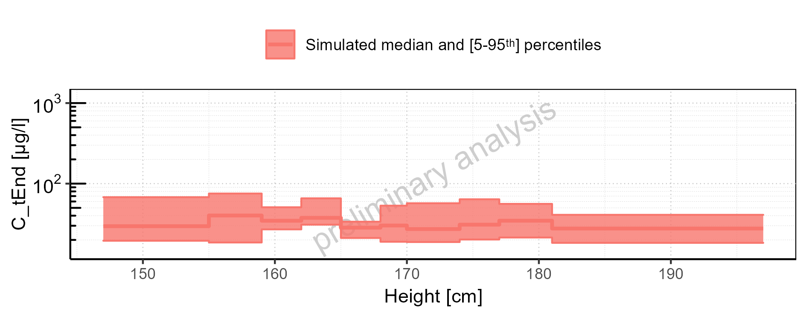

Figure 2-92: Height-dependence of C_tEnd for Filmcoated_tablet_400mg_sd. Profiles are plotted in a linear scale.

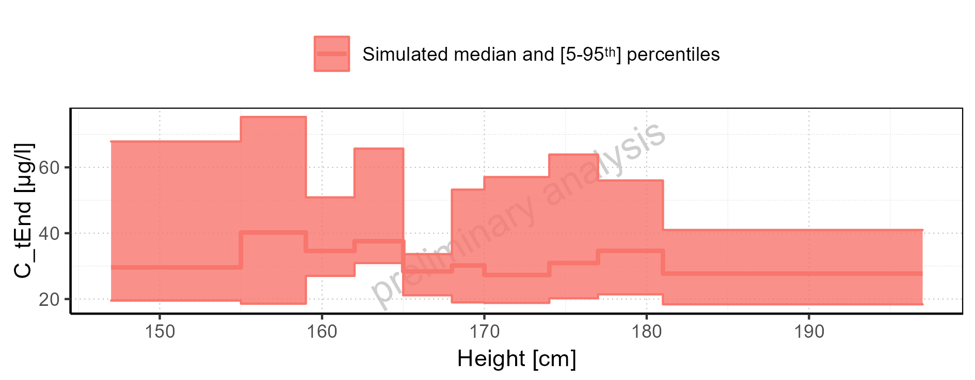

Figure 2-93: Weight-dependence of C_tEnd for Larson 2013 8y-18y 400mg FCT meal in comparison to Filmcoated_tablet_400mg_sd. Profiles are plotted in a logarithmic scale.

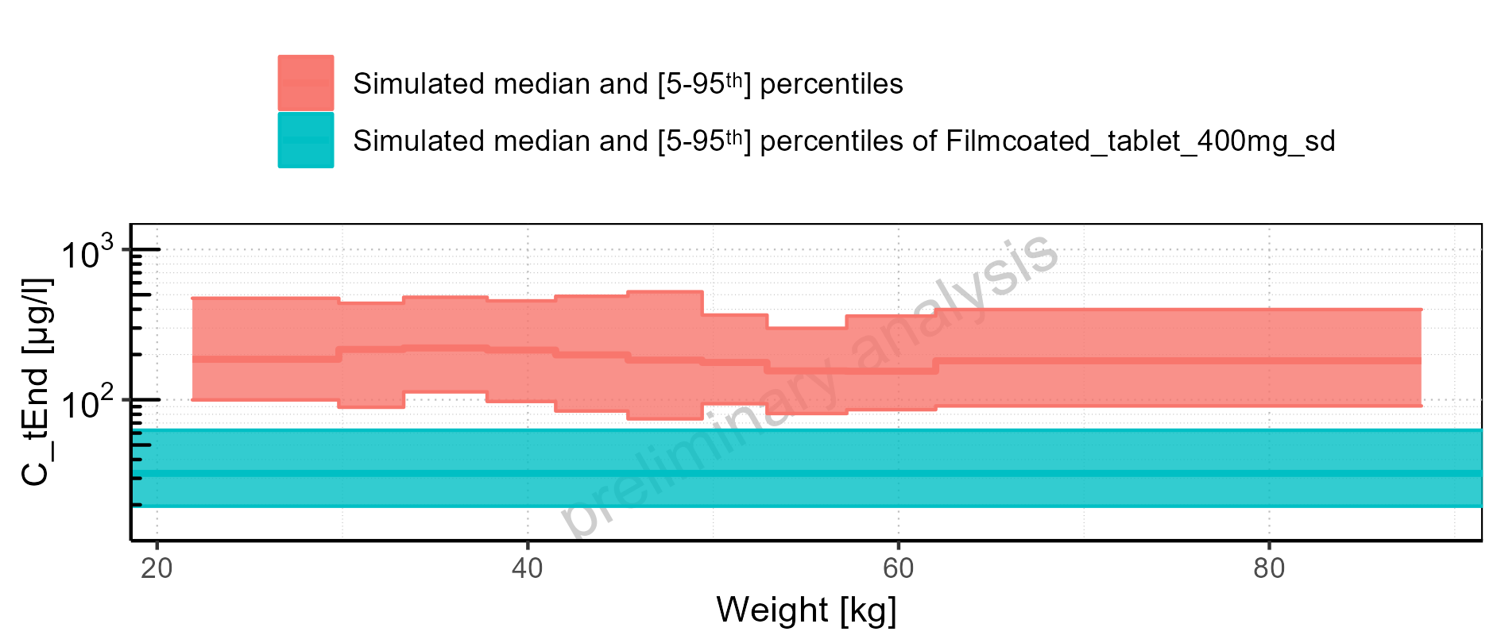

Figure 2-94: Weight-dependence of C_tEnd for Larson 2013 8y-18y 400mg FCT meal in comparison to Filmcoated_tablet_400mg_sd. Profiles are plotted in a linear scale.

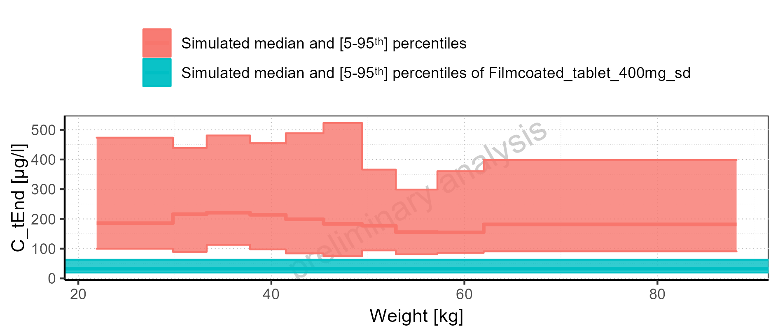

Figure 2-95: Weight-dependence of C_tEnd for Larson 2013 8y-18y 400mg FCT meal. Profiles are plotted in a logarithmic scale.

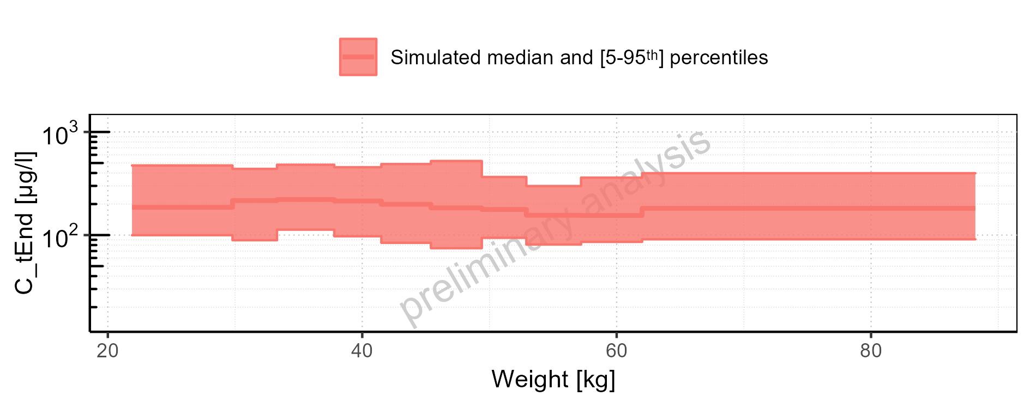

Figure 2-96: Weight-dependence of C_tEnd for Larson 2013 8y-18y 400mg FCT meal. Profiles are plotted in a linear scale.

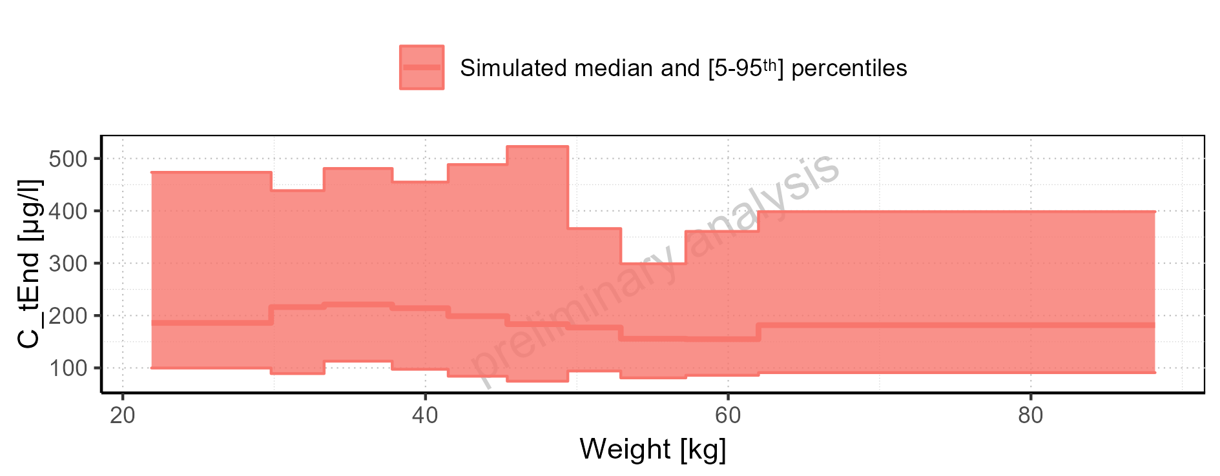

Figure 2-97: Weight-dependence of C_tEnd for Filmcoated_tablet_400mg_sd. Profiles are plotted in a logarithmic scale.

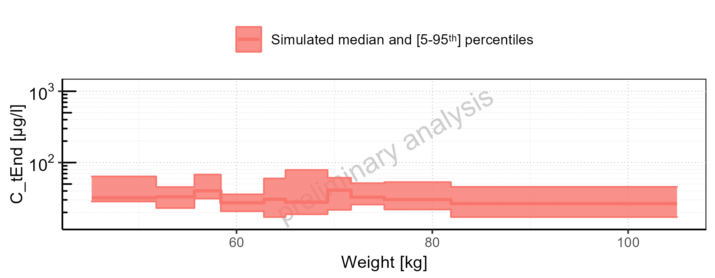

Figure 2-98: Weight-dependence of C_tEnd for Filmcoated_tablet_400mg_sd. Profiles are plotted in a linear scale.

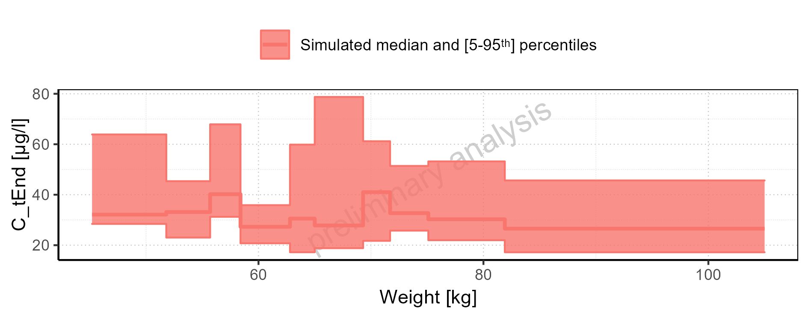

Figure 2-99: BMI-dependence of C_tEnd for Larson 2013 8y-18y 400mg FCT meal in comparison to Filmcoated_tablet_400mg_sd. Profiles are plotted in a logarithmic scale.

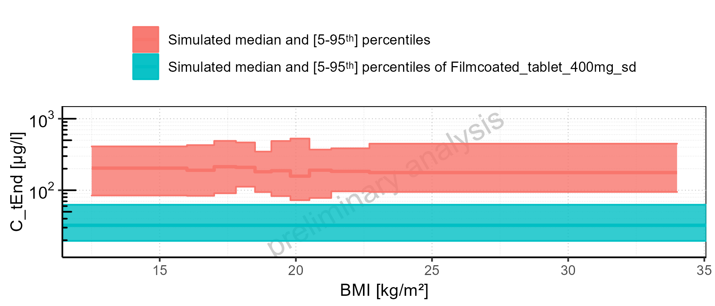

Figure 2-100: BMI-dependence of C_tEnd for Larson 2013 8y-18y 400mg FCT meal in comparison to Filmcoated_tablet_400mg_sd. Profiles are plotted in a linear scale.

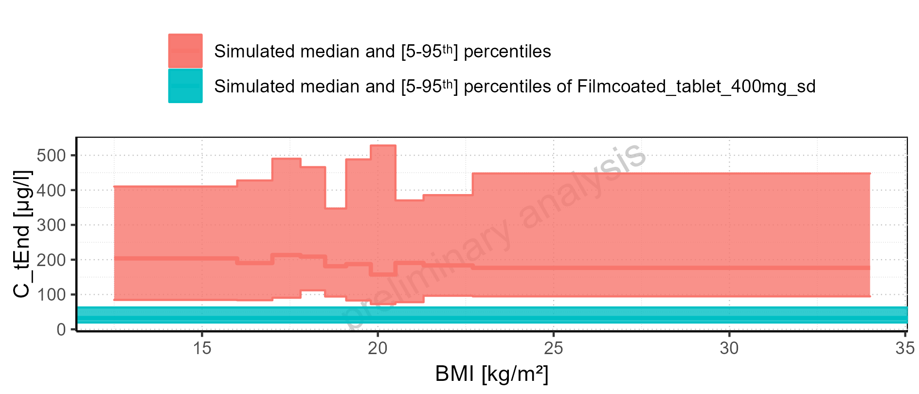

Figure 2-101: BMI-dependence of C_tEnd for Larson 2013 8y-18y 400mg FCT meal. Profiles are plotted in a logarithmic scale.

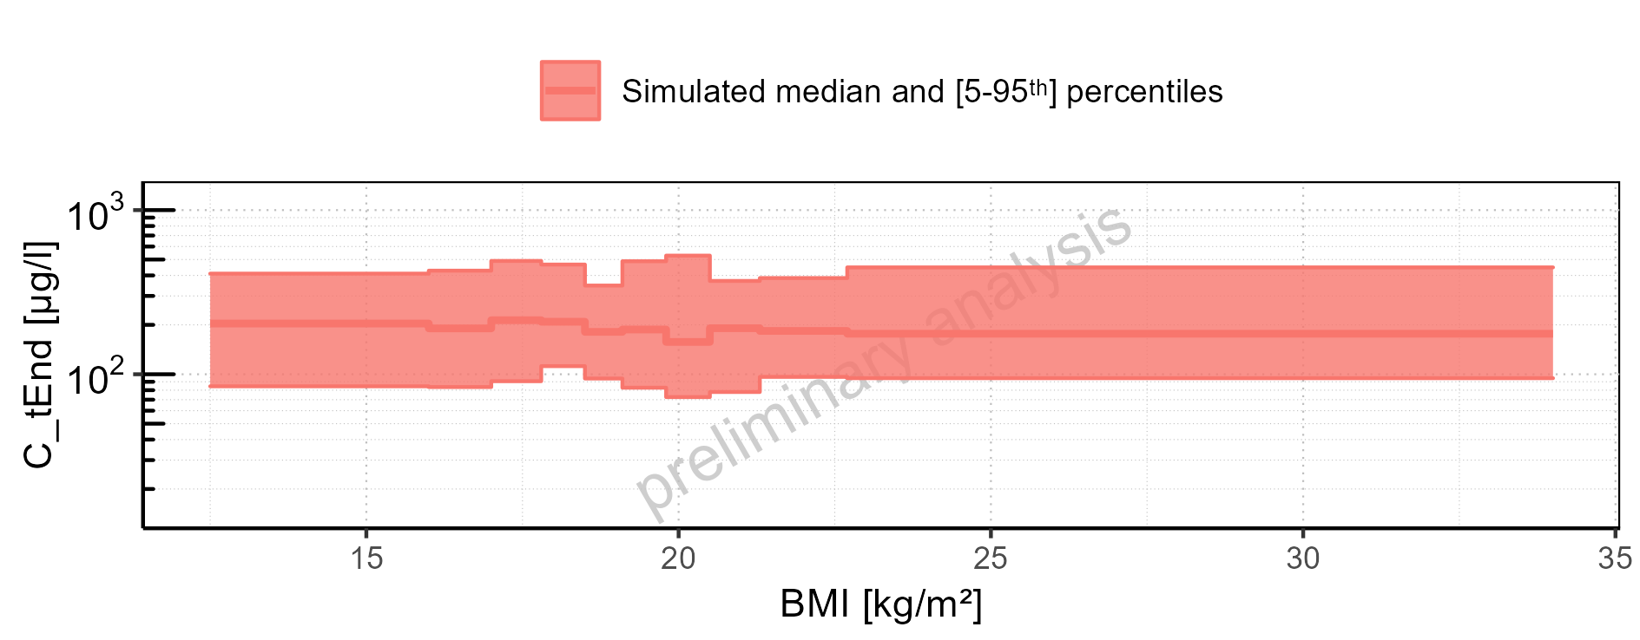

Figure 2-102: BMI-dependence of C_tEnd for Larson 2013 8y-18y 400mg FCT meal. Profiles are plotted in a linear scale.

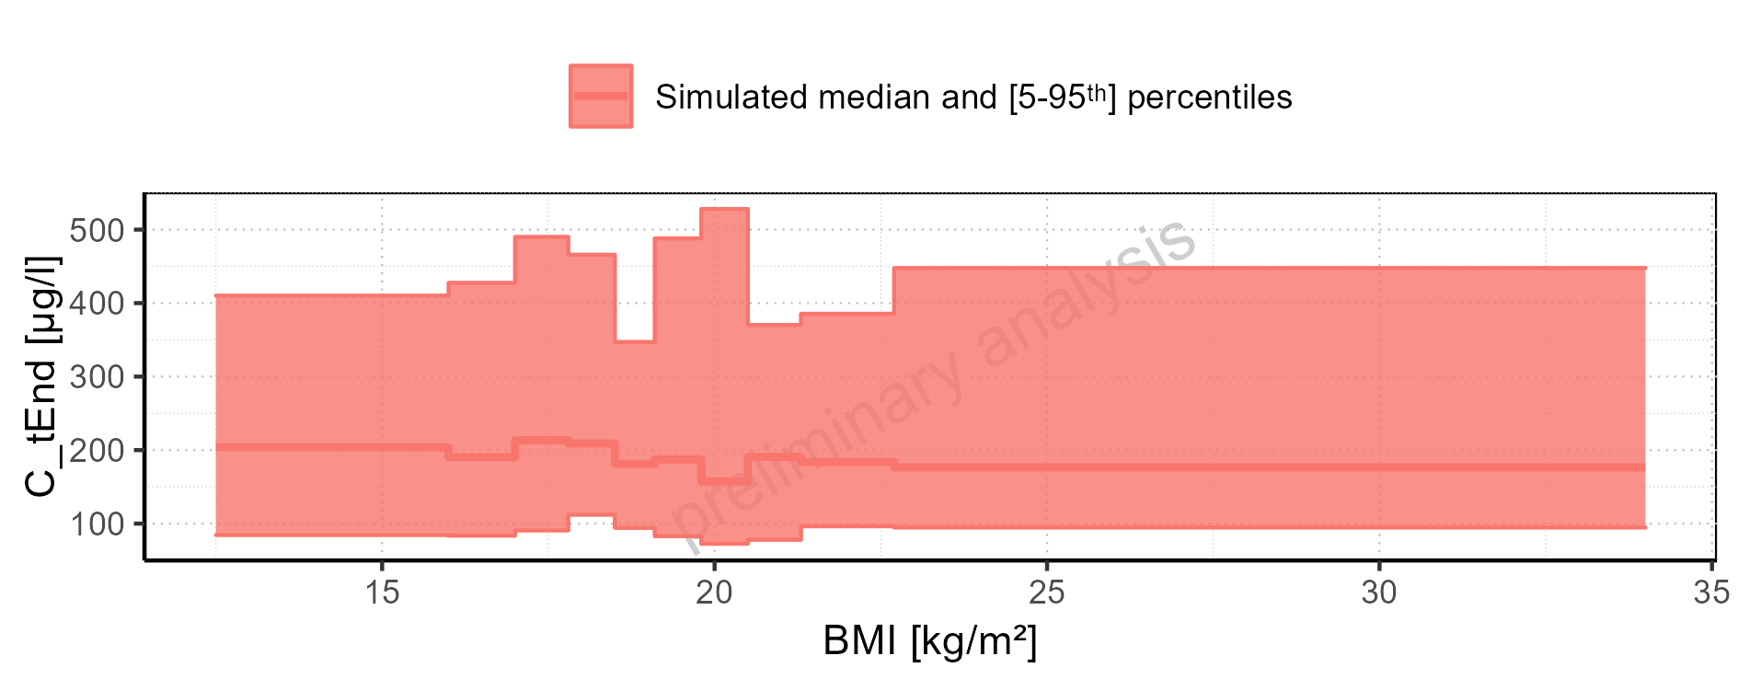

Figure 2-103: BMI-dependence of C_tEnd for Filmcoated_tablet_400mg_sd. Profiles are plotted in a logarithmic scale.

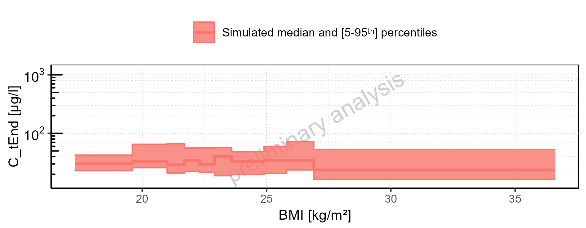

Figure 2-104: BMI-dependence of C_tEnd for Filmcoated_tablet_400mg_sd. Profiles are plotted in a linear scale.

### AUC

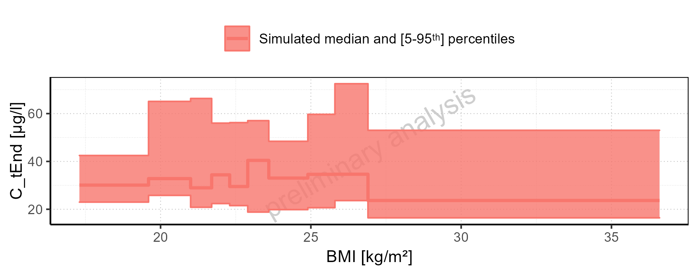

Figure 2-105: AUC of Raltegravir for Larson 2013 8y-18y 400mg FCT meal, Filmcoated_tablet_400mg_sd shown as box-whisker plot, which indicates the 5<U+1D57><U+02B0>, 25<U+1D57><U+02B0>, 50<U+1D57><U+02B0>, 75<U+1D57><U+02B0>, 95<U+1D57><U+02B0> percentiles in logarithmic scale.

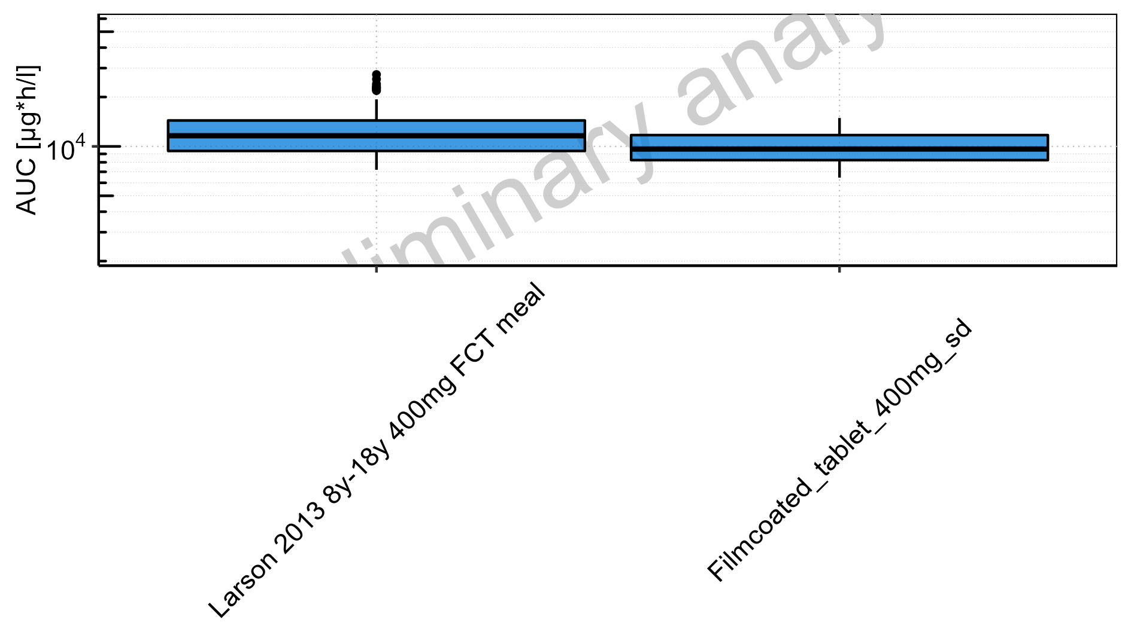

Figure 2-106: AUC of Raltegravir for Larson 2013 8y-18y 400mg FCT meal, Filmcoated_tablet_400mg_sd shown as box-whisker plot, which indicates the 5<U+1D57><U+02B0>, 25<U+1D57><U+02B0>, 50<U+1D57><U+02B0>, 75<U+1D57><U+02B0>, 95<U+1D57><U+02B0> percentiles in linear scale.

**Table 2-5: AUC of Raltegravir for Larson 2013 8y-18y 400mg FCT meal, Filmcoated_tablet_400mg_sd reported in [µg*h/l]**

|  |  |  |  |  |  |  |  |  |  |  |
| --- | --- | --- | --- | --- | --- | --- | --- | --- | --- | --- |
| Population | N | 5<U+1D57><U+02B0> pctl | 25<U+1D57><U+02B0> pctl | 50<U+1D57><U+02B0> pctl | 75<U+1D57><U+02B0> pctl | 95<U+1D57><U+02B0> pctl | Mean | SD | Geo Mean | Geo SD |
| Larson 2013 8y-18y 400mg FCT meal | 500 | 7207.27 | 9378.92 | 11615.20 | 14388.94 | 19343.22 | 12199.86 | 3756.55 | 11656.08 | 1.35 |
| Filmcoated_tablet_400mg_sd | 100 | 6449.27 | 8248.74 | 9637.50 | 11717.00 | 14901.10 | 10129.70 | 2672.29 | 9784.56 | 1.31 |

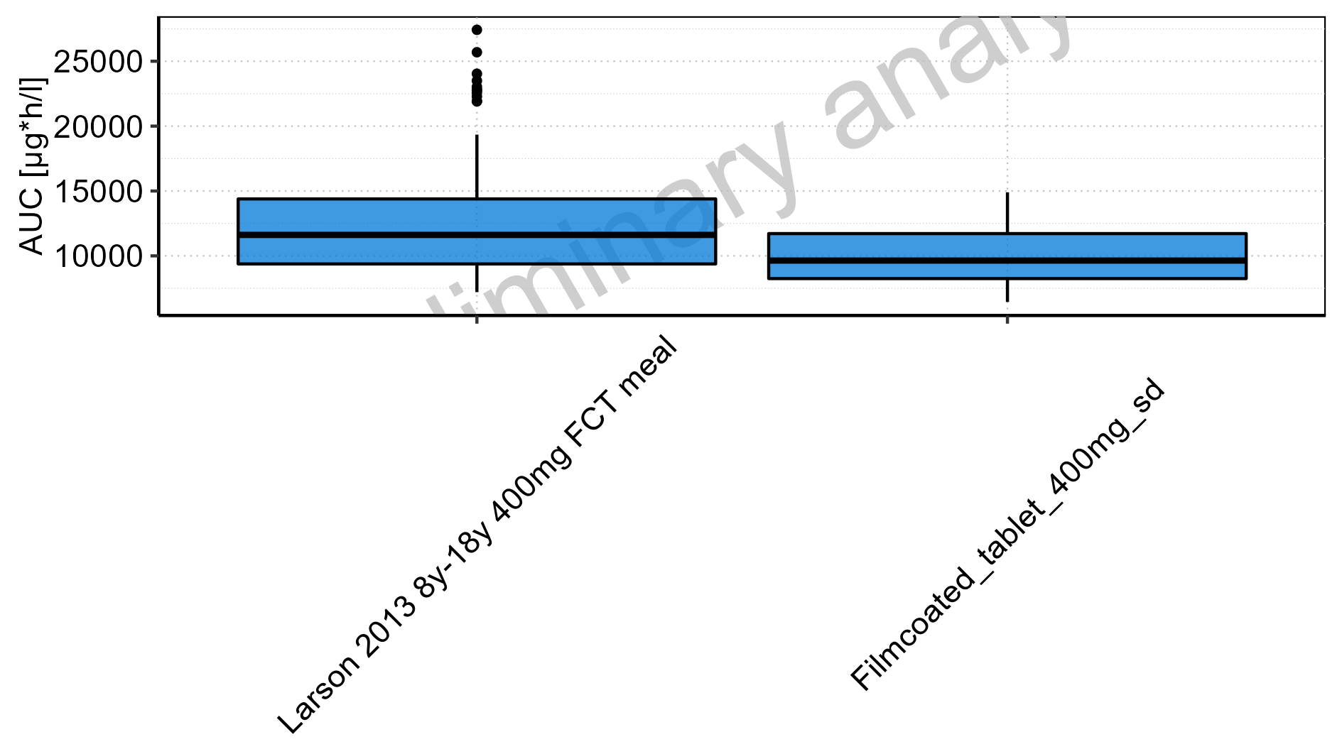

Figure 2-107: Age-dependence of AUC for Larson 2013 8y-18y 400mg FCT meal in comparison to Filmcoated_tablet_400mg_sd. Profiles are plotted in a logarithmic scale.

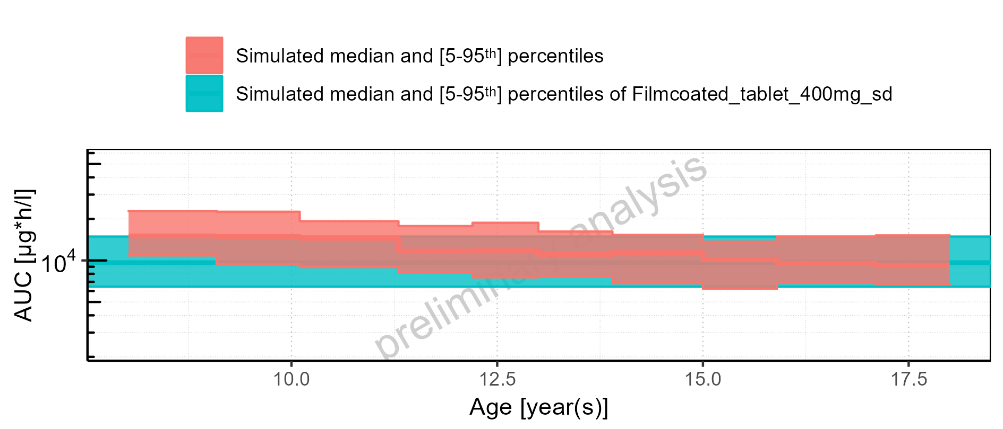

Figure 2-108: Age-dependence of AUC for Larson 2013 8y-18y 400mg FCT meal in comparison to Filmcoated_tablet_400mg_sd. Profiles are plotted in a linear scale.

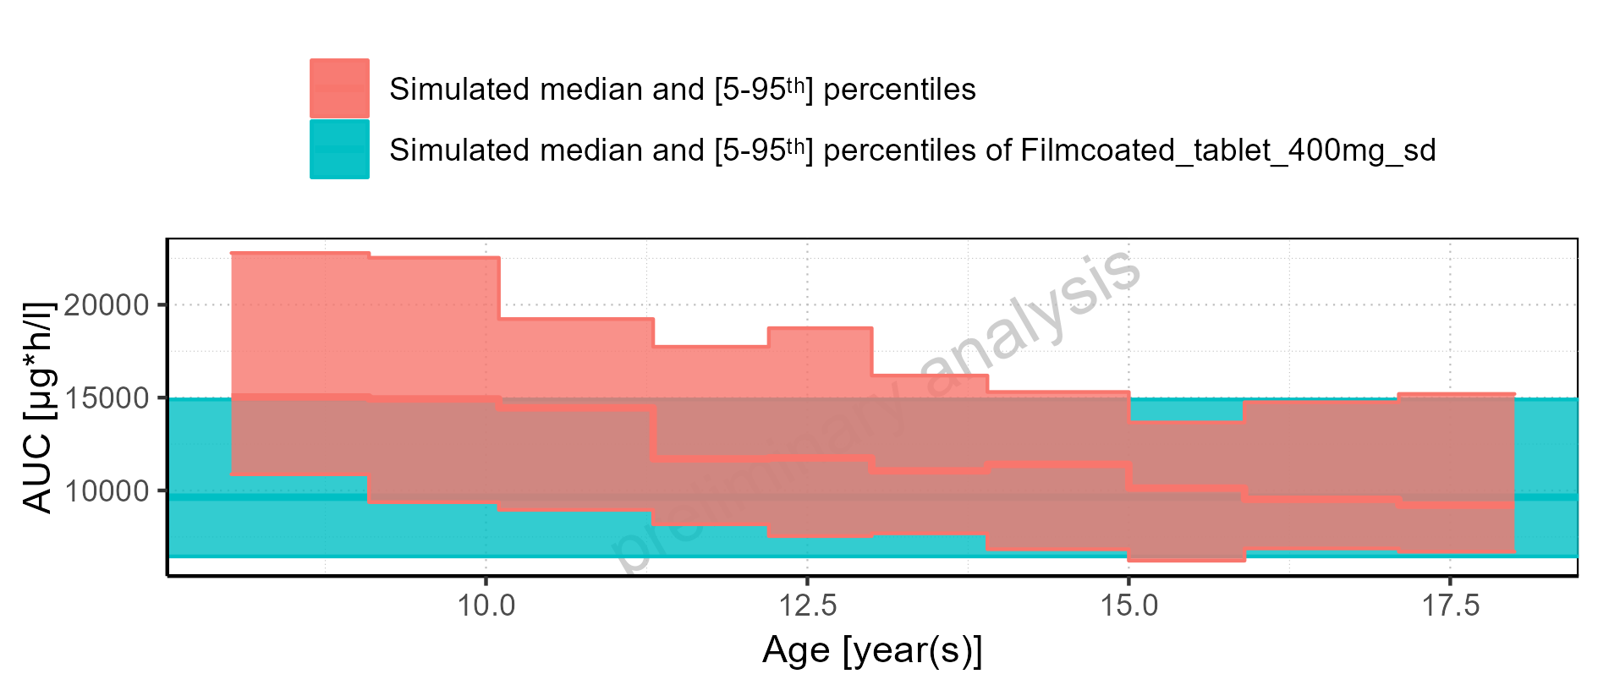

Figure 2-109: Age-dependence of AUC for Larson 2013 8y-18y 400mg FCT meal. Profiles are plotted in a logarithmic scale.

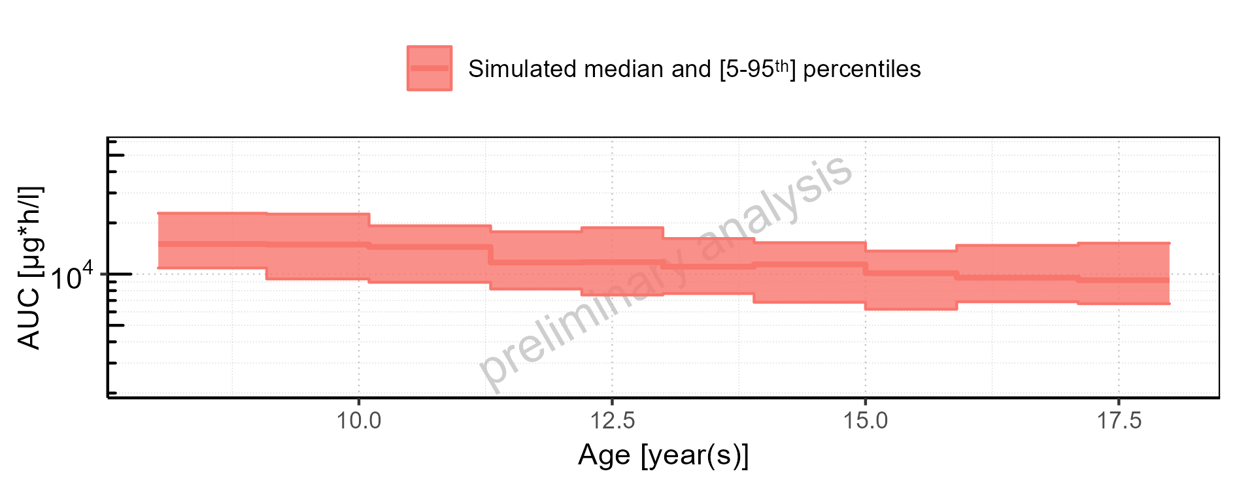

Figure 2-110: Age-dependence of AUC for Larson 2013 8y-18y 400mg FCT meal. Profiles are plotted in a linear scale.

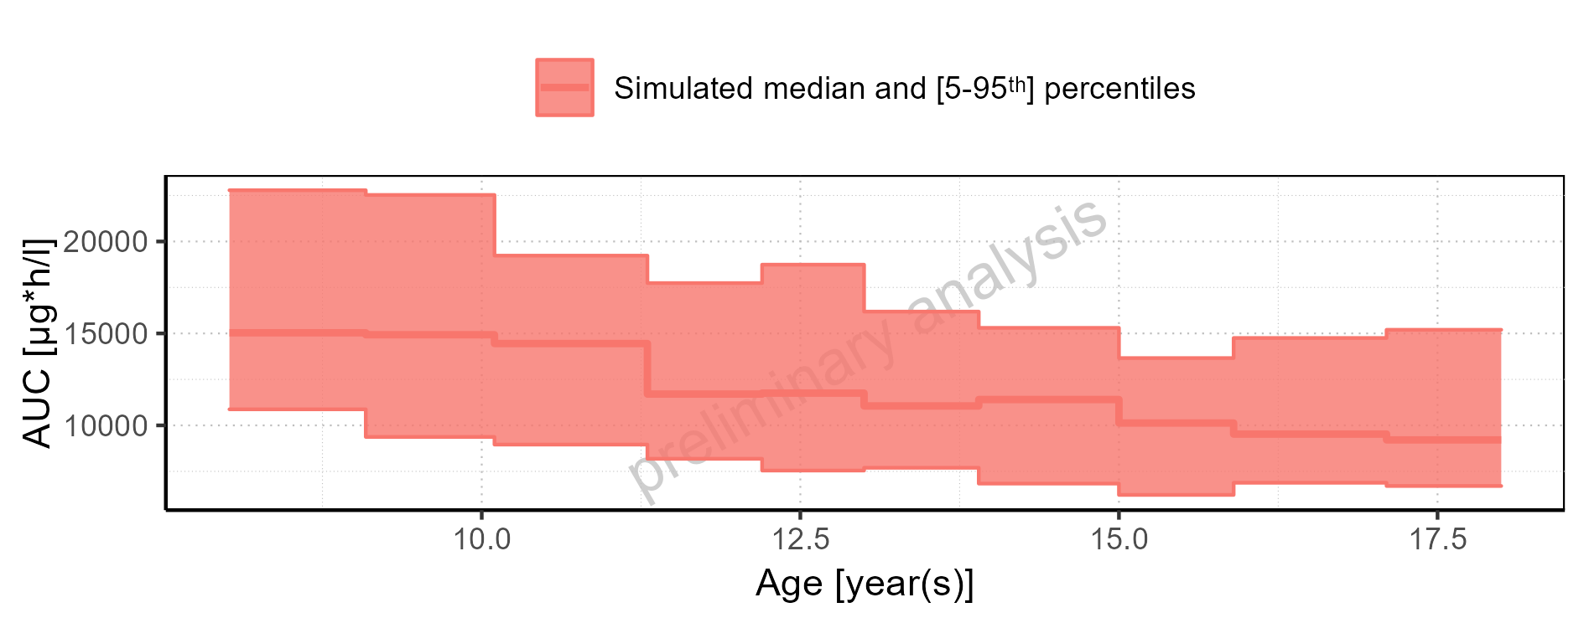

Figure 2-111: Age-dependence of AUC for Filmcoated_tablet_400mg_sd. Profiles are plotted in a logarithmic scale.

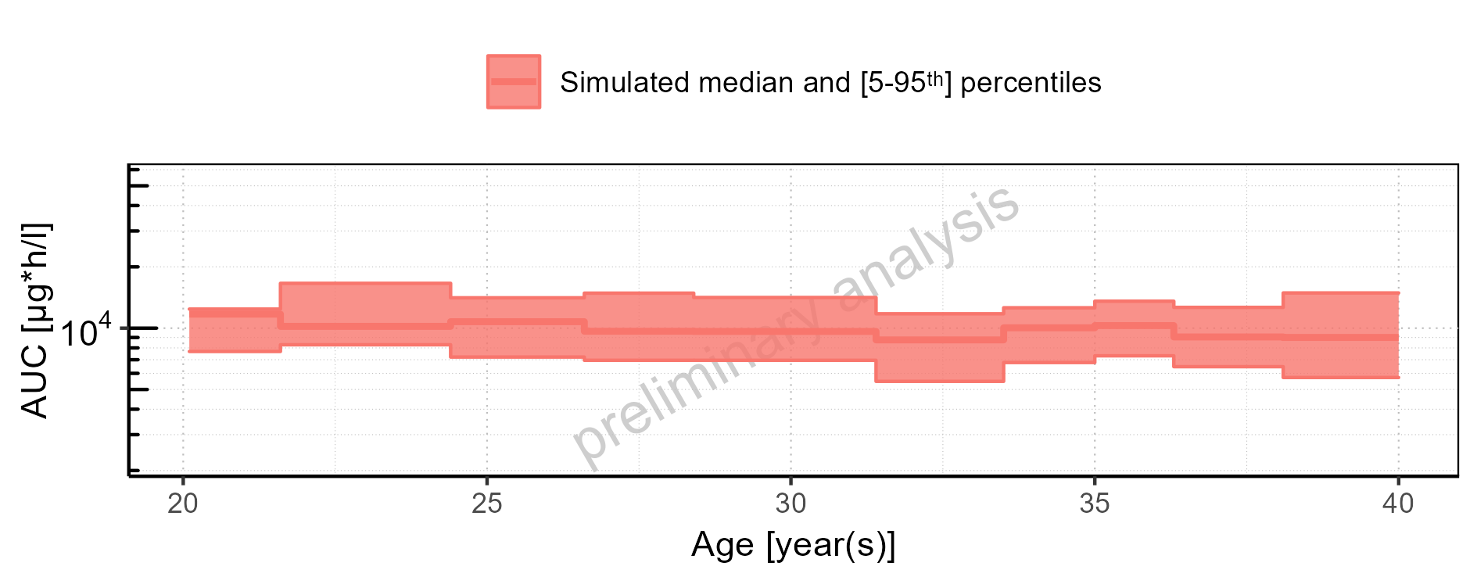

Figure 2-112: Age-dependence of AUC for Filmcoated_tablet_400mg_sd. Profiles are plotted in a linear scale.

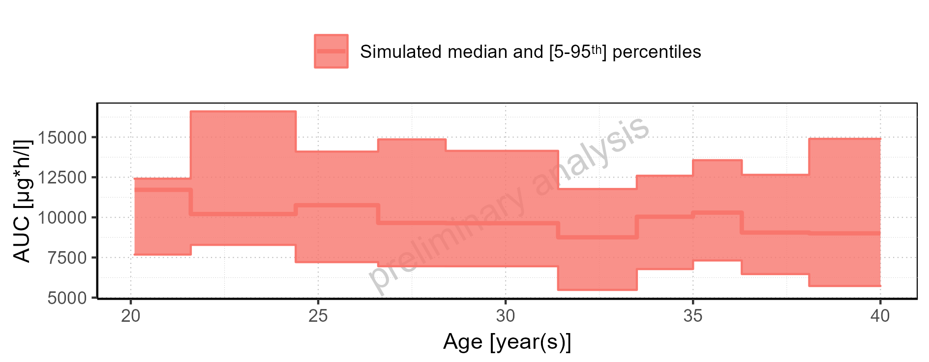

Figure 2-113: Height-dependence of AUC for Larson 2013 8y-18y 400mg FCT meal in comparison to Filmcoated_tablet_400mg_sd. Profiles are plotted in a logarithmic scale.

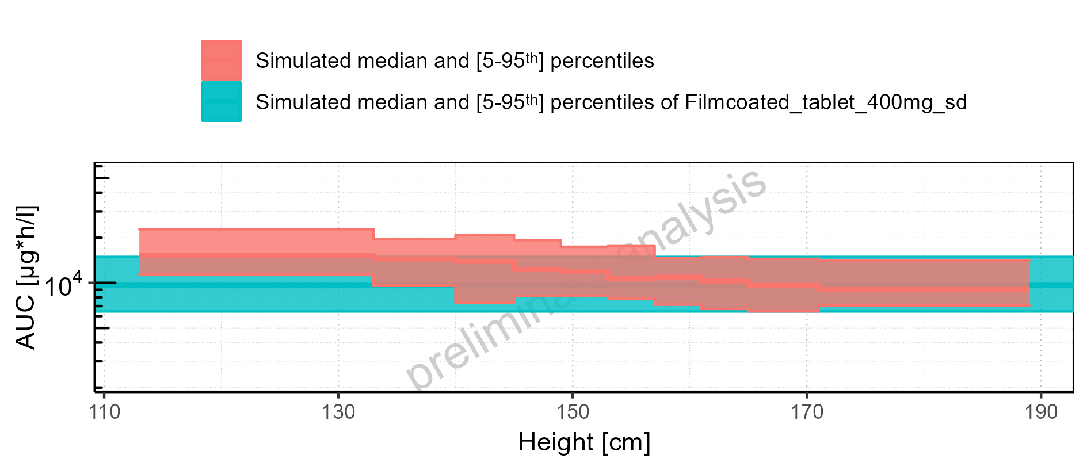

Figure 2-114: Height-dependence of AUC for Larson 2013 8y-18y 400mg FCT meal in comparison to Filmcoated_tablet_400mg_sd. Profiles are plotted in a linear scale.

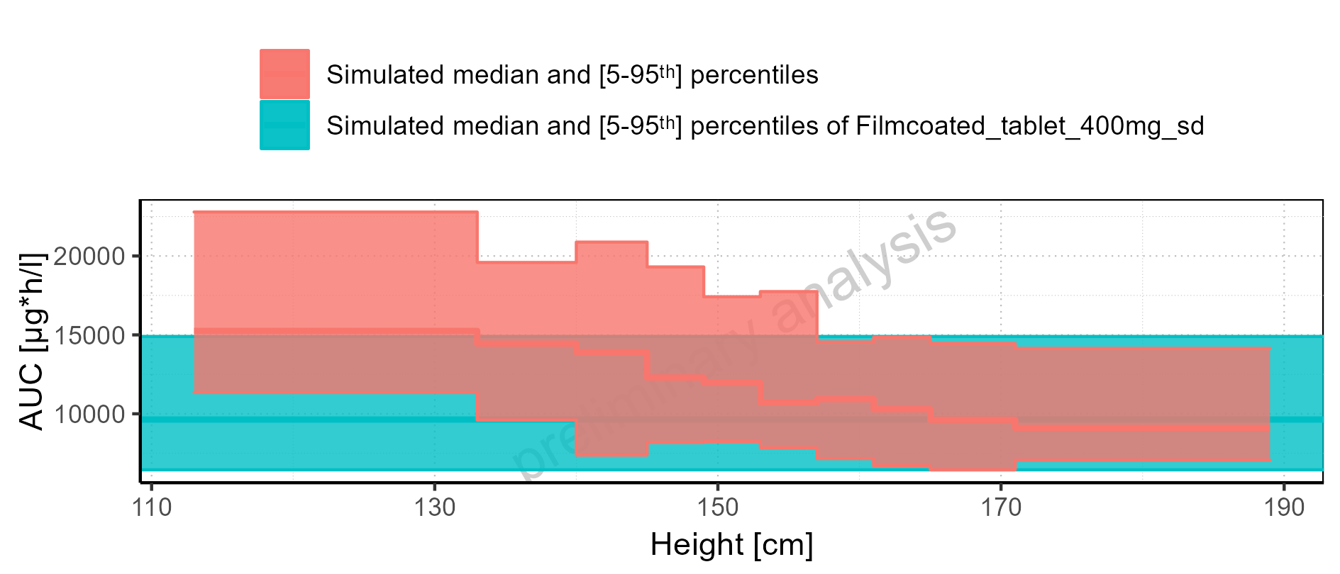

Figure 2-115: Height-dependence of AUC for Larson 2013 8y-18y 400mg FCT meal. Profiles are plotted in a logarithmic scale.

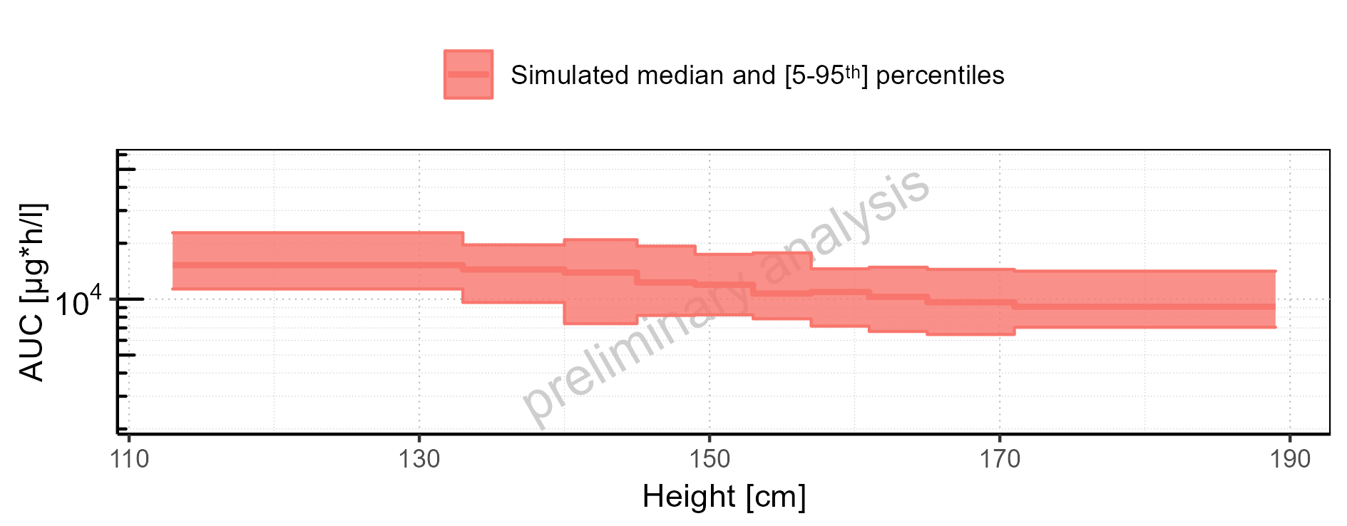

Figure 2-116: Height-dependence of AUC for Larson 2013 8y-18y 400mg FCT meal. Profiles are plotted in a linear scale.

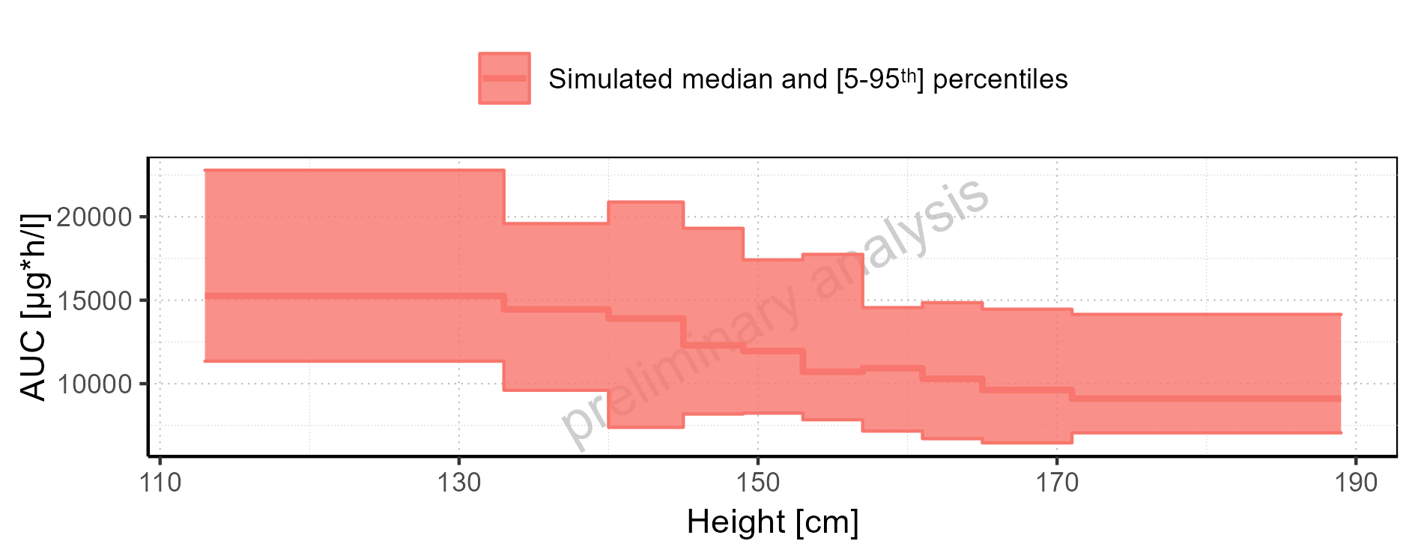

Figure 2-117: Height-dependence of AUC for Filmcoated_tablet_400mg_sd. Profiles are plotted in a logarithmic scale.

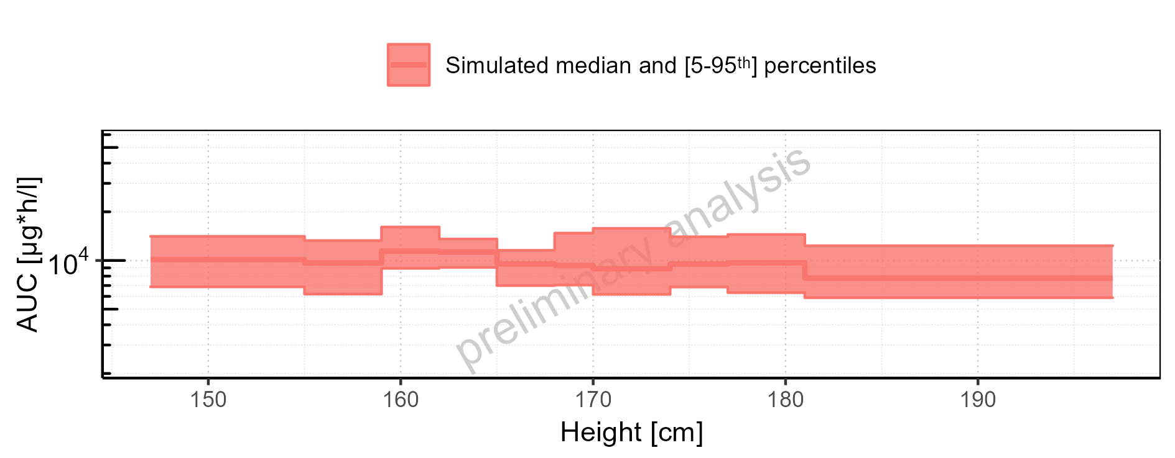

Figure 2-118: Height-dependence of AUC for Filmcoated_tablet_400mg_sd. Profiles are plotted in a linear scale.

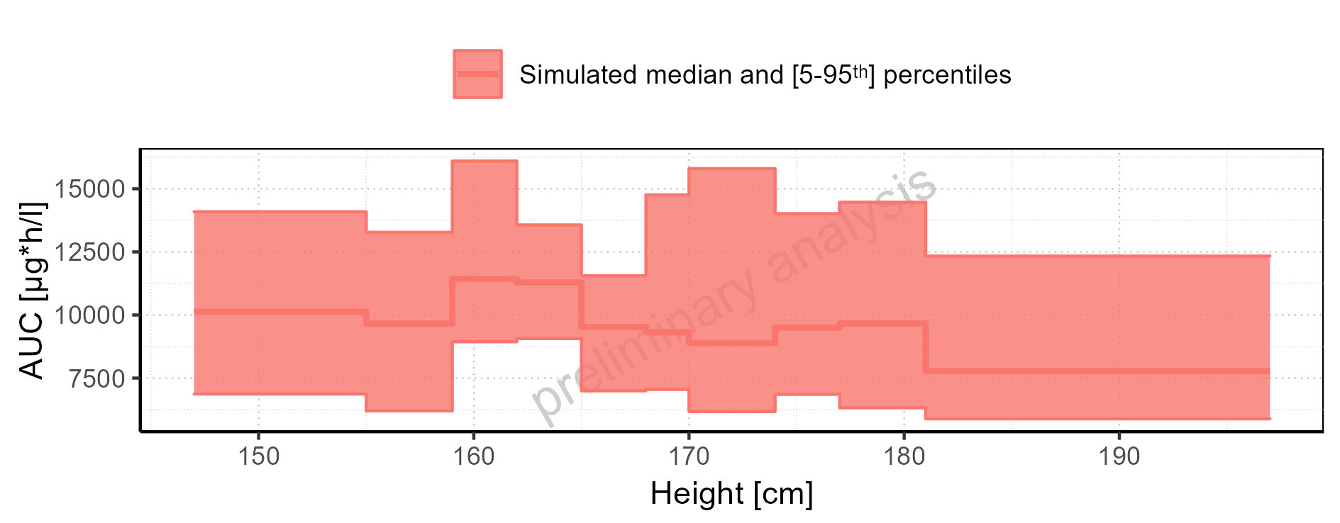

Figure 2-119: Weight-dependence of AUC for Larson 2013 8y-18y 400mg FCT meal in comparison to Filmcoated_tablet_400mg_sd. Profiles are plotted in a logarithmic scale.

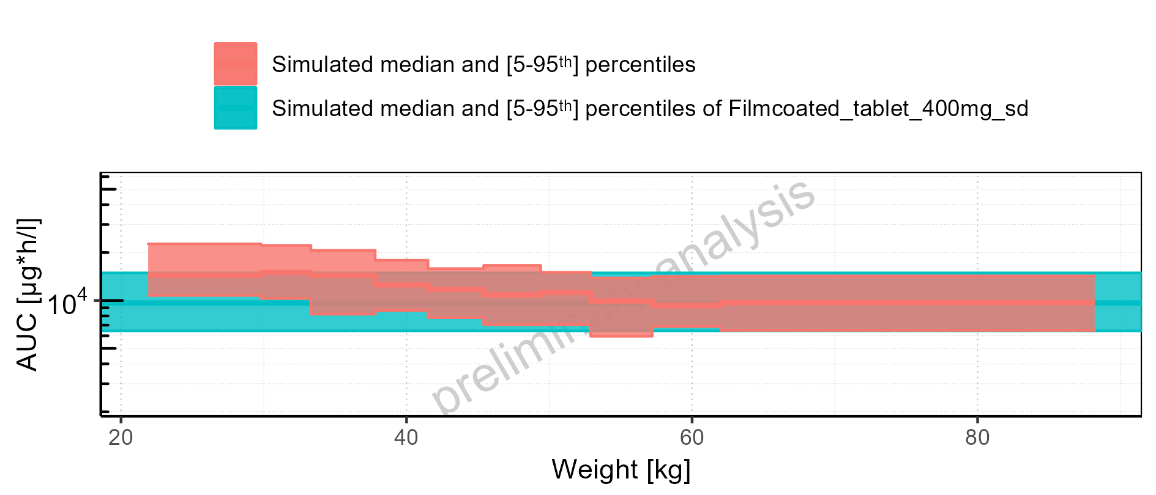

Figure 2-120: Weight-dependence of AUC for Larson 2013 8y-18y 400mg FCT meal in comparison to Filmcoated_tablet_400mg_sd. Profiles are plotted in a linear scale.

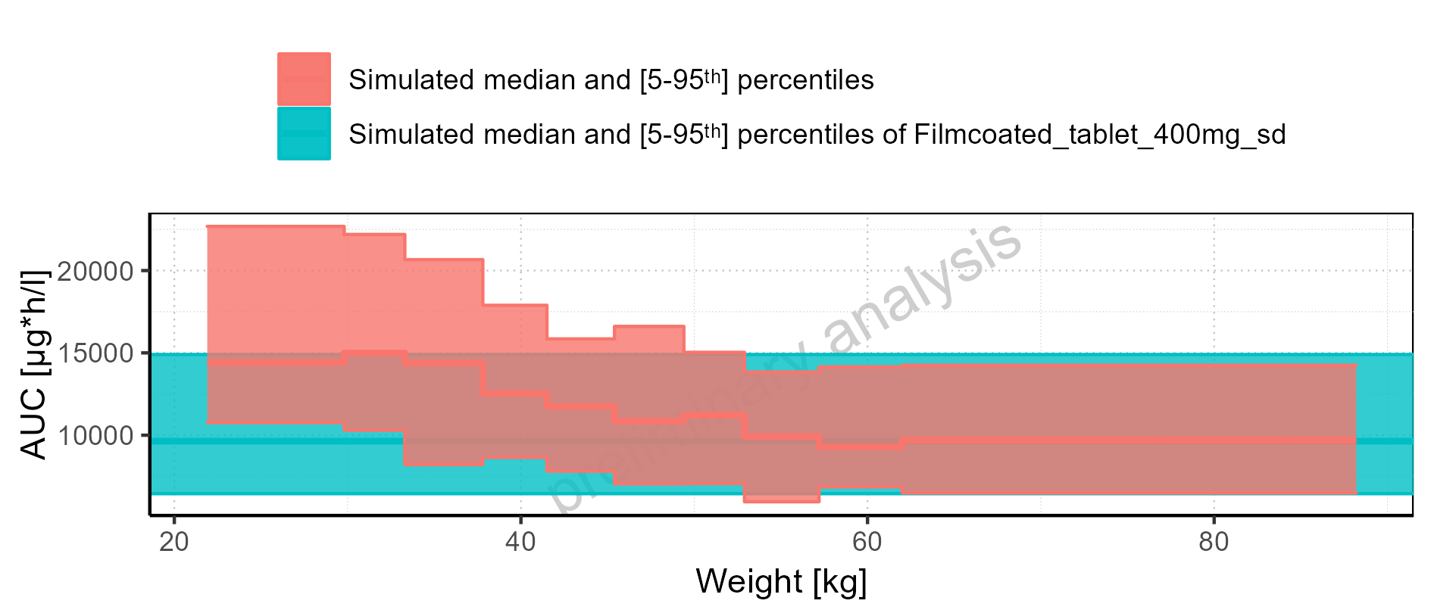

Figure 2-121: Weight-dependence of AUC for Larson 2013 8y-18y 400mg FCT meal. Profiles are plotted in a logarithmic scale.

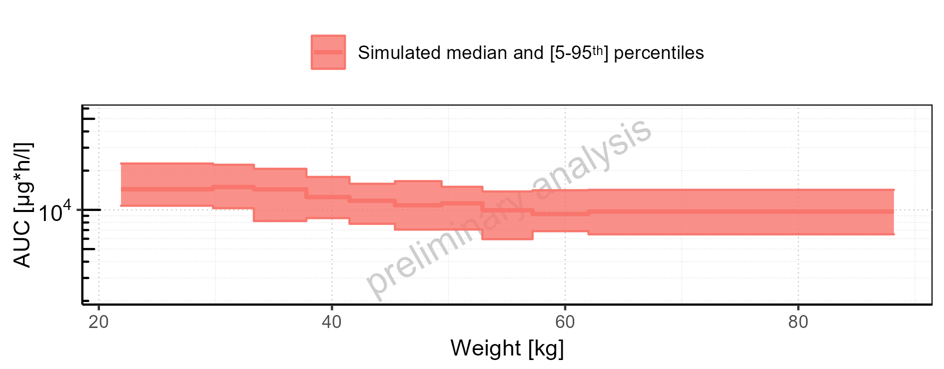

Figure 2-122: Weight-dependence of AUC for Larson 2013 8y-18y 400mg FCT meal. Profiles are plotted in a linear scale.

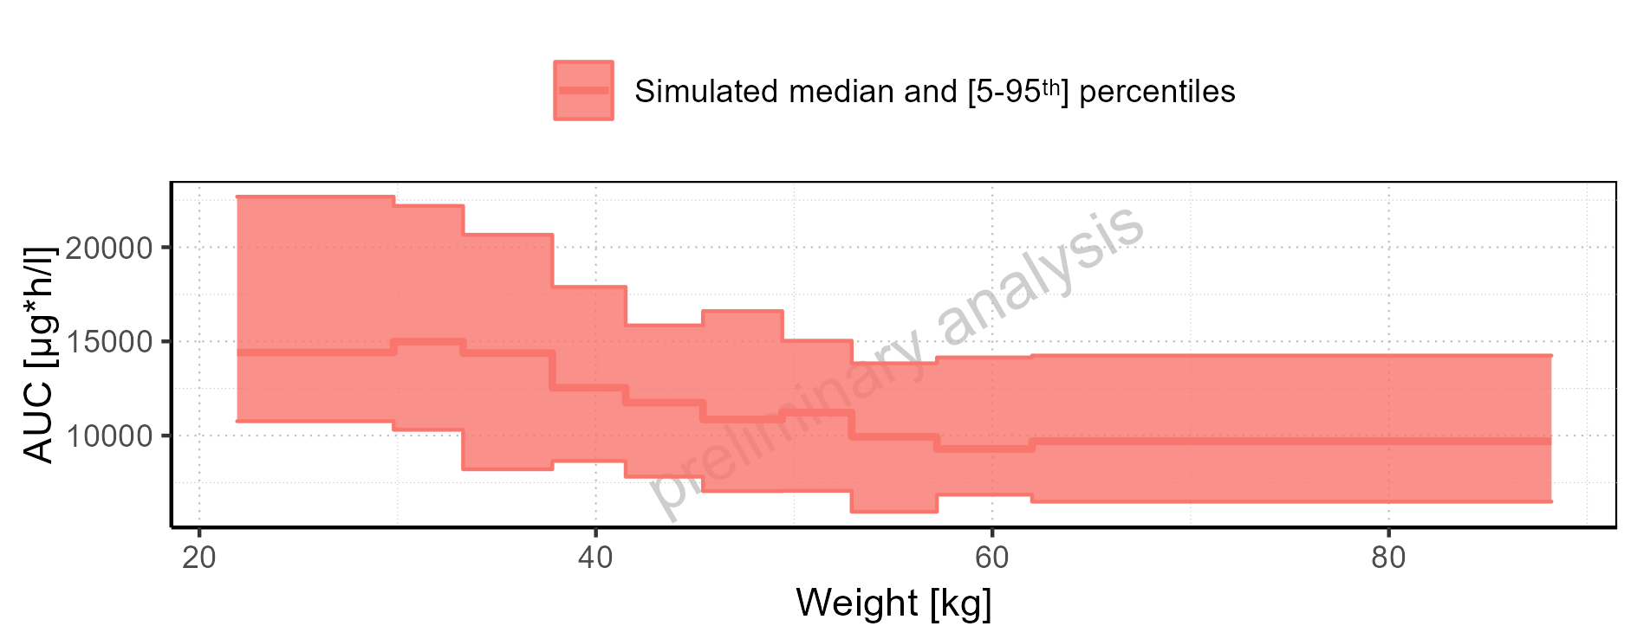

Figure 2-123: Weight-dependence of AUC for Filmcoated_tablet_400mg_sd. Profiles are plotted in a logarithmic scale.

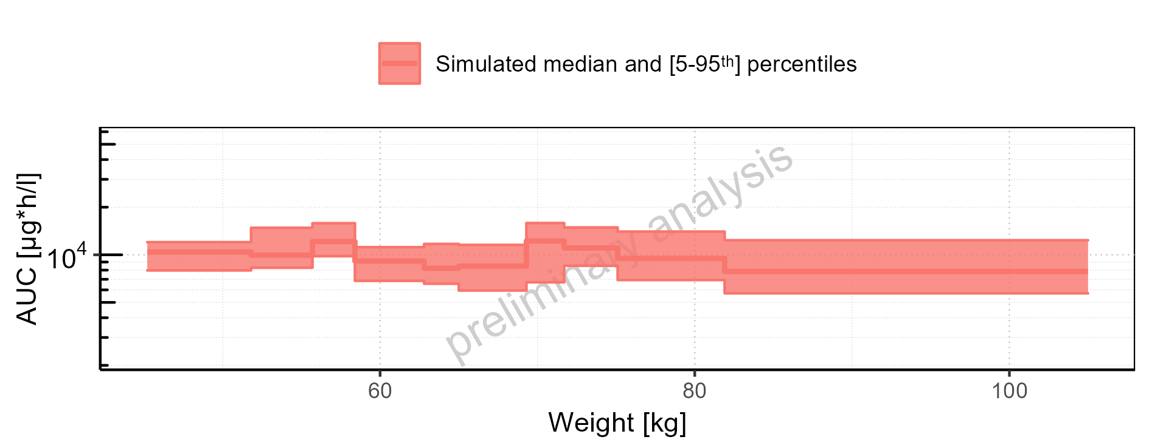

Figure 2-124: Weight-dependence of AUC for Filmcoated_tablet_400mg_sd. Profiles are plotted in a linear scale.

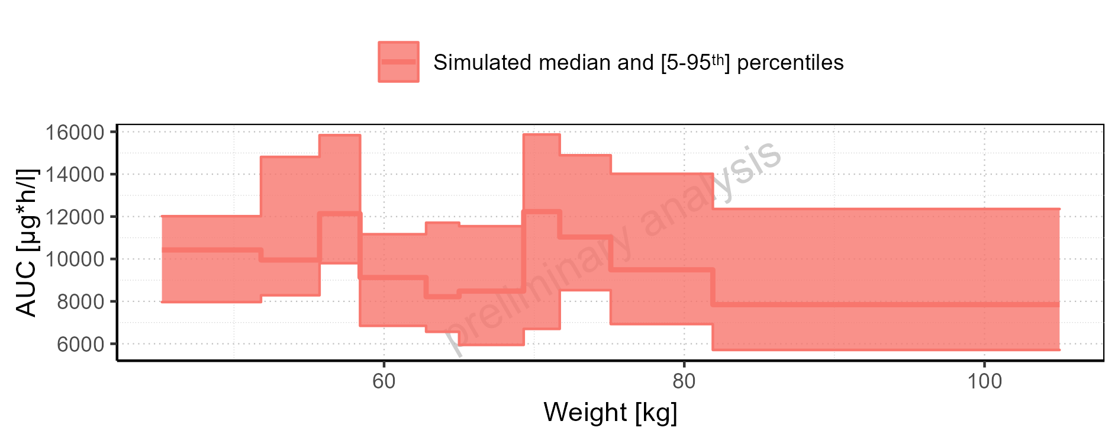

Figure 2-125: BMI-dependence of AUC for Larson 2013 8y-18y 400mg FCT meal in comparison to Filmcoated_tablet_400mg_sd. Profiles are plotted in a logarithmic scale.

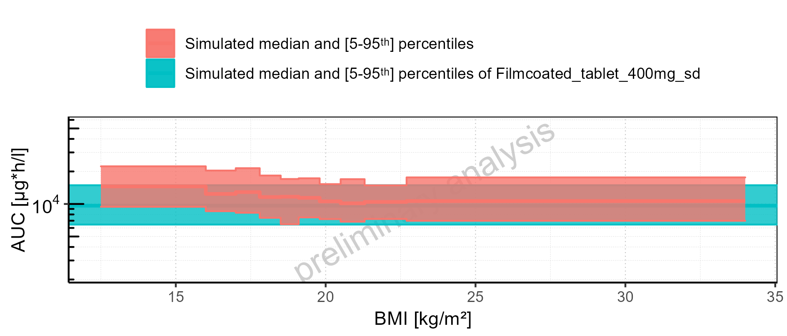

Figure 2-126: BMI-dependence of AUC for Larson 2013 8y-18y 400mg FCT meal in comparison to Filmcoated_tablet_400mg_sd. Profiles are plotted in a linear scale.

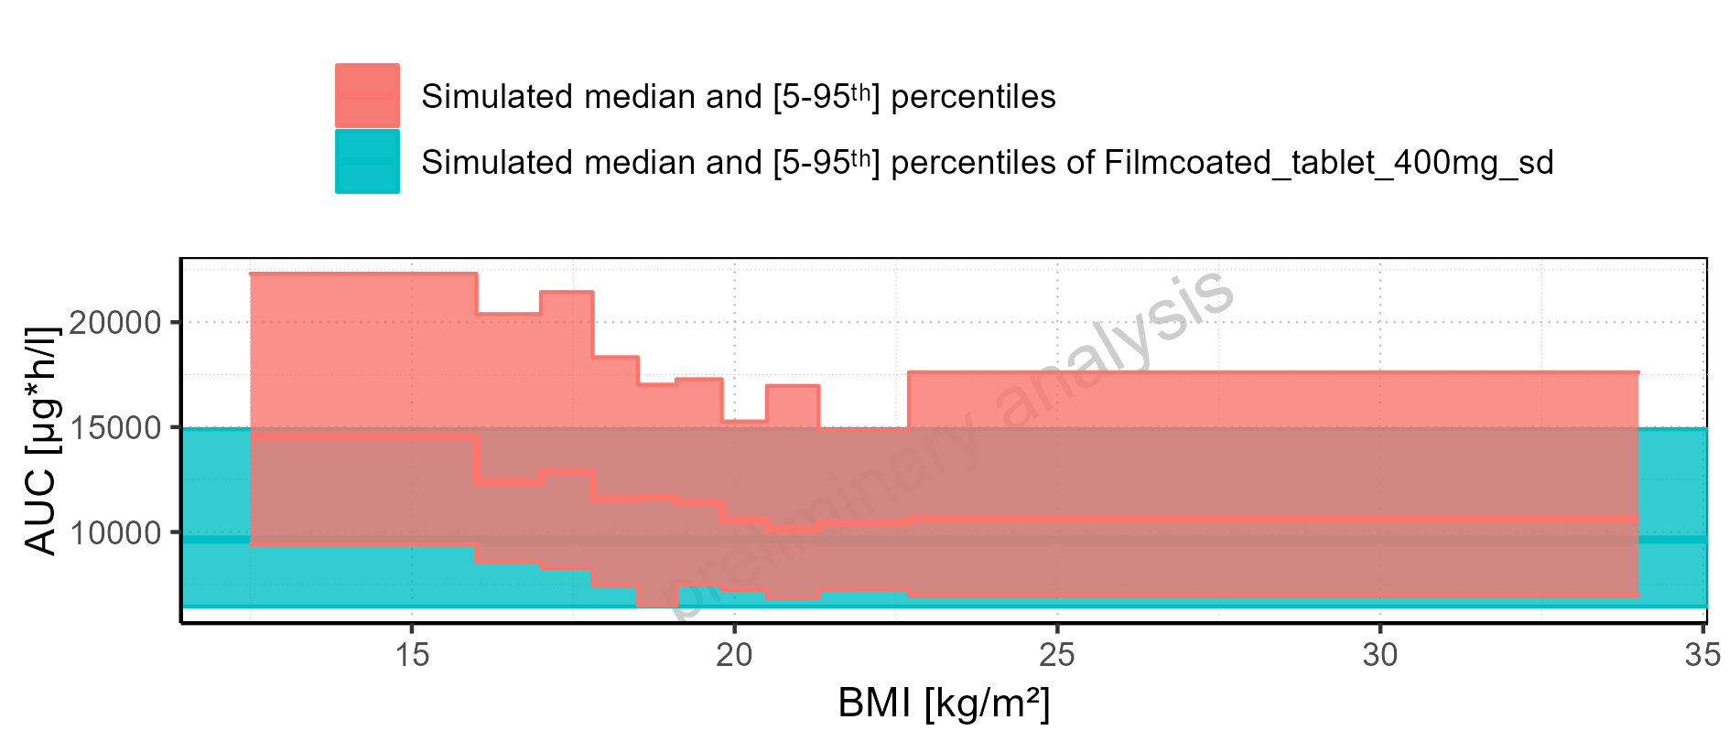

Figure 2-127: BMI-dependence of AUC for Larson 2013 8y-18y 400mg FCT meal. Profiles are plotted in a logarithmic scale.

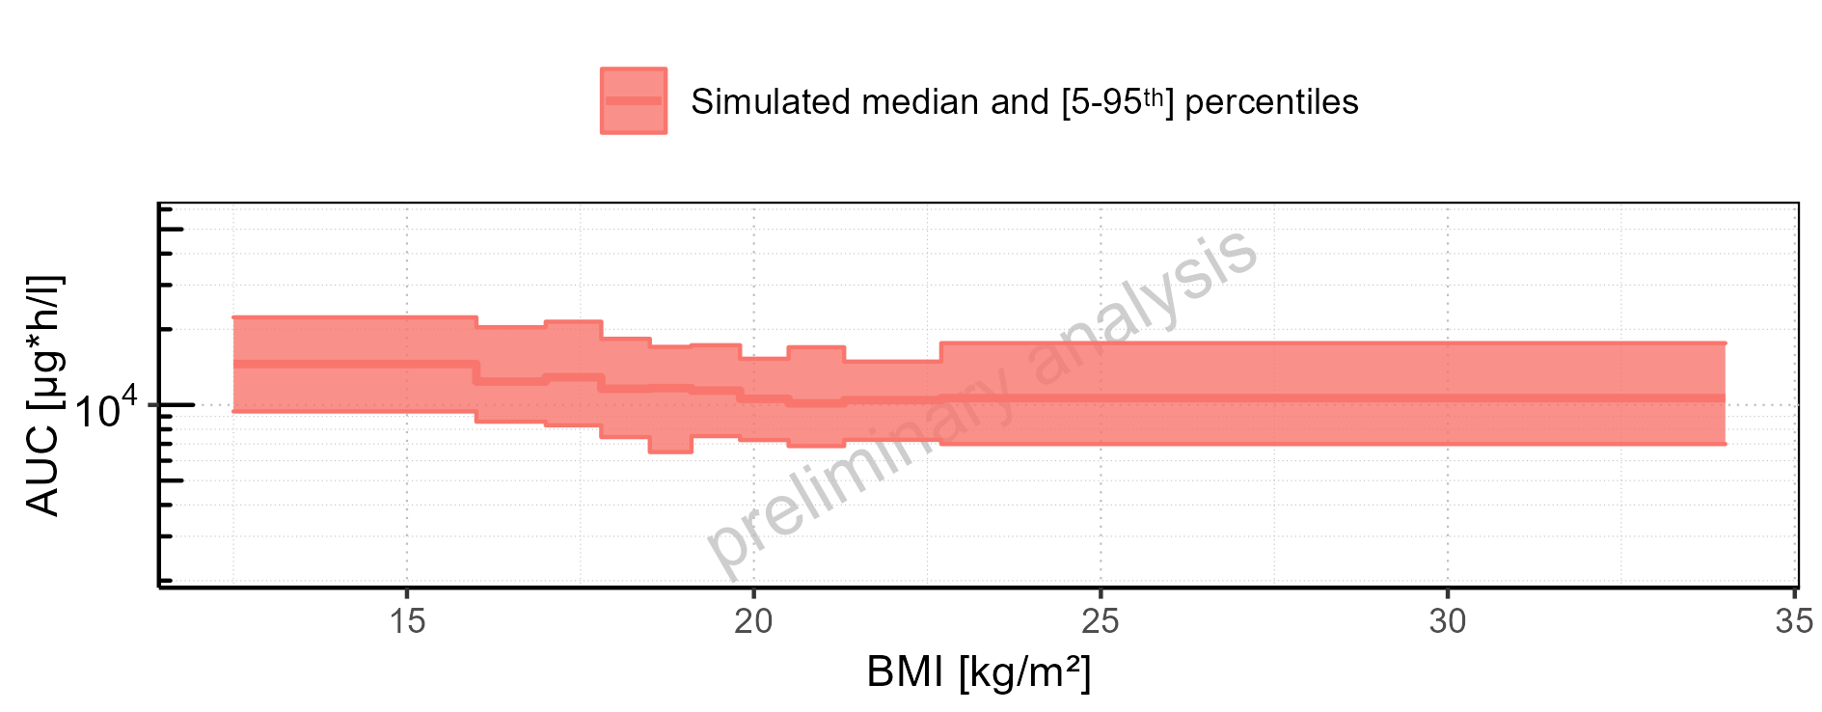

Figure 2-128: BMI-dependence of AUC for Larson 2013 8y-18y 400mg FCT meal. Profiles are plotted in a linear scale.

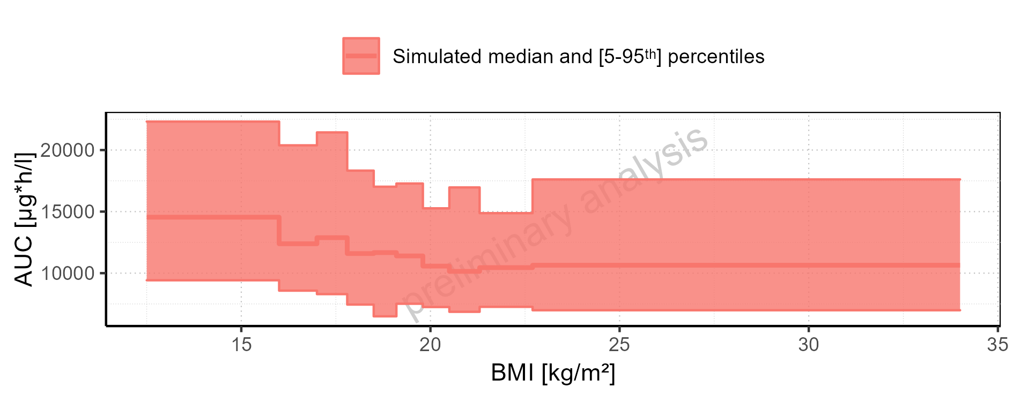

Figure 2-129: BMI-dependence of AUC for Filmcoated_tablet_400mg_sd. Profiles are plotted in a logarithmic scale.

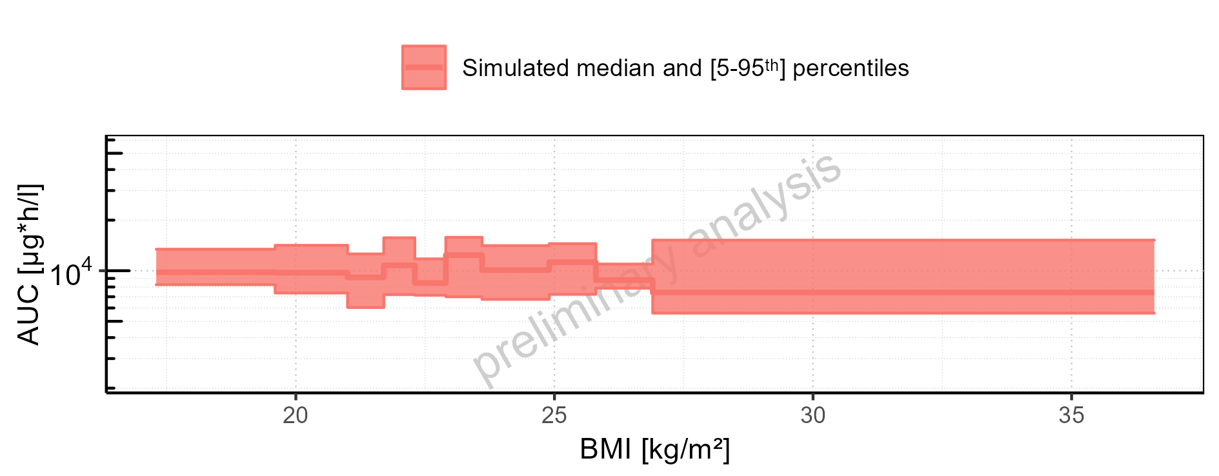

Figure 2-130: BMI-dependence of AUC for Filmcoated_tablet_400mg_sd. Profiles are plotted in a linear scale.

### AUC_norm

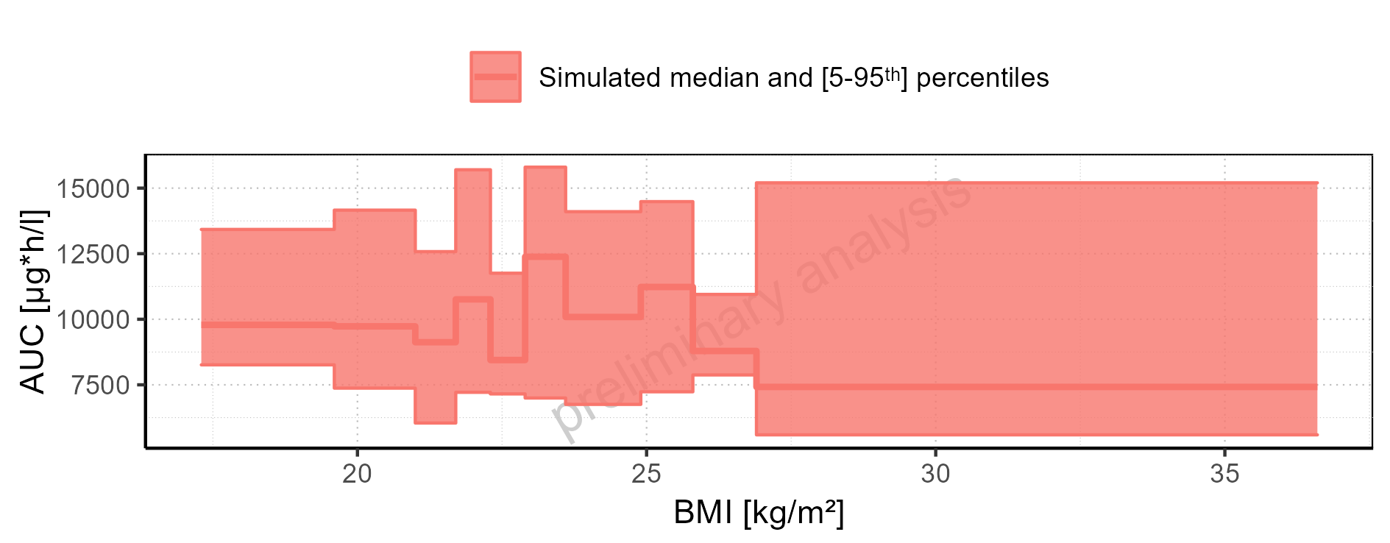

Figure 2-131: AUC_norm of Raltegravir for Larson 2013 8y-18y 400mg FCT meal, Filmcoated_tablet_400mg_sd shown as box-whisker plot, which indicates the 5<U+1D57><U+02B0>, 25<U+1D57><U+02B0>, 50<U+1D57><U+02B0>, 75<U+1D57><U+02B0>, 95<U+1D57><U+02B0> percentiles in logarithmic scale.

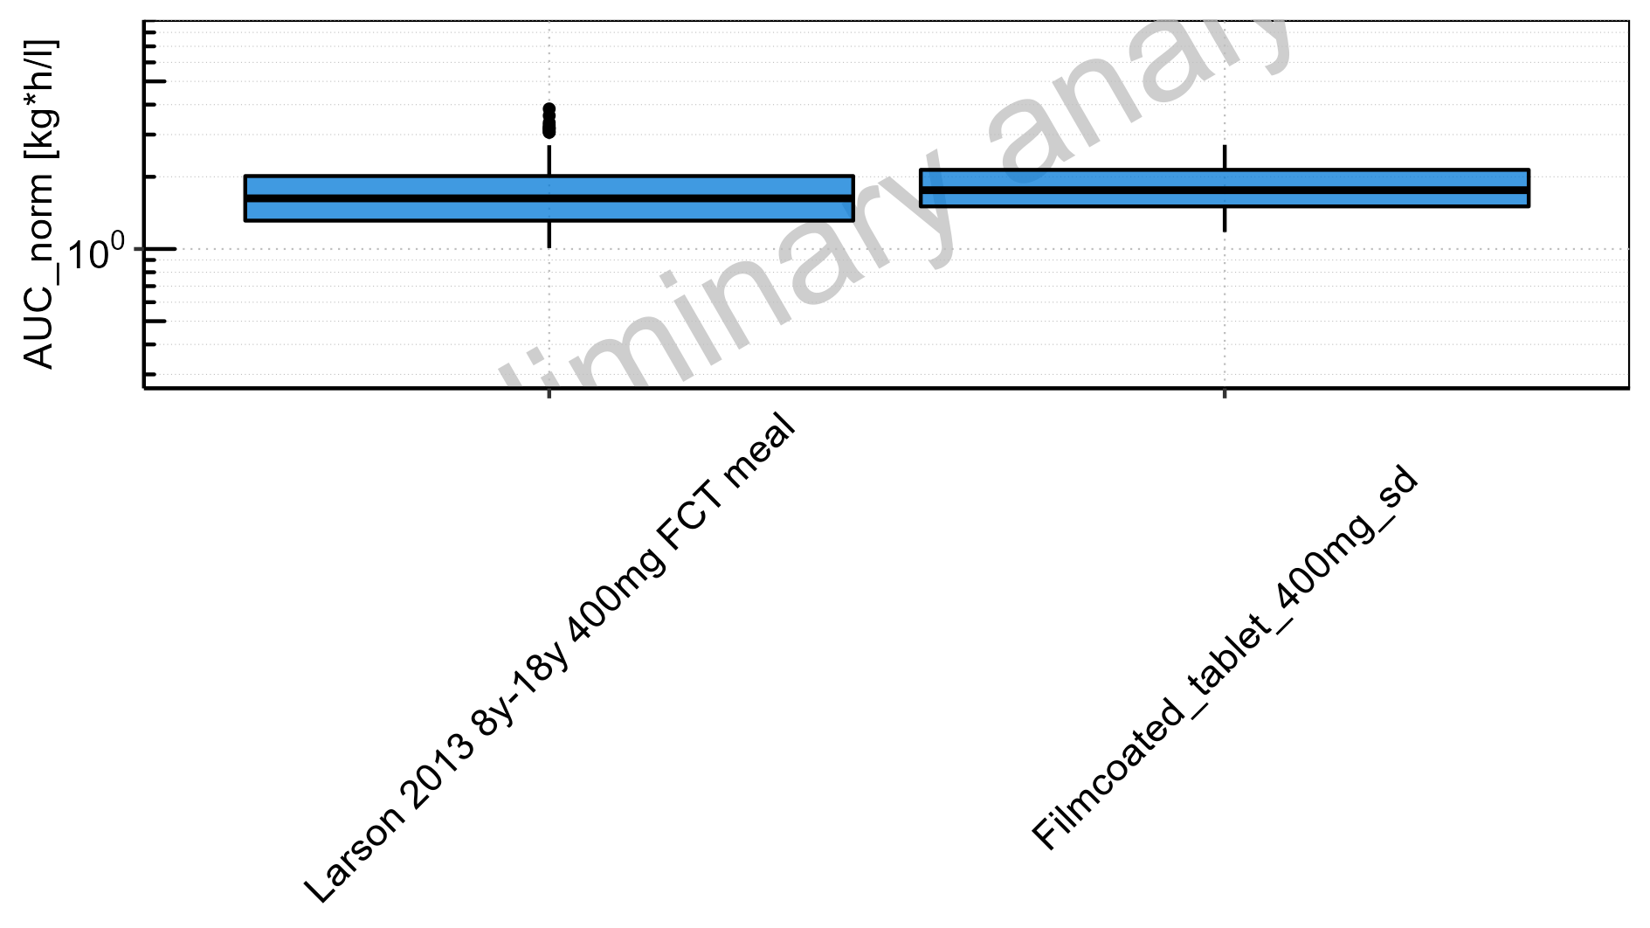

Figure 2-132: AUC_norm of Raltegravir for Larson 2013 8y-18y 400mg FCT meal, Filmcoated_tablet_400mg_sd shown as box-whisker plot, which indicates the 5<U+1D57><U+02B0>, 25<U+1D57><U+02B0>, 50<U+1D57><U+02B0>, 75<U+1D57><U+02B0>, 95<U+1D57><U+02B0> percentiles in linear scale.

**Table 2-6: AUC_norm of Raltegravir for Larson 2013 8y-18y 400mg FCT meal, Filmcoated_tablet_400mg_sd reported in [kg*h/l]**

|  |  |  |  |  |  |  |  |  |  |  |
| --- | --- | --- | --- | --- | --- | --- | --- | --- | --- | --- |
| Population | N | 5<U+1D57><U+02B0> pctl | 25<U+1D57><U+02B0> pctl | 50<U+1D57><U+02B0> pctl | 75<U+1D57><U+02B0> pctl | 95<U+1D57><U+02B0> pctl | Mean | SD | Geo Mean | Geo SD |
| Larson 2013 8y-18y 400mg FCT meal | 500 | 1.01 | 1.31 | 1.63 | 2.01 | 2.71 | 1.71 | 0.53 | 1.63 | 1.35 |
| Filmcoated_tablet_400mg_sd | 100 | 1.18 | 1.51 | 1.76 | 2.14 | 2.72 | 1.85 | 0.49 | 1.79 | 1.31 |

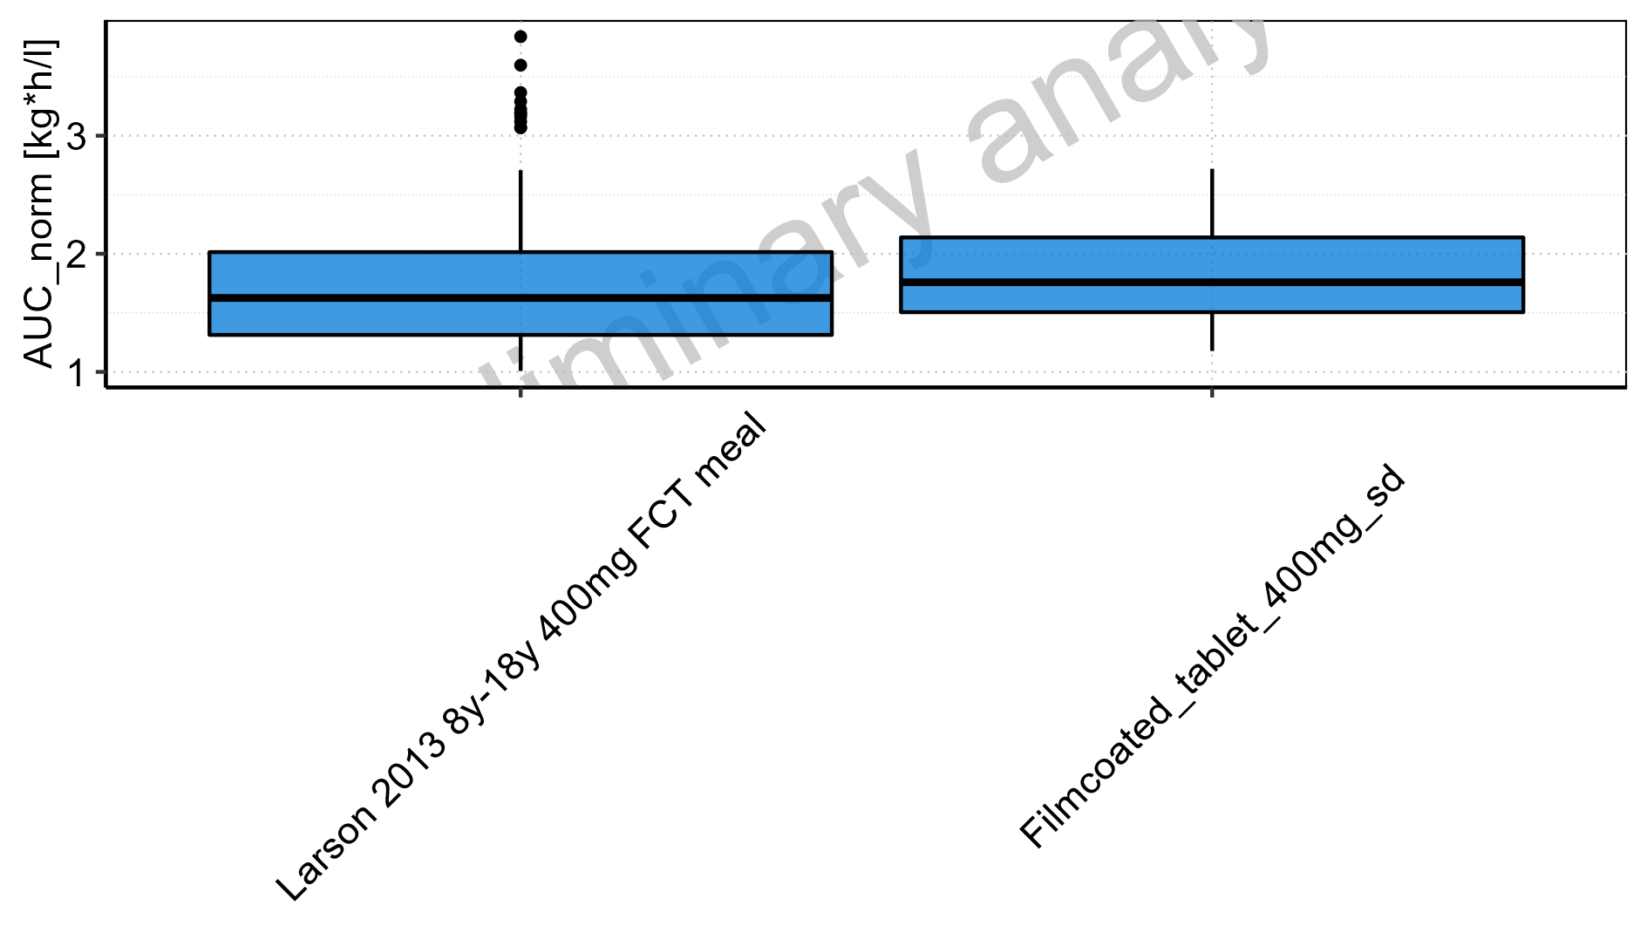

Figure 2-133: Age-dependence of AUC_norm for Larson 2013 8y-18y 400mg FCT meal in comparison to Filmcoated_tablet_400mg_sd. Profiles are plotted in a logarithmic scale.

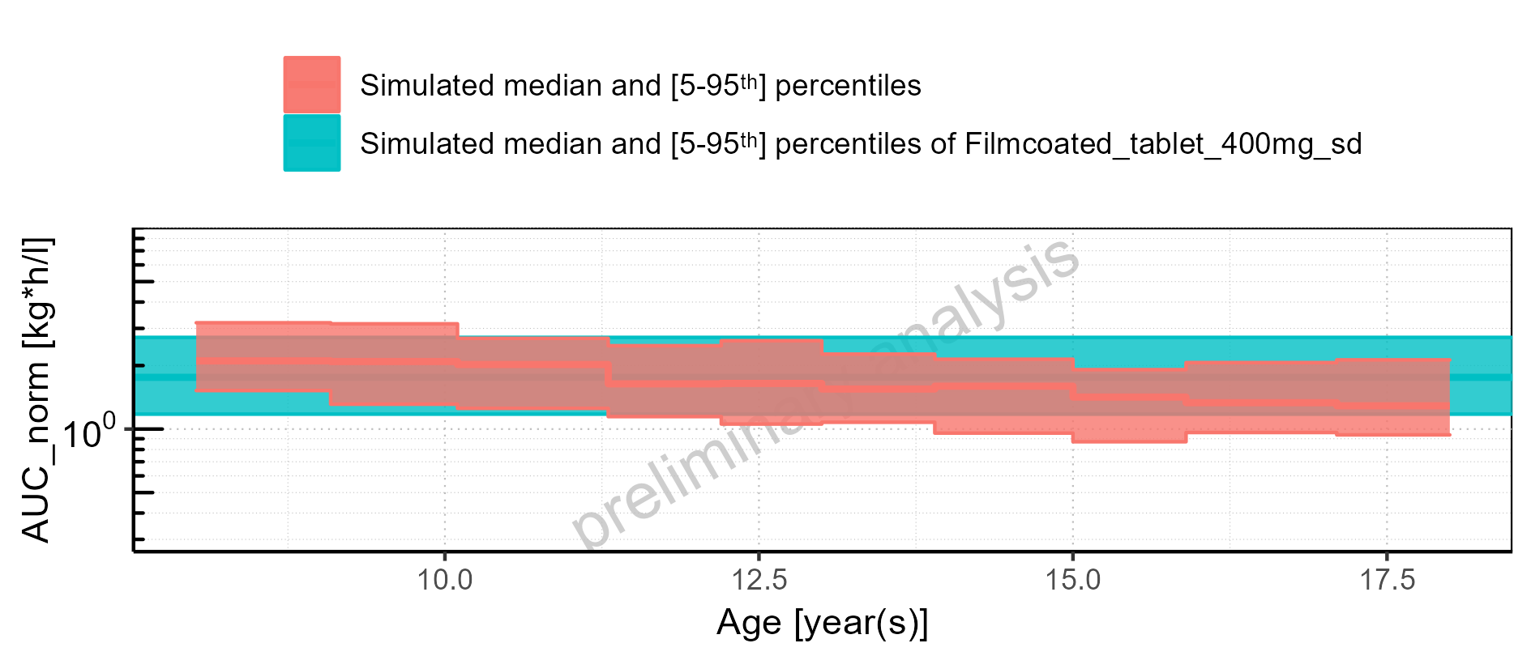

Figure 2-134: Age-dependence of AUC_norm for Larson 2013 8y-18y 400mg FCT meal in comparison to Filmcoated_tablet_400mg_sd. Profiles are plotted in a linear scale.

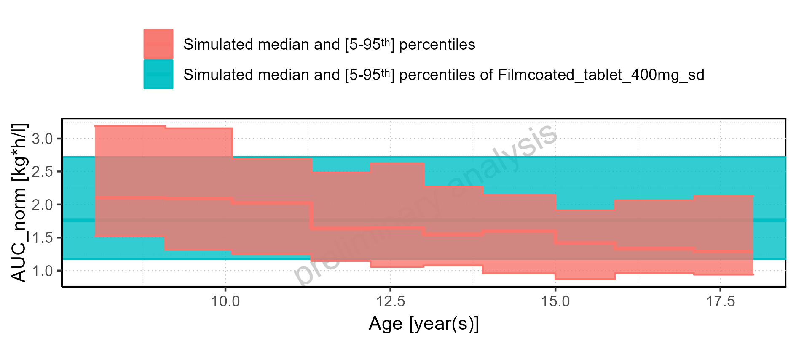

Figure 2-135: Age-dependence of AUC_norm for Larson 2013 8y-18y 400mg FCT meal. Profiles are plotted in a logarithmic scale.

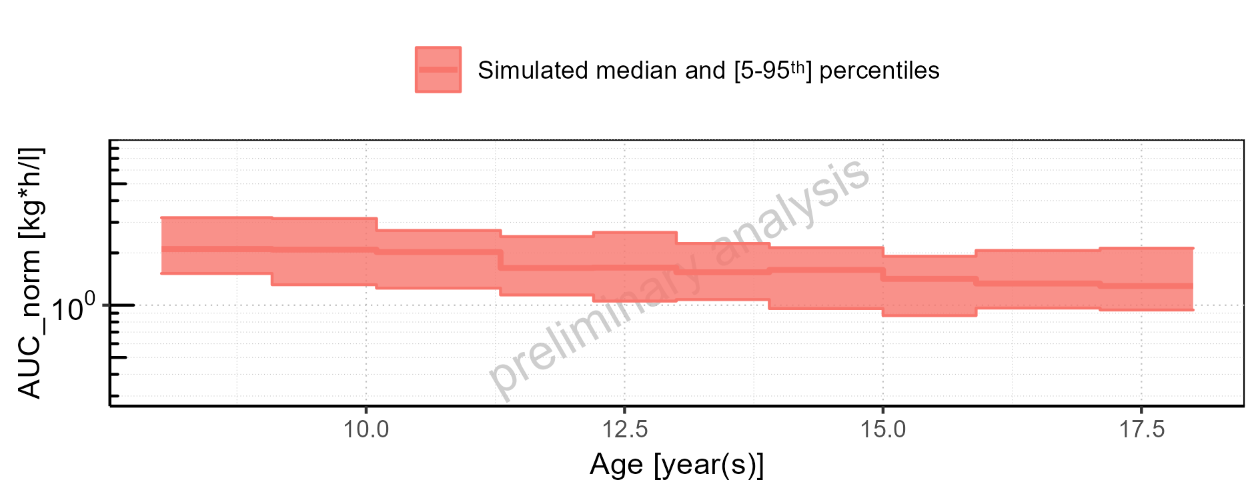

Figure 2-136: Age-dependence of AUC_norm for Larson 2013 8y-18y 400mg FCT meal. Profiles are plotted in a linear scale.

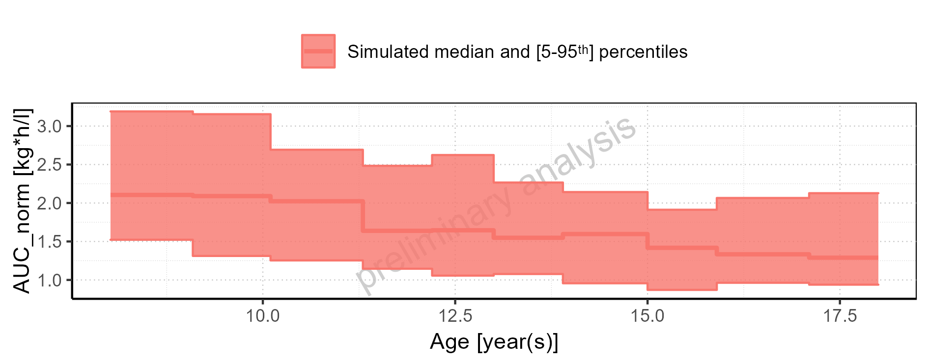

Figure 2-137: Age-dependence of AUC_norm for Filmcoated_tablet_400mg_sd. Profiles are plotted in a logarithmic scale.

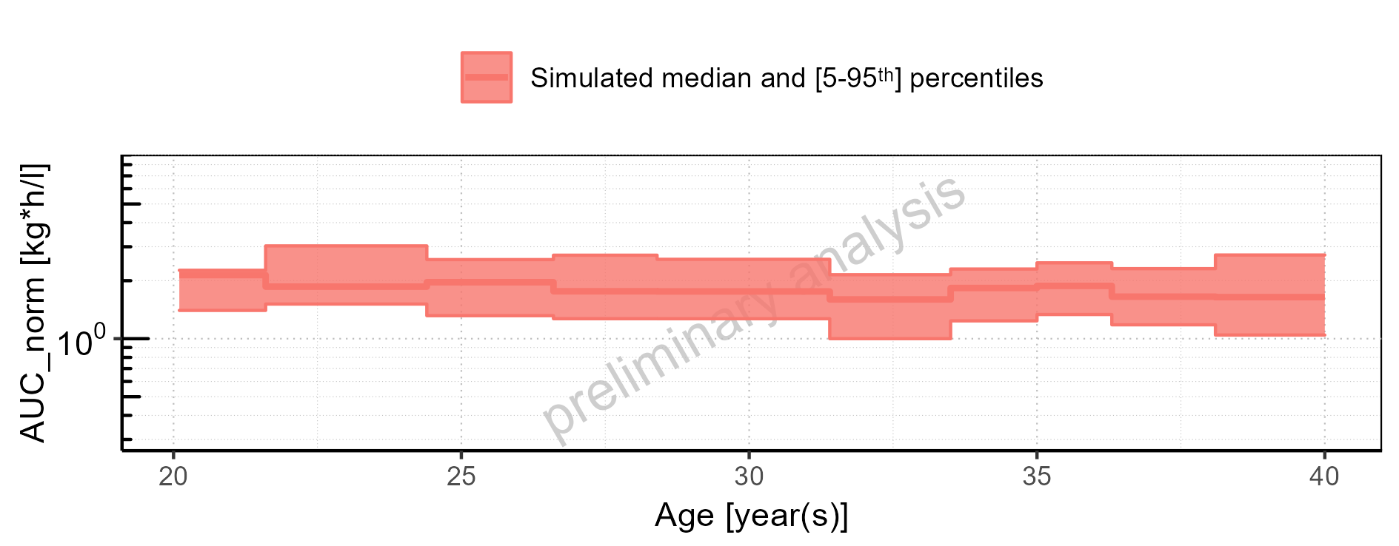

Figure 2-138: Age-dependence of AUC_norm for Filmcoated_tablet_400mg_sd. Profiles are plotted in a linear scale.

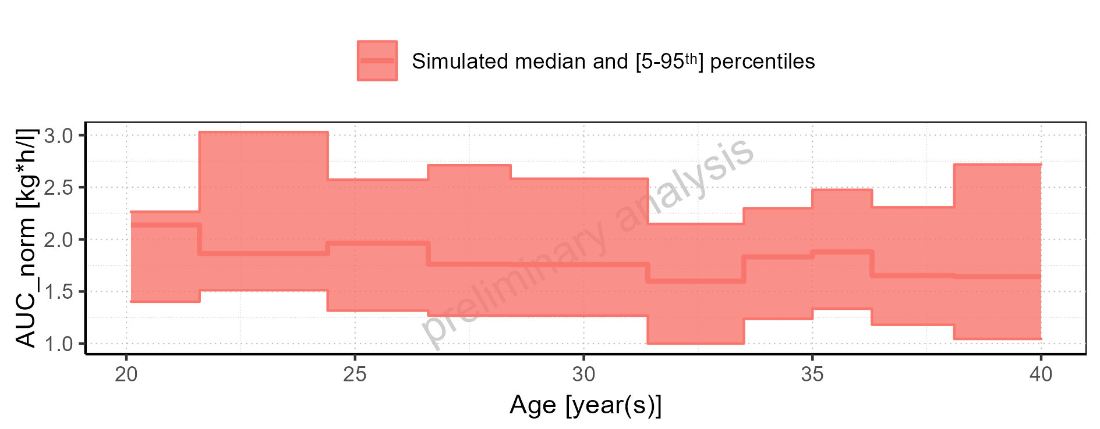

Figure 2-139: Height-dependence of AUC_norm for Larson 2013 8y-18y 400mg FCT meal in comparison to Filmcoated_tablet_400mg_sd. Profiles are plotted in a logarithmic scale.

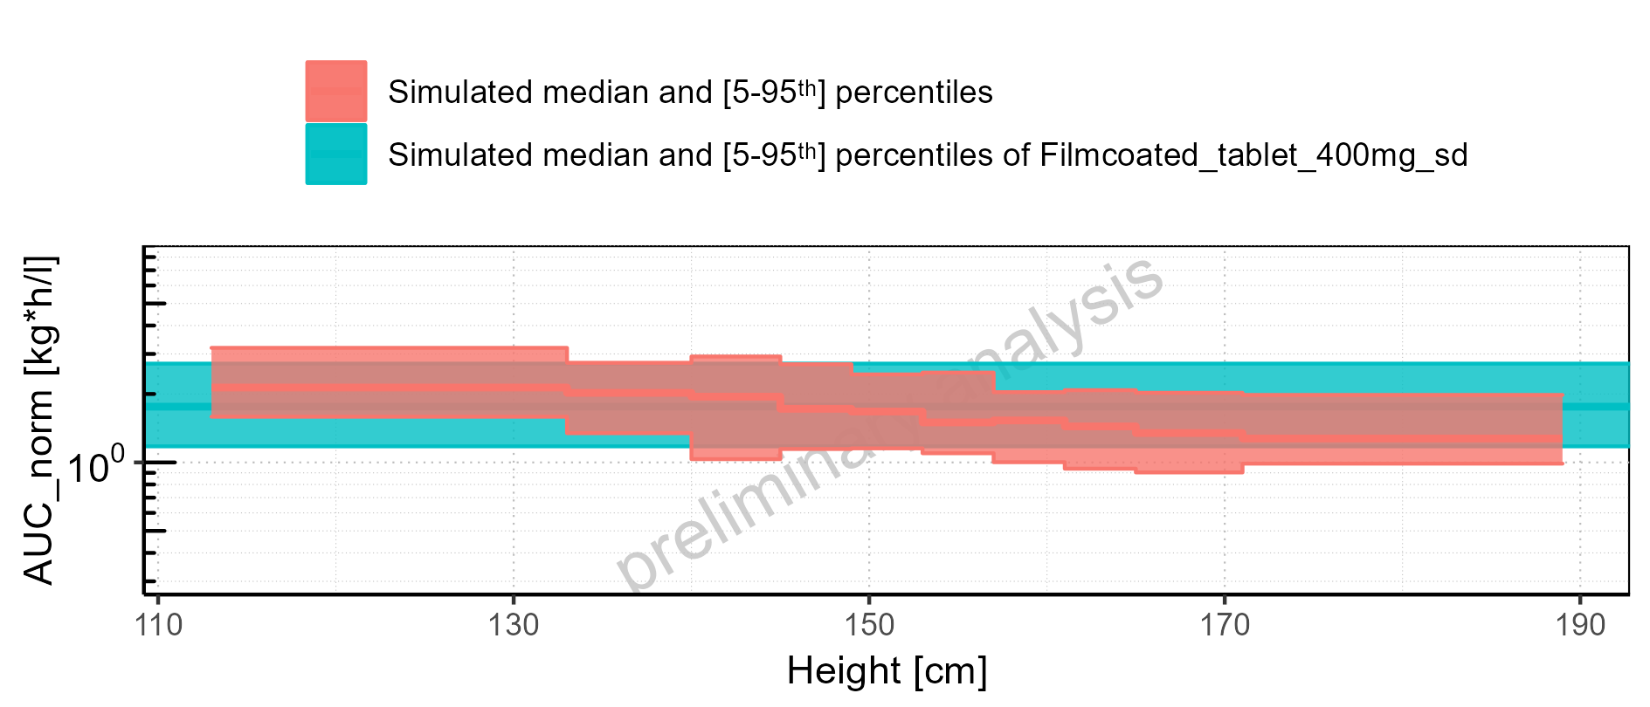

Figure 2-140: Height-dependence of AUC_norm for Larson 2013 8y-18y 400mg FCT meal in comparison to Filmcoated_tablet_400mg_sd. Profiles are plotted in a linear scale.

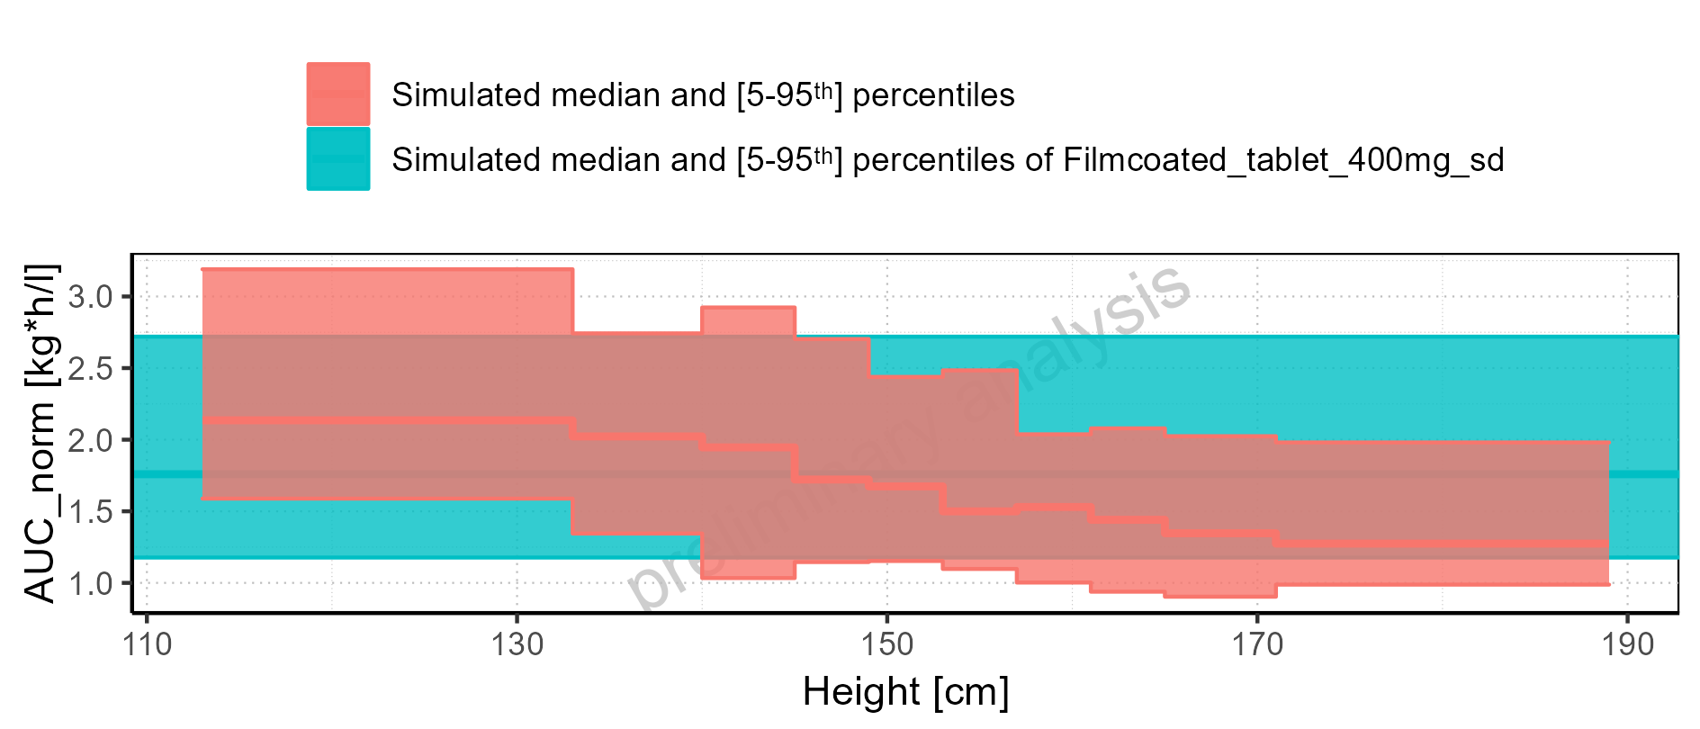

Figure 2-141: Height-dependence of AUC_norm for Larson 2013 8y-18y 400mg FCT meal. Profiles are plotted in a logarithmic scale.

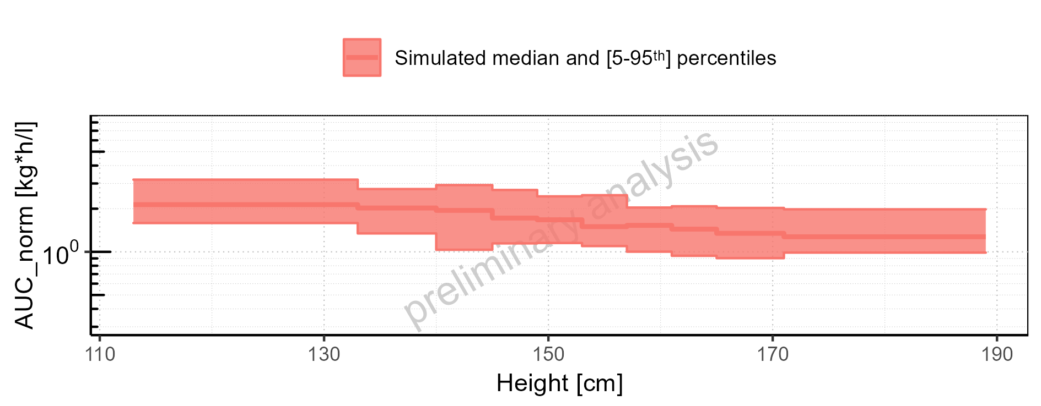

Figure 2-142: Height-dependence of AUC_norm for Larson 2013 8y-18y 400mg FCT meal. Profiles are plotted in a linear scale.

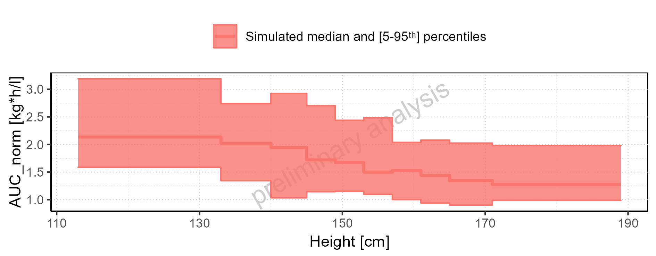

Figure 2-143: Height-dependence of AUC_norm for Filmcoated_tablet_400mg_sd. Profiles are plotted in a logarithmic scale.

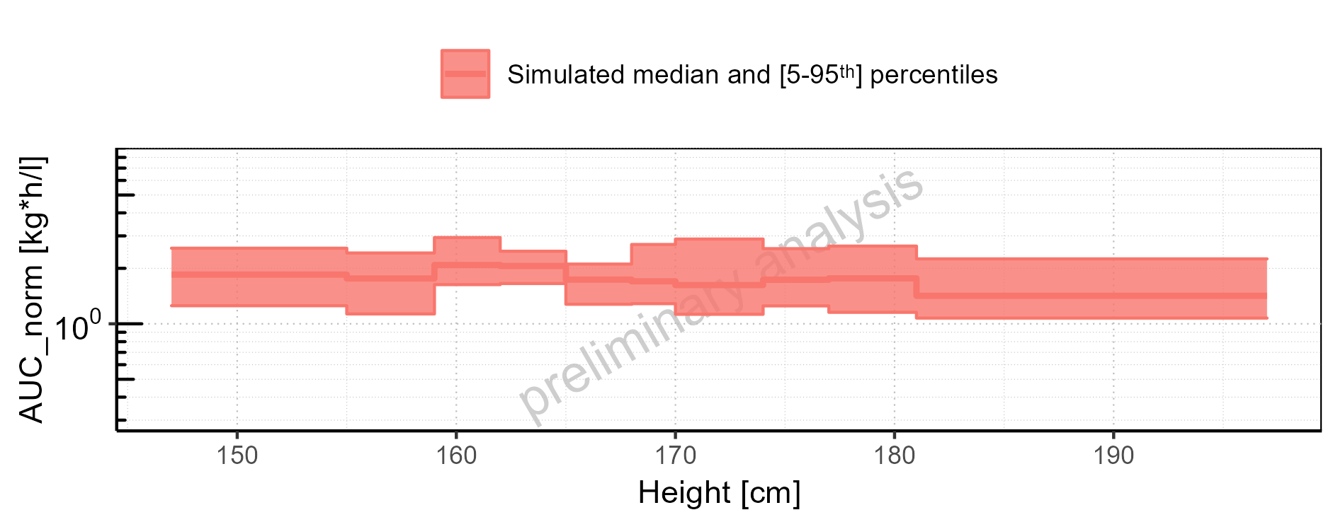

Figure 2-144: Height-dependence of AUC_norm for Filmcoated_tablet_400mg_sd. Profiles are plotted in a linear scale.

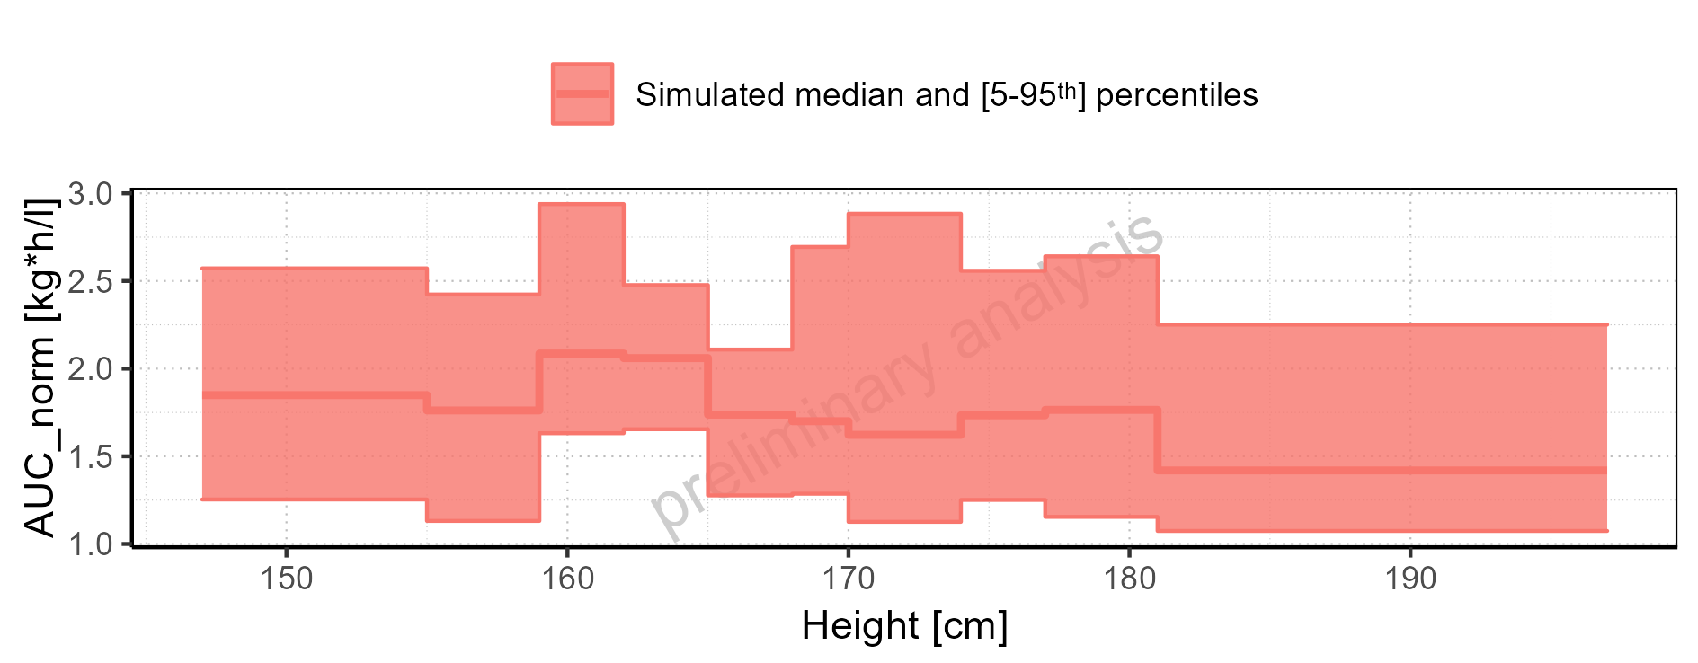

Figure 2-145: Weight-dependence of AUC_norm for Larson 2013 8y-18y 400mg FCT meal in comparison to Filmcoated_tablet_400mg_sd. Profiles are plotted in a logarithmic scale.

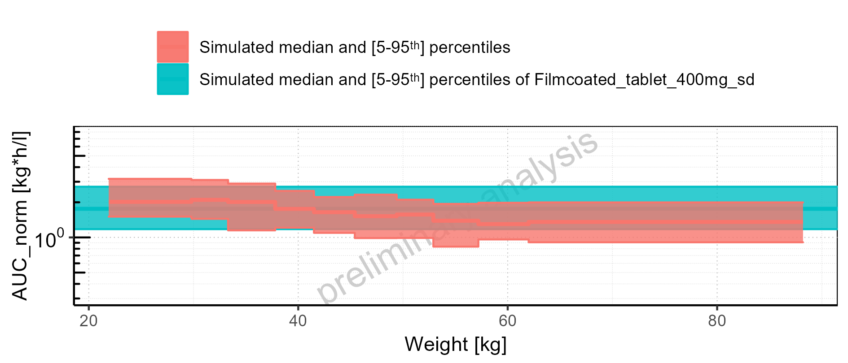

Figure 2-146: Weight-dependence of AUC_norm for Larson 2013 8y-18y 400mg FCT meal in comparison to Filmcoated_tablet_400mg_sd. Profiles are plotted in a linear scale.

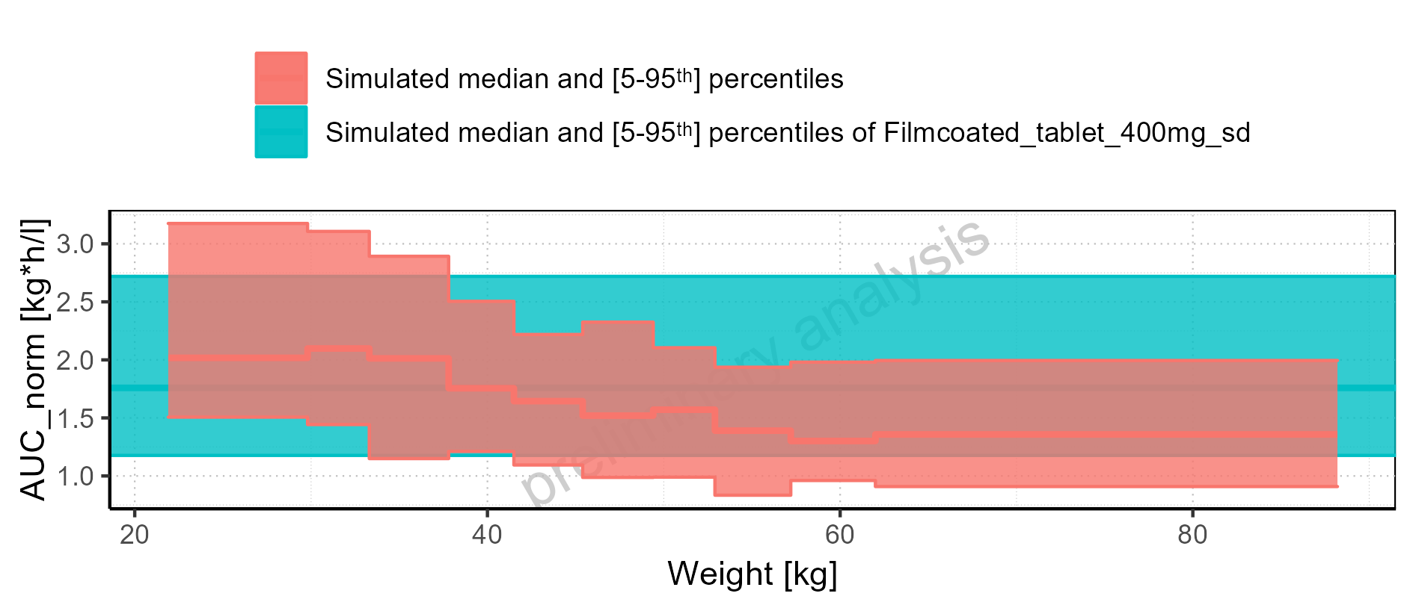

Figure 2-147: Weight-dependence of AUC_norm for Larson 2013 8y-18y 400mg FCT meal. Profiles are plotted in a logarithmic scale.

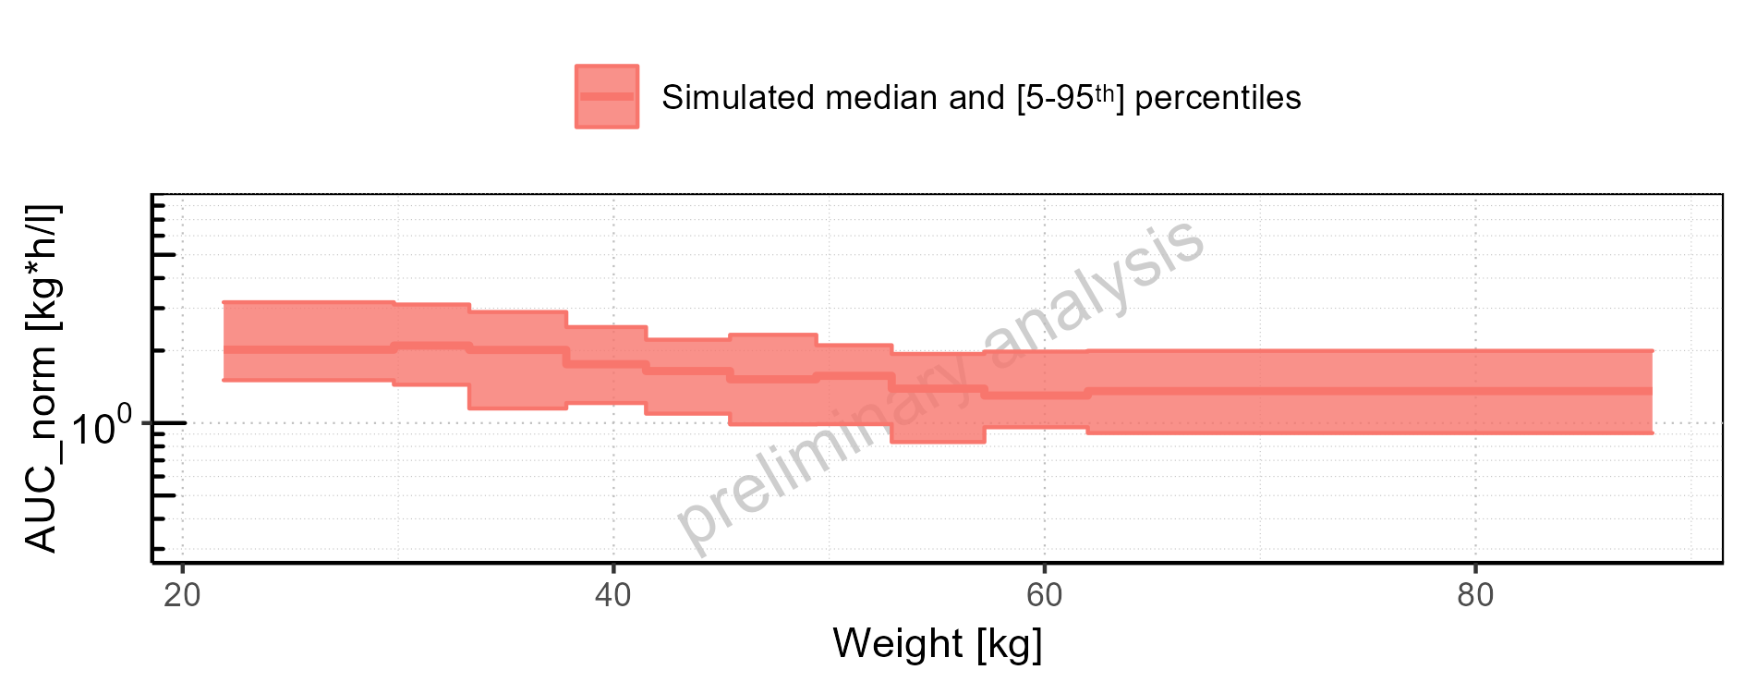

Figure 2-148: Weight-dependence of AUC_norm for Larson 2013 8y-18y 400mg FCT meal. Profiles are plotted in a linear scale.

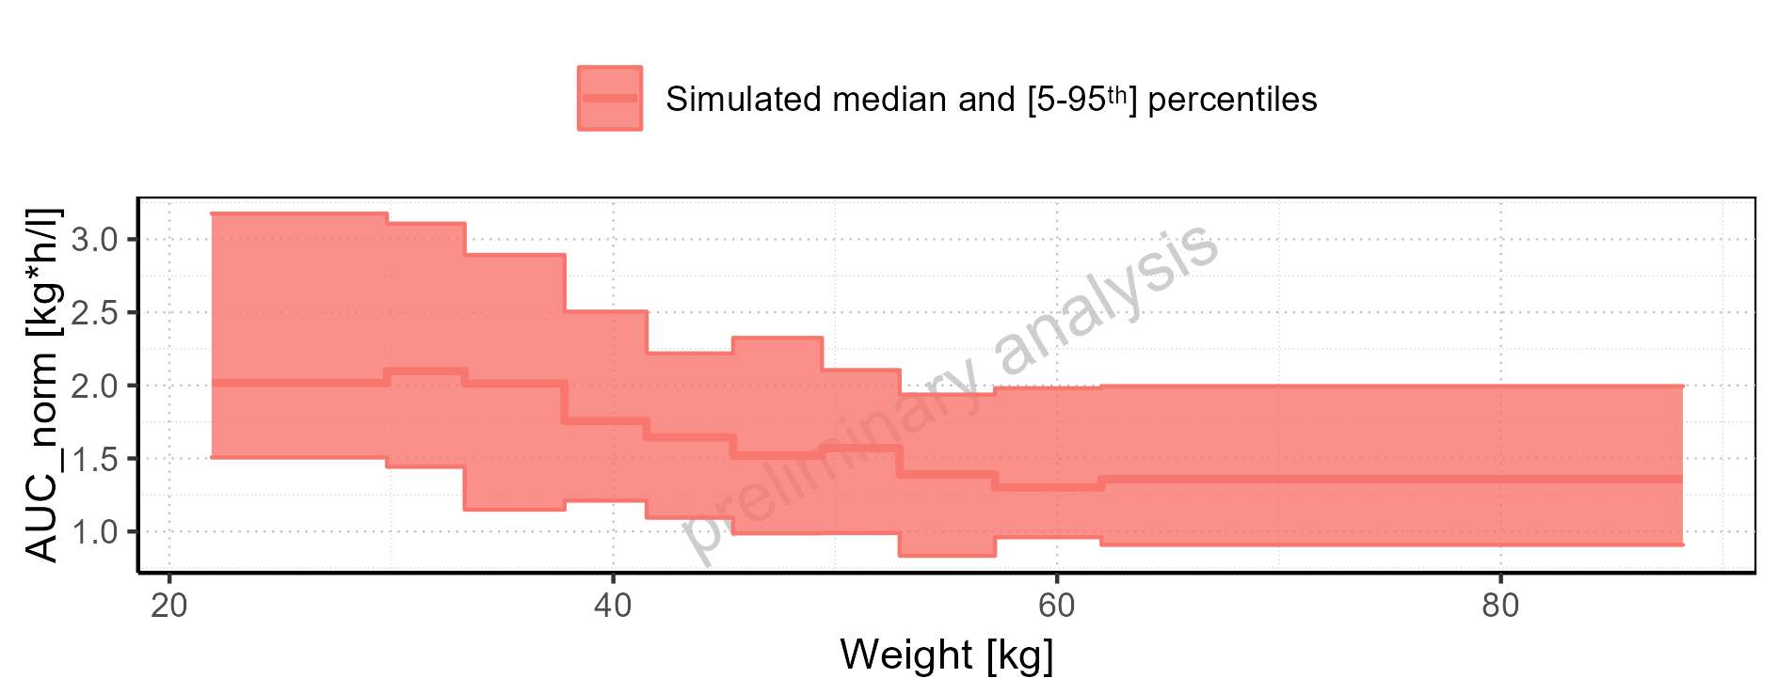

Figure 2-149: Weight-dependence of AUC_norm for Filmcoated_tablet_400mg_sd. Profiles are plotted in a logarithmic scale.

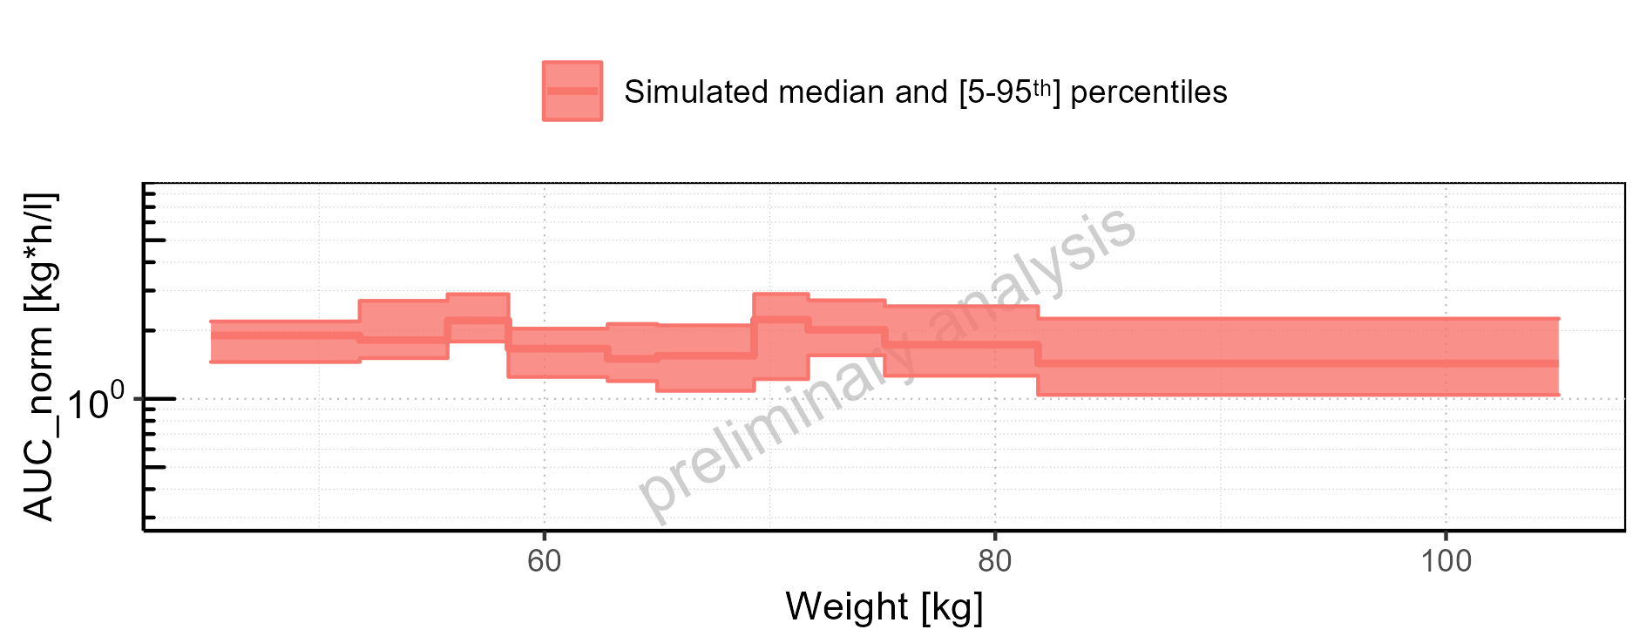

Figure 2-150: Weight-dependence of AUC_norm for Filmcoated_tablet_400mg_sd. Profiles are plotted in a linear scale.

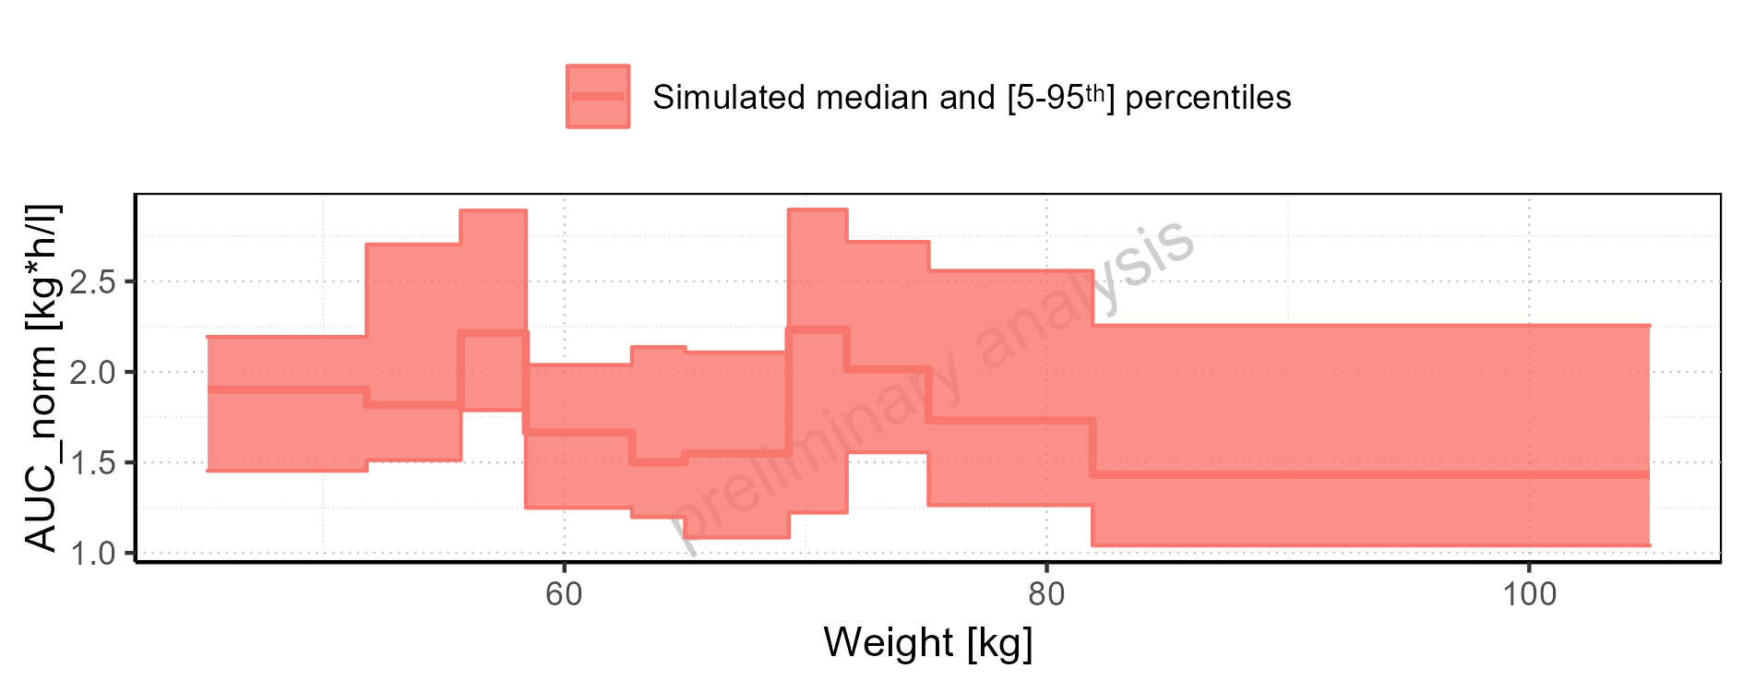

Figure 2-151: BMI-dependence of AUC_norm for Larson 2013 8y-18y 400mg FCT meal in comparison to Filmcoated_tablet_400mg_sd. Profiles are plotted in a logarithmic scale.

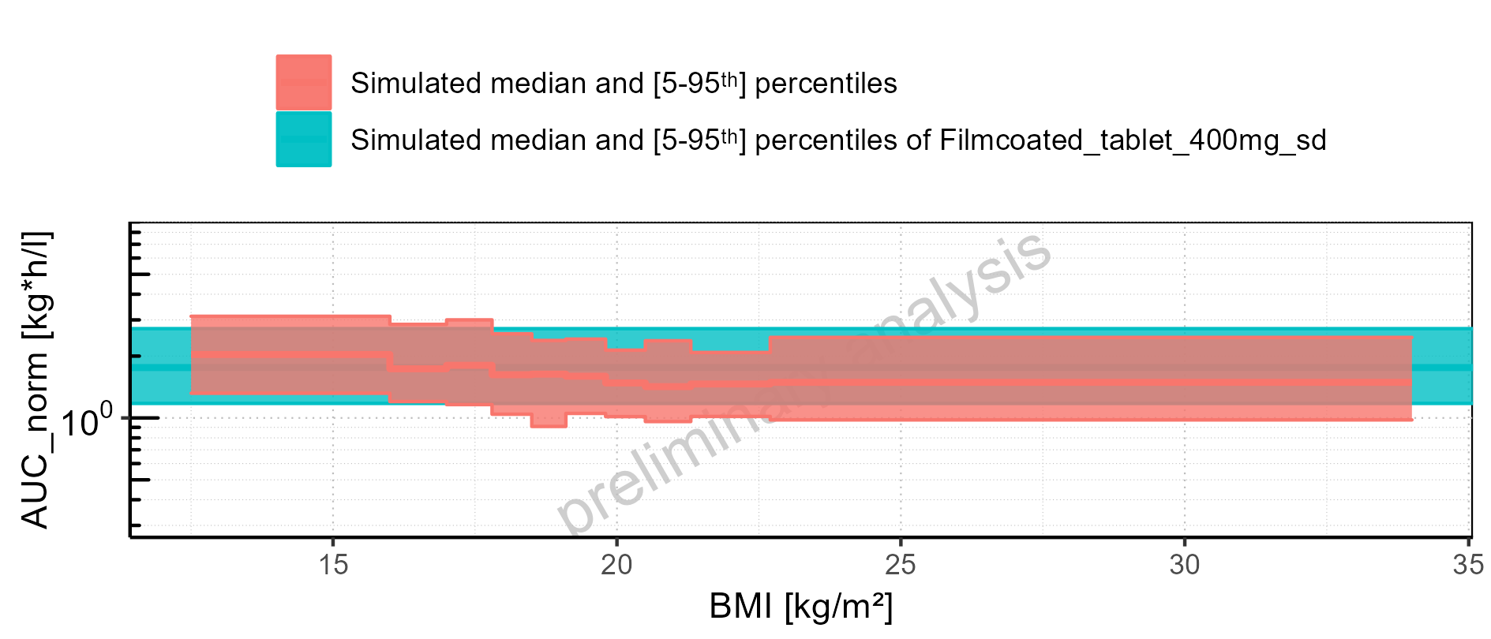

Figure 2-152: BMI-dependence of AUC_norm for Larson 2013 8y-18y 400mg FCT meal in comparison to Filmcoated_tablet_400mg_sd. Profiles are plotted in a linear scale.

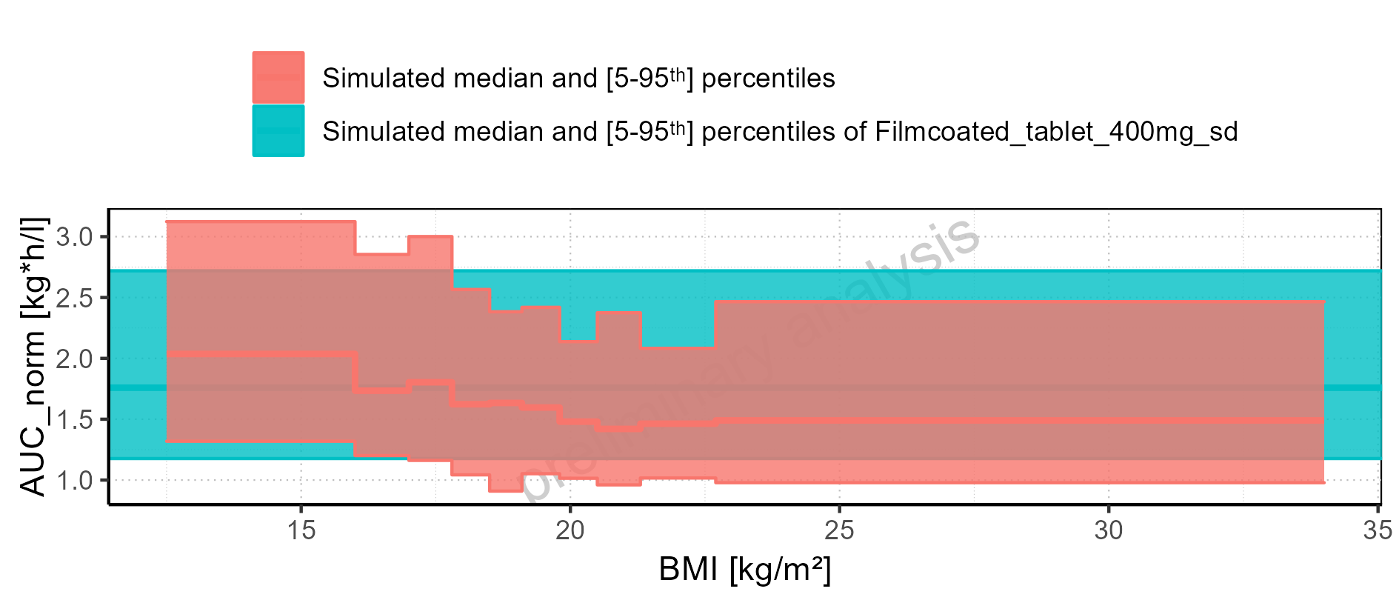

Figure 2-153: BMI-dependence of AUC_norm for Larson 2013 8y-18y 400mg FCT meal. Profiles are plotted in a logarithmic scale.

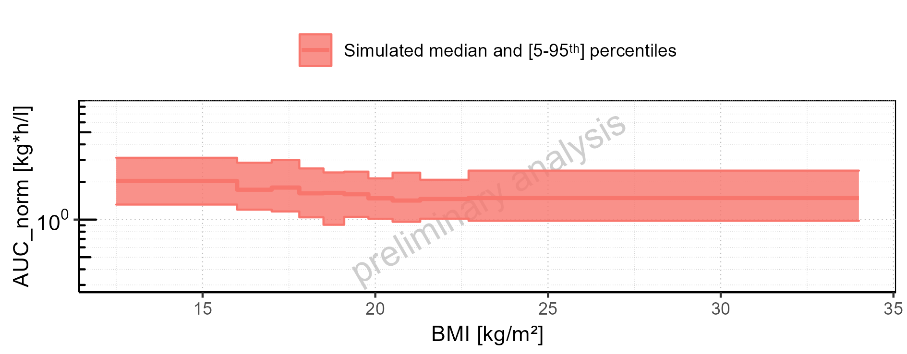

Figure 2-154: BMI-dependence of AUC_norm for Larson 2013 8y-18y 400mg FCT meal. Profiles are plotted in a linear scale.

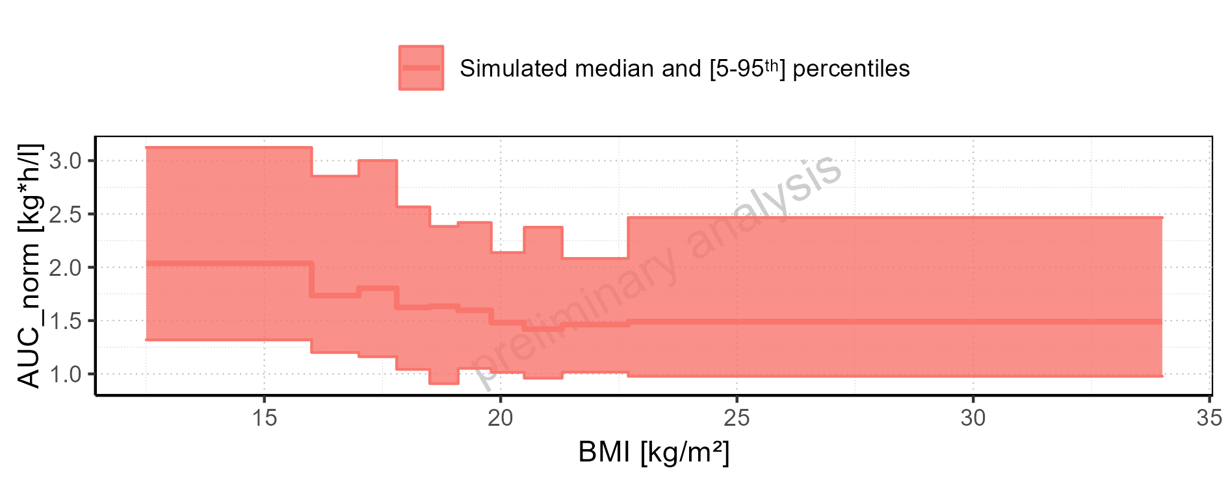

Figure 2-155: BMI-dependence of AUC_norm for Filmcoated_tablet_400mg_sd. Profiles are plotted in a logarithmic scale.

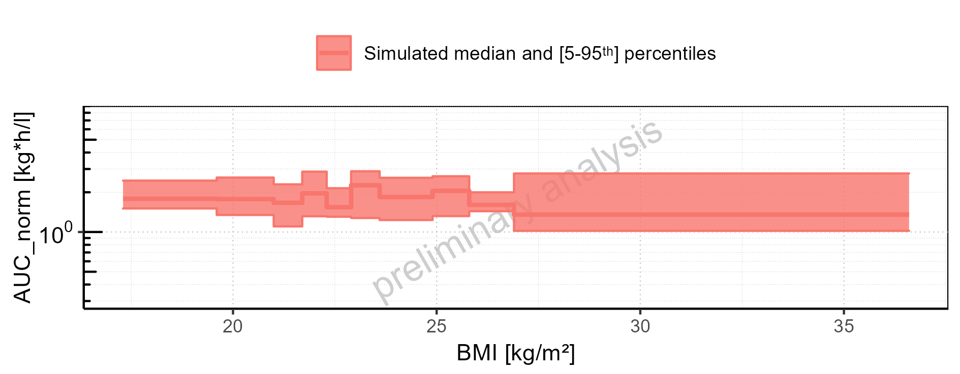

Figure 2-156: BMI-dependence of AUC_norm for Filmcoated_tablet_400mg_sd. Profiles are plotted in a linear scale.

### AUC_inf

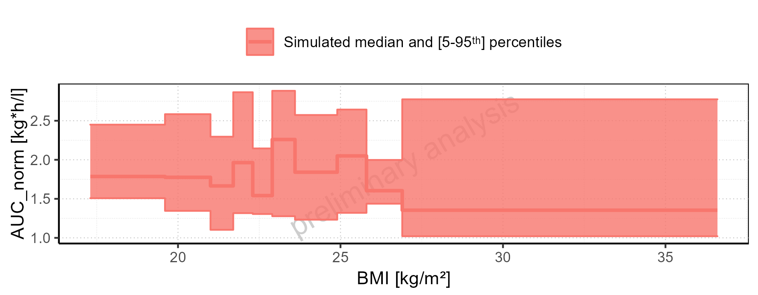

Figure 2-157: AUC_inf of Raltegravir for Larson 2013 8y-18y 400mg FCT meal, Filmcoated_tablet_400mg_sd shown as box-whisker plot, which indicates the 5<U+1D57><U+02B0>, 25<U+1D57><U+02B0>, 50<U+1D57><U+02B0>, 75<U+1D57><U+02B0>, 95<U+1D57><U+02B0> percentiles in logarithmic scale.

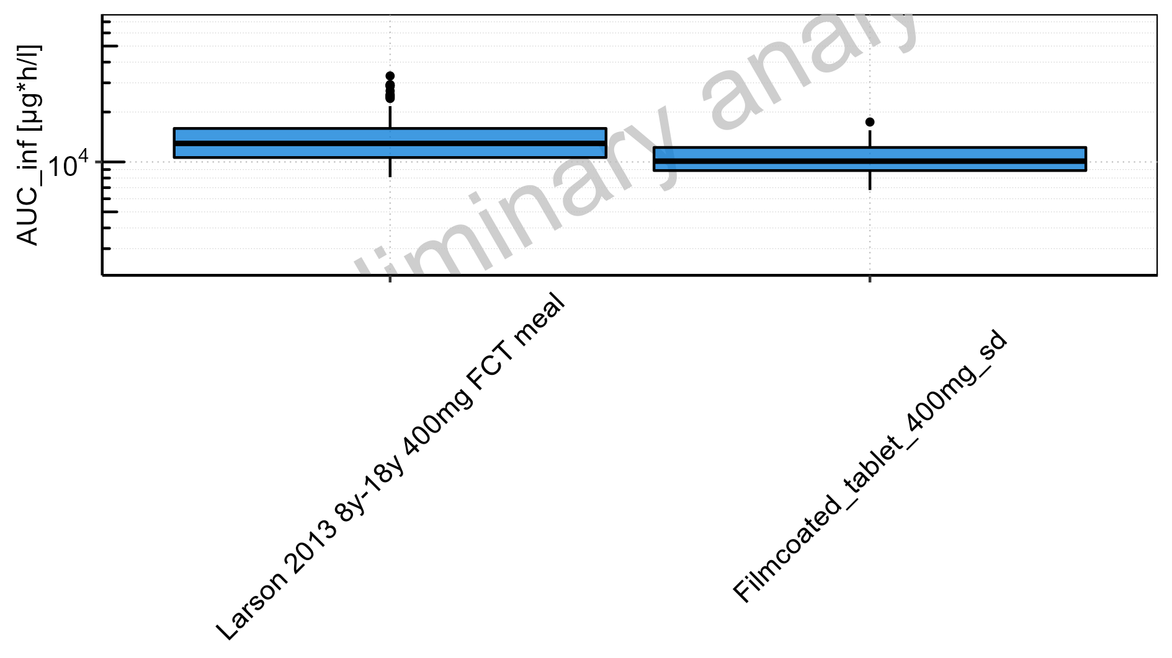

Figure 2-158: AUC_inf of Raltegravir for Larson 2013 8y-18y 400mg FCT meal, Filmcoated_tablet_400mg_sd shown as box-whisker plot, which indicates the 5<U+1D57><U+02B0>, 25<U+1D57><U+02B0>, 50<U+1D57><U+02B0>, 75<U+1D57><U+02B0>, 95<U+1D57><U+02B0> percentiles in linear scale.

**Table 2-7: AUC_inf of Raltegravir for Larson 2013 8y-18y 400mg FCT meal, Filmcoated_tablet_400mg_sd reported in [µg*h/l]**

|  |  |  |  |  |  |  |  |  |  |  |
| --- | --- | --- | --- | --- | --- | --- | --- | --- | --- | --- |
| Population | N | 5<U+1D57><U+02B0> pctl | 25<U+1D57><U+02B0> pctl | 50<U+1D57><U+02B0> pctl | 75<U+1D57><U+02B0> pctl | 95<U+1D57><U+02B0> pctl | Mean | SD | Geo Mean | Geo SD |
| Larson 2013 8y-18y 400mg FCT meal | 500 | 8017.56 | 10533.54 | 12921.05 | 15892.61 | 21707.95 | 13652.19 | 4460.23 | 0.00 | - |
| Filmcoated_tablet_400mg_sd | 100 | 6771.99 | 8875.70 | 10112.32 | 12229.14 | 15523.15 | 10626.71 | 2757.61 | 10275.45 | 1.30 |

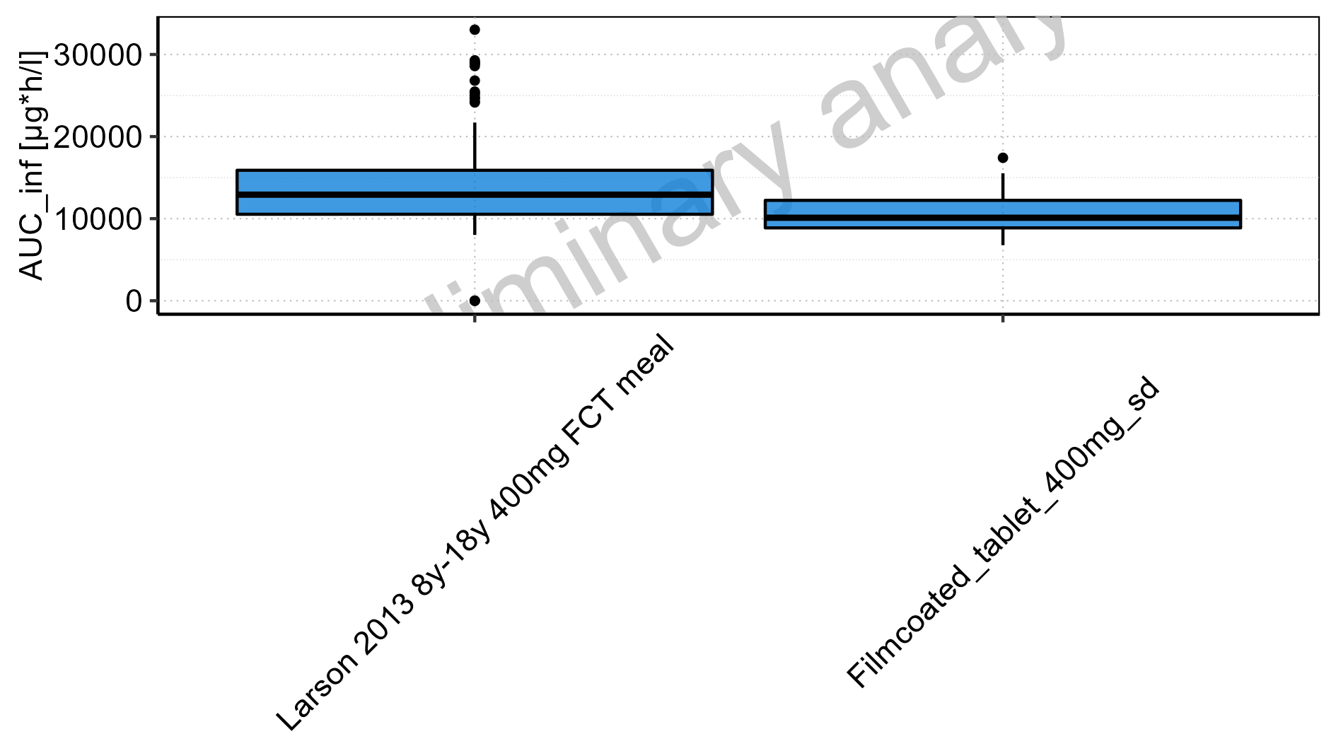

Figure 2-159: Age-dependence of AUC_inf for Larson 2013 8y-18y 400mg FCT meal in comparison to Filmcoated_tablet_400mg_sd. Profiles are plotted in a logarithmic scale.

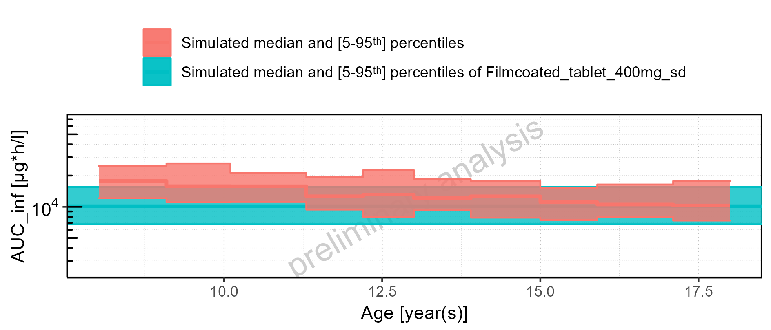

Figure 2-160: Age-dependence of AUC_inf for Larson 2013 8y-18y 400mg FCT meal in comparison to Filmcoated_tablet_400mg_sd. Profiles are plotted in a linear scale.

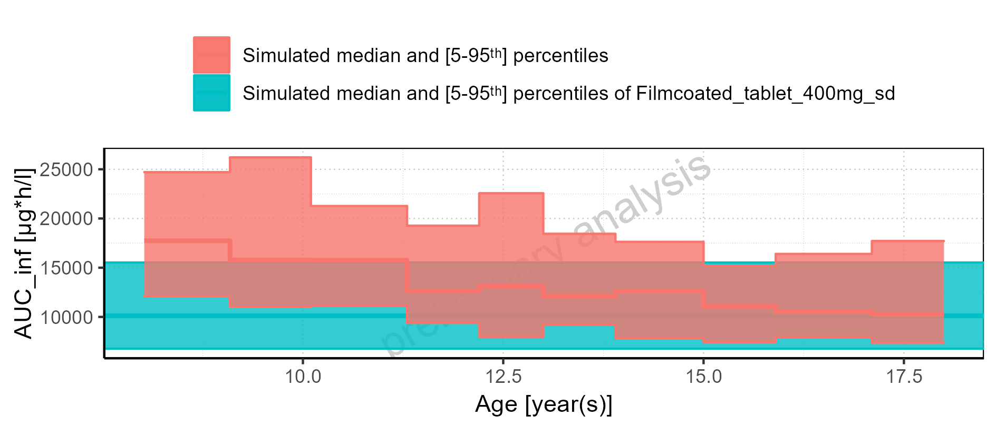

Figure 2-161: Age-dependence of AUC_inf for Larson 2013 8y-18y 400mg FCT meal. Profiles are plotted in a logarithmic scale.

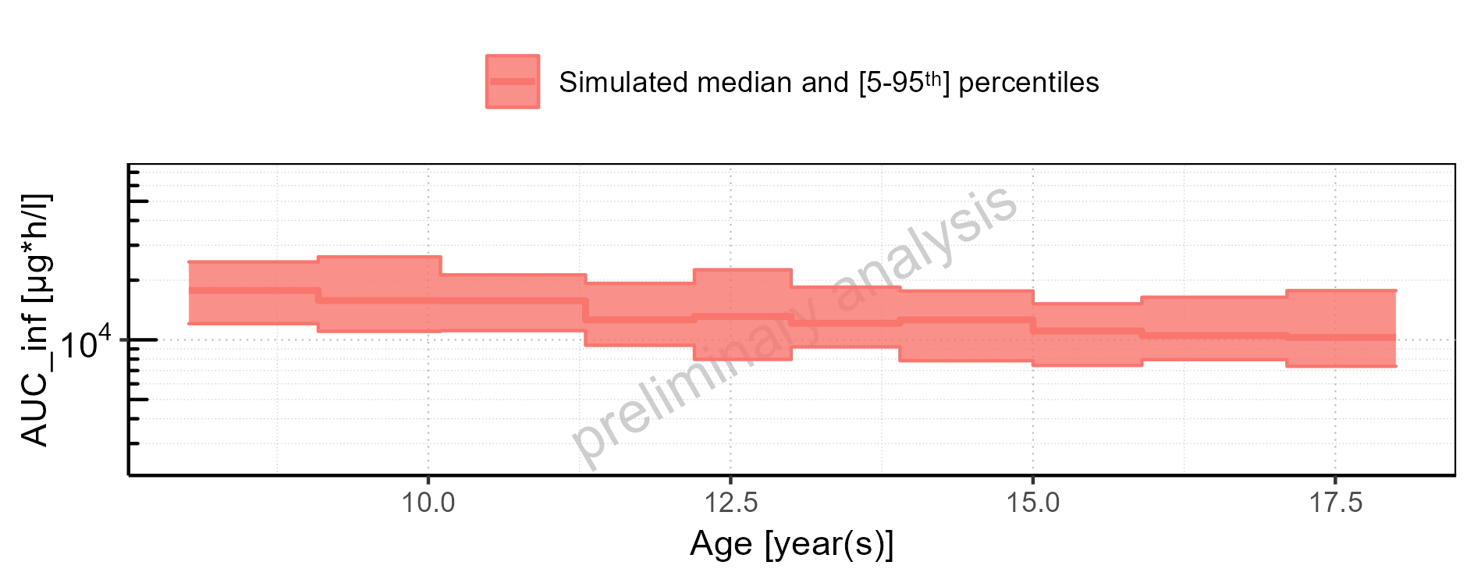

Figure 2-162: Age-dependence of AUC_inf for Larson 2013 8y-18y 400mg FCT meal. Profiles are plotted in a linear scale.

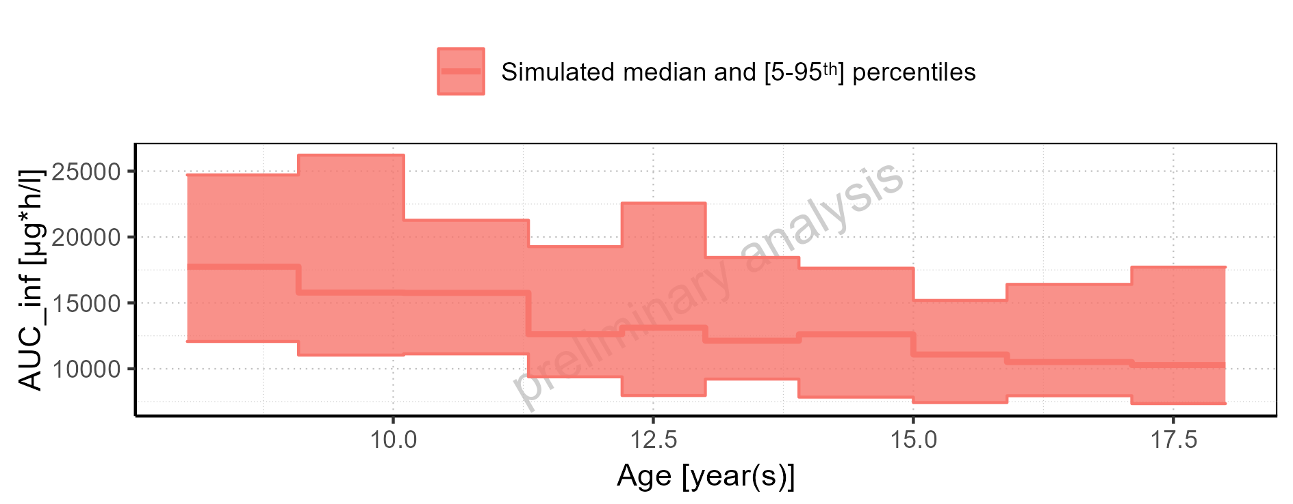

Figure 2-163: Age-dependence of AUC_inf for Filmcoated_tablet_400mg_sd. Profiles are plotted in a logarithmic scale.

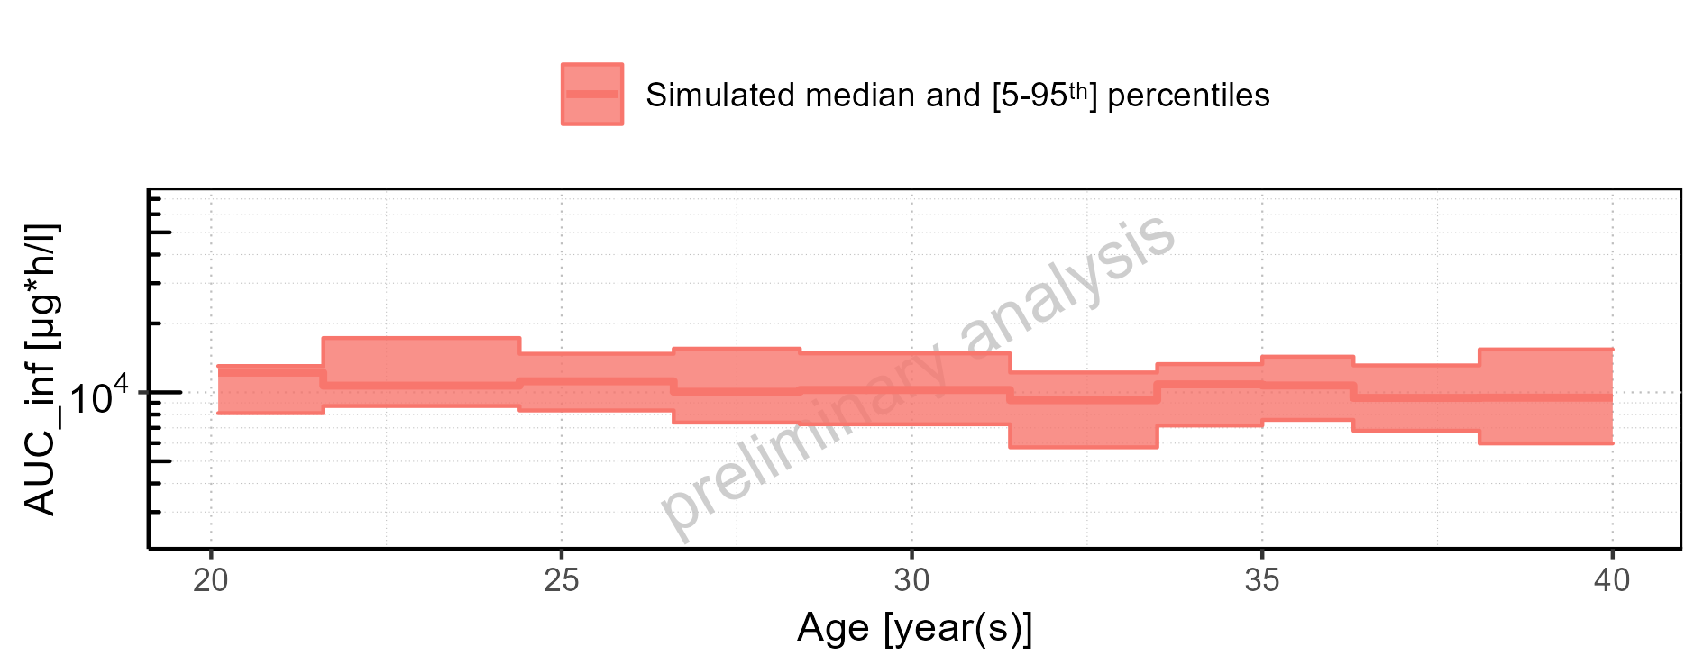

Figure 2-164: Age-dependence of AUC_inf for Filmcoated_tablet_400mg_sd. Profiles are plotted in a linear scale.

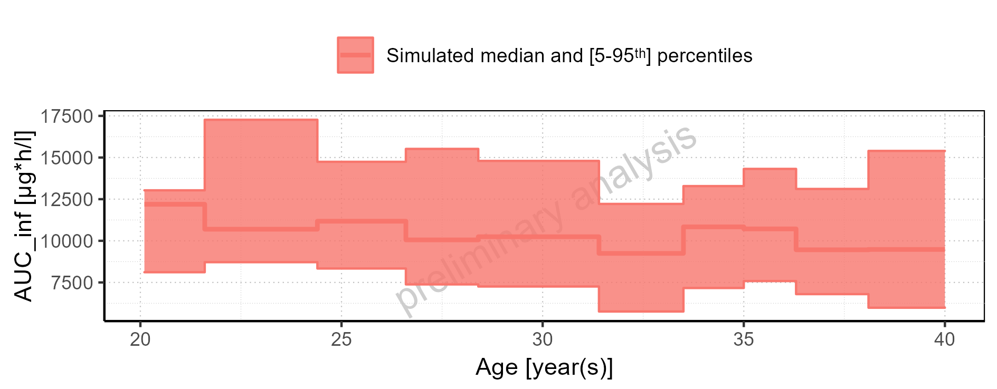

Figure 2-165: Height-dependence of AUC_inf for Larson 2013 8y-18y 400mg FCT meal in comparison to Filmcoated_tablet_400mg_sd. Profiles are plotted in a logarithmic scale.

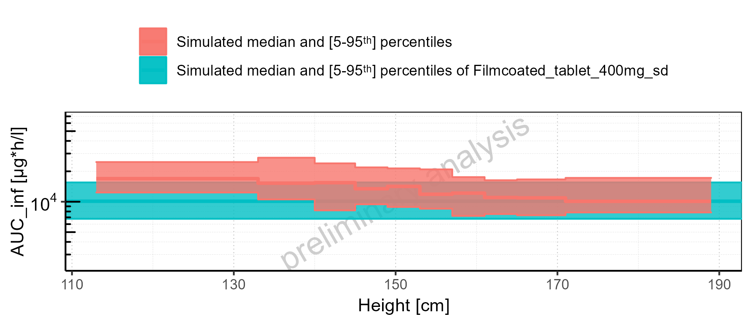

Figure 2-166: Height-dependence of AUC_inf for Larson 2013 8y-18y 400mg FCT meal in comparison to Filmcoated_tablet_400mg_sd. Profiles are plotted in a linear scale.

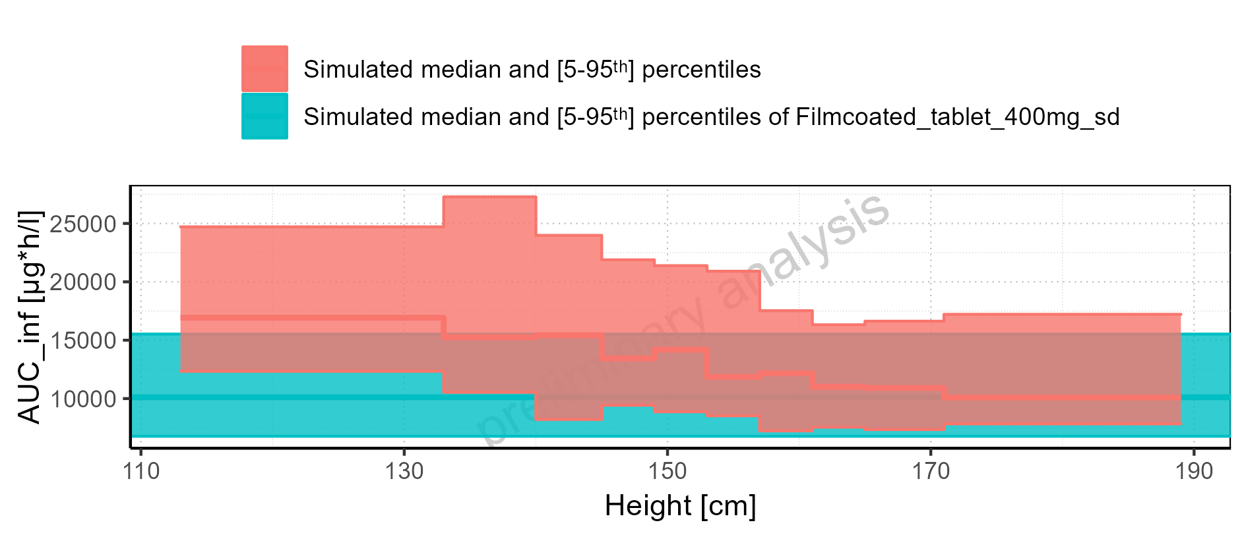

Figure 2-167: Height-dependence of AUC_inf for Larson 2013 8y-18y 400mg FCT meal. Profiles are plotted in a logarithmic scale.

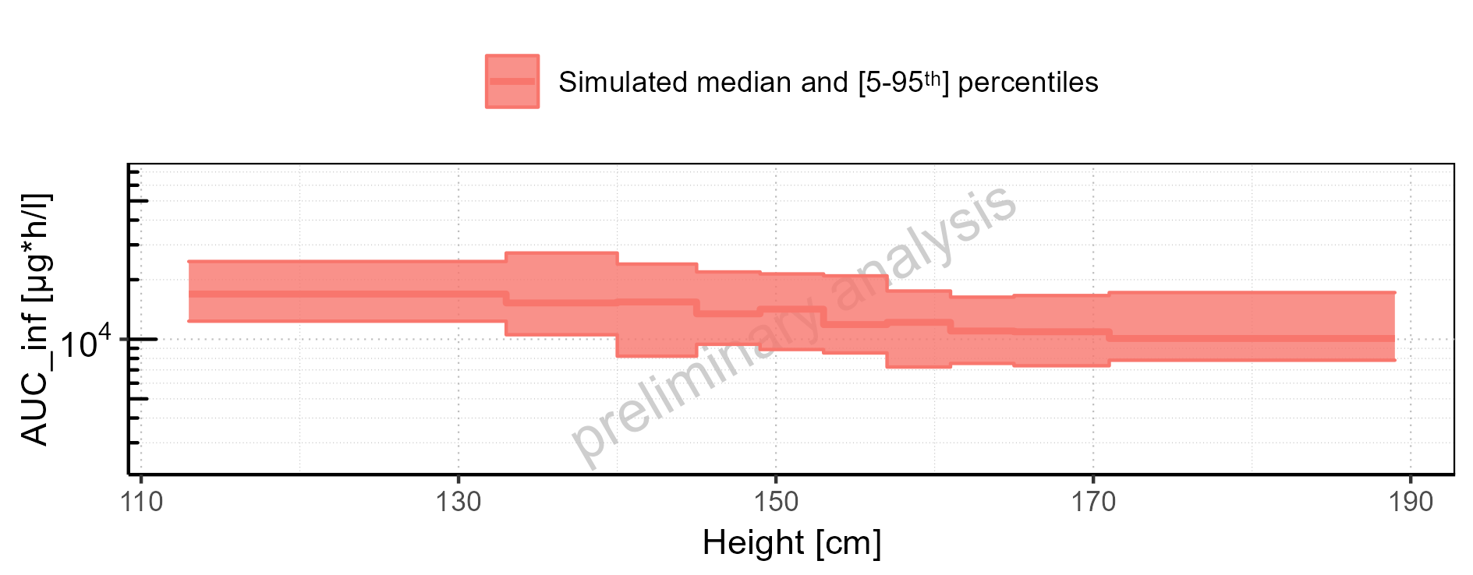

Figure 2-168: Height-dependence of AUC_inf for Larson 2013 8y-18y 400mg FCT meal. Profiles are plotted in a linear scale.

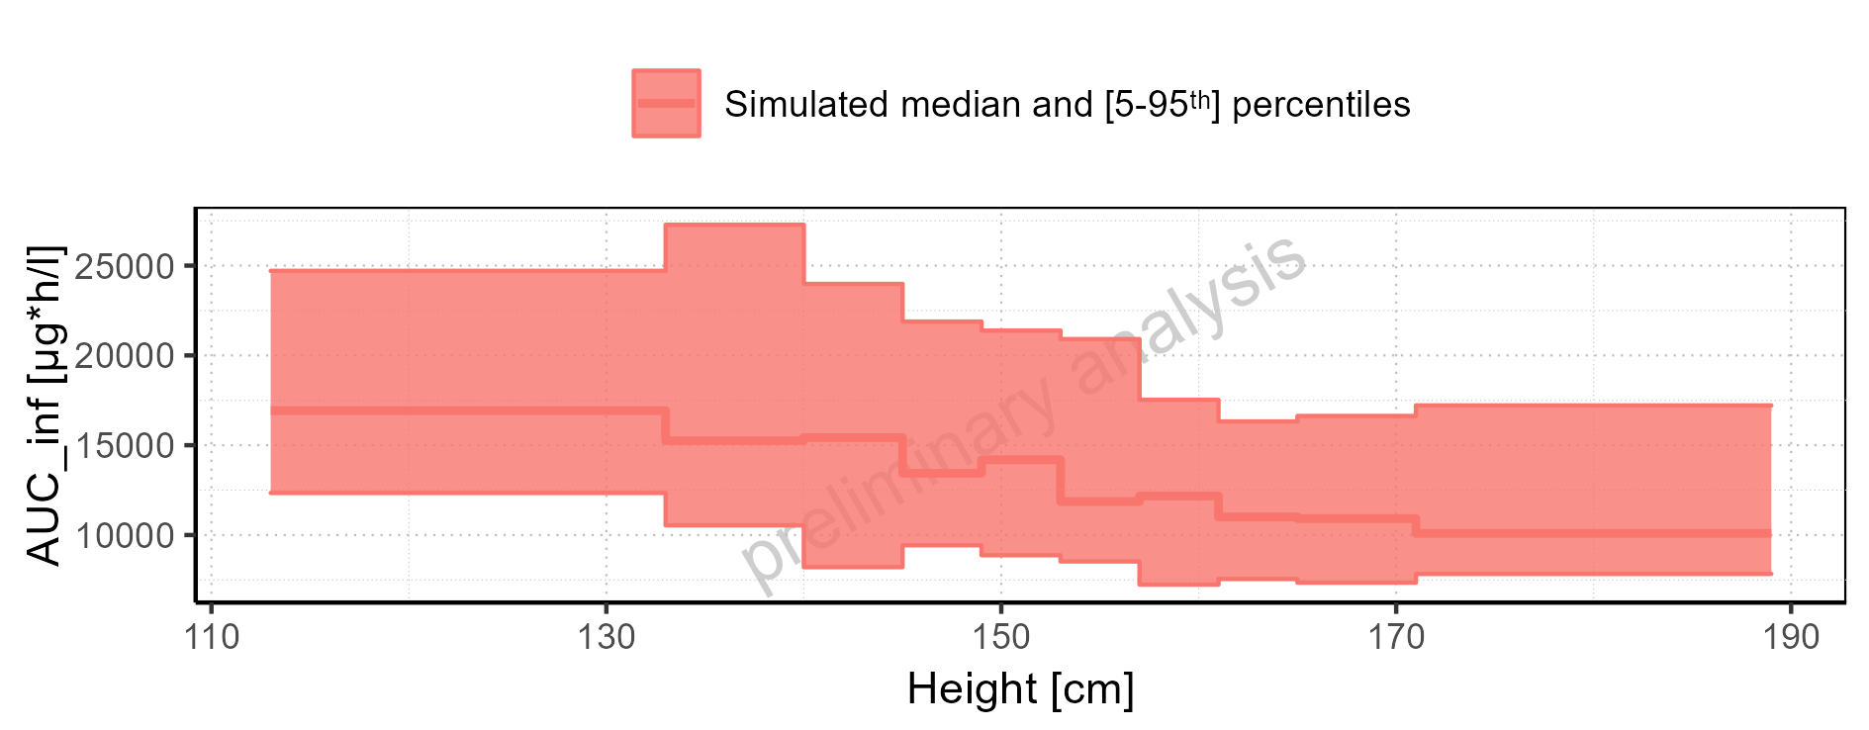

Figure 2-169: Height-dependence of AUC_inf for Filmcoated_tablet_400mg_sd. Profiles are plotted in a logarithmic scale.

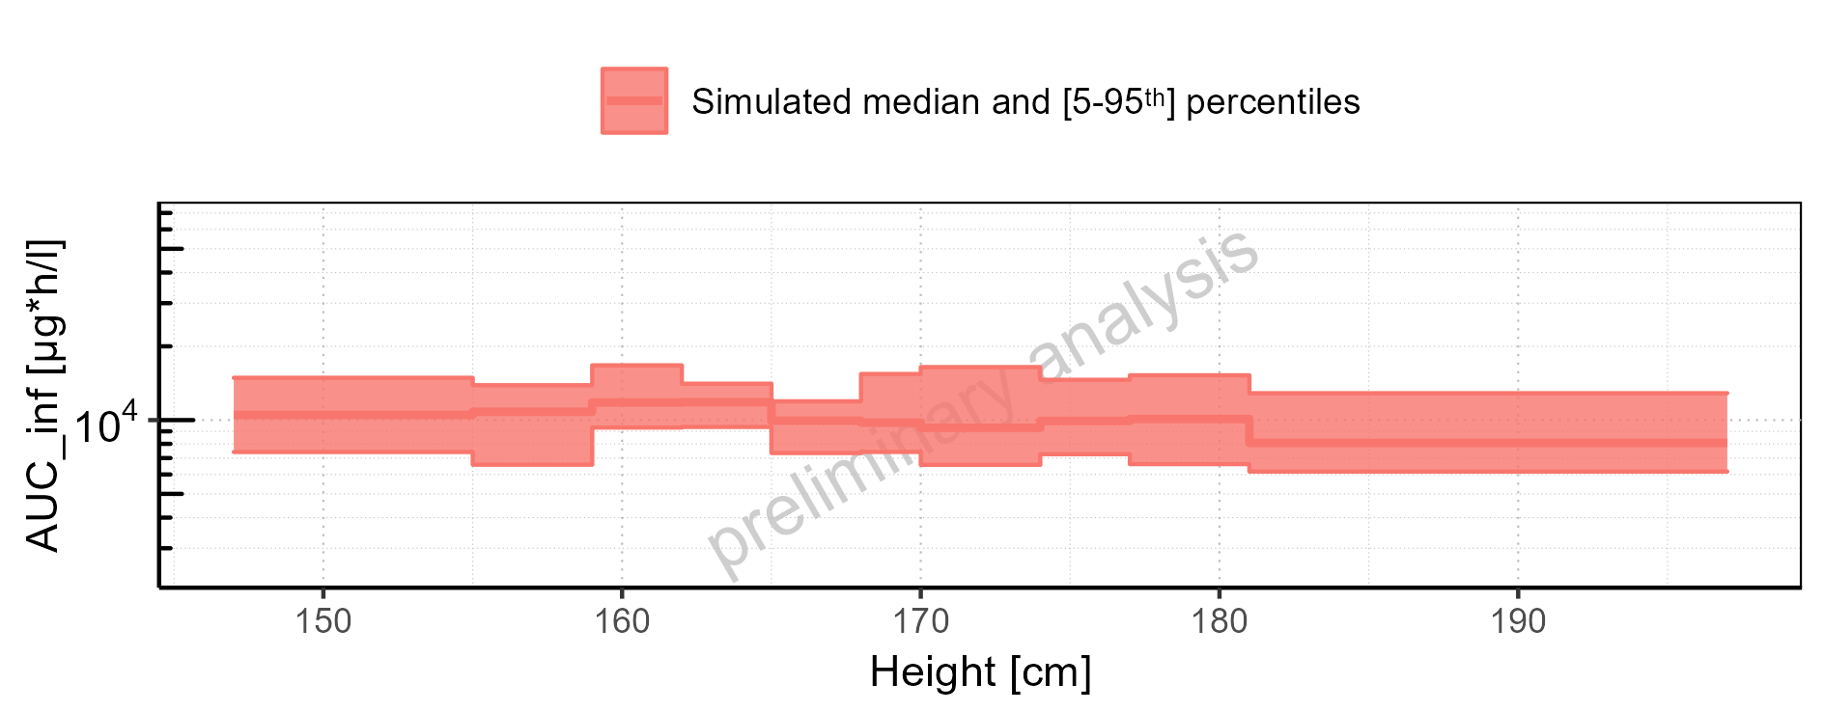

Figure 2-170: Height-dependence of AUC_inf for Filmcoated_tablet_400mg_sd. Profiles are plotted in a linear scale.

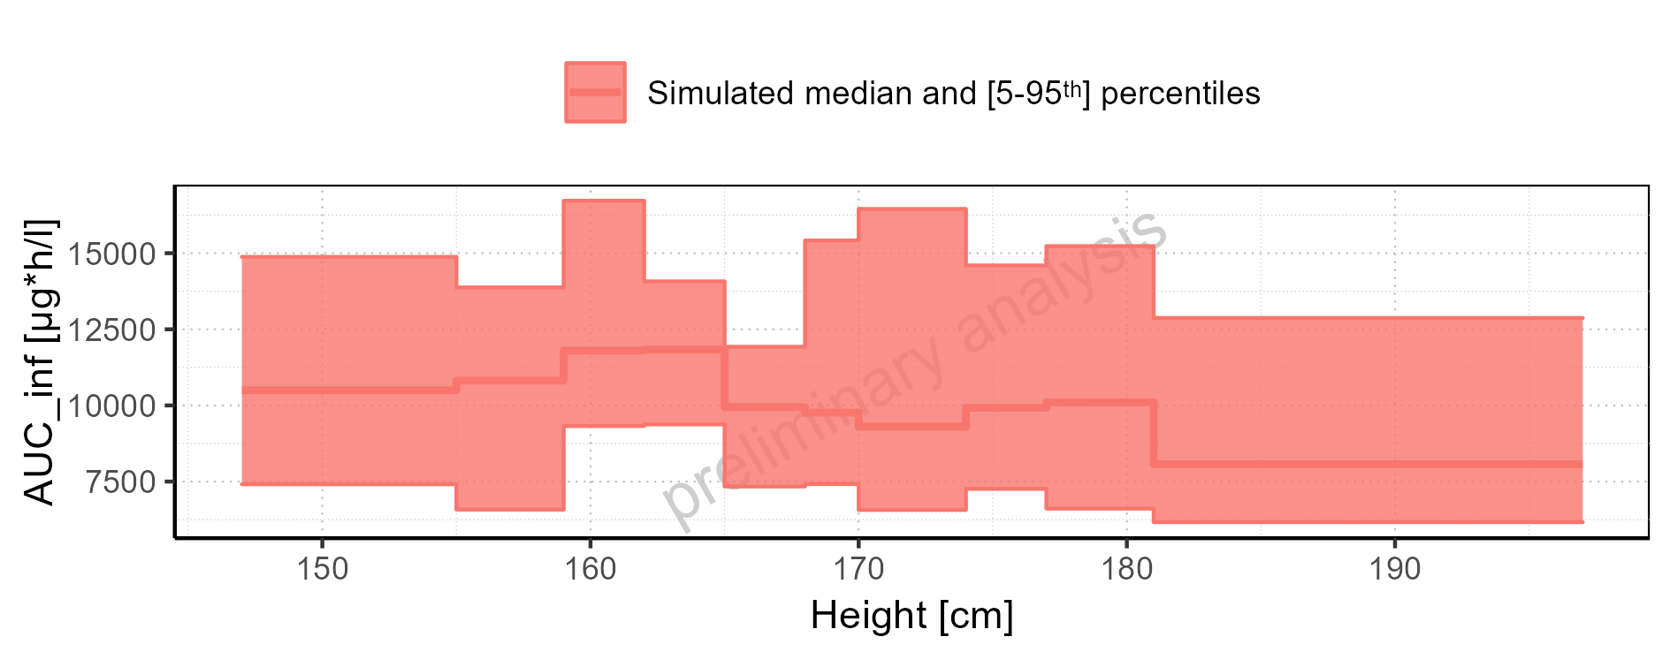

Figure 2-171: Weight-dependence of AUC_inf for Larson 2013 8y-18y 400mg FCT meal in comparison to Filmcoated_tablet_400mg_sd. Profiles are plotted in a logarithmic scale.

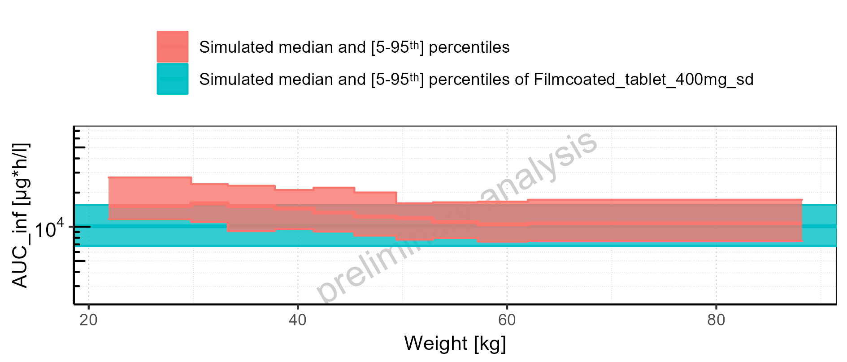

Figure 2-172: Weight-dependence of AUC_inf for Larson 2013 8y-18y 400mg FCT meal in comparison to Filmcoated_tablet_400mg_sd. Profiles are plotted in a linear scale.

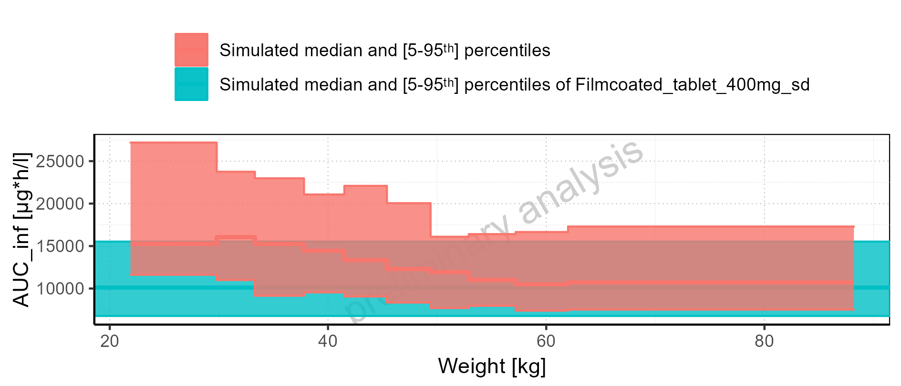

Figure 2-173: Weight-dependence of AUC_inf for Larson 2013 8y-18y 400mg FCT meal. Profiles are plotted in a logarithmic scale.

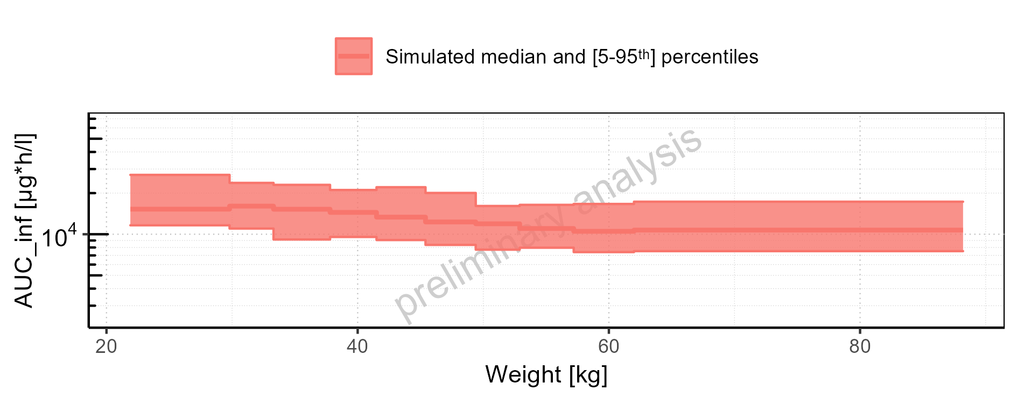

Figure 2-174: Weight-dependence of AUC_inf for Larson 2013 8y-18y 400mg FCT meal. Profiles are plotted in a linear scale.

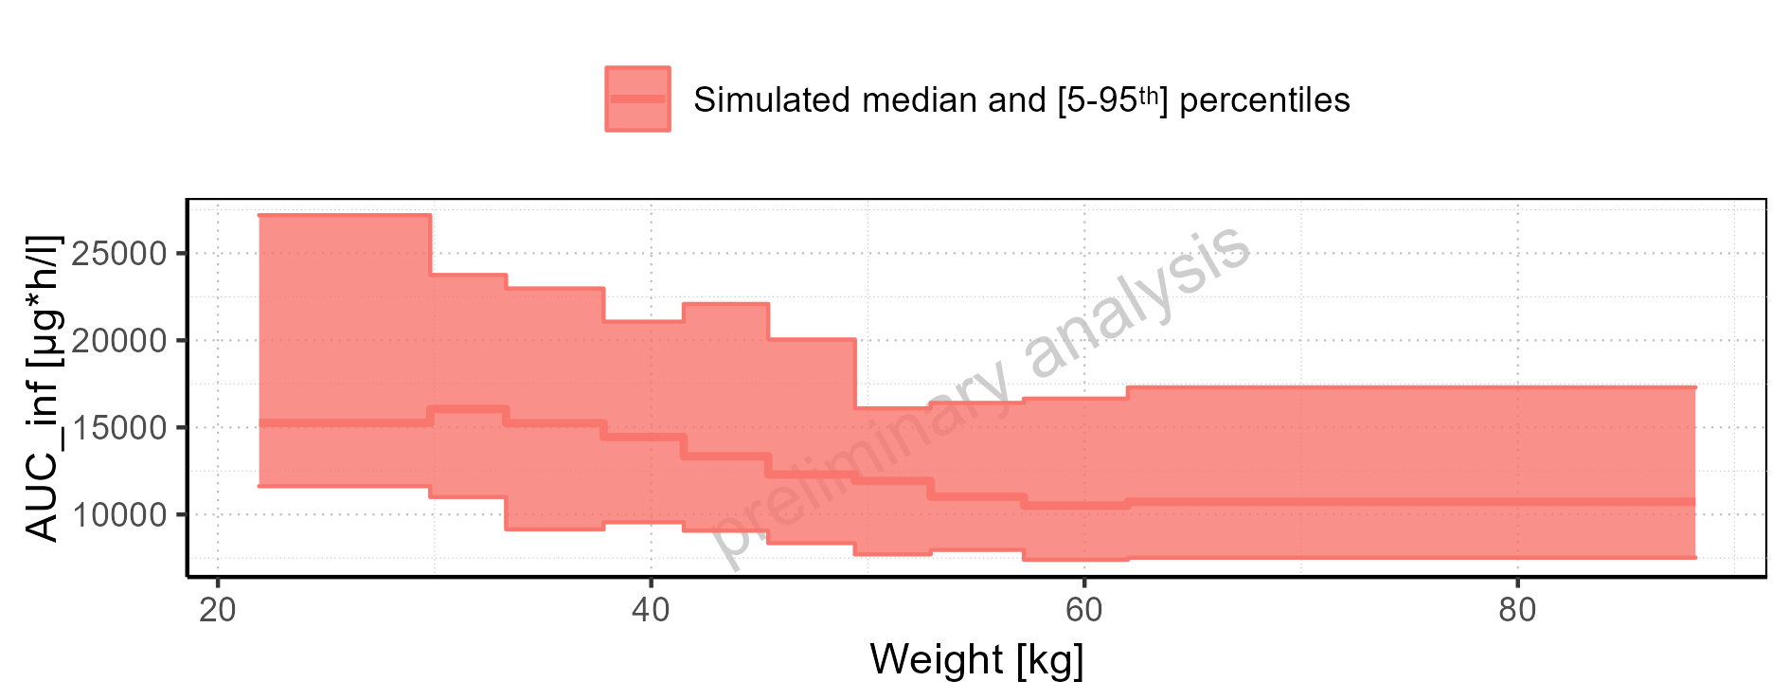

Figure 2-175: Weight-dependence of AUC_inf for Filmcoated_tablet_400mg_sd. Profiles are plotted in a logarithmic scale.

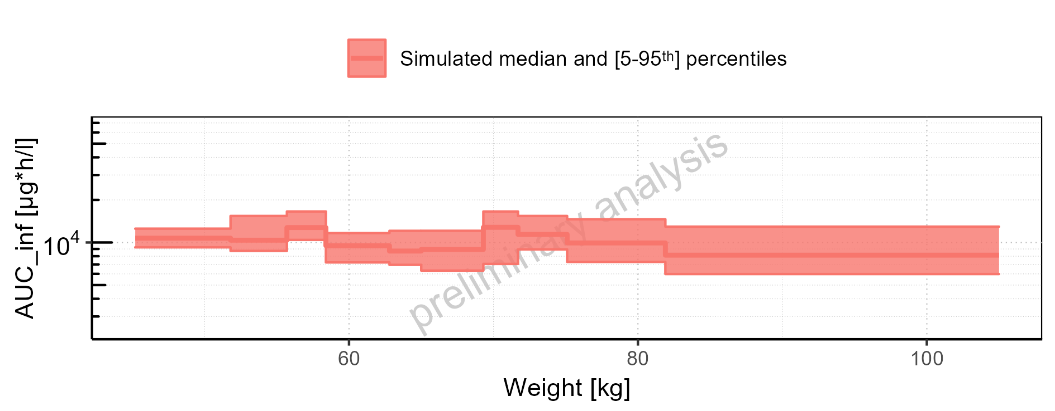

Figure 2-176: Weight-dependence of AUC_inf for Filmcoated_tablet_400mg_sd. Profiles are plotted in a linear scale.

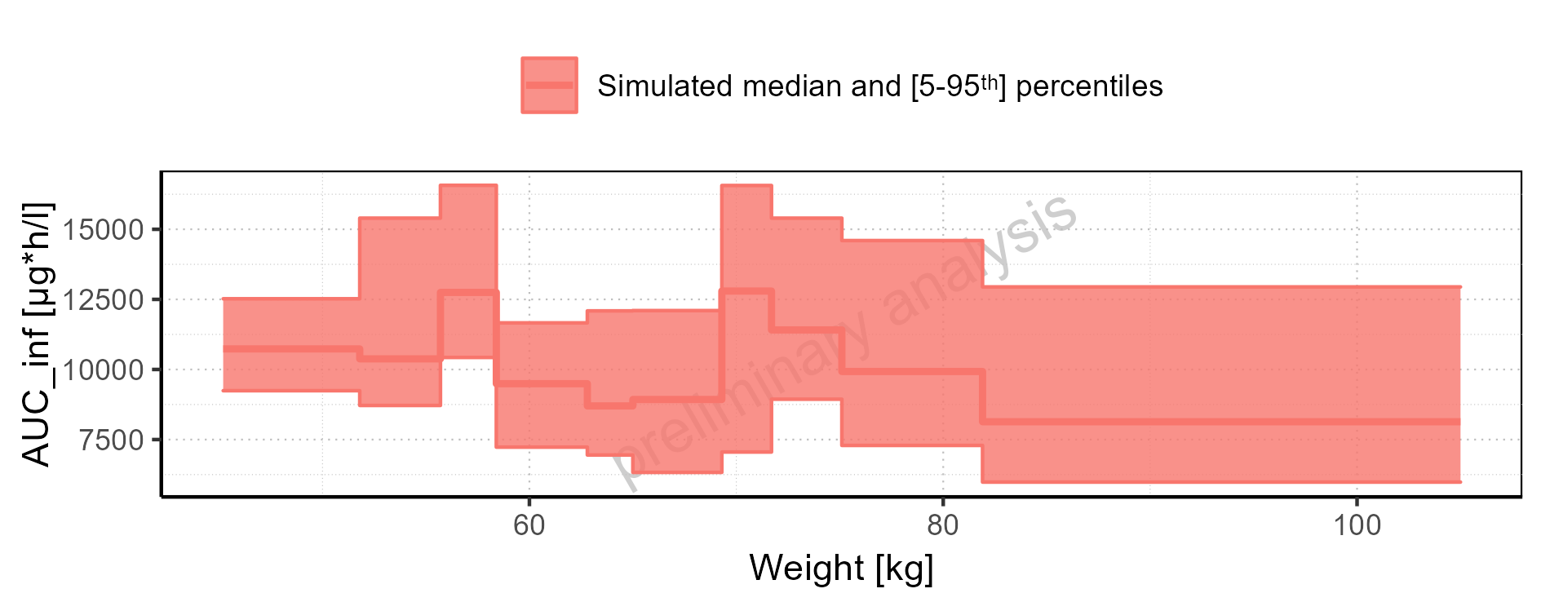

Figure 2-177: BMI-dependence of AUC_inf for Larson 2013 8y-18y 400mg FCT meal in comparison to Filmcoated_tablet_400mg_sd. Profiles are plotted in a logarithmic scale.

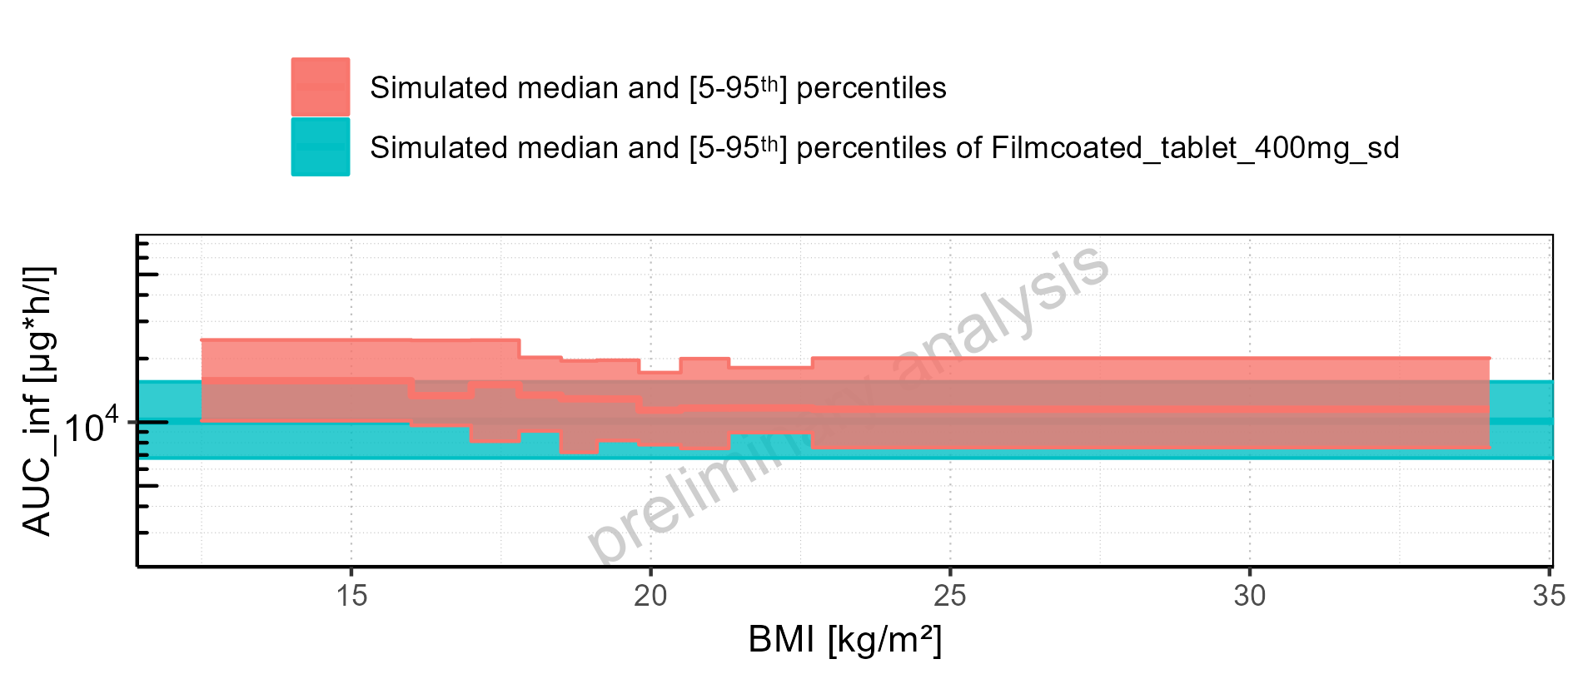

Figure 2-178: BMI-dependence of AUC_inf for Larson 2013 8y-18y 400mg FCT meal in comparison to Filmcoated_tablet_400mg_sd. Profiles are plotted in a linear scale.

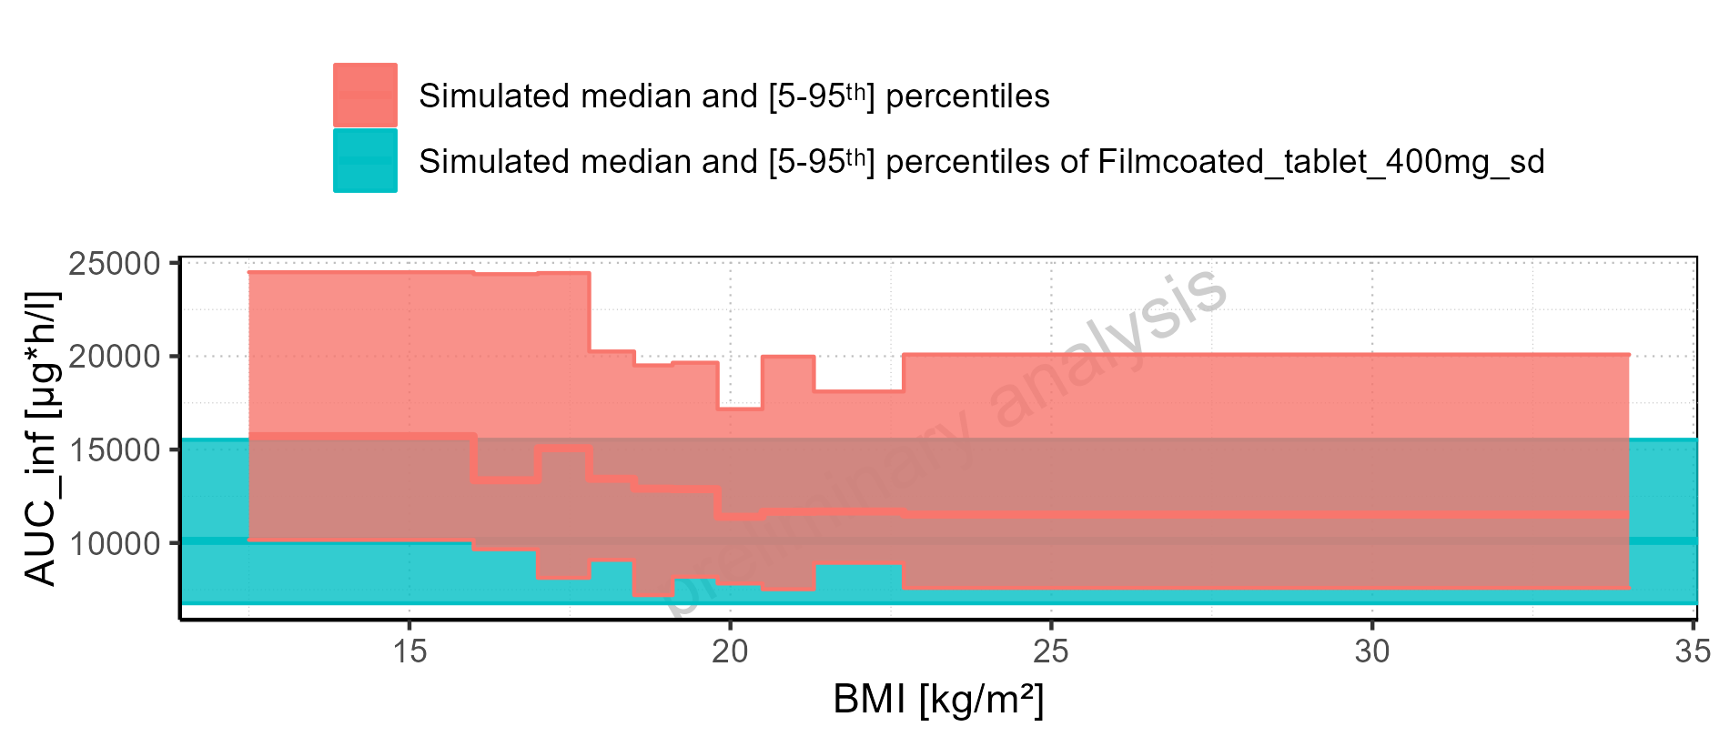

Figure 2-179: BMI-dependence of AUC_inf for Larson 2013 8y-18y 400mg FCT meal. Profiles are plotted in a logarithmic scale.

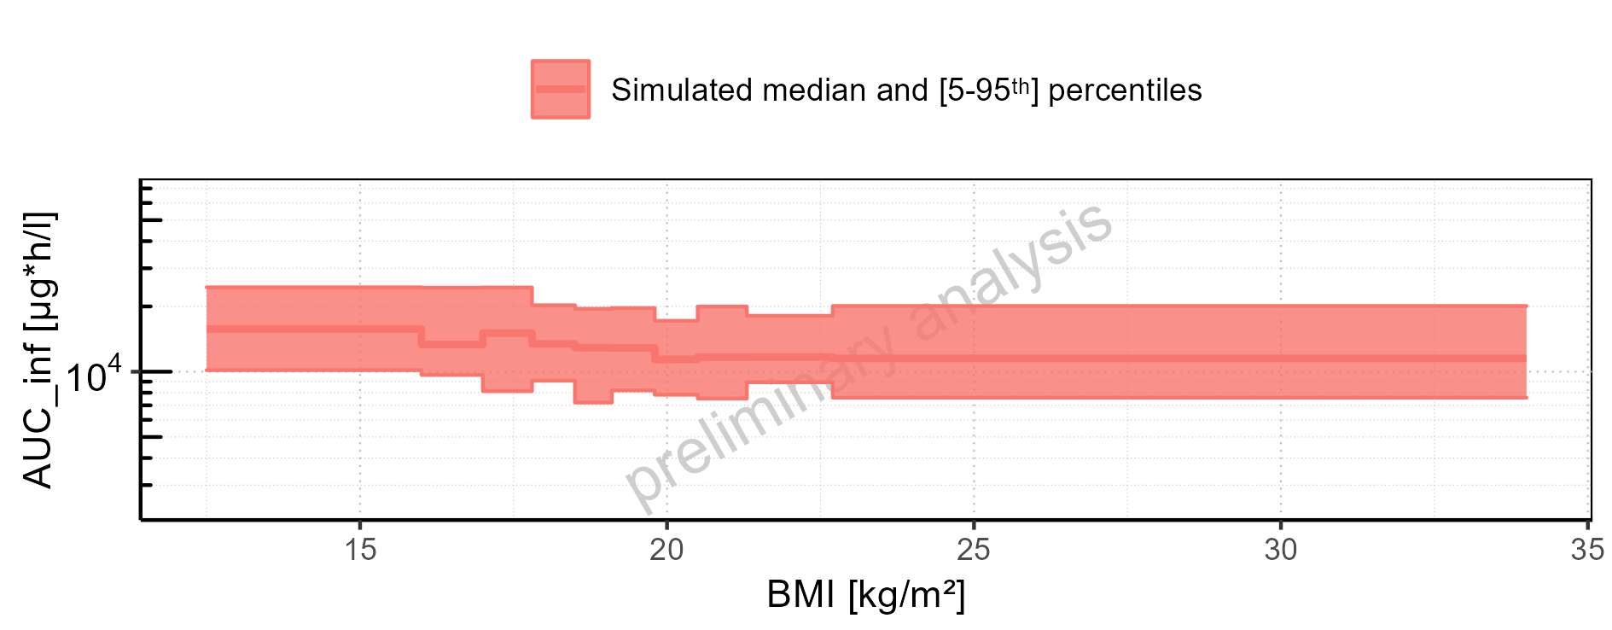

Figure 2-180: BMI-dependence of AUC_inf for Larson 2013 8y-18y 400mg FCT meal. Profiles are plotted in a linear scale.

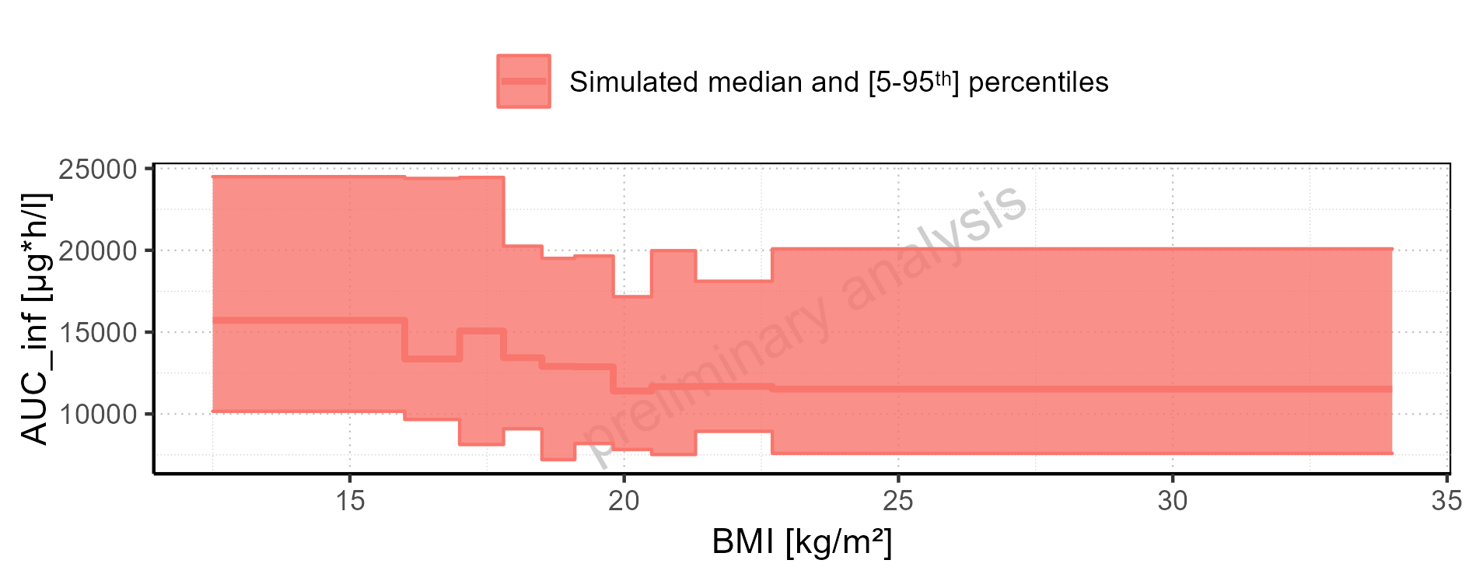

Figure 2-181: BMI-dependence of AUC_inf for Filmcoated_tablet_400mg_sd. Profiles are plotted in a logarithmic scale.

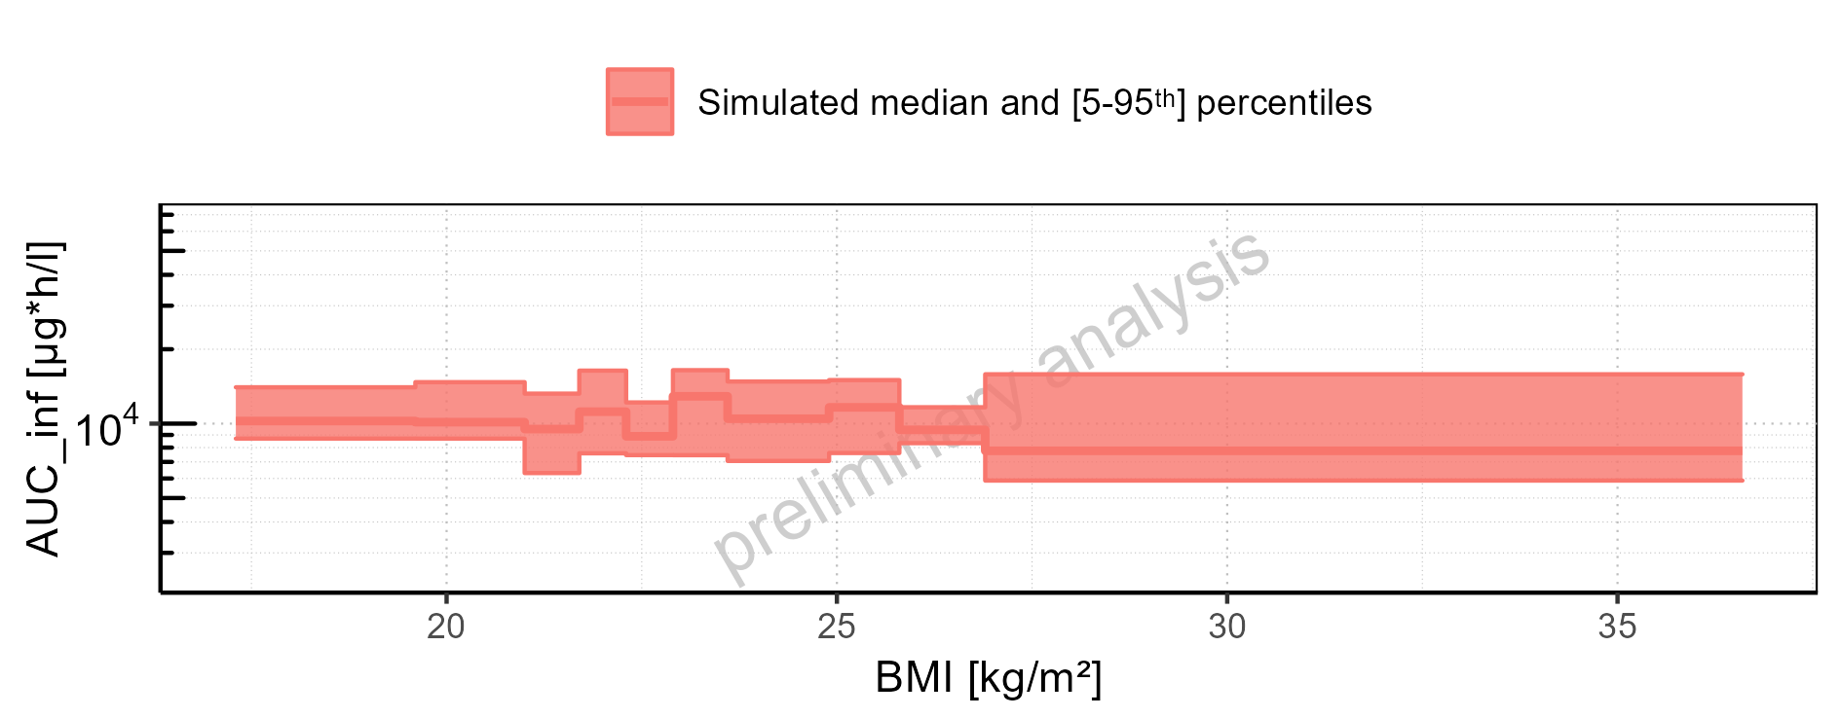

Figure 2-182: BMI-dependence of AUC_inf for Filmcoated_tablet_400mg_sd. Profiles are plotted in a linear scale.

### AUC_inf_norm

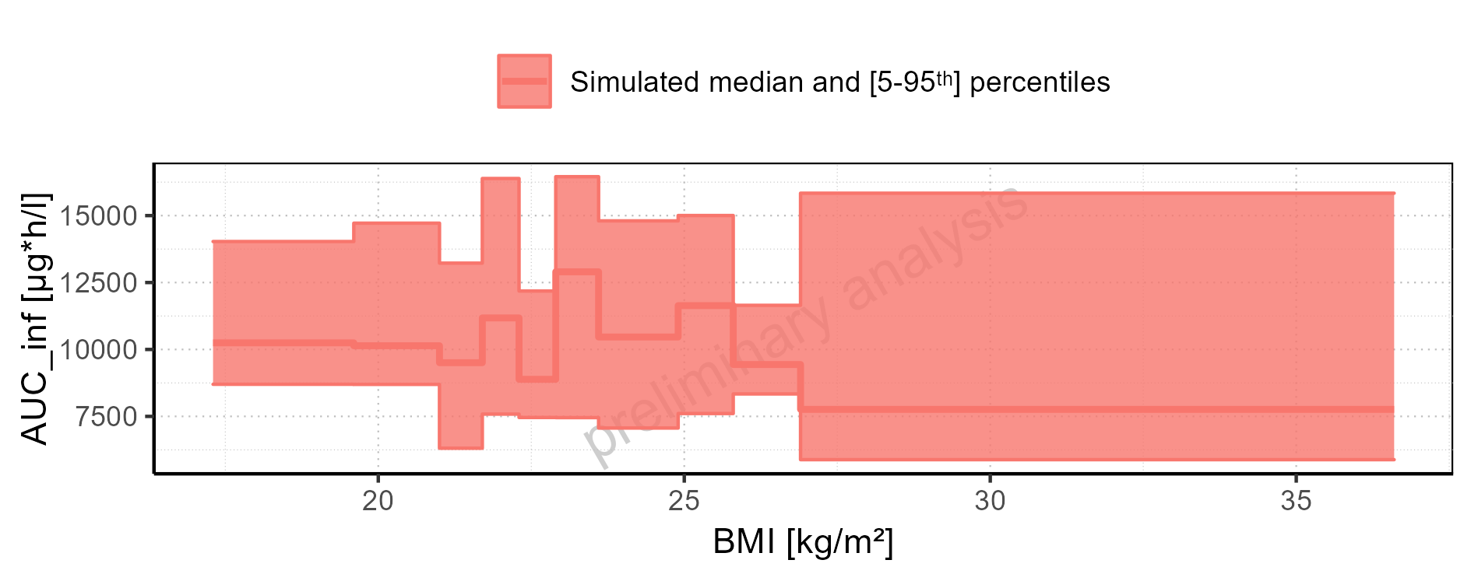

Figure 2-183: AUC_inf_norm of Raltegravir for Larson 2013 8y-18y 400mg FCT meal, Filmcoated_tablet_400mg_sd shown as box-whisker plot, which indicates the 5<U+1D57><U+02B0>, 25<U+1D57><U+02B0>, 50<U+1D57><U+02B0>, 75<U+1D57><U+02B0>, 95<U+1D57><U+02B0> percentiles in logarithmic scale.

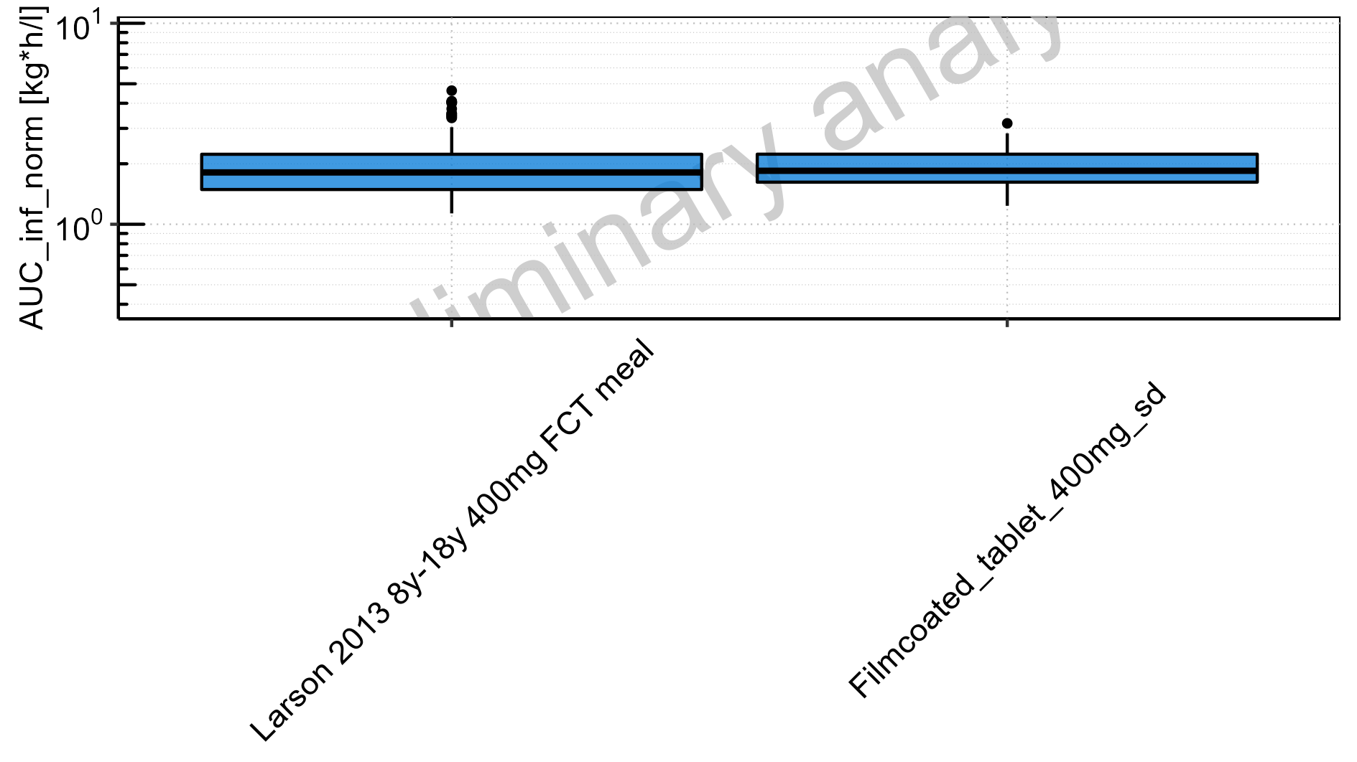

Figure 2-184: AUC_inf_norm of Raltegravir for Larson 2013 8y-18y 400mg FCT meal, Filmcoated_tablet_400mg_sd shown as box-whisker plot, which indicates the 5<U+1D57><U+02B0>, 25<U+1D57><U+02B0>, 50<U+1D57><U+02B0>, 75<U+1D57><U+02B0>, 95<U+1D57><U+02B0> percentiles in linear scale.

**Table 2-8: AUC_inf_norm of Raltegravir for Larson 2013 8y-18y 400mg FCT meal, Filmcoated_tablet_400mg_sd reported in [kg*h/l]**

|  |  |  |  |  |  |  |  |  |  |  |
| --- | --- | --- | --- | --- | --- | --- | --- | --- | --- | --- |
| Population | N | 5<U+1D57><U+02B0> pctl | 25<U+1D57><U+02B0> pctl | 50<U+1D57><U+02B0> pctl | 75<U+1D57><U+02B0> pctl | 95<U+1D57><U+02B0> pctl | Mean | SD | Geo Mean | Geo SD |
| Larson 2013 8y-18y 400mg FCT meal | 500 | 1.12 | 1.47 | 1.81 | 2.22 | 3.04 | 1.91 | 0.62 | 0.00 | - |
| Filmcoated_tablet_400mg_sd | 100 | 1.24 | 1.62 | 1.85 | 2.23 | 2.83 | 1.94 | 0.50 | 1.88 | 1.30 |

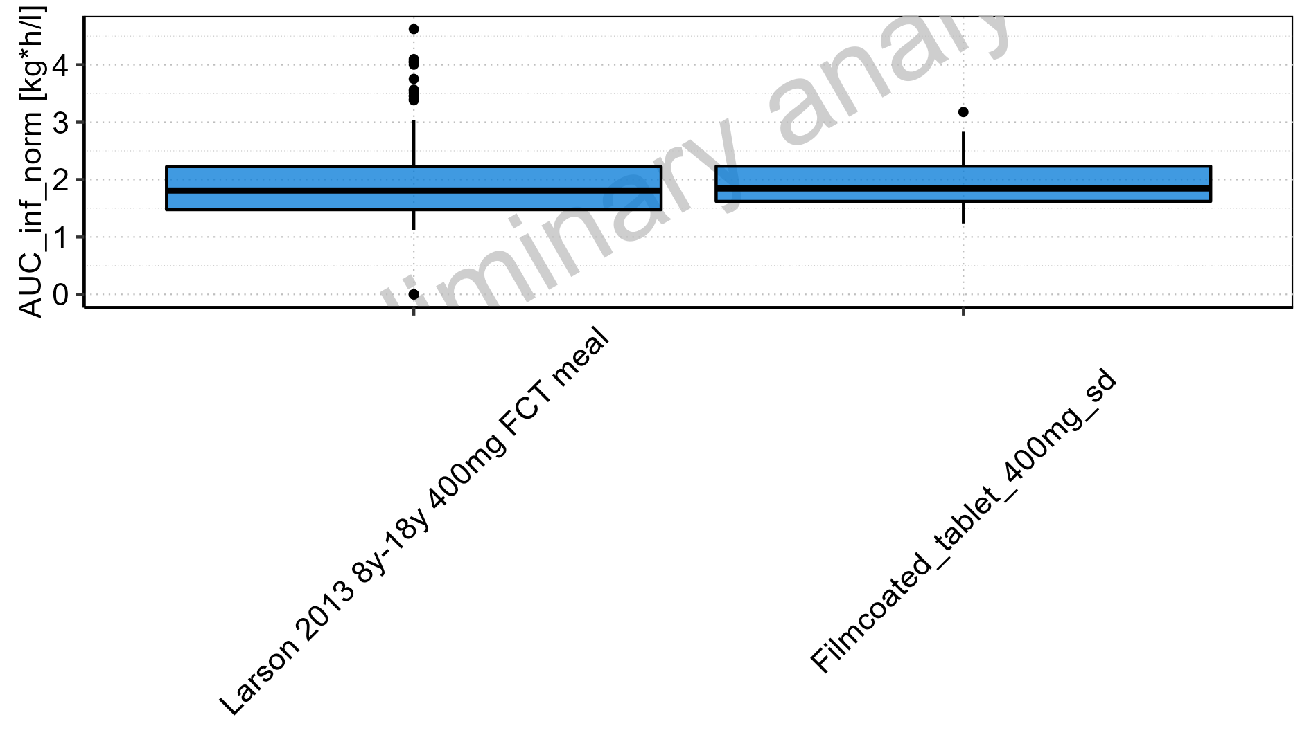

Figure 2-185: Age-dependence of AUC_inf_norm for Larson 2013 8y-18y 400mg FCT meal in comparison to Filmcoated_tablet_400mg_sd. Profiles are plotted in a logarithmic scale.

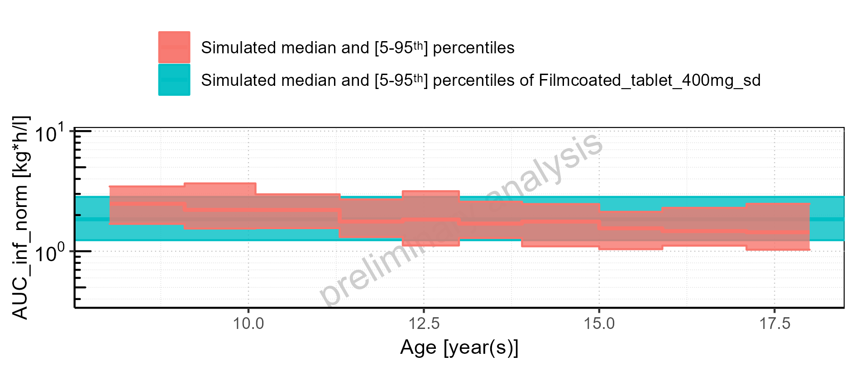

Figure 2-186: Age-dependence of AUC_inf_norm for Larson 2013 8y-18y 400mg FCT meal in comparison to Filmcoated_tablet_400mg_sd. Profiles are plotted in a linear scale.

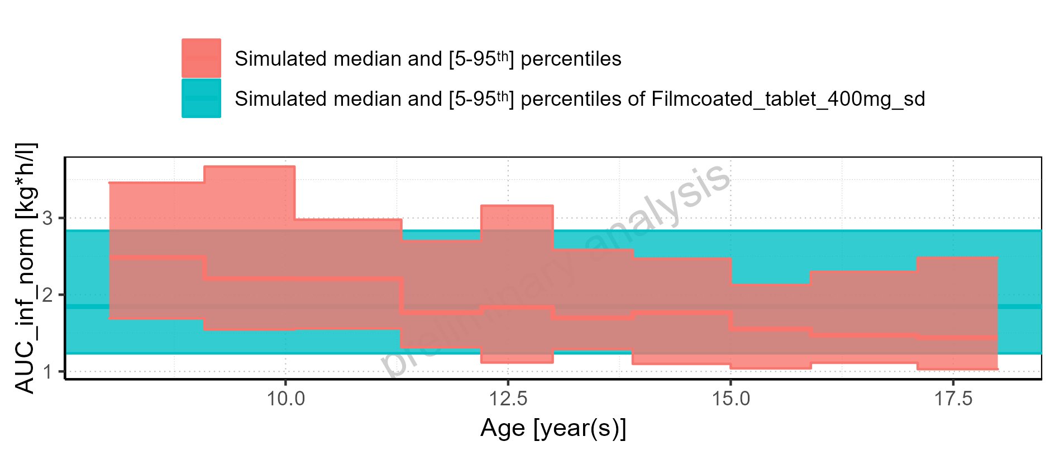

Figure 2-187: Age-dependence of AUC_inf_norm for Larson 2013 8y-18y 400mg FCT meal. Profiles are plotted in a logarithmic scale.

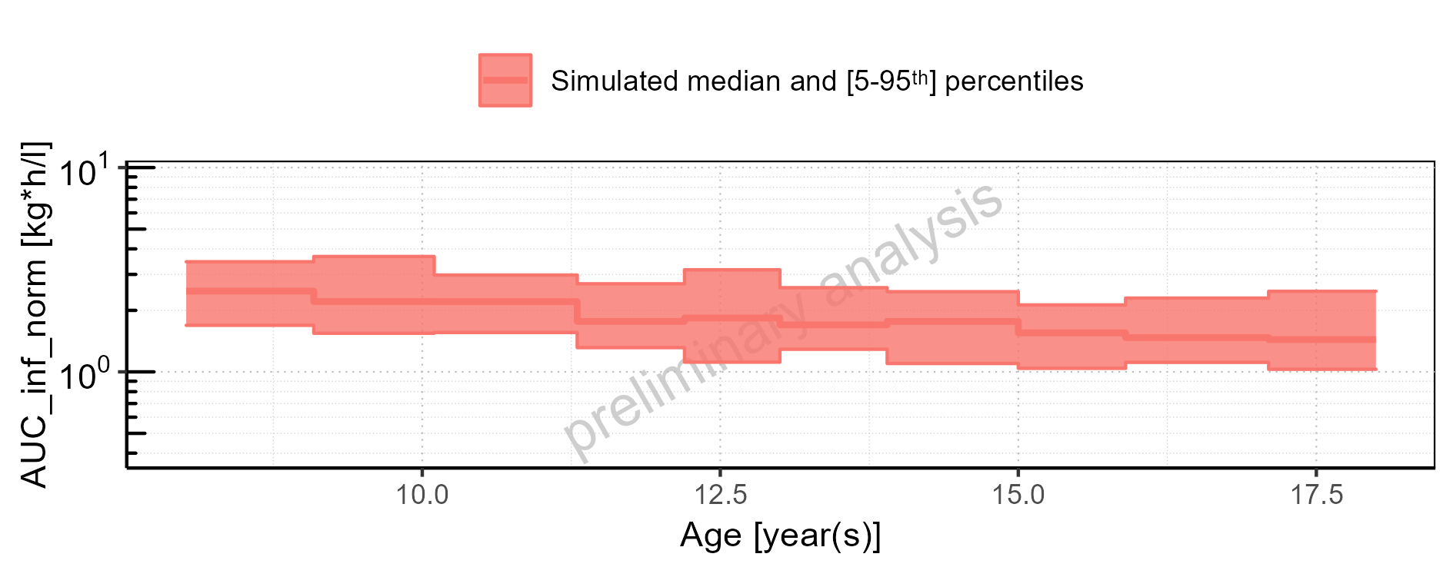

Figure 2-188: Age-dependence of AUC_inf_norm for Larson 2013 8y-18y 400mg FCT meal. Profiles are plotted in a linear scale.

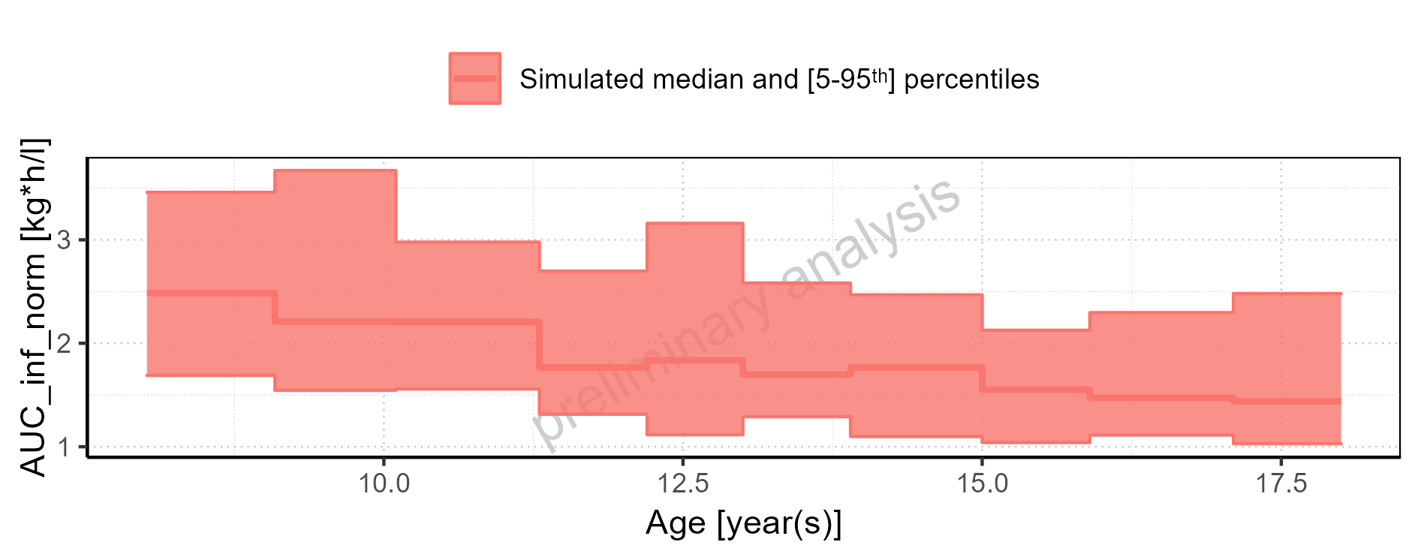

Figure 2-189: Age-dependence of AUC_inf_norm for Filmcoated_tablet_400mg_sd. Profiles are plotted in a logarithmic scale.

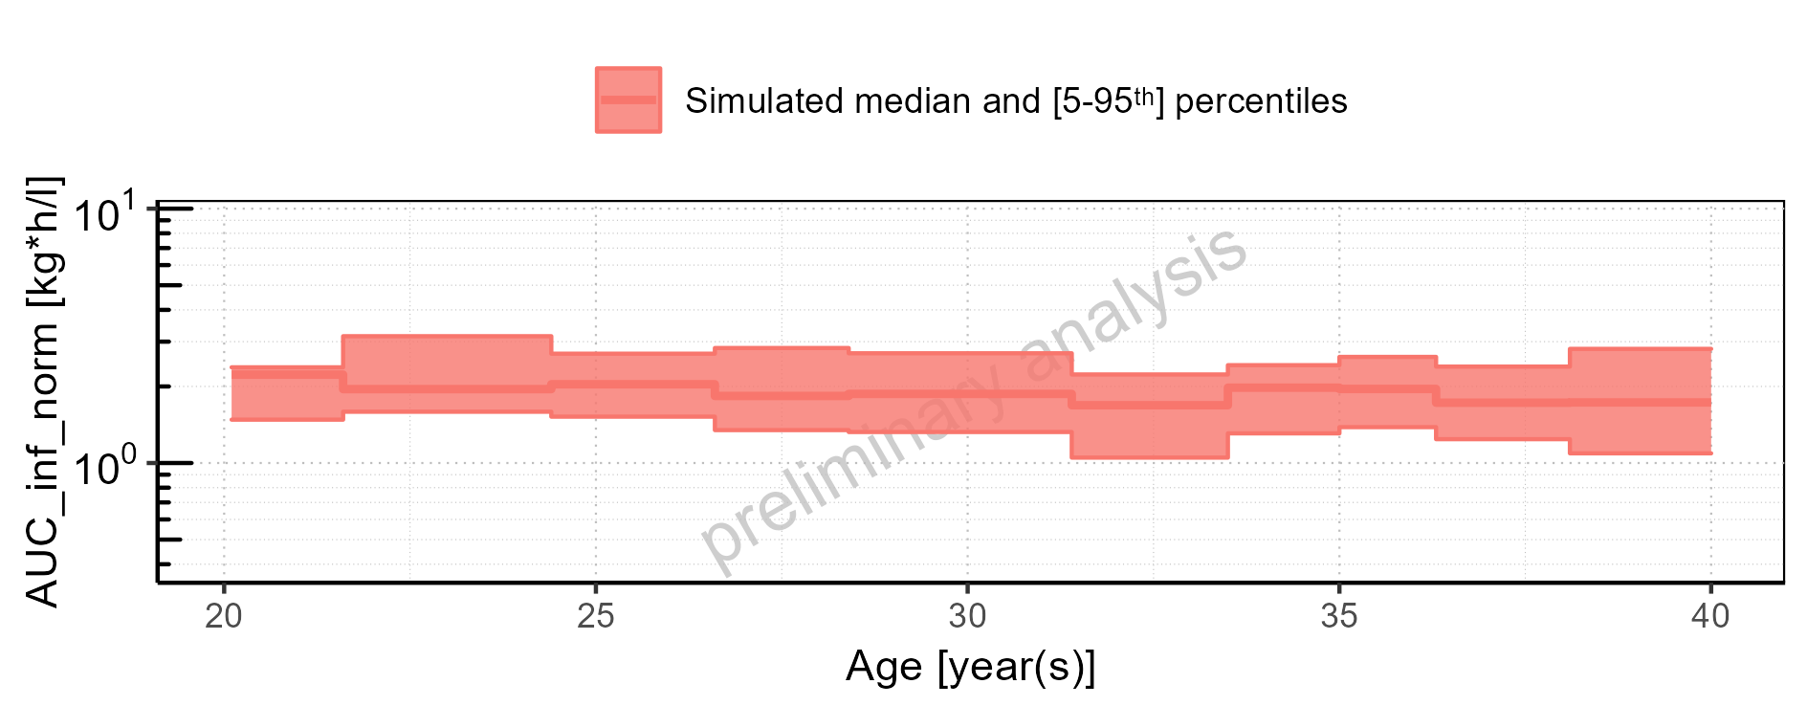

Figure 2-190: Age-dependence of AUC_inf_norm for Filmcoated_tablet_400mg_sd. Profiles are plotted in a linear scale.

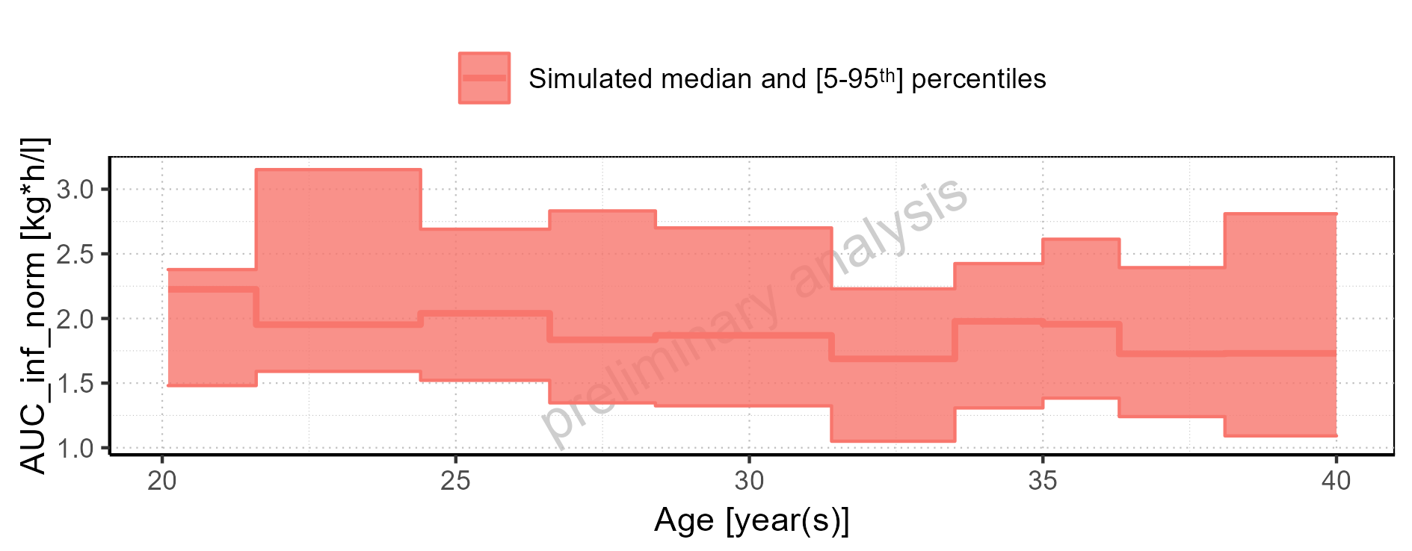

Figure 2-191: Height-dependence of AUC_inf_norm for Larson 2013 8y-18y 400mg FCT meal in comparison to Filmcoated_tablet_400mg_sd. Profiles are plotted in a logarithmic scale.

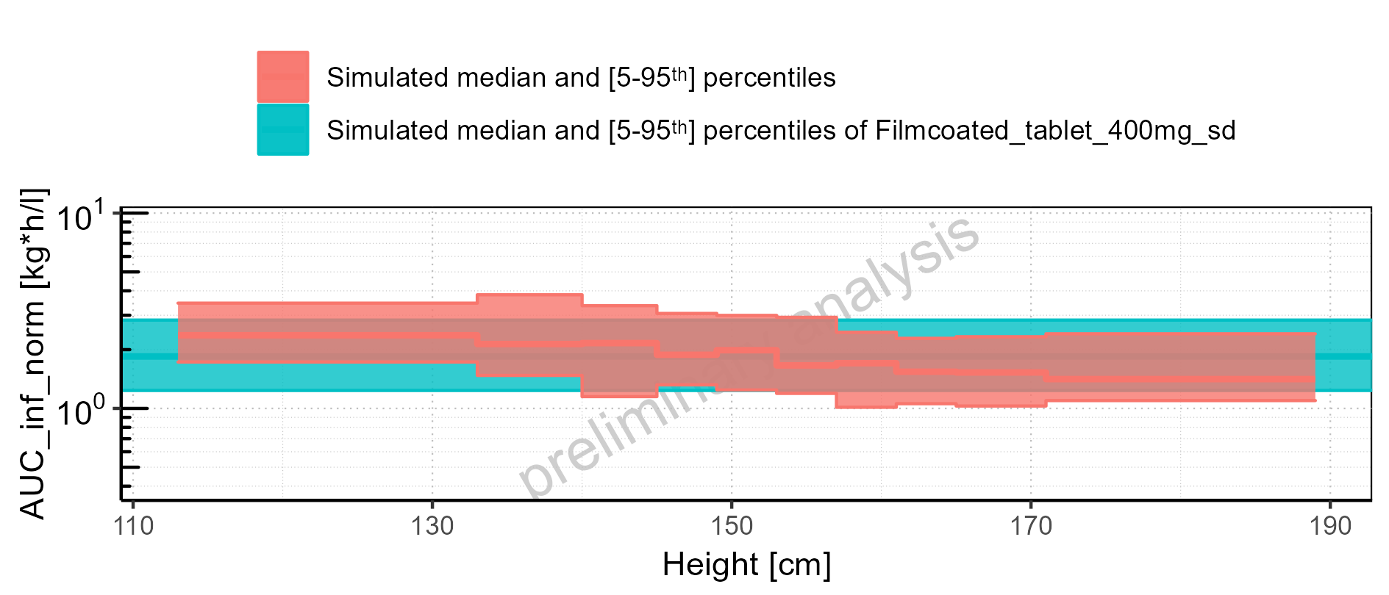

Figure 2-192: Height-dependence of AUC_inf_norm for Larson 2013 8y-18y 400mg FCT meal in comparison to Filmcoated_tablet_400mg_sd. Profiles are plotted in a linear scale.

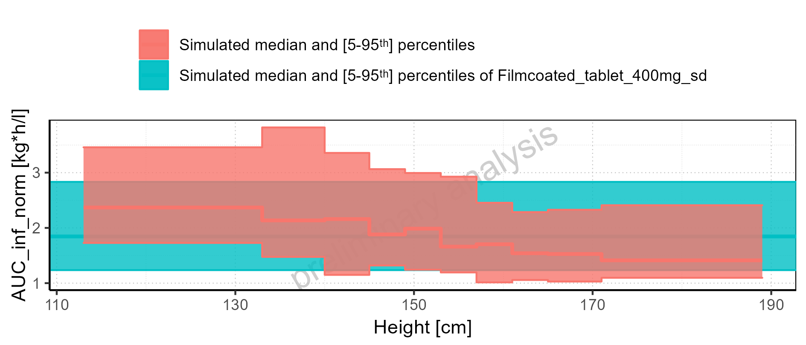

Figure 2-193: Height-dependence of AUC_inf_norm for Larson 2013 8y-18y 400mg FCT meal. Profiles are plotted in a logarithmic scale.

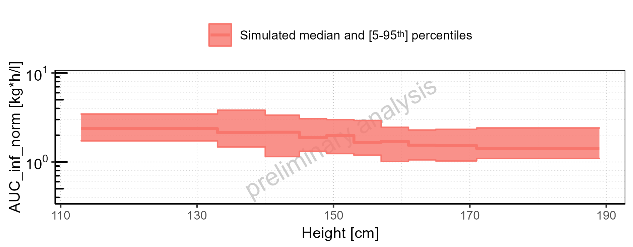

Figure 2-194: Height-dependence of AUC_inf_norm for Larson 2013 8y-18y 400mg FCT meal. Profiles are plotted in a linear scale.

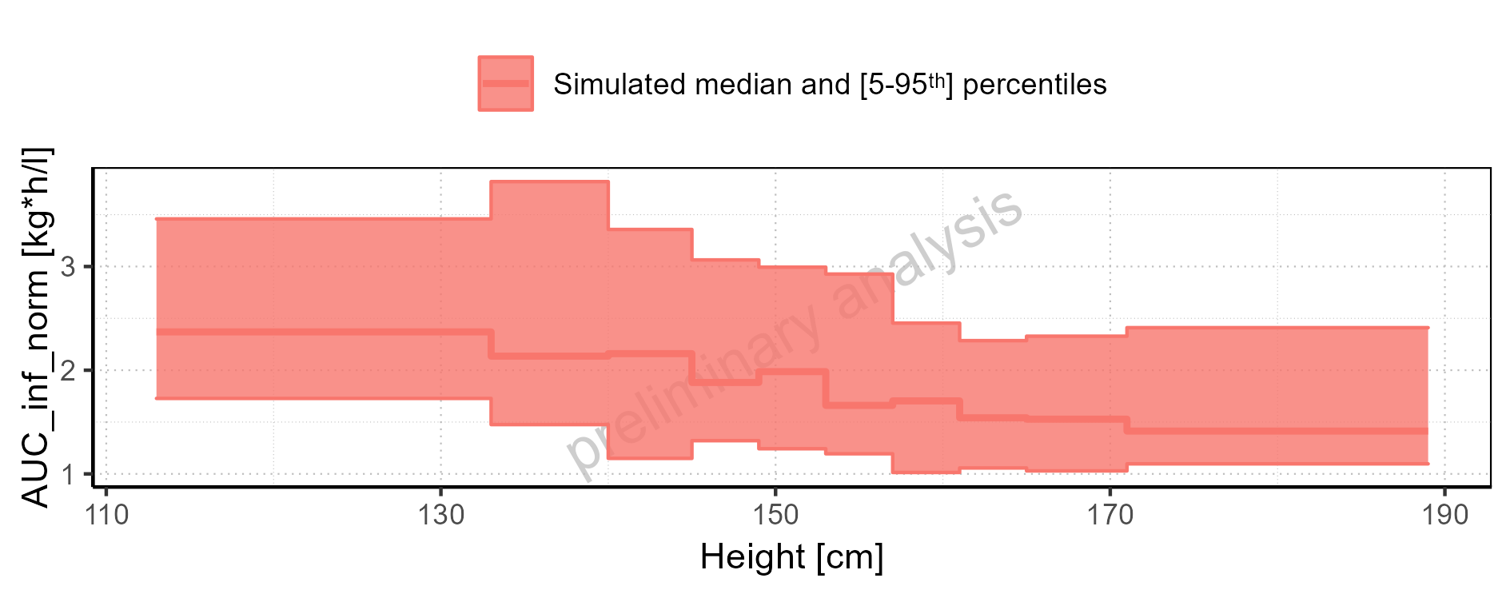

Figure 2-195: Height-dependence of AUC_inf_norm for Filmcoated_tablet_400mg_sd. Profiles are plotted in a logarithmic scale.

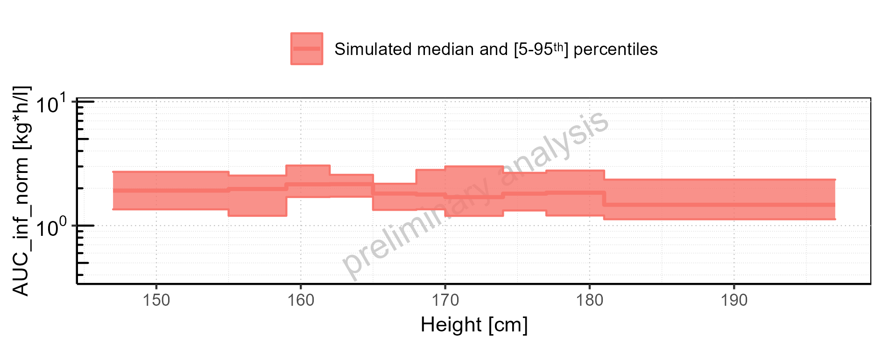

Figure 2-196: Height-dependence of AUC_inf_norm for Filmcoated_tablet_400mg_sd. Profiles are plotted in a linear scale.

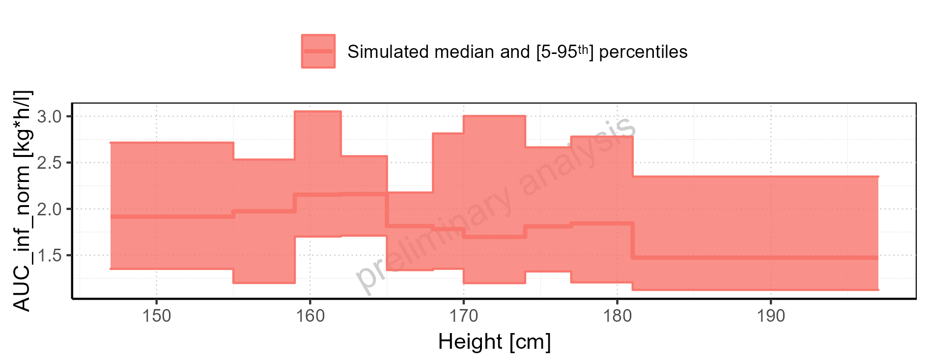

Figure 2-197: Weight-dependence of AUC_inf_norm for Larson 2013 8y-18y 400mg FCT meal in comparison to Filmcoated_tablet_400mg_sd. Profiles are plotted in a logarithmic scale.

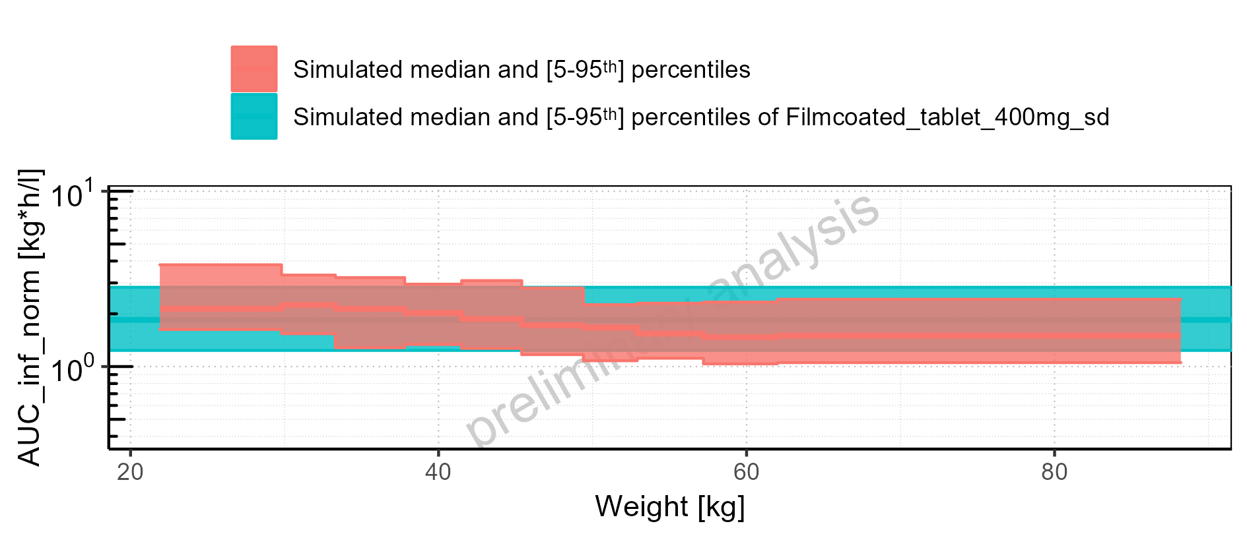

Figure 2-198: Weight-dependence of AUC_inf_norm for Larson 2013 8y-18y 400mg FCT meal in comparison to Filmcoated_tablet_400mg_sd. Profiles are plotted in a linear scale.

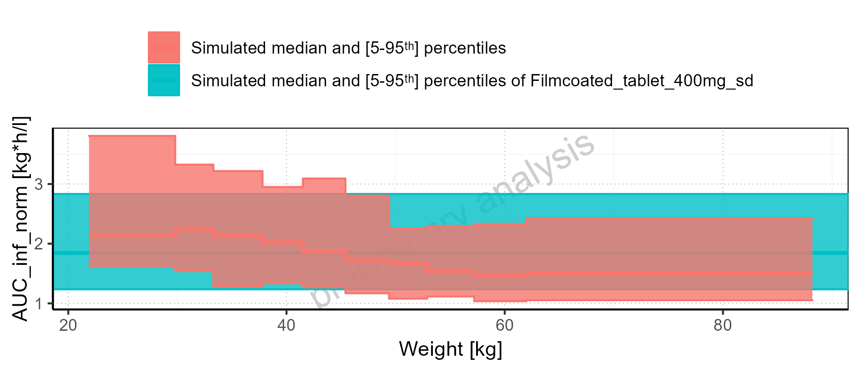

Figure 2-199: Weight-dependence of AUC_inf_norm for Larson 2013 8y-18y 400mg FCT meal. Profiles are plotted in a logarithmic scale.

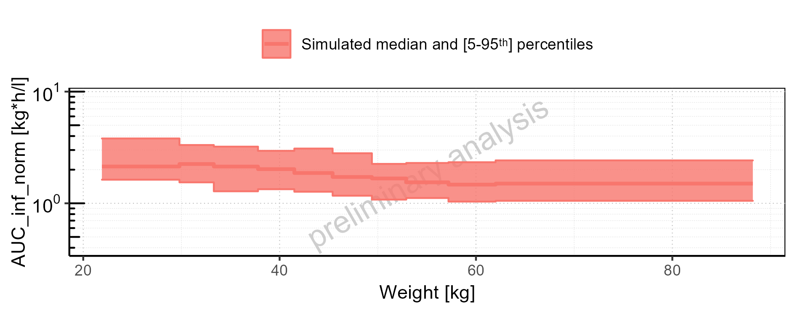

Figure 2-200: Weight-dependence of AUC_inf_norm for Larson 2013 8y-18y 400mg FCT meal. Profiles are plotted in a linear scale.

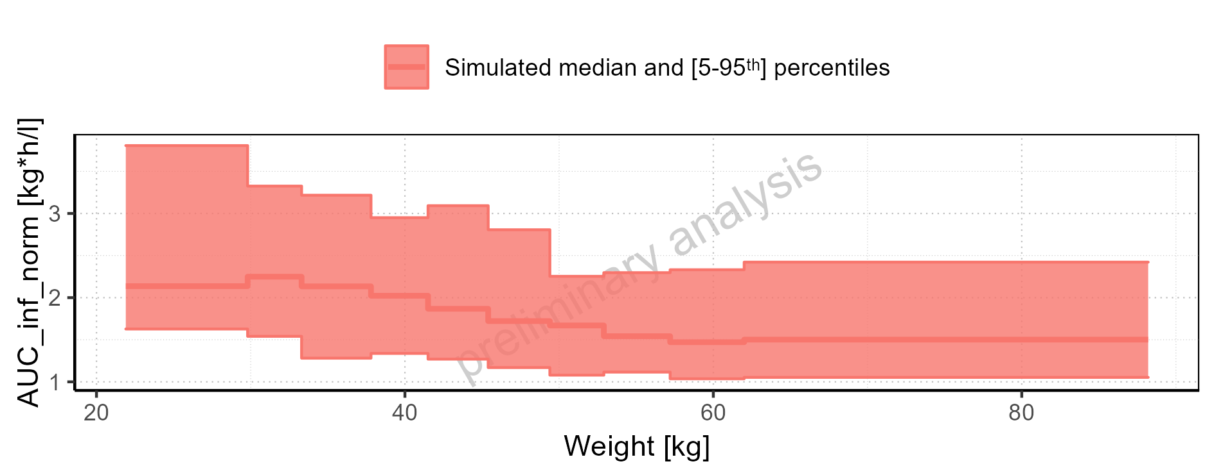

Figure 2-201: Weight-dependence of AUC_inf_norm for Filmcoated_tablet_400mg_sd. Profiles are plotted in a logarithmic scale.

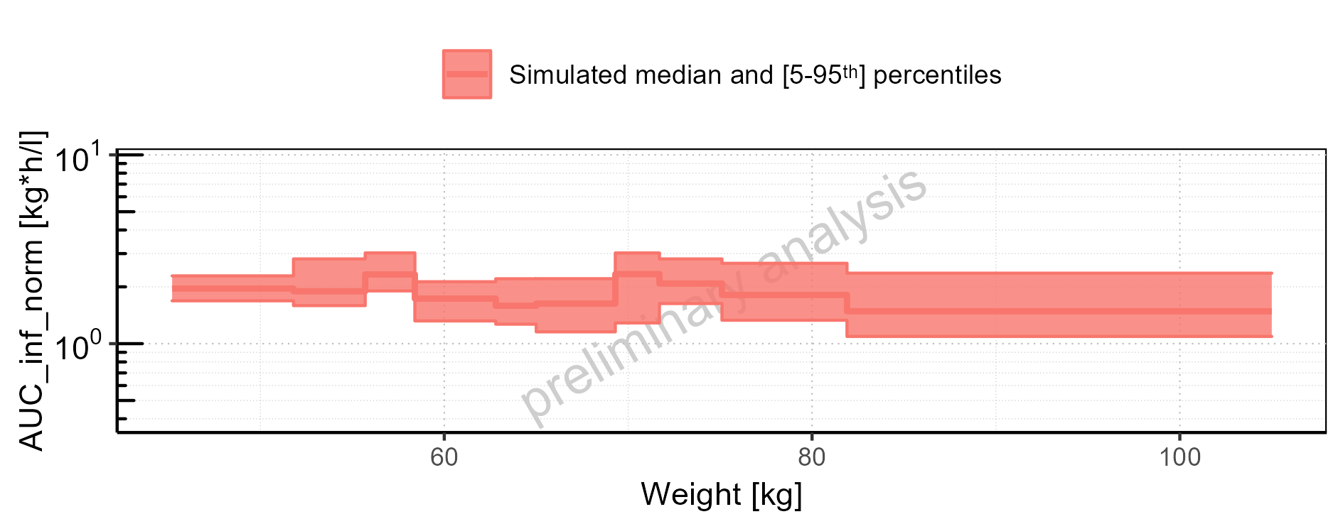

Figure 2-202: Weight-dependence of AUC_inf_norm for Filmcoated_tablet_400mg_sd. Profiles are plotted in a linear scale.

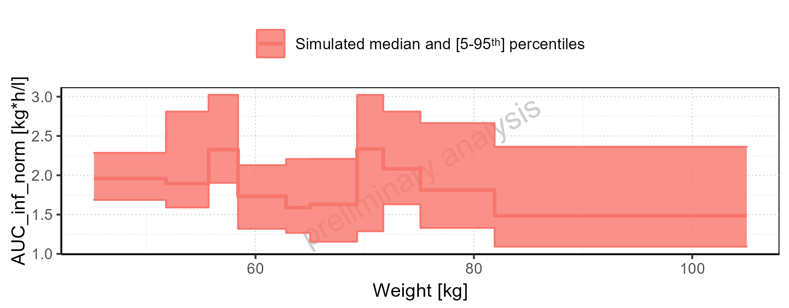

Figure 2-203: BMI-dependence of AUC_inf_norm for Larson 2013 8y-18y 400mg FCT meal in comparison to Filmcoated_tablet_400mg_sd. Profiles are plotted in a logarithmic scale.

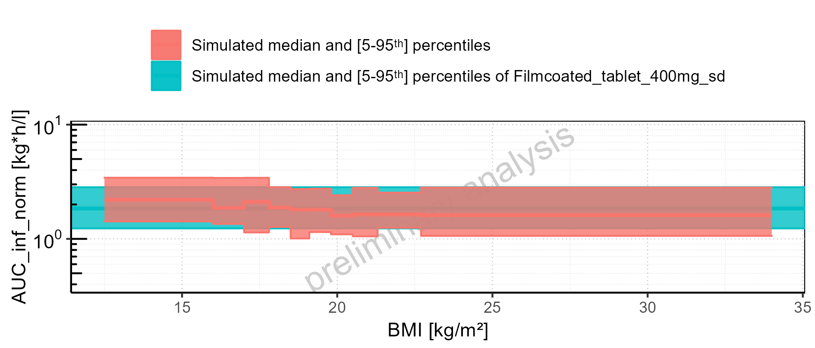

Figure 2-204: BMI-dependence of AUC_inf_norm for Larson 2013 8y-18y 400mg FCT meal in comparison to Filmcoated_tablet_400mg_sd. Profiles are plotted in a linear scale.

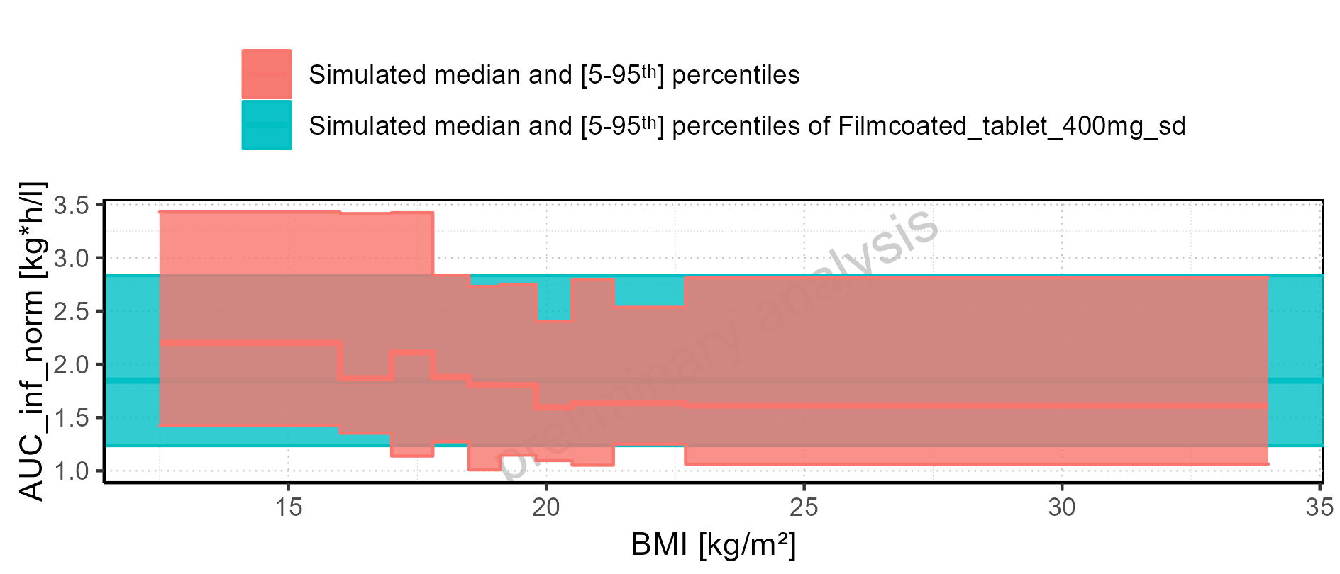

Figure 2-205: BMI-dependence of AUC_inf_norm for Larson 2013 8y-18y 400mg FCT meal. Profiles are plotted in a logarithmic scale.

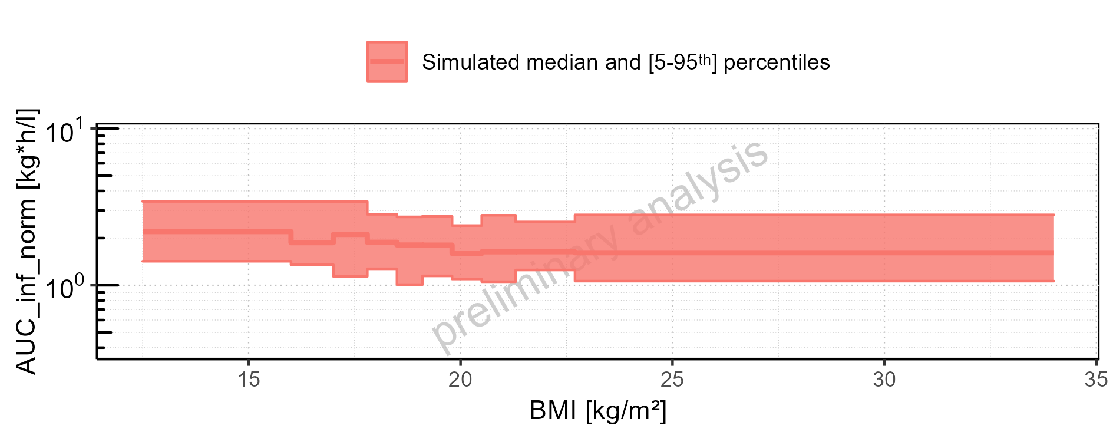

Figure 2-206: BMI-dependence of AUC_inf_norm for Larson 2013 8y-18y 400mg FCT meal. Profiles are plotted in a linear scale.

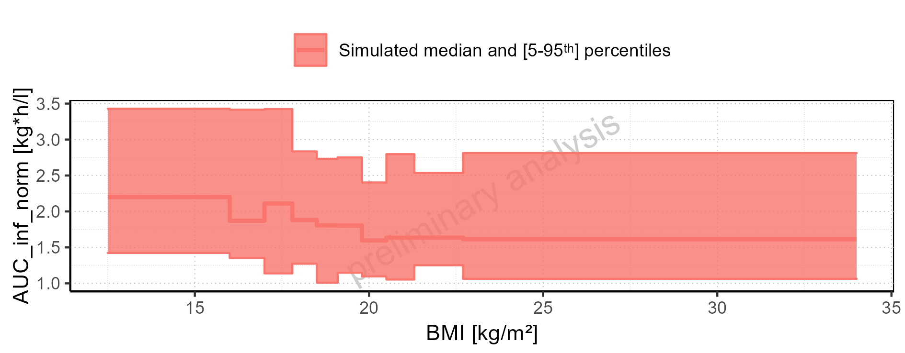

Figure 2-207: BMI-dependence of AUC_inf_norm for Filmcoated_tablet_400mg_sd. Profiles are plotted in a logarithmic scale.

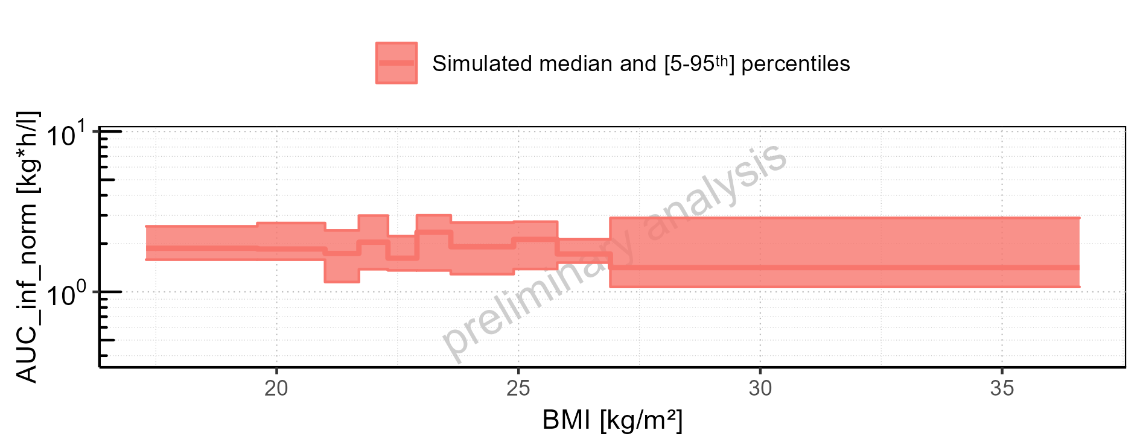

Figure 2-208: BMI-dependence of AUC_inf_norm for Filmcoated_tablet_400mg_sd. Profiles are plotted in a linear scale.

### MRT

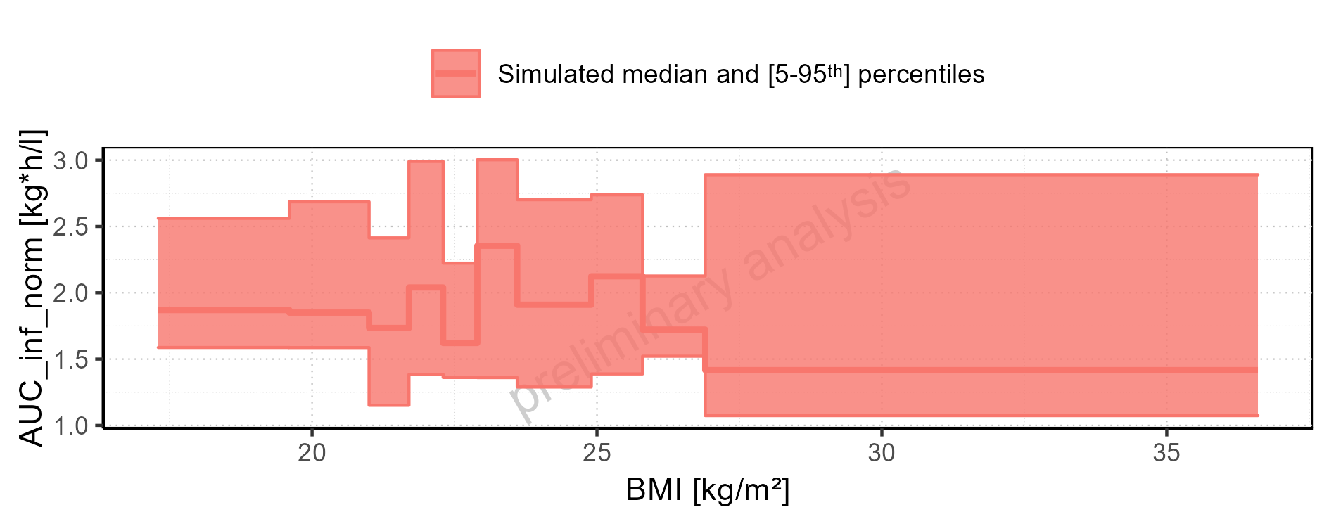

Figure 2-209: MRT of Raltegravir for Larson 2013 8y-18y 400mg FCT meal, Filmcoated_tablet_400mg_sd shown as box-whisker plot, which indicates the 5<U+1D57><U+02B0>, 25<U+1D57><U+02B0>, 50<U+1D57><U+02B0>, 75<U+1D57><U+02B0>, 95<U+1D57><U+02B0> percentiles in logarithmic scale.

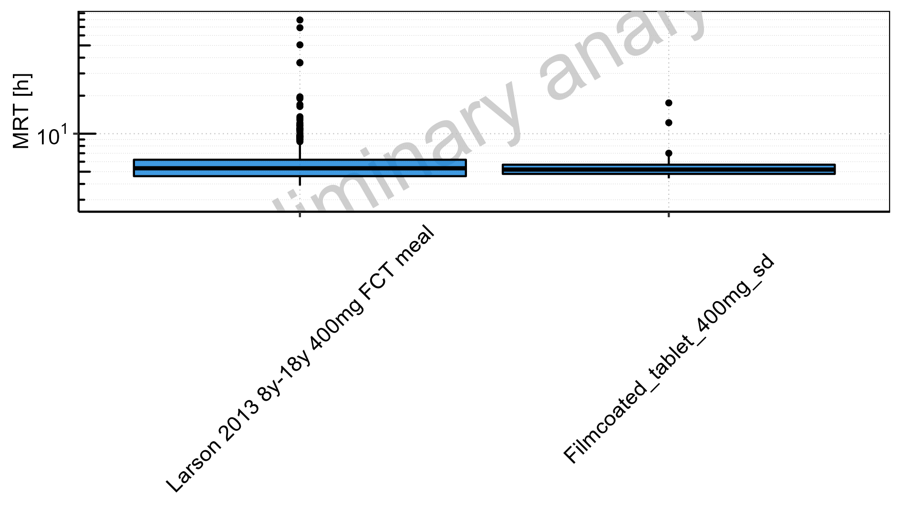

Figure 2-210: MRT of Raltegravir for Larson 2013 8y-18y 400mg FCT meal, Filmcoated_tablet_400mg_sd shown as box-whisker plot, which indicates the 5<U+1D57><U+02B0>, 25<U+1D57><U+02B0>, 50<U+1D57><U+02B0>, 75<U+1D57><U+02B0>, 95<U+1D57><U+02B0> percentiles in linear scale.

**Table 2-9: MRT of Raltegravir for Larson 2013 8y-18y 400mg FCT meal, Filmcoated_tablet_400mg_sd reported in [h]**

|  |  |  |  |  |  |  |  |  |  |  |
| --- | --- | --- | --- | --- | --- | --- | --- | --- | --- | --- |
| Population | N | 5<U+1D57><U+02B0> pctl | 25<U+1D57><U+02B0> pctl | 50<U+1D57><U+02B0> pctl | 75<U+1D57><U+02B0> pctl | 95<U+1D57><U+02B0> pctl | Mean | SD | Geo Mean | Geo SD |
| Larson 2013 8y-18y 400mg FCT meal | 497 | 3.88 | 4.61 | 5.32 | 6.22 | 10.31 | 6.26 | 5.56 | 5.64 | 1.44 |
| Filmcoated_tablet_400mg_sd | 100 | 4.43 | 4.80 | 5.20 | 5.68 | 6.70 | 5.44 | 1.54 | 5.32 | 1.21 |

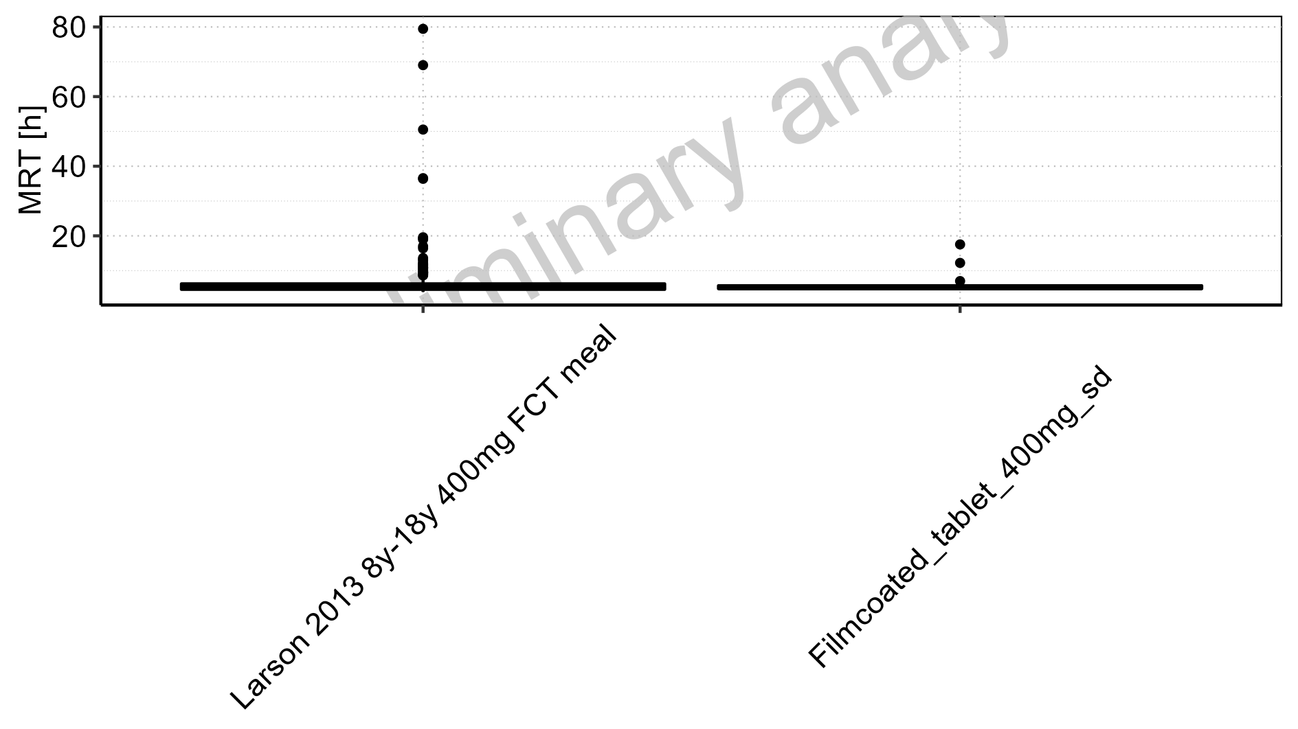

Figure 2-211: Age-dependence of MRT for Larson 2013 8y-18y 400mg FCT meal in comparison to Filmcoated_tablet_400mg_sd. Profiles are plotted in a logarithmic scale.

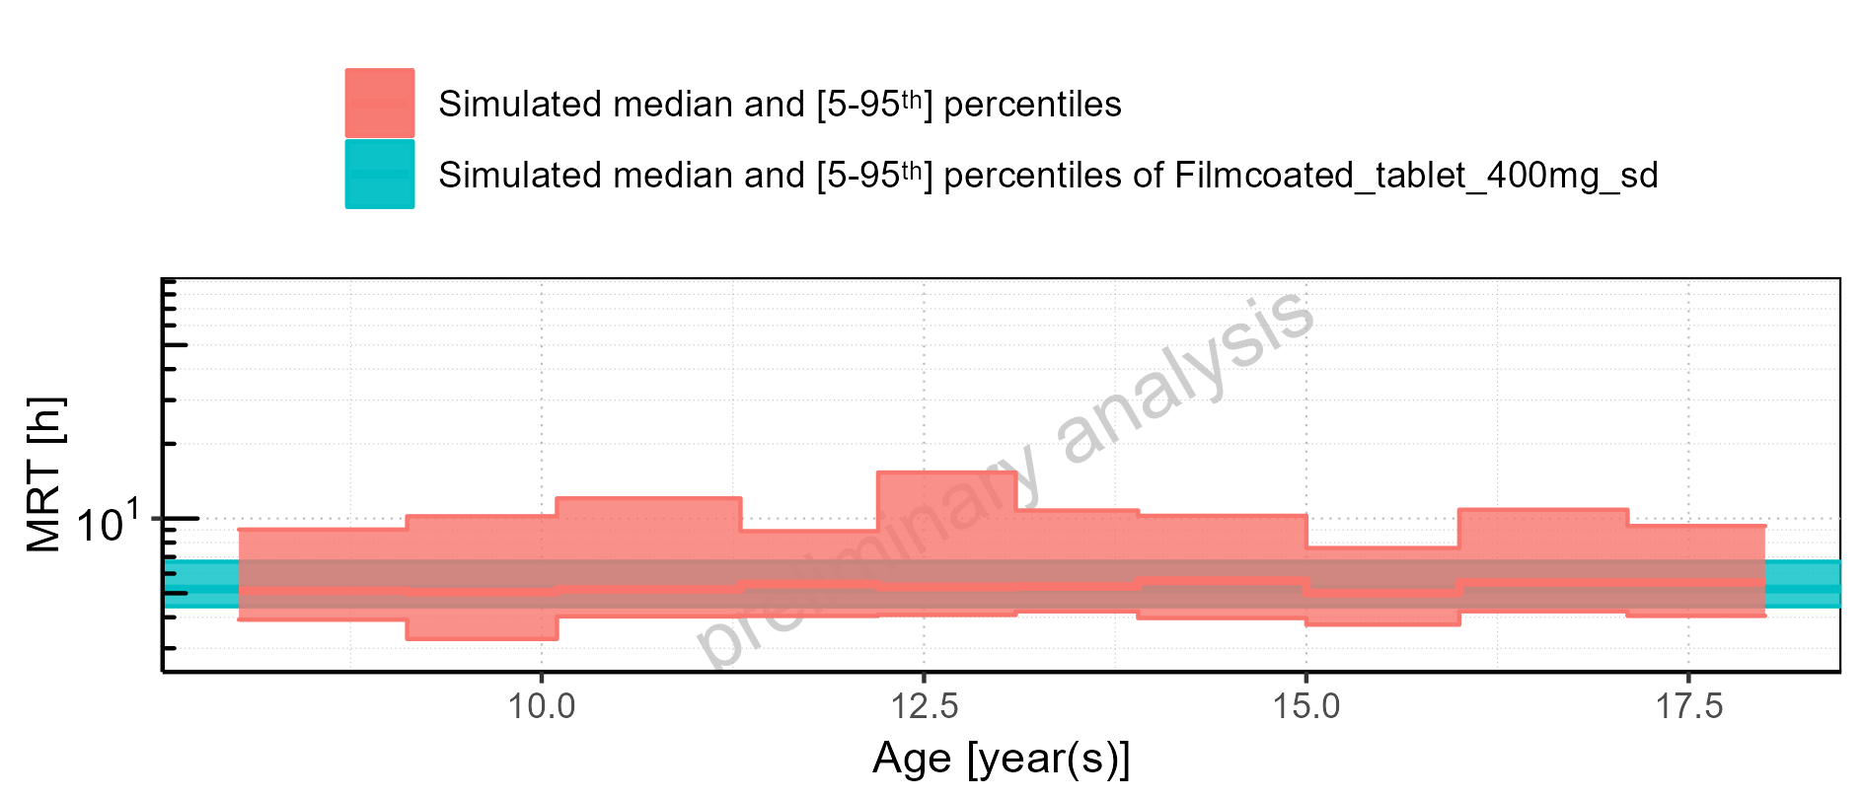

Figure 2-212: Age-dependence of MRT for Larson 2013 8y-18y 400mg FCT meal in comparison to Filmcoated_tablet_400mg_sd. Profiles are plotted in a linear scale.

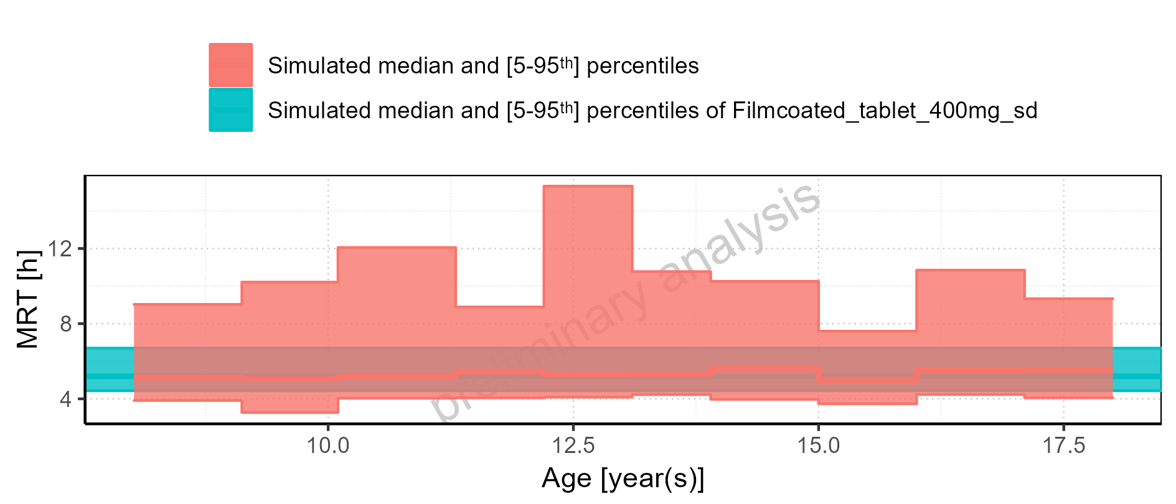

Figure 2-213: Age-dependence of MRT for Larson 2013 8y-18y 400mg FCT meal. Profiles are plotted in a logarithmic scale.

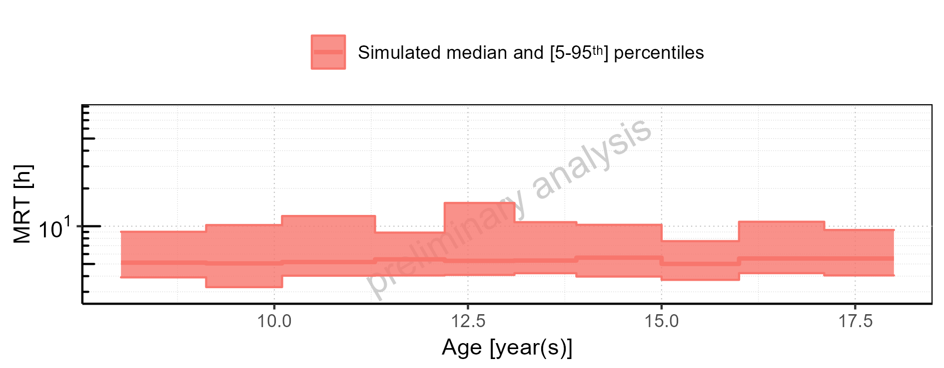

Figure 2-214: Age-dependence of MRT for Larson 2013 8y-18y 400mg FCT meal. Profiles are plotted in a linear scale.

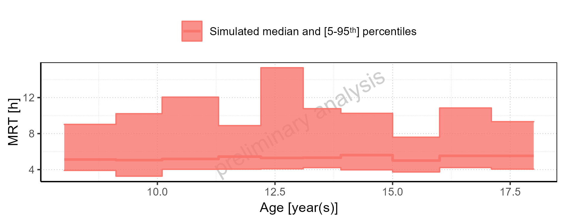

Figure 2-215: Age-dependence of MRT for Filmcoated_tablet_400mg_sd. Profiles are plotted in a logarithmic scale.

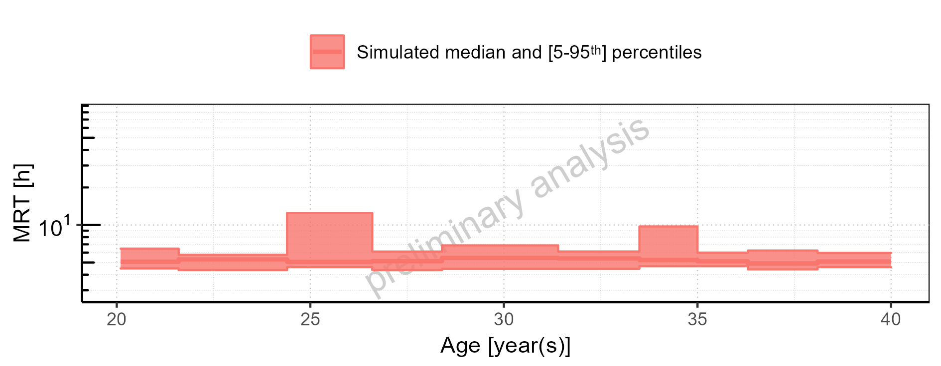

Figure 2-216: Age-dependence of MRT for Filmcoated_tablet_400mg_sd. Profiles are plotted in a linear scale.

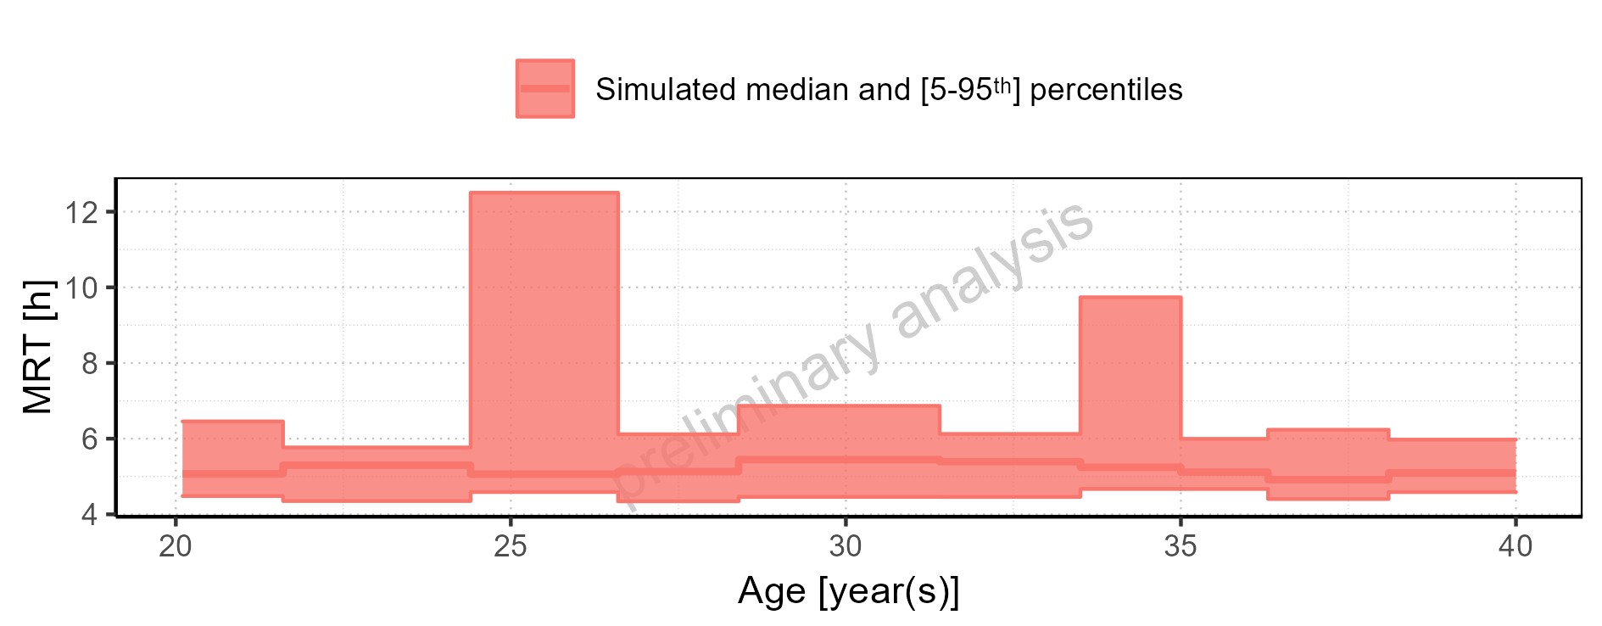

Figure 2-217: Height-dependence of MRT for Larson 2013 8y-18y 400mg FCT meal in comparison to Filmcoated_tablet_400mg_sd. Profiles are plotted in a logarithmic scale.

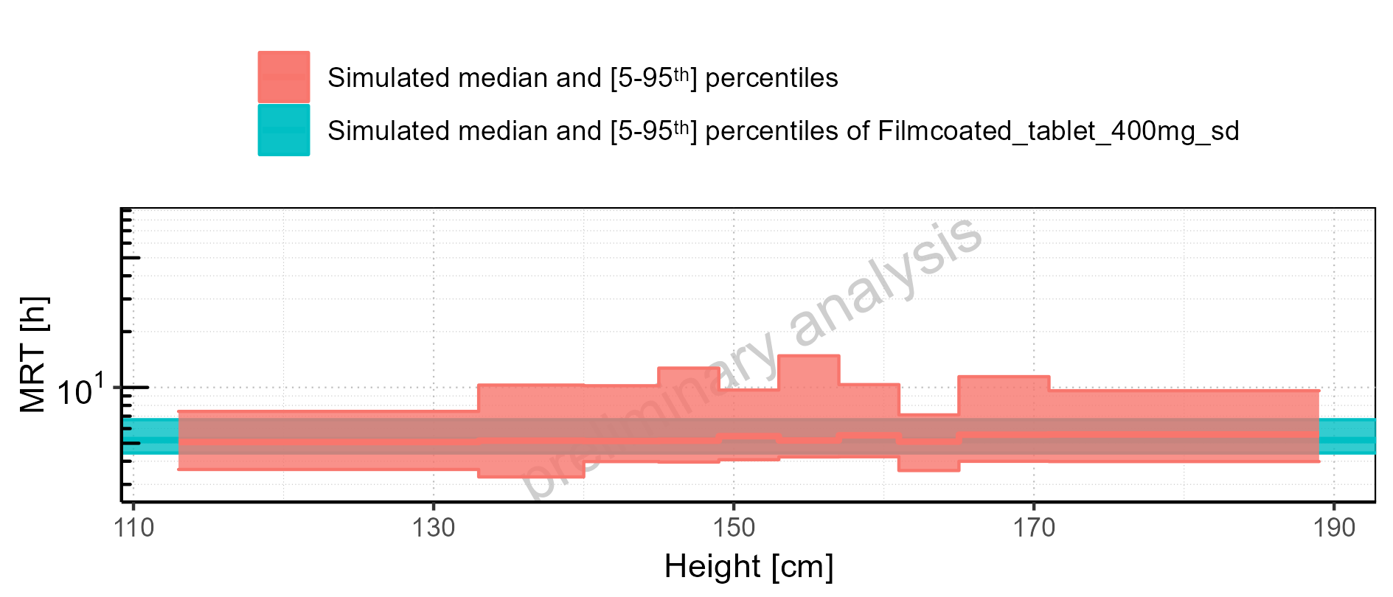

Figure 2-218: Height-dependence of MRT for Larson 2013 8y-18y 400mg FCT meal in comparison to Filmcoated_tablet_400mg_sd. Profiles are plotted in a linear scale.

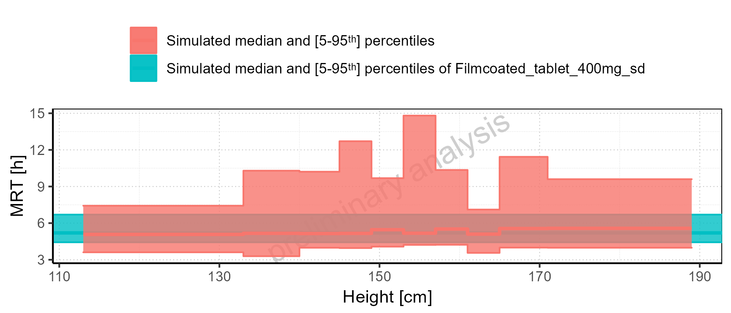

Figure 2-219: Height-dependence of MRT for Larson 2013 8y-18y 400mg FCT meal. Profiles are plotted in a logarithmic scale.

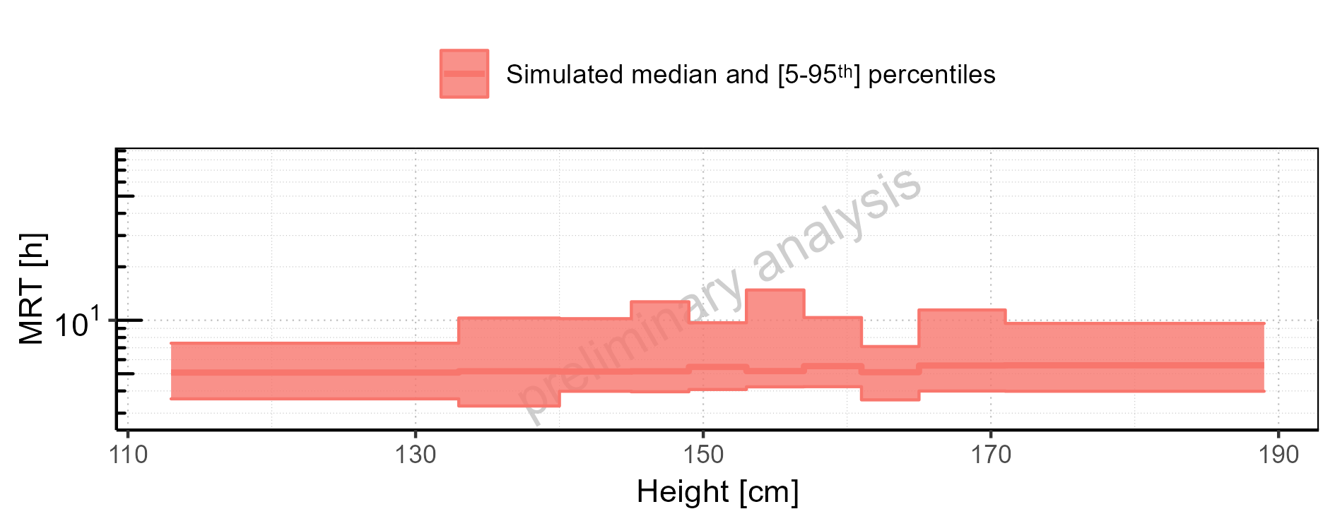

Figure 2-220: Height-dependence of MRT for Larson 2013 8y-18y 400mg FCT meal. Profiles are plotted in a linear scale.

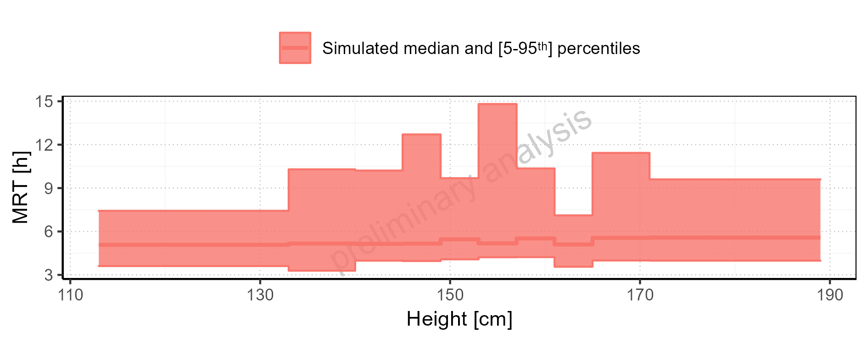

Figure 2-221: Height-dependence of MRT for Filmcoated_tablet_400mg_sd. Profiles are plotted in a logarithmic scale.

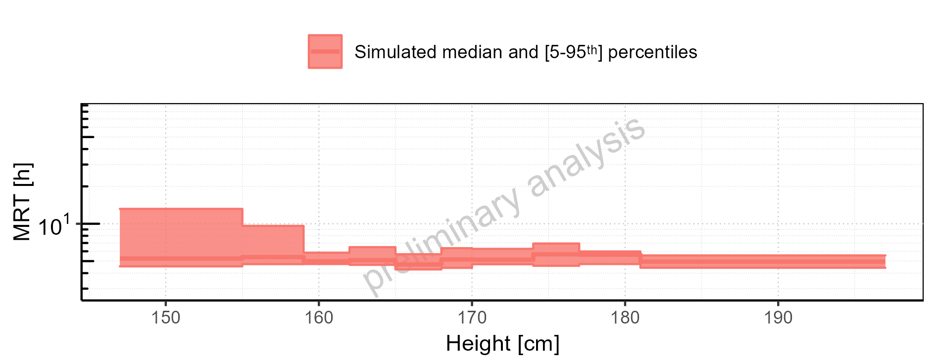

Figure 2-222: Height-dependence of MRT for Filmcoated_tablet_400mg_sd. Profiles are plotted in a linear scale.

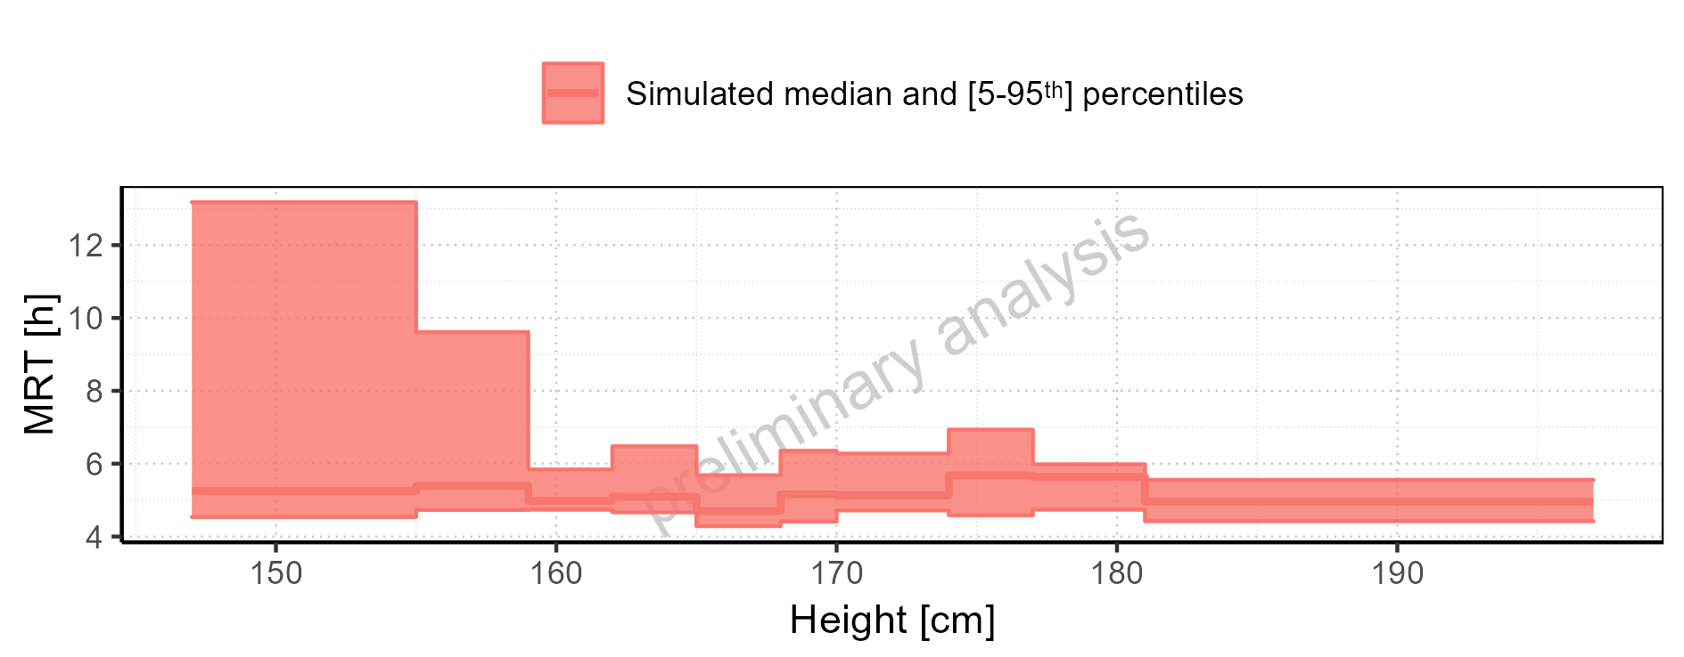

Figure 2-223: Weight-dependence of MRT for Larson 2013 8y-18y 400mg FCT meal in comparison to Filmcoated_tablet_400mg_sd. Profiles are plotted in a logarithmic scale.

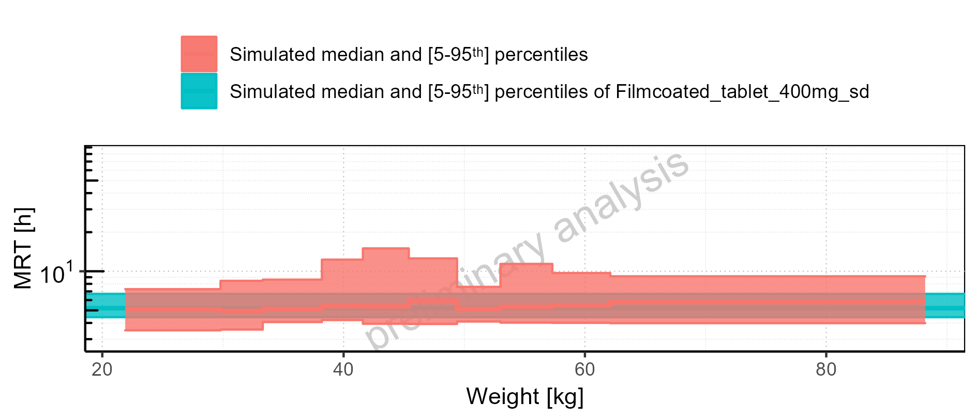

Figure 2-224: Weight-dependence of MRT for Larson 2013 8y-18y 400mg FCT meal in comparison to Filmcoated_tablet_400mg_sd. Profiles are plotted in a linear scale.

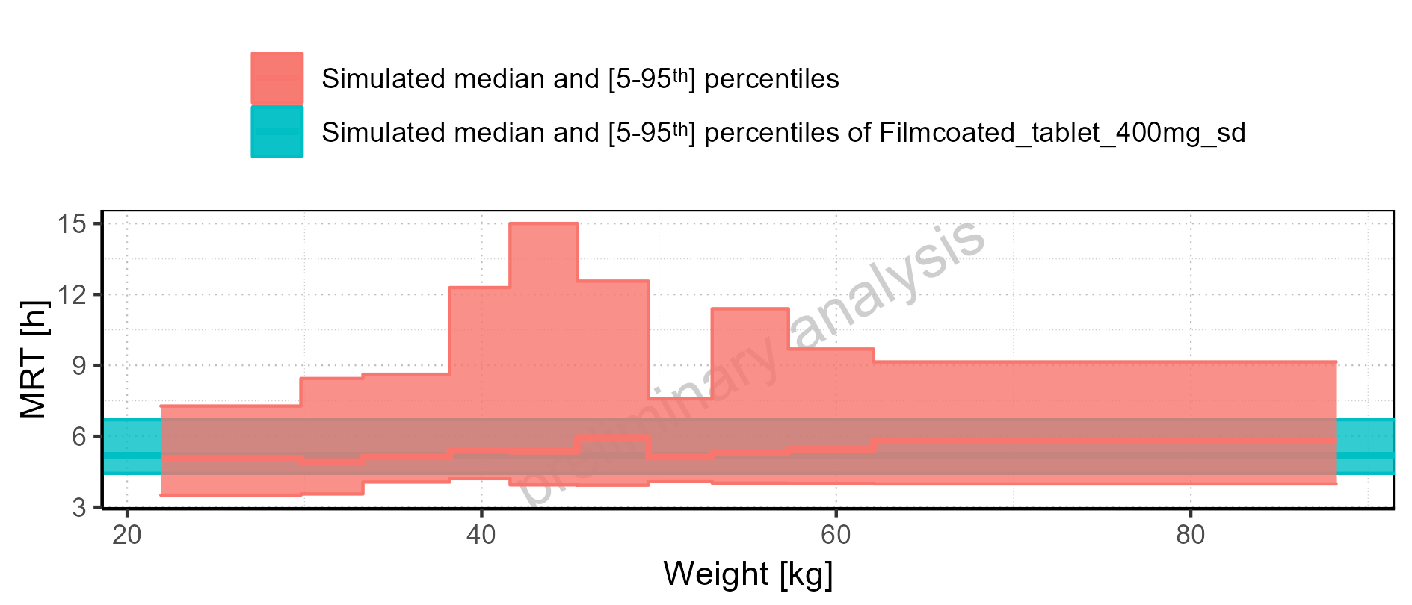

Figure 2-225: Weight-dependence of MRT for Larson 2013 8y-18y 400mg FCT meal. Profiles are plotted in a logarithmic scale.

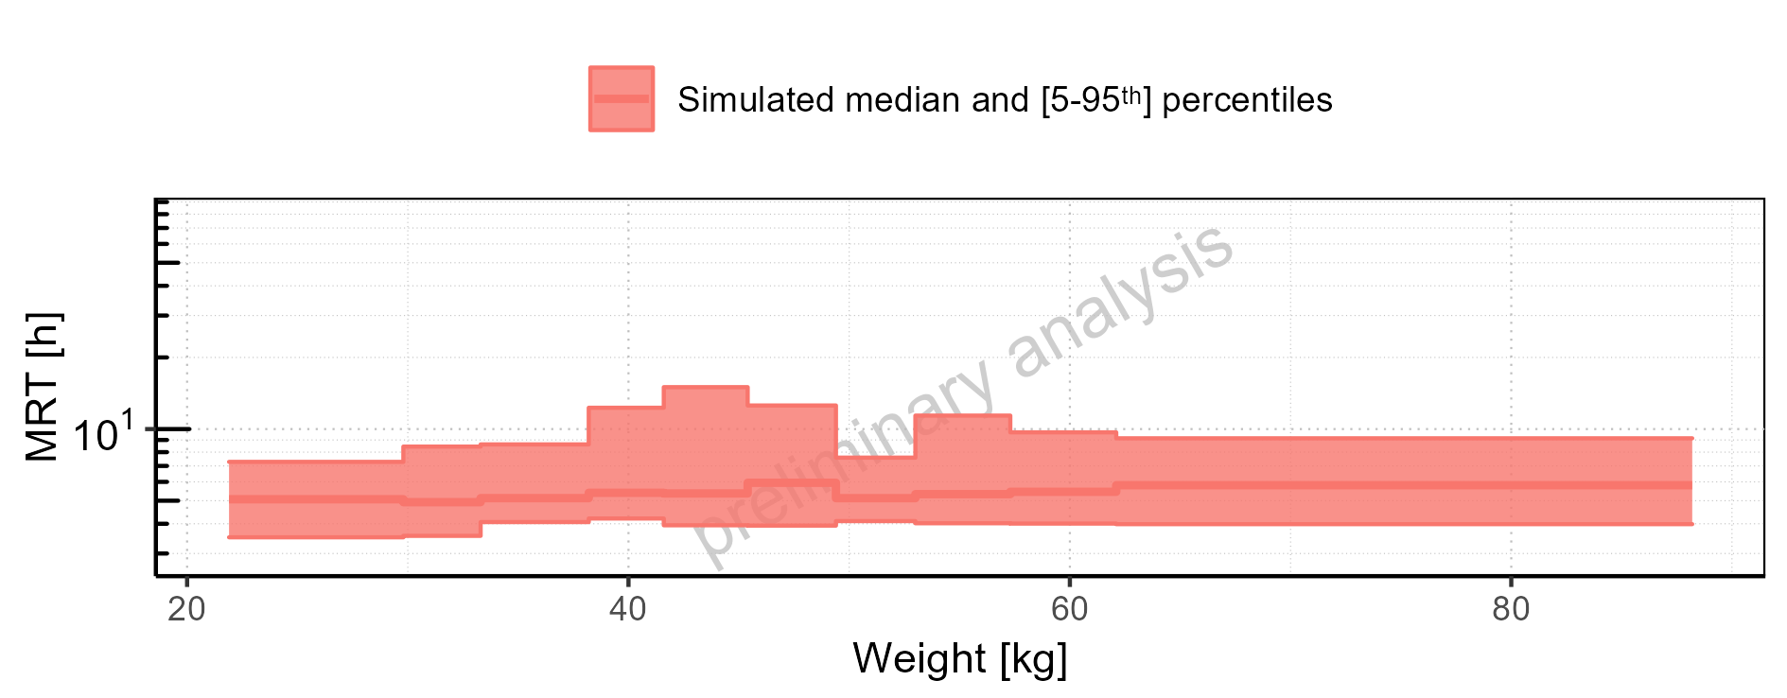

Figure 2-226: Weight-dependence of MRT for Larson 2013 8y-18y 400mg FCT meal. Profiles are plotted in a linear scale.

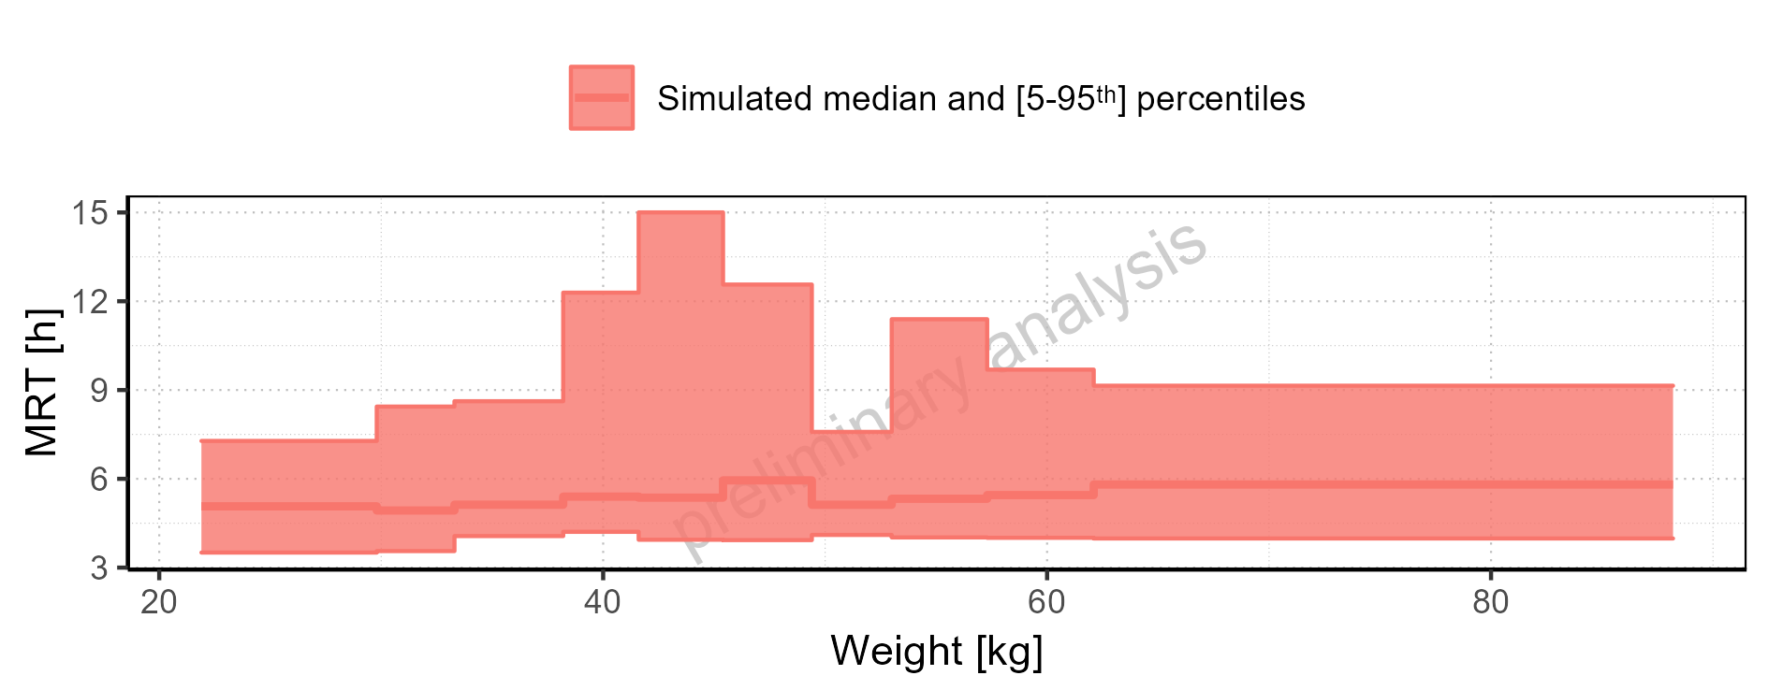

Figure 2-227: Weight-dependence of MRT for Filmcoated_tablet_400mg_sd. Profiles are plotted in a logarithmic scale.

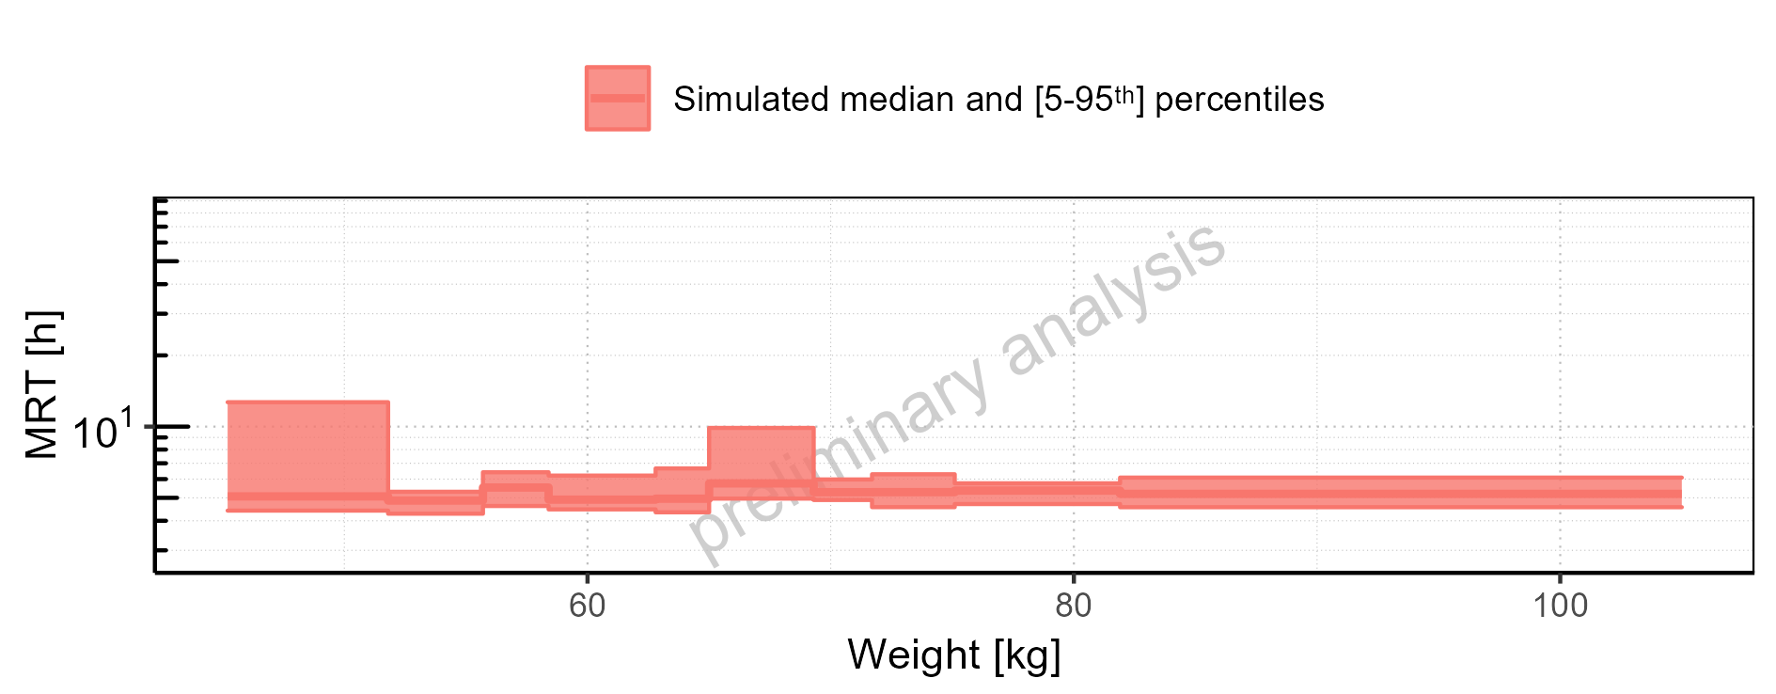

Figure 2-228: Weight-dependence of MRT for Filmcoated_tablet_400mg_sd. Profiles are plotted in a linear scale.

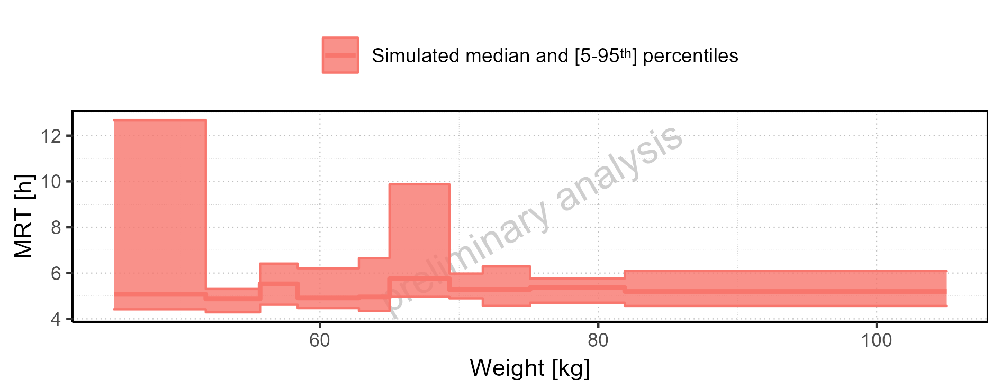

Figure 2-229: BMI-dependence of MRT for Larson 2013 8y-18y 400mg FCT meal in comparison to Filmcoated_tablet_400mg_sd. Profiles are plotted in a logarithmic scale.

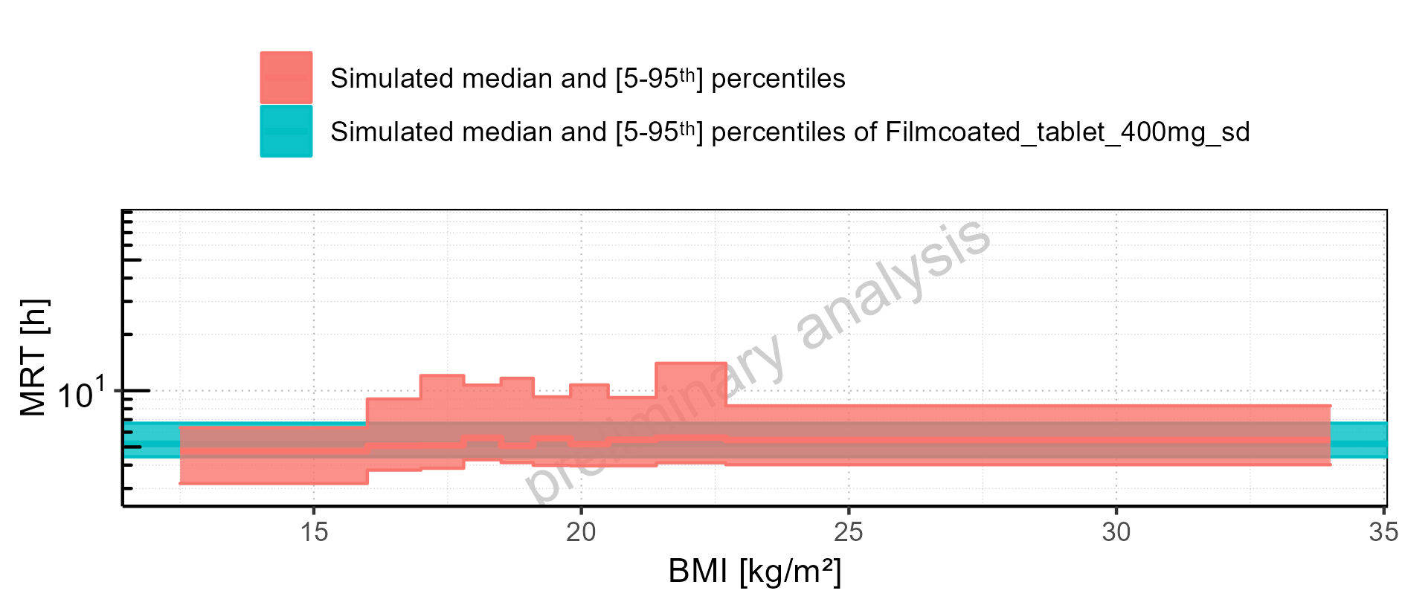

Figure 2-230: BMI-dependence of MRT for Larson 2013 8y-18y 400mg FCT meal in comparison to Filmcoated_tablet_400mg_sd. Profiles are plotted in a linear scale.

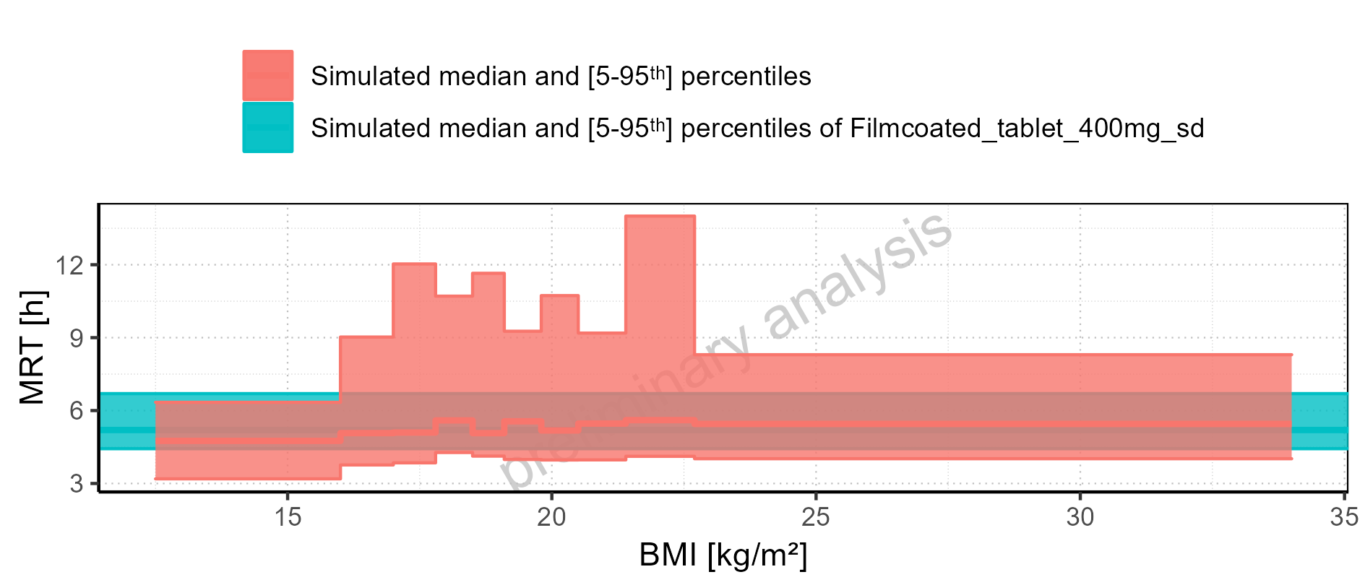

Figure 2-231: BMI-dependence of MRT for Larson 2013 8y-18y 400mg FCT meal. Profiles are plotted in a logarithmic scale.

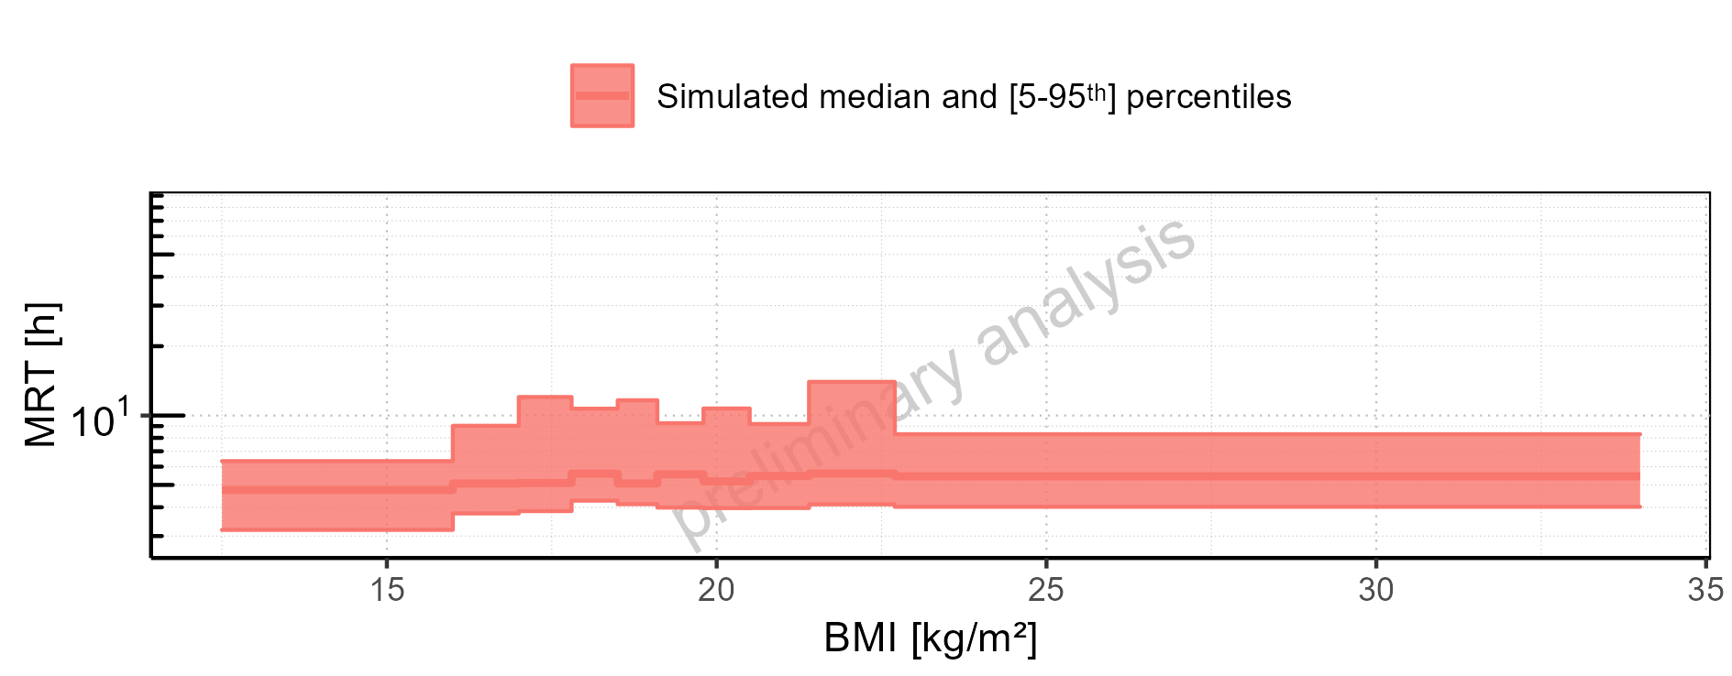

Figure 2-232: BMI-dependence of MRT for Larson 2013 8y-18y 400mg FCT meal. Profiles are plotted in a linear scale.

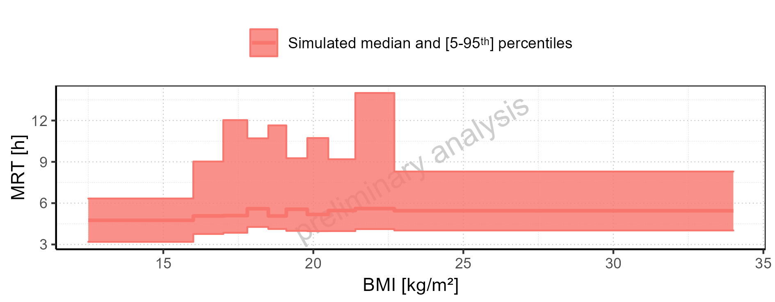

Figure 2-233: BMI-dependence of MRT for Filmcoated_tablet_400mg_sd. Profiles are plotted in a logarithmic scale.

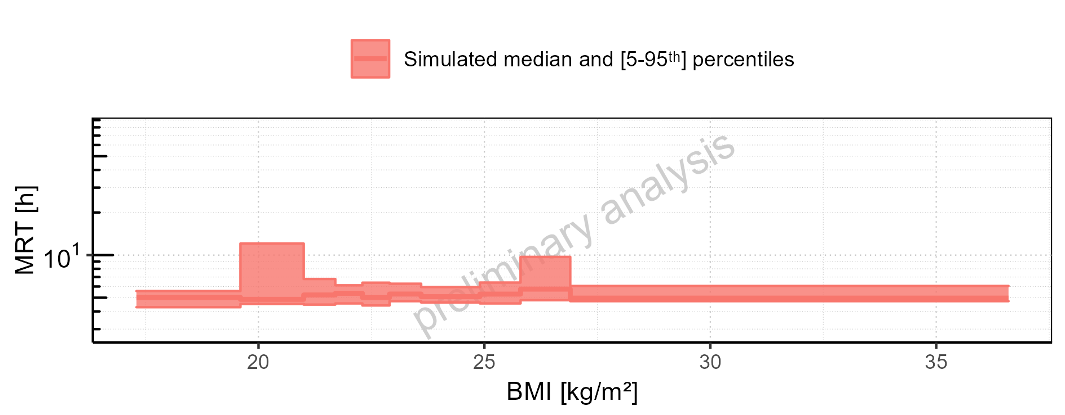

Figure 2-234: BMI-dependence of MRT for Filmcoated_tablet_400mg_sd. Profiles are plotted in a linear scale.

### Thalf

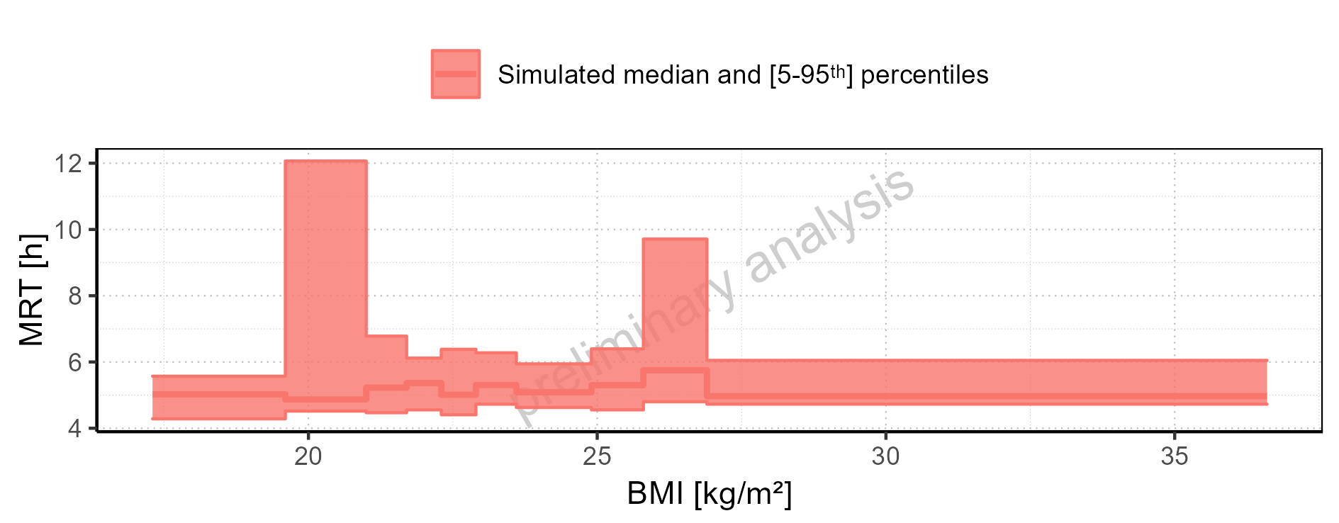

Figure 2-235: Thalf of Raltegravir for Larson 2013 8y-18y 400mg FCT meal, Filmcoated_tablet_400mg_sd shown as box-whisker plot, which indicates the 5<U+1D57><U+02B0>, 25<U+1D57><U+02B0>, 50<U+1D57><U+02B0>, 75<U+1D57><U+02B0>, 95<U+1D57><U+02B0> percentiles in logarithmic scale.

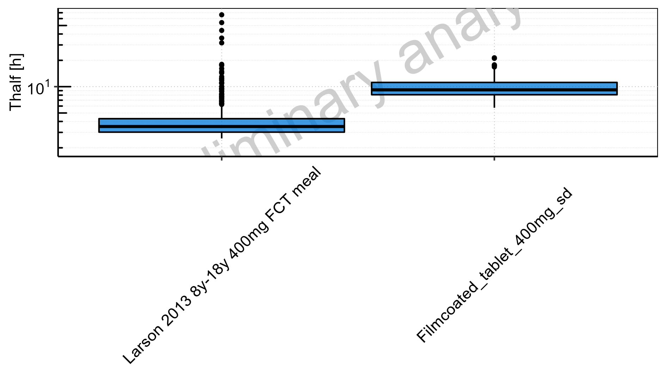

Figure 2-236: Thalf of Raltegravir for Larson 2013 8y-18y 400mg FCT meal, Filmcoated_tablet_400mg_sd shown as box-whisker plot, which indicates the 5<U+1D57><U+02B0>, 25<U+1D57><U+02B0>, 50<U+1D57><U+02B0>, 75<U+1D57><U+02B0>, 95<U+1D57><U+02B0> percentiles in linear scale.

**Table 2-10: Thalf of Raltegravir for Larson 2013 8y-18y 400mg FCT meal, Filmcoated_tablet_400mg_sd reported in [h]**

|  |  |  |  |  |  |  |  |  |  |  |
| --- | --- | --- | --- | --- | --- | --- | --- | --- | --- | --- |
| Population | N | 5<U+1D57><U+02B0> pctl | 25<U+1D57><U+02B0> pctl | 50<U+1D57><U+02B0> pctl | 75<U+1D57><U+02B0> pctl | 95<U+1D57><U+02B0> pctl | Mean | SD | Geo Mean | Geo SD |
| Larson 2013 8y-18y 400mg FCT meal | 500 | 2.55 | 3.01 | 3.49 | 4.30 | 9.43 | 3.90 | 10.49 | - | - |
| Filmcoated_tablet_400mg_sd | 100 | 5.74 | 8.08 | 9.20 | 11.18 | 16.81 | 9.99 | 3.18 | 9.55 | 1.35 |

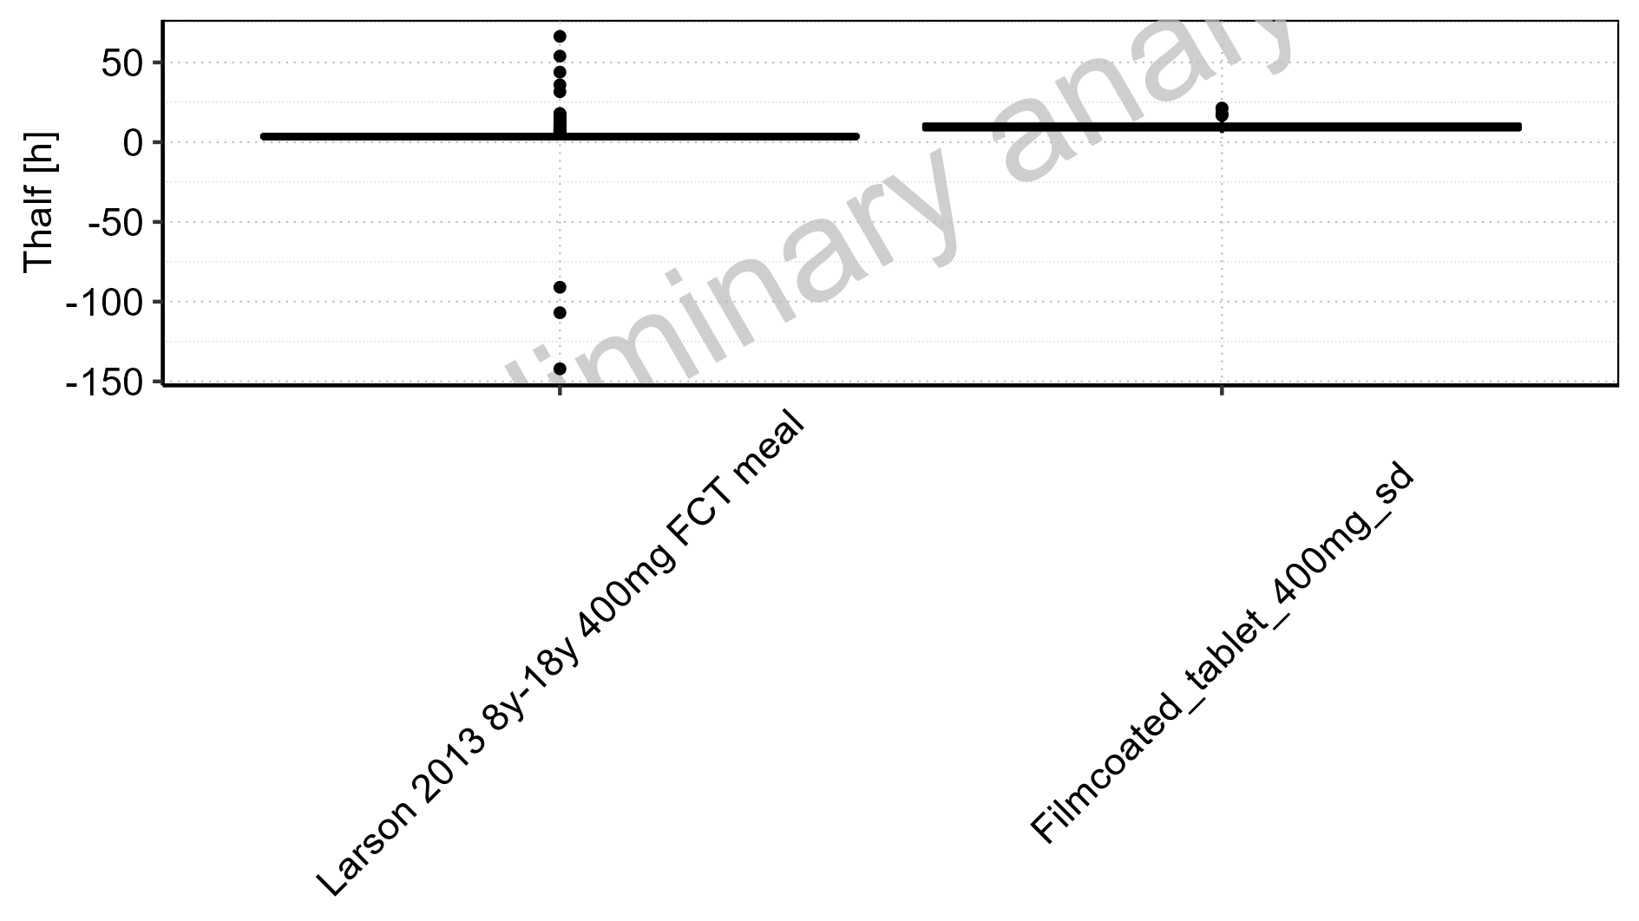

Figure 2-237: Age-dependence of Thalf for Larson 2013 8y-18y 400mg FCT meal in comparison to Filmcoated_tablet_400mg_sd. Profiles are plotted in a logarithmic scale.

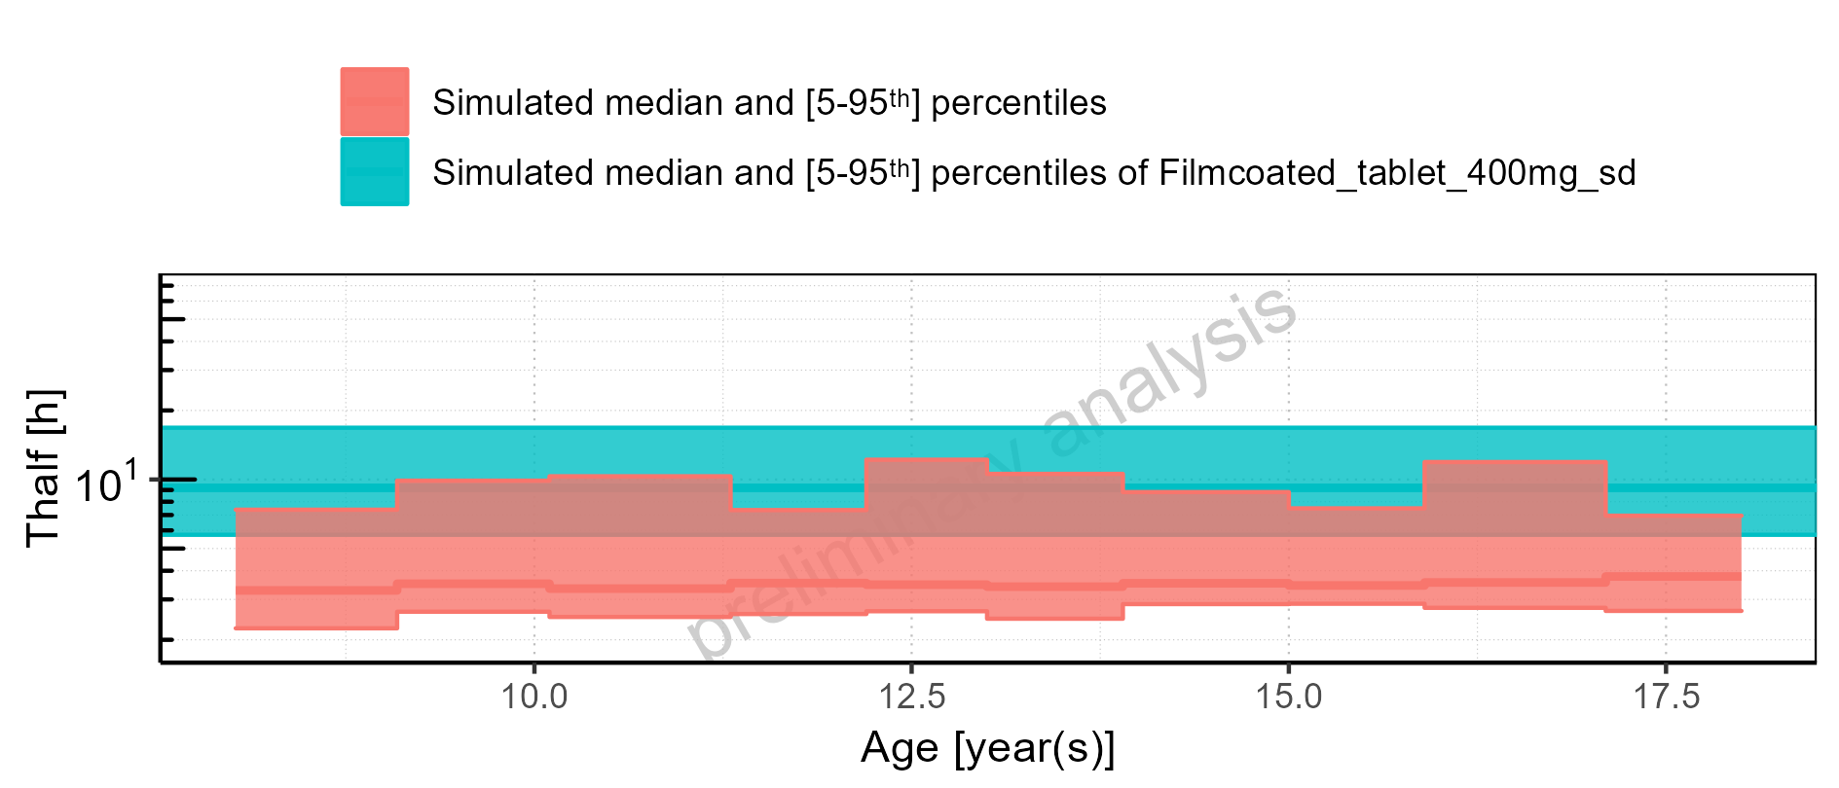

Figure 2-238: Age-dependence of Thalf for Larson 2013 8y-18y 400mg FCT meal in comparison to Filmcoated_tablet_400mg_sd. Profiles are plotted in a linear scale.

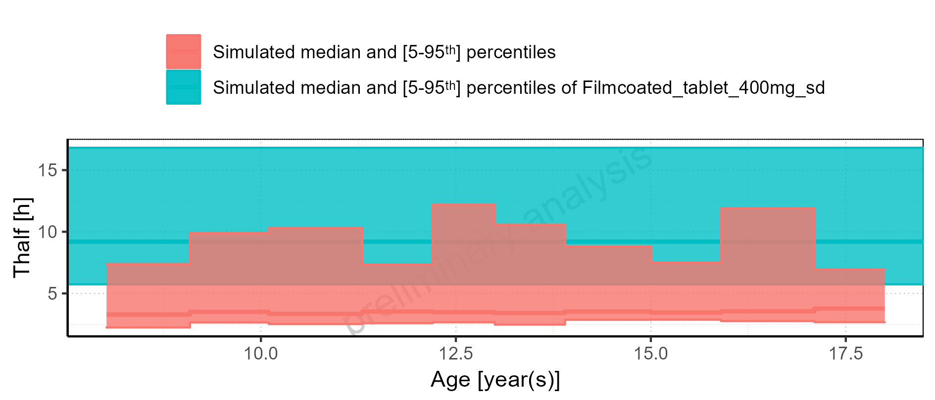

Figure 2-239: Age-dependence of Thalf for Larson 2013 8y-18y 400mg FCT meal. Profiles are plotted in a logarithmic scale.

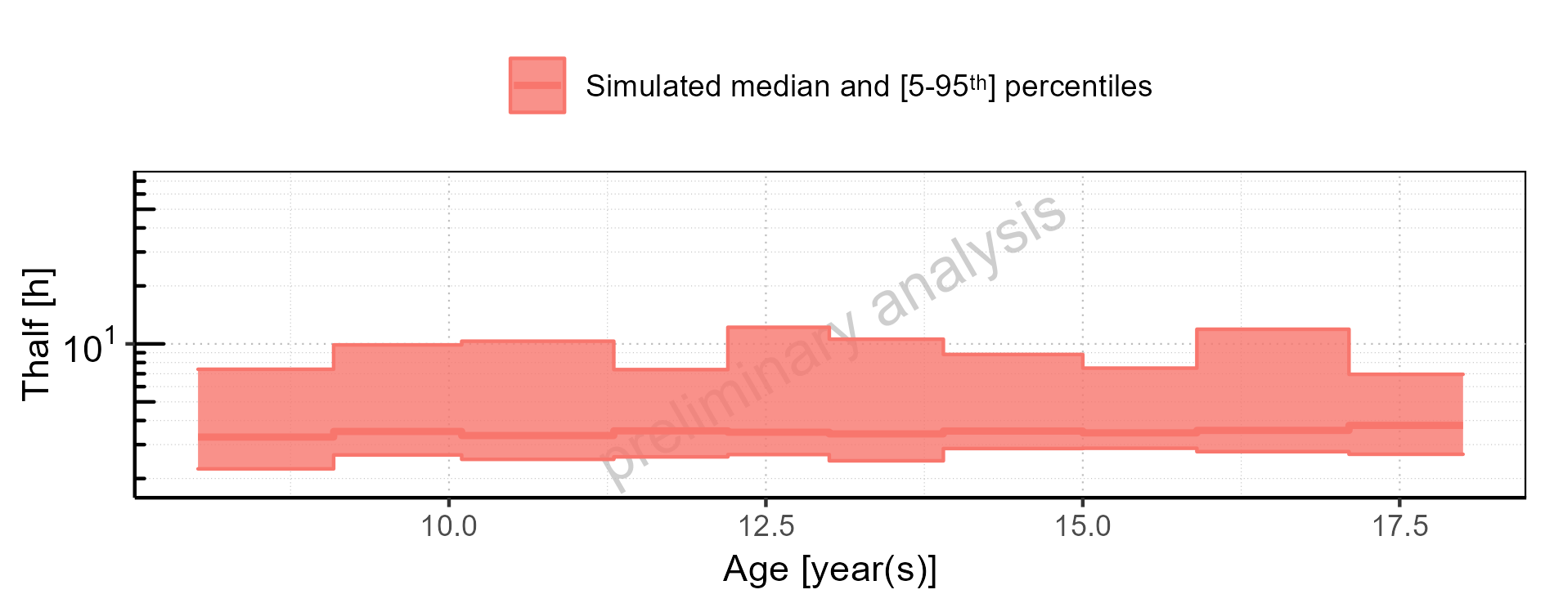

Figure 2-240: Age-dependence of Thalf for Larson 2013 8y-18y 400mg FCT meal. Profiles are plotted in a linear scale.

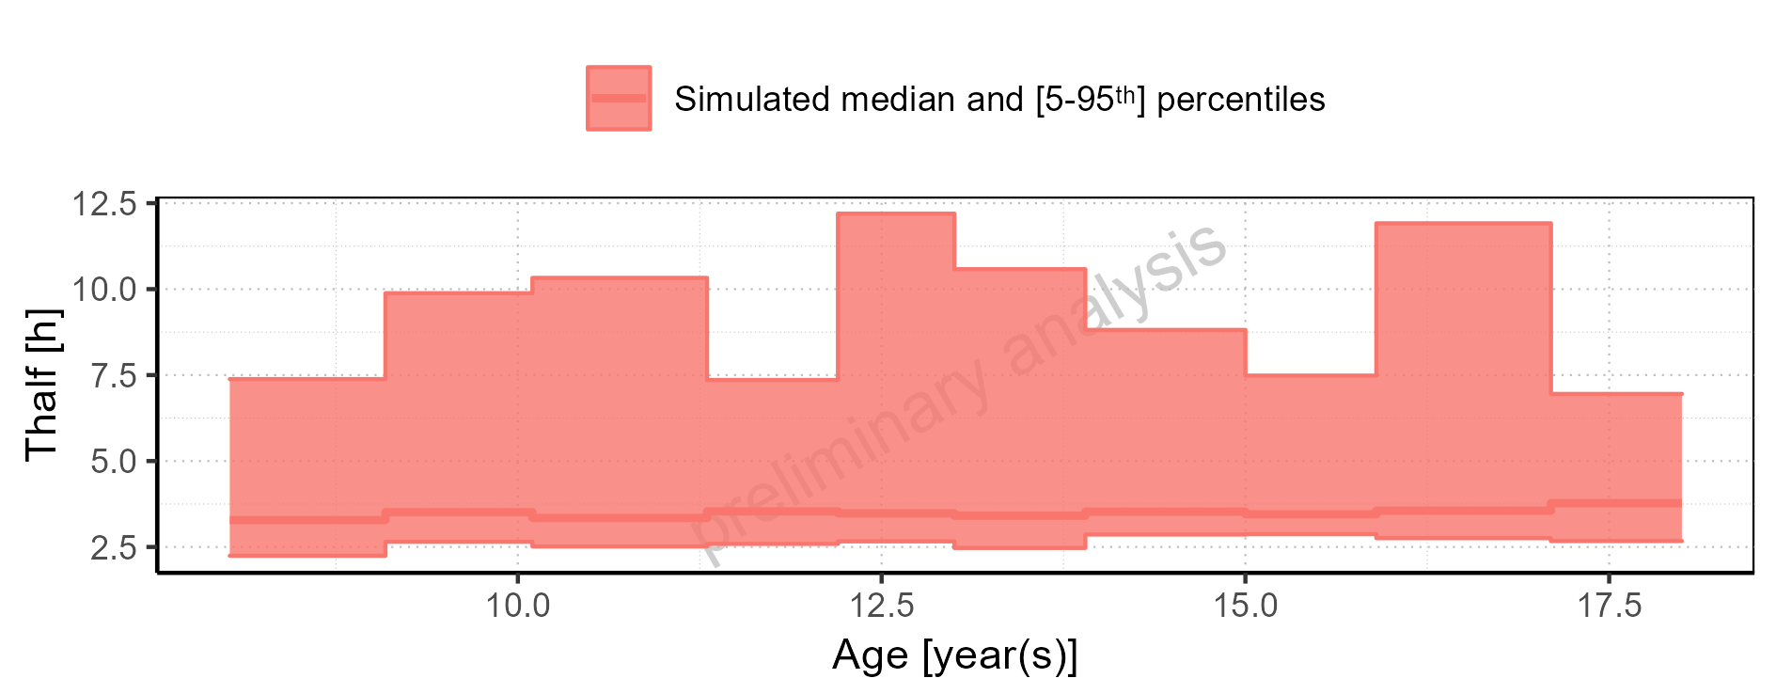

Figure 2-241: Age-dependence of Thalf for Filmcoated_tablet_400mg_sd. Profiles are plotted in a logarithmic scale.

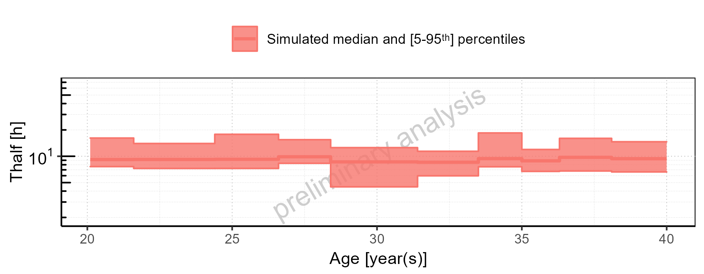

Figure 2-242: Age-dependence of Thalf for Filmcoated_tablet_400mg_sd. Profiles are plotted in a linear scale.

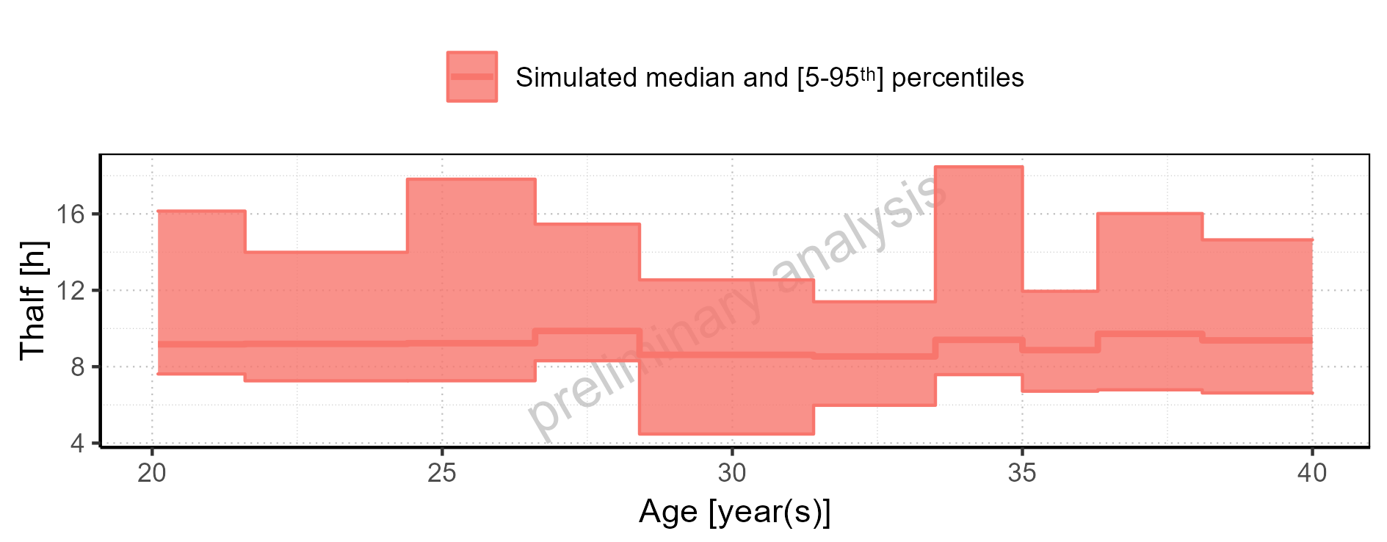

Figure 2-243: Height-dependence of Thalf for Larson 2013 8y-18y 400mg FCT meal in comparison to Filmcoated_tablet_400mg_sd. Profiles are plotted in a logarithmic scale.

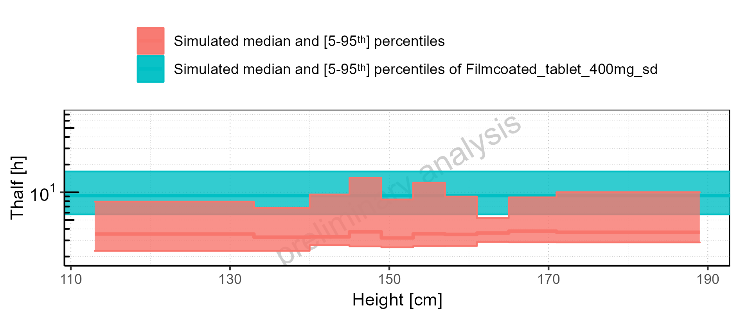

Figure 2-244: Height-dependence of Thalf for Larson 2013 8y-18y 400mg FCT meal in comparison to Filmcoated_tablet_400mg_sd. Profiles are plotted in a linear scale.

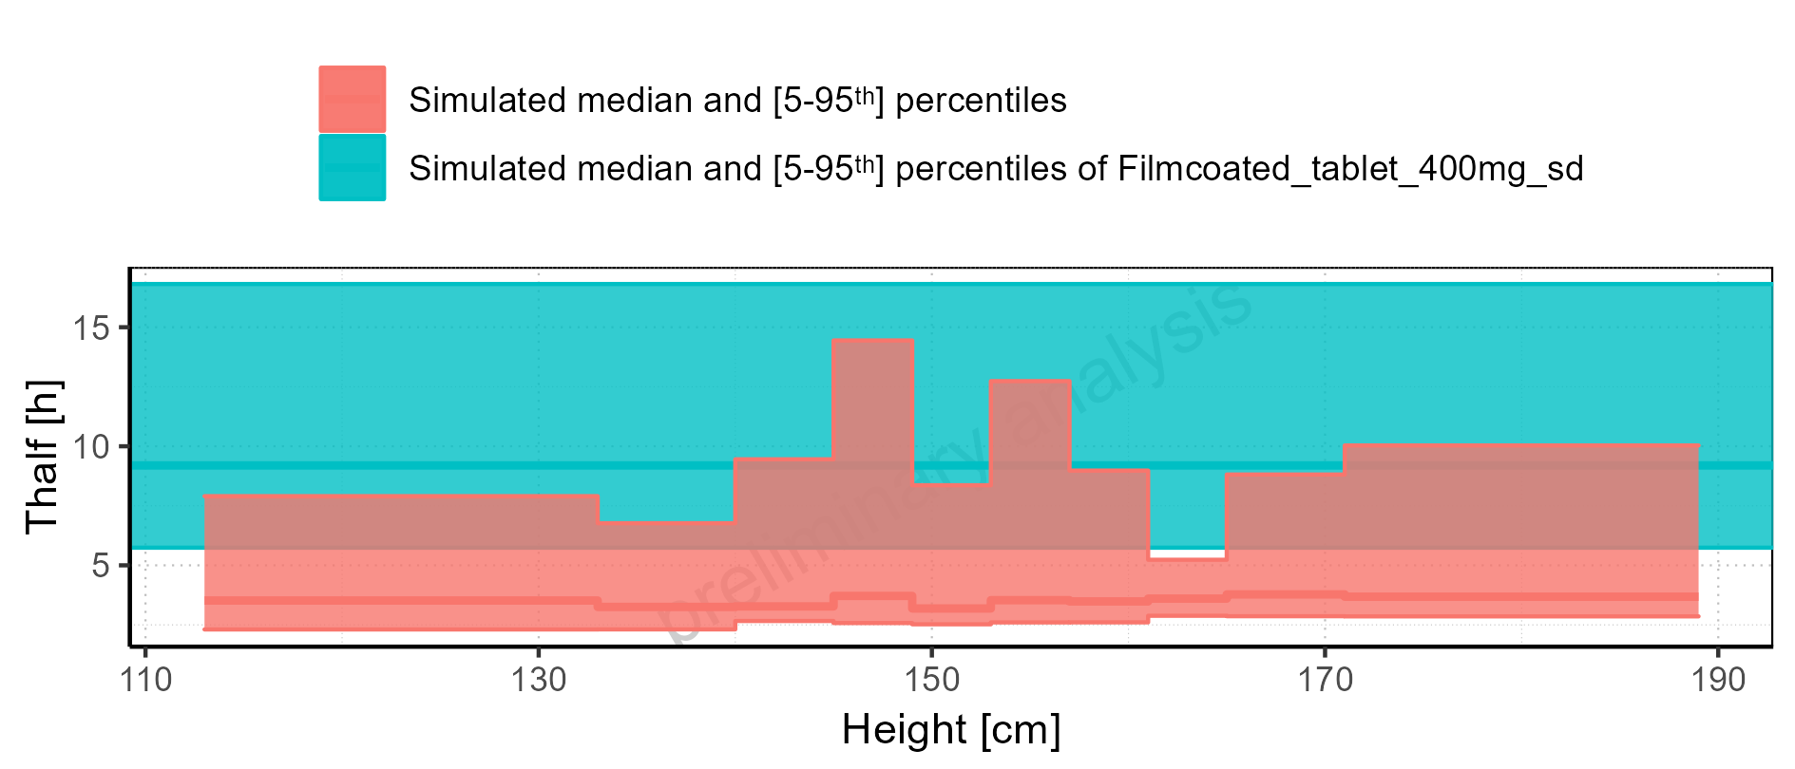

Figure 2-245: Height-dependence of Thalf for Larson 2013 8y-18y 400mg FCT meal. Profiles are plotted in a logarithmic scale.

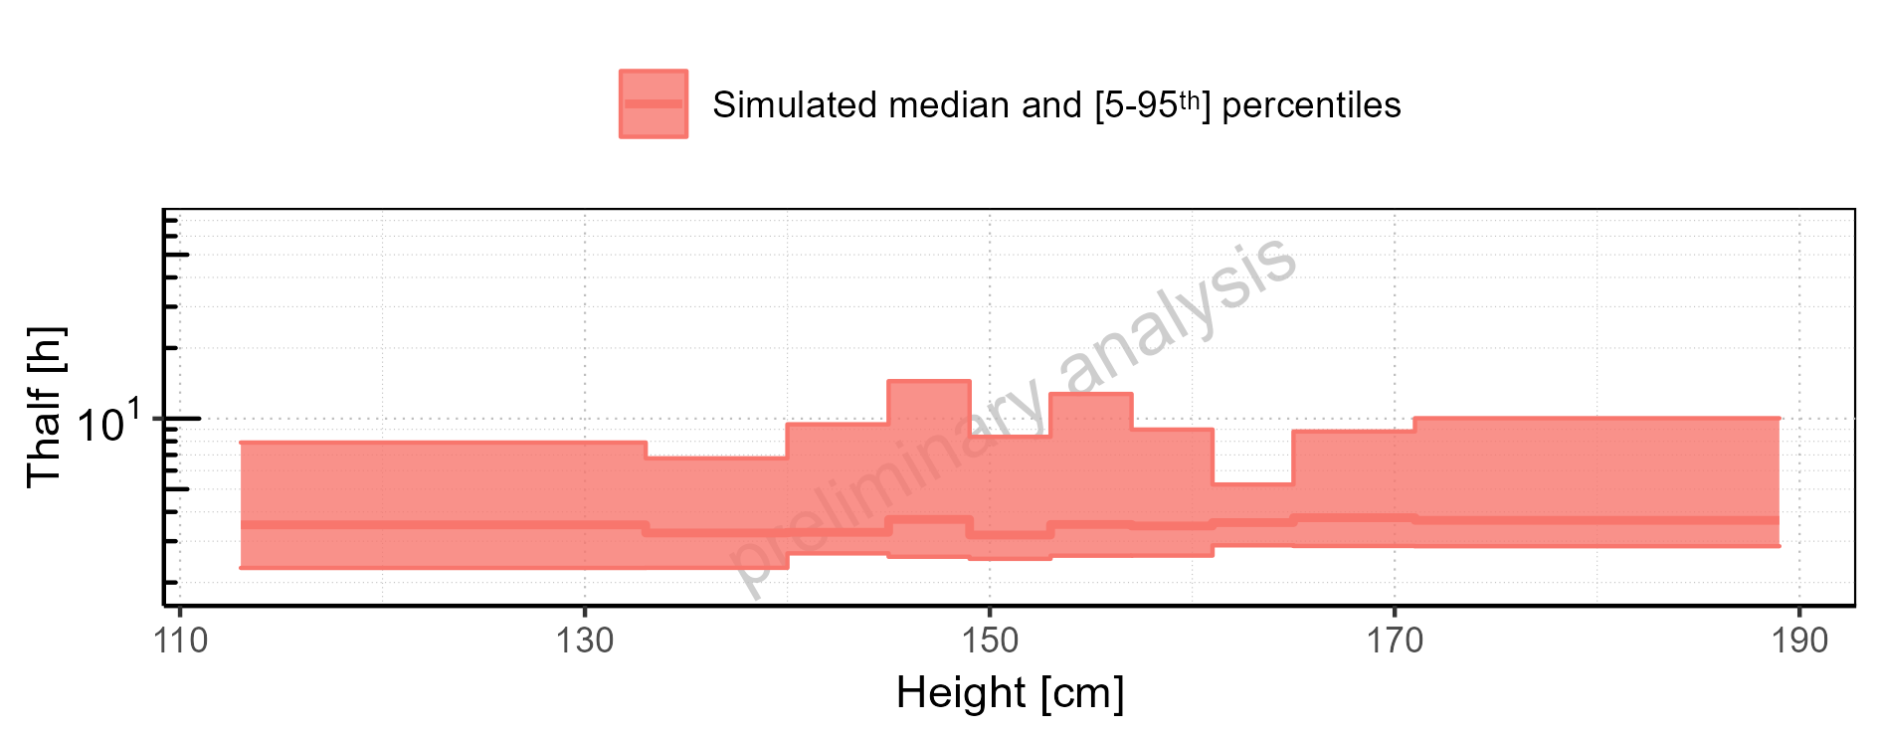

Figure 2-246: Height-dependence of Thalf for Larson 2013 8y-18y 400mg FCT meal. Profiles are plotted in a linear scale.

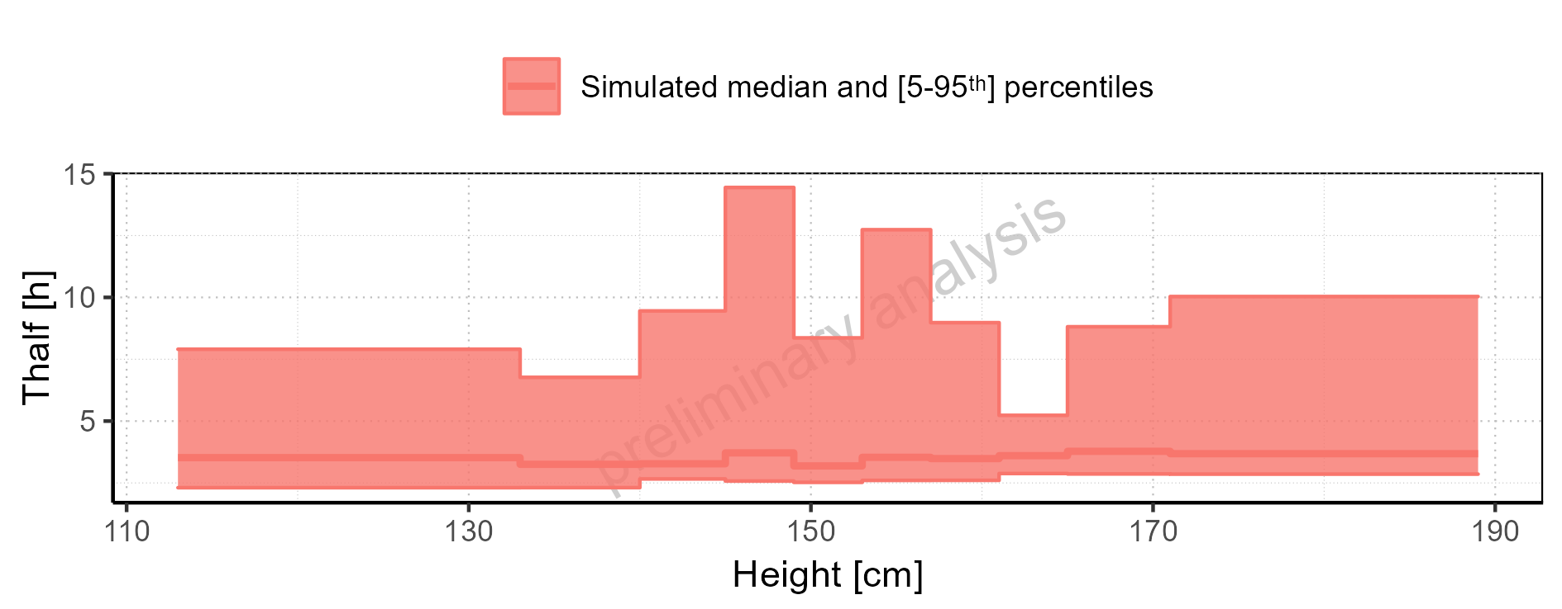

Figure 2-247: Height-dependence of Thalf for Filmcoated_tablet_400mg_sd. Profiles are plotted in a logarithmic scale.

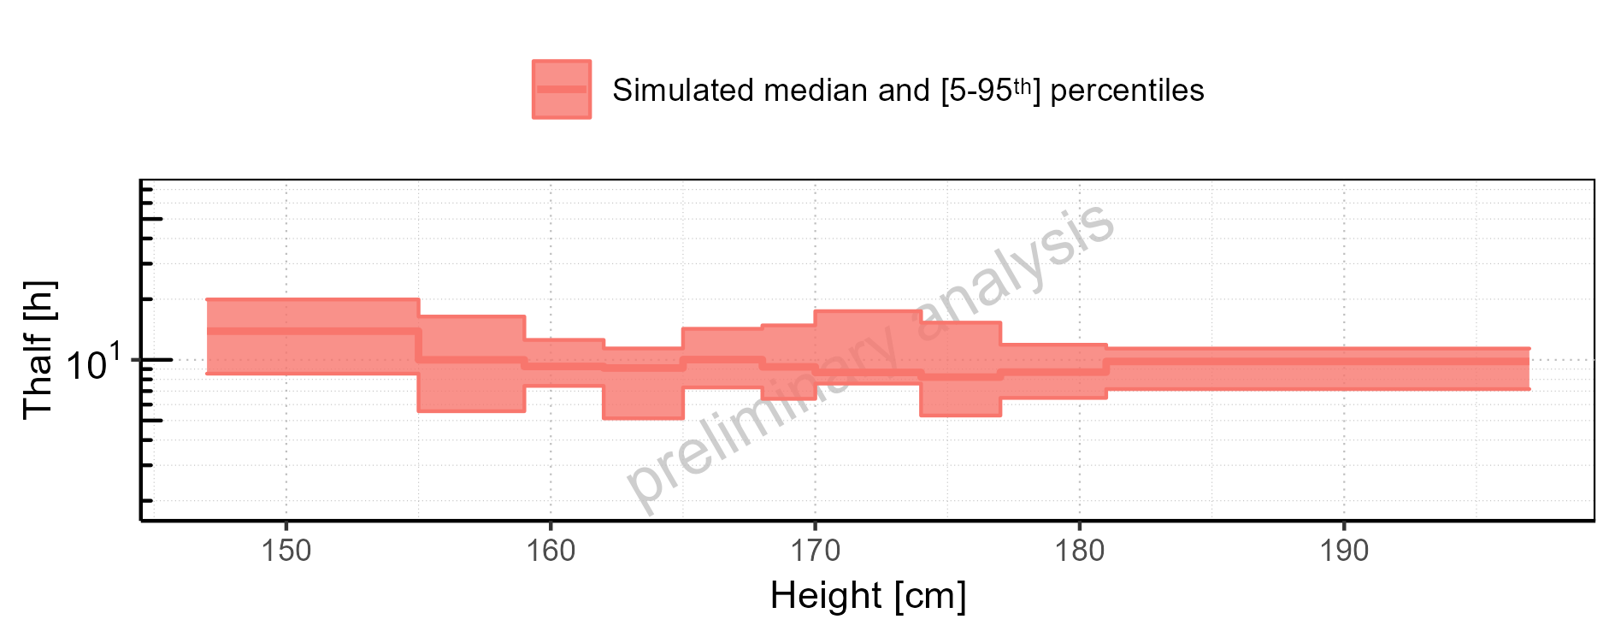

Figure 2-248: Height-dependence of Thalf for Filmcoated_tablet_400mg_sd. Profiles are plotted in a linear scale.

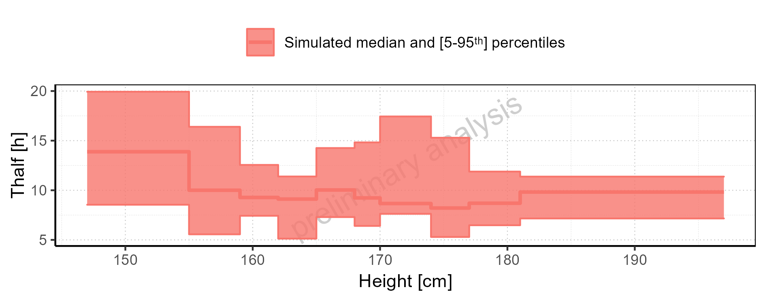

Figure 2-249: Weight-dependence of Thalf for Larson 2013 8y-18y 400mg FCT meal in comparison to Filmcoated_tablet_400mg_sd. Profiles are plotted in a logarithmic scale.

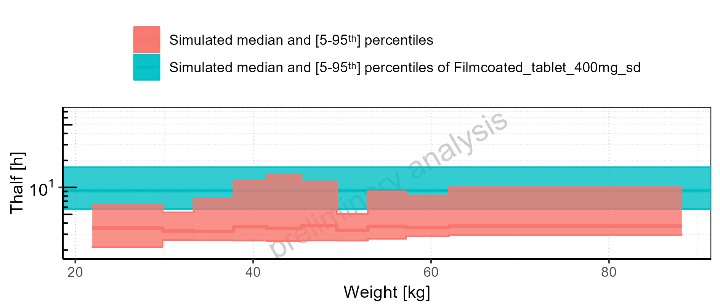

Figure 2-250: Weight-dependence of Thalf for Larson 2013 8y-18y 400mg FCT meal in comparison to Filmcoated_tablet_400mg_sd. Profiles are plotted in a linear scale.

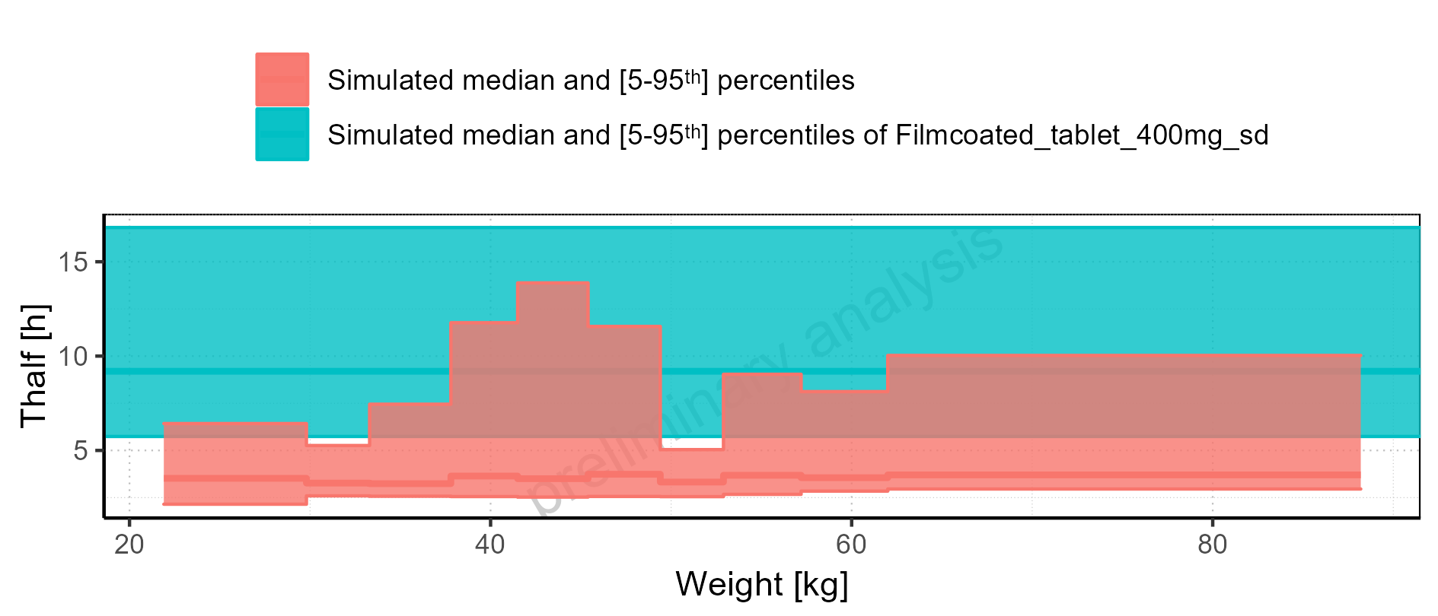

Figure 2-251: Weight-dependence of Thalf for Larson 2013 8y-18y 400mg FCT meal. Profiles are plotted in a logarithmic scale.

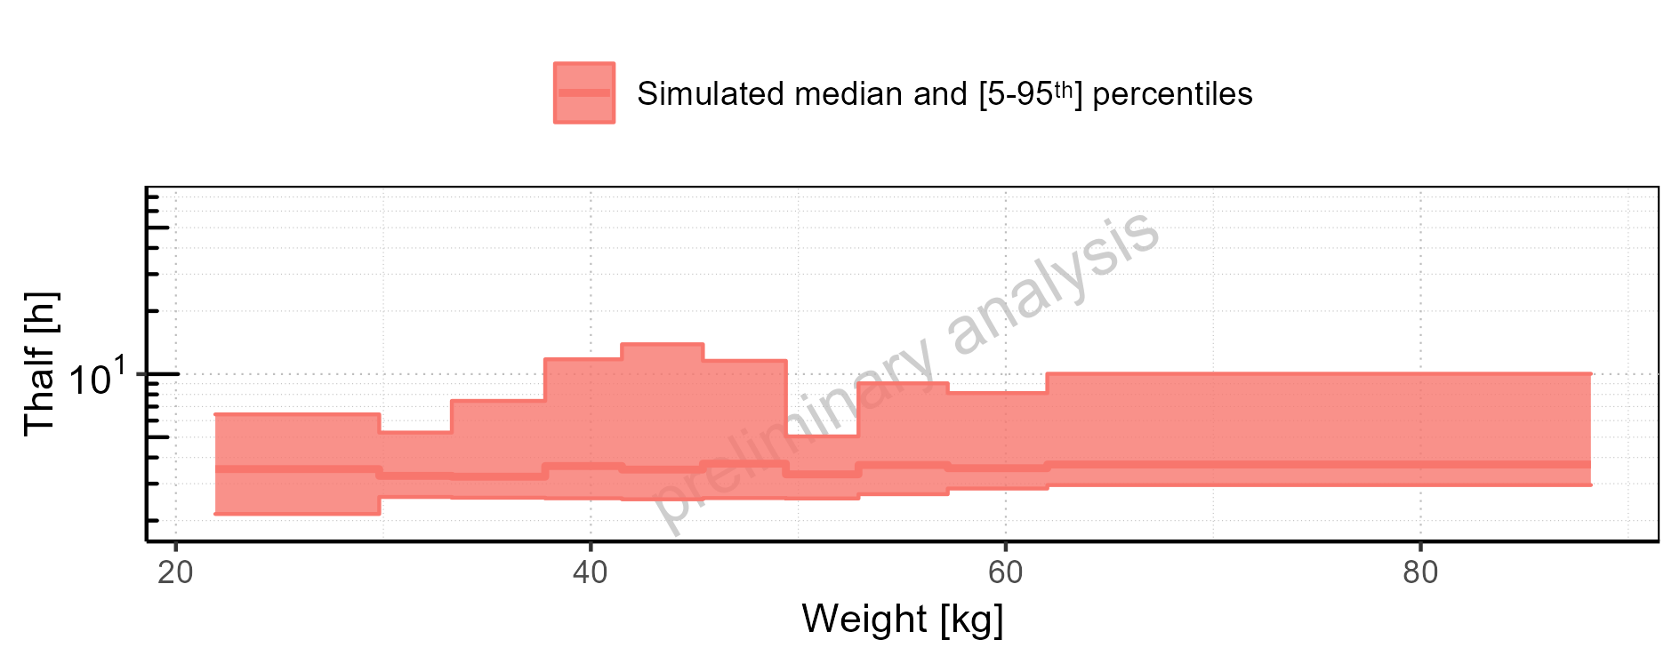

Figure 2-252: Weight-dependence of Thalf for Larson 2013 8y-18y 400mg FCT meal. Profiles are plotted in a linear scale.

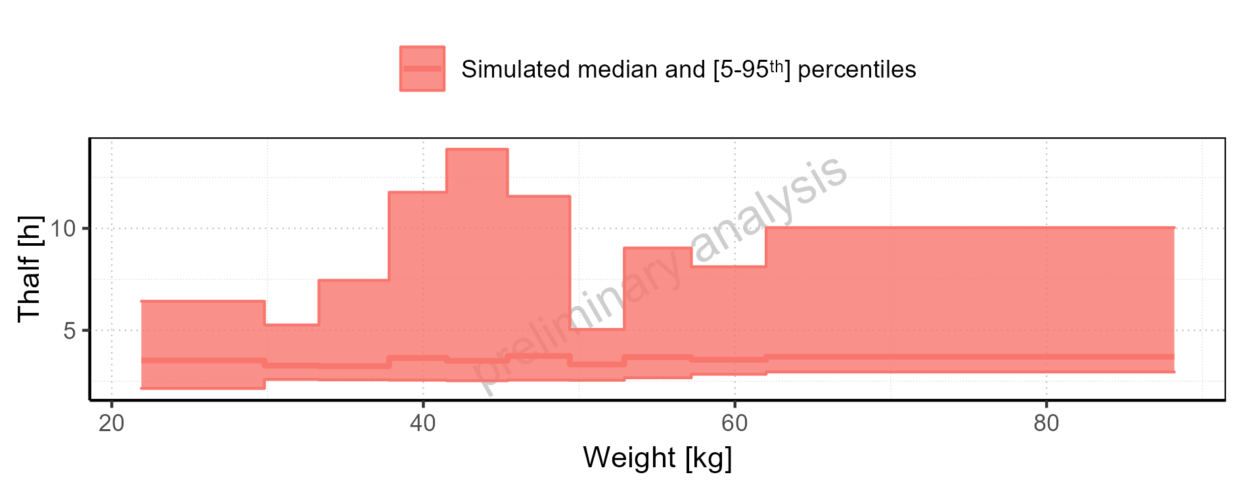

Figure 2-253: Weight-dependence of Thalf for Filmcoated_tablet_400mg_sd. Profiles are plotted in a logarithmic scale.

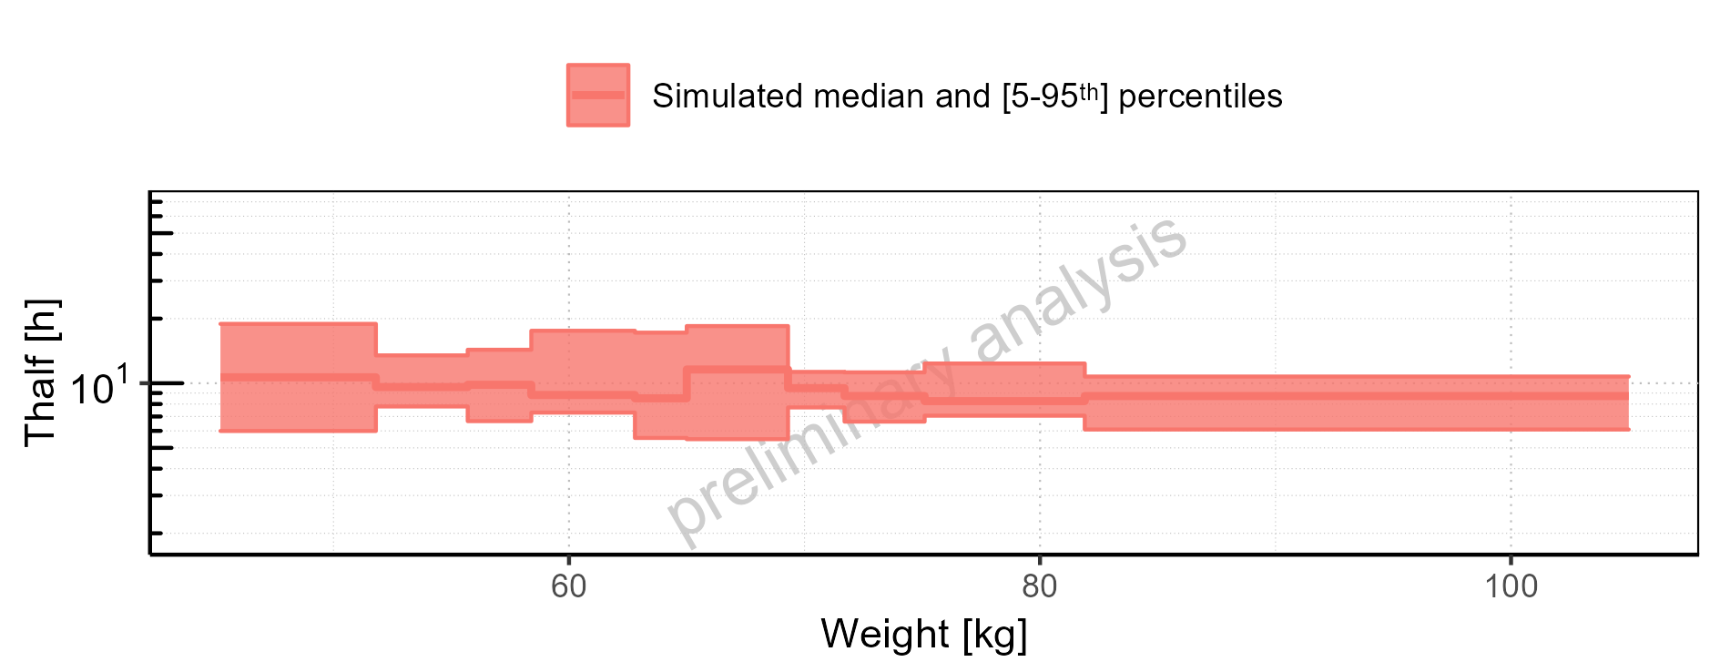

Figure 2-254: Weight-dependence of Thalf for Filmcoated_tablet_400mg_sd. Profiles are plotted in a linear scale.

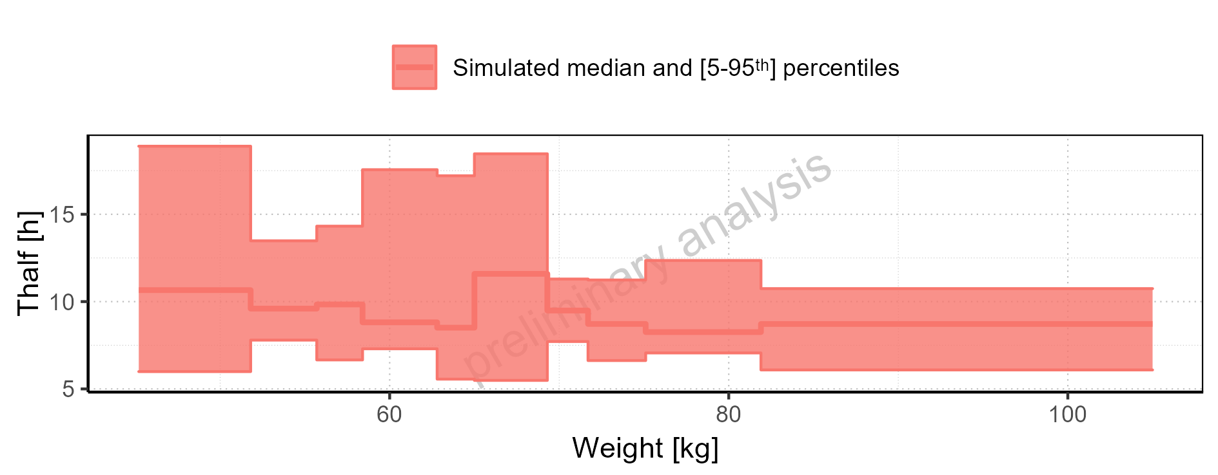

Figure 2-255: BMI-dependence of Thalf for Larson 2013 8y-18y 400mg FCT meal in comparison to Filmcoated_tablet_400mg_sd. Profiles are plotted in a logarithmic scale.

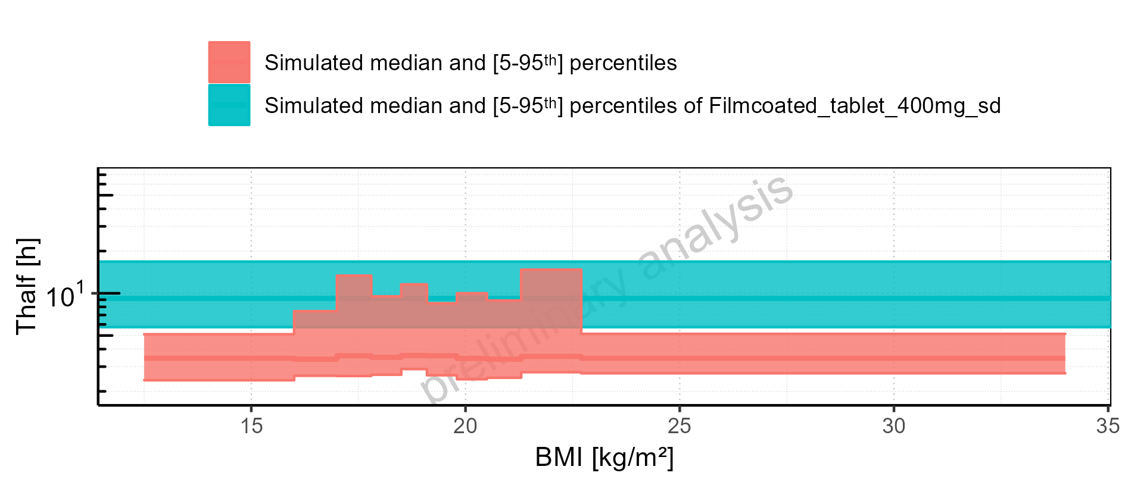

Figure 2-256: BMI-dependence of Thalf for Larson 2013 8y-18y 400mg FCT meal in comparison to Filmcoated_tablet_400mg_sd. Profiles are plotted in a linear scale.

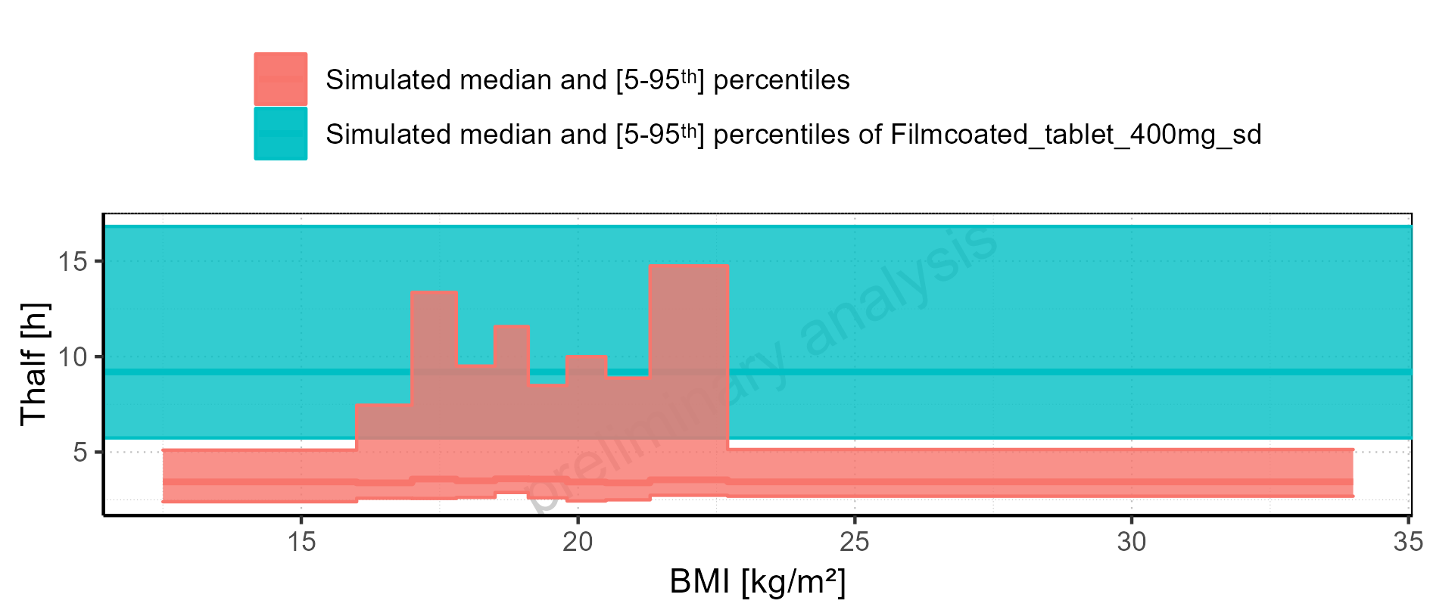

Figure 2-257: BMI-dependence of Thalf for Larson 2013 8y-18y 400mg FCT meal. Profiles are plotted in a logarithmic scale.

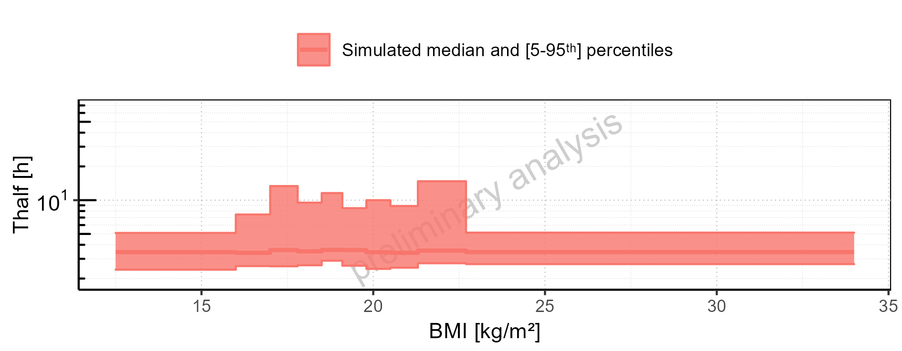

Figure 2-258: BMI-dependence of Thalf for Larson 2013 8y-18y 400mg FCT meal. Profiles are plotted in a linear scale.

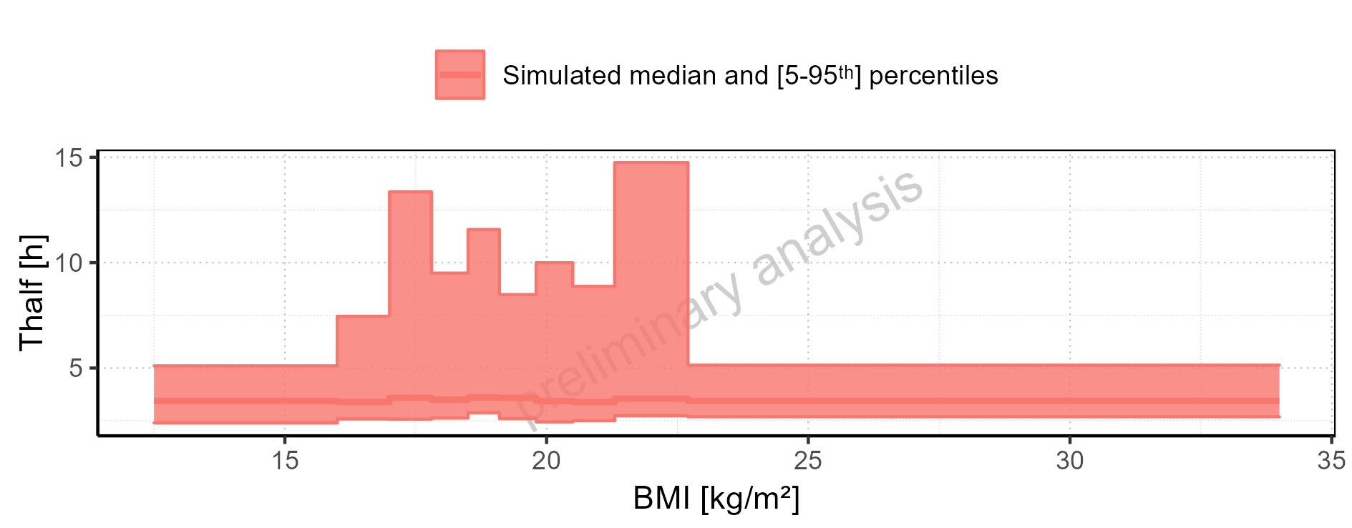

Figure 2-259: BMI-dependence of Thalf for Filmcoated_tablet_400mg_sd. Profiles are plotted in a logarithmic scale.

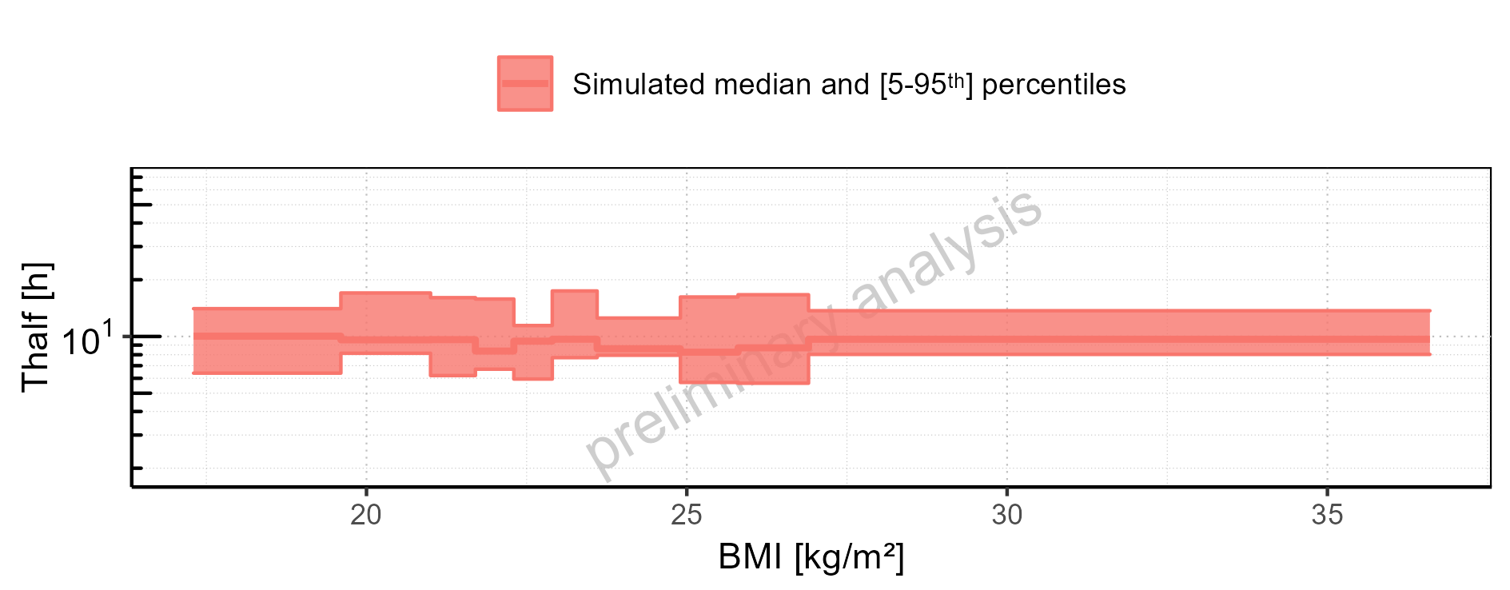

Figure 2-260: BMI-dependence of Thalf for Filmcoated_tablet_400mg_sd. Profiles are plotted in a linear scale.

### CL

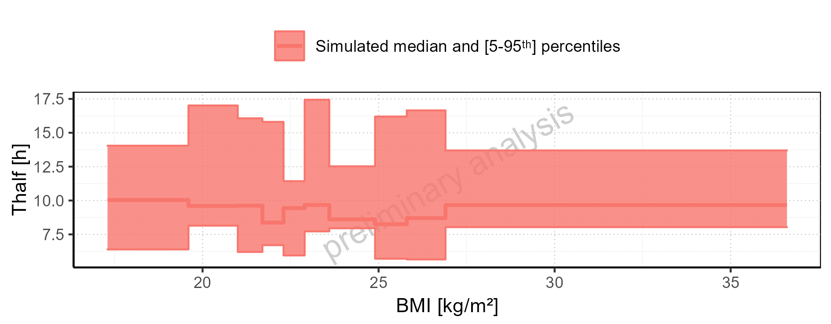

Figure 2-261: CL of Raltegravir for Larson 2013 8y-18y 400mg FCT meal, Filmcoated_tablet_400mg_sd shown as box-whisker plot, which indicates the 5<U+1D57><U+02B0>, 25<U+1D57><U+02B0>, 50<U+1D57><U+02B0>, 75<U+1D57><U+02B0>, 95<U+1D57><U+02B0> percentiles in logarithmic scale.

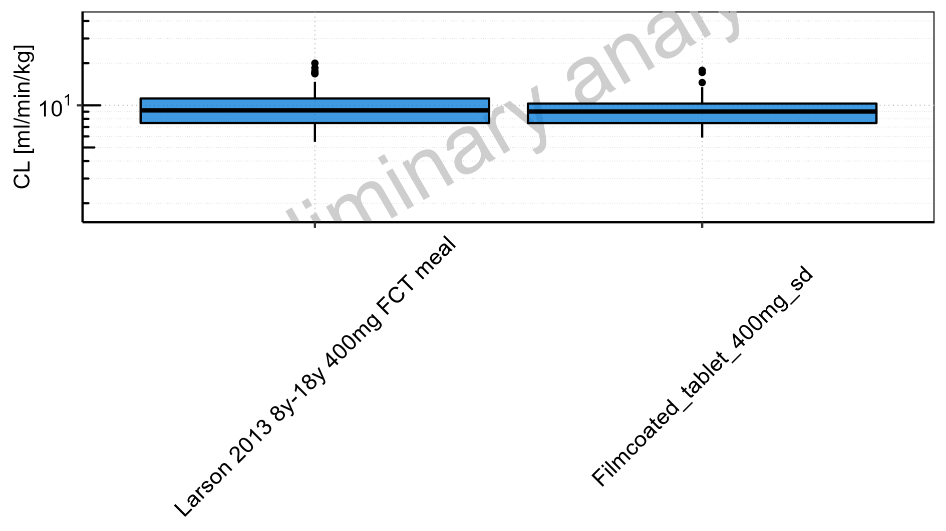

Figure 2-262: CL of Raltegravir for Larson 2013 8y-18y 400mg FCT meal, Filmcoated_tablet_400mg_sd shown as box-whisker plot, which indicates the 5<U+1D57><U+02B0>, 25<U+1D57><U+02B0>, 50<U+1D57><U+02B0>, 75<U+1D57><U+02B0>, 95<U+1D57><U+02B0> percentiles in linear scale.

**Table 2-11: CL of Raltegravir for Larson 2013 8y-18y 400mg FCT meal, Filmcoated_tablet_400mg_sd reported in [ml/min/kg]**

|  |  |  |  |  |  |  |  |  |  |  |
| --- | --- | --- | --- | --- | --- | --- | --- | --- | --- | --- |
| Population | N | 5<U+1D57><U+02B0> pctl | 25<U+1D57><U+02B0> pctl | 50<U+1D57><U+02B0> pctl | 75<U+1D57><U+02B0> pctl | 95<U+1D57><U+02B0> pctl | Mean | SD | Geo Mean | Geo SD |
| Larson 2013 8y-18y 400mg FCT meal | 497 | 5.48 | 7.47 | 9.20 | 11.19 | 14.71 | 9.49 | 2.84 | 9.08 | 1.35 |
| Filmcoated_tablet_400mg_sd | 100 | 5.88 | 7.47 | 9.03 | 10.29 | 13.49 | 9.20 | 2.50 | 8.89 | 1.30 |

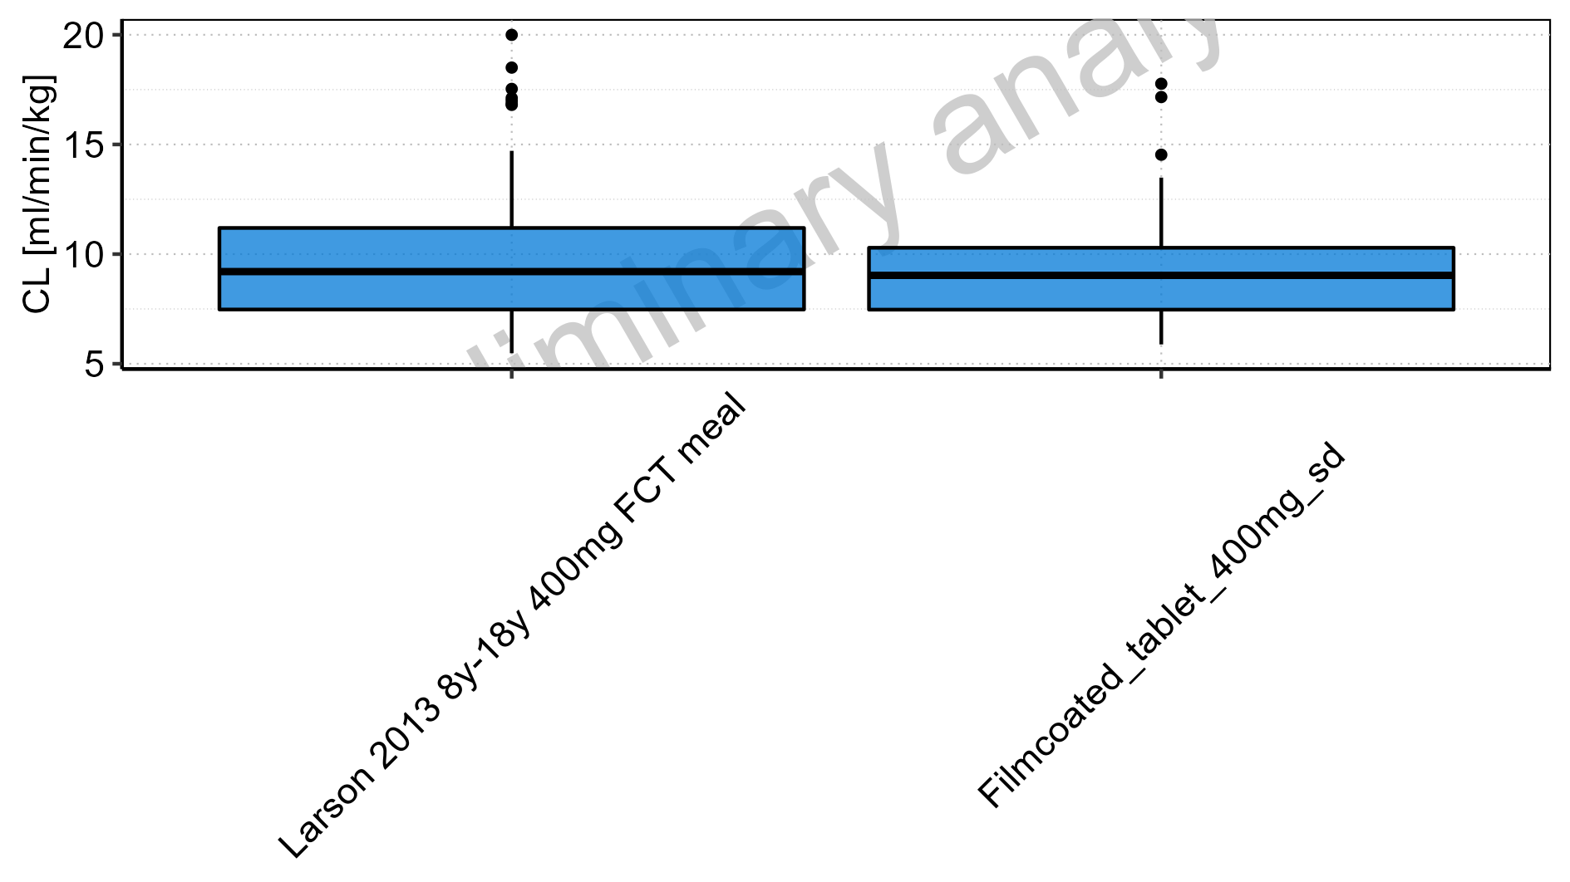

Figure 2-263: Age-dependence of CL for Larson 2013 8y-18y 400mg FCT meal in comparison to Filmcoated_tablet_400mg_sd. Profiles are plotted in a logarithmic scale.

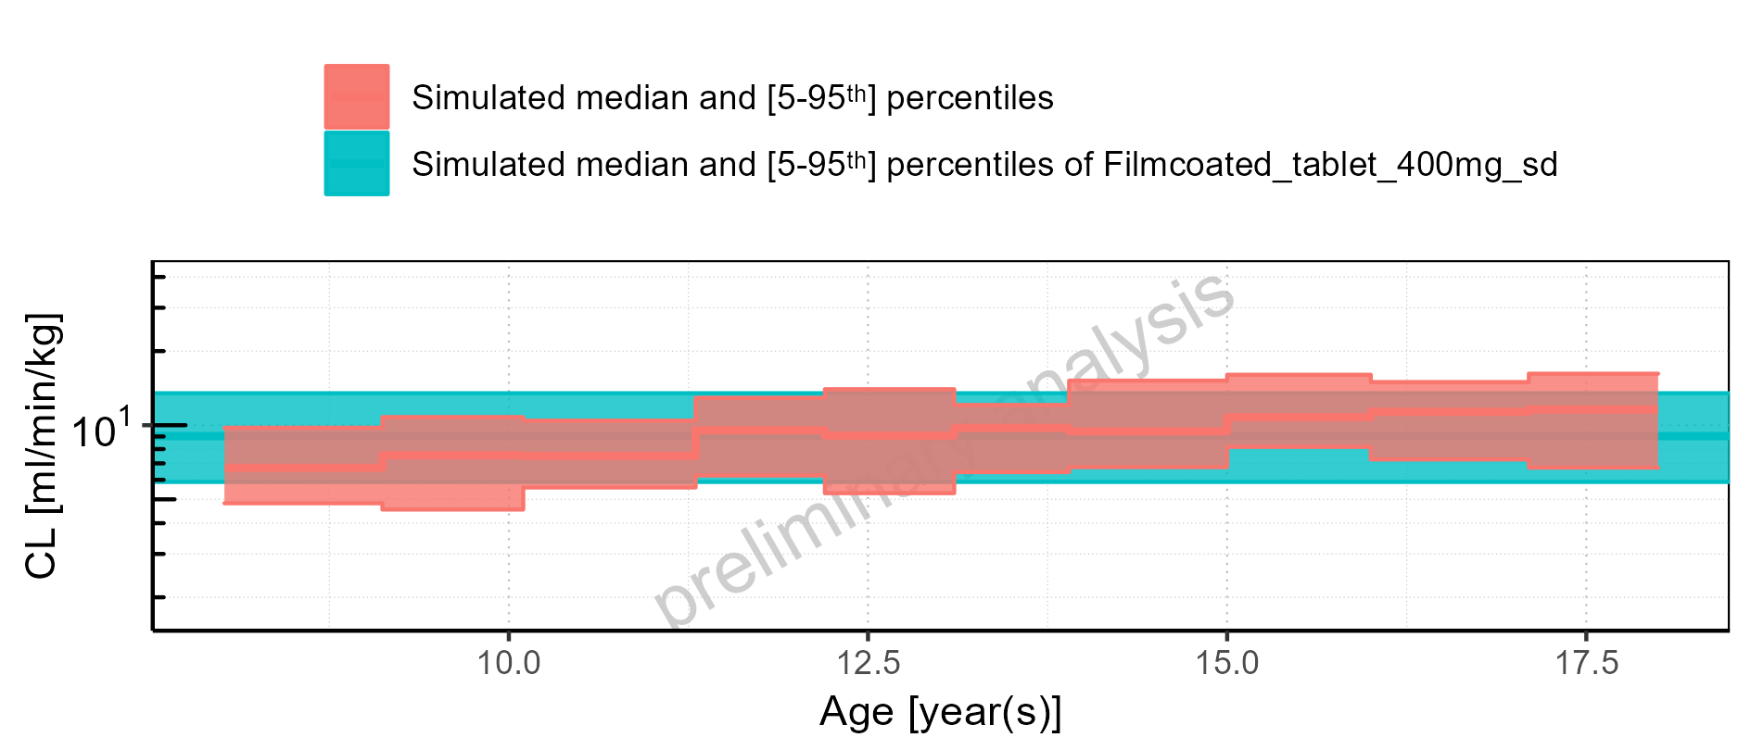

Figure 2-264: Age-dependence of CL for Larson 2013 8y-18y 400mg FCT meal in comparison to Filmcoated_tablet_400mg_sd. Profiles are plotted in a linear scale.

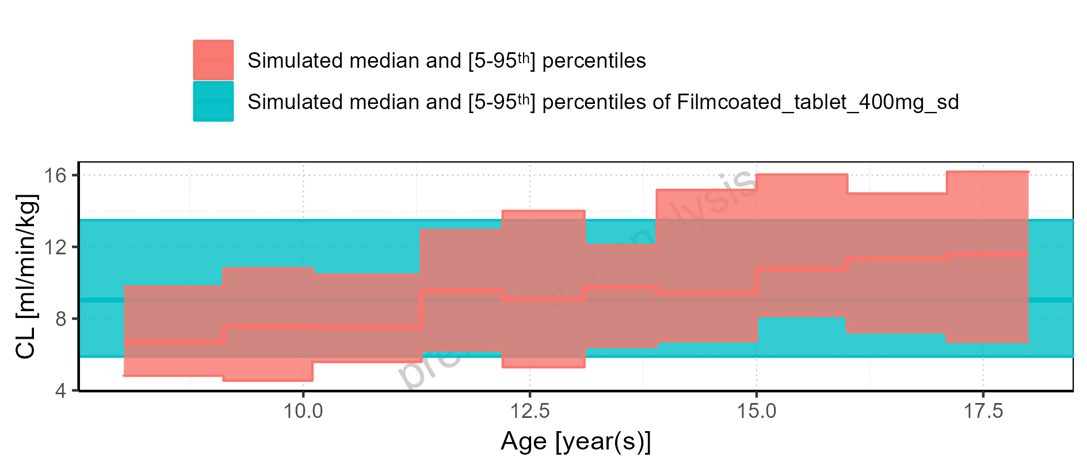

Figure 2-265: Age-dependence of CL for Larson 2013 8y-18y 400mg FCT meal. Profiles are plotted in a logarithmic scale.

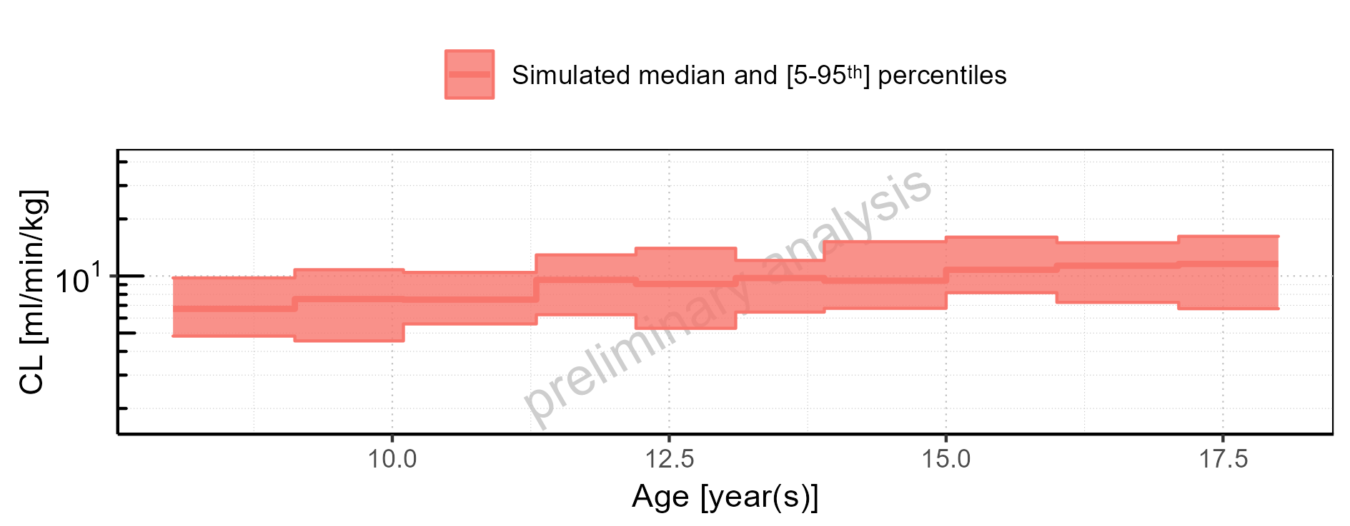

Figure 2-266: Age-dependence of CL for Larson 2013 8y-18y 400mg FCT meal. Profiles are plotted in a linear scale.

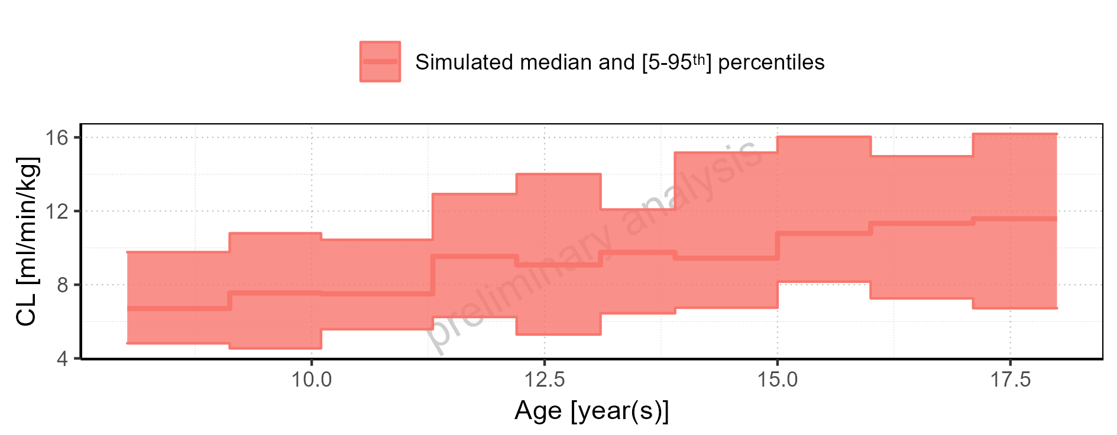

Figure 2-267: Age-dependence of CL for Filmcoated_tablet_400mg_sd. Profiles are plotted in a logarithmic scale.

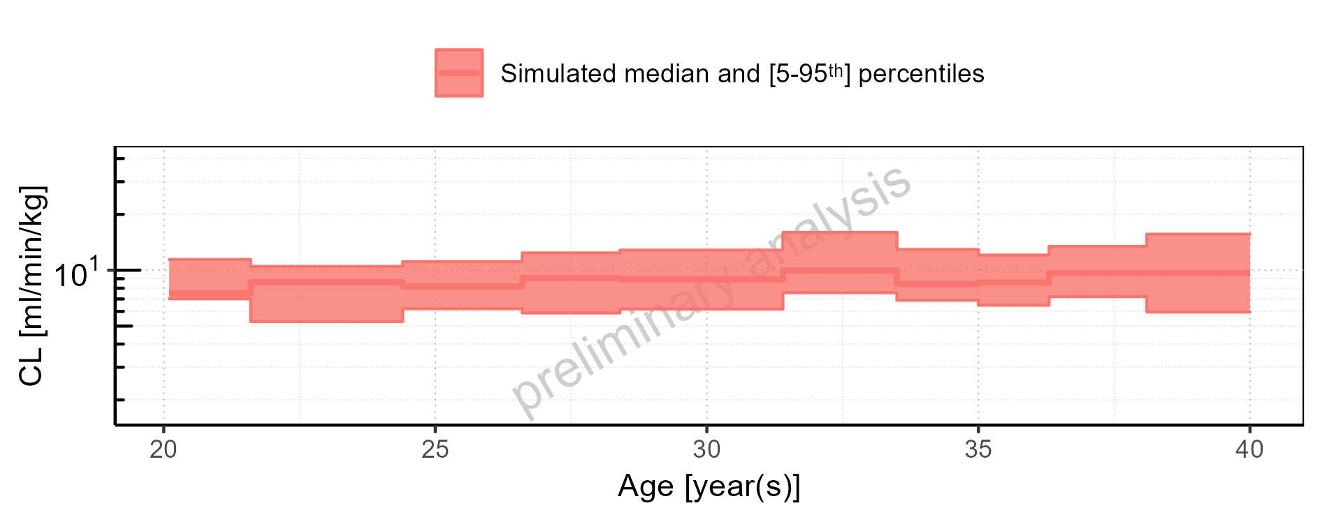

Figure 2-268: Age-dependence of CL for Filmcoated_tablet_400mg_sd. Profiles are plotted in a linear scale.

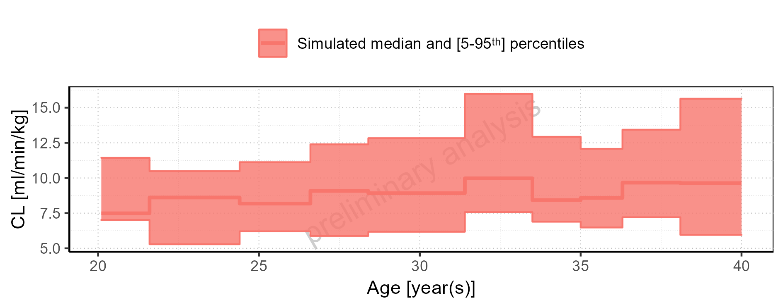

Figure 2-269: Height-dependence of CL for Larson 2013 8y-18y 400mg FCT meal in comparison to Filmcoated_tablet_400mg_sd. Profiles are plotted in a logarithmic scale.

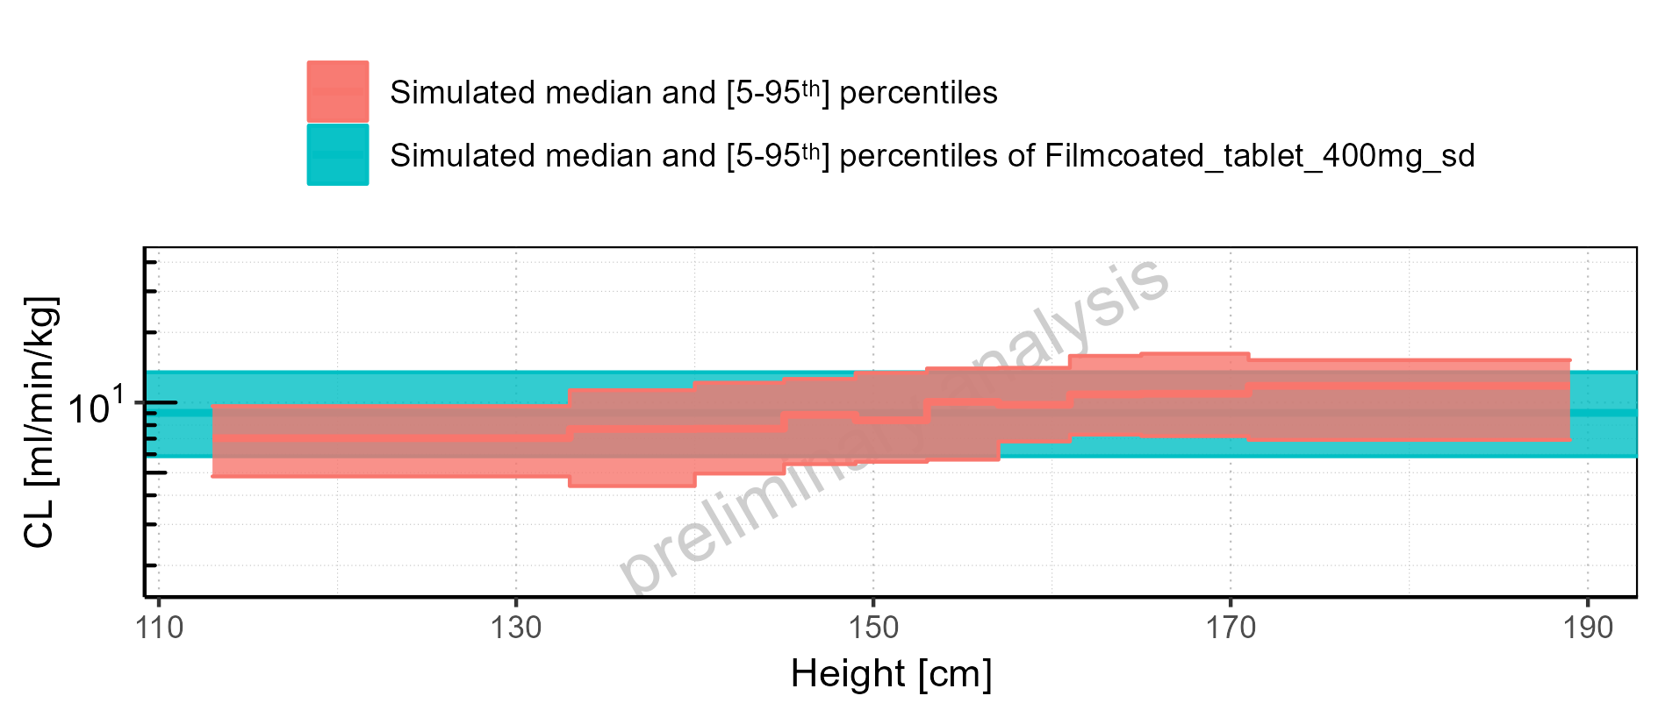

Figure 2-270: Height-dependence of CL for Larson 2013 8y-18y 400mg FCT meal in comparison to Filmcoated_tablet_400mg_sd. Profiles are plotted in a linear scale.

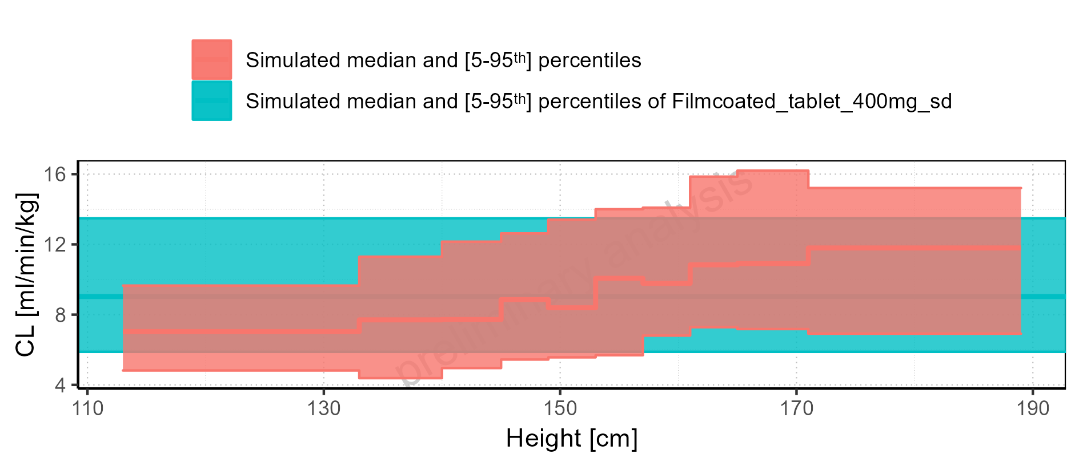

Figure 2-271: Height-dependence of CL for Larson 2013 8y-18y 400mg FCT meal. Profiles are plotted in a logarithmic scale.

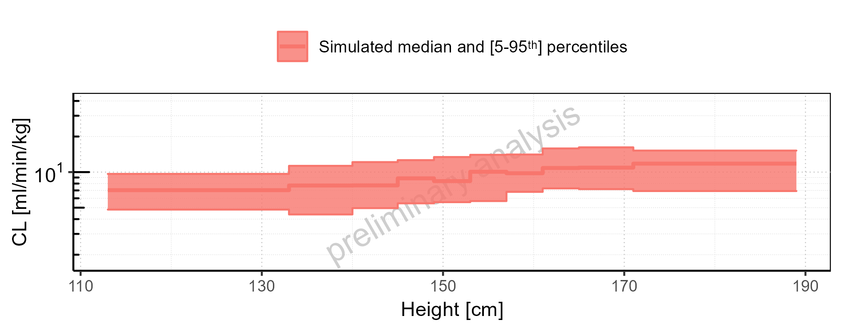

Figure 2-272: Height-dependence of CL for Larson 2013 8y-18y 400mg FCT meal. Profiles are plotted in a linear scale.

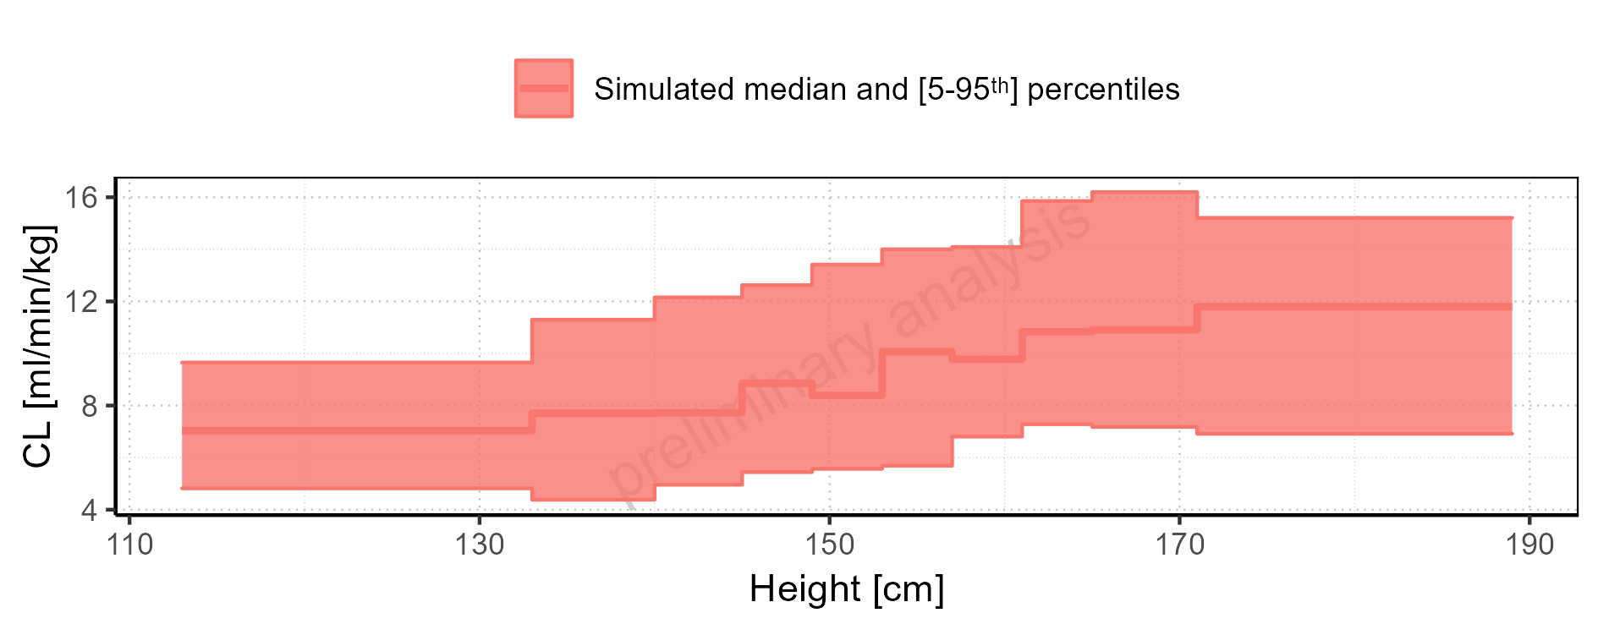

Figure 2-273: Height-dependence of CL for Filmcoated_tablet_400mg_sd. Profiles are plotted in a logarithmic scale.

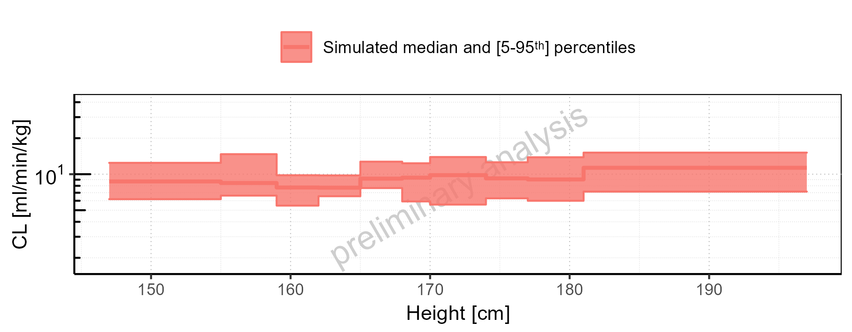

Figure 2-274: Height-dependence of CL for Filmcoated_tablet_400mg_sd. Profiles are plotted in a linear scale.

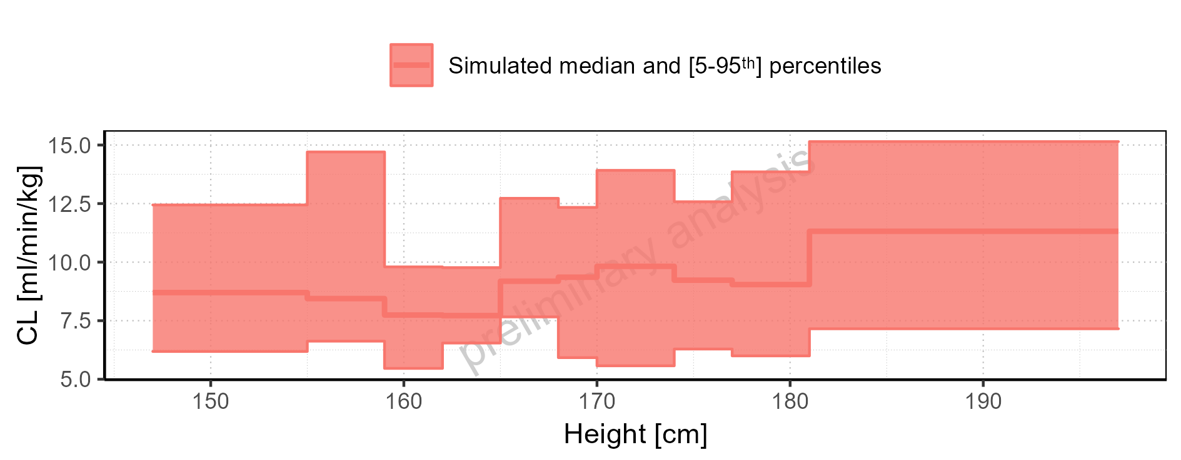

Figure 2-275: Weight-dependence of CL for Larson 2013 8y-18y 400mg FCT meal in comparison to Filmcoated_tablet_400mg_sd. Profiles are plotted in a logarithmic scale.

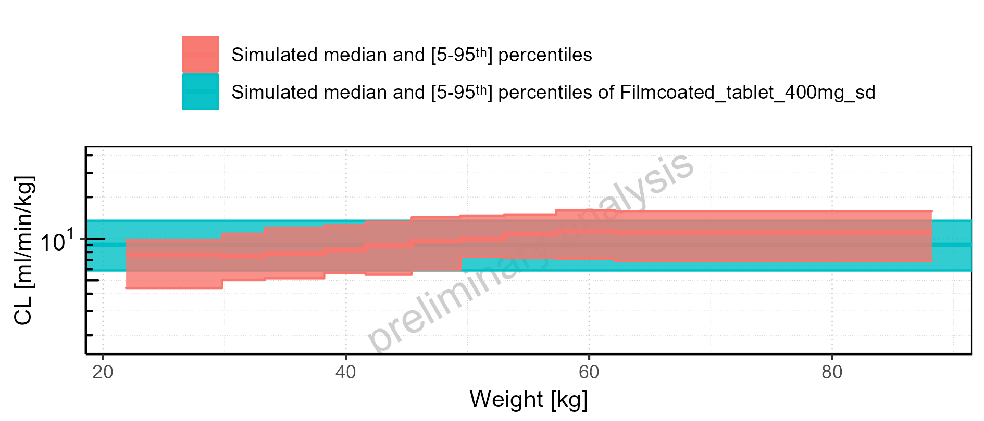

Figure 2-276: Weight-dependence of CL for Larson 2013 8y-18y 400mg FCT meal in comparison to Filmcoated_tablet_400mg_sd. Profiles are plotted in a linear scale.

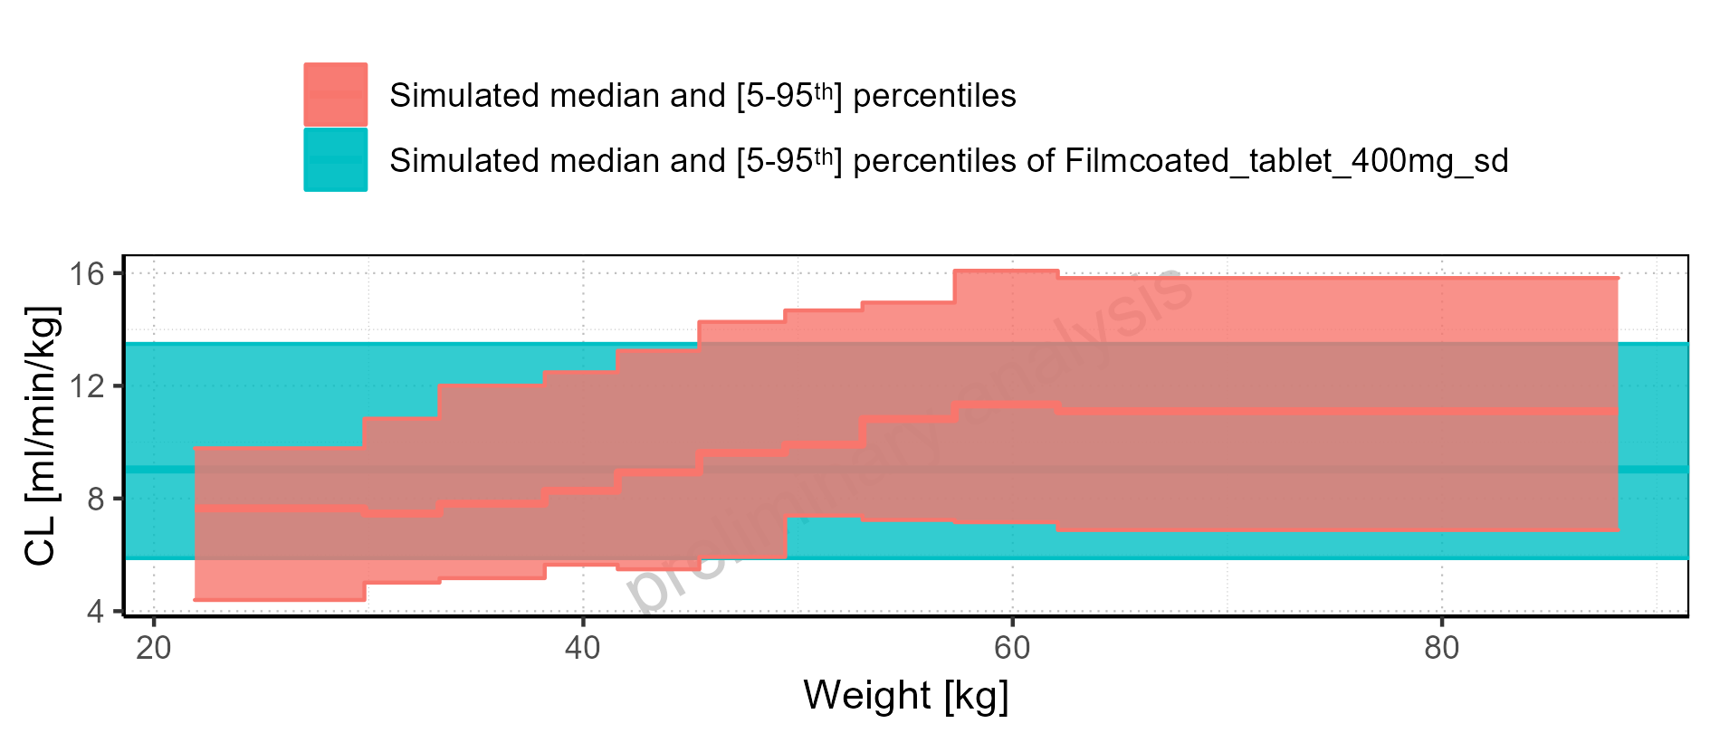

Figure 2-277: Weight-dependence of CL for Larson 2013 8y-18y 400mg FCT meal. Profiles are plotted in a logarithmic scale.

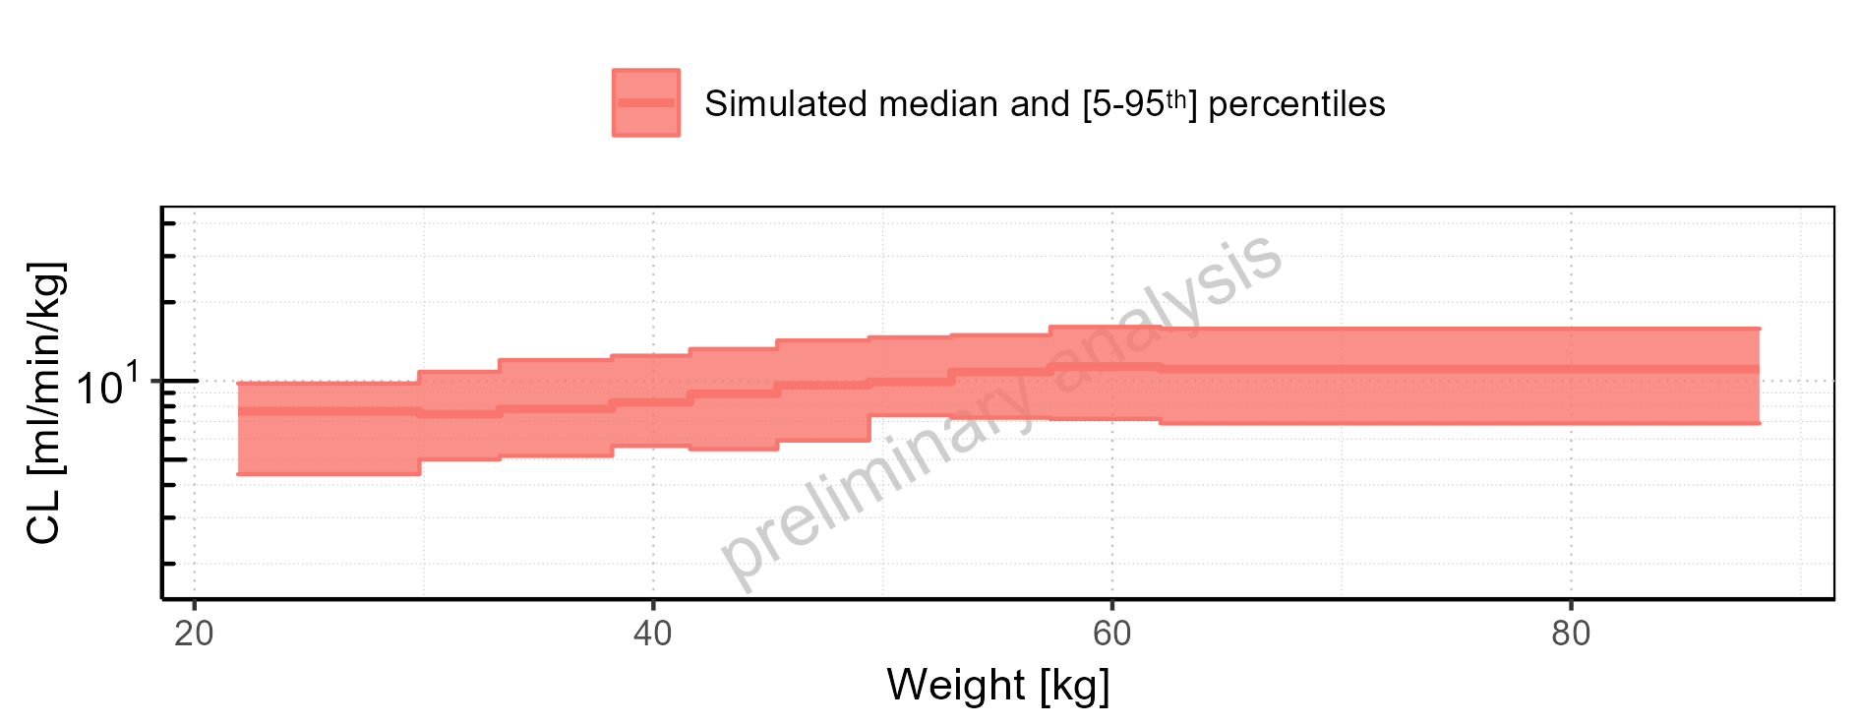

Figure 2-278: Weight-dependence of CL for Larson 2013 8y-18y 400mg FCT meal. Profiles are plotted in a linear scale.

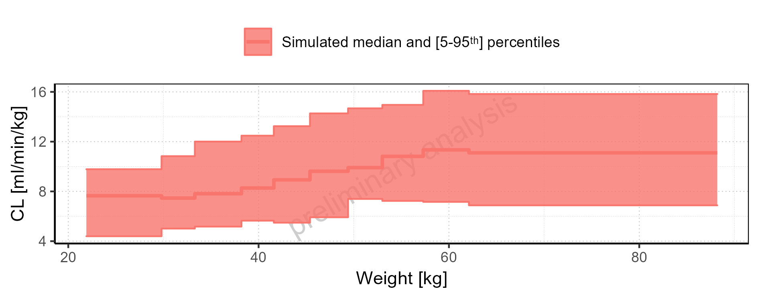

Figure 2-279: Weight-dependence of CL for Filmcoated_tablet_400mg_sd. Profiles are plotted in a logarithmic scale.

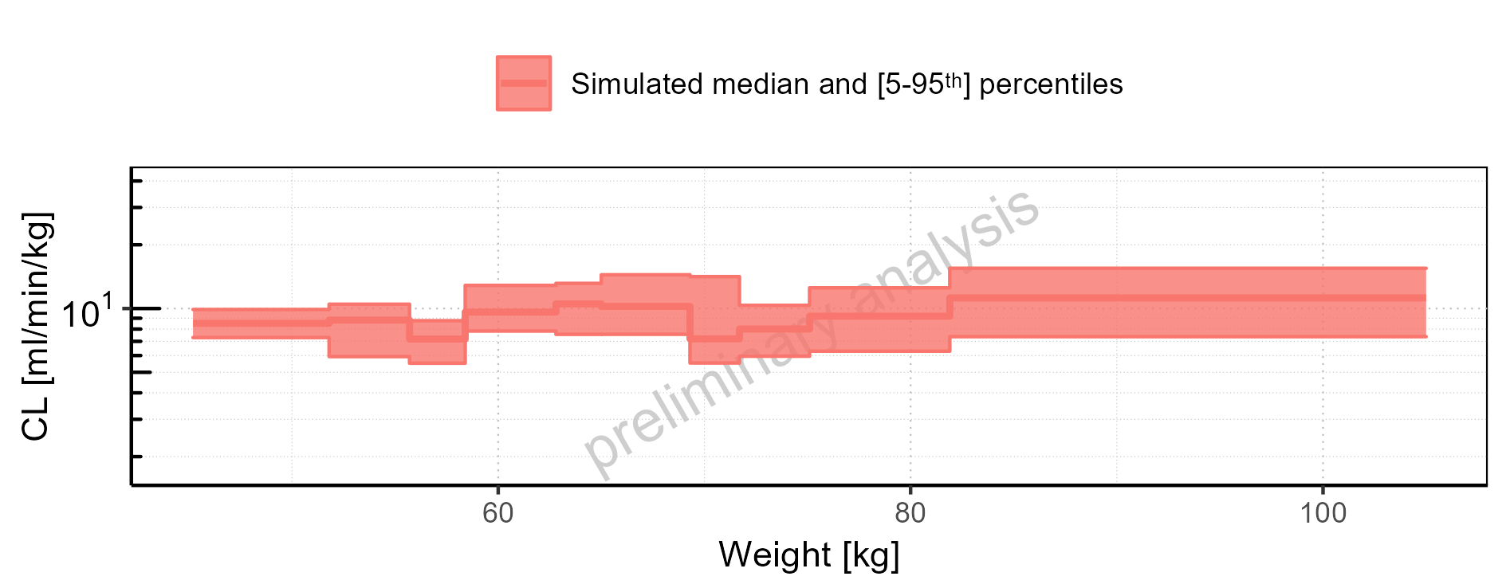

Figure 2-280: Weight-dependence of CL for Filmcoated_tablet_400mg_sd. Profiles are plotted in a linear scale.

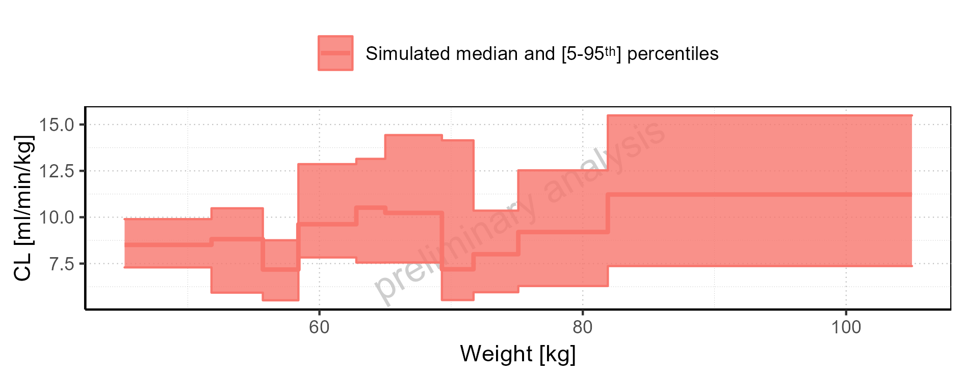

Figure 2-281: BMI-dependence of CL for Larson 2013 8y-18y 400mg FCT meal in comparison to Filmcoated_tablet_400mg_sd. Profiles are plotted in a logarithmic scale.

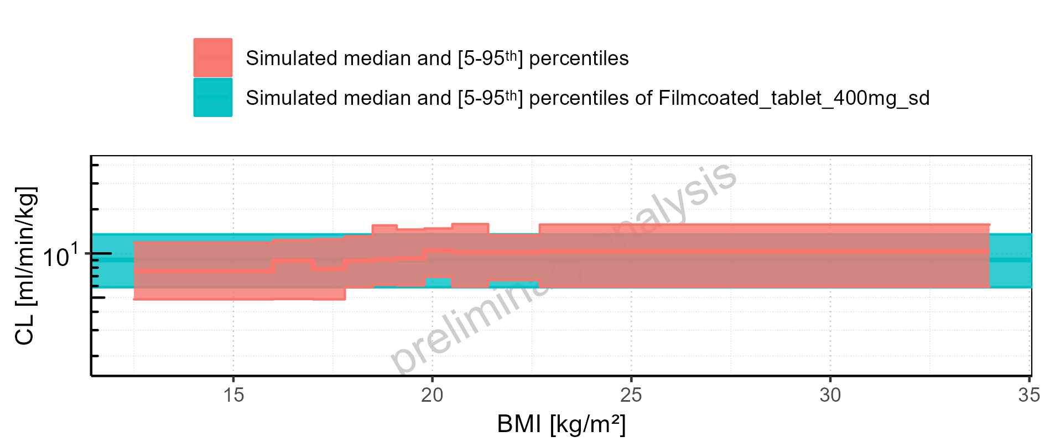

Figure 2-282: BMI-dependence of CL for Larson 2013 8y-18y 400mg FCT meal in comparison to Filmcoated_tablet_400mg_sd. Profiles are plotted in a linear scale.

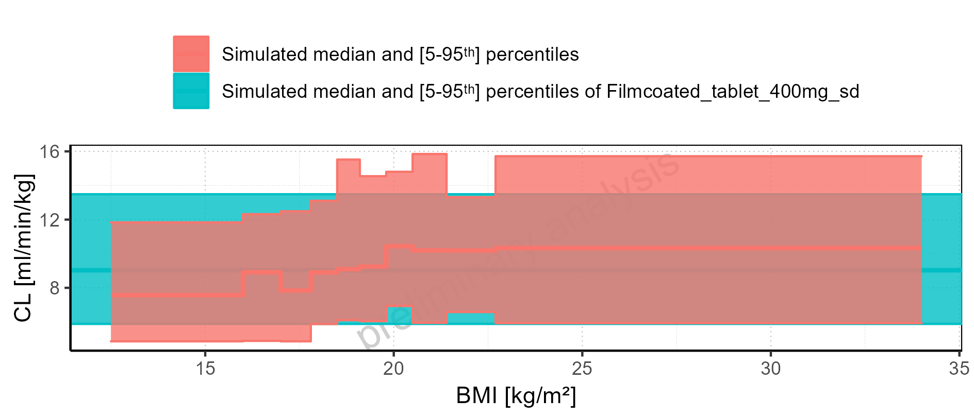

Figure 2-283: BMI-dependence of CL for Larson 2013 8y-18y 400mg FCT meal. Profiles are plotted in a logarithmic scale.

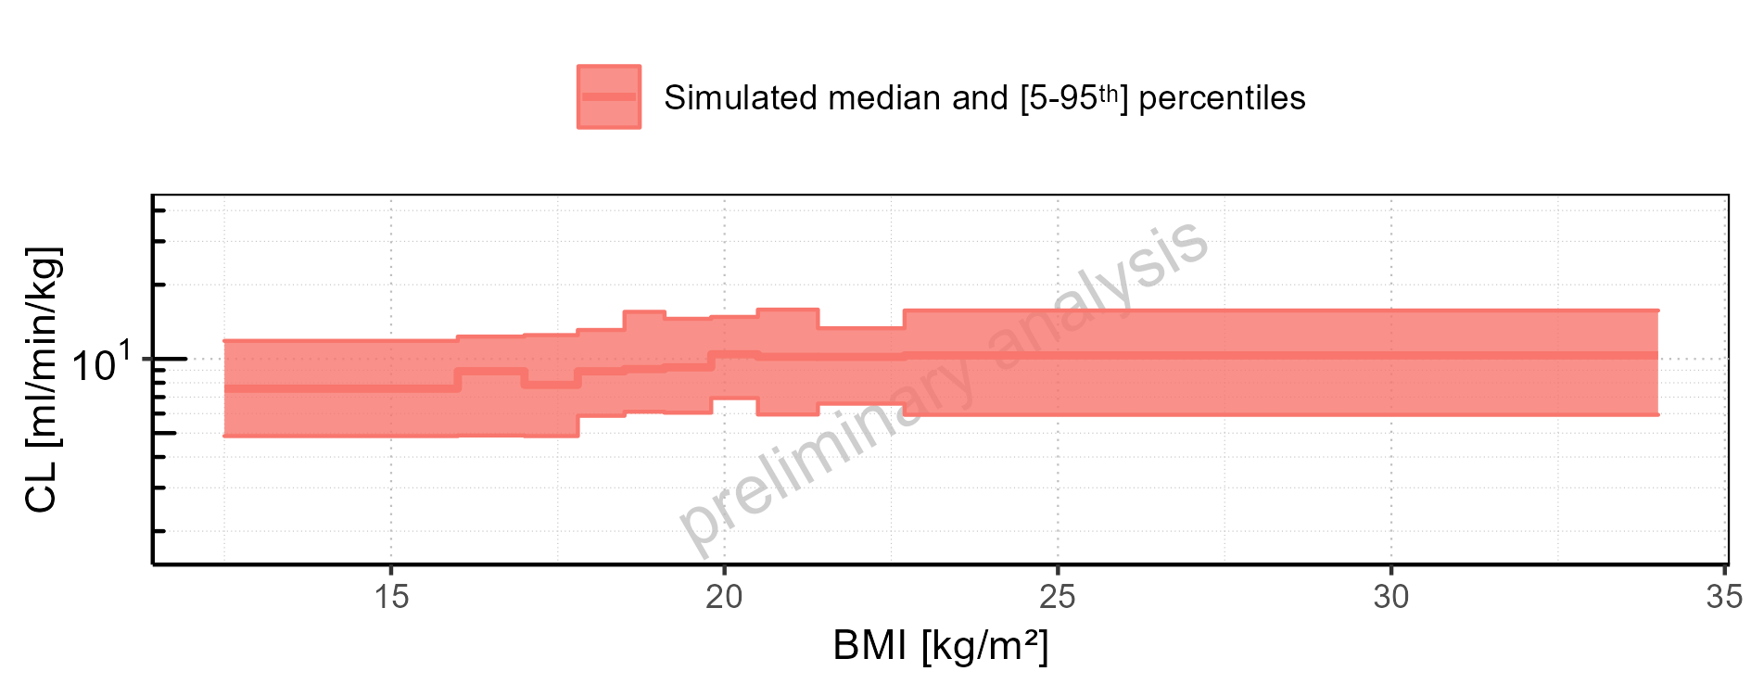

Figure 2-284: BMI-dependence of CL for Larson 2013 8y-18y 400mg FCT meal. Profiles are plotted in a linear scale.

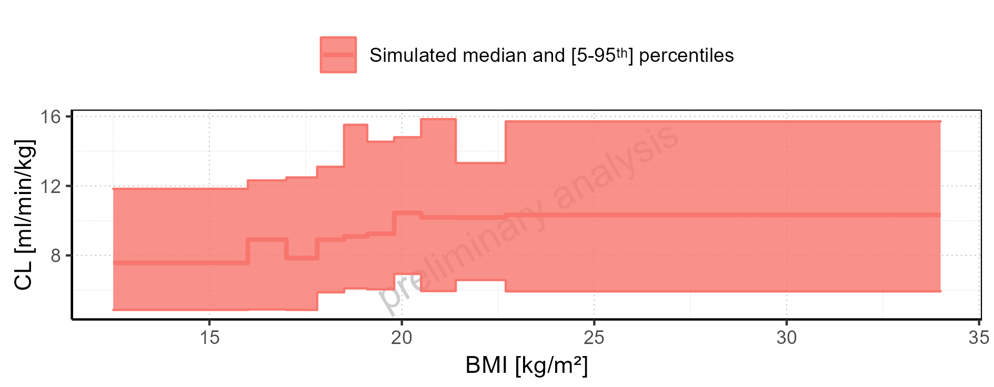

Figure 2-285: BMI-dependence of CL for Filmcoated_tablet_400mg_sd. Profiles are plotted in a logarithmic scale.

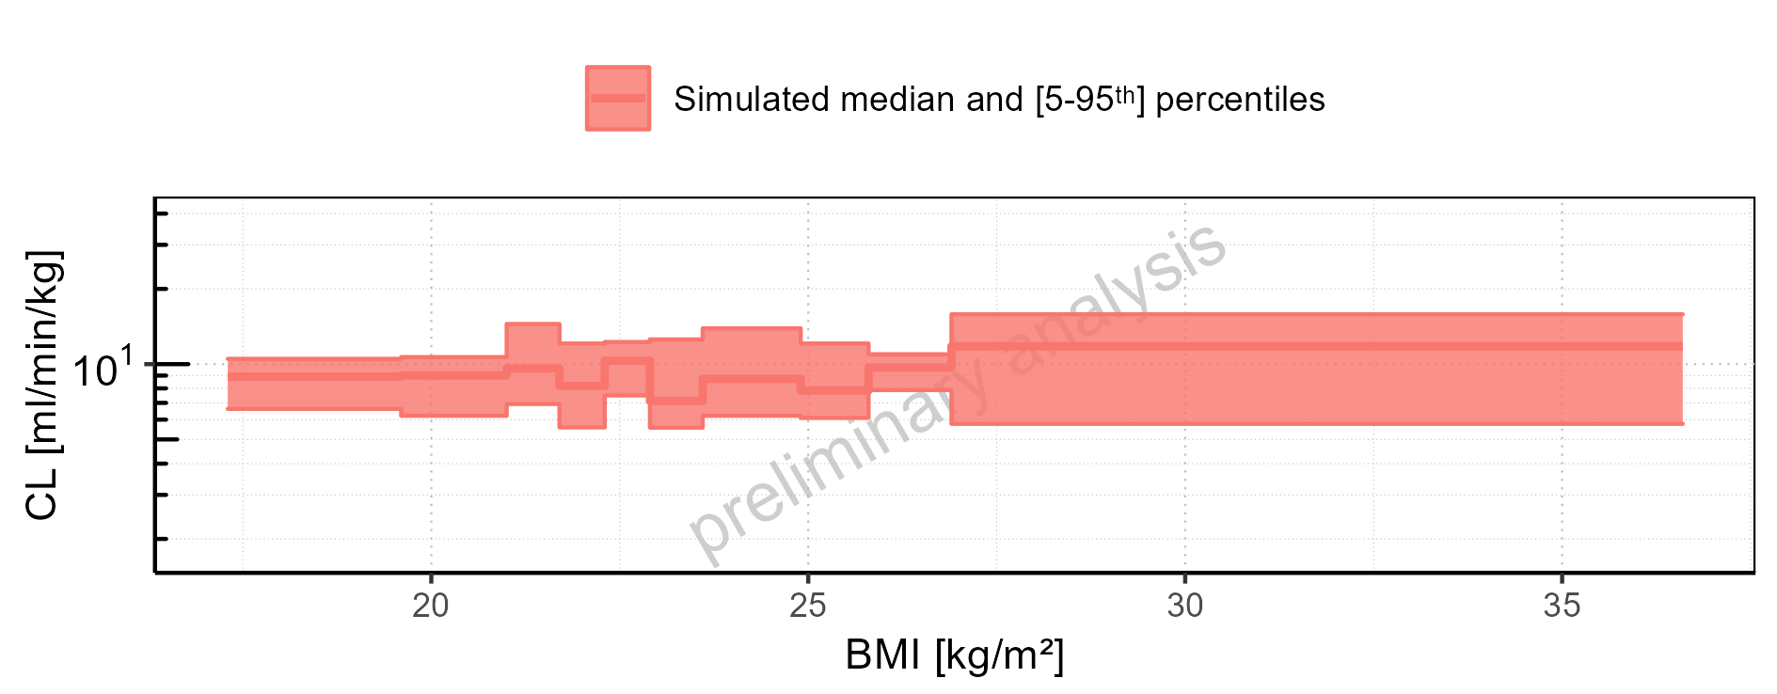

Figure 2-286: BMI-dependence of CL for Filmcoated_tablet_400mg_sd. Profiles are plotted in a linear scale.

### Vss

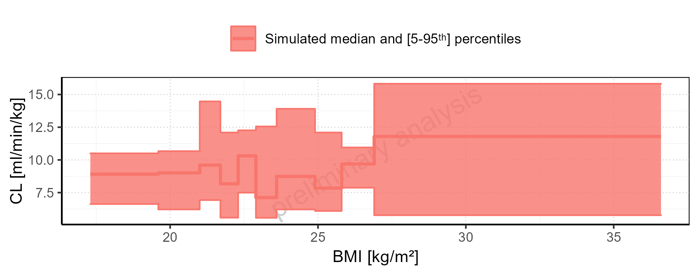

Figure 2-287: Vss of Raltegravir for Larson 2013 8y-18y 400mg FCT meal, Filmcoated_tablet_400mg_sd shown as box-whisker plot, which indicates the 5<U+1D57><U+02B0>, 25<U+1D57><U+02B0>, 50<U+1D57><U+02B0>, 75<U+1D57><U+02B0>, 95<U+1D57><U+02B0> percentiles in logarithmic scale.

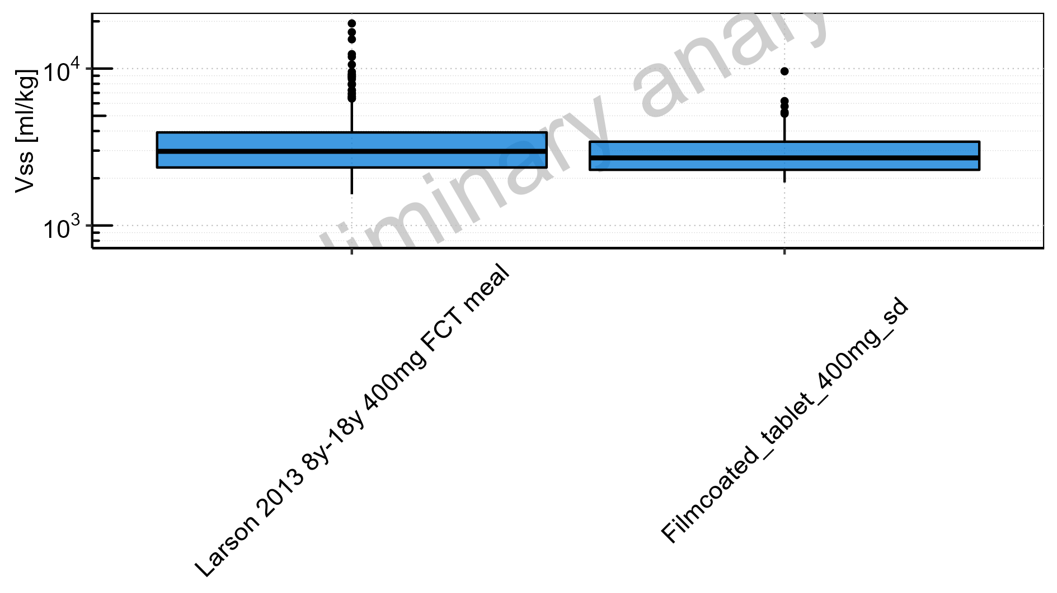

Figure 2-288: Vss of Raltegravir for Larson 2013 8y-18y 400mg FCT meal, Filmcoated_tablet_400mg_sd shown as box-whisker plot, which indicates the 5<U+1D57><U+02B0>, 25<U+1D57><U+02B0>, 50<U+1D57><U+02B0>, 75<U+1D57><U+02B0>, 95<U+1D57><U+02B0> percentiles in linear scale.

**Table 2-12: Vss of Raltegravir for Larson 2013 8y-18y 400mg FCT meal, Filmcoated_tablet_400mg_sd reported in [ml/kg]**

|  |  |  |  |  |  |  |  |  |  |  |
| --- | --- | --- | --- | --- | --- | --- | --- | --- | --- | --- |
| Population | N | 5<U+1D57><U+02B0> pctl | 25<U+1D57><U+02B0> pctl | 50<U+1D57><U+02B0> pctl | 75<U+1D57><U+02B0> pctl | 95<U+1D57><U+02B0> pctl | Mean | SD | Geo Mean | Geo SD |
| Larson 2013 8y-18y 400mg FCT meal | 497 | 1581.09 | 2341.62 | 2968.06 | 3917.84 | 6249.02 | 3396.63 | 1880.06 | 3071.48 | 1.53 |
| Filmcoated_tablet_400mg_sd | 100 | 1880.27 | 2263.55 | 2695.83 | 3418.90 | 4890.56 | 2993.70 | 1138.98 | 2836.19 | 1.37 |

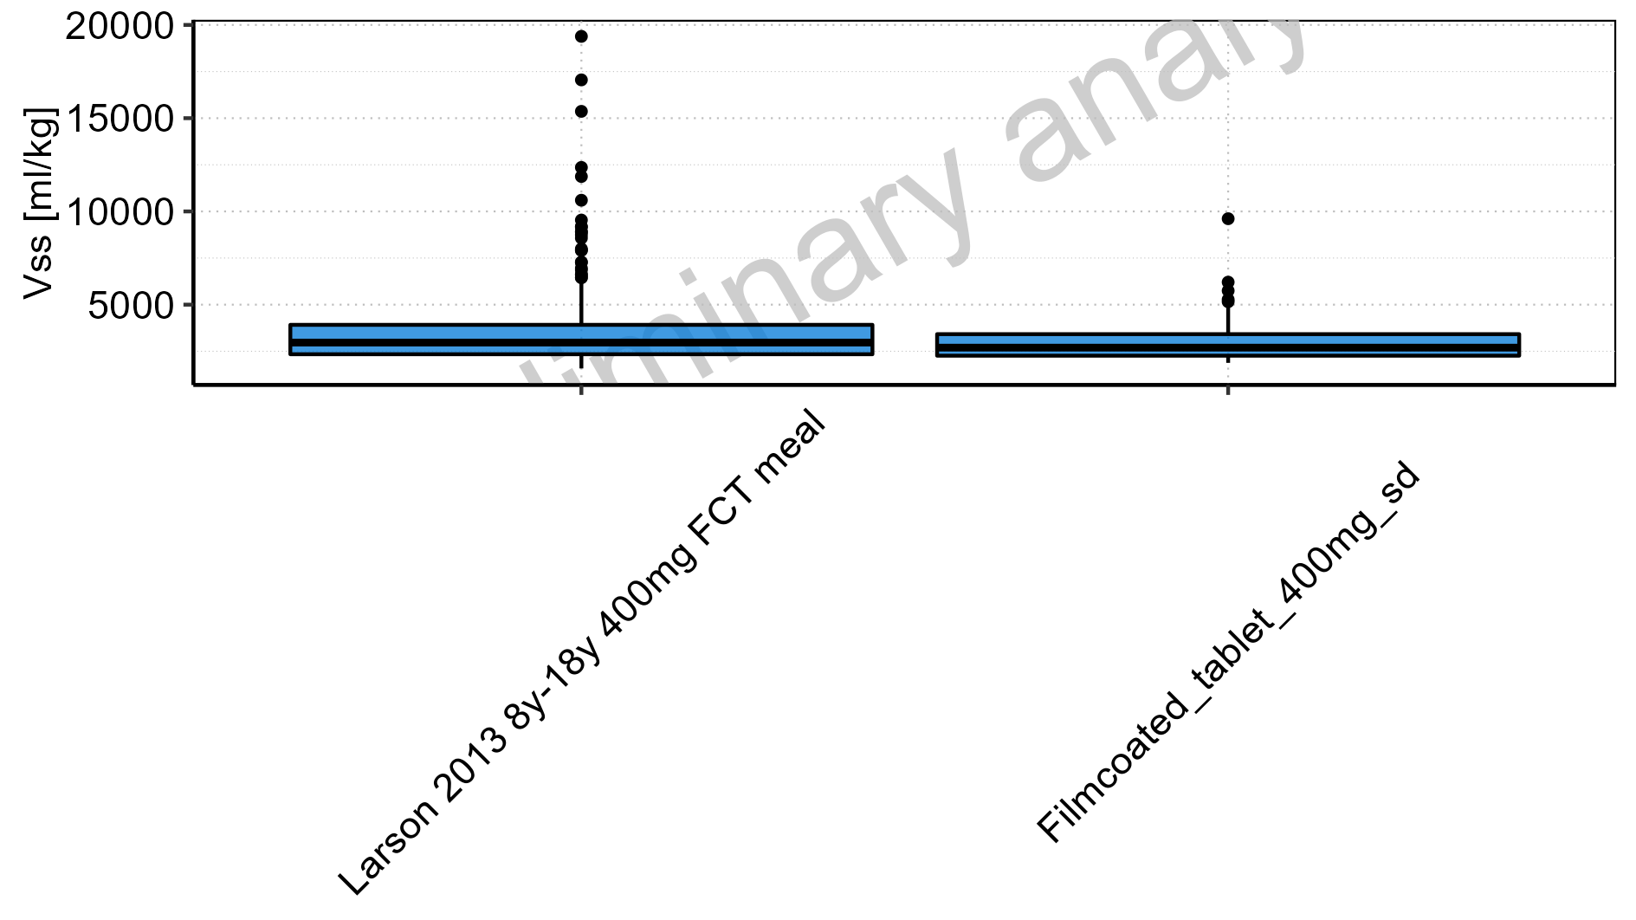

Figure 2-289: Age-dependence of Vss for Larson 2013 8y-18y 400mg FCT meal in comparison to Filmcoated_tablet_400mg_sd. Profiles are plotted in a logarithmic scale.

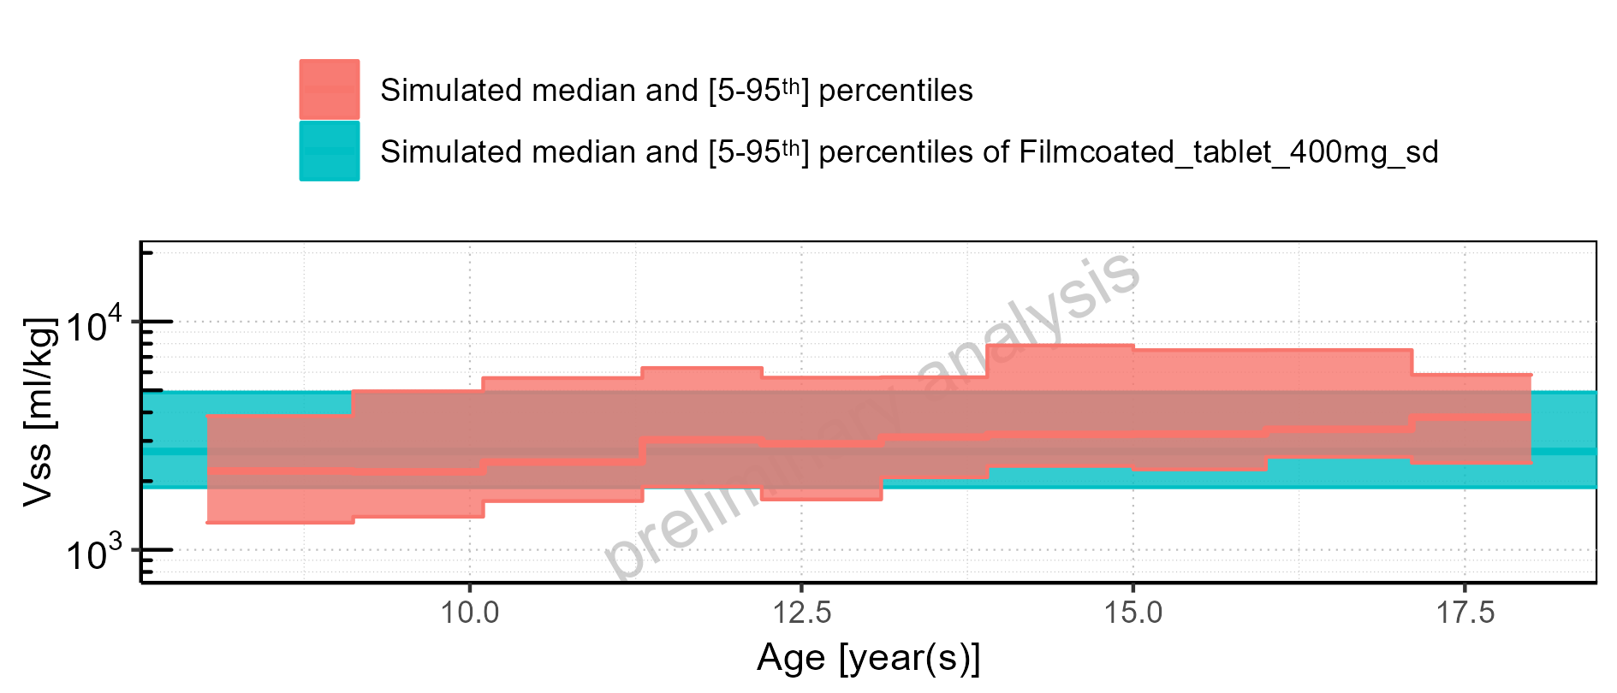

Figure 2-290: Age-dependence of Vss for Larson 2013 8y-18y 400mg FCT meal in comparison to Filmcoated_tablet_400mg_sd. Profiles are plotted in a linear scale.

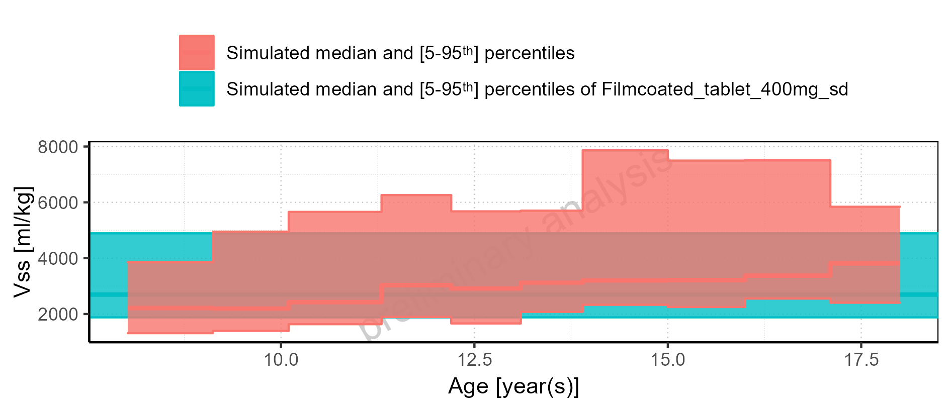

Figure 2-291: Age-dependence of Vss for Larson 2013 8y-18y 400mg FCT meal. Profiles are plotted in a logarithmic scale.

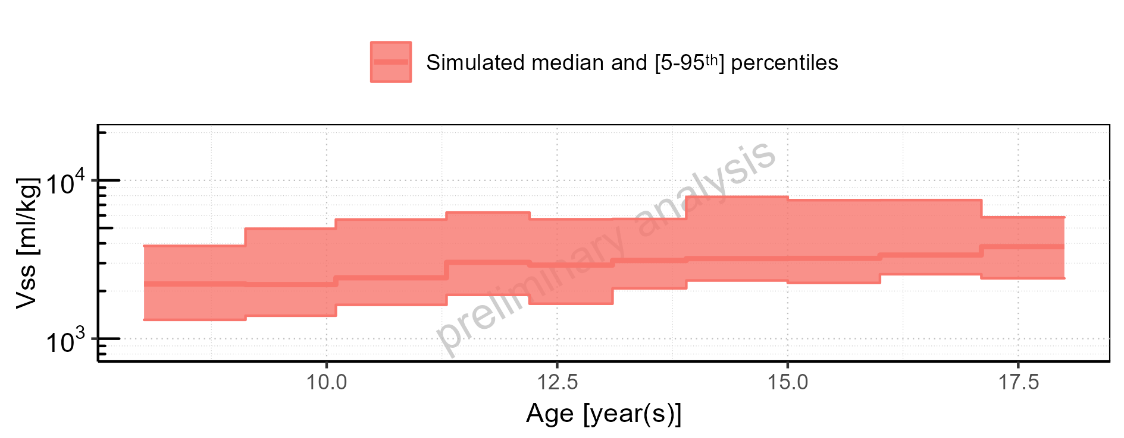

Figure 2-292: Age-dependence of Vss for Larson 2013 8y-18y 400mg FCT meal. Profiles are plotted in a linear scale.

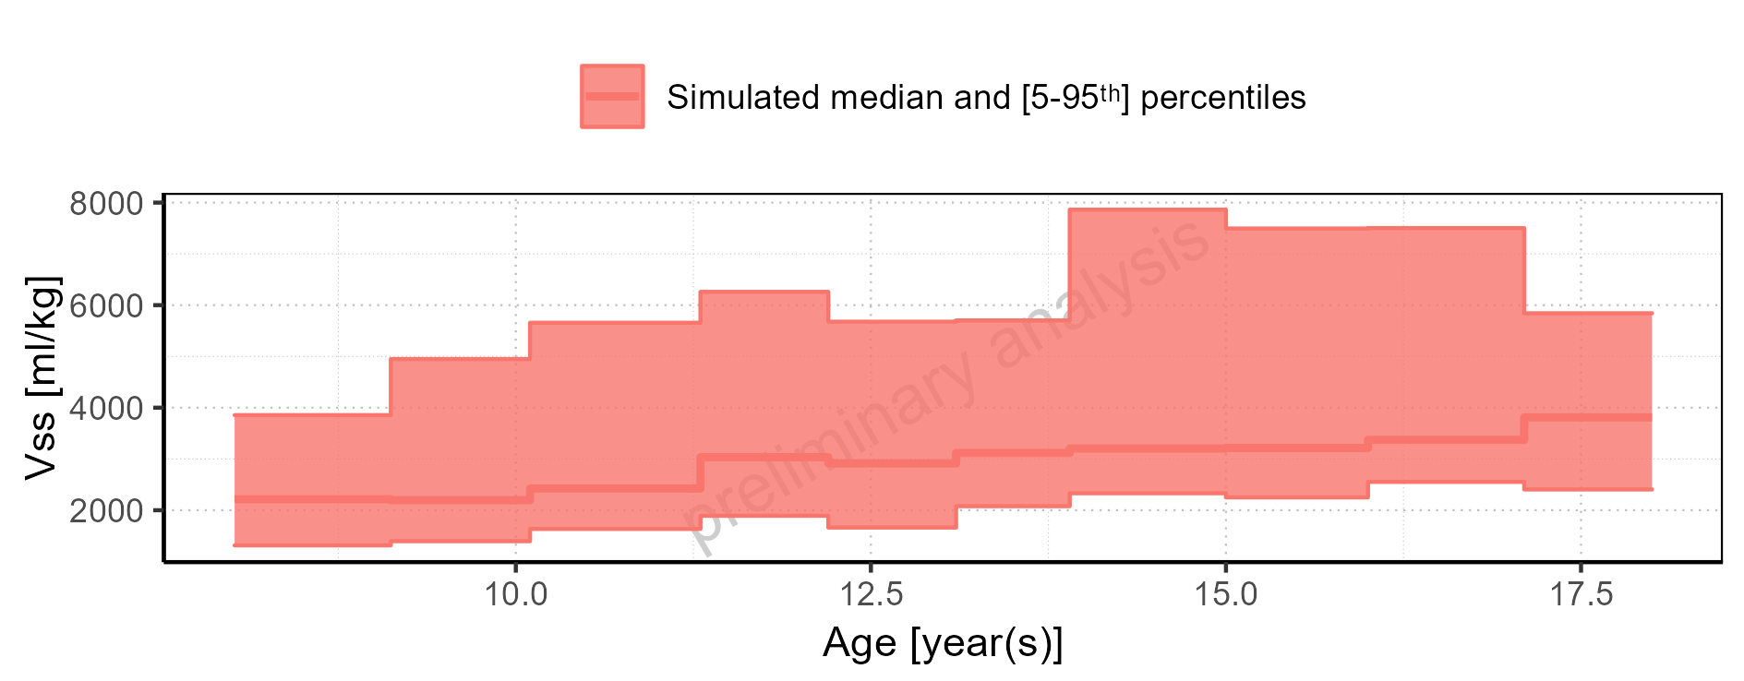

Figure 2-293: Age-dependence of Vss for Filmcoated_tablet_400mg_sd. Profiles are plotted in a logarithmic scale.

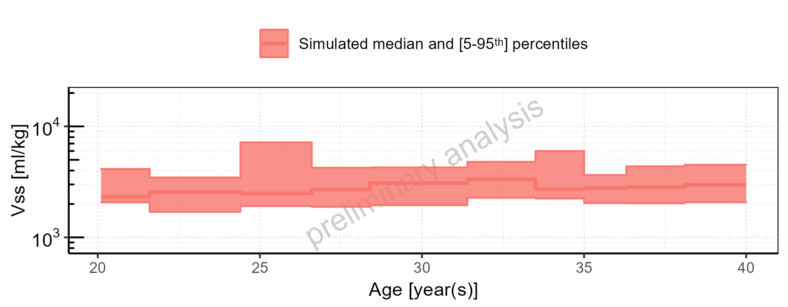

Figure 2-294: Age-dependence of Vss for Filmcoated_tablet_400mg_sd. Profiles are plotted in a linear scale.

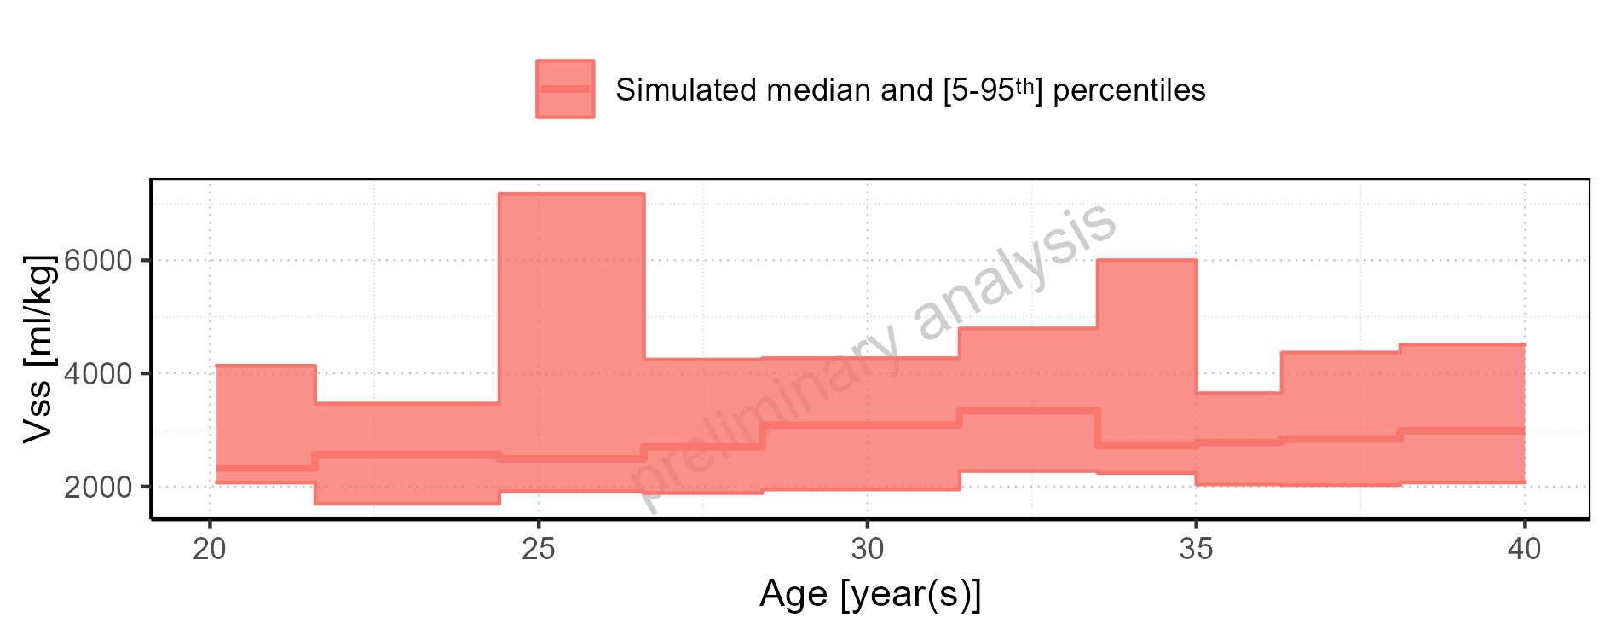

Figure 2-295: Height-dependence of Vss for Larson 2013 8y-18y 400mg FCT meal in comparison to Filmcoated_tablet_400mg_sd. Profiles are plotted in a logarithmic scale.

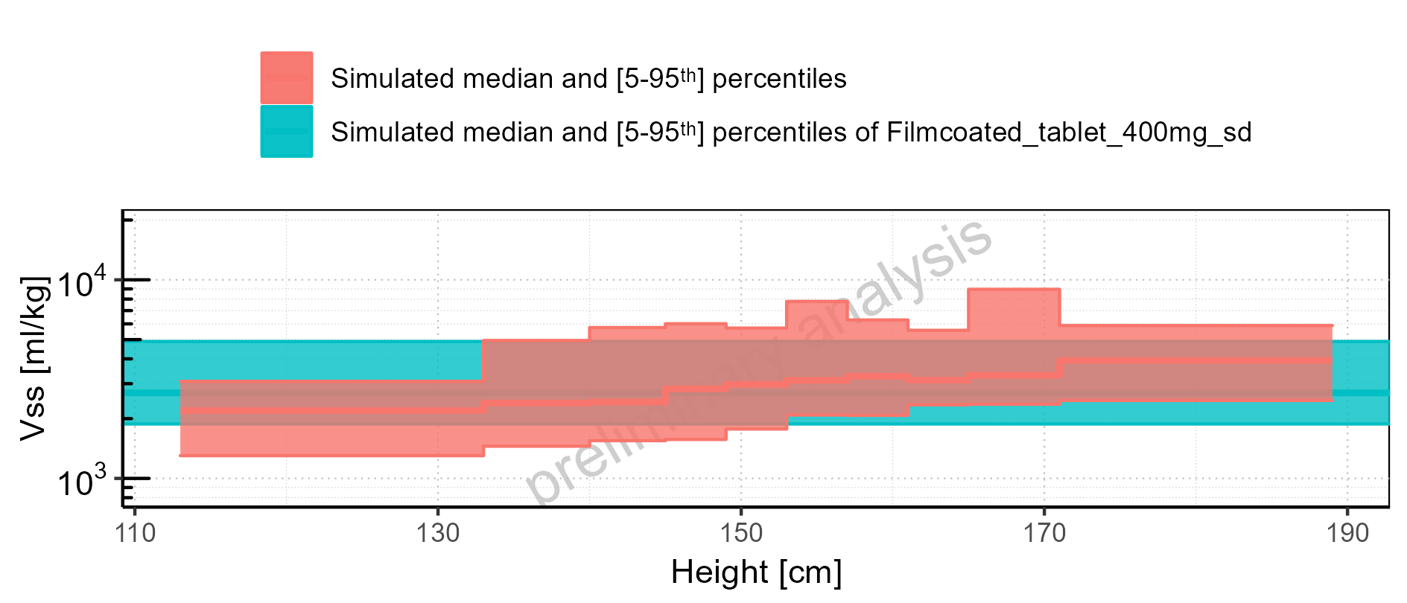

Figure 2-296: Height-dependence of Vss for Larson 2013 8y-18y 400mg FCT meal in comparison to Filmcoated_tablet_400mg_sd. Profiles are plotted in a linear scale.

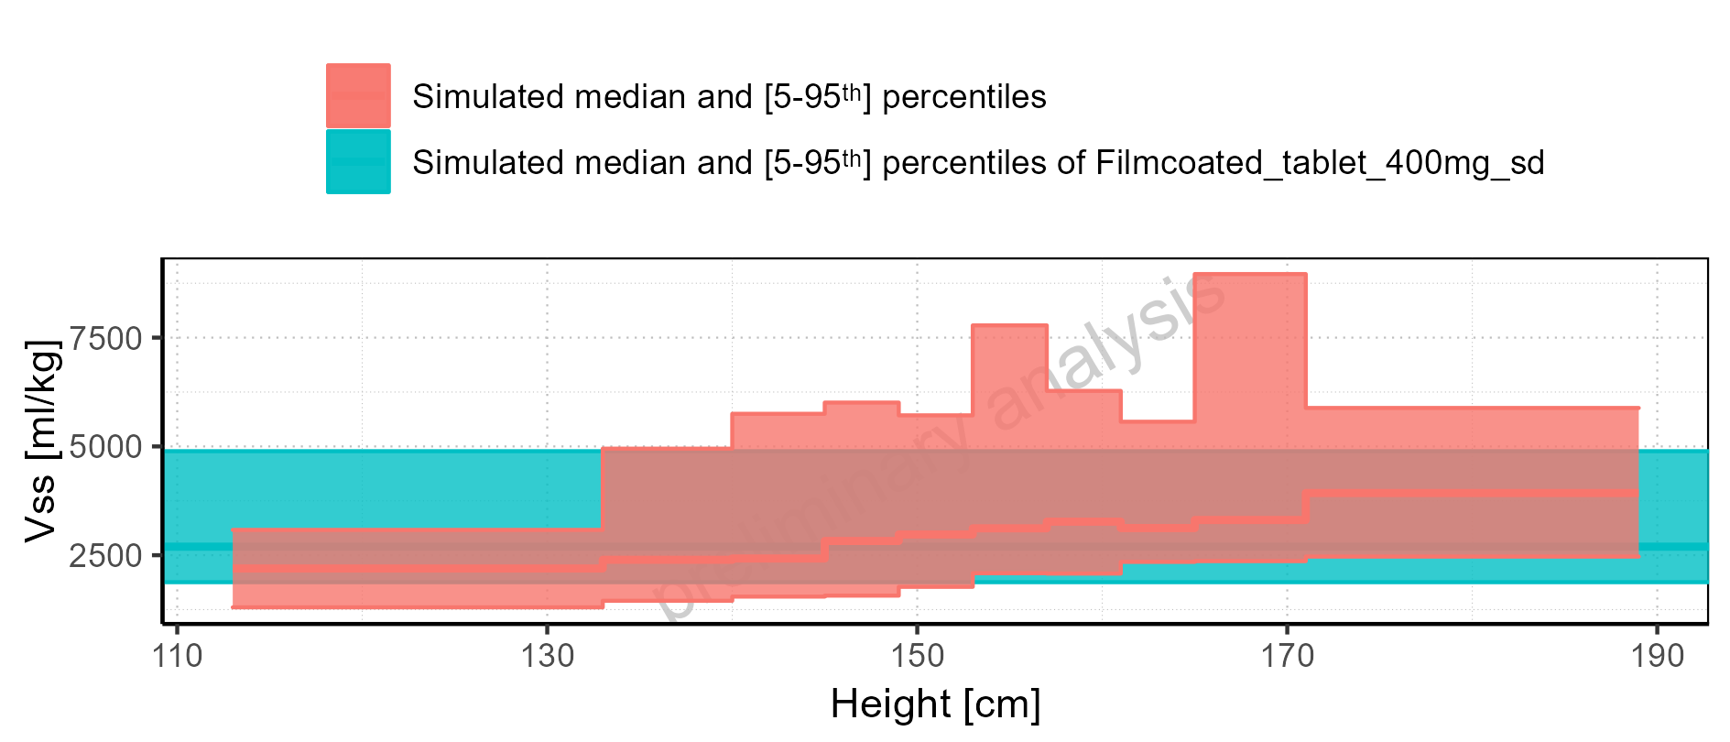

Figure 2-297: Height-dependence of Vss for Larson 2013 8y-18y 400mg FCT meal. Profiles are plotted in a logarithmic scale.

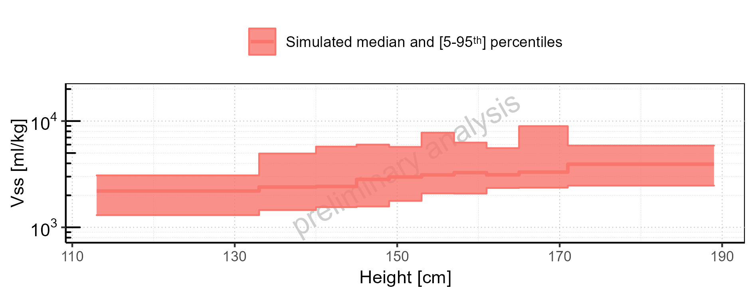

Figure 2-298: Height-dependence of Vss for Larson 2013 8y-18y 400mg FCT meal. Profiles are plotted in a linear scale.

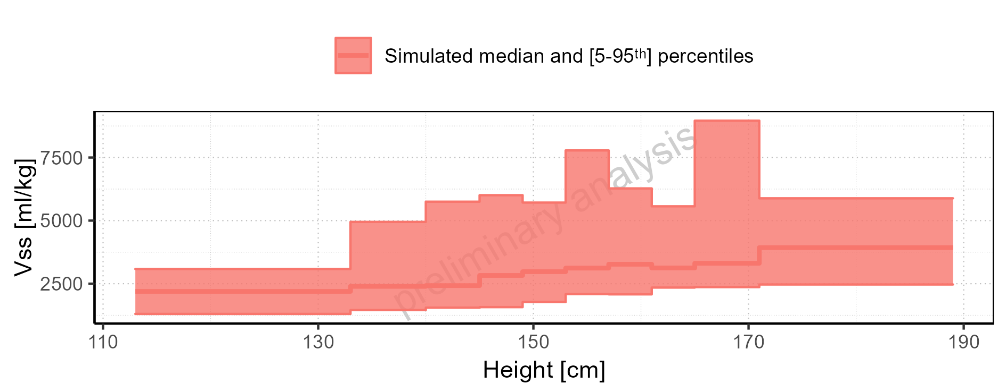

Figure 2-299: Height-dependence of Vss for Filmcoated_tablet_400mg_sd. Profiles are plotted in a logarithmic scale.

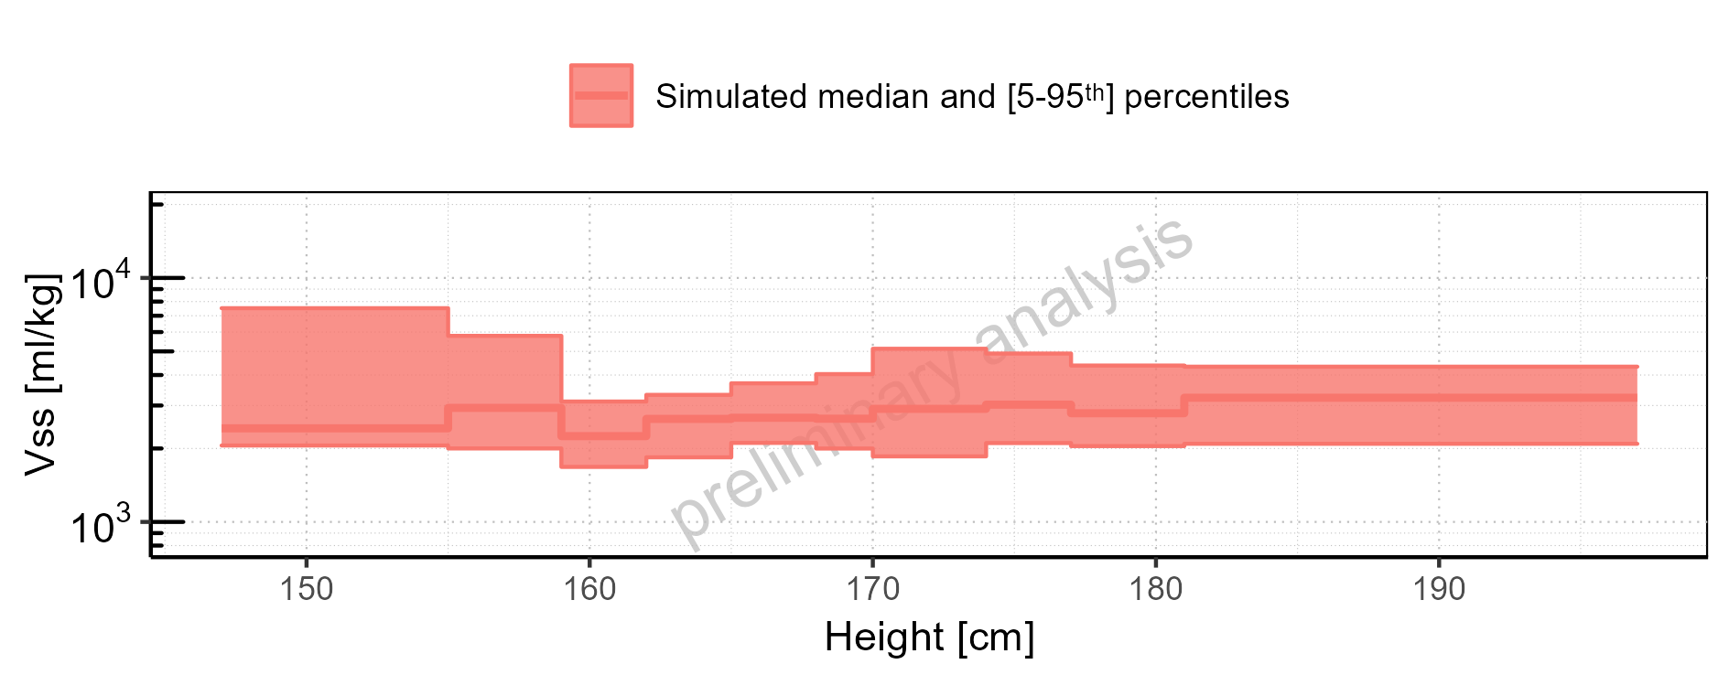

Figure 2-300: Height-dependence of Vss for Filmcoated_tablet_400mg_sd. Profiles are plotted in a linear scale.

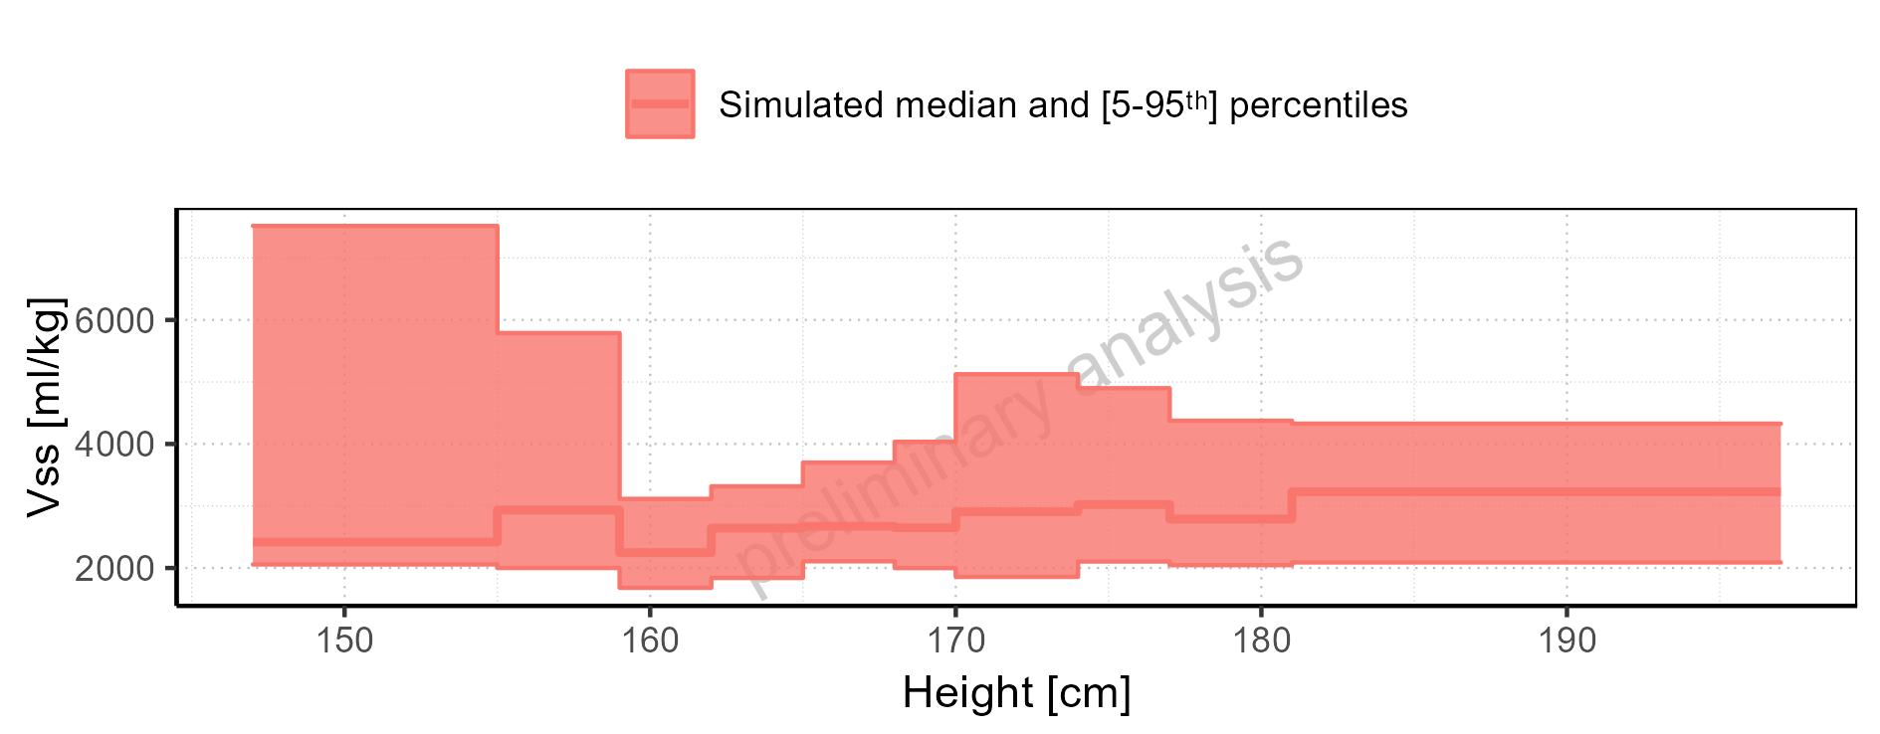

Figure 2-301: Weight-dependence of Vss for Larson 2013 8y-18y 400mg FCT meal in comparison to Filmcoated_tablet_400mg_sd. Profiles are plotted in a logarithmic scale.

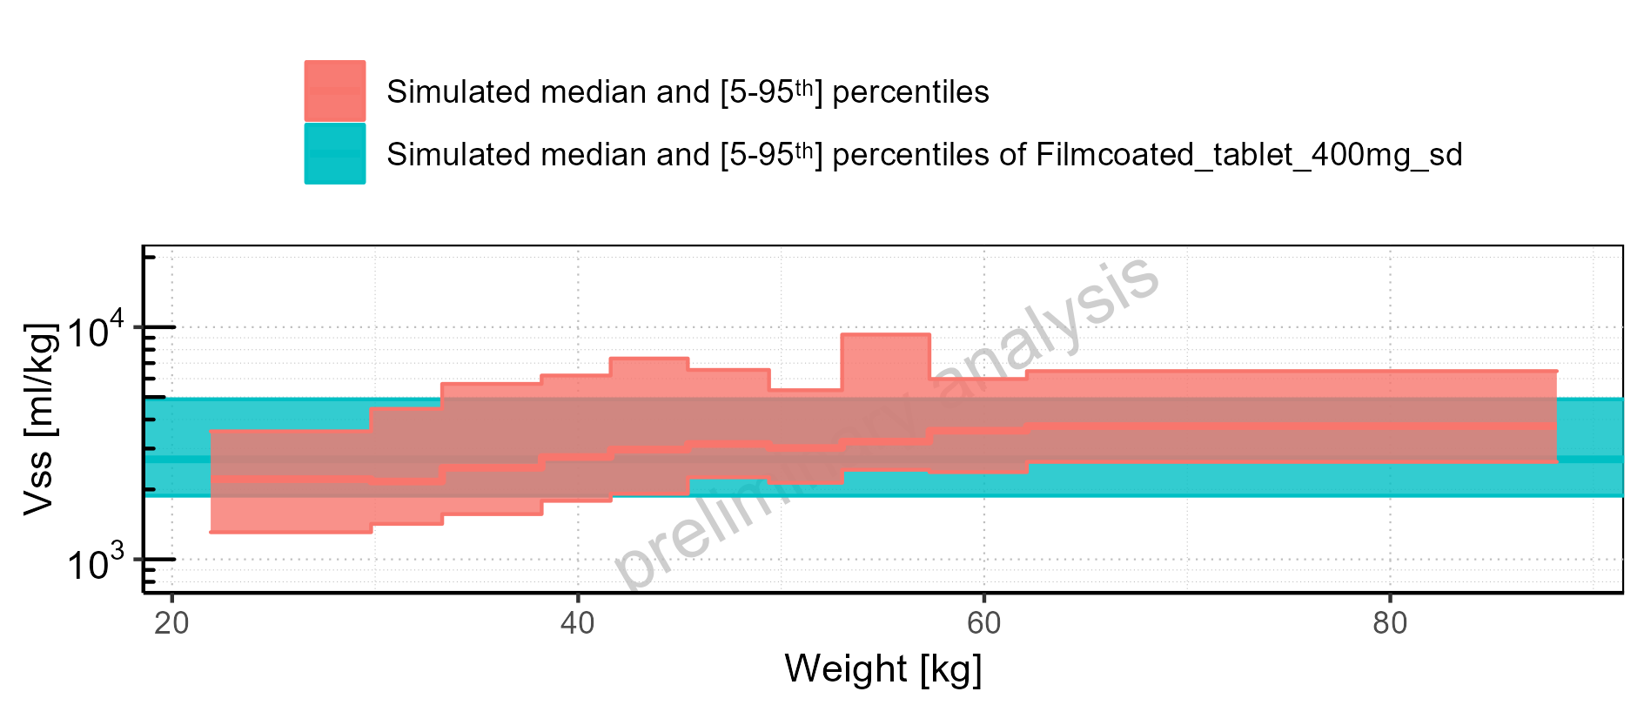

Figure 2-302: Weight-dependence of Vss for Larson 2013 8y-18y 400mg FCT meal in comparison to Filmcoated_tablet_400mg_sd. Profiles are plotted in a linear scale.

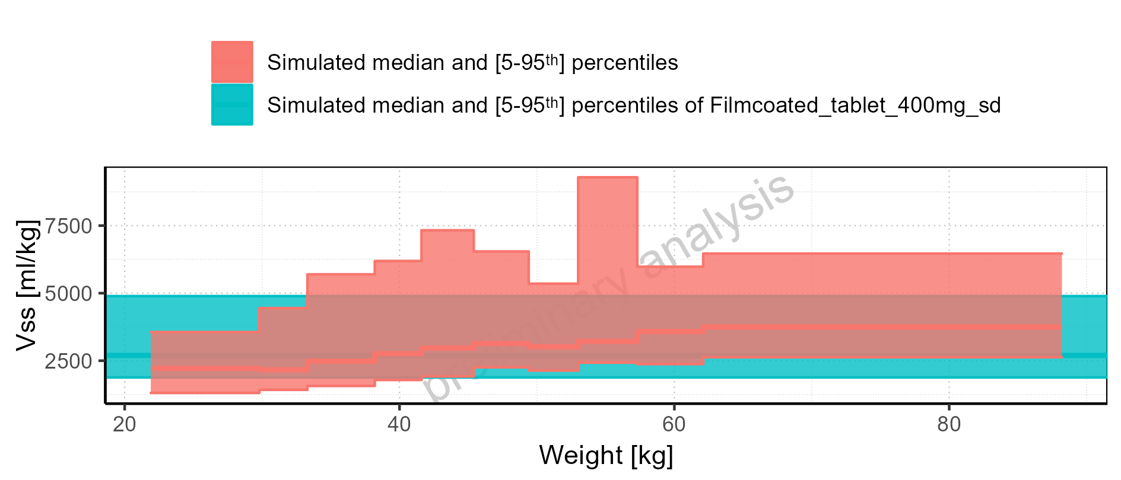

Figure 2-303: Weight-dependence of Vss for Larson 2013 8y-18y 400mg FCT meal. Profiles are plotted in a logarithmic scale.

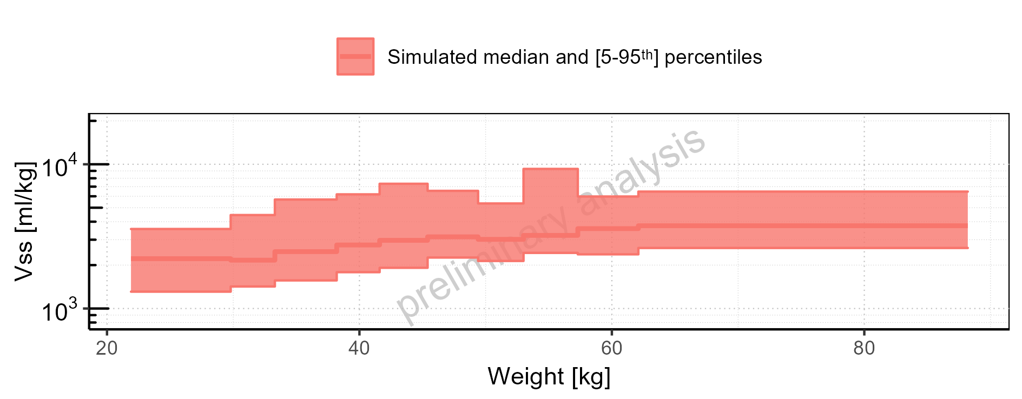

Figure 2-304: Weight-dependence of Vss for Larson 2013 8y-18y 400mg FCT meal. Profiles are plotted in a linear scale.

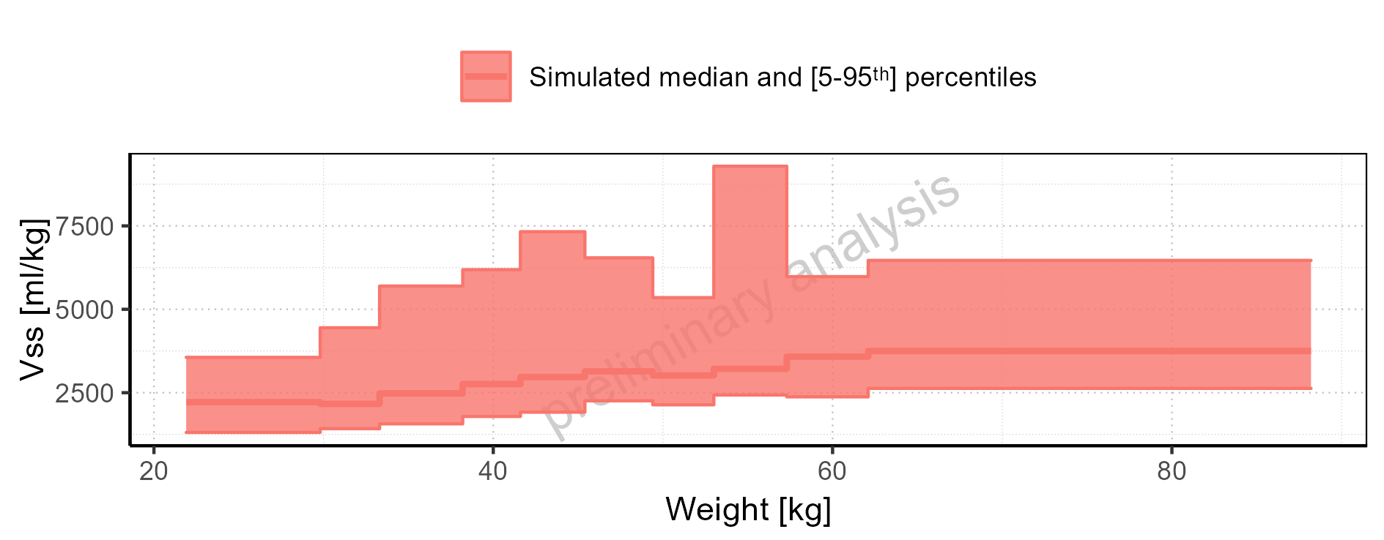

Figure 2-305: Weight-dependence of Vss for Filmcoated_tablet_400mg_sd. Profiles are plotted in a logarithmic scale.

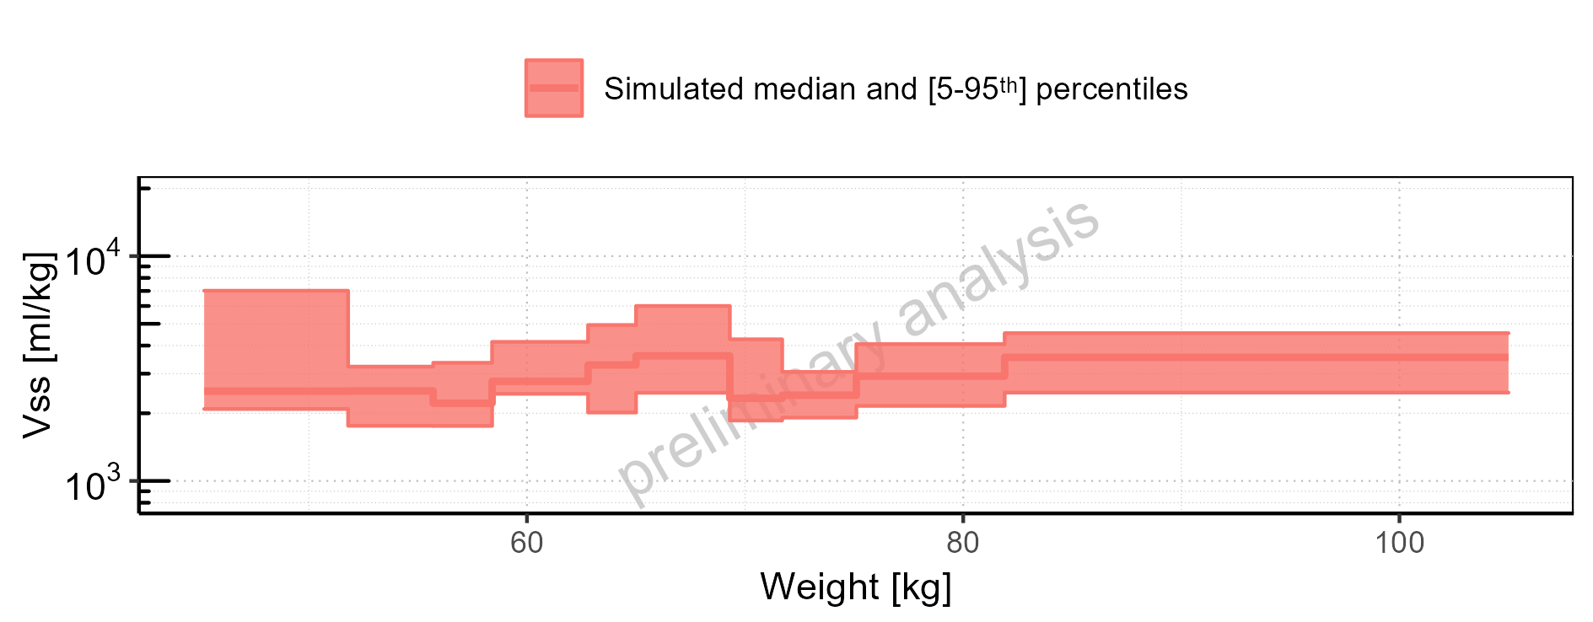

Figure 2-306: Weight-dependence of Vss for Filmcoated_tablet_400mg_sd. Profiles are plotted in a linear scale.

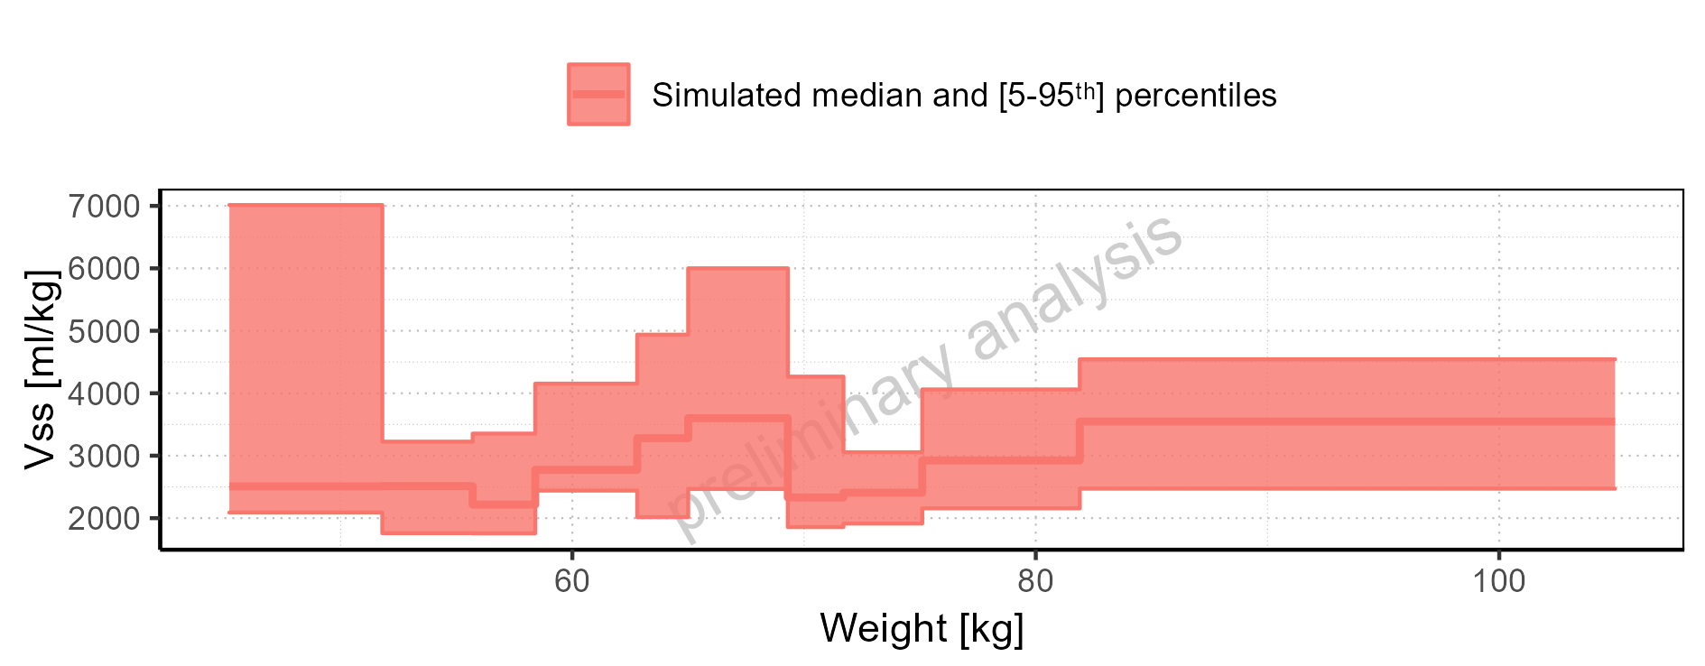

Figure 2-307: BMI-dependence of Vss for Larson 2013 8y-18y 400mg FCT meal in comparison to Filmcoated_tablet_400mg_sd. Profiles are plotted in a logarithmic scale.

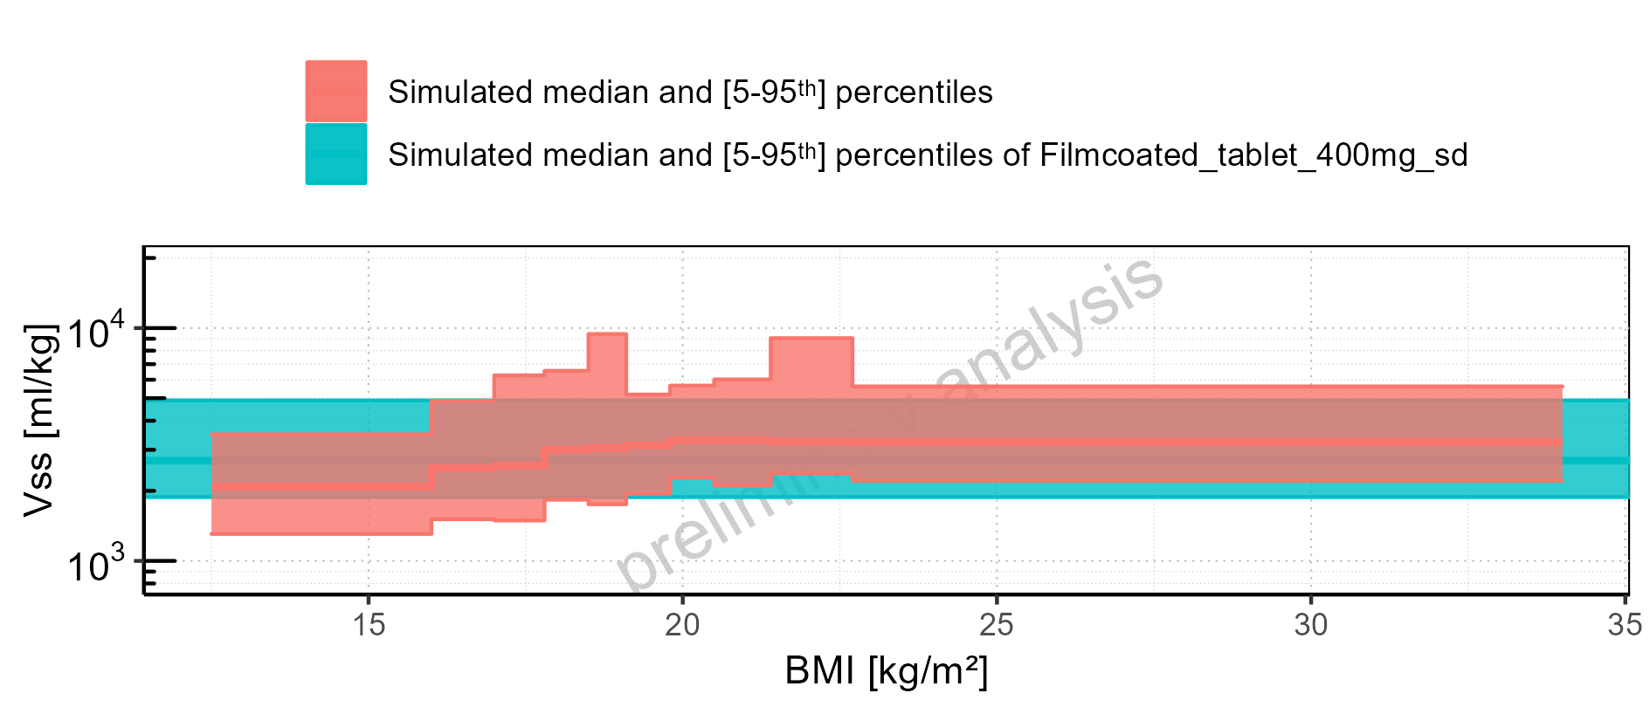

Figure 2-308: BMI-dependence of Vss for Larson 2013 8y-18y 400mg FCT meal in comparison to Filmcoated_tablet_400mg_sd. Profiles are plotted in a linear scale.

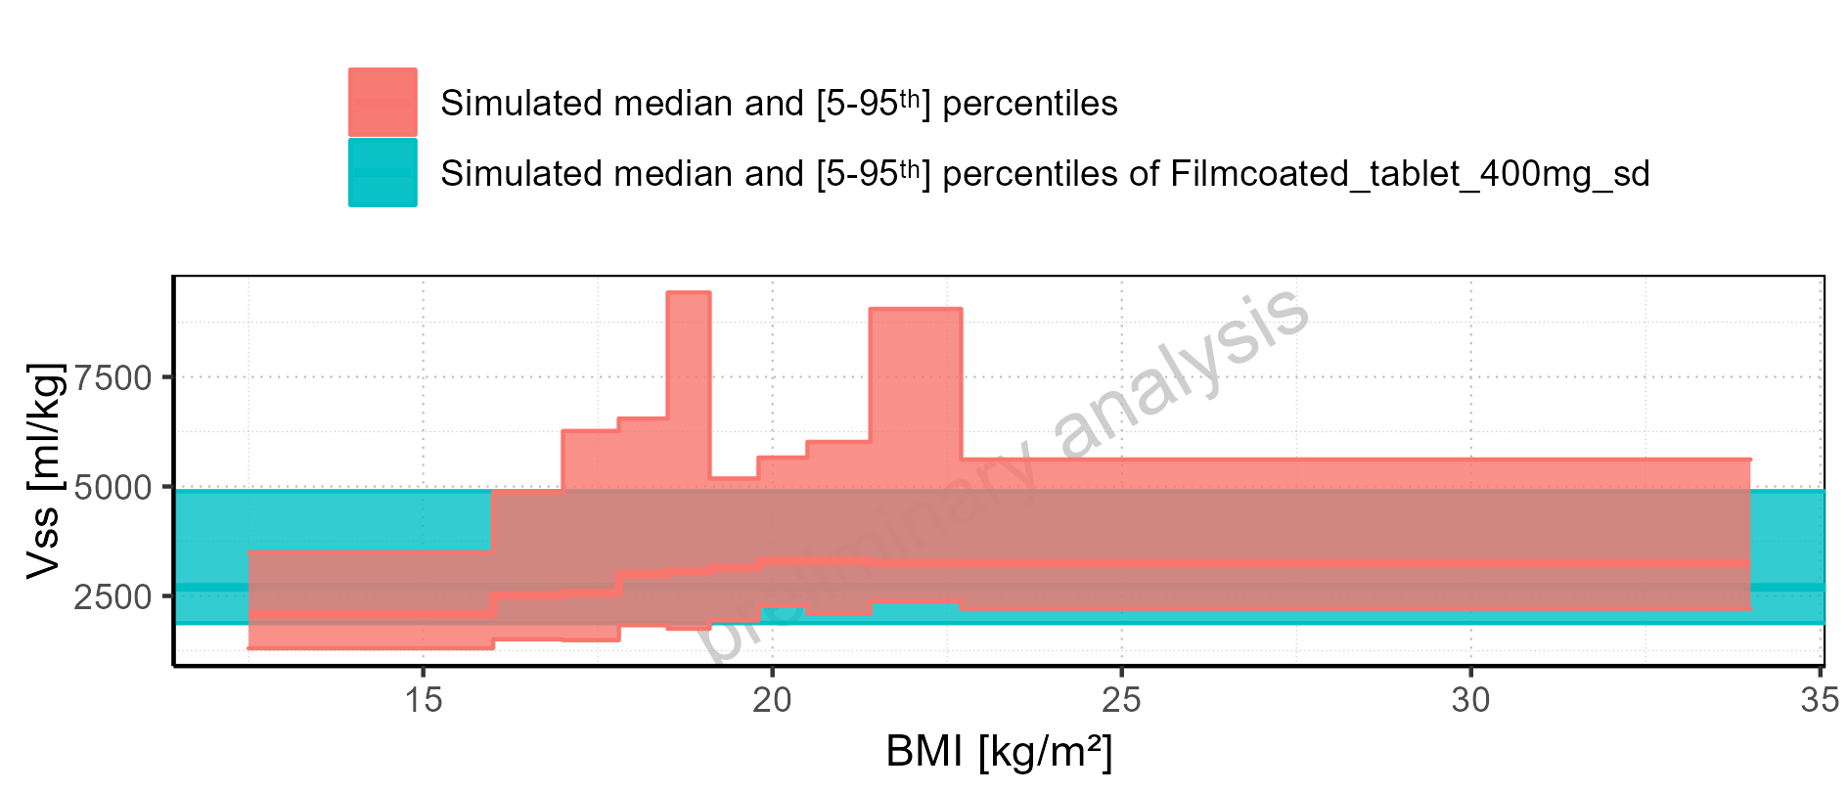

Figure 2-309: BMI-dependence of Vss for Larson 2013 8y-18y 400mg FCT meal. Profiles are plotted in a logarithmic scale.

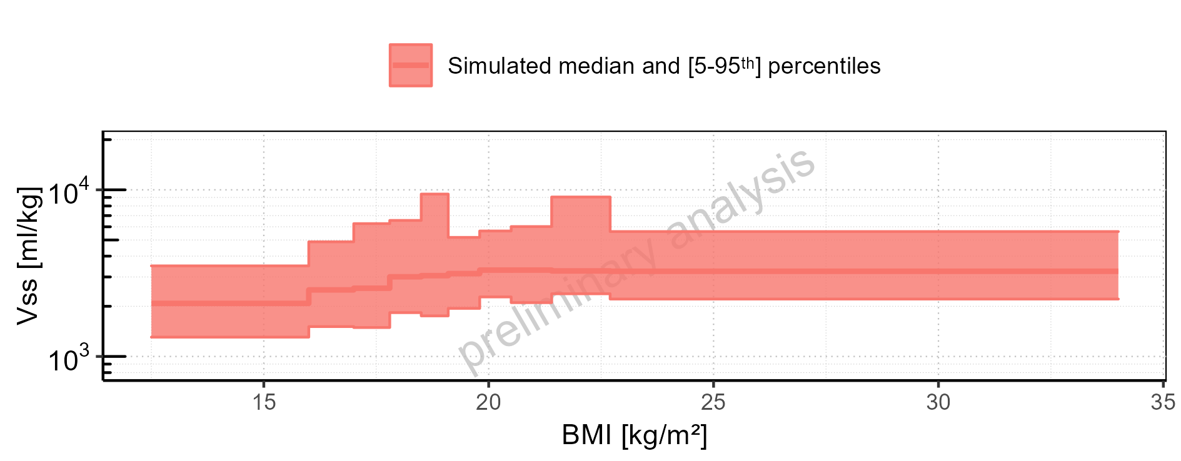

Figure 2-310: BMI-dependence of Vss for Larson 2013 8y-18y 400mg FCT meal. Profiles are plotted in a linear scale.

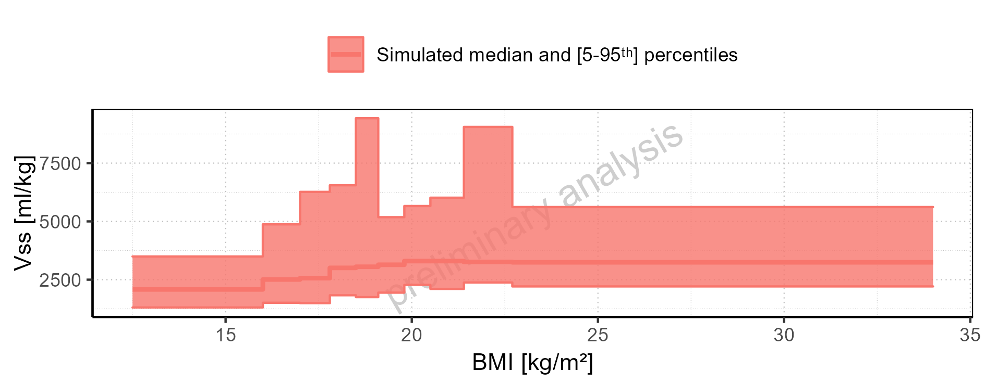

Figure 2-311: BMI-dependence of Vss for Filmcoated_tablet_400mg_sd. Profiles are plotted in a logarithmic scale.

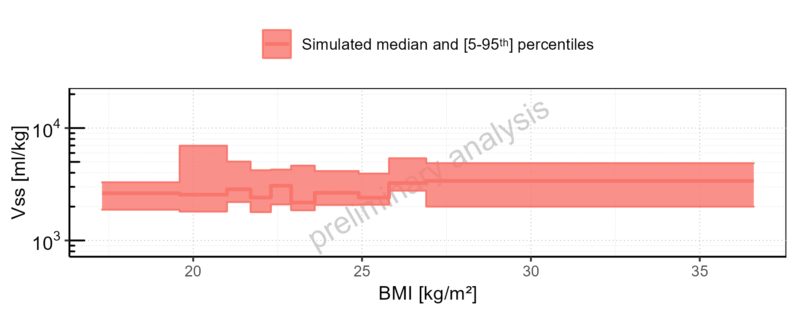

Figure 2-312: BMI-dependence of Vss for Filmcoated_tablet_400mg_sd. Profiles are plotted in a linear scale.

### Vd

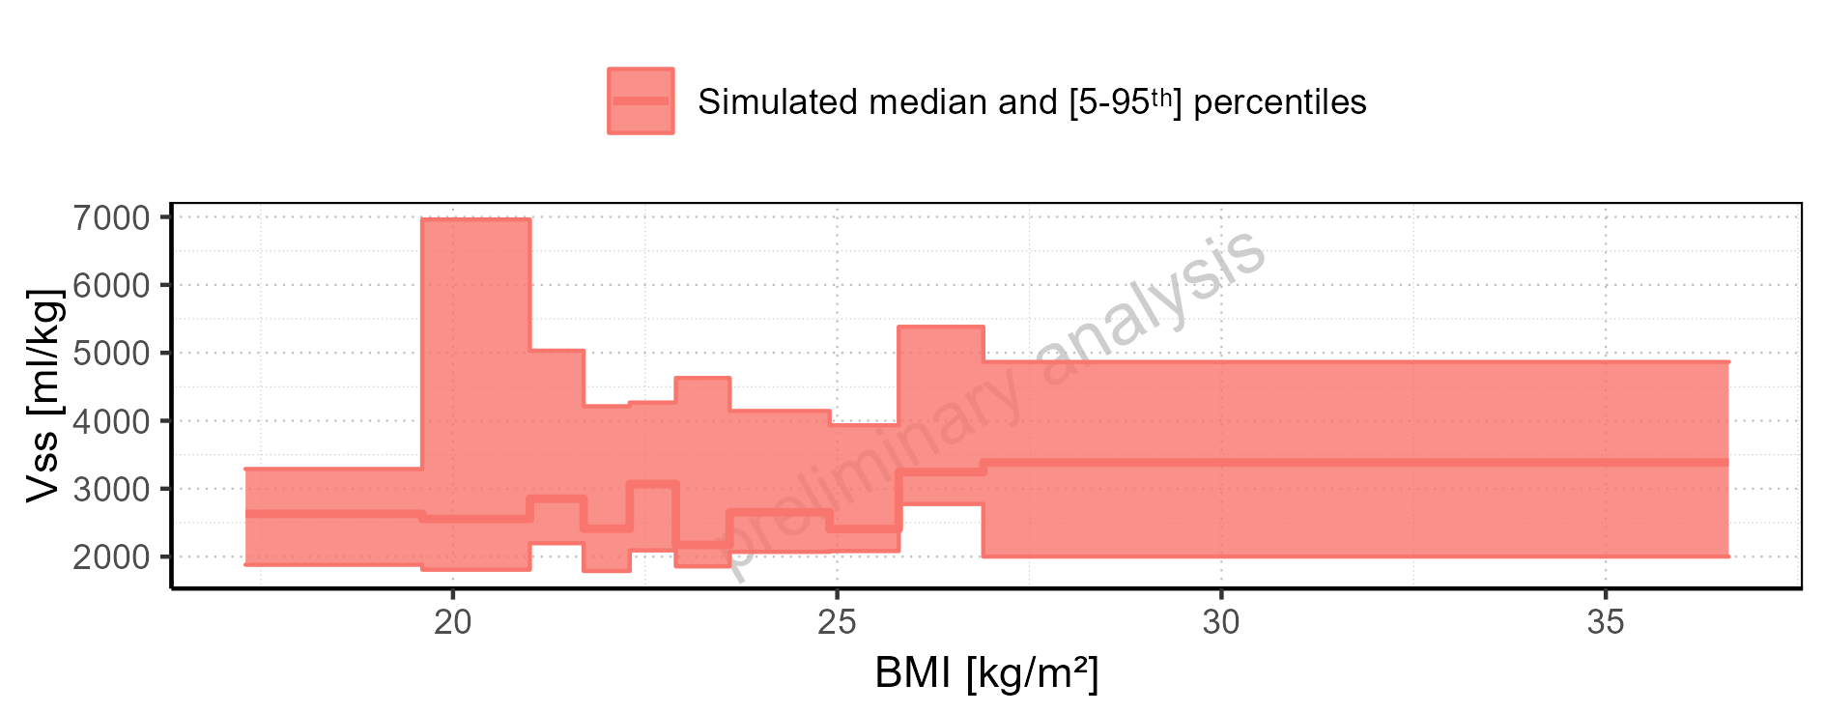

Figure 2-313: Vd of Raltegravir for Larson 2013 8y-18y 400mg FCT meal, Filmcoated_tablet_400mg_sd shown as box-whisker plot, which indicates the 5<U+1D57><U+02B0>, 25<U+1D57><U+02B0>, 50<U+1D57><U+02B0>, 75<U+1D57><U+02B0>, 95<U+1D57><U+02B0> percentiles in logarithmic scale.

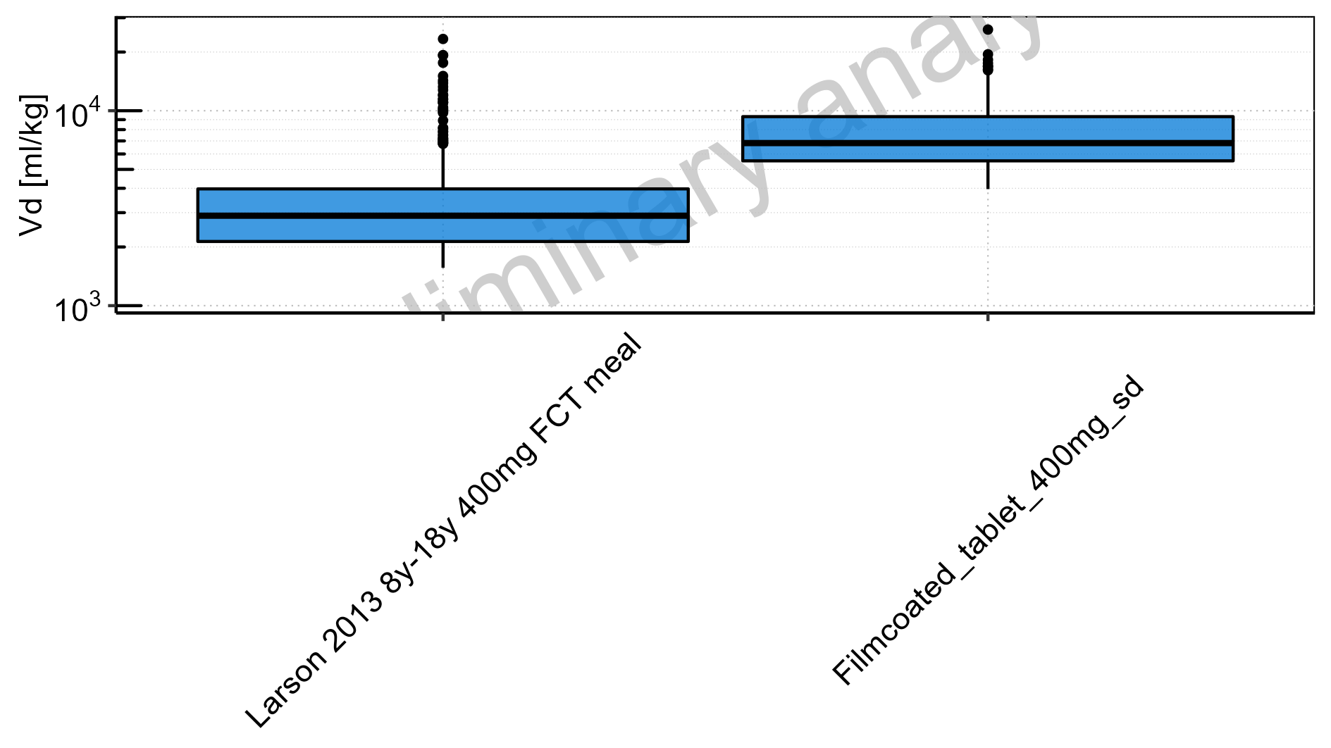

Figure 2-314: Vd of Raltegravir for Larson 2013 8y-18y 400mg FCT meal, Filmcoated_tablet_400mg_sd shown as box-whisker plot, which indicates the 5<U+1D57><U+02B0>, 25<U+1D57><U+02B0>, 50<U+1D57><U+02B0>, 75<U+1D57><U+02B0>, 95<U+1D57><U+02B0> percentiles in linear scale.

**Table 2-13: Vd of Raltegravir for Larson 2013 8y-18y 400mg FCT meal, Filmcoated_tablet_400mg_sd reported in [ml/kg]**

|  |  |  |  |  |  |  |  |  |  |  |
| --- | --- | --- | --- | --- | --- | --- | --- | --- | --- | --- |
| Population | N | 5<U+1D57><U+02B0> pctl | 25<U+1D57><U+02B0> pctl | 50<U+1D57><U+02B0> pctl | 75<U+1D57><U+02B0> pctl | 95<U+1D57><U+02B0> pctl | Mean | SD | Geo Mean | Geo SD |
| Larson 2013 8y-18y 400mg FCT meal | 497 | 1564.17 | 2133.96 | 2893.52 | 3971.83 | 7809.40 | 3610.03 | 2601.88 | 3089.07 | 1.67 |
| Filmcoated_tablet_400mg_sd | 100 | 3961.86 | 5531.19 | 6823.96 | 9325.52 | 16886.12 | 8090.43 | 4000.17 | 7343.52 | 1.53 |

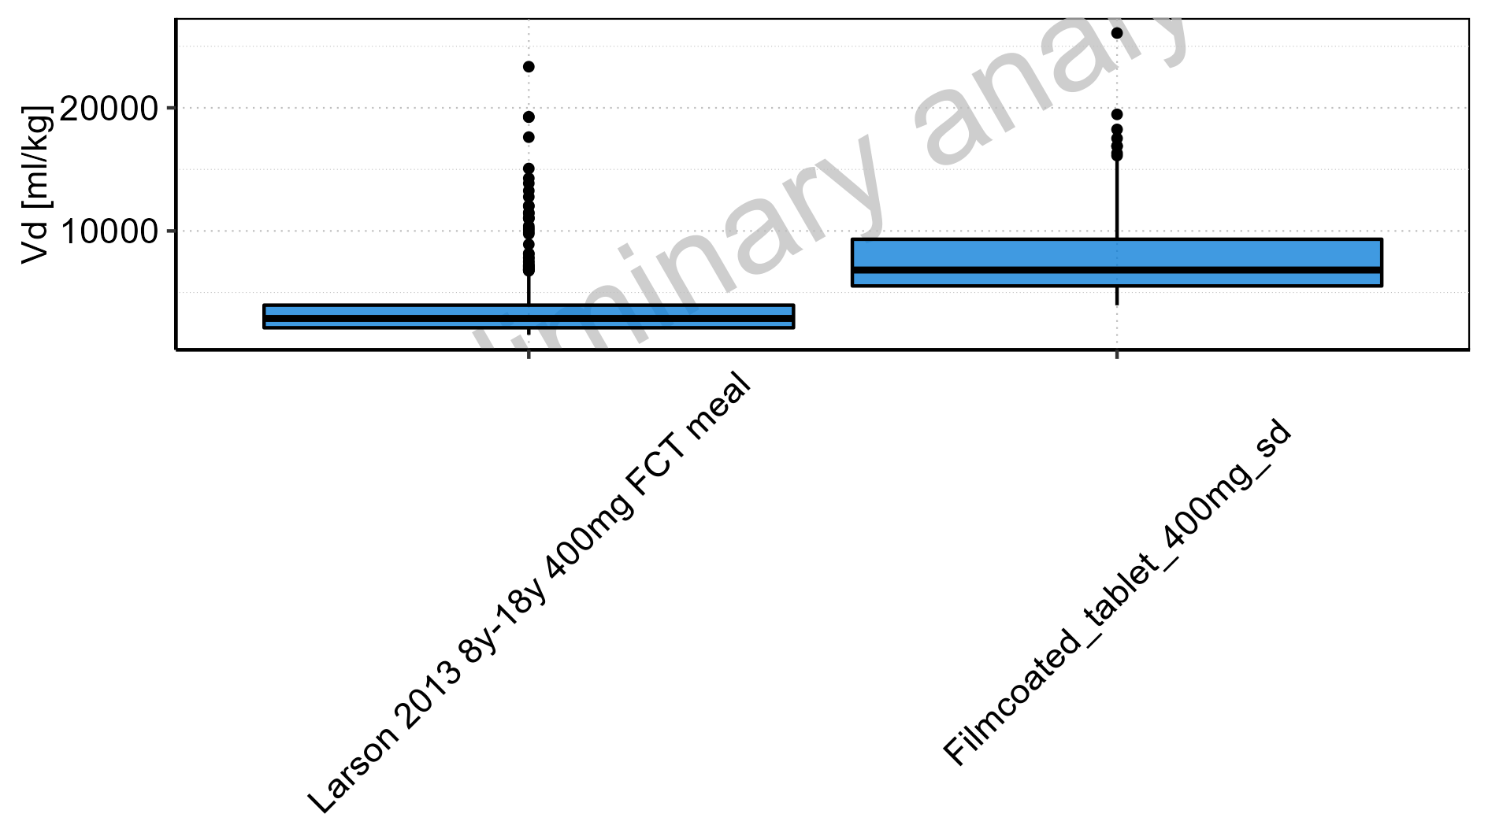

Figure 2-315: Age-dependence of Vd for Larson 2013 8y-18y 400mg FCT meal in comparison to Filmcoated_tablet_400mg_sd. Profiles are plotted in a logarithmic scale.

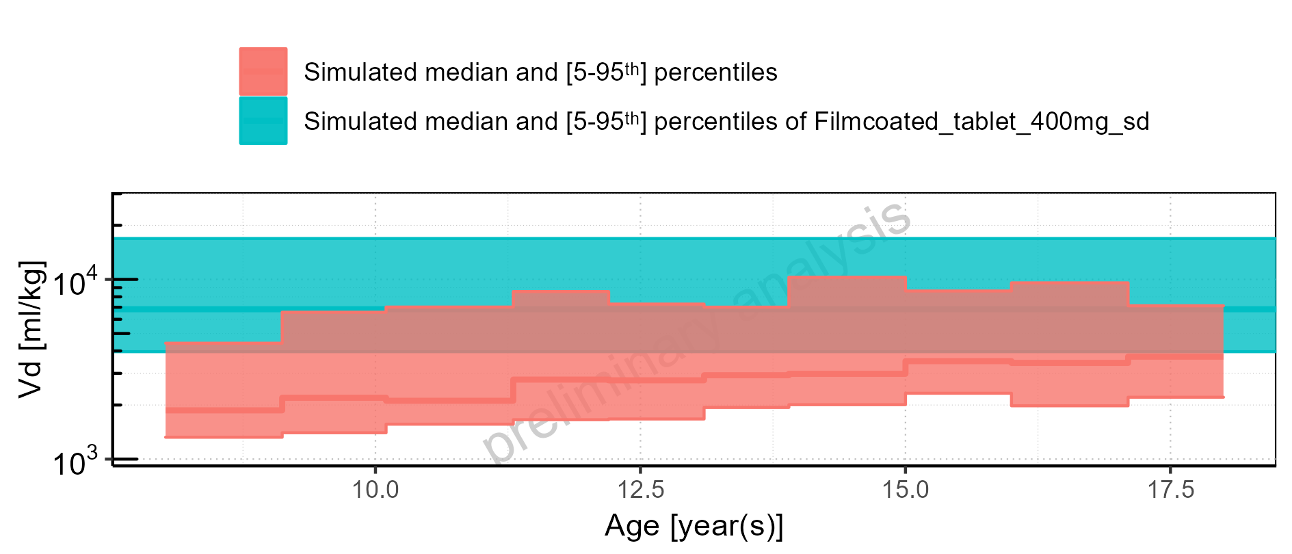

Figure 2-316: Age-dependence of Vd for Larson 2013 8y-18y 400mg FCT meal in comparison to Filmcoated_tablet_400mg_sd. Profiles are plotted in a linear scale.

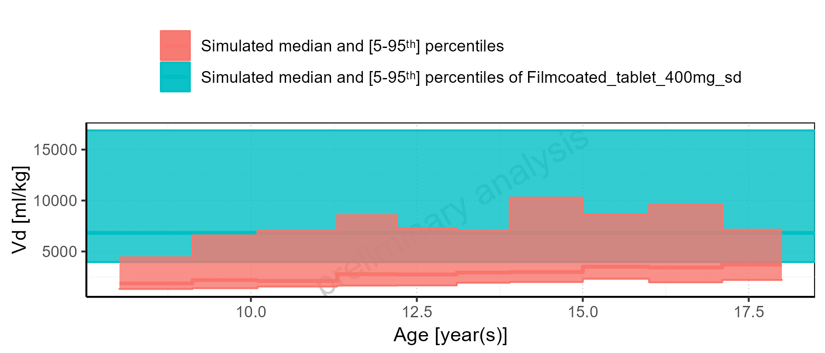

Figure 2-317: Age-dependence of Vd for Larson 2013 8y-18y 400mg FCT meal. Profiles are plotted in a logarithmic scale.

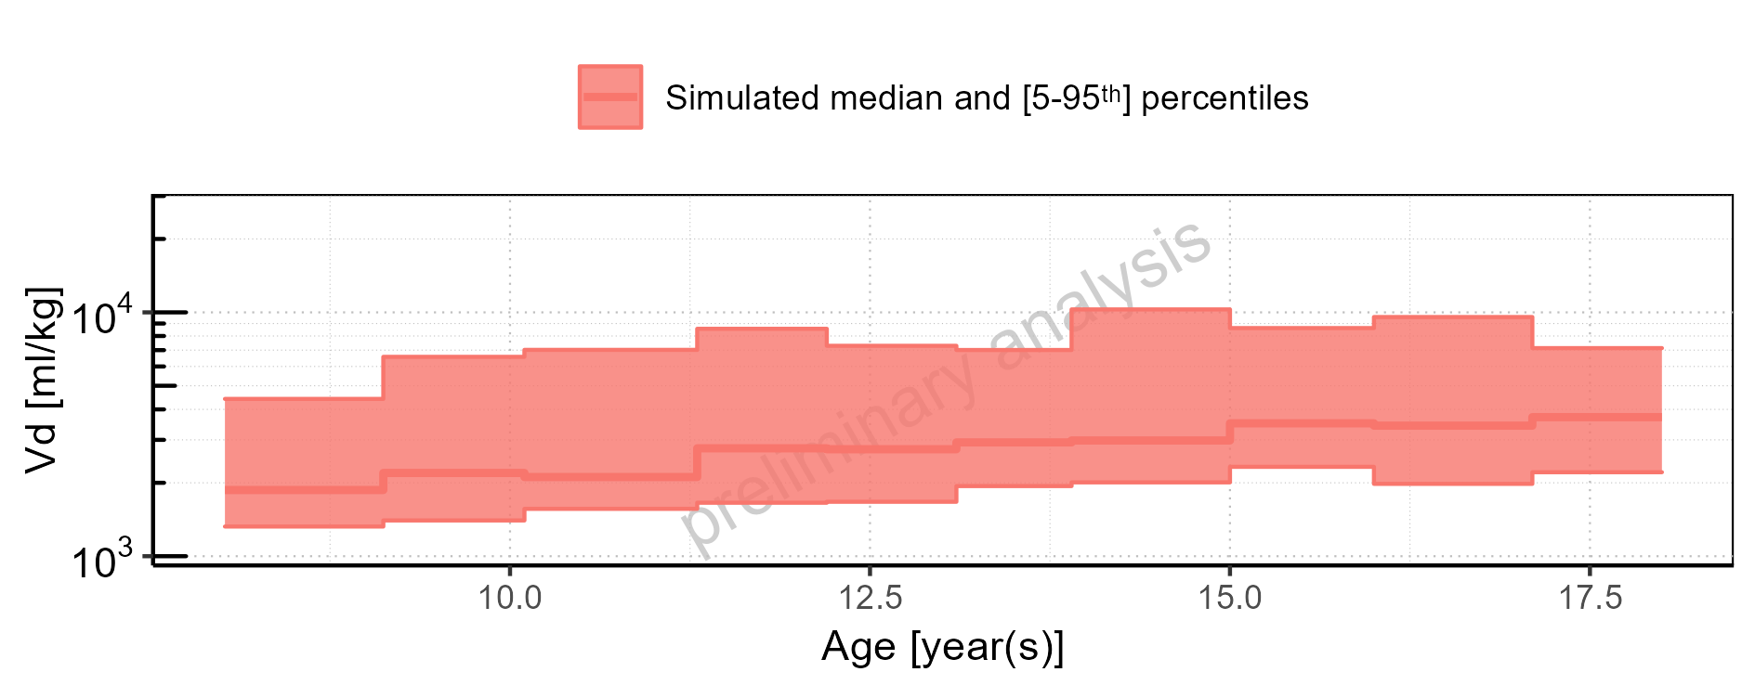

Figure 2-318: Age-dependence of Vd for Larson 2013 8y-18y 400mg FCT meal. Profiles are plotted in a linear scale.

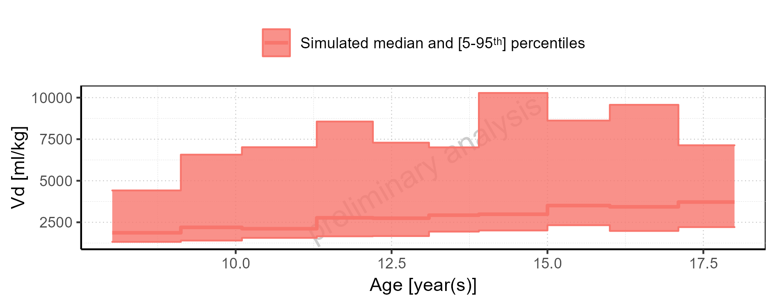

Figure 2-319: Age-dependence of Vd for Filmcoated_tablet_400mg_sd. Profiles are plotted in a logarithmic scale.

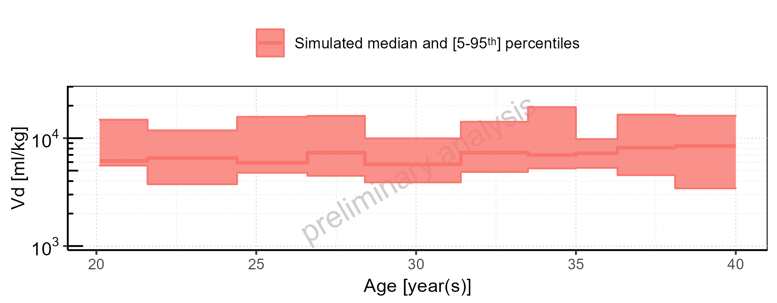

Figure 2-320: Age-dependence of Vd for Filmcoated_tablet_400mg_sd. Profiles are plotted in a linear scale.

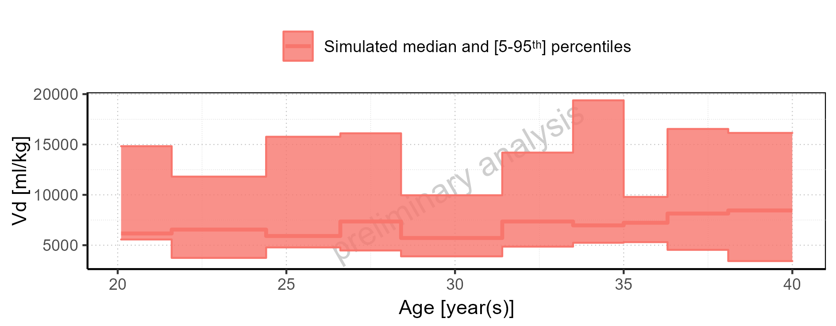

Figure 2-321: Height-dependence of Vd for Larson 2013 8y-18y 400mg FCT meal in comparison to Filmcoated_tablet_400mg_sd. Profiles are plotted in a logarithmic scale.

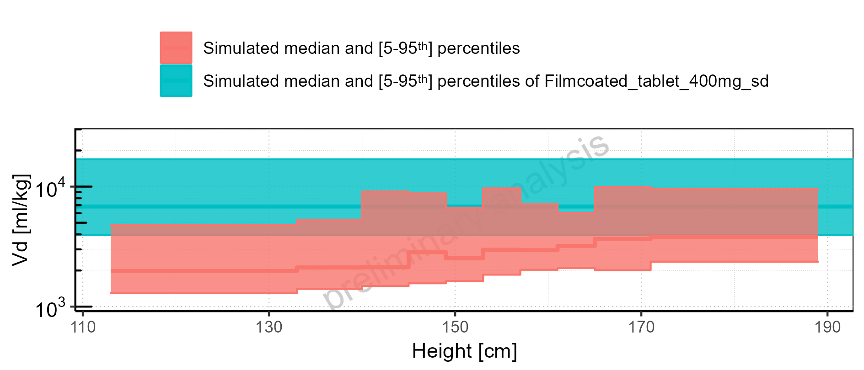

Figure 2-322: Height-dependence of Vd for Larson 2013 8y-18y 400mg FCT meal in comparison to Filmcoated_tablet_400mg_sd. Profiles are plotted in a linear scale.

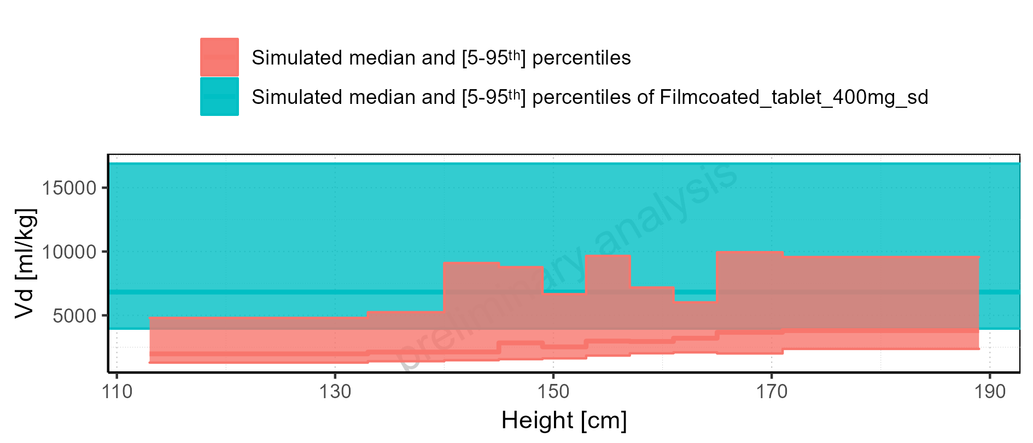

Figure 2-323: Height-dependence of Vd for Larson 2013 8y-18y 400mg FCT meal. Profiles are plotted in a logarithmic scale.

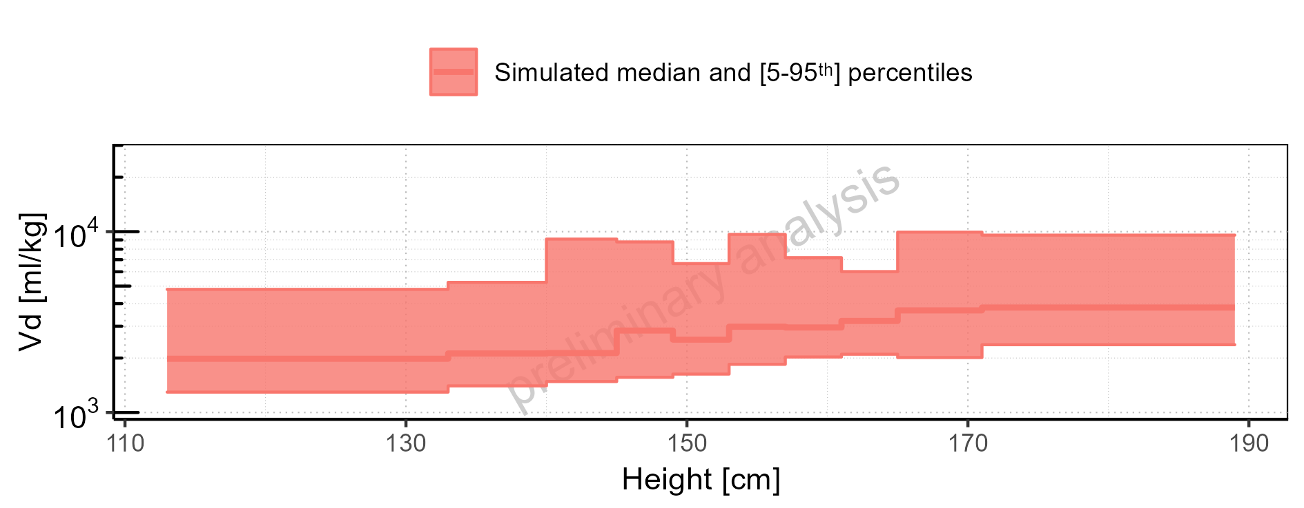

Figure 2-324: Height-dependence of Vd for Larson 2013 8y-18y 400mg FCT meal. Profiles are plotted in a linear scale.

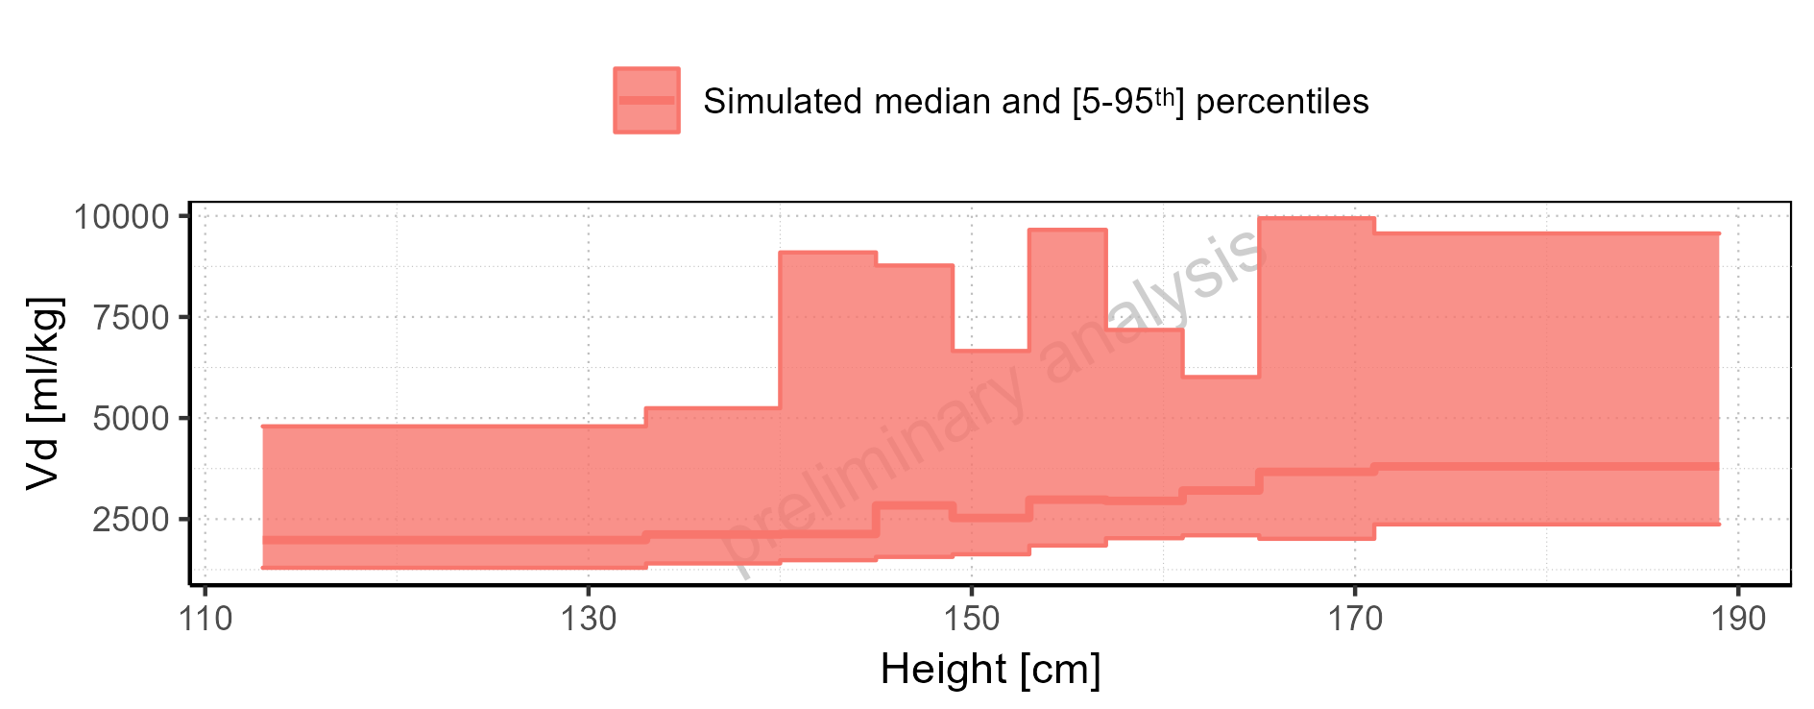

Figure 2-325: Height-dependence of Vd for Filmcoated_tablet_400mg_sd. Profiles are plotted in a logarithmic scale.

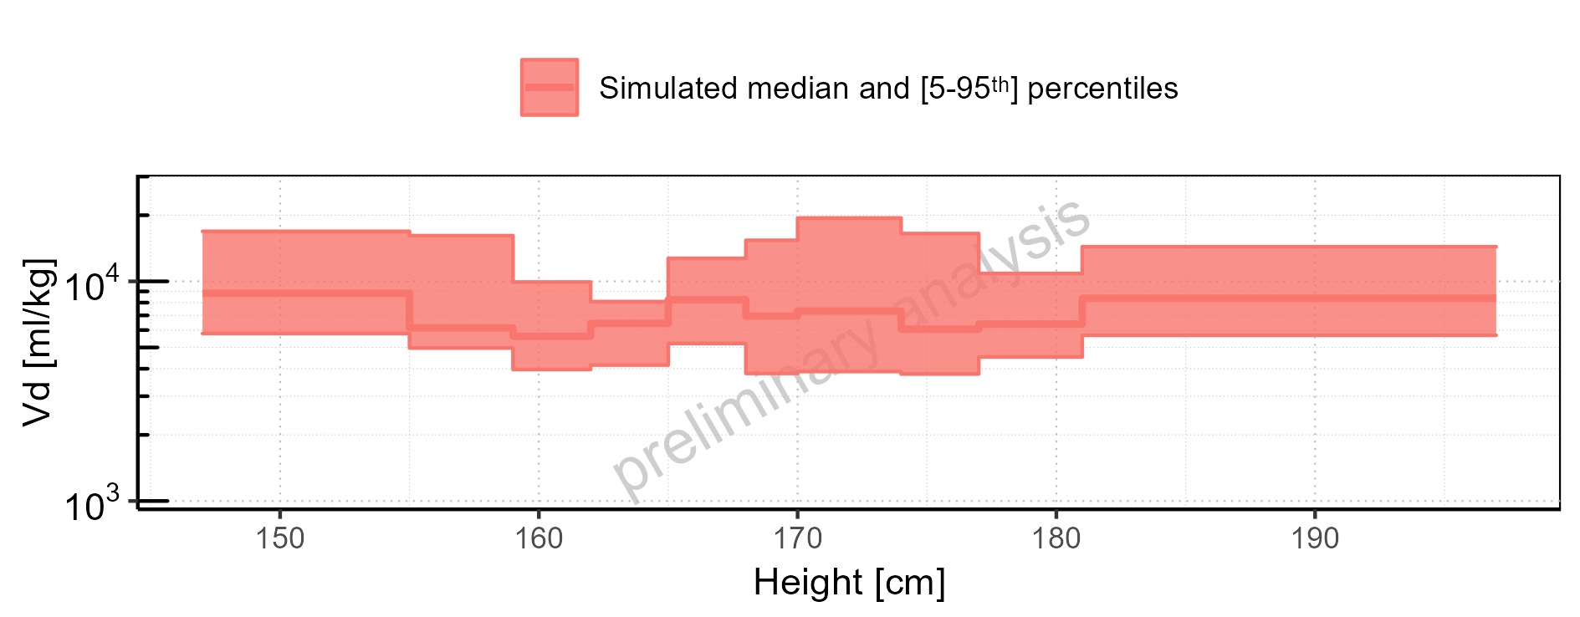

Figure 2-326: Height-dependence of Vd for Filmcoated_tablet_400mg_sd. Profiles are plotted in a linear scale.

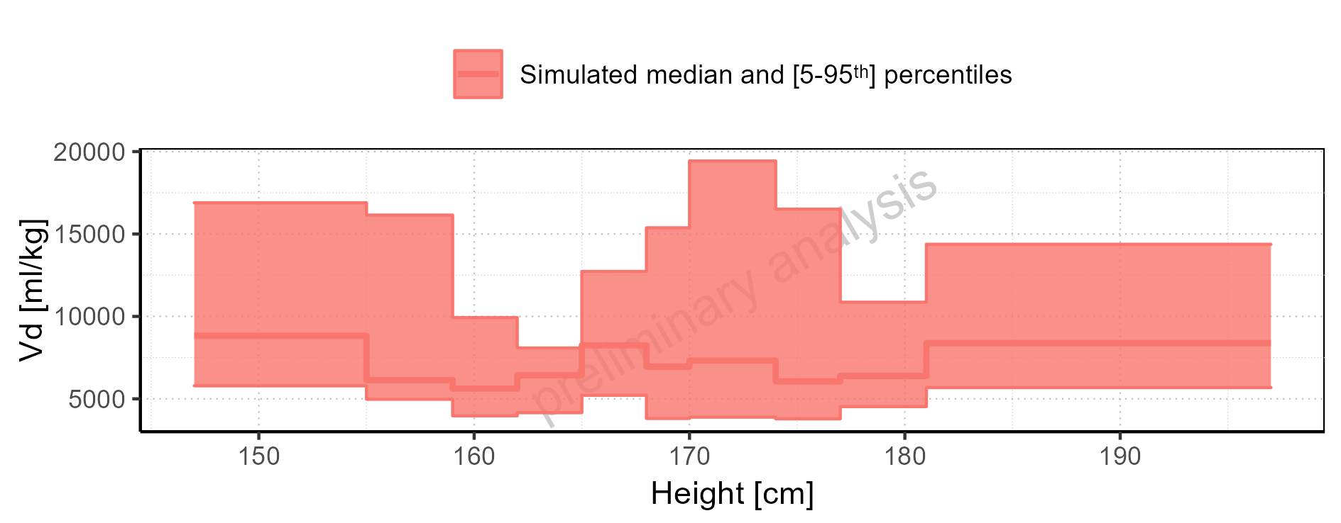

Figure 2-327: Weight-dependence of Vd for Larson 2013 8y-18y 400mg FCT meal in comparison to Filmcoated_tablet_400mg_sd. Profiles are plotted in a logarithmic scale.

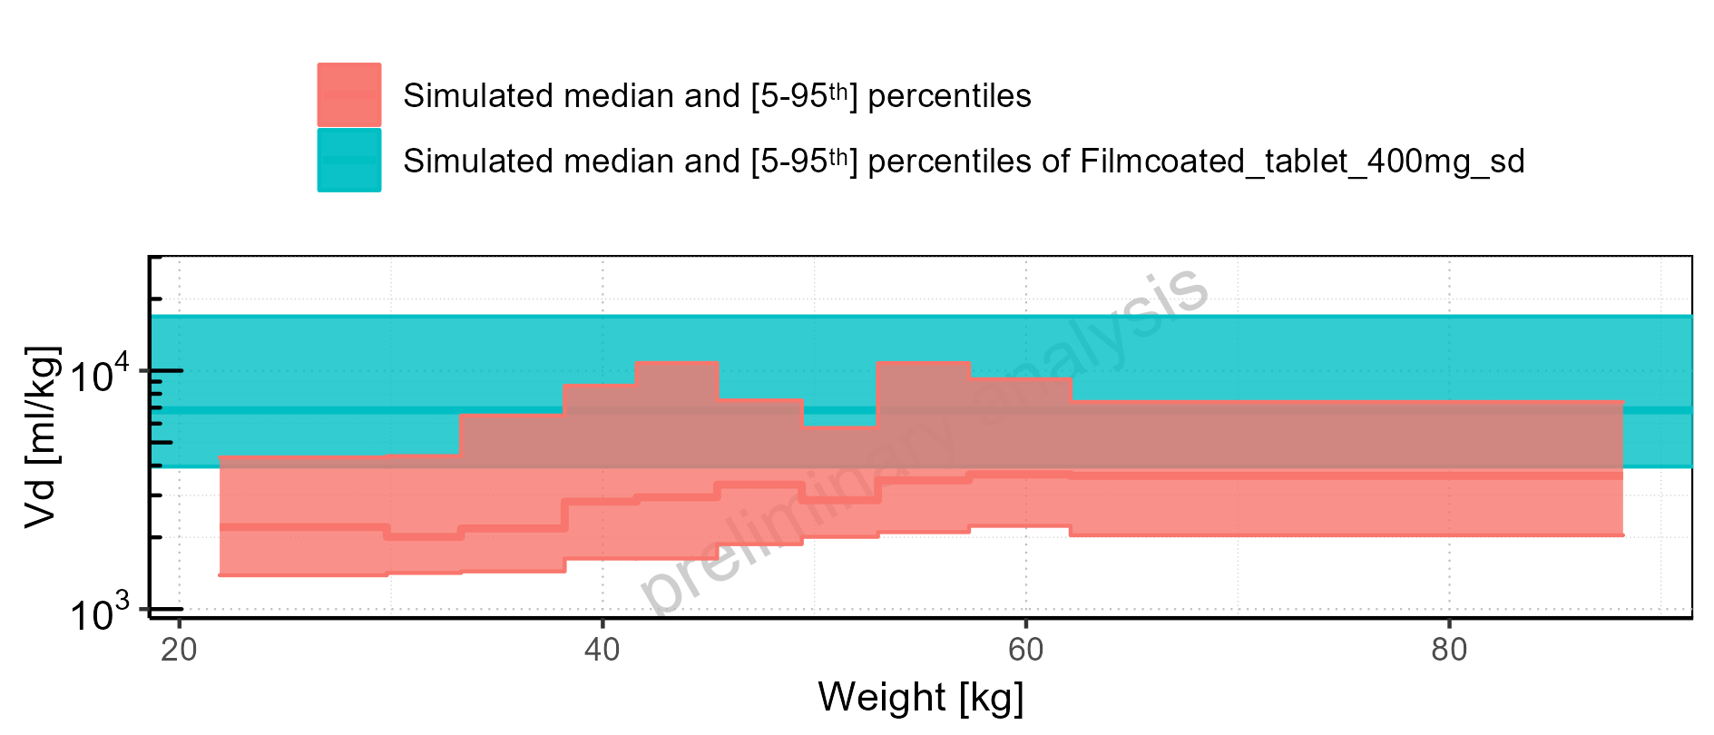

Figure 2-328: Weight-dependence of Vd for Larson 2013 8y-18y 400mg FCT meal in comparison to Filmcoated_tablet_400mg_sd. Profiles are plotted in a linear scale.

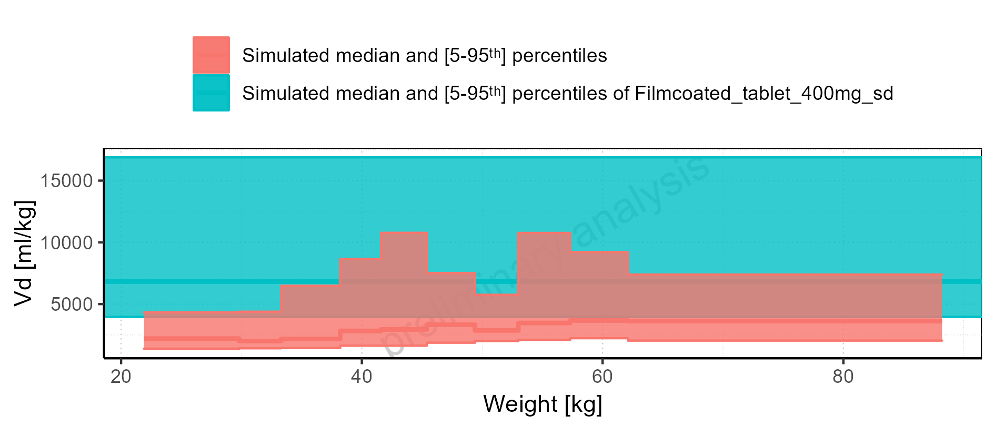

Figure 2-329: Weight-dependence of Vd for Larson 2013 8y-18y 400mg FCT meal. Profiles are plotted in a logarithmic scale.

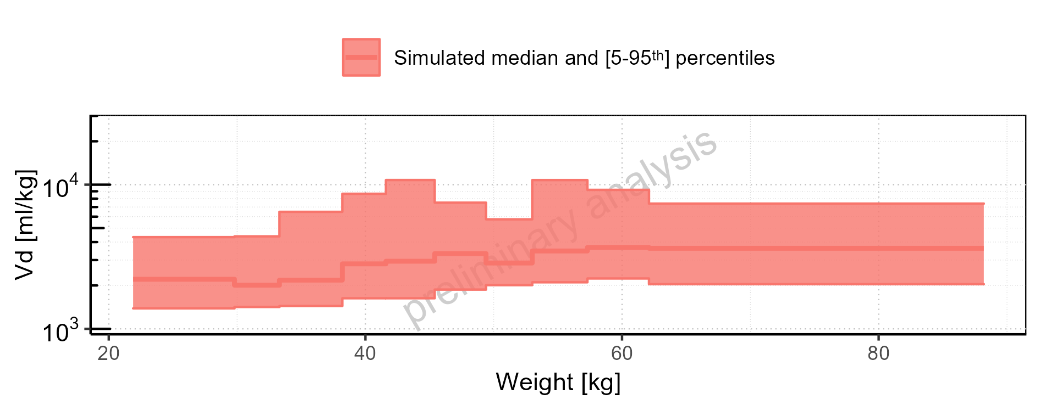

Figure 2-330: Weight-dependence of Vd for Larson 2013 8y-18y 400mg FCT meal. Profiles are plotted in a linear scale.

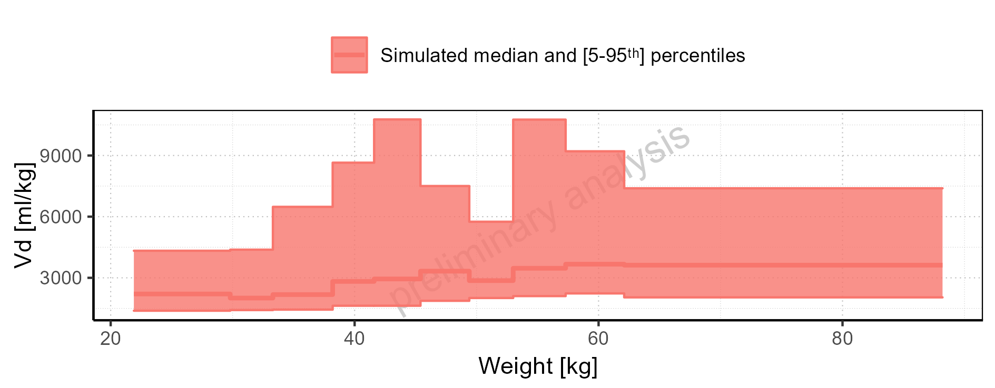

Figure 2-331: Weight-dependence of Vd for Filmcoated_tablet_400mg_sd. Profiles are plotted in a logarithmic scale.

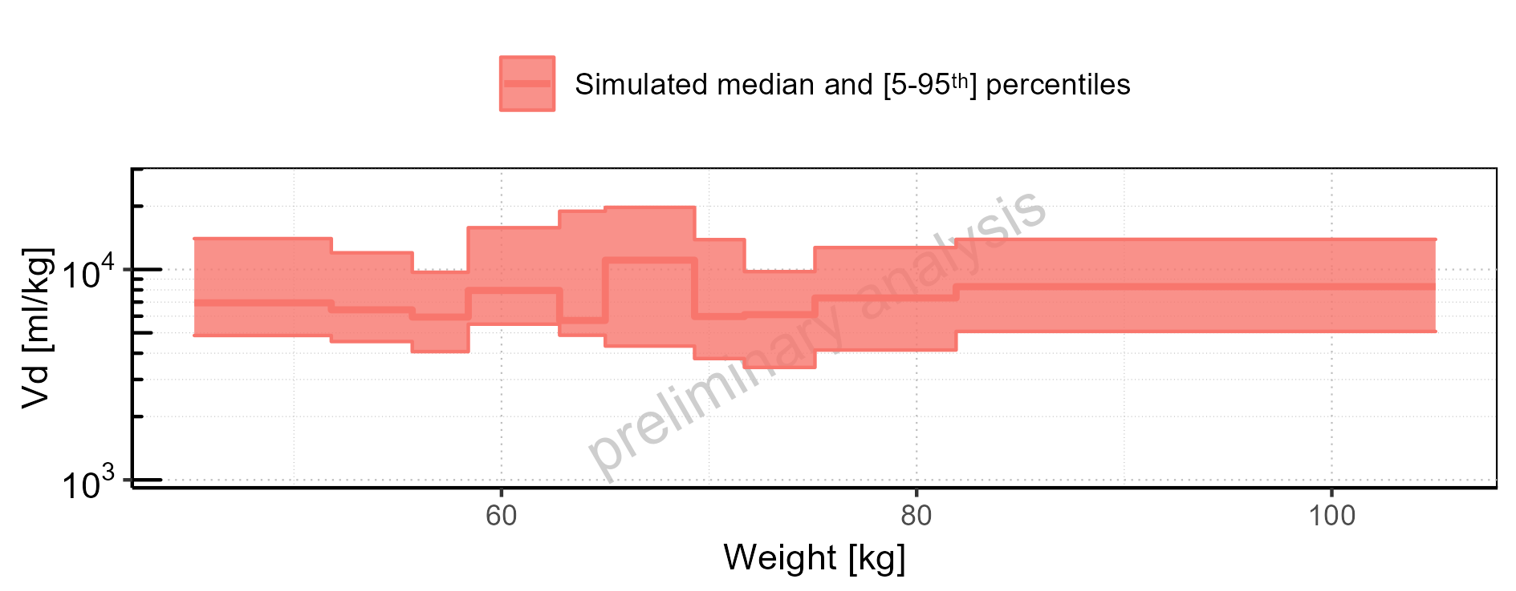

Figure 2-332: Weight-dependence of Vd for Filmcoated_tablet_400mg_sd. Profiles are plotted in a linear scale.

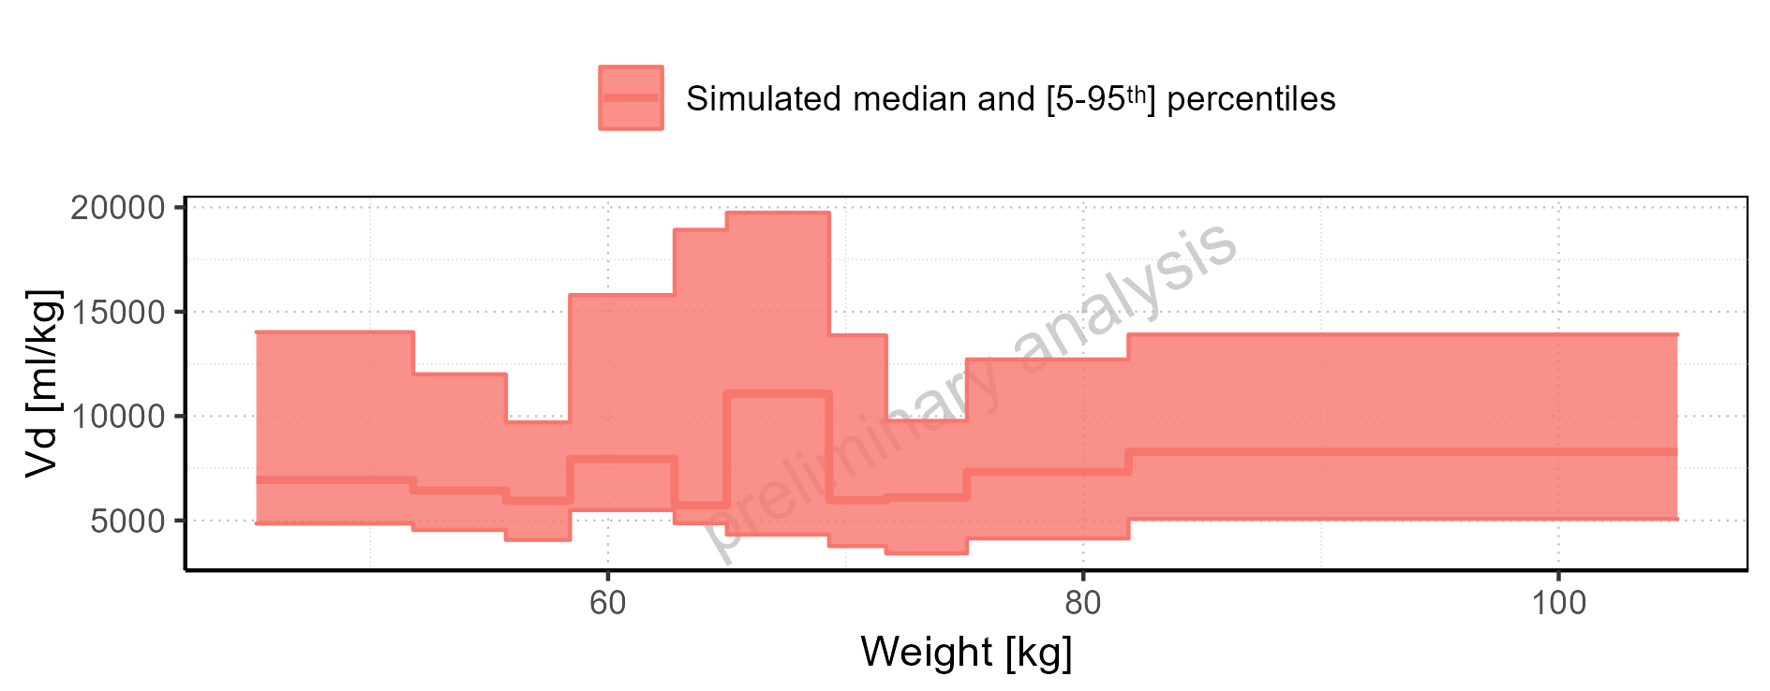

Figure 2-333: BMI-dependence of Vd for Larson 2013 8y-18y 400mg FCT meal in comparison to Filmcoated_tablet_400mg_sd. Profiles are plotted in a logarithmic scale.

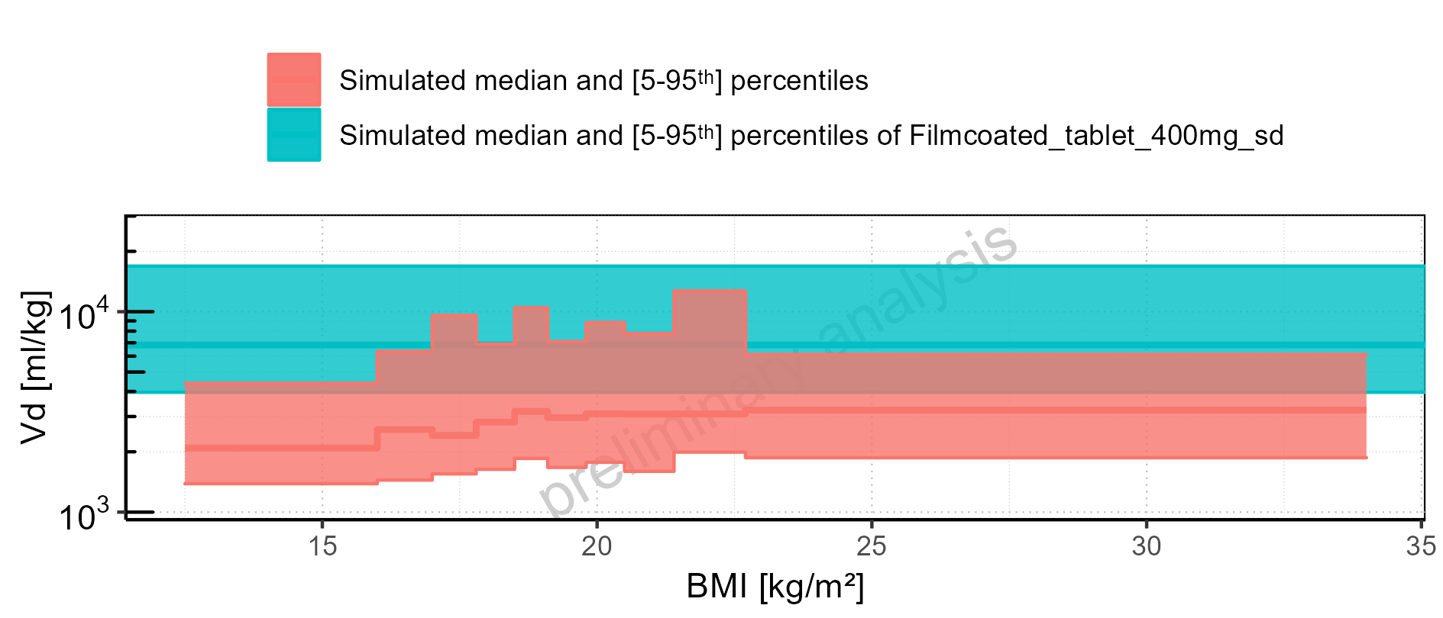

Figure 2-334: BMI-dependence of Vd for Larson 2013 8y-18y 400mg FCT meal in comparison to Filmcoated_tablet_400mg_sd. Profiles are plotted in a linear scale.

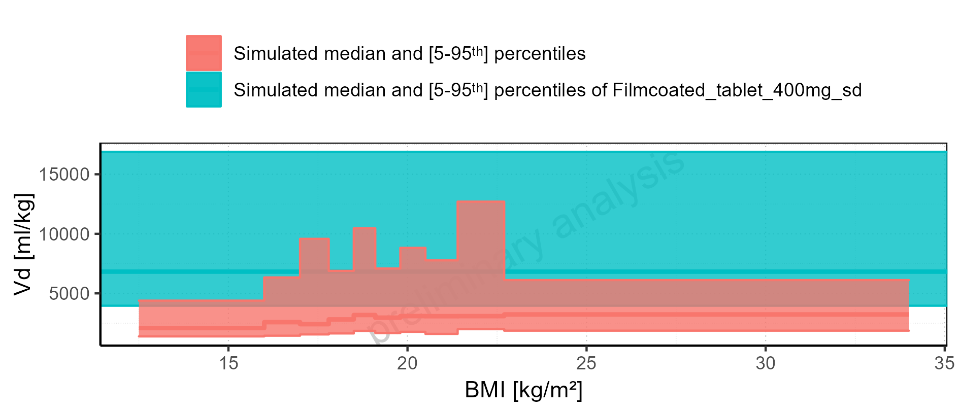

Figure 2-335: BMI-dependence of Vd for Larson 2013 8y-18y 400mg FCT meal. Profiles are plotted in a logarithmic scale.

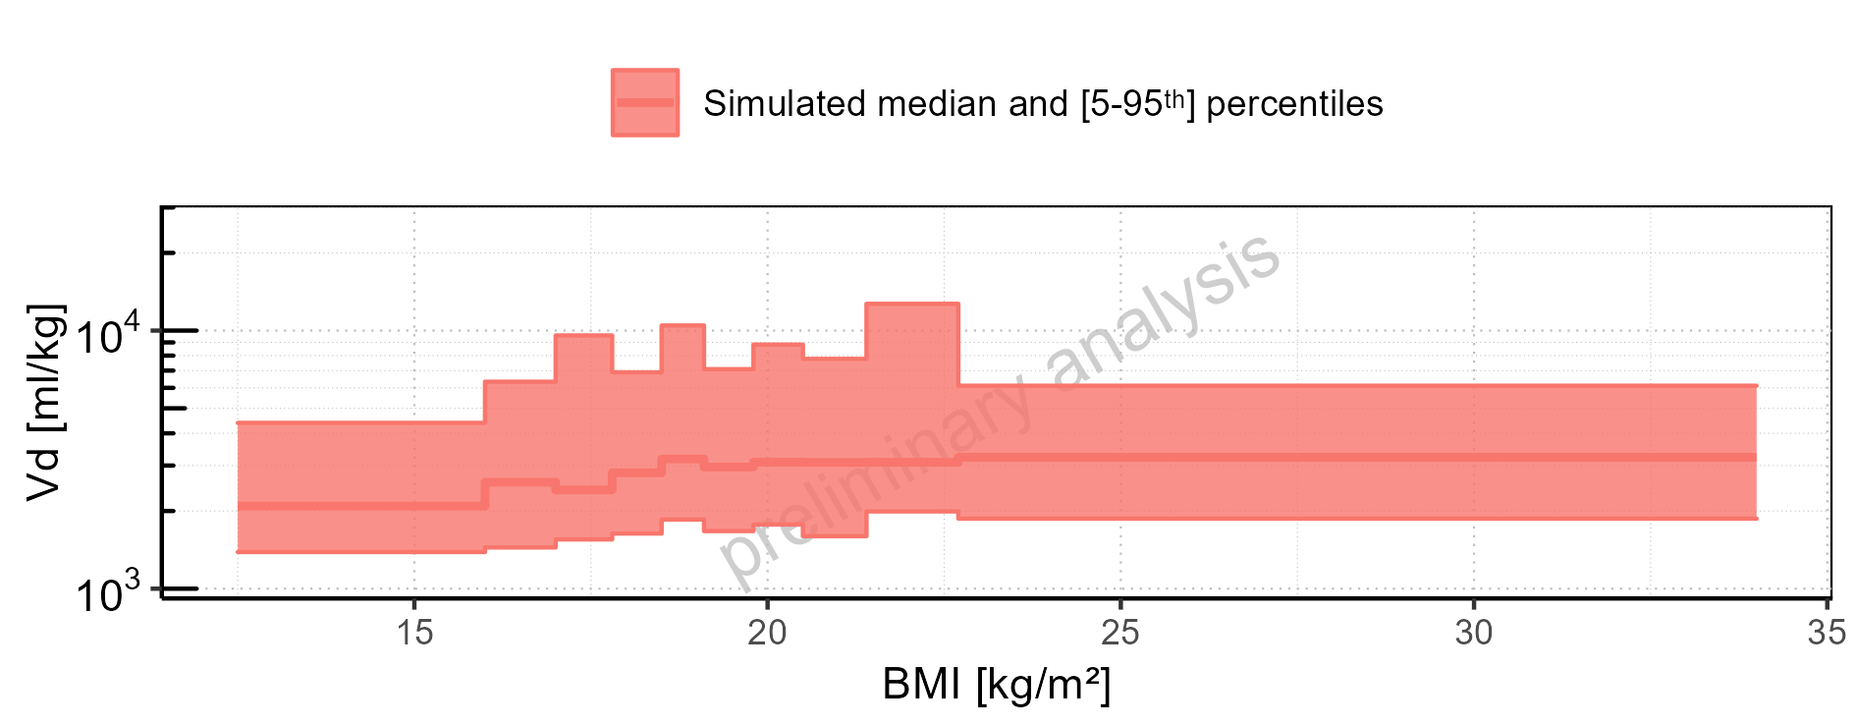

Figure 2-336: BMI-dependence of Vd for Larson 2013 8y-18y 400mg FCT meal. Profiles are plotted in a linear scale.

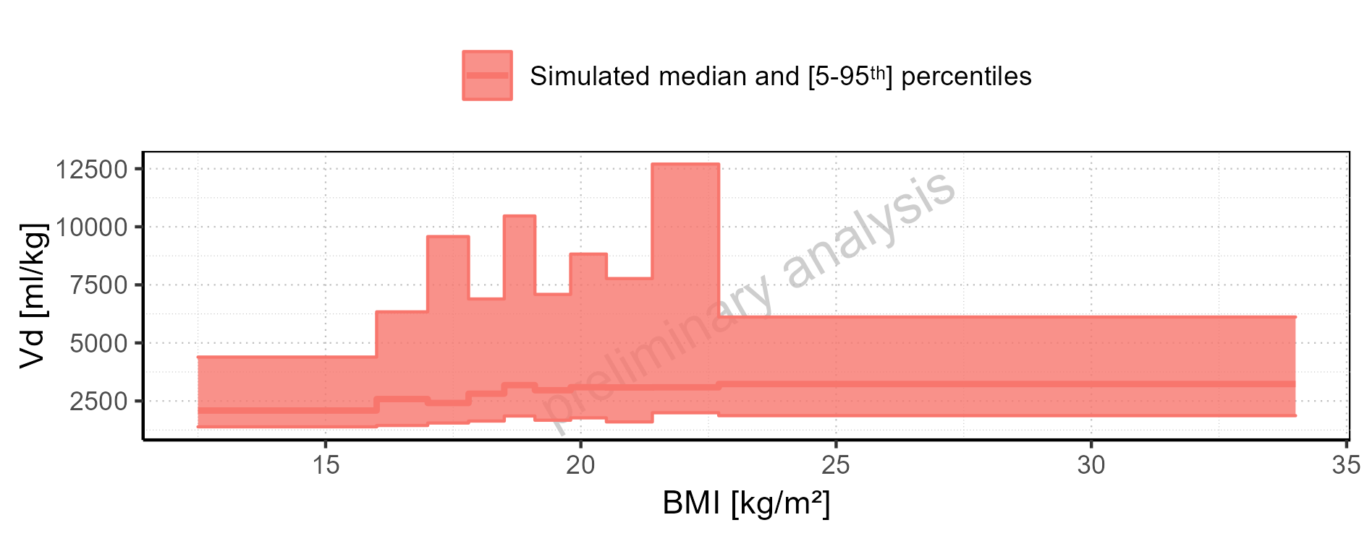

Figure 2-337: BMI-dependence of Vd for Filmcoated_tablet_400mg_sd. Profiles are plotted in a logarithmic scale.

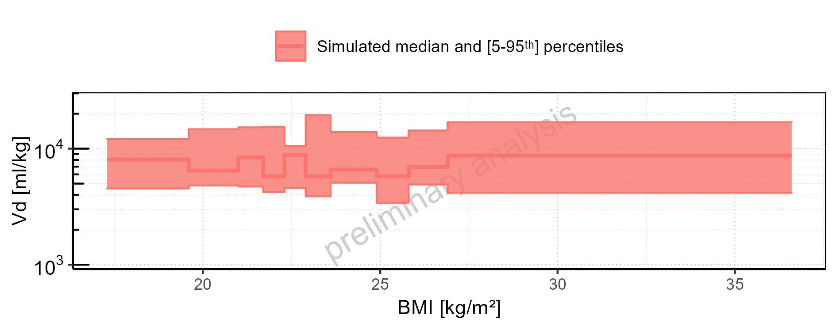

Figure 2-338: BMI-dependence of Vd for Filmcoated_tablet_400mg_sd. Profiles are plotted in a linear scale.

# Time profiles and residual plots

## Time profiles and residual plots for Filmcoated_tablet_400mg_sd

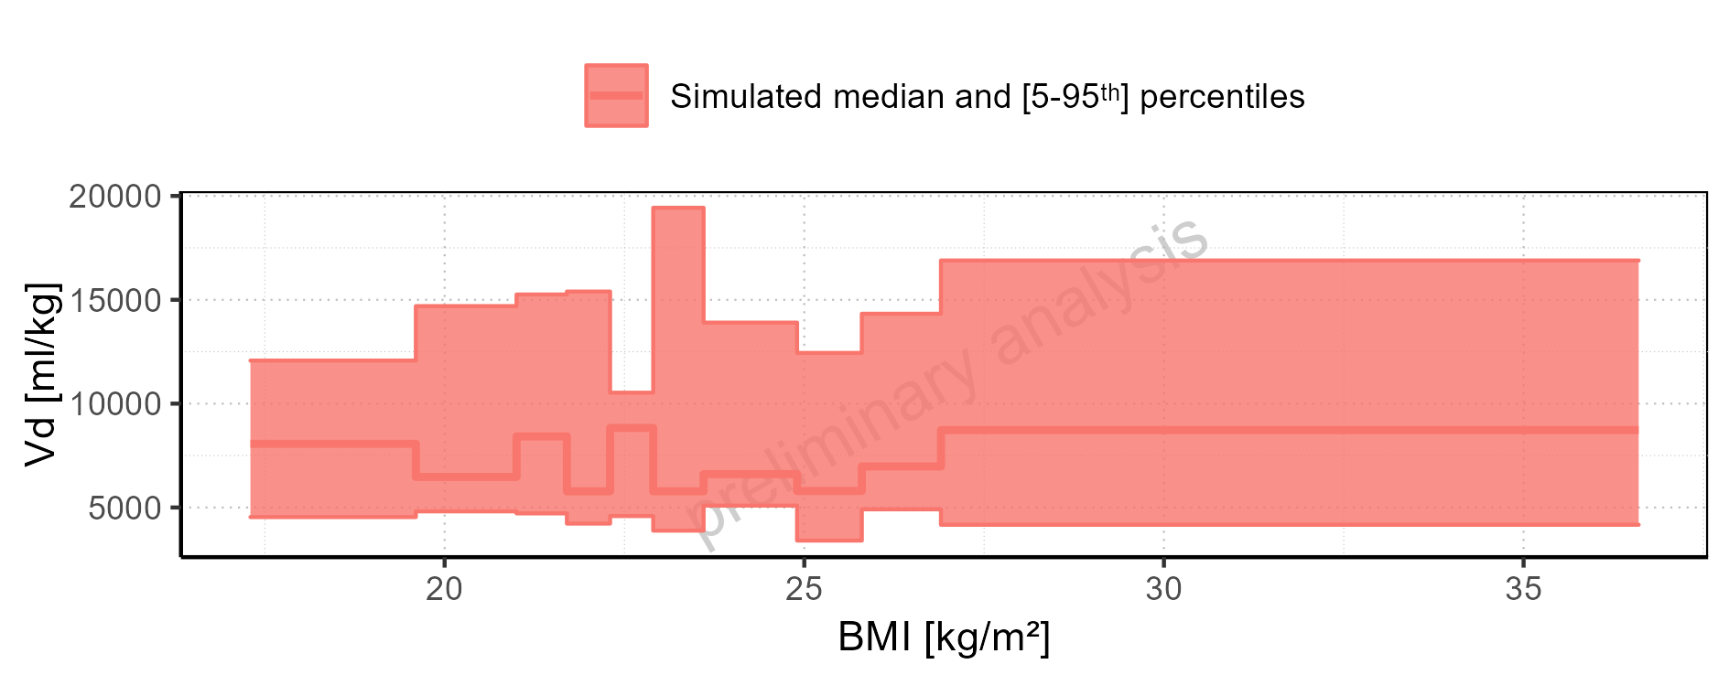

Figure 3-1: Time profiles for Filmcoated_tablet_400mg_sd. Data source: Data/Raltegravir_PK.txt .. Time profiles are plotted in a linear scale.

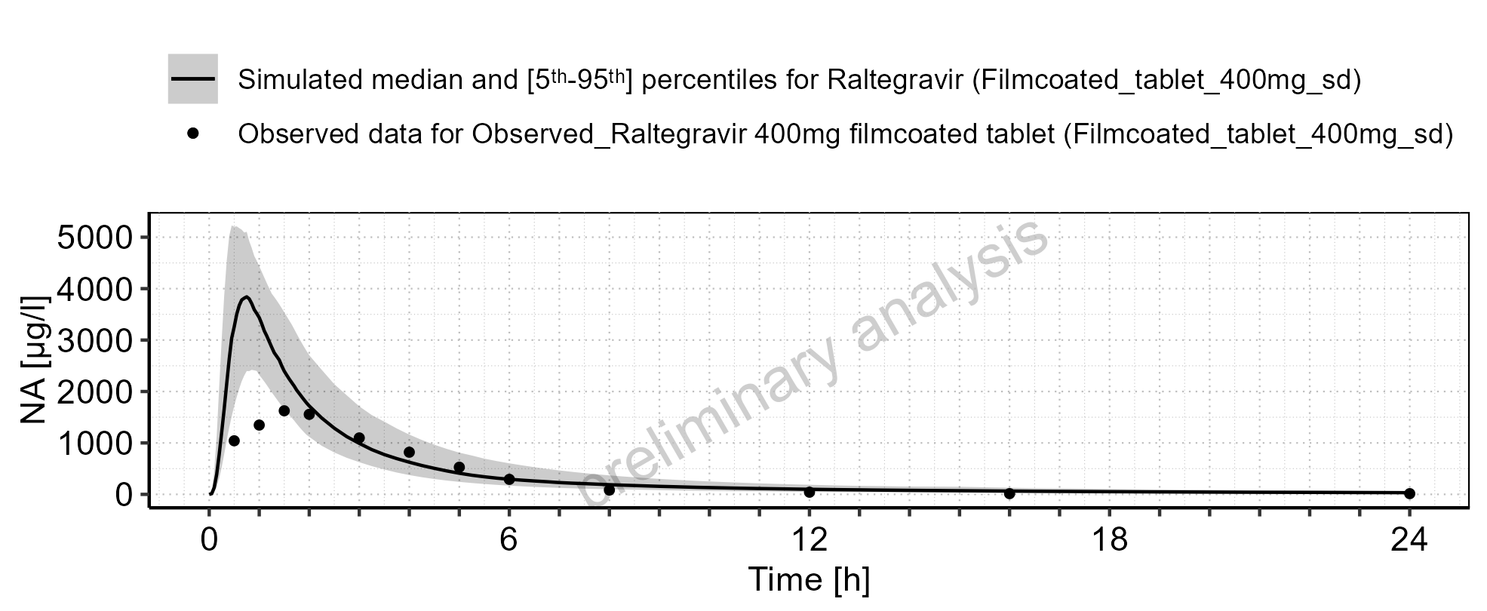

Figure 3-2: Time profiles for Filmcoated_tablet_400mg_sd. Data source: Data/Raltegravir_PK.txt .. Time profiles are plotted in a logarithmic scale.

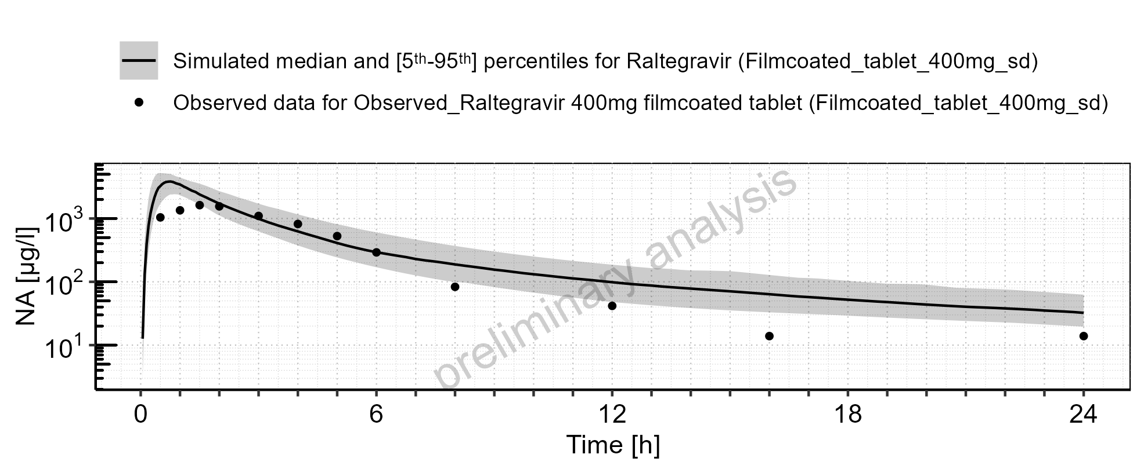

Figure 3-3: Predicted (median) vs observed for Filmcoated_tablet_400mg_sd. Data source: Data/Raltegravir_PK.txt .. Predictions and observations are plotted in a linear scale.

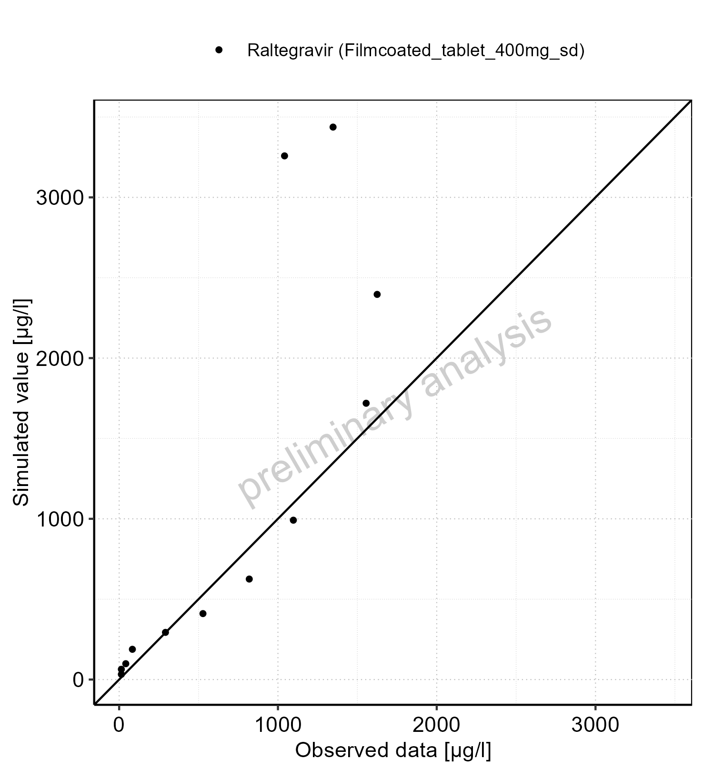

Figure 3-4: Predicted (median) vs observed for Filmcoated_tablet_400mg_sd. Data source: Data/Raltegravir_PK.txt .. Predictions and observations are plotted in a logarithmic scale.

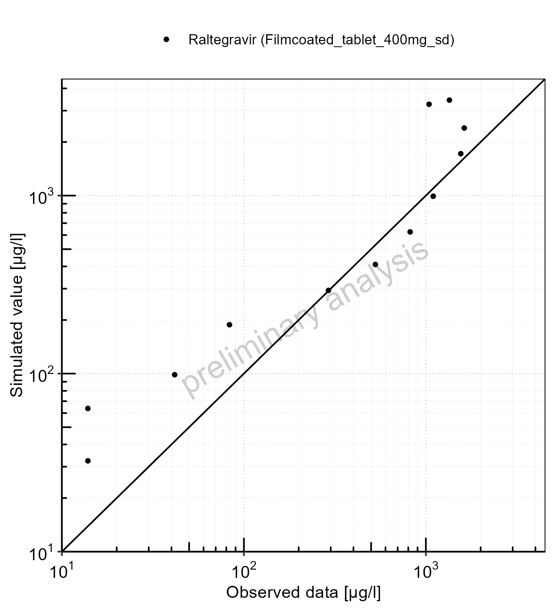

Figure 3-5: Logarithmic residuals vs predicted (median) values for Filmcoated_tablet_400mg_sd. Data source: Data/Raltegravir_PK.txt .

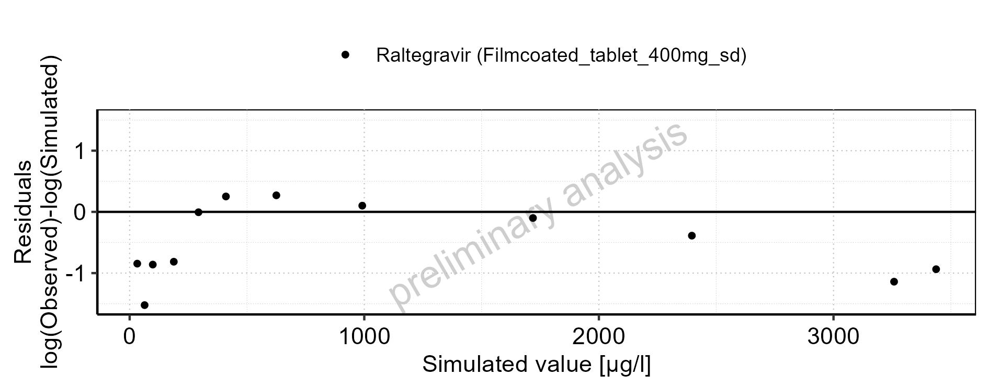

Figure 3-6: Logarithmic residuals vs time values for Filmcoated_tablet_400mg_sd. Data source: Data/Raltegravir_PK.txt .

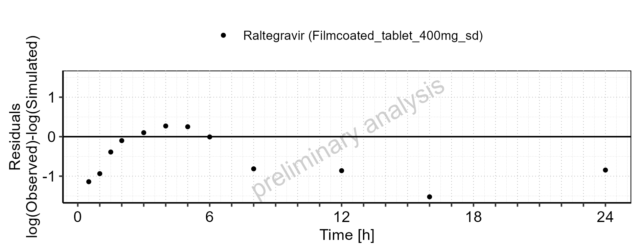

Figure 3-7: Logarithmic residuals distribution (stacked) for Filmcoated_tablet_400mg_sd. Data source: Data/Raltegravir_PK.txt .

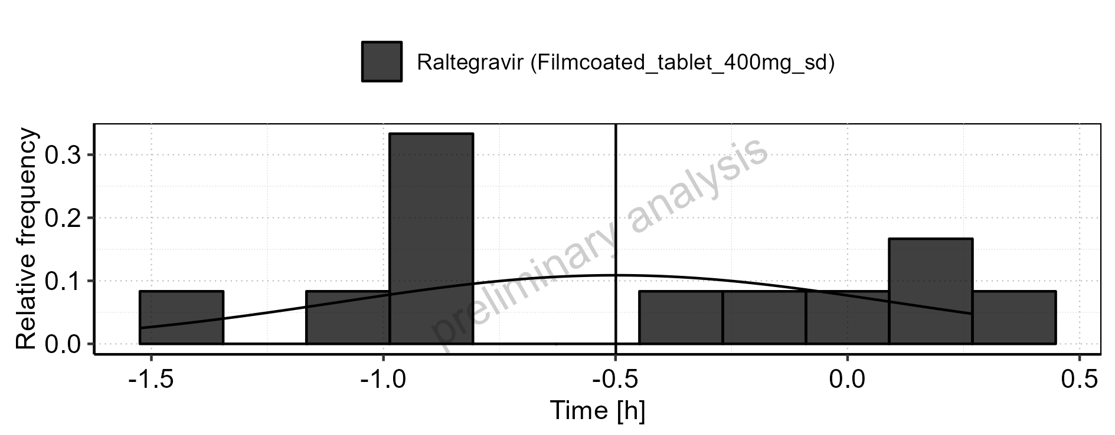

Figure 3-8: Logarithmic residuals for Filmcoated_tablet_400mg_sd as quantile-quantile plot. Data source: Data/Raltegravir_PK.txt .

## Time profiles and residual plots for Larson 2013 8y-18y 400mg FCT meal

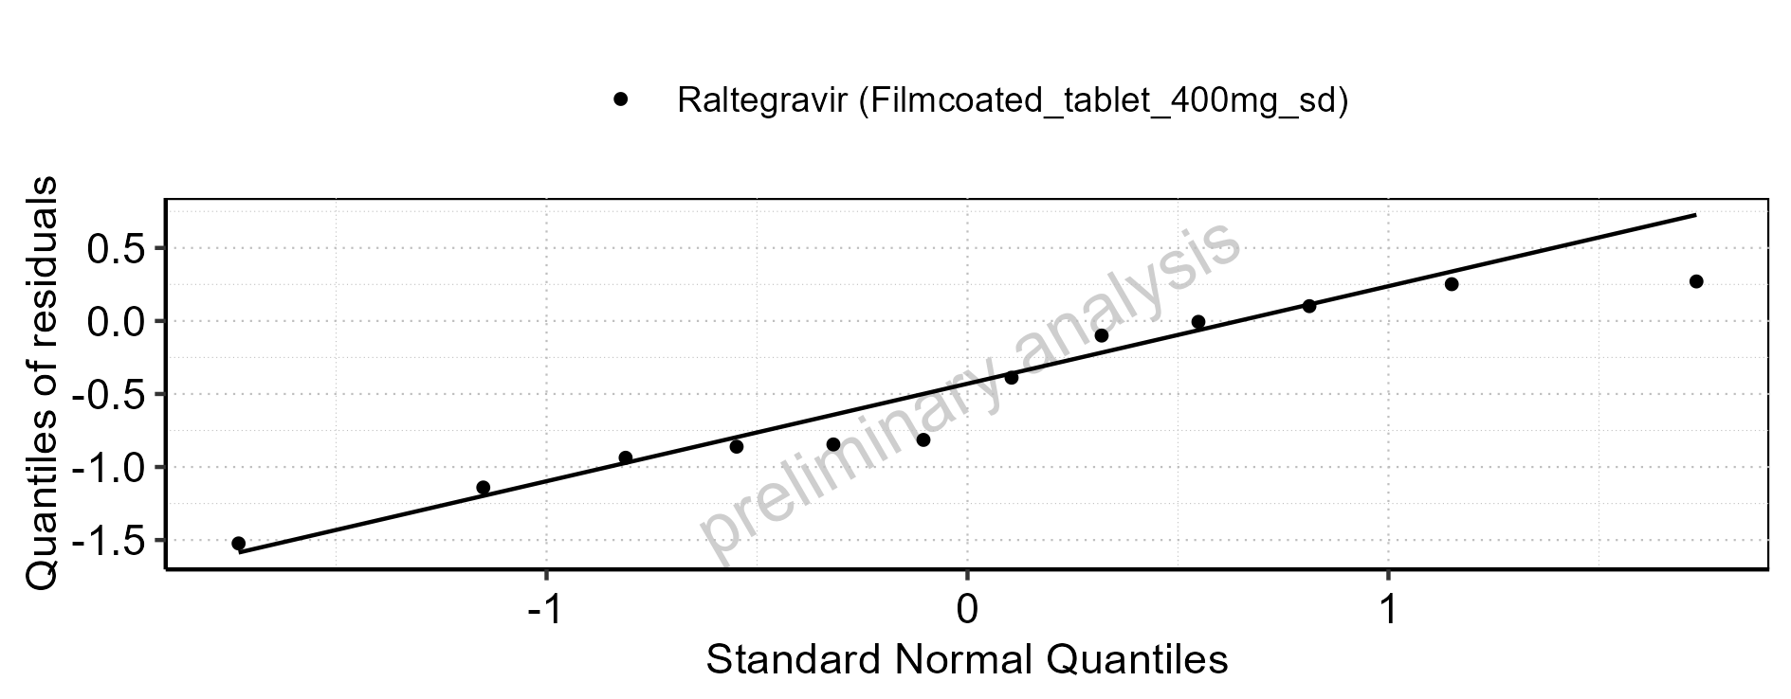

Figure 3-9: Time profiles for Larson 2013 8y-18y 400mg FCT meal. Data source: Data/Raltegravir_PK.txt .. Time profiles are plotted in a linear scale.

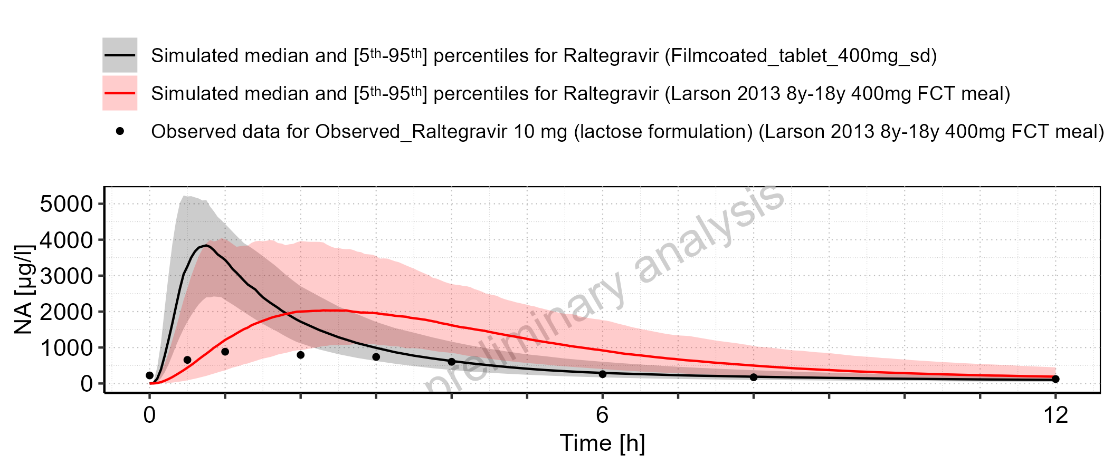

Figure 3-10: Time profiles for Larson 2013 8y-18y 400mg FCT meal. Data source: Data/Raltegravir_PK.txt .. Time profiles are plotted in a logarithmic scale.

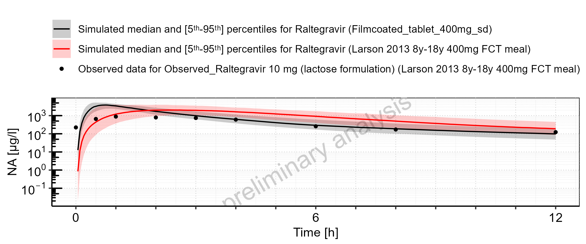

Figure 3-11: Predicted (median) vs observed for Larson 2013 8y-18y 400mg FCT meal. Data source: Data/Raltegravir_PK.txt .. Predictions and observations are plotted in a linear scale.

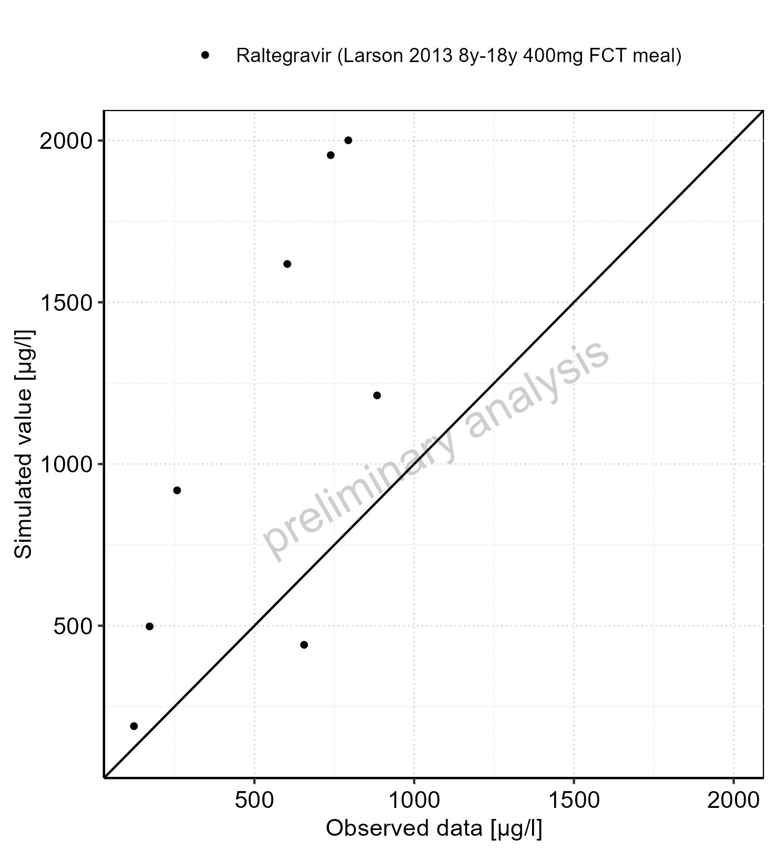

Figure 3-12: Predicted (median) vs observed for Larson 2013 8y-18y 400mg FCT meal. Data source: Data/Raltegravir_PK.txt .. Predictions and observations are plotted in a logarithmic scale.

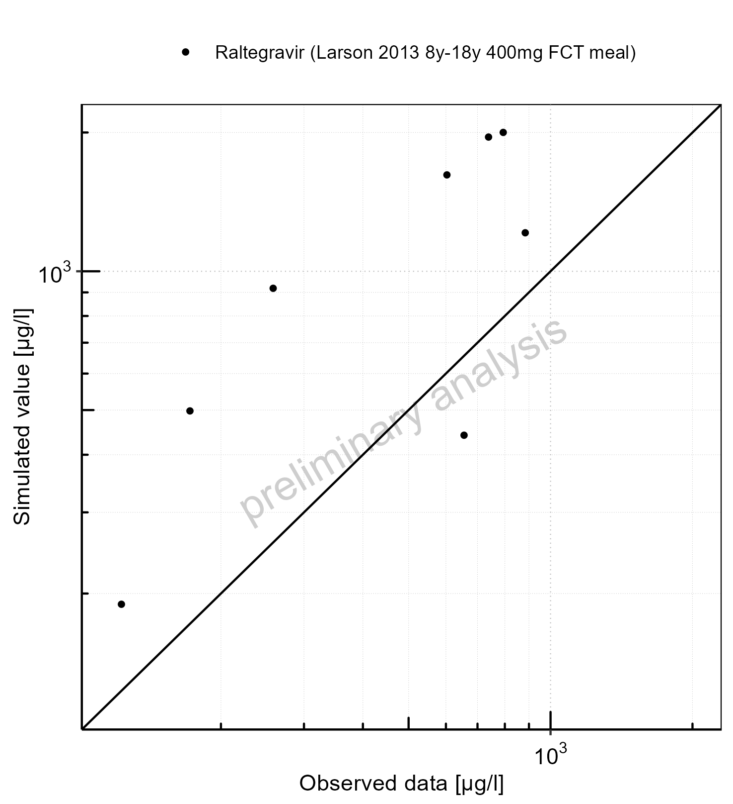

Figure 3-13: Logarithmic residuals vs predicted (median) values for Larson 2013 8y-18y 400mg FCT meal. Data source: Data/Raltegravir_PK.txt .

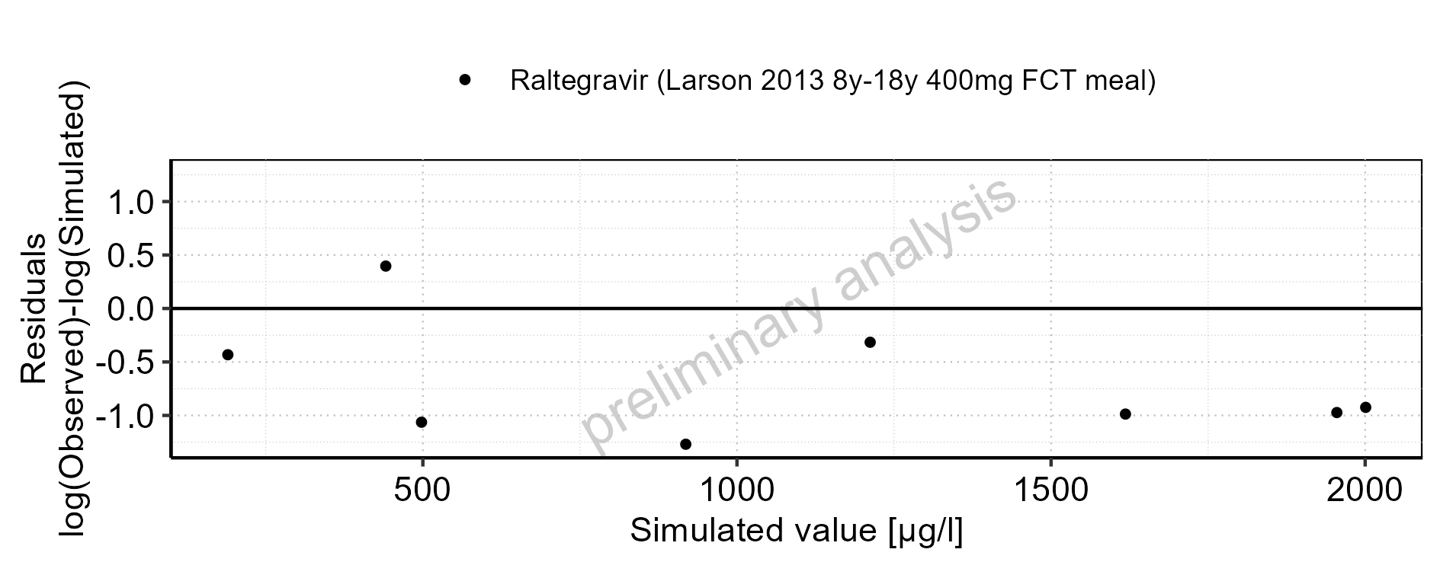

Figure 3-14: Logarithmic residuals vs time values for Larson 2013 8y-18y 400mg FCT meal. Data source: Data/Raltegravir_PK.txt .

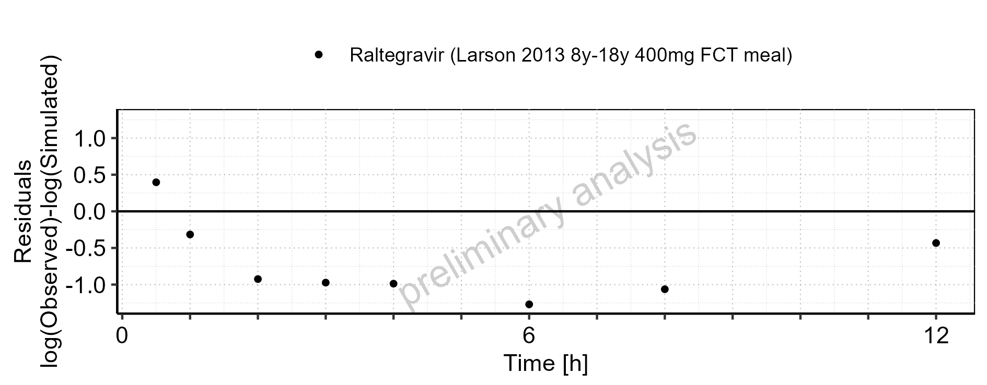

Figure 3-15: Logarithmic residuals distribution (stacked) for Larson 2013 8y-18y 400mg FCT meal. Data source: Data/Raltegravir_PK.txt .

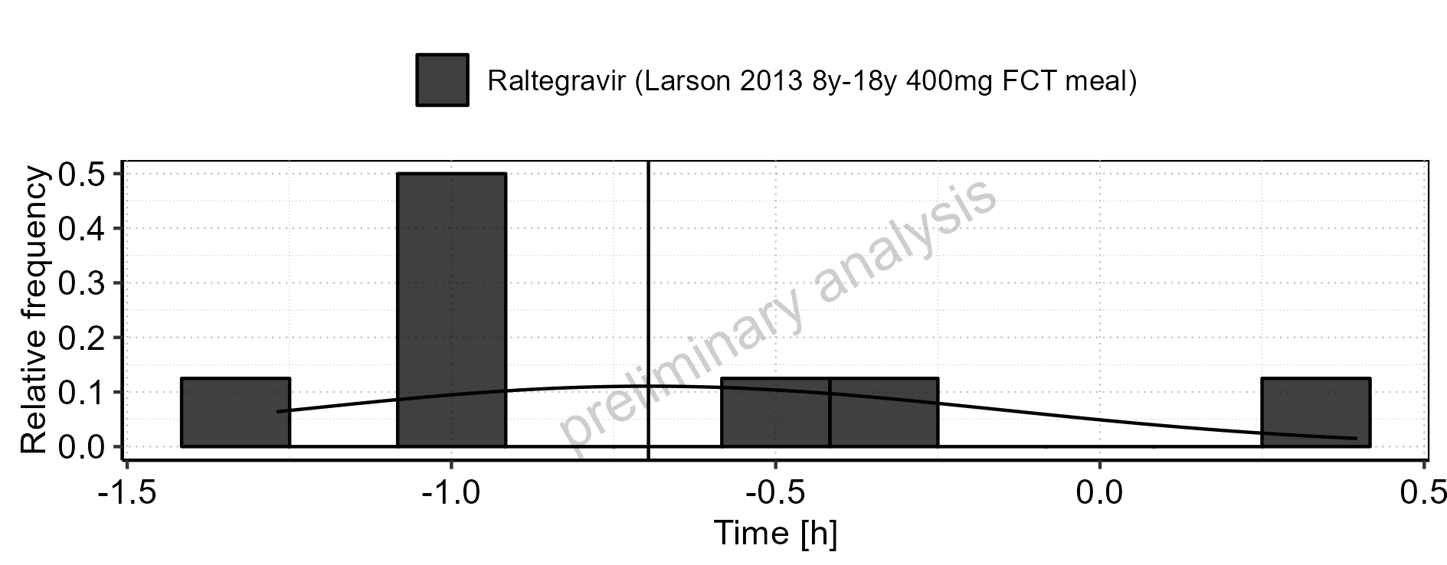

Figure 3-16: Logarithmic residuals for Larson 2013 8y-18y 400mg FCT meal as quantile-quantile plot. Data source: Data/Raltegravir_PK.txt .

## Residuals across all simulations

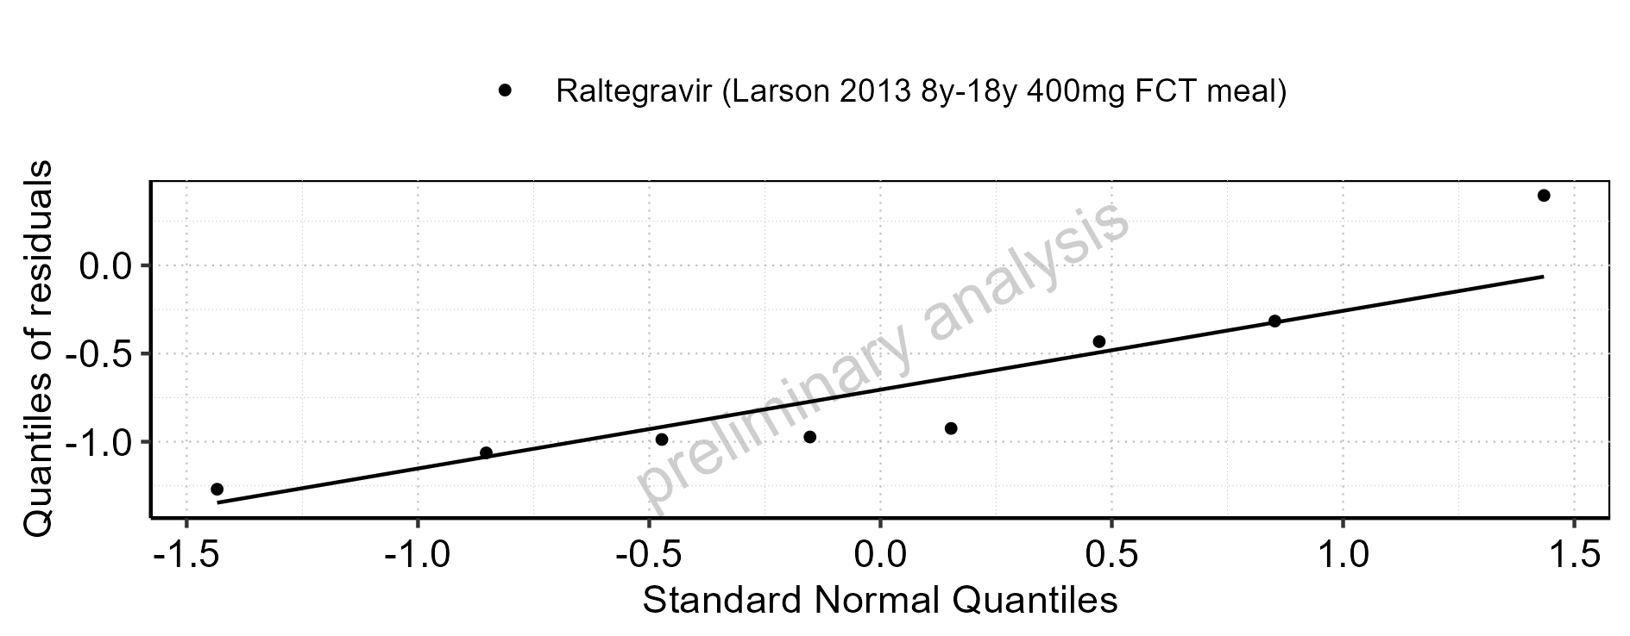

Figure 3-17: Predicted vs observed for Raltegravir across Filmcoated_tablet_400mg_sd, Larson 2013 8y-18y 400mg FCT meal. Predictions and observations are plotted in a linear scale.

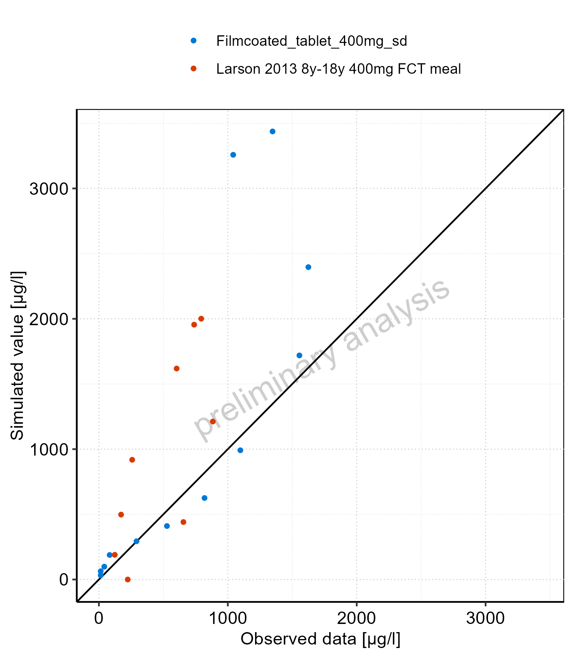

Figure 3-18: Predicted vs observed for Raltegravir across Filmcoated_tablet_400mg_sd, Larson 2013 8y-18y 400mg FCT meal. Predictions and observations are plotted in a logarithmic scale.

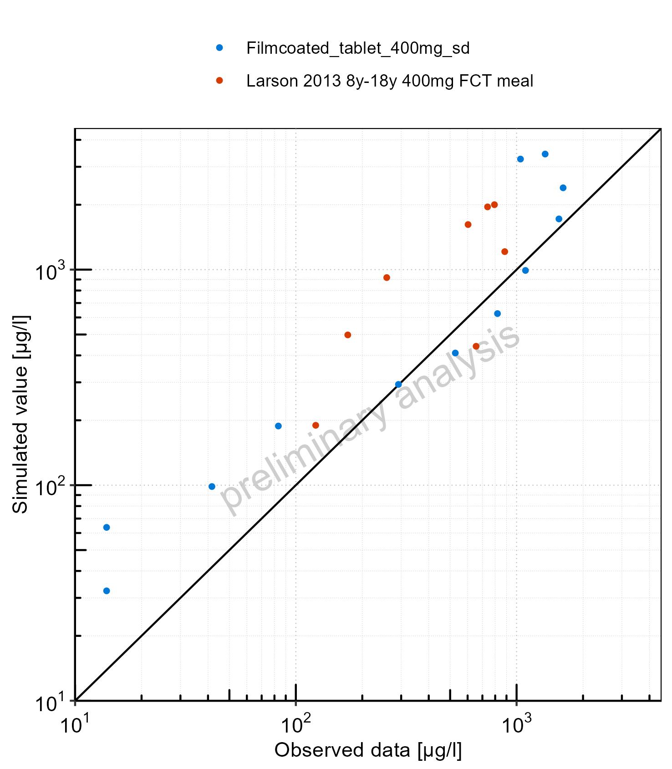

Figure 3-19: Logarithmic residuals vs predicted values for Raltegravir across Filmcoated_tablet_400mg_sd, Larson 2013 8y-18y 400mg FCT meal

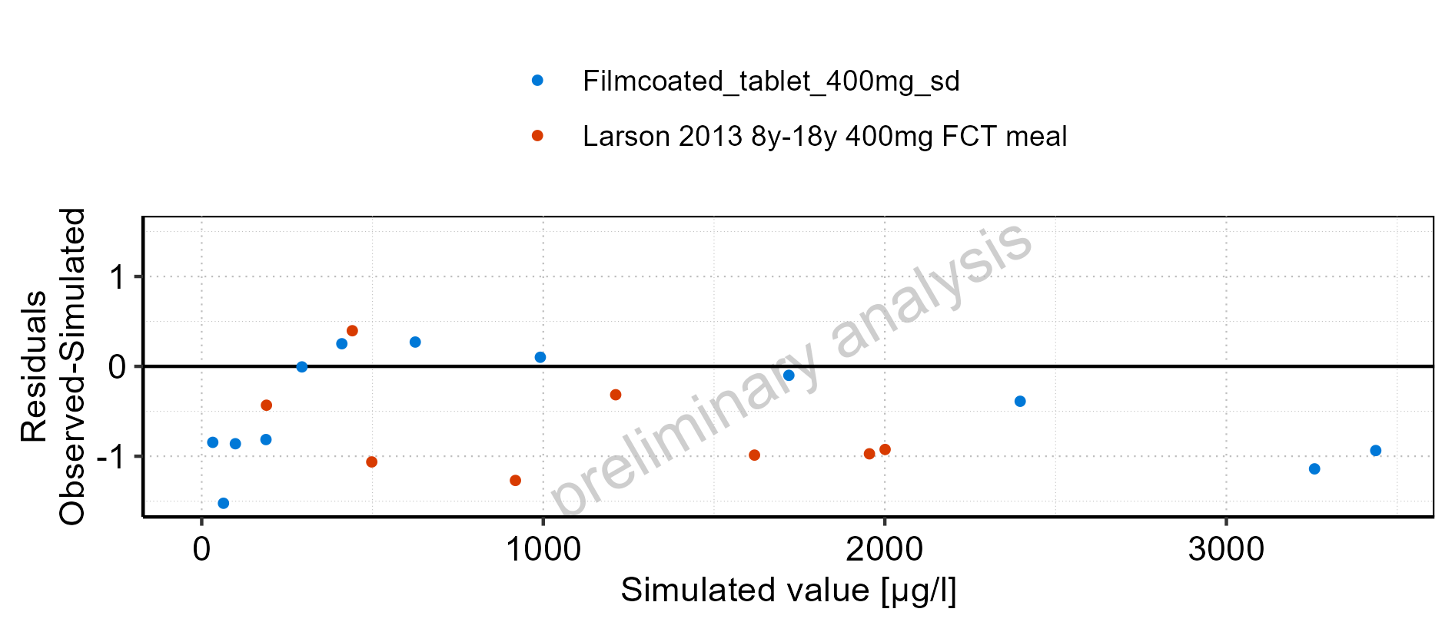

Figure 3-20: Logarithmic residuals vs time values for Raltegravir across Filmcoated_tablet_400mg_sd, Larson 2013 8y-18y 400mg FCT meal

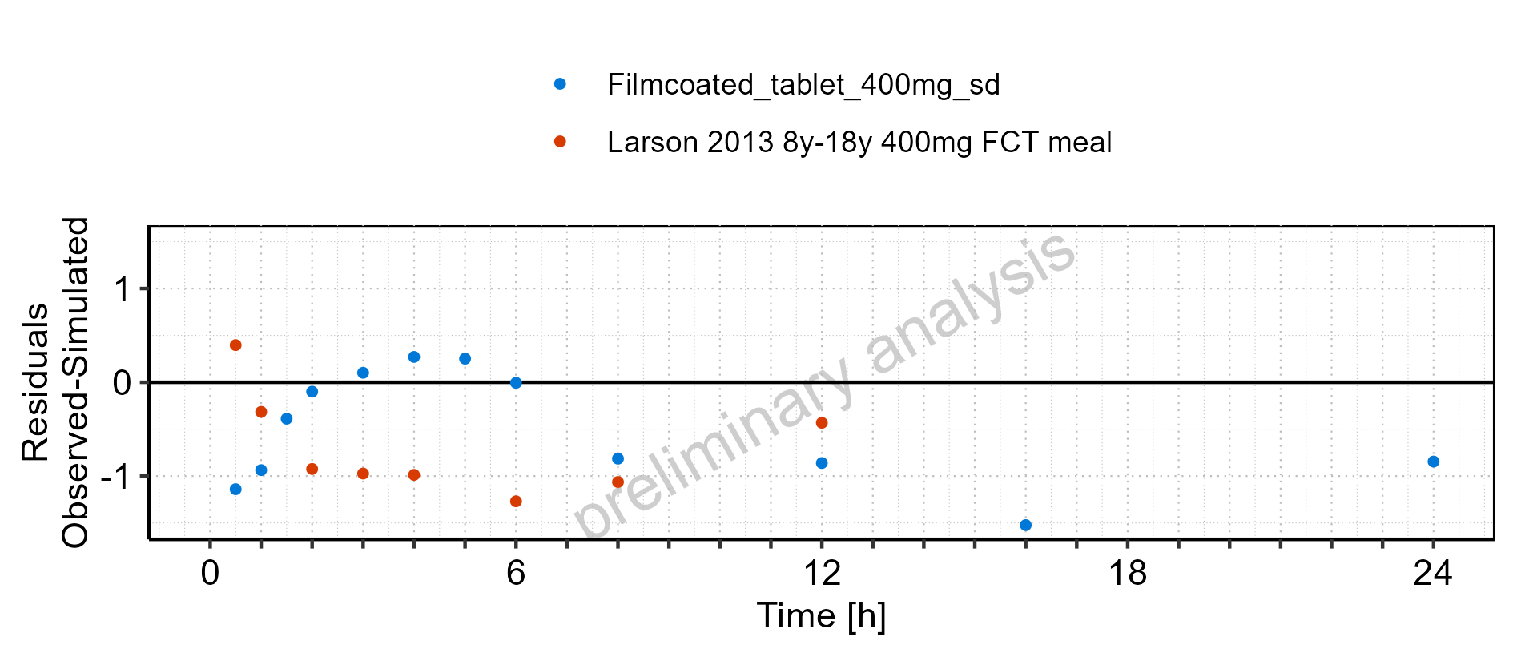

Figure 3-21: Logarithmic residuals distribution (stacked) for Raltegravir across Filmcoated_tablet_400mg_sd, Larson 2013 8y-18y 400mg FCT meal

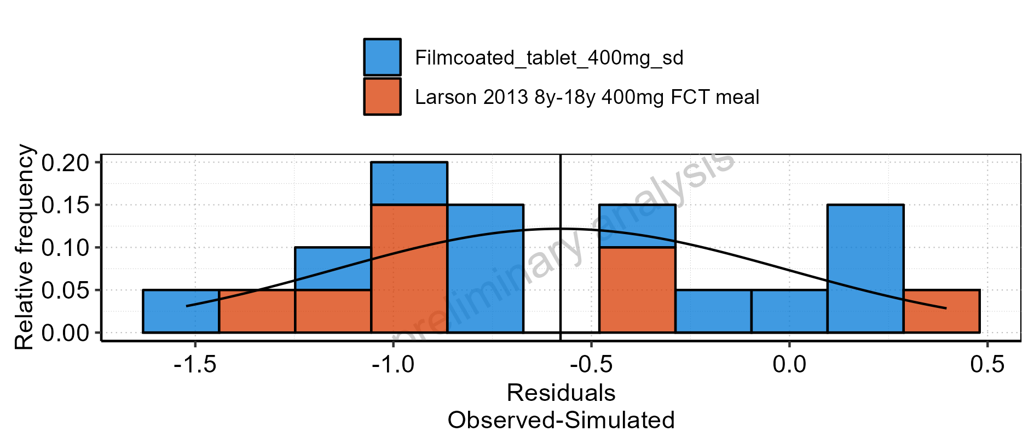

Figure 3-22: Logarithmic residuals for Raltegravir across Filmcoated_tablet_400mg_sd, Larson 2013 8y-18y 400mg FCT meal as quantile-quantile plot

# Demography

## Age-dependence

### Dependence of Height

#### For Larson 2013 8y-18y 400mg FCT meal

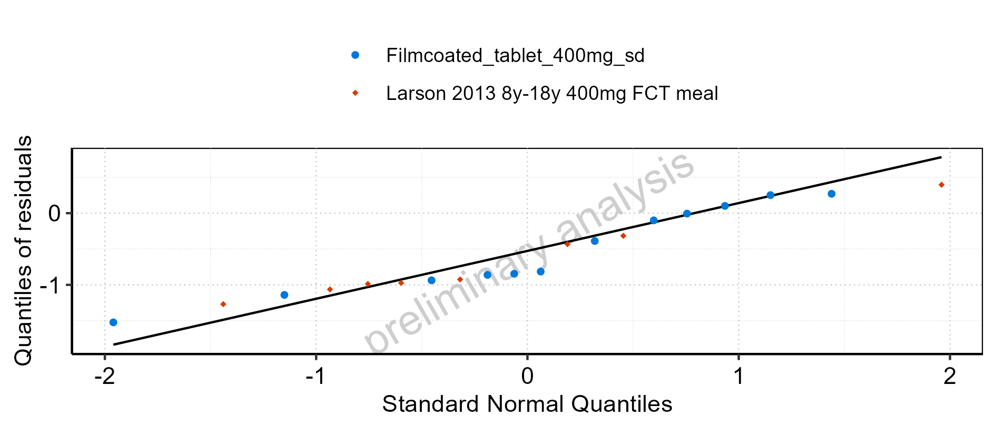

Figure 4-1: Age-dependence of Height for Larson 2013 8y-18y 400mg FCT meal in comparison to Filmcoated_tablet_400mg_sd. Profiles are plotted in a linear scale.

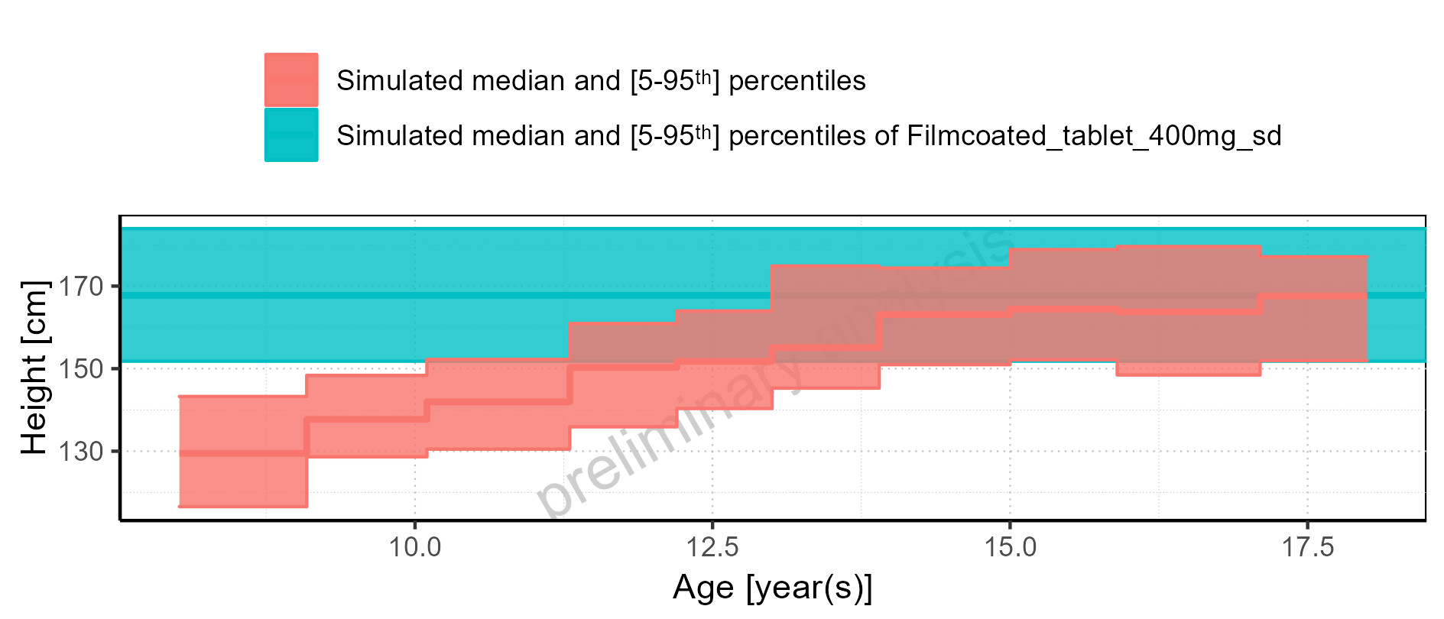

Figure 4-2: Age-dependence of Height for Larson 2013 8y-18y 400mg FCT meal in comparison to Filmcoated_tablet_400mg_sd. Profiles are plotted in a logarithmic scale.

#### For Larson 2013 8y-18y 400mg FCT meal

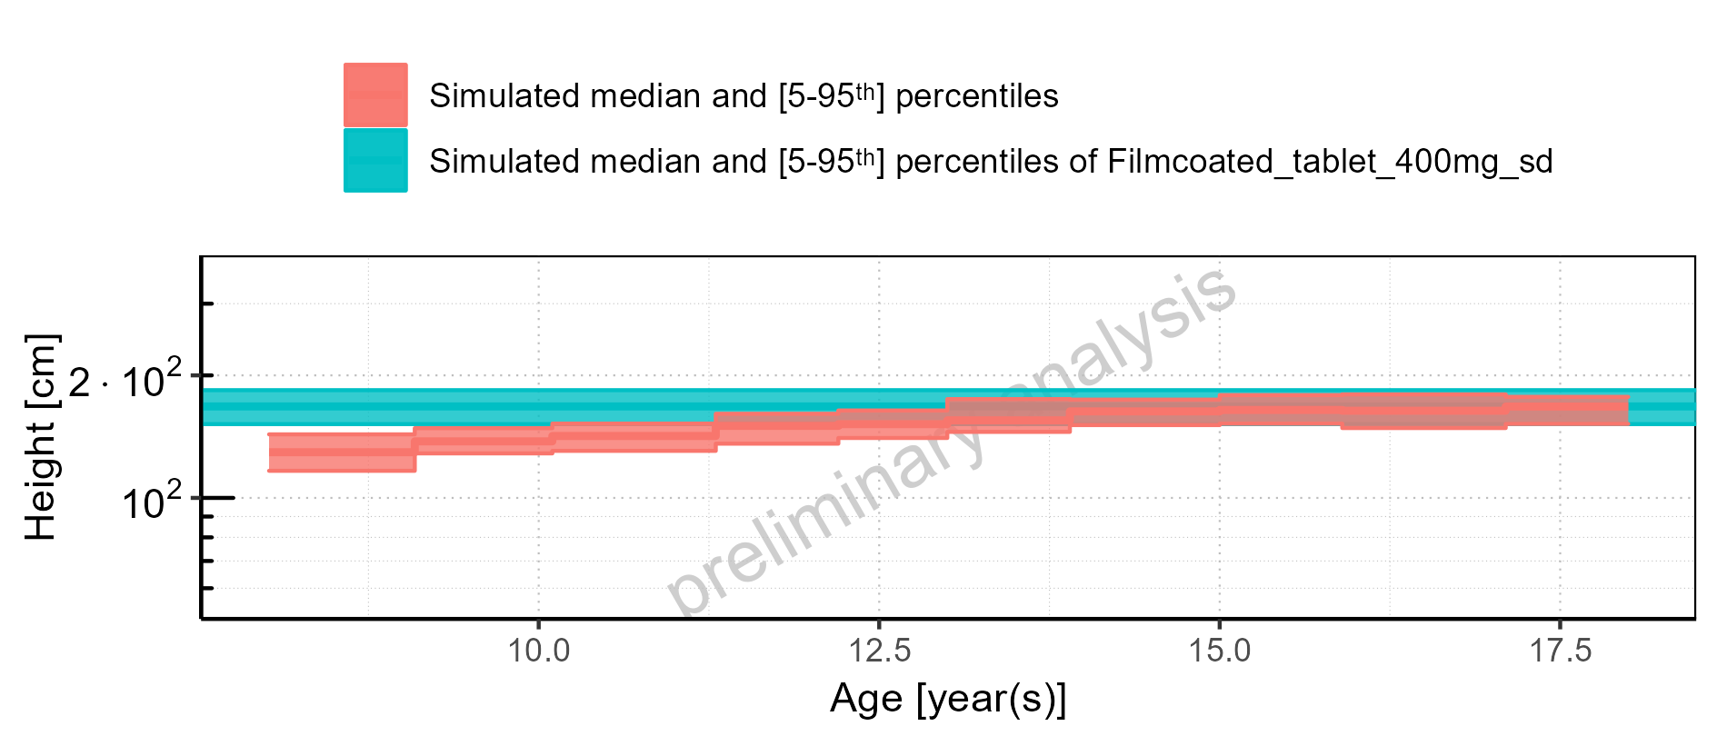

Figure 4-3: Age-dependence of Height for Larson 2013 8y-18y 400mg FCT meal. Profiles are plotted in a linear scale.

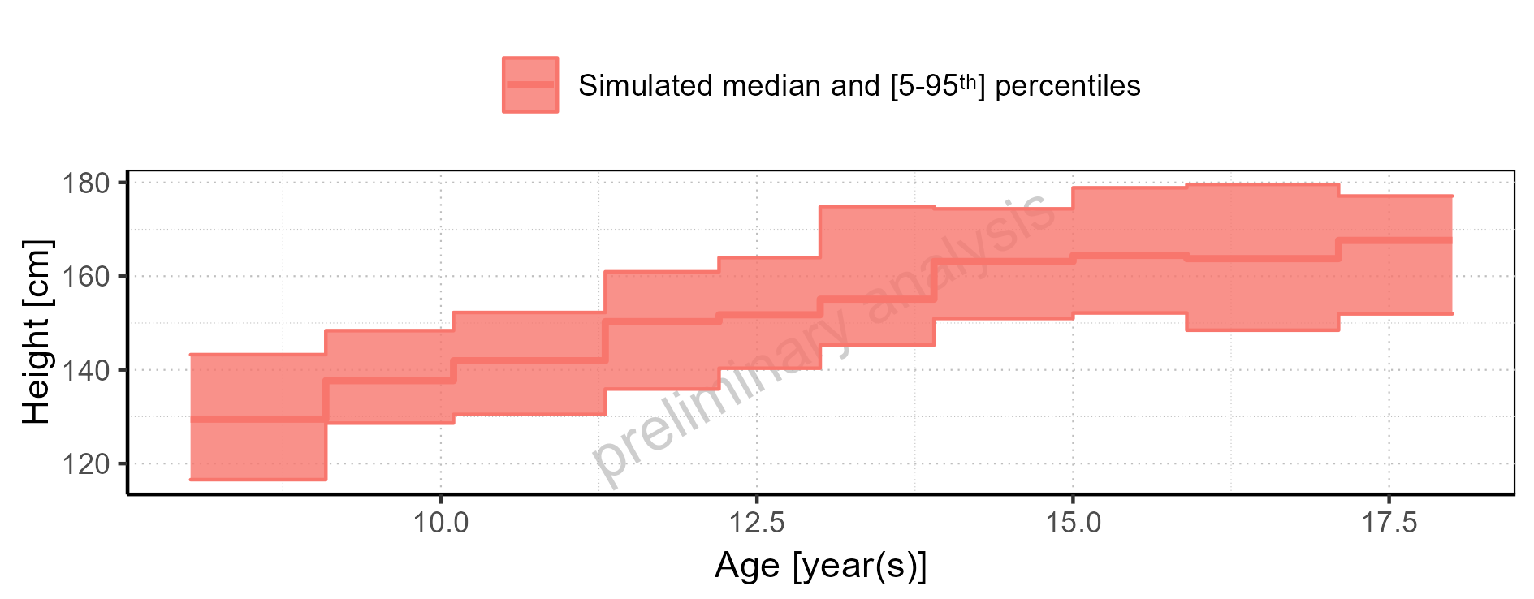

Figure 4-4: Age-dependence of Height for Larson 2013 8y-18y 400mg FCT meal. Profiles are plotted in a logarithmic scale.

#### For Filmcoated_tablet_400mg_sd

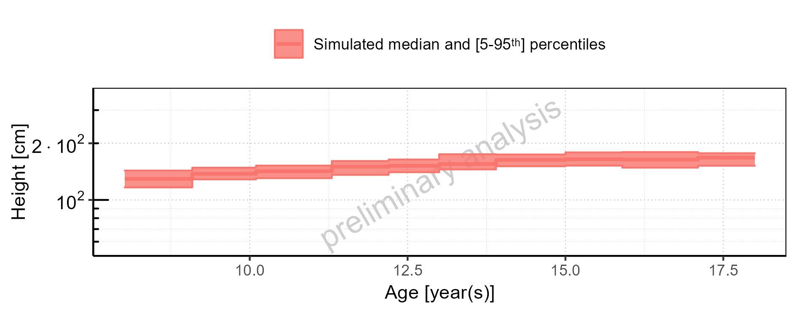

Figure 4-5: Age-dependence of Height for Filmcoated_tablet_400mg_sd. Profiles are plotted in a linear scale.

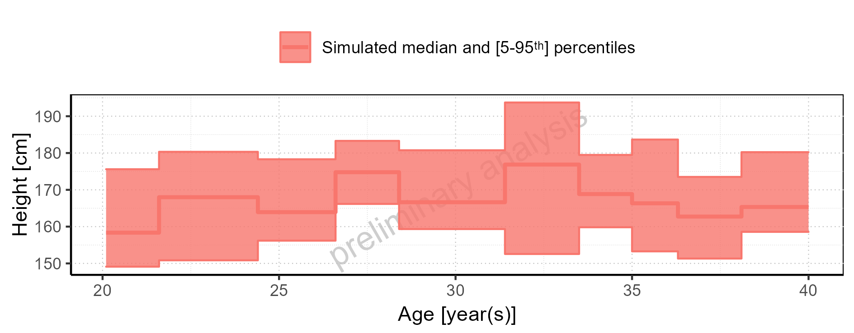

Figure 4-6: Age-dependence of Height for Filmcoated_tablet_400mg_sd. Profiles are plotted in a logarithmic scale.

### Dependence of Weight

#### For Larson 2013 8y-18y 400mg FCT meal

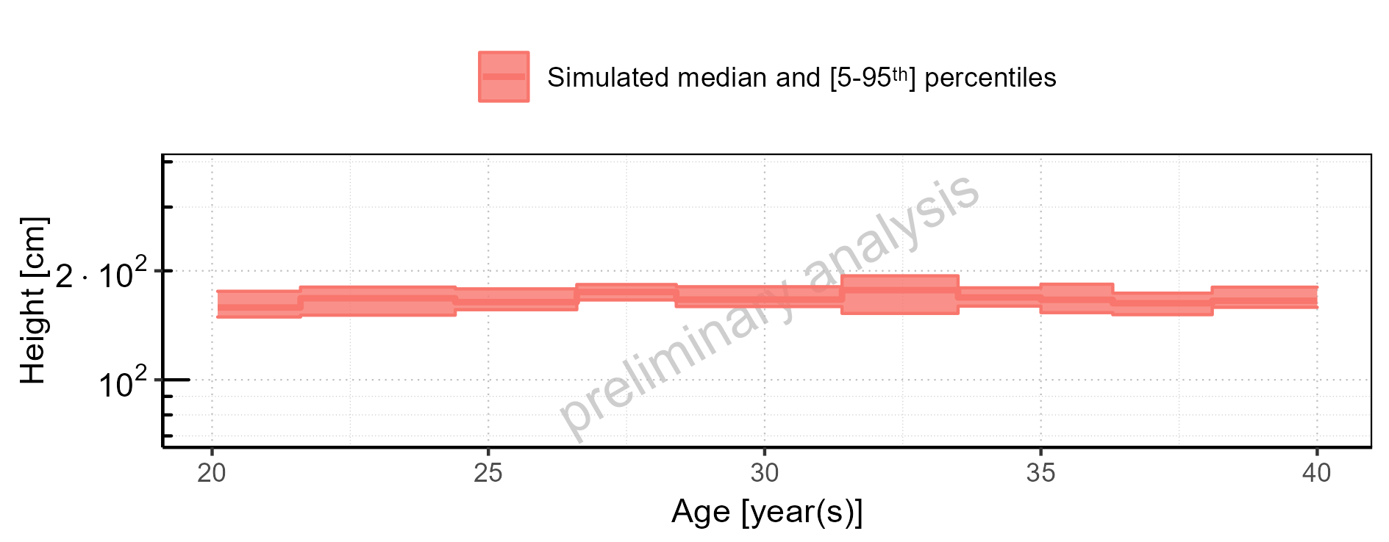

Figure 4-7: Age-dependence of Weight for Larson 2013 8y-18y 400mg FCT meal in comparison to Filmcoated_tablet_400mg_sd. Profiles are plotted in a linear scale.

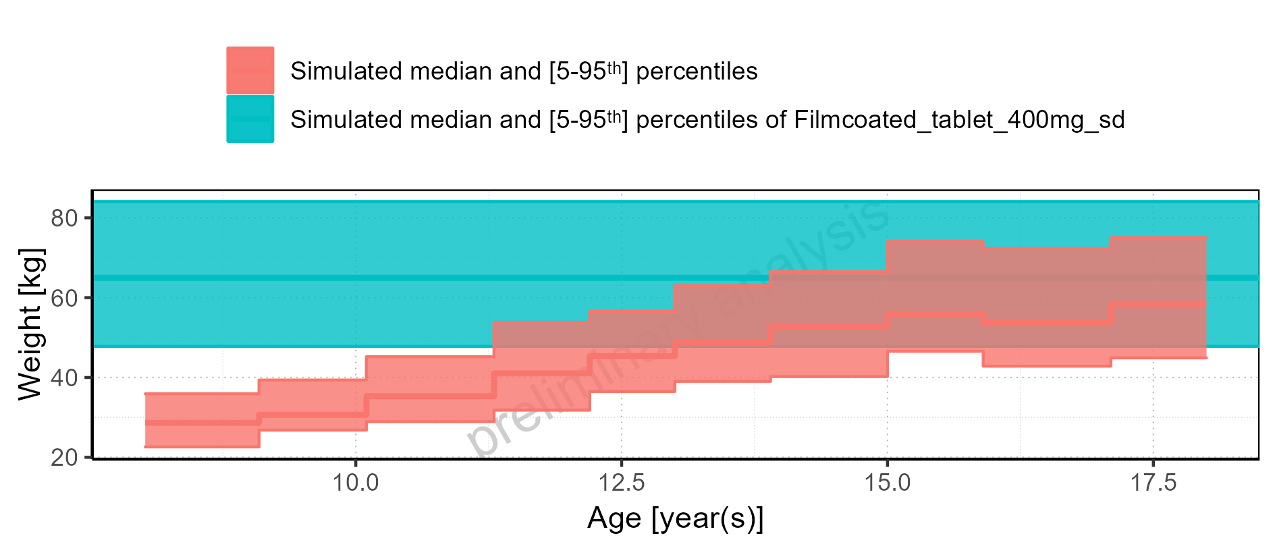

Figure 4-8: Age-dependence of Weight for Larson 2013 8y-18y 400mg FCT meal in comparison to Filmcoated_tablet_400mg_sd. Profiles are plotted in a logarithmic scale.

#### For Larson 2013 8y-18y 400mg FCT meal

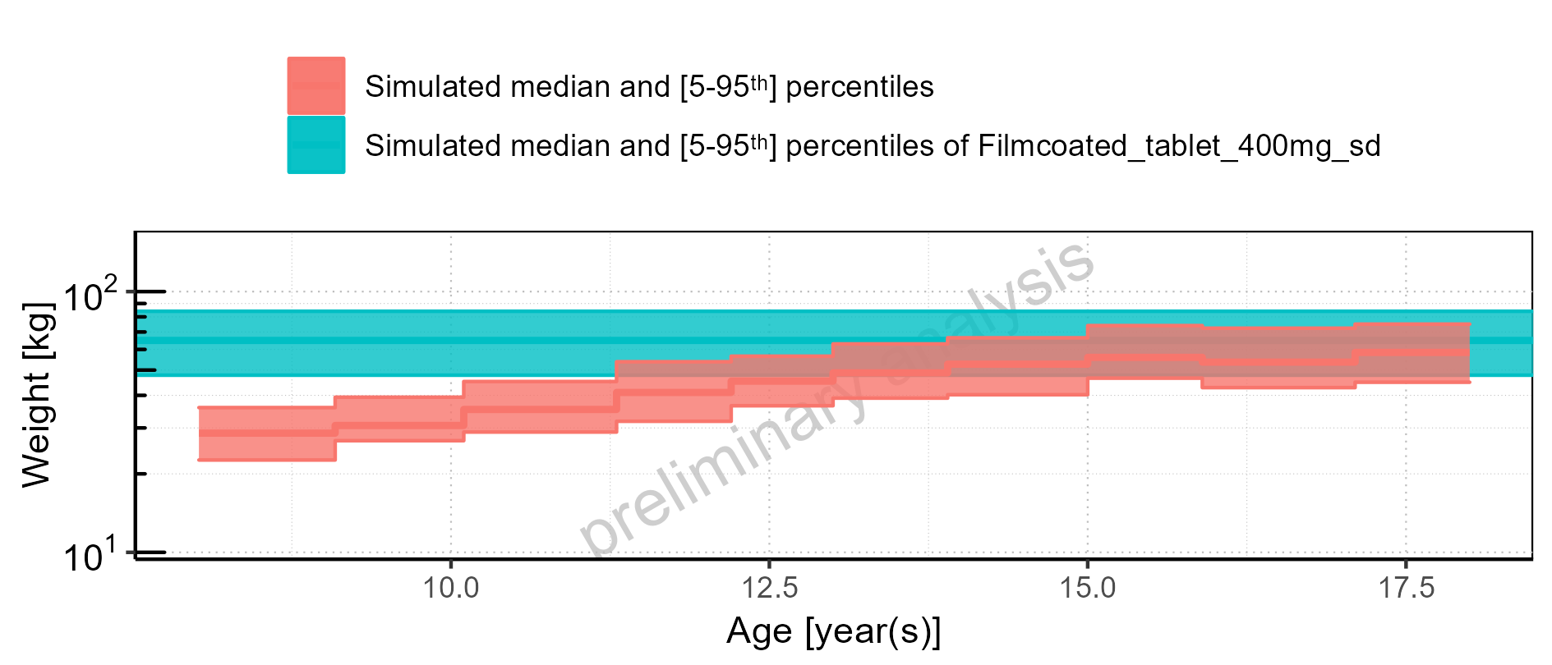

Figure 4-9: Age-dependence of Weight for Larson 2013 8y-18y 400mg FCT meal. Profiles are plotted in a linear scale.

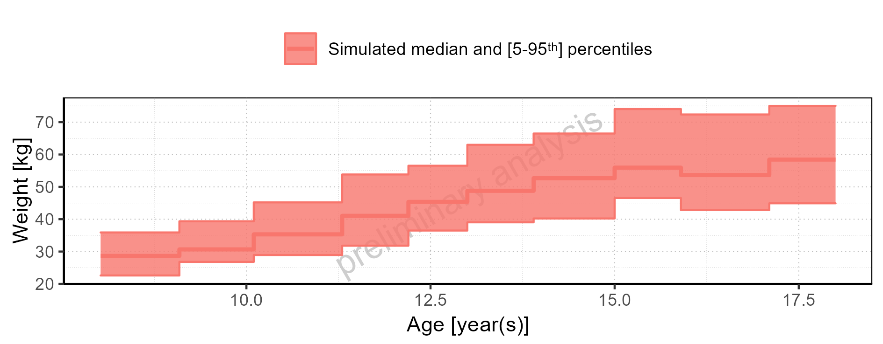

Figure 4-10: Age-dependence of Weight for Larson 2013 8y-18y 400mg FCT meal. Profiles are plotted in a logarithmic scale.

#### For Filmcoated_tablet_400mg_sd

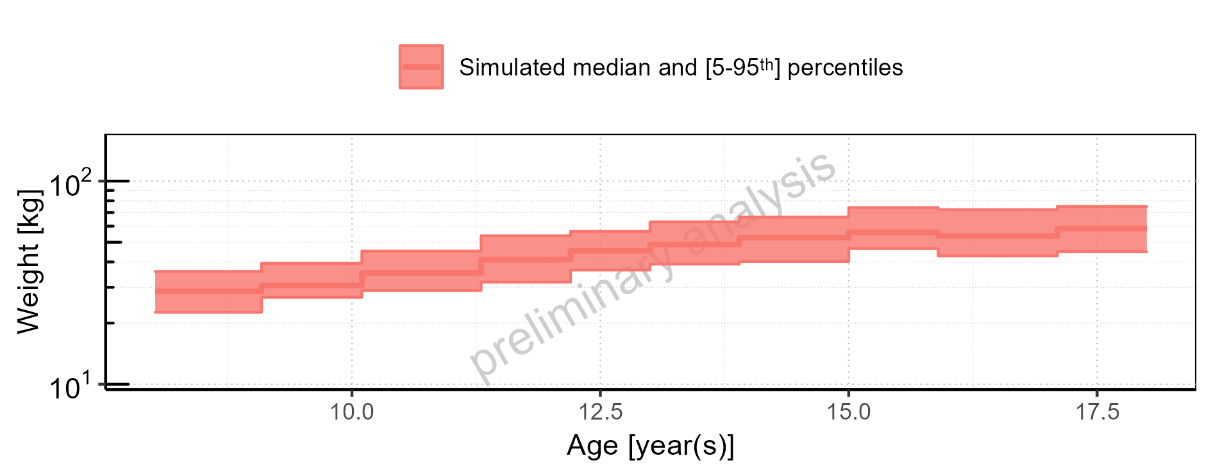

Figure 4-11: Age-dependence of Weight for Filmcoated_tablet_400mg_sd. Profiles are plotted in a linear scale.

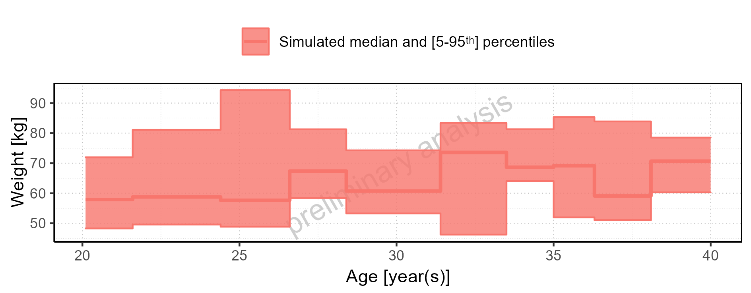

Figure 4-12: Age-dependence of Weight for Filmcoated_tablet_400mg_sd. Profiles are plotted in a logarithmic scale.

### Dependence of BMI

#### For Larson 2013 8y-18y 400mg FCT meal

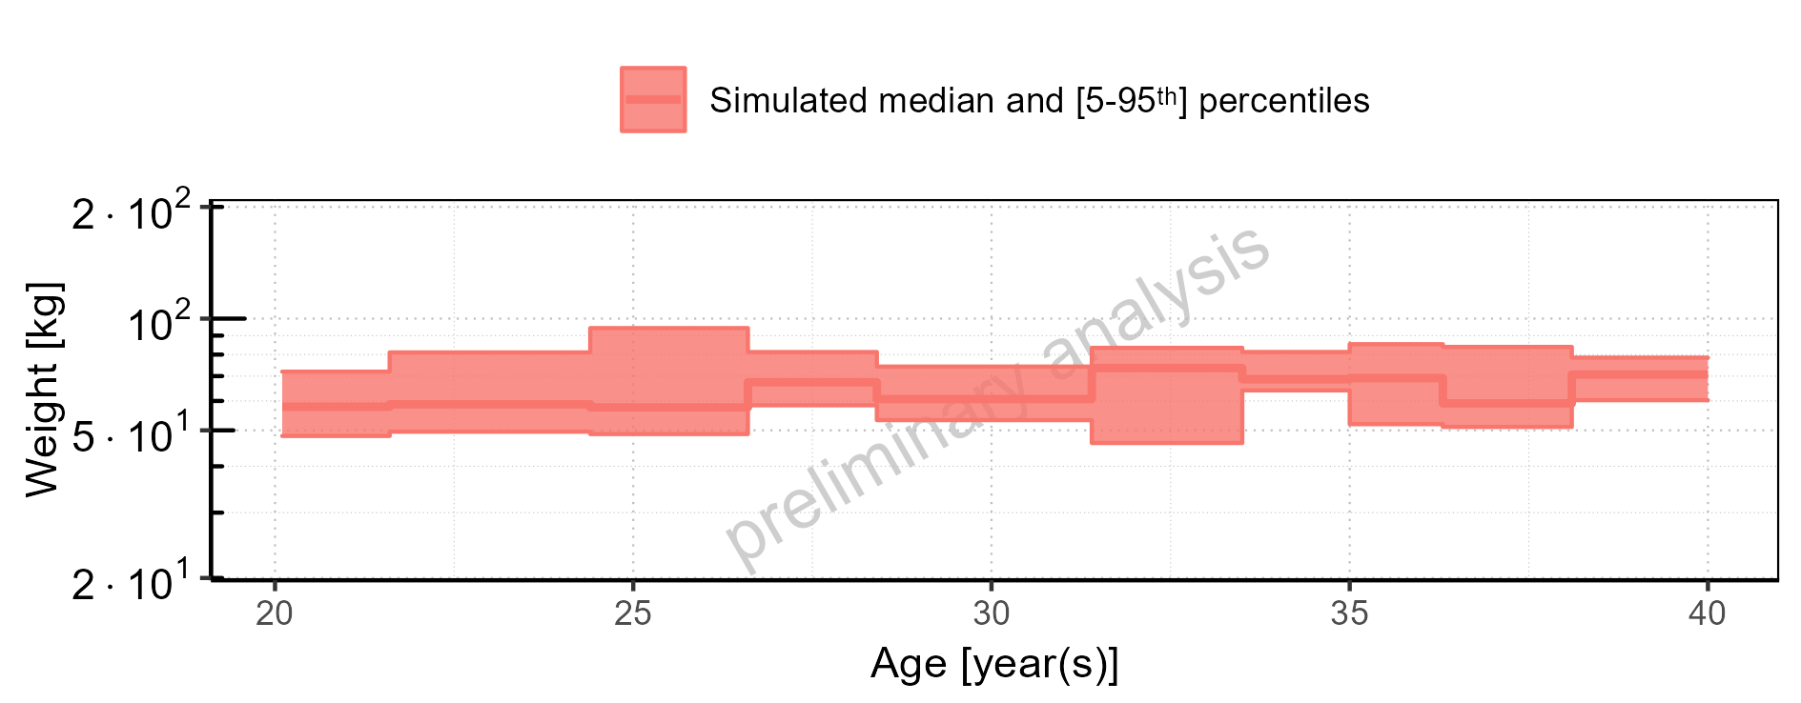

Figure 4-13: Age-dependence of BMI for Larson 2013 8y-18y 400mg FCT meal in comparison to Filmcoated_tablet_400mg_sd. Profiles are plotted in a linear scale.

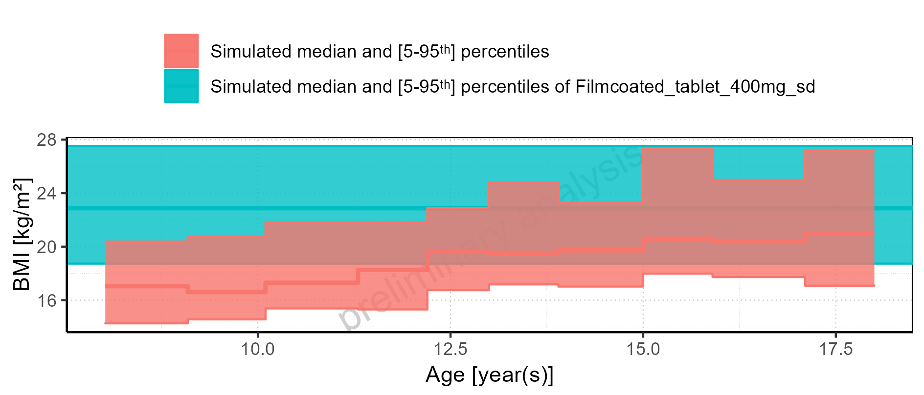

Figure 4-14: Age-dependence of BMI for Larson 2013 8y-18y 400mg FCT meal in comparison to Filmcoated_tablet_400mg_sd. Profiles are plotted in a logarithmic scale.

#### For Larson 2013 8y-18y 400mg FCT meal

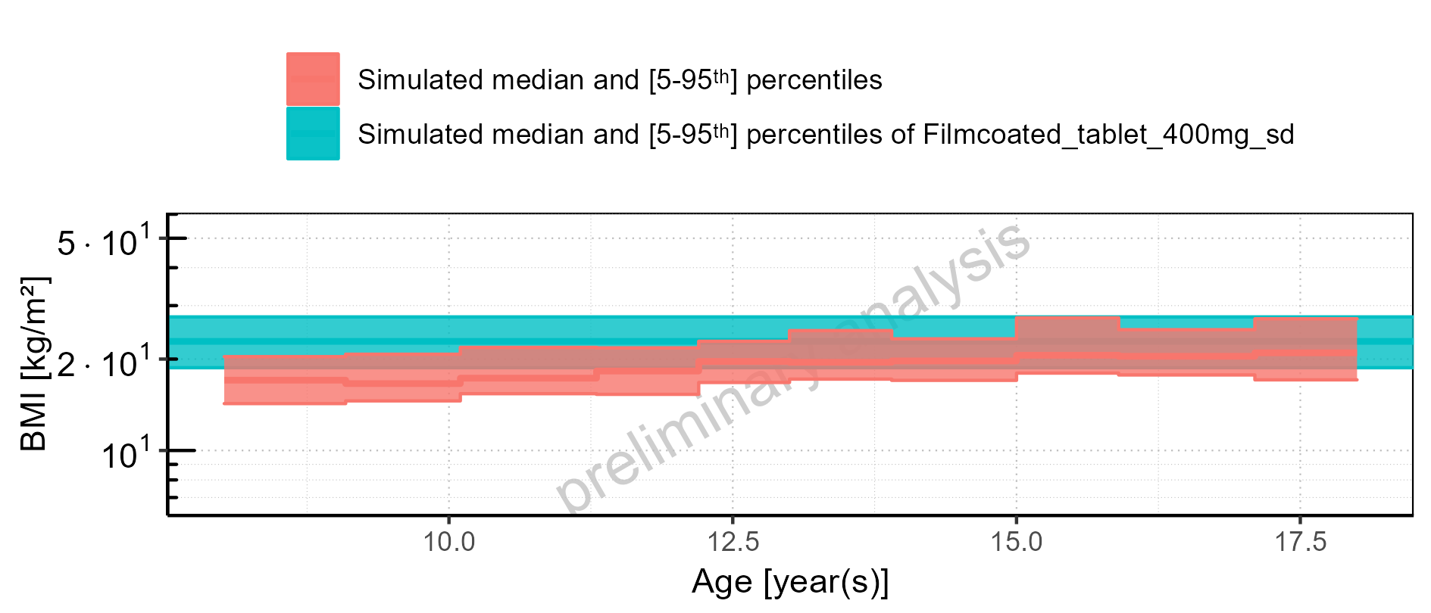

Figure 4-15: Age-dependence of BMI for Larson 2013 8y-18y 400mg FCT meal. Profiles are plotted in a linear scale.

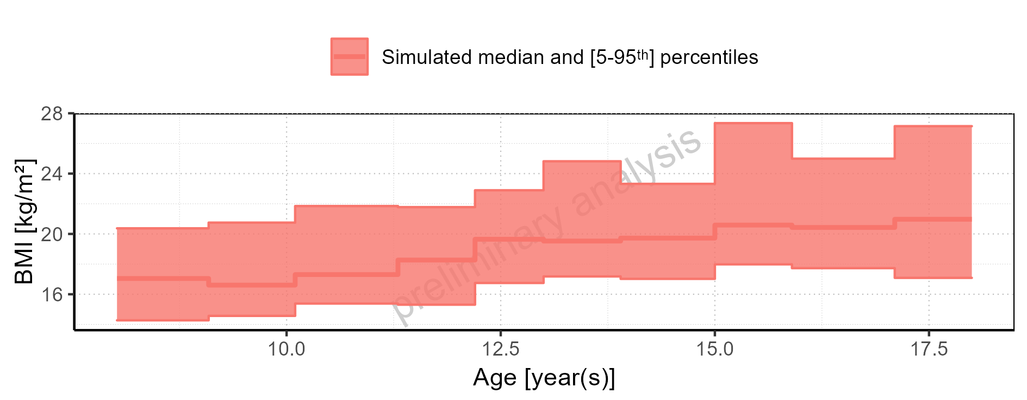

Figure 4-16: Age-dependence of BMI for Larson 2013 8y-18y 400mg FCT meal. Profiles are plotted in a logarithmic scale.

#### For Filmcoated_tablet_400mg_sd

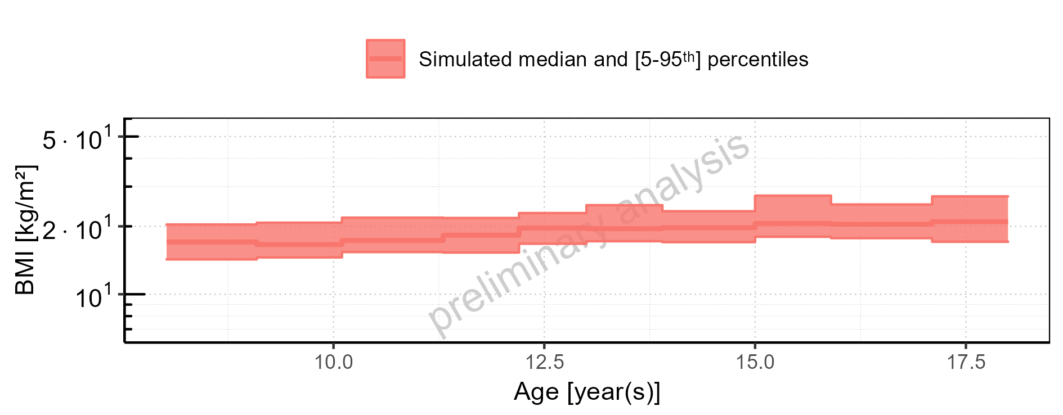

Figure 4-17: Age-dependence of BMI for Filmcoated_tablet_400mg_sd. Profiles are plotted in a linear scale.

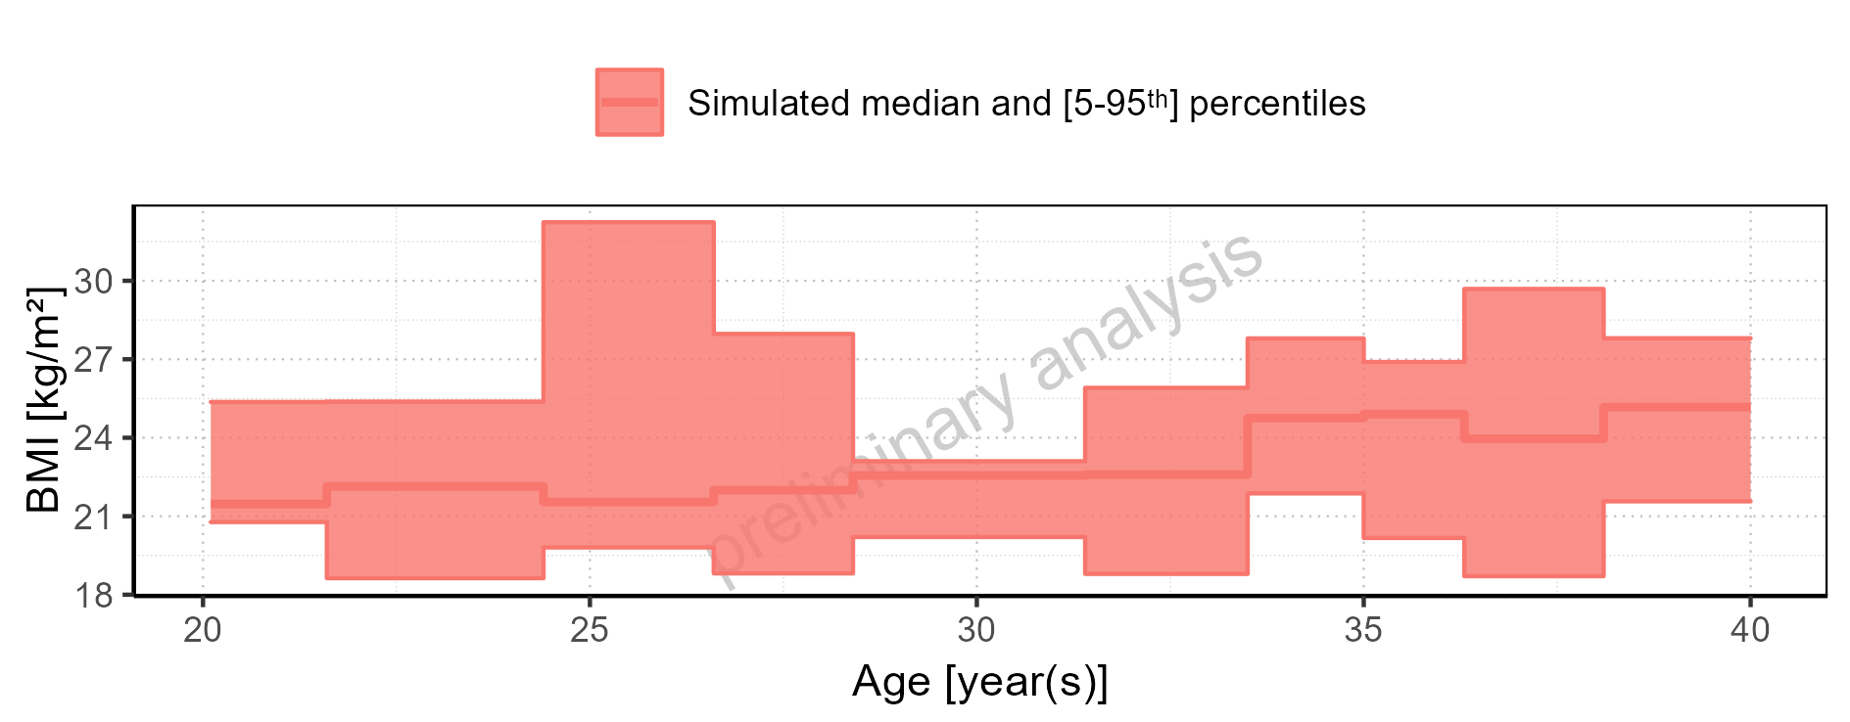

Figure 4-18: Age-dependence of BMI for Filmcoated_tablet_400mg_sd. Profiles are plotted in a logarithmic scale.